
St. Francis Institute of Technology
(Engineering College)
(An Autonomous Institute, Affiliated to University of Mumbai)
AICTE Approved | NAAC A+ grade: 03 programs are NBA Accredited: ISO 9001:2015 Certified

Department of Information Technology

MINI-PROJECT REPORT
Web Based Business Model (Mini Project 2A) (ITM 501)
Title of Mini Project

B. E. Information Technology
By

Rahil Kritikar 49
Anushka Kotal 52
Abhit Kunkalkar 53
Karthik Janardhan 54

Guide

Ms. Akanksha Naik
Assistant Professor

Academic Year: 2025-2026

DECLARATION

We declare that this written submission represents our ideas in our own words and where others ideas or words have been included, we have adequately cited and referenced the original sources.
We also declare that we have adhered to all principles of academic honesty and integrity and have not misrepresented or fabricated or falsified any idea/data/fact/source in this submission. We understand that any violation of the above will be cause for disciplinary action by the Institute and can also evoke penal action from the sources which have thus not been properly cited or from whom proper permission has not been taken when needed.

1.
( Rahil Kritikar 49 )

2.
( Anushka Kotal 52 )

3.
( Abhit Kunkalkar 53 )

4.
( Karthik Janardhan 54 )

Date: 7/11/2025

CERTIFICATE

This Web-Based Business Model Mini-project {Skillora} by { Rahil Kritikar 49, Anushka Kotal 52, Abhit Kunkalkar 53, Karthik Janardhan 54 } is complete in all respects and was successfully demonstrated on {Final external presentation date}.

(Name of Internal Examiner) (Name of External Examiner)

Dr. Prachi Raut
HoD, Department of Information Technology

Date: 7/11/25
Place: Mumbai

CONTENTS

Sr. No. | Chapter Name | Page No.
1 | Introduction | 5-6
 | 1.1 Description of the problem | 5
 | 1.2 Suggested solution | 5
 | 1.3 Competition Study | 6
 | 1.4 Problem Statement | 6
2 | Business Model Canvas | 7-9
 | 2.1 Customer segments | 7
 | 2.2 Customer Relationships | 7
 | 2.3 Channel | 7
 | 2.4 Key partners | 7
 | 2.5 Key activities | 8
 | 2.6 Key resources | 8
 | 2.7 Value proposition | 8
 | 2.8 Cost Structure | 8
 | 2.9 Revenue Model | 9
3 | System Design | 10-11
 | 3.1 System design diagram | 10
 | 3.2 Technologies used | 11
4 | Product Prototype | 12-14
 | 4.1 Frontend screenshots | 12-13
 | 4.2 Test cases | 14
5 | Conclusion | 15
 | References | 16

Chapter 1

INTRODUCTION

  - Description of the problem

In the modern digital era, students and job seekers face several challenges in building a clear and structured path from learning to employment. Most existing online platforms offer fragmented learning experiences, focusing either on providing courses or connecting candidates to jobs, but not both. This lack of integration makes it difficult for learners to identify relevant skills that match industry needs, track their progress, or gain recognized certifications that truly reflect their capabilities. As a result, many learners feel lost in their career journey despite having access to multiple learning resources.

On the other hand, educators and employers also struggle within this uncoordinated system. Teachers lack flexible and rewarding platforms to share their expertise effectively or to reach a large audience. Employers face challenges in finding skilled, job-ready candidates who meet their organization’s requirements. This disconnect between students, instructors, and employers leads to inefficiency, wasted potential, and slower career growth. Therefore, there is a strong need for a unified and interactive platform that bridges the gap between skill development, mentorship, and employment opportunities.

  - Suggested solution

To address the challenges faced by learners, educators, and employers, Skillora is designed as an all-in-one e-learning and career development platform. It aims to create a seamless connection between skill acquisition and job placement by offering structured, interactive, and affordable courses. Learners can access a wide range of skill-based programs, track their progress through personalized dashboards, and earn verified certifications that enhance their employability. The platform also promotes hands-on learning and mentorship, helping students gain real-world experience and confidence in their abilities.

Skillora empowers educators by providing them with flexible teaching tools and opportunities to share and monetize their expertise. Employers, in turn, benefit from direct access to a pool of pre-trained, job-ready candidates, reducing their hiring time and costs. By integrating education, mentorship, and employment within one digital ecosystem, Skillora ensures a smoother and more effective journey from learning to earning. This holistic approach not only bridges the gap between education and industry but also fosters a sustainable environment where all stakeholders including students, teachers, and employers mutually benefit.

  - Competition study
The e-learning and job development market includes platforms like Coursera, Udemy, and LinkedIn Learning, which focus mainly on providing online courses, and portals like Internshala and Naukri, which concentrate on internships and job placements. However, these platforms operate separately, lacking a unified approach that connects learning with direct employment opportunities. Skillora differentiates itself by integrating both aspects into a single ecosystem that offers structured learning, mentorship, certification, and job placement. This holistic model ensures that learners not only gain industry-relevant skills but also have access to real job opportunities. With its focus on affordability, personalized learning, and verified achievements, Skillora bridges the gap between education and employment, positioning itself as a complete solution that supports students, educators, and employers alike.

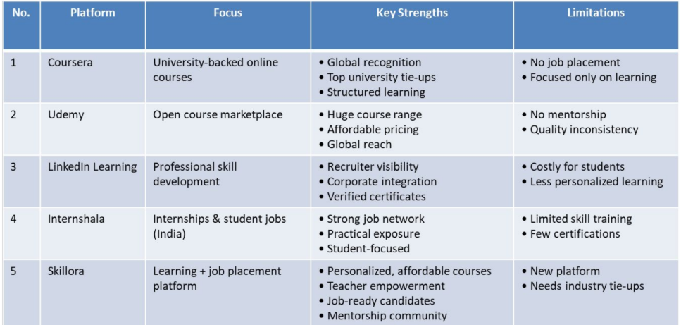

  - Problem statement
In today’s digital learning environment, there is a significant gap between skill acquisition and employability. Existing online platforms either focus solely on providing educational content or on connecting candidates with employers, resulting in a fragmented learning-to-employment pathway. This separation leaves students unsure of which skills align with industry needs, while educators struggle to reach and engage learners effectively. At the same time, employers face difficulty finding qualified, job-ready candidates who possess both theoretical knowledge and practical skills.
Therefore, there is a need for a unified and interactive digital platform that integrates learning, mentorship, certification, and job placement into one ecosystem. Such a solution should empower students to gain relevant skills, enable teachers to share expertise efficiently, and assist employers in identifying competent candidates ultimately bridging the gap between education and employment.

Chapter 2 BUSINESS MODEL CANVAS

  - Customer segments
Skillora primarily targets four groups: students, teachers/trainers, job seekers, and employers/recruiters. Students, particularly undergraduates and college learners, form the core audience seeking to enhance their skills and employability. Teachers and trainers use the platform to share their expertise and generate income by offering courses or mentorship. Job seekers utilize Skillora to access certified training and connect with potential employers. Meanwhile, recruiters and companies gain access to a pool of pre-trained, job-ready candidates, reducing hiring costs and improving the quality of recruitment.
  - Customer relationships

Skillora maintains personalized and interactive relationships with users. Students receive one-on-one mentoring, guidance, and support through a community-driven environment. Teachers are supported with onboarding, training resources, and networking opportunities. Employers are engaged through recruitment alerts and collaborations. The main communication and delivery channels include the website, mobile app, and social media platforms, ensuring accessibility and continuous engagement. These channels help users interact with content, track progress, and connect seamlessly with instructors and recruiters.

  - Channel

Skillora’s success depends on partnerships with educational institutions, training providers, teachers, and companies seeking skilled talent. Key activities include curating and updating learning content, monitoring placement services, and conducting assessments. The platform also focuses on personalized career guidance to align skills with market demand. Its essential resources are the technology platform (built on Django, SQLite, and Bootstrap), content partnerships, and user data. Together, these elements ensure the platform runs efficiently and delivers value to its users.

  - Key partners

Skillora’s key partners include students, schools, colleges, universities, and job seekers, along with teachers, trainers, and corporate recruiters. Educational institutions help Skillora reach learners and integrate the platform into academic programs. Teachers and trainers act as content creators and mentors, enriching the platform with high-quality learning materials. Employers and recruitment firms are also essential partners, as they offer job opportunities and internships to trained candidates. These collaborations create a complete ecosystem that connects education with employment.

  - Key activities

The main activities of Skillora involve curating and updating skill development content, conducting job training and placement services, and analyzing user engagement for continuous improvement. The platform partners with training providers to design industry-relevant courses and certifications. It also offers personalized career guidance and skill assessments to help learners understand their strengths and areas for growth. Additionally, community events, workshops, and mentoring programs are organized to enhance user participation and professional development.

  - Key resources

Skillora relies on several key resources to operate effectively. Its most vital asset is the technology platform, built using Django and SQLite with a Bootstrap-based interface for a seamless user experience. The platform also depends on partnerships with content providers, educational institutions, and job placement agencies. Human resources such as instructors, mentors, and the support team contribute to course delivery and guidance. The growing user base—students, job seekers, and employers—acts as both a resource and a driver for continuous innovation and engagement.

  - Value proposition

Skillora offers a unique value by bridging the gap between learning and employment. For students and job seekers, it provides access to affordable, high-quality, and personalized skill development programs. Teachers and trainers benefit from opportunities to share knowledge, build credibility, and earn income. Employers gain access to verified, job-ready candidates, saving time in recruitment. By combining education, mentorship, and employment into one platform, Skillora ensures a smooth transition from learning to career success.
  - Cost structure
The cost structure of Skillora includes technology and infrastructure expenses required to maintain and update the platform, along with costs related to content creation and development. Marketing and customer acquisition also account for a significant portion of expenses, helping attract new users and partners. Additionally, the platform invests in customer support, community management, and staff salaries to ensure smooth operation and user satisfaction. These costs together ensure the continuous growth and reliability of the platform.

  - Revenue model
Skillora generates revenue through multiple streams. The platform earns commissions from companies for successful job placements and charges placement fees from candidates. Additional income is generated from premium services such as personalized mentoring, advanced training modules, and certification courses. It may also collect fees from course enrollments and partnerships with educational institutions. This diversified revenue model ensures sustainability while supporting Skillora’s mission to connect talent with opportunity.

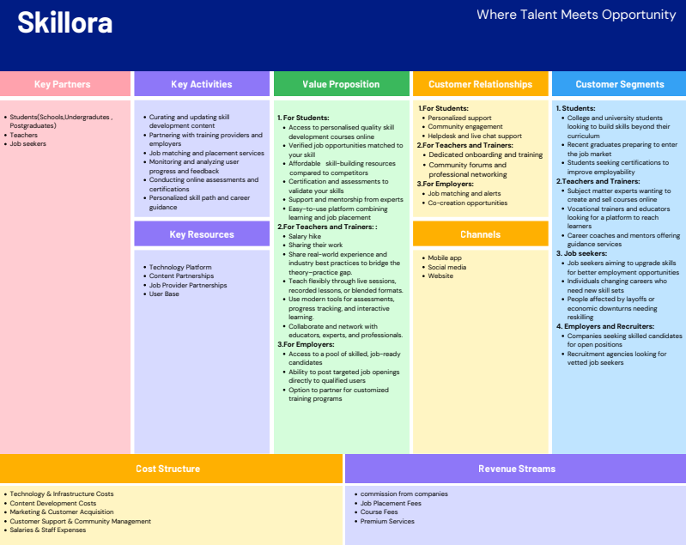
Chapter 3

SYSTEM DESIGN

  - System Design Diagram/Flowchart Explanation
The system design of Skillora follows a structured client–server model.
- User Interaction Layer – This is the front end where students, teachers, and employers interact through the web interface. Users can sign up, log in, browse courses, access dashboards, and communicate with other users.
- Application Layer – Once the user performs an action, it is processed by the Django-based backend. This layer handles authentication, user role management, course allocation, progress tracking, and job posting functionalities.
- Database Layer – All user data, course content, progress reports, and job listings are stored in the SQLite database. Django interacts with this database to fetch, store, and update information as needed.
- Flow Overview –
    - A student logs in → searches for a course → enrolls and completes lessons → earns certification.
    - A teacher logs in → uploads or manages courses → tracks student performance.
    - An employer posts a job → views candidates who have completed relevant courses → connects with them for hiring.
This design ensures a smooth data flow between users, the server, and the database while maintaining security and efficiency.

  - Hardware/Software used

Hardware Used:
Since Skillora is a web-based application, the hardware requirements are minimal and primarily needed for development and hosting:
- Server/Hosting Machine – For deploying the Django application and SQLite database.
- Client System – Any computer or laptop with internet access and a modern web browser (e.g., Chrome, Edge).
- Network Equipment – Basic internet connectivity with stable bandwidth for real-time operations.
Software Used:
Skillora is developed using open-source and lightweight technologies:
- Frontend: HTML, CSS, JavaScript, and Bootstrap for responsive design.
- Backend: Django Framework (Python) for server-side logic and API handling.
- Database: SQLite, an integrated and efficient database for managing user data.
- Development Tools: VS Code for coding, GitHub for version control.
- Server & Hosting: Localhost and render
- Operating System: Compatible with Windows, macOS.

Chapter 4

PRODUCT PROTOTYPE

  - Front end Screenshots
SignUp:

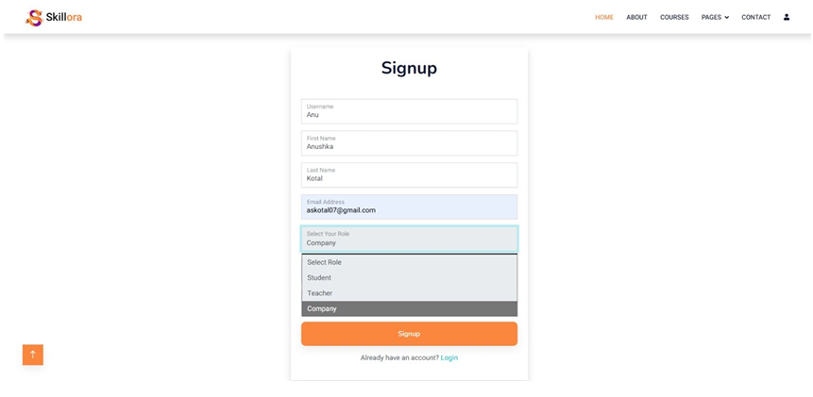

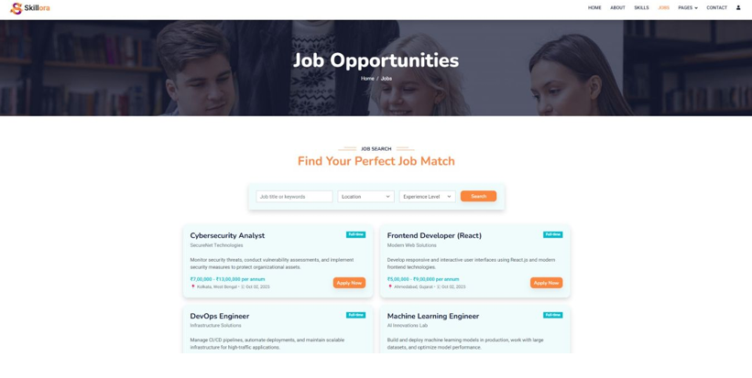

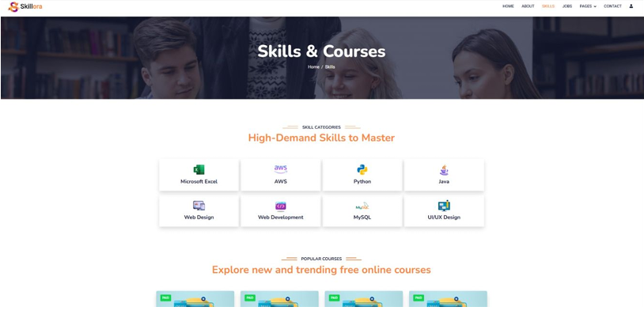

4.1 Test Cases

Test Case ID | Test Case Description | Input / Action | Expected Output / Result | Status
TC01 | User Registration | New user enters name, email, password, and selects role (Student/Teacher/Employer) | Account created successfully and confirmation message displayed | Pass
TC02 | User Login | Valid credentials entered in login form | User redirected to respective dashboard | Pass
TC03 | Invalid Login | Incorrect username or password | Error message displayed: “Invalid credentials” | Pass
TC04 | View Course Catalog | Student clicks on “Browse Courses” | List of available courses displayed | Pass
TC05 | Enroll in a Course | Student selects a course and clicks “Enroll” | Enrollment confirmation message displayed and course appears in student dashboard | Pass
TC06 | Upload Course (Teacher) | Teacher uploads course title, description, and content | Course added successfully and visible in catalog | Pass
TC07 | Track Progress | Student completes a lesson | Progress bar updates accordingly in dashboard | Pass
TC08 | Generate Certificate | Student completes entire course | Verified digital certificate generated and downloadable | Pass
TC09 | Post a Job (Employer) | Employer fills job title, requirements, and deadline | Job post published and visible to eligible candidates | Pass

Chapter 5

CONCLUSION

Skillora positions itself as a unique bridge between learning and employment by integrating
personalized skill development with direct job placement opportunities. Unlike competitors such as Coursera, Udemy, and LinkedIn Learning, which primarily focus on online education, or Internshala, which emphasizes job matching, Skillora offers a unified platform that connects both aspects. Its strengths include affordable, personalized courses accessible to students and job seekers empowerment of teachers through flexible teaching tools and monetization options; and value for employers by providing access to pre-trained, job-ready candidates. With a community-driven mentorship model that enhances engagement and outcomes, Skillora creates a holistic ecosystem where learners, educators, and employers all benefit, ensuring scalability and long-term impact beyond platforms that address only one side of the learning or employment spectrum.

REFERENCES

[1] H. Abuhassna, W. M. Al-Rahmi, N. Yahya, M. A. Zahiri, and M. Darwish, “Development of a new model on utilising online learning platforms to improve students’ academic achievements and satisfaction,” International Journal of Educational Technology in Higher Education, vol. 17, no. 38, 2020. [Online]. Available: https://educationaltechnologyjournal.springeropen.com/articles/10.1186/s41239-020-00216-z
[2] R. Kumar, “Assessing the impact of online learning platforms on student engagement and retention,” Siddhanta’s International Journal of Educational Research, vol. 1, no. 1, pp. 77–88, 2025. [Online]. Available: https://siddhantainternationalpublication.net/index.php/sijer/article/view/29
[3] S. Ishaq and Z. Asghar, “Perceived work readiness among graduates: A case study from Pakistan,” Empirical Economic Review, 2023. [Online]. Available: https://ojs.umt.edu.pk/index.php/eer/article/view/2110
[4] B. Harris-Reeves, A. Pearson, J. Vanderlelie, and H. Massa, “The value of employability-focused assessment: Student perceptions of career readiness,” Journal of Teaching and Learning for Graduate Employability, 2024. [Online]. Available: https://ojs.deakin.edu.au/index.php/jtlge/article/view/1903
[5] H. K. Azzaakiyyah and A. Junaidi, “Analysis of employee career development strategies based on gamification and microlearning in enhancing retention and HR performance,” ADMAN: Journal of Contemporary Administration and Management, vol. 1, 2025. [Online]. Available: https://journal.literasisainsnusantara.com/index.php/adman/article/view/285
[6] M. A. Perera, T. Fernandes, and P. Paniker, “Career readiness: A survey on effectiveness of learning employability skills at university level,” International Journal of Engineering Technologies and Management Research, vol. 5, no. 9, pp. 83–92, 2018. [Online]. Available: https://granthaalayahpublication.org/ijetmr-ojms/ijetmr/article/view/09_IJETMR18_A12_578
[7] S. V. Phulari, A. Lavale, A. Raut, K. Naykodi, and P. Gadekar, “Academia: Web platform for e-learning,” International Journal for Research in Applied Science and Engineering Technology (IJRASET), vol. 10, no. 3, pp. 211–215, 2022. [Online]. Available: https://www.ijraset.com/research-paper/web-platform-for-e-learning
[8] F. St-Hilaire et al., “A new era: Intelligent tutoring systems will transform online learning for millions,” arXiv preprint arXiv:2203.03724, 2022. [Online]. Available: https://arxiv.org/abs/2203.03724

