St. Francis Institute of Technology, Mumbai-400 103
Department of Information Technology

A.Y. 2025-2026
Class: TE-ITA/B, Semester: V

Subject: Advanced DevOps Lab


Experiment – 2: a)To Build Your Application using AWS CodeBuild and Deploy on S3 / SEBS using AWS CodePipeline, deploy Sample Application on EC2 instance using AWS CodeDeploy.
b)To understand and implement the concept of a pipeline by using GitHub as a platform for continuous integration and deployment on a sample application.

- Aim: To Build Your Application using AWS CodeBuild and Deploy on S3 / SEBS using AWS CodePipeline, deploy Sample Application on EC2 instance using AWS CodeDeploy.
- Objectives: After study of this experiment, the student will be able to
  - Build an application using AWS CodeBuild and Deploy on S3 using CodePipeline.
  - Deploy an application on EC2 using AWS CodeDeploy.
- Outcomes: After study of this experiment, the student will be able to
  - Build an application using AWS CodeBuild and Deploy on S3 using CodePipeline.
  - Deploy an application on EC2 using AWS CodeDeploy.

- Prerequisite: Fundamentals of cloud computing

- Requirements: PC and Internet

- Pre-Experiment Exercise:

Brief Theory:

AWS CodePipeline:
AWS CodePipeline is a continuous delivery service you can use to model, visualize, and automate the steps required to release your software. You can quickly model and configure the different stages of a software release process. CodePipeline automates the steps required to release your software changes continuously.
CICD:
odePipeline is a continuous delivery service that automates the building, testing, and deployment of your software into production.
Continuous delivery is a software development methodology where the release process is automated. Every software change is automatically built, tested, and deployed to production. Before the final push to production, a person, an automated test, or a business rule decides when the final push should occur. Although every successful software change can be immediately released to production with continuous delivery, not all changes need to be released right away.
Continuous integration is a software development practice where members of a team use a version control system and frequently integrate their work to the same location, such as a main branch. Each change is built and verified to detect integration errors as quickly as possible. Continuous integration is focused on automatically building and testing code, as compared to continuous delivery, which automates the entire software release process up to production.
Features:
You can use CodePipeline to help you automatically build, test, and deploy your applications in the cloud. Specifically, you can:
- Automate your release processes: CodePipeline fully automates your release process from end to end, starting from your source repository through build, test, and deployment. You can prevent changes from moving through a pipeline by including a manual approval action in any stage except a Source stage. You can release when you want, in the way you want, on the systems of your choice, across one instance or multiple instances.
- Establish a consistent release process: Define a consistent set of steps for every code change. CodePipeline runs each stage of your release according to your criteria.
- Speed up delivery while improving quality: You can automate your release process to allow your developers to test and release code incrementally and speed up the release of new features to your customers.
- Use your favorite tools: You can incorporate your existing source, build, and deployment tools into your pipeline. For a full list of AWS services and third-party tools currently supported by CodePipeline..
- View progress at a glance: You can review real-time status of your pipelines, check the details of any alerts, retry failed actions, view details about the source revisions used in the latest pipeline execution in each stage, and manually rerun any pipeline.
- View pipeline history details: You can view details about executions of a pipeline, including start and end times, run duration, and execution IDs.

You will create the pipeline using AWS CodePipeline, a service that builds, tests, and deploys your code every time there is a code change. You will use your GitHub account, an Amazon Simple Storage Service (S3) bucket, or an AWS CodeCommit repository as the source location for the sample app’s code. You will also use AWS Elastic Beanstalk as the deployment target for the sample app. Your completed pipeline will be able to detect changes made to the source repository containing the sample app and then automatically update your live sample app.

- Laboratory Exercise

1) To simplify the process of setting up and configuring EC2 instances, you will spin up a sample environment using AWS Elastic Beanstalk. Elastic Beanstalk lets you easily host web applications without needing to launch, configure, or operate virtual servers on your own. It automatically provisions and operates the infrastructure (e.g. virtual servers, load balancers, etc.) and provides the application stack (e.g. OS, language and framework, web and application server, etc.) for you.
Your continuous deployment pipeline will need a target environment containing virtual servers, or
Amazon EC2 instances, where it will deploy sample code. You will prepare this environment before creating the pipeline.
Step1: Create a deployment environment

Step 2: Get the copy of Sample Code
In this step you will retrieve the sample app’s code and choose a source to host the code.
Pipeline takes the code and performs actions on it.
You can use three options.
- GitHub Repository
- Amazon S3 Bucket
- AWS CodeCommit Repository
Open Amazon S3 console and Create your S3 Bucket:
- Create Bucket
- Upload the code to Bucket
- Select Bucket and Click on Upload ( Right Corner)
- Add Files --🡪 upload zip file from downloads of your computer. Click on Upload Button

Step 3: Create Pipeline
In this step, you will create and configure a simple pipeline with two actions: source and deploy. You will provide CodePipeline with the locations of your source repository and deployment environment.

Create new pipeline:
Source Provider = Amazon S3,
Bucket = YourBucketName,
S3 Object Key = Copy S3 Uri from Amazon S3 bucket.

Add Deploy Stage:

Review the settings and create the pipeline.

Add deploy stage and Give details :
Deployement provider : AWS Elastic Beanstalk,
Region,
Application Name and Environment Name…(Auto suggested.)

Pipeline created successfully.

After your pipeline is created, the pipeline status page appears and the pipeline automatically starts to run. You can view progress as well as success and failure messages as the pipeline perform each action.

To verify your pipeline ran successfully, monitor the progress of the pipeline as it moves through each stage. The status of each stage will change from No executions yet to In Progress, and then to either Succeeded or Failed. The pipeline should complete the first run within a few minutes.
Now go to your EBS environment and click on the URL to view the sample website you deployed.

Step 4: Activate your pipeline to deploy your code

Step 5: Clean up the resources
To avoid future charges, you will delete all the resources you launched which includes the pipeline, the Elastic Beanstalk application, and the source you set up to host the code.
First, you will delete your pipeline:
- In the pipeline view, click Edit.
- Click Delete.
- Type in the name of your pipeline and click Delete.

Second, delete your Elastic Beanstalk application:
- Visit the Elastic Beanstalk console.
- Click Actions.
- Then click Terminate Environment.
- We have successfully created an automated software release pipeline using AWS CodePipeline! Using CodePipeline, We created a pipeline that uses GitHub, Amazon S3, or AWS CodeCommit as the source location for application code and then deploys the code to an Amazon EC2 instance managed by AWS Elastic Beanstalk. Pipeline will automatically deploy your code every time there is a code change.

PART A:
Create a EC2 Instance Profile for ElasticBeanstalks
Create role: ElasticBeanstalk-Instance-Profile , Add these 3 Permission Policies: AWSElasticBeanstalkWebTier, AWSElasticBeanstalkWorkerTier,
AWSElasticBeanstalkMulticontainerDocker
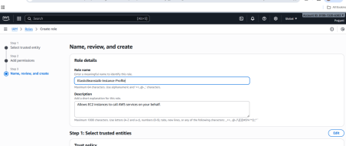
Observation: The first image is a screenshot from the AWS Management Console, specifically the IAM (Identity and Access Management) service where a new role is being created. The role name, "ElasticBeanstalk Instance Profile," is being entered, and the description provided explains that this role will allow EC2 instances to call AWS services on the user's behalf. Below the role name and description fields, there's an option to configure the trusted entities and attach relevant policies. This screen is part of the process to define and assign permissions that EC2 instances need to interact with other AWS services, specifically for an Elastic Beanstalk environment.

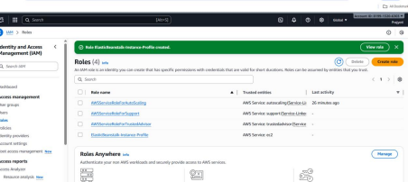
Observation: The second image captures the screen right after successfully creating the IAM role, "ElasticBeanstalk Instance Profile." A green confirmation banner at the top indicates that the role has been created. Below the banner, the newly created role appears in the list of IAM roles, along with its trusted entities (such as AWS services) and the most recent activity related to it. The list shows other roles as well, indicating a broader context of IAM roles that are managed within the console. This image highlights the ease with which roles are created and the transparency of role management in AWS.
Step 1: Create a new AWS ElasticBeanStalk Application
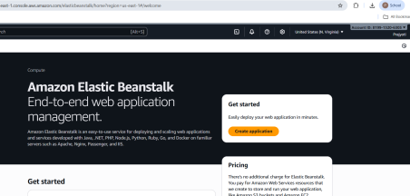
Observation: The third image is a screenshot of the Amazon Elastic Beanstalk dashboard, which is part of AWS's service for managing web applications. The page presents an overview of the platform’s capabilities, such as deploying and scaling web apps developed in various programming languages like Java, Python, .NET, and Docker. The "Create Applications" button stands out, inviting users to start deploying their web apps quickly. This image emphasizes the user-friendly interface of Elastic Beanstalk, which simplifies the deployment process and removes much of the complexity traditionally associated with managing web applications in the cloud.
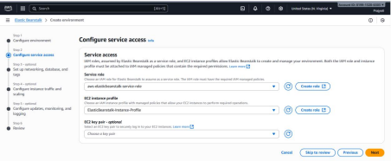
Observation: This image displays the configuration screen for service access within an AWS Elastic Beanstalk environment setup. The user is setting permissions for the AWS service role and EC2 instance profile, essential for Elastic Beanstalk to create and manage the environment. The service role (aws.elasticbeanstalk.service-role) is selected, and the option to create a new role is available. Similarly, the EC2 instance profile is also being configured, with an option to create a new profile if needed. The "EC2 key pair" section is optional, allowing users to choose an existing key pair or create one to securely access EC2 instances. The interface is clear, with multiple options to customize roles and permissions.
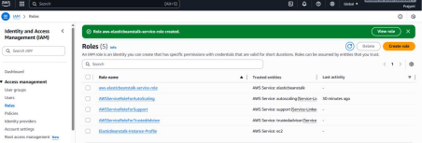
Skip to review and create
Observation: This image shows the IAM (Identity and Access Management) dashboard where roles have been created in AWS. The green banner at the top indicates that the role for Elastic Beanstalk service access has been successfully created. Several roles are listed, such as "aws.elasticbeanstalk.service-role" and "ElasticBeanstalk instance Profile," along with other roles related to support and instances. The roles are clearly identified by their trusted entities and the latest activity timestamps, providing an overview of their usage within the AWS environment. It reflects an organized and functional IAM setup.
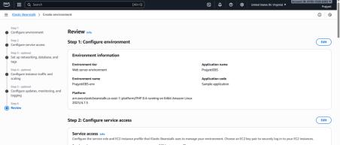
Observation: This image shows the IAM (Identity and Access Management) dashboard where roles have been created in AWS. The green banner at the top indicates that the role for Elastic Beanstalk service access has been successfully created. Several roles are listed, such as "aws.elasticbeanstalk.service-role" and "ElasticBeanstalk instance Profile," along with other roles related to support and instances. The roles are clearly identified by their trusted entities and the latest activity timestamps, providing an overview of their usage within the AWS environment. It reflects an organized and functional IAM setup.
Step 2: Create a new AWS S3 Bucket
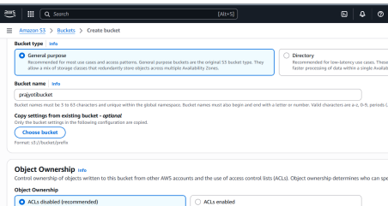
Observation: This image represents the review step of the Elastic Beanstalk environment creation process. The user is reviewing the environment configuration and service access settings. In this step, the environment information is displayed, showing details like the environment name, platform, and application details. The service access configuration is also summarized, confirming the role and instance profile settings chosen earlier. This step is the final overview before the actual creation of the environment, ensuring that all configuration settings are correct.
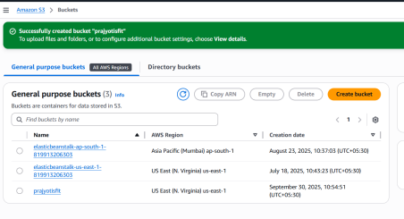
Observation: This screenshot displays an Amazon Web Services (AWS) S3 (Simple Storage Service) dashboard showing a list of three S3 buckets. It shows the creation dates, names, and associated AWS regions for each bucket. For example, two of the buckets are located in Asia Pacific (Mumbai) and the U.S. East (N. Virginia) regions. The new bucket, named "prayotisft," was recently created in the U.S. East (N. Virginia) region. The interface also includes options to copy the ARN, delete, or configure additional settings for the buckets.
Step 3: Download the source code .zip file
https://github.com/imoisharma/aws-codepipeline-s3-codedeploy-linux-2.0 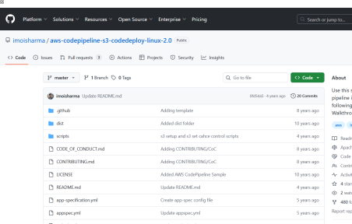
Observation: This image presents a GitHub repository page titled "aws-codepipeline-s3-codedeploy-linux-2.0." It includes a list of files and directories, such as "README.md," "scripts," and "appspec.yml," and highlights commits made over the years. This repository appears to be a sample or project related to AWS CodePipeline and AWS S3 CodeDeploy for Linux, with recent updates and changes to the documentation files. There are also options to interact with the repository (e.g., clone, create pull requests, etc.).
Step 4: Upload .zip file in the new S3 Bucket
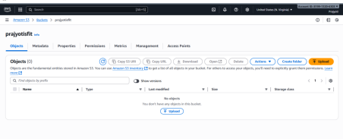
Observation: This screenshot is from the S3 bucket named "prayotisft." It shows the "Objects" tab where users can upload, organize, or manage objects within this specific bucket. At the moment, there are no objects listed in the bucket, as indicated by the message "No objects." The interface offers various actions such as uploading files, creating folders, copying the S3 URL, or downloading existing files, allowing users to manage the data stored in this specific bucket.
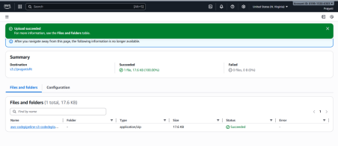
Observation: The first image shows the AWS S3 console where an upload process is taking place. A file named aws-codedeploy-linux-codedeploy-linux-2.0-master.zip (17.6 KB) has been successfully uploaded to a specific destination. The status of the upload is marked as "successful" in green, which means the file was uploaded without issues. The "Summary" section also confirms that no files failed during the process, and the "Files and Folders" section provides a quick overview of the file’s details, including its type (application/zip) and size.
Open the newly added zip file and copy the key
aws-codepipeline-s3-codedeploy-linux-2.0-master (1).zip
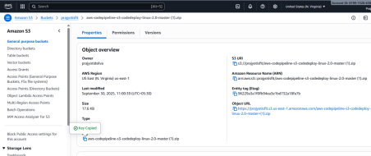

Observation: The second image provides more details about the file that was just uploaded in AWS S3. It displays the object properties, including the file's S3 URI, the AWS region in which it resides, its last modification timestamp, size (17.6 KB), and the file type. The "Object URL" section also gives the specific URL where the file can be accessed. The file appears to be stored properly and ready for use within the AWS infrastructure.
Step 5: Create a new AWS CodePipeline
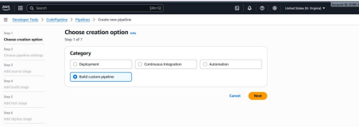
Observation: In the third image, the user is in the process of creating a new pipeline in AWS CodePipeline. The "Choose creation option" page is visible, showing three categories for pipeline creation: Deployment, Continuous Integration, and Automation. The "Build custom pipeline" option is selected, indicating that the user is customizing the pipeline setup. The user can proceed to the next step by clicking "Next" after making a selection, suggesting that this is part of an initial pipeline setup process for automating some workflow.
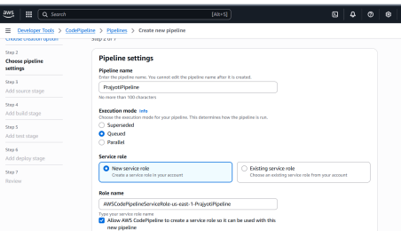
Observation: This image shows the initial setup of a new pipeline in AWS CodePipeline. The screen focuses on the "Pipeline settings" section, where the user defines important configuration options. The "Pipeline name" is set to "PrayojitPipeline," and the user is guided to enter a name for the pipeline that cannot be modified after the creation process. The "Execution mode" is selected as "Queued," meaning that the pipeline will run in a sequential manner rather than in parallel. The "Service role" section is also visible, with the option to either create a new service role or use an existing one. The chosen service role name is "AWSCodePipelineServiceRole," which is related to the creation of a pipeline role in AWS.
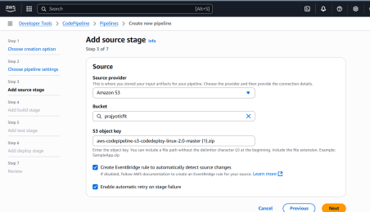
Observation: This image displays the "Add source stage" section of the AWS CodePipeline setup process. The source of the input artifacts is selected as Amazon S3. In this case, the bucket chosen for storing the source artifacts is called "projectS3Rt." The user is required to input an S3 object key, which points to the location of a zip file named "aws-codedeploy-pipeline-s3-codedeploykit-lina-2.0-master (1).zip."

Paste the copied key for the zip file in S3 object key field
Skip the Add Build stage, Add Test Stage
Review and Create Pipeline
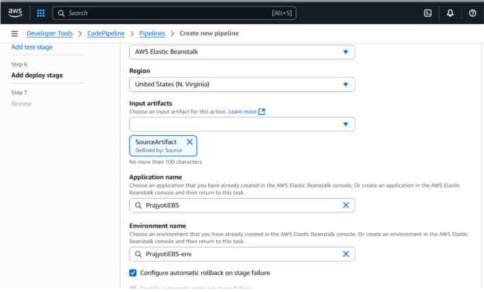
Observation: This image shows the "Add deploy stage" configuration screen in AWS CodePipeline. The deployment stage is being configured to use AWS Elastic Beanstalk for deployment. The region for the deployment is set to "United States (N. Virginia)." The "SourceArtifact" is selected as the input artifact defined earlier in the source stage. The application and environment names are pre-defined as "PrayojitEBS" and "PrayojitEBS-env," respectively. Additionally, the option to configure automatic rollback on stage failure is enabled, which ensures that if the deployment fails, AWS Elastic Beanstalk will automatically roll back to the previous stable state.

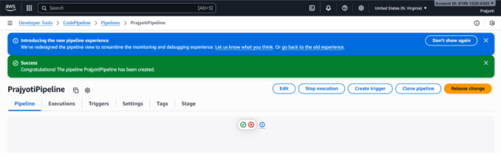
Observation: This image shows the AWS CodePipeline dashboard after the successful creation of a pipeline named "PrajyotiPipeline." A success message in green confirms that the pipeline was created without issues. It is likely in the early stages of configuration or deployment. Additionally, the pipeline interface allows for editing, stopping execution, creating triggers, cloning the pipeline, or releasing changes. The UI is designed to offer quick access to these operations, streamlining the management of the pipeline.
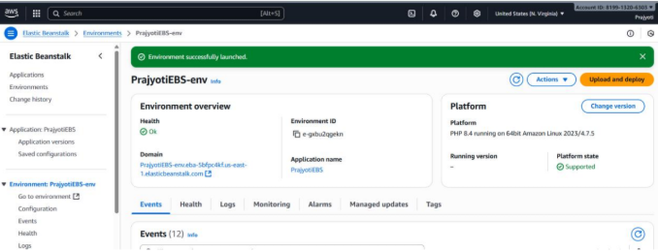
Observation: The second image presents the AWS Elastic Beanstalk environment dashboard, indicating that the "PrajyotiEBS-env" environment was successfully launched. The green notification confirms the environment's status as healthy and operational. The environment is running PHP 8.4 on Amazon Linux, and key information such as the environment ID, application name, and domain is visible. The image also shows an "Actions" dropdown menu, which offers options like uploading and deploying code to the environment.

Step 6: Visit the website
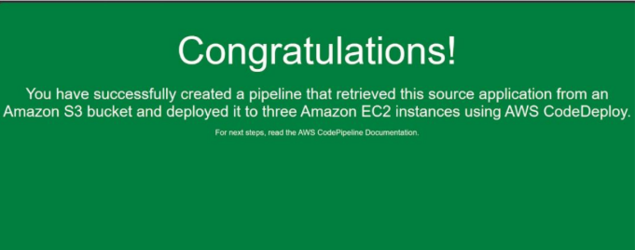
Observation: In the third image, a large green "Congratulations!" message appears, signifying the successful creation and execution of a deployment pipeline. This pipeline pulled a source application from an Amazon S3 bucket and deployed it to three Amazon EC2 instances via AWS CodeDeploy. The message emphasizes the completion of this task and directs the user to the AWS CodePipeline documentation for the next steps in their pipeline management. The visual conveys a sense of achievement in completing a key DevOps process.
Step 7: Make Changes to the code and Release Change on CodePipeline
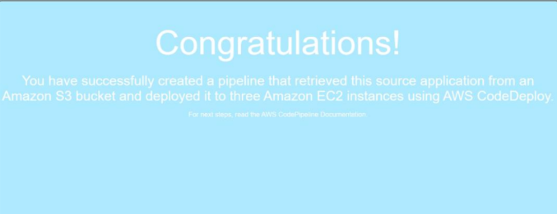
Observation: In the third image, a large light blue "Congratulations!" message appears, signifying the successful creation and execution of a deployment pipeline. This pipeline pulled a source application from an Amazon S3 bucket and deployed it to three Amazon EC2 instances via AWS CodeDeploy. The message emphasizes the completion of this task and directs the user to the AWS CodePipeline documentation for the next steps in their pipeline management. The visual conveys a sense of achievement in completing a key DevOps process.
Step 9: Delete CodePipeline, Delete S3 Bucket, First Empty Bucket then Delete
Delete ElasticBeanstalks, First Terminate the environment , Then delete the Application n IAM > Roles, delete all roles that were made by the services you used Don’t delete ElasticBeanstalk-Instance-Profile.
Part B: Implement the concept of a pipeline by using GitHub as a platform for continuous integration and deployment on a sample application
- Create Repository:
visit this link and download the repository / extract it / and upload to github
https://github.com/imoisharma/aws-codepipeline-s3-codedeploy-linux-2.0

2. Configure Workflow (Pipeline):
In your repo, create a directory: .github/workflows/
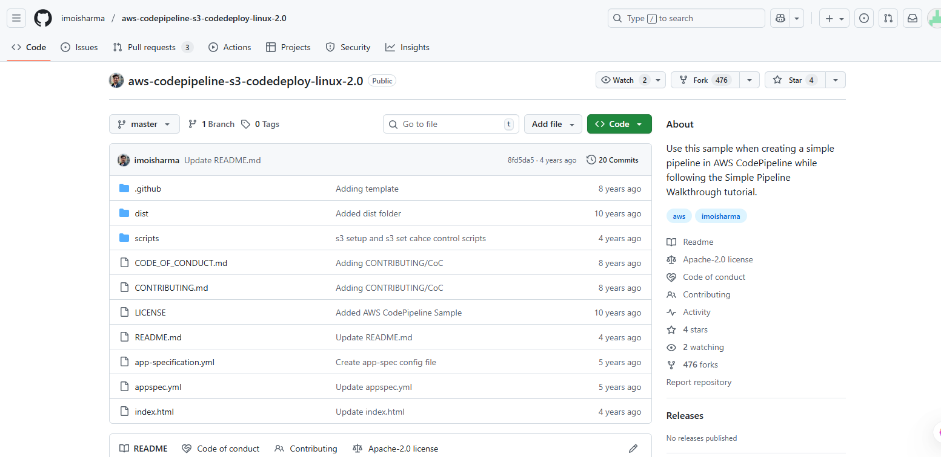
Observation: This GitHub repository, `aws-codepipeline-s3-codedeploy-linux-2.0` by *ironsimba*, provides a sample project for creating a simple AWS CodePipeline setup using S3 and CodeDeploy on a Linux environment, mainly intended as a tutorial reference.
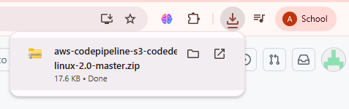
Observation: Downloaded the git repo.

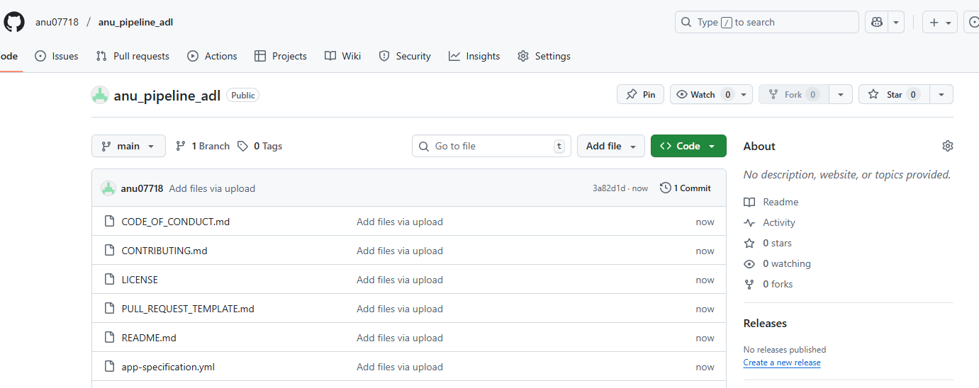
Observation: The first image displays the contents of a GitHub repository under the user anu07718 for a project called anu_pipeline_adl. It shows a list of files within the repository, including markdown files (e.g., CODE_OF_CONDUCT.md, CONTRIBUTING.md, LICENSE, etc.), and the app-specification.yml. Each file has a prompt to "Add files via upload," indicating that no files have been uploaded yet or they are in the process of being added. Additionally, the user has committed changes, as seen with the commit hash 3a82fbd. The repository appears to be in its early stages, with an emphasis on documentation and configuration files.
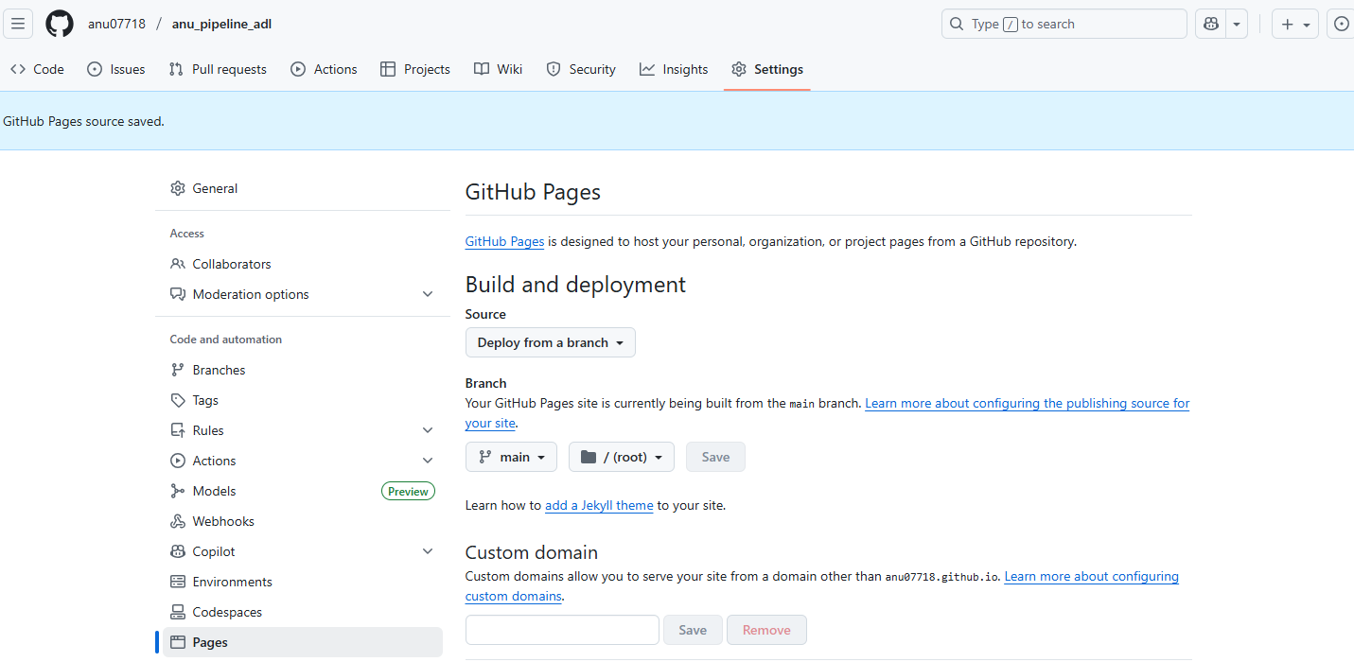
Observation: The second image shows the GitHub Pages settings for the same repository. Specifically, it highlights the configuration for deploying the project to GitHub Pages from the main branch. The user has chosen to deploy the site from a branch and has set it to main, which is indicated under the Build and deployment section. This configuration is part of the setup for making the repository publicly accessible through a web URL provided by GitHub Pages. The Custom domain option is visible, but no custom domain has been added yet. The interface also shows a "Preview" option and guidance on how to add a theme to the site.
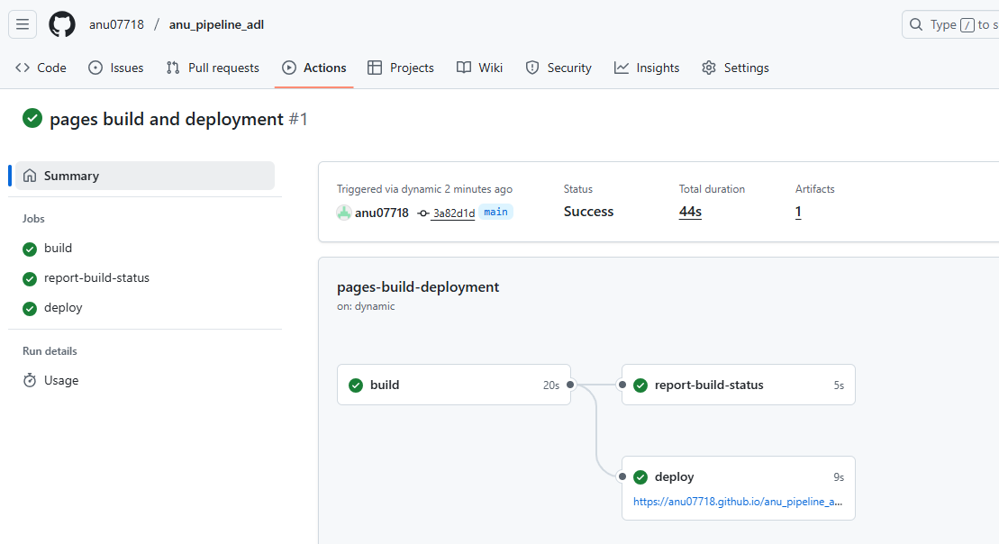
Observation: The third image captures the status of a GitHub Actions workflow run for deploying the repository to GitHub Pages. The run has completed successfully in 44 seconds. The workflow is broken down into three stages: build, report-build-status, and deploy. Each stage has been marked green, indicating successful execution. The final deployment step is represented by the URL https://anu07718.github.io/anu_pipeline_adl, which points to the live page. This suggests that the repository is set up for continuous integration and deployment (CI/CD), where the changes pushed to the repository automatically trigger builds and deployments.

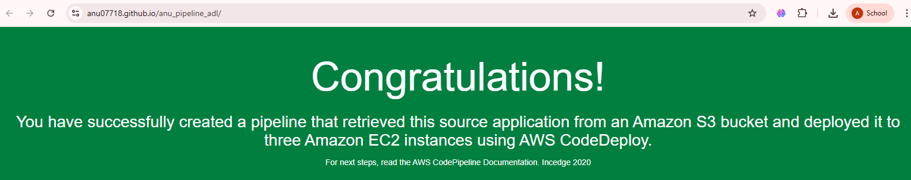
Observation: The first image presents a success message related to the creation of an AWS pipeline. The background is a green color with white text that congratulates the user. It says that the user has successfully created a pipeline, which retrieved an application from an Amazon S3 bucket and deployed it to three Amazon EC2 instances using AWS CodeDeploy. This indicates that a CI/CD (Continuous Integration and Continuous Deployment) process was set up to automate the process of building and deploying an application. It mentions that for the next steps, the user can refer to the AWS CodePipeline Documentation, suggesting that this is part of a learning or setup process in using AWS services.

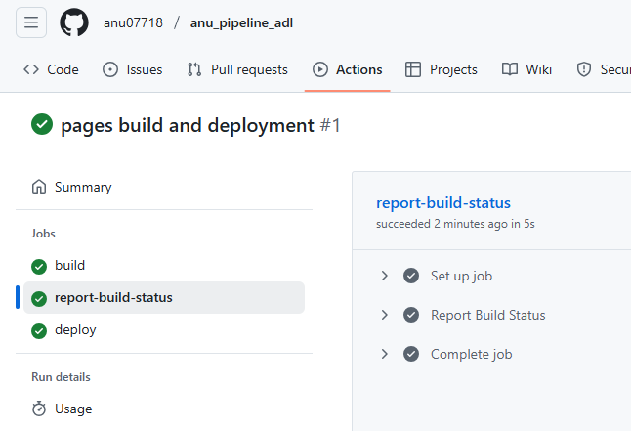
Observation: The second image shows a GitHub Actions dashboard for a project titled "anu_pipeline_adl." The image specifically highlights a successful execution of two main tasks: "report-build-status" and "deploy." These tasks are part of a pipeline that automates the process of building and deploying a project. The first task, "report-build-status," is marked as successful with a "green check" and is followed by sub-tasks that include setting up the job, reporting the build status, and completing the job. The second task, "deploy," is also marked as successful, indicating that after the build process, the application was deployed correctly. This integration between GitHub Actions and AWS tools suggests the user is leveraging both for an automated DevOps pipeline.
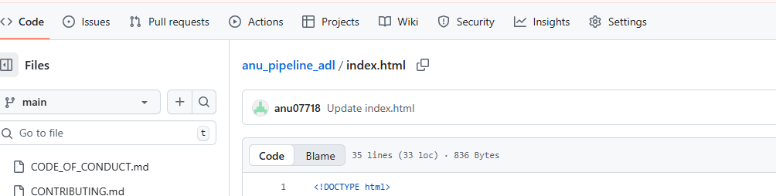
Observation: Change of colour in index file.
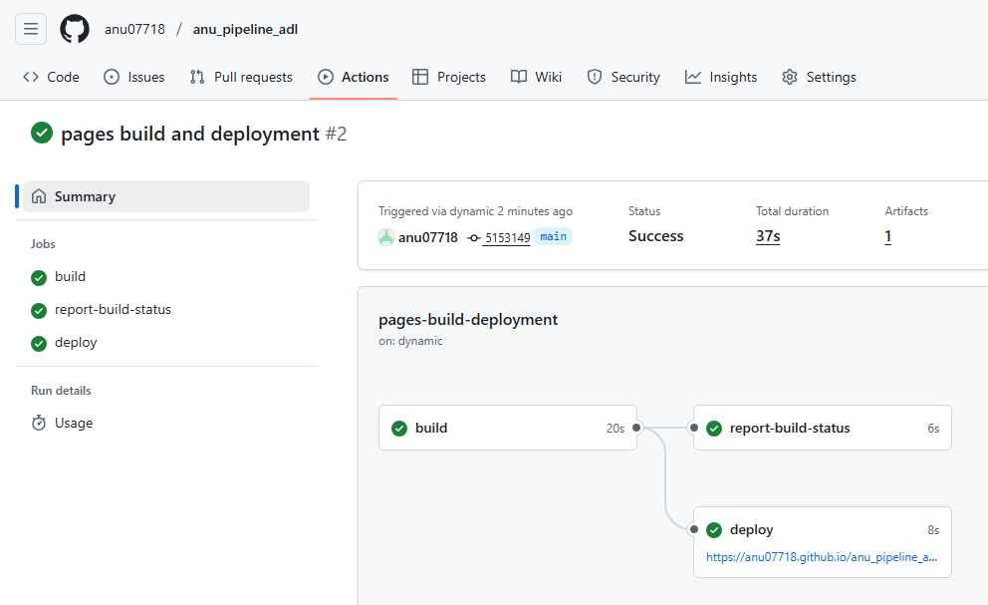
Observation: The third image captures the status of a GitHub Actions workflow run for deploying the repository to GitHub Pages. The run has completed successfully in 44 seconds. The workflow is broken down into three stages: build, report-build-status, and deploy. Each stage has been marked green, indicating successful execution. The final deployment step is represented by the URL https://anu07718.github.io/anu_pipeline_adl, which points to the live page. This suggests that the repository is set up for continuous integration and deployment (CI/CD), where the changes pushed to the repository automatically trigger builds and deployments.

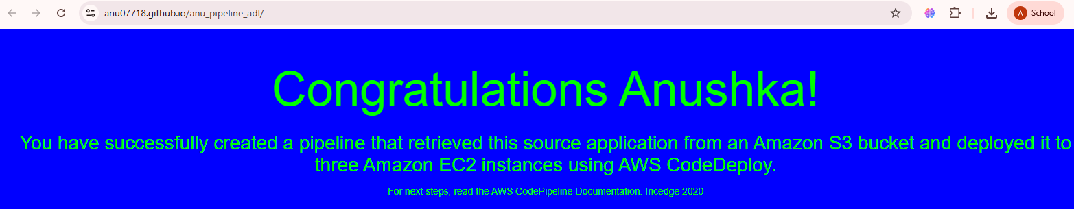
Observation: The first image presents a success message related to the creation of an AWS pipeline. The background is a green color with white text that congratulates the user. It says that the user has successfully created a pipeline, which retrieved an application from an Amazon S3 bucket and deployed it to three Amazon EC2 instances using AWS CodeDeploy. This indicates that a CI/CD (Continuous Integration and Continuous Deployment) process was set up to automate the process of building and deploying an application. It mentions that for the next steps, the user can refer to the AWS CodePipeline Documentation, suggesting that this is part of a learning or setup process in using AWS services.

Add a workflow file, e.g., ci-cd-pipeline.yml
name: CI Pipeline

on:
push:
branches: [ "main" ]
pull_request:
branches: [ "main" ]

jobs:
build:
runs-on: ubuntu-latest

steps:
- name: Checkout code
uses: actions/checkout@v3

- name: Set up Node.js
uses: actions/setup-node@v3
with:
node-version: '16'

- name: Install dependencies
run: npm install

- name: Run tests
run: npm test

3. Commit and Push Workflow:
Commit the .yml file and push it to GitHub.
GitHub will automatically trigger the workflow when code is pushed.

4. Observe Pipeline Execution:Go to the Actions tab in your repository. Monitor build, test, and deployment stages.
5. Make changes to index.html , commit it and repeat step 4
- Post-Experiments Exercise (Handwritten)
- Extended Theory:
- Deploy Web Application using Elastic BeanStalk
- AWS Storage Service: S3
- Questions:
Q.1 Does AWS Elastic Beanstalk store anything in Amazon S3?
Q.2 What database solutions can we use with AWS Elastic Beanstalk?
- Conclusion:
Write the significance of the topic studied in the experiment.
- References:
- https://aws.amazon.com/elasticbeanstalk/faqs/#

- https://docs.aws.amazon.com/AmazonS3/latest/userguide/UsingBucket.html

---------------------------------

