Face
SQL: Structured Querry Language
It is a language used for interacting with data base.
What can SQL Do?
- SQL can execute queries on a database
- SQL can retrieve data from a database
- SQL can insert records in a database
- SQL can update records in a database
- SQL can delete records from a database
- SQL can create new tables in a database
- SQL can create views in a database
What is a Data base ?
- It is a place where we are going to store all related information
- Data base is a place or media which can store the data in systematic and organized manner.
What does a Data base do ?
- The basic operations that can be performed on the database are:
  - Create/Insert
  - Read/ Retrieve
  - Update/ Modify
  - Drop/ Delete
- This operation are universally know as “CRUD” operation
What is DBMS ?
- Data base management system is a software that will allow the users to create the data, maintain the data and share the data
- Ex: MS-Access, DB2 and Fox pro.
- Database is a software which is used to maintain and manage the database
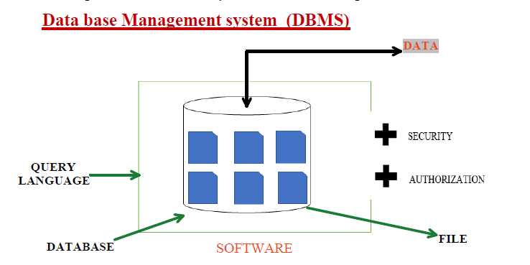
- Security and Authorization are the two important key features provided by the DBMS.
- We use Query language to communicate or interact with the DBMS
- DBMS stores the data in the form of Files
Relational Data Base Management System (RDBMS)
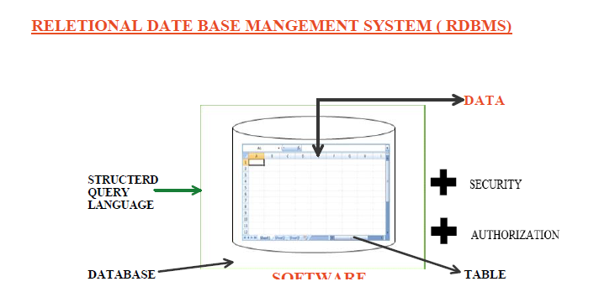
- Relational Data Base Management System is a collection of program that allows the users to create the data, maintain the data, share the data and Relate the data.
- Ex: Oracle SQL, Microsoft SQL Server, Sybase.
- RDBMS stores the data in the form of tables
- We can interact with RDBMS using SQL.
Interview Question:
When do we call any DBMS as RDBMS?
- If any DBMS supports minimum 6 CODD rules than these DBMS will be called RDBMS.

Relational Model
- Relational Model was designed by E.F CODD
- In relational model we store the data in form of Rows and Columns
- Any DBMS which follows Relational Model becomes on RDBMS

Table:
- Table is a logical organization of Data which consists of Rows and Columns

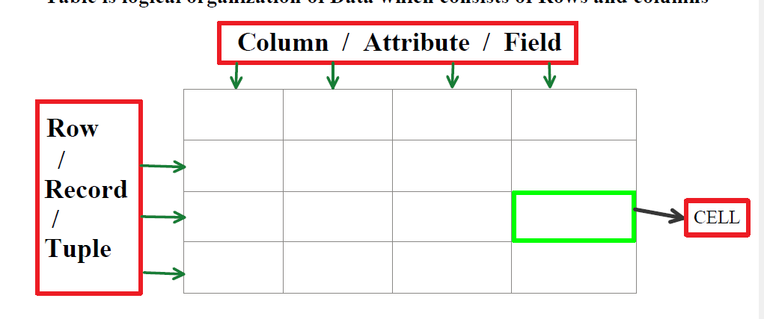

Columns:
- A column is also know as attributes or field
- A column is used to represent property of all the entity

Row:
- Row is also known as Record or Tuples
- Row is used to represent all properties of a single entities

Cell:
- Cell is the smallest unit of the table in which we store the data
- The interaction of rows and columns generate cells.

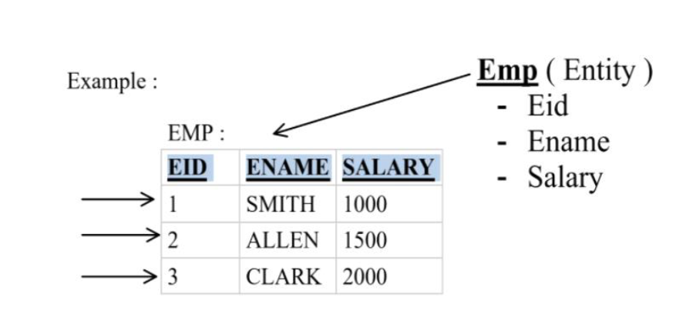
Data entered into the table must be validated
They can be classified as two ways:
- By assigning “Data Type”
- By assigning “Constraints”

Data Type are mandatory where as constrains are optional

Data Type
Data Type is used to specify/ determine the type/kind of data that will be stored in a particular memory allocation.

Date Type in SQL
- Char
- Varchar /Varchar2
- Number
- Date
- Large Object
  - Character Large Object (Clob)
  - Binary large Object(Blob)
- Note: SQL is not case sensitive language

- Char:
In char data type we can store characters such as
Example: ‘A-Z’, ‘a-z’, ‘0-9’ and special characters (‘$’, ’#’, ’%’, ’&’)
When ever we use char data type we must specify the size
Syntax: Char(size)
Size-> Number of characters
It is used to specify number of characters that can be stored
We can store max of 2000 characters
Character must always be with in single quote (‘ ‘)
Ex: ‘ABC’, ‘RAJ’, ‘A’
Character data type follows “fixed length memory allocation”
Default size of char is one
Char(8)
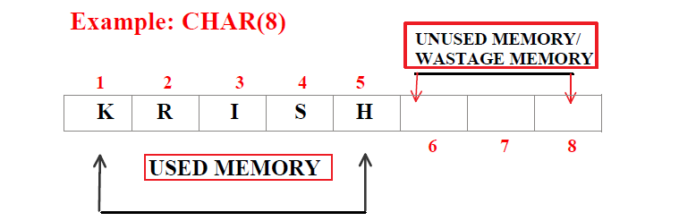

- VARCHAR/VARCHAR2

In VARCHAR data type we can store characters such as

Example: ‘A-Z’, ‘a-z’, ‘0-9’ and special characters (‘$’ , ‘#’, ‘%’, ‘&’)

Whenever we use varchar data type we must specify the size

Syntax: varchar(size)

Size:
It is used to specify number of characters that can be stored

We can store a max of 2000 characters

Character must always be with in single quote (‘ ‘)
Ex: ‘ABC’, ‘Raj’, ‘A’

Varchar datatype follows variable length memory allocation default size of varchar is zero.

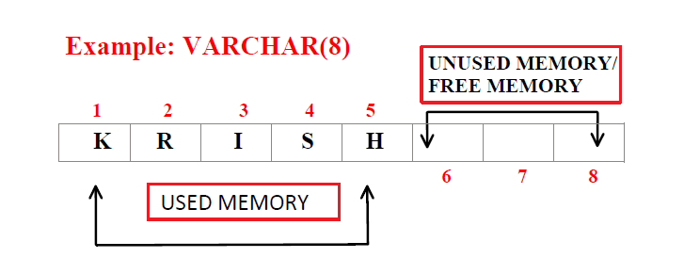

Note:
Varchar2 is nothing but update version of varchar
Max size is 4000 character
Assignment
- Difference between char and varchar/varchar 2

3.Number
‘This number data type is used to store numeric value’
Number data type can accept 2 arguments such as
Precision
Scale
Syntax: Number(precision [scale])

Precision
- Precision is used to determine the number of digit used to store ‘Integer value’
- The range of the precision is 1 to 38

Scale:
- Scale is used to determine the number of digit used to store Decimal (Float) value within the precision
- The value of scale is ‘Zero’
- The range of scale is -84 to 127.

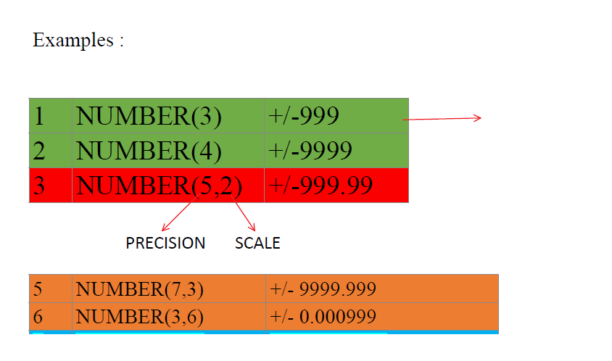

4.Date
The Data datatype is used to store the date in specific format
Syntax: Date
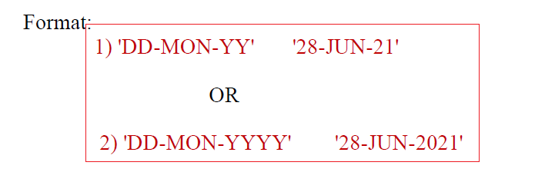
5. Large Object
Character Large Object: (CLOB)
Character large Object (CLOB) is used to store huge amount of character up to 4GB of size.
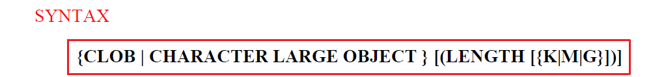

BINARY LARGE Object (BLOB)
Binary large object(BLOB) is used to store the binary values of “IMAGES, MP3, MP4, PDF” etc up-to 4GB of size.

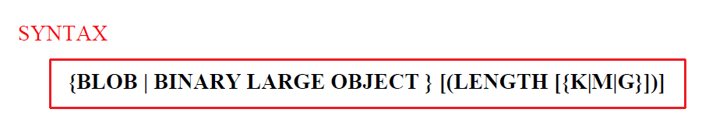

What are Constraints?
- Definition:
A constraint in SQL is a rule applied to a column or table that ensures the validity, accuracy, and integrity of data.
- Why needed?
Without constraints, the database would accept anything → duplicates, nulls, invalid values.
Constraints make sure only meaningful and consistent data gets stored.
Think of constraints as “guards” at the entry gate of a table.

Types of Constraints in SQL Server
1. NOT NULL
- Ensures a column cannot store NULL (empty) values.
- Use when the field is mandatory.
- StudentID and Name cannot be NULL.
- Age can be NULL.
2. UNIQUE
- Ensures all values in a column are unique (no duplicates).
- Allows NULL once (in SQL Server).
- No two employees can have the same EmpID or Email.
3. CHECK
- Adds a custom condition to validate values.
- If the condition is true, the value is accepted; otherwise rejected.
- Percentage must be between 0–100.
- Phone must be exactly 10 digits.
4. PRIMARY KEY (PK)
- A column (or set of columns) that uniquely identifies each record in the table.
- Rules:
  - Only one Primary Key per table.
  - PK = UNIQUE + NOT NULL automatically.
Characteristics of Primary key :
- We can have only 1 PK in a table
- PK cannot accept duplicate / repeated values .
- PK cannot accept Null
- PK is always a combination of Unique and Not Null Constraint.
- PK is not mandatory but highly recommended.
Example: StudentID uniquely identifies each student.

5. FOREIGN KEY (FK)
- "It is used to establish a connection between the The tables "
- A column that references a Primary Key in another table.
- Used to link two tables (Parent–Child relationship).
- Enforces Referential Integrity → cannot insert a value in FK column unless it exists in parent PK.

Characteristics of Foreign key :
- We can have Multiple FK in a table
- FK can accept duplicate / repeated values .
- FK can accept Null
- FK is not a combination of Unique and Not Null Constraint.
- For an Attribute ( column ) to become a FK ,it is mandatory
- that it must be a PK in its own table .
- FK are present in child table but it actually belongs to parent table
- FK is also known as "REFRENTIAL INTEGRITY CONSTRAINT"
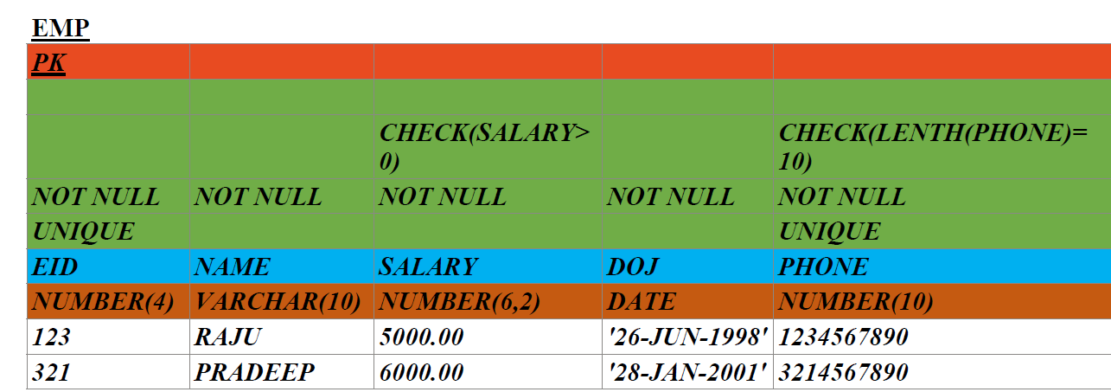
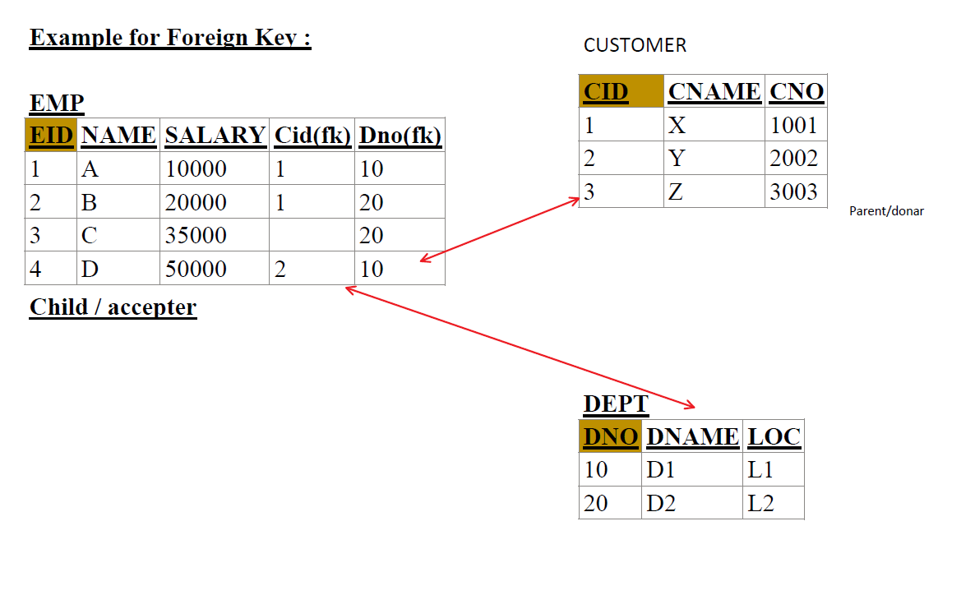
Differentiate between Primary key and Foreign key .
Primary Key (PK)
- Used to uniquely identify a record in a table.
- Cannot accept NULL values.
- Cannot accept duplicate values.
- Always a combination of NOT NULL and UNIQUE constraint.
- Only one Primary Key is allowed per table.
Foreign Key (FK)
- Used to establish a relationship/connection between two tables.
- Can accept NULL values.
- Can accept duplicate values.
- Not a combination of NOT NULL and UNIQUE.
- A table can have multiple Foreign Keys.

NOTE : NULL
Null Is a keyword which is used to represent Nothing / Empty Cell.

Characteristics of Null :
- Null doesn’t represent 0 or Space .
- Any operations performed on a Null will result in Null itself
- Null doesn’t Occupy any Memory .
- We cannot Equate Null .
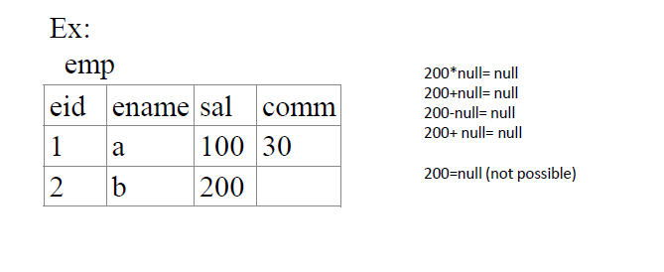
SQL Statements
What is Statement in SQL ?
- A Statement in SQL is a command or instruction written in SQL language that tells the database what action to perform
- Actions can include creating tables, inserting data, updating records, retrieving information or controlling access.
- Each statement usually ends with a semicolon(;) not always required in SQL server but good practice.
- Think of SQL statements as the sentences you speak to the database in it own language.

Why do we need SQL Statements ?
- SQL statements are used to:
  - Define the structure of data(Tables, schemas, indexes)
  - Manipulate data (insert, update, delete)
  - Retrieve data (queries)
  - Control user access and permissions
  - Maintain transactions (commit, rollback)
- Without statements, the DBMS wont know what action you want.

Types of SQL statements (5 Categories)
SQL statements are broadly divided into 5 categories each serving a different purpose.
- DDL: CREATE, ALTER, TRUNCATE, DROP
- DML: INSERT, UPDATE, DELETE
- DQL: SELECT ... FROM ... WHERE ... ORDER BY ...
- TCL: BEGIN TRAN, SAVE TRAN, COMMIT, ROLLBACK
- DCL: GRANT, REVOKE

- DDL – Data Definition Language.
- Used to define or modify the structure of the database(schema, tables, columns, constraints).
- Key statements
  - CREATE -> Create database objects (table, database, index, view)
  - Alter -> modify an existing object (add/remove column, change datatype)
  - Drop -> permanently delete a database object
  - Truncate -> remove all rows from a table but keep the structure
  - Rename -> Change the name of a database object

Creating a Database

Syntax

CREATE DATABASE DatabaseName;

Example
CREATE DATABASE SchoolDB;

This will create a new database named SchoolDB.

Using a Database
After creating, you must switch to that database before creating tables.
Syntax
USE DatabaseName;
Example
USE SchoolDB;

Creating a Table
Syntax:
CREATE TABLE TableName (
ColumnName1 DataType Constraints,
ColumnName2 DataType Constraints,
...
);

TableName → Name of your table.
ColumnName → Attribute/field name.
DataType → INT, VARCHAR, DATE, etc.
Constraints → Rules (PRIMARY KEY, NOT NULL, UNIQUE, DEFAULT, CHECK).

Example: Create Students Table
CREATE TABLE Students (
StudentID INT PRIMARY KEY, -- unique student identifier
Name VARCHAR(50) NOT NULL, -- cannot be empty
Age INT CHECK (Age > 0), -- must be positive
Marks INT DEFAULT 0 -- default value = 0 if not provided
);

Inserting Records into the Table
Syntax
INSERT INTO TableName (col1, col2, col3, ...)
VALUES (value1, value2, value3, ...);
Example:
INSERT INTO Students (StudentID, Name, Age, Marks)
VALUES (101, 'Rahul', 16, 85);

INSERT INTO Students (StudentID, Name, Age)
VALUES (102, 'Priya', 17); -- Marks will default to 0

Retrieving Data (First SELECT)
SELECT * FROM Students;

Output might look like:
StudentID | Name | Age | Marks
101 | Rahul | 16 | 85
102 | Priya | 17 | 0

Deleting a Table or Database
Delete Table
DROP TABLE Students;

Delete Database
DROP DATABASE SchoolDB;

Note: You must USE master; before dropping a DB, and disconnect active sessions.
USE master;
ALTER DATABASE SchoolDB SET SINGLE_USER WITH ROLLBACK IMMEDIATE;
DROP DATABASE SchoolDB;

DDL Statements Continuation
ALTER
Definition: Used to change table structure (add/remove columns, change datatype).

Syntax:
ALTER TABLE TableName ADD ColumnName DataType;
ALTER TABLE TableName ALTER COLUMN ColumnName NewDataType;
ALTER TABLE TableName DROP COLUMN ColumnName;

Query:
ALTER TABLE Students ADD Email VARCHAR(100);
ALTER TABLE Students ALTER COLUMN Name VARCHAR(80); -- increase size
ALTER TABLE Students DROP COLUMN Email;

TRUNCATE
Definition: Removes all data from a table but keeps its structure. Faster than DELETE.
Syntax:
TRUNCATE TABLE TableName;
Example:
TRUNCATE TABLE Students;
Note: After truncating, Students table is empty but still exists.
DROP
Definition: Permanently deletes the object (table or database).
Syntax
DROP TABLE TableName;
DROP DATABASE DatabaseName;
Example:
DROP TABLE Students;

USE master;
ALTER DATABASE SchoolDB SET SINGLE_USER WITH ROLLBACK IMMEDIATE;
DROP DATABASE SchoolDB;
Warning: Cannot be rolled back once executed.
2. DML (Data Manipulation Language)
Definition
- DML statements are used to insert, update, and delete data stored inside tables.
- They don’t change the structure of the database, only the content.
Key DML Statements
- INSERT → Add new records.
- UPDATE → Modify existing records.
- DELETE → Remove records.

INSERT
Syntax:
INSERT INTO TableName (col1, col2, col3, ...)
VALUES (val1, val2, val3, ...);

Example:
INSERT INTO Students (StudentID, Name, Age, Marks)
VALUES (101, 'Rahul', 16, 85);

INSERT INTO Students (StudentID, Name, Age)
VALUES (102, 'Priya', 17); -- Marks will default to 0

In SQL Server, you can insert multiple rows in a single INSERT query by separating each record with a comma.

Syntax:
INSERT INTO TableName (col1, col2, col3, ...)
VALUES
(value1a, value2a, value3a, ...),
(value1b, value2b, value3b, ...),
(value1c, value2c, value3c, ...);

Example with your Students table:
INSERT INTO Students (StudentID, Name, Age, Marks)
VALUES
(105, 'Amit', 17, 88),
(106, 'Sara', 16, 92),
(107, 'Kiran', 18, 75);

UPDATE
Syntax:
UPDATE TableName
SET col1 = val1, col2 = val2
WHERE condition;
Example:
UPDATE Students
SET Marks = 90
WHERE StudentID = 101;

DELETE
Syntax:
DELETE FROM TableName WHERE condition;
Example:
DELETE FROM Students
WHERE StudentID = 102;
Without WHERE, all rows will be deleted:
Example
DELETE FROM Students;

3. TCL (Transaction Control Language)
Definition
- TCL statements are used to manage transactions — groups of SQL commands that are executed as a single unit.
- They ensure data integrity using the ACID properties.
What are Transactions?
- A transaction is like a package of SQL commands that must all succeed together or fail together.
- Example: In banking, when you transfer money, one account must be debited and another credited. Both must succeed, or both must fail — you can’t let only one happen.

What does TCL do?
- TCL (Transaction Control Language) helps you control these transactions.
- Think of it as the remote control for database actions: you decide whether to keep them, undo them, or pause at a checkpoint.
Why is it needed? (ACID properties)
Transactions must follow ACID rules so that data always stays correct:
- Atomicity → All or nothing.
(Money debit + credit both happen, or neither.)
- Consistency → Database always stays valid.
(Balances remain correct before and after.)
- Isolation → Transactions don’t disturb each other.
(Two people withdrawing at the same time won’t clash.)
- Durability → Once saved, it’s permanent.
(Power cut won’t lose committed changes.)

BEGIN TRAN → Start transaction.
SAVE TRAN → Create checkpoint.
COMMIT → Save permanently.
ROLLBACK → Undo changes.

Key TCL Statements
- COMMIT → Save all changes permanently.
- ROLLBACK → Undo changes since last commit.
- SAVEPOINT → Create a checkpoint inside a transaction.
COMMIT → Save the changes permanently.
ROLLBACK → Undo changes before saving.
SAVEPOINT → Mark a checkpoint so you can roll back partially.

COMMIT
Syntax: COMMIT;
Example:
BEGIN TRAN;
UPDATE Students SET Marks = 95 WHERE StudentID = 101;
COMMIT; -- changes saved

ROLLBACK
Syntax:
ROLLBACK;
Example:
BEGIN TRAN;
DELETE FROM Students WHERE StudentID = 101;
ROLLBACK; -- undo delete
SAVEPOINT
Syntax:
SAVE TRAN SavepointName;
ROLLBACK TRAN SavepointName;
Example:
BEGIN TRAN;

INSERT INTO Students (StudentID, Name, Age, Marks)
VALUES (103, 'John', 15, 70);

SAVE TRAN sp1;

INSERT INTO Students (StudentID, Name, Age, Marks)
VALUES (104, 'Anita', 18, 80);

-- rollback only second insert
ROLLBACK TRAN sp1;

COMMIT; -- first insert saved, second undone

4. DQL (Data Query Language)
Definition
- DQL statements are used to retrieve and view data from the database.
- They do not modify the structure or the content of data, only query it.
- In SQL Server, SELECT is the main DQL command.
Why is DQL important?
- Without DQL, databases would just store data but you couldn’t analyze or use it.
- DQL makes data meaningful by turning it into information (e.g., fetching only top students, or filtering sales for last month).

SELECT
SYNTAX:
SELECT column1, column2, ...
FROM TableName
WHERE condition
ORDER BY column ASC|DESC;

Example 1: Retrieve all columns
SELECT * FROM Students;

Example 2: Retrieve selected columns
SELECT Name, Marks FROM Students;

Example 3: Filter records
SELECT * FROM Students
WHERE Marks > 80;

Example 4: Sort records
SELECT * FROM Students
ORDER BY Marks DESC;

5. DCL (Data Control Language)
Definition
- DCL statements are used to control access and permissions in the database.
- They ensure security by deciding who can do what in the system.
Key DCL Statements
- GRANT → Give user permission.
- REVOKE → Remove user permission.

GRANT
Syntax:
GRANT permission_type
ON object_name
TO user_name;

Example
GRANT SELECT, INSERT
ON Students
TO John;
This allows user John to read and insert into the Students table.

REVOKE
Syntax:
REVOKE permission_type
ON object_name
FROM user_name;

Example
REVOKE INSERT
ON Students
FROM John;
Now John can only read (SELECT) but cannot insert anymore.

Interview Questions:
DBMS (Database Management System)
- Definition:
A DBMS is software used to store and manage data. Data in DBMS is often stored in files rather than in strictly organized relational tables.
- Key Points:
  - DBMS does not support client–server architecture → it’s usually used on a single system.
  - DBMS generally does not enforce integrity constraints.
    - Integrity constraints = rules to ensure correctness and consistency of data.
    - Example: Preventing duplicate student roll numbers, ensuring an age cannot be negative.
  - DBMS was first introduced in the 1960s by Charles Bachman.
  - Data is often organized as an inverted tree (hierarchical model) → one parent, many children.
  - Supports single user only, best suited for small-scale applications.
- Examples:
Microsoft Access, dBASE, early file-based systems.
RDBMS (Relational Database Management System)
- Definition:
An RDBMS is an advanced DBMS that stores data in tables (rows and columns) and enforces relationships between tables.
- Key Points:
  - Data is stored in two-dimensional tables (called relations).
  - Supports client–server architecture → multiple users can access it simultaneously.
  - Imposes integrity constraints to maintain accuracy. Common constraints:
    - Primary Key → uniquely identifies each record.
    - Foreign Key → links two tables.
    - Unique, Not Null, Check constraints.
  - Follows Normalization:
    - Process of organizing data into tables to reduce duplication and improve consistency.
    - Example: Instead of repeating department name for every student, create a Departments table and reference it using a foreign key.
  - RDBMS was introduced by Dr. E.F. Codd (IBM, 1970s).
  - Designed for multi-user, large-scale operations.
- Examples:
Microsoft SQL Server, Oracle, MySQL, PostgreSQL.

Difference between:
- Delete & Truncate
- Delete & Drop
- Drop & Truncate
- DDL & DML
- Insert & Alter
- Alter & update
- Commit & RollBack
- Commit & Save point
1. DELETE vs TRUNCATE
- DELETE
  - DML command (Data Manipulation Language).
  - Removes rows one by one (row-level operation).
  - Can use WHERE clause → delete specific rows.
  - Slower for large data (logs each row).
  - Can be rolled back (inside a transaction).
  - Triggers do fire.
- TRUNCATE
  - DDL command (Data Definition Language).
  - Removes all rows at once (bulk operation).
  - Cannot use WHERE (clears full table).
  - Much faster for large data.
  - Cannot be rolled back (auto-commit).
  - Triggers do not fire.
Interview Tip: DELETE = row-by-row, TRUNCATE = bulk clear.
2. DELETE vs DROP
- DELETE → Removes only the data, table structure remains.
- DROP → Deletes the table and its structure completely.
- DELETE is reversible (with rollback), DROP is permanent.
- DELETE = content removal; DROP = object removal.
Interview Tip: DELETE affects rows, DROP affects the whole table.
3. DROP vs TRUNCATE
- DROP
  - Deletes the entire table (data + structure).
  - Cannot be rolled back.
  - Table must be recreated if needed again.
- TRUNCATE
  - Deletes only the data, keeps the structure.
  - Cannot be rolled back.
  - Can immediately re-insert new data.
Interview Tip: DROP = removes table, TRUNCATE = clears table.
4. DDL vs DML
- DDL (Data Definition Language)
  - Defines database structure (schema).
  - Examples: CREATE, ALTER, DROP, TRUNCATE.
  - Auto-committed, no rollback.
- DML (Data Manipulation Language)
  - Manipulates data inside tables.
  - Examples: INSERT, UPDATE, DELETE.
  - Can be rolled back (transaction safe).
Interview Tip: DDL = structure, DML = data.
5. INSERT vs ALTER
- INSERT
  - DML command.
  - Adds new records (rows) to a table.
  - Deals with data only.
- ALTER
  - DDL command.
  - Changes table structure (add/drop/modify columns).
  - Deals with schema only.
Interview Tip: INSERT = add data, ALTER = change structure.
6. ALTER vs UPDATE
- ALTER
  - DDL command.
  - Modifies table design (columns, constraints).
  - Affects schema, not row data.
- UPDATE
  - DML command.
  - Changes values in existing rows.
  - Affects data, not schema.
Interview Tip: ALTER = schema change, UPDATE = data change.
7. COMMIT vs ROLLBACK
- COMMIT
  - Saves all changes permanently.
  - Cannot be undone once committed.
  - Makes changes visible to other users.
- ROLLBACK
  - Undoes changes since the last COMMIT.
  - Restores database to a safe state.
  - Used when an error/mistake occurs.
Interview Tip: COMMIT = save, ROLLBACK = undo.
8. COMMIT vs SAVEPOINT
- COMMIT
  - Saves all changes permanently.
  - No undo possible after commit.
  - Ends the transaction.
- SAVEPOINT
  - Creates a checkpoint inside a transaction.
  - Lets you roll back part of a transaction instead of the whole.
  - Does not end the transaction.
Interview Tip: COMMIT = full stop, SAVEPOINT = bookmark inside transaction.

1. Create Database

CREATE DATABASE CompanyDB;

USE CompanyDB;

2. Create Department Table (dept)
CREATE TABLE dept (
DEPTNO INT PRIMARY KEY,
DNAME VARCHAR(50),
LOC VARCHAR(50)
);
3. Insert Records into dept
INSERT INTO dept (DEPTNO, DNAME, LOC) VALUES
(10, 'ACCOUNTING', 'NEW YORK'),
(20, 'RESEARCH', 'DALLAS'),
(30, 'SALES', 'CHICAGO'),
(40, 'OPERATIONS', 'BOSTON');

4. Create Employee Table (emp)
CREATE TABLE emp (
EMPNO INT PRIMARY KEY,
ENAME VARCHAR(50),
JOB VARCHAR(50),
MGR INT NULL,
HIREDATE DATE,
SAL INT,
COMM INT NULL,
DEPTNO INT FOREIGN KEY REFERENCES dept(DEPTNO)
);

5. Insert Records into emp
INSERT INTO emp (EMPNO, ENAME, JOB, MGR, HIREDATE, SAL, COMM, DEPTNO) VALUES
(7369, 'SMITH', 'CLERK', 7902, '1980-12-17', 800, NULL, 20),
(7499, 'ALLEN', 'SALESMAN', 7698, '1981-02-20', 1600, 300, 30),
(7521, 'WARD', 'SALESMAN', 7698, '1981-02-22', 1250, 500, 30),
(7566, 'JONES', 'MANAGER', 7839, '1981-04-02', 2975, NULL, 20),
(7654, 'MARTIN', 'SALESMAN', 7698, '1981-09-28', 1250, 1400, 30),
(7698, 'BLAKE', 'MANAGER', 7839, '1981-05-01', 2850, NULL, 30),
(7782, 'CLARK', 'MANAGER', 7839, '1981-06-09', 2450, NULL, 10),
(7788, 'SCOTT', 'ANALYST', 7566, '1987-07-13', 3000, NULL, 20),
(7839, 'KING', 'PRESIDENT', NULL, '1981-11-17', 5000, NULL, 10),
(7844, 'TURNER', 'SALESMAN', 7698, '1981-09-08', 1500, 0, 30),
(7876, 'ADAMS', 'CLERK', 7788, '1987-05-23', 1100, NULL, 20),
(7900, 'JAMES', 'CLERK', 7698, '1981-12-03', 950, NULL, 30),
(7902, 'FORD', 'ANALYST', 7566, '1981-12-03', 3000, NULL, 20),
(7934, 'MILLER', 'CLERK', 7782, '1982-01-23', 1300, NULL, 10);

What is an Operator in SQL?
- An operator in SQL is a special symbol or keyword used to perform an operation on values.
- Think of it as a tool that helps SQL compare, calculate, or combine data in queries.
In short: Operators are like the + , - , = , > signs we use in math or logic, but inside SQL.

Why do we need Operators in SQL?
We need operators because:
- To filter data → Example: Find all employees with salary > 2000 (> operator).
- To compare values → Example: Check if department number = 20 (= operator).
- To combine conditions → Example: Employees in dept 10 AND salary > 1000 (AND operator).
- To perform calculations → Example: Salary + Commission (+ operator).
- To check special cases → Example: Find rows where commission is NULL (IS NULL operator).

🔹 1. Arithmetic Operators
Used for mathematical operations on numeric data.
- + → Addition
- - → Subtraction
- * → Multiplication
- / → Division
- % → Modulus (remainder after division – supported in SQL Server/MySQL, not in all DBs)

🔹 2. Concatenation Operator
Used to join strings/text.
- || → Concatenate strings (Oracle, PostgreSQL)
- + → Concatenate strings (SQL Server)

🔹 3. Comparison Operators
Used to compare values, return TRUE / FALSE / UNKNOWN.
- = → Equal to
- <> or != → Not equal to
- > → Greater than
- < → Less than
- >= → Greater than or equal to
- <= → Less than or equal to

🔹 4. Logical Operators
Used to combine multiple conditions.
- AND → True if all conditions are true
- OR → True if any one condition is true
- NOT → Reverses the result (True → False, False → True)

🔹 5. Special Operators
Used for advanced filtering/matching.
- IN → Match against a list of values
- NOT IN → Exclude a list of values
- BETWEEN … AND … → Within a range (inclusive)
- NOT BETWEEN … AND … → Outside a range
- IS NULL → Value is NULL
- IS NOT NULL → Value is NOT NULL
- LIKE → Pattern matching (%, _)
- NOT LIKE → Opposite of LIKE

Arithmetic operators

-- + Add: salary + commission (treat NULL commission as 0)
SELECT ENAME, SAL, COMM, SAL + ISNULL(COMM, 0) AS TotalPay
FROM emp;

Note: ISNULL(COMM, 0) is just telling SQL Server:
“if COMM is empty (NULL), treat it as 0.”

-- - Subtract: salary after a flat tax of 200
SELECT ENAME, SAL, SAL - 200 AS NetAfterFlatTax
FROM emp;

-- * Multiply: annual salary (12 months)
SELECT ENAME, SAL, SAL * 12 AS AnnualSalary
FROM emp;

-- / Divide: approximate per-day pay (30-day month)
SELECT ENAME, SAL, CAST(SAL / 30.0 AS DECIMAL(10,2)) AS PerDayPay
FROM emp;

Why CAST is used here?
- In SQL Server, if you divide integers, the result is also an integer (it cuts off decimals).
- Example: 100 / 30 = 3 (not 3.33).
- To fix this, we use CAST to convert it into a decimal so SQL gives us a precise value like 3.33.

🔹 2. Concatenation Operator (|| or + in SQL Server)
Used to combine text (strings).
Example (SQL Server uses +):
SELECT ENAME + ' works as ' + JOB AS EmployeeDetails
FROM emp;
Output: "SMITH works as CLERK".

🔹 3. Comparison Operators (=, != or <>)
Used to compare values.
Example:
-- Employees in department 30
SELECT ENAME, DEPTNO
FROM emp
WHERE DEPTNO = 30;

-- Employees not in dept 30
SELECT ENAME, DEPTNO
FROM emp
WHERE DEPTNO <> 30;

🔹 4. Relational Operators (>, <, >=, <=)
Used to compare greater than, less than, etc.
Example:
-- Employees earning more than 2000
SELECT ENAME, SAL
FROM emp
WHERE SAL > 2000;

-- Employees earning less than or equal to 1000
SELECT ENAME, SAL
FROM emp
WHERE SAL <= 1000;

🔹 5. Logical Operators (AND, OR, NOT)
Used to combine conditions.
Examples:
-- Employees in dept 30 earning more than 1500
SELECT ENAME, DEPTNO, SAL
FROM emp
WHERE DEPTNO = 30 AND SAL > 1500;

-- Employees in dept 10 OR dept 20
SELECT ENAME, DEPTNO
FROM emp
WHERE DEPTNO = 10 OR DEPTNO = 20;

-- Employees NOT in dept 10
SELECT ENAME, DEPTNO
FROM emp
WHERE NOT DEPTNO = 10;

🔹 6. Special Operators
a) IN
Checks if a value is in a list.
SELECT ENAME, DEPTNO
FROM emp
WHERE DEPTNO IN (10, 20);
b) NOT IN
Opposite of IN.
SELECT ENAME, DEPTNO
FROM emp
WHERE DEPTNO NOT IN (10, 20);
c) BETWEEN
Checks if a value is between two values (inclusive).
SELECT ENAME, SAL
FROM emp
WHERE SAL BETWEEN 1000 AND 2000;
d) NOT BETWEEN
Opposite of BETWEEN.
SELECT ENAME, SAL
FROM emp
WHERE SAL NOT BETWEEN 1000 AND 2000;
e) IS
Used to check for NULL values.
SELECT ENAME, COMM
FROM emp
WHERE COMM IS NULL;
f) IS NOT
Opposite of IS.
SELECT ENAME, COMM
FROM emp
WHERE COMM IS NOT NULL;
g) LIKE
Used for pattern matching (wildcards).
- % → any number of characters.
- _ → single character.
-- Names starting with 'S'
SELECT ENAME
FROM emp
WHERE ENAME LIKE 'S%';

-- Names with 5 letters only
SELECT ENAME
FROM emp
WHERE ENAME LIKE '_____';

h) NOT LIKE
Opposite of LIKE.
-- Employees whose name does NOT start with 'S'
SELECT ENAME
FROM emp
WHERE ENAME NOT LIKE 'S%';

Interview Questions
1. What are operators in SQL and why are they needed?
Answer:
- Operators are symbols or keywords that perform operations on values.
- They help filter, compare, calculate, or combine data inside queries.
- Example: WHERE SAL > 2000 → > is an operator checking salary greater than 2000.

2. Difference between comparison operators (=, <>, >, <) and logical operators (AND, OR, NOT)?
Answer:
- Comparison operators compare one column/value with another and return TRUE/FALSE.
- Logical operators combine multiple conditions.
- Example:
SELECT ENAME FROM emp
WHERE DEPTNO = 10 AND SAL > 2000;
Here = and > are comparison, AND is logical.

3. How does BETWEEN differ from using >= and <=?
Answer:
- BETWEEN is shorthand for checking inclusive range.
- Example:
WHERE SAL BETWEEN 1000 AND 2000
is same as
WHERE SAL >= 1000 AND SAL <= 2000
4. What is the difference between IN and multiple OR conditions?
Answer:
- Both give the same result, but IN is shorter and more readable.
Example
WHERE DEPTNO IN (10,20,30)
is same as
WHERE DEPTNO = 10 OR DEPTNO = 20 OR DEPTNO = 30;
In interviews: Always say IN is better for readability and maintenance.
5. What does IS NULL do, and why can’t we use = NULL?
Answer:
- NULL means unknown or missing, not zero/blank.
- = NULL won’t work because NULL cannot be compared with equality operators.
Correct way:
WHERE COMM IS NULL
6. Real-world use of LIKE operator?
Answer:
- Used for pattern matching in search.
- Example: Search all emails ending with @gmail.com.
WHERE Email LIKE '%@gmail.com'
Industry use: Login validations, reporting, data cleanup.

Functions
What are Functions in SQL?
- A function is like a ready-made mini-program inside SQL that takes input, performs a task, and returns a value.
- Functions save time because you don’t need to write logic again and again.
Real world example:
- Instead of writing a formula to calculate an employee’s name length, you just use LEN(Name).
- Instead of coding date math, use DATEDIFF to quickly find employee tenure.
Why do we need Functions?
- To transform data quickly (uppercase, formatting, date math).
- To make reports readable (round salaries, format dates).
- To simplify logic → instead of long queries, use small functions.
- To improve performance → many functions are optimized internally.
Types of Functions
- System / Built-in Functions – Provided by SQL Server.
  - Example: LEN(), ROUND(), GETDATE()
- User Defined Functions (UDFs) – You create them when system functions are not enough.
  - Example: CREATE FUNCTION GetFullName(...)

Character / String Functions
System / Built in functions
- Character / String functions.
- Its a functions where it is working on the character and the strings.
  - LEN() → Returns length of string
  - SELECT ENAME,LEN(ENAME) AS NameLength FROM EMP;
  - Real world: Find employees whose name are too short/Long for ID cards.
  - SUBSTRING () → Extracts part of a string
  - SELECT ENAME, SUBSTRING(ENAME,1,3)As FirstThreeCharacters FROM EMP;
  - Many Real-world: (banking, telecom, legacy ERP) stores data as text for compatibility.
  - REPLACE()→ Replace part of string
  - SELECT ENAME, REPLACE(ENAME,'a','@') As MaskedName from EMP;
  - Real world: Mask Sensitive info( replace digits in passport).
  - UPPER() / LOWER()
  - SELECT UPPER(ENAME), LOWER(ENAME) FROM EMP;
  - Industry use: Standardize data before comparison/ Search.

Numeric Functions
1. ROUND() → Round to n decimals
SELECT Salary, ROUND(Salary, 2) AS RoundedSalary
FROM Emp;
1234.567 → 1234.57
Use: Financial reports, invoices.

2. CEILING() → Round up
SELECT CEILING(Salary/1000.0) AS SalaryInThousands
FROM Emp;
3450 → 4 (thousands)
Use: Estimating project budgets.

3. FLOOR() → Round down
SELECT FLOOR(Salary/1000.0) AS SalaryInThousands
FROM Emp;
3450 → 3
Use: Billing cycles (round down to nearest day/hour).
4. ABS() → Absolute value
SELECT ABS(Salary - 5000) AS Difference
FROM Emp;
If Salary = 4800 → 200
Use: Error calculation, deviation analysis.
What does ABS() mean?
- ABS = Absolute value function.
- It simply removes the sign (– or +) from a number and gives the magnitude.
- Example:
  - ABS(10) → 10
  - ABS(-10) → 10
So, ABS(x) always returns a non-negative value.

Date Functions
1. GETDATE() → Current system date & time
SELECT GETDATE() AS Today;
Use: Audit logging (last updated time).

2. DATEADD() → Add interval
SELECT Ename, HIREDATE, DATEADD(YEAR,1,HIREDATE)AS NextReview FROM emp;
Adds 1 year to hire date.
Use: Probation review, contract renewals.

3. DATEDIFF() → Difference between dates
SELECT ENAME,HIREDATE, DATEDIFF(YEAR, HIREDATE, GETDATE()) AS Experience FROM emp;
Returns years of service.
Use: Employee appraisal, tenure tracking.

4. DATEPART() → Extract part of date
SELECT ENAME,HIREDATE, DATEPART(MONTH, HIREDATE)As JoinMonth from emp;
If HireDate = 2023-05-15 → 5
Use: Find seasonal hiring trends.

Conversion Functions
1. CAST() → Convert data type
SELECT ENAME,sal, CAST(SAL AS VARCHAR)+' INR' AS SalaryWithcurrency from emp;

2. CONVERT() → Convert with style
SELECT ENAME, HIREDATE, CONVERT(VARCHAR, HIREDATE, 103) AS UKFORMAT FROM emp;
15-05-2023
Use: Regional date formatting (UK, US, India).
CONVERT(VARCHAR, HireDate, 103)
- CONVERT() changes a value from one data type to another.
- Here:
  - HireDate (a DATE/DATETIME) → converted into a string (VARCHAR).
  - 103 → is a style code that tells SQL how to format the date.
Style Code 103
- 103 = British/UK date format → dd/MM/yyyy
- Example:
  - If HireDate = 2023-05-15 (database stores in yyyy-MM-dd format)
  - After conversion → "15/05/2023"
AS UKFormat
- This renames the output column to UKFormat for clarity.

INTERVIEW QUESTIONS
1. What are functions in SQL and why do we use them?
Answer:
- Functions are pre-built mini-programs in SQL.
- They take input, process it, and return a single value.
- Needed for formatting, calculations, reporting, and performance.
Example:
SELECT LEN(ENAME) FROM emp;

2. Difference between system functions and user-defined functions (UDFs)?
Answer:
- System functions: Predefined in SQL (LEN, ROUND, GETDATE).
- UDFs: Created by users when system functions are not enough.
Example: CREATE FUNCTION fn_GetFullName(...)

3. What’s the difference between LEN() and SUBSTRING() functions?
Answer:
- LEN() returns the length of a string.
- SUBSTRING() extracts part of a string.
Example:
LEN('Karthik') → 7
SUBSTRING('Karthik', 1, 3) → Kar
Industry use: Cleaning names, extracting codes from IDs.
4. Real-world example of REPLACE()?
Answer:
- Used to mask sensitive information.
SELECT REPLACE(Phone, '123', 'XXX') FROM Customers;
Use: Data privacy, compliance (mask PAN, Aadhar, Phone numbers).

5. Explain ROUND, CEIL, FLOOR with real-world examples.
Answer:
- ROUND(1234.567, 2) → 1234.57 → Use in invoices.
- CEILING(3450/1000.0) → 4 → Round UP to nearest 1000 for budgets.
- FLOOR(3450/1000.0) → 3 → Round DOWN to nearest 1000 for billing.

6. Difference between GETDATE() and DATEDIFF()?
Answer:
- GETDATE() → current system date & time.
- DATEDIFF() → calculates gap between two dates.
Example:
DATEDIFF(YEAR, HireDate, GETDATE()) AS Experience
Use: Finding employee tenure for appraisal.
7. When do we use CAST vs CONVERT?
Answer:
- Both change data type.
- CAST: ANSI standard, portable.
- CONVERT: SQL Server-specific, supports style formatting (e.g., date formats).
Example:
CAST(SAL AS VARCHAR)
CONVERT(VARCHAR, HireDate, 103) → dd-mm-yyyy format

Aggregate (Grouping) Functions in SQL
1. What are Aggregate Functions?
- Aggregate functions perform calculations on a set of rows and return a single summarized value.
- They are also called grouping functions because they are often used with GROUP BY to summarize data by groups (e.g., per department).
Think of aggregate functions as the "Excel SUM, AVERAGE, COUNT" but inside SQL for databases.

2. Why do we need Aggregate Functions?
- To get insights from large datasets.
- To summarize and report data instead of checking row by row.
- Industry examples:
  - Calculate average salary in each department.
  - Find the highest transaction amount in banking.
  - Get the total sales for a product.
  - Count the number of students enrolled in a course.
Keywords with Explanation
- SUM() – Adds all numeric values.
Example: SUM(Salary) → total salary bill of employees.
- AVG() – Returns average of numeric values.
Example: AVG(Salary) → average salary in a department.
- COUNT() – Counts number of rows (or non-null values in a column).
Example: COUNT(*) → number of employees.
- MAX() – Returns the maximum value.
Example: MAX(Salary) → highest paid employee’s salary.
- MIN() – Returns the minimum value.
Example: MIN(HireDate) → earliest hire date.

🔹 SUM()
- Adds up all values in a numeric column.

Example
-- Total salary of all employees
SELECT SUM(SAL) AS TotalSalary
FROM Emp;
Industry use: Find total revenue, total expenses, etc.

🔹 AVG()
- Calculates the average of a numeric column.
-- Average salary in company
SELECT AVG(SAL) AS AvgSalary
FROM Emp;
Industry use: Find average transaction size, average marks, average response time.

🔹 COUNT()
- Counts number of rows (or non-null values in a column).
-- Total employees
SELECT COUNT(*) AS TotalEmployees
FROM Emp;

-- Employees who earn commission
SELECT COUNT(COMM) AS EmployeesWithComm
FROM Emp;
Industry use: Count active users, number of products sold, attendance in class.

🔹 MIN()
- Finds the smallest value in a column.
-- Minimum salary
SELECT MIN(SAL) AS MinSalary
FROM Emp;
Industry use: Find lowest score, minimum delivery time, cheapest price.

🔹 MAX()
- Finds the largest value in a column.
-- Highest salary
SELECT MAX(SAL) AS MaxSalary
FROM Emp;
Industry use: Find highest sales, maximum marks, fastest delivery time.
Display maximum salary for deptno 10
SELECT MAX(SAL) AS MaxSalary FROM Emp WHERE DEPTNO=10;
Display maximum salary for deptno 20
SELECT MAX(SAL) AS MaxSalary FROM Emp WHERE DEPTNO=20;
Display maximum salary for deptno 30
SELECT MAX(SAL) AS MaxSalary FROM Emp WHERE DEPTNO=30;

SELECT MAX(SAL) AS MaxSalary FROM Emp WHERE DEPTNO in (10,20,30)
Note: It will not show the salary department wise, it will show the total maximum salary.

4. Using Aggregate Functions with GROUP BY
Aggregate functions are powerful when used with GROUP BY to summarize data per group.
-- Total salary by department
SELECT DEPTNO, SUM(SAL) AS TotalDeptSalary
FROM Emp
GROUP BY DEPTNO;

-- Average salary by job
SELECT JOB, AVG(SAL) AS AvgJobSalary
FROM Emp
GROUP BY JOB;

Display Job wise average salary, minimum salary, maximum salary, sumon salary, number of salary?
Select min(sal) AS MinSal,max(sal) AS MaxSal, avg(sal) AS AVGSal, sum(sal)AS SUMSAL, count(sal)AS CountSal, job from emp group by JOB;

Display job wise average salary only if average salary greater than 2000
Select avg(sal), job from emp group by job where avg(sal)> 2000;
Error: Incorrect syntax near the keyword 'where'.

Select avg(sal), job from emp where avg(SAL) > 2000 group by JOB;
Error: An aggregate may not appear in the WHERE clause unless it is in a subquery contained in a HAVING clause or a select list, and the column being aggregated is an outer reference.

Conditions to Apply Group by
- To apply the filter on grouping values we should not use where clause for that we have “having” clause.
- Where clause is used for applying the filter on non-grouping values.
- The columns which are selected must be in group by clause.
- Note: Grouping values mean either AVG, MIN, or MAX or SUM or COUNT.
- Non-grouping values mean ex: sal > or Job or Deptno in etc.

select avg(sal), job from emp group by job having avg(sal)> 2000;

SQL: GROUPING, HAVING & SELECT Flow

1. The SELECT Statement Flow
- Syntax order (what you write):
SELECT … FROM … WHERE … GROUP BY … HAVING … ORDER BY …

2. Row-level vs Group-level Data
- Row-level (detail data): Columns directly from the table like ENAME, SAL, DEPTNO.
- Group-level (aggregated data): Results after grouping like AVG(SAL), SUM(SAL).
Rule: In a grouped query, everything you SELECT must be either:
- in the GROUP BY clause, OR
- an aggregate function.
Otherwise, SQL will throw:
“Column … is invalid in the select list because it is not contained in either an aggregate function or the GROUP BY clause.”

4. WHERE vs HAVING
- WHERE → filters rows before grouping (works on detail data).
Example: Only consider employees with salary > 1000.
- HAVING → filters groups after grouping (works on aggregated data).
Example: Only show departments whose average salary > 2000.
Memory tip:
- WHERE = rows
- HAVING = groups

5. GROUP BY Essentials
- All non-aggregated columns in SELECT must appear in GROUP BY.
- You can group by multiple columns (e.g., DEPTNO, JOB).
- Aggregate functions ignore NULLs (except COUNT(*), which counts all rows).
6. ORDER BY in Grouped Queries
- You can sort by any column, aggregate, or even alias.
- Example: ORDER BY SUM(SAL) DESC → highest total salary departments on top.

Mastering WHERE, HAVING, GROUP BY, ORDER BY
Example 1: Filtering with WHERE before grouping
Problem: Show departments with employees earning more than 2000.
Explanation: Here we filter individual rows before grouping.
SELECT DEPTNO, ENAME, SAL
FROM Emp
WHERE SAL > 2000;
Insight: WHERE always filters row-level data (non-aggregates).

Example 2: Filtering groups with HAVING
Problem: Show departments where the average salary is above 2500.
Explanation: You cannot use WHERE AVG(SAL) because aggregates come after grouping → use HAVING.
SELECT DEPTNO, AVG(SAL) AS AvgSalary
FROM Emp
GROUP BY DEPTNO
HAVING AVG(SAL) > 2500;
Insight: HAVING is specifically for aggregate conditions.

Example 3: WHERE + HAVING together
Problem: Count employees per department, but only consider salaries > 1000. Then show departments having at least 3 employees.
SELECT DEPTNO, COUNT(*) AS EmpCount
FROM Emp
WHERE SAL > 1000 -- filters rows first
GROUP BY DEPTNO
HAVING COUNT(*) >= 3; -- filters groups after aggregation
Insight: Order of evaluation: WHERE filters rows → GROUP BY buckets → HAVING filters buckets.

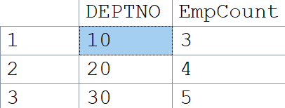

Example 4: GROUP BY multiple columns
Problem: Find average salary per department and job.
SELECT DEPTNO, JOB, AVG(SAL) AS AvgSalary
FROM Emp
GROUP BY DEPTNO, JOB
ORDER BY DEPTNO, AvgSalary DESC;
Insight: Multiple columns in GROUP BY create smaller buckets (Dept+Job).
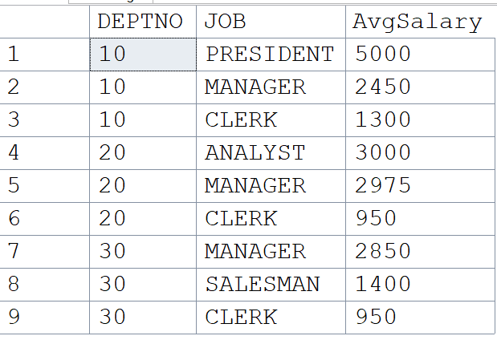

Example 5: ORDER BY aggregates
Problem: Show departments sorted by total salary (highest first).
SELECT DEPTNO, SUM(SAL) AS TotalSalary
FROM Emp
GROUP BY DEPTNO
ORDER BY TotalSalary DESC;
Insight: You can order results using aggregates or aliases.

Example 6: Classic Error — non-grouped column
Problem: Show department with employee names and average salary.
Wrong:
SELECT DEPTNO, ENAME, AVG(SAL)
FROM Emp
GROUP BY DEPTNO;
Error: ENAME is not in GROUP BY or aggregated.
Fix: Use STRING_AGG or COUNT instead.
SELECT DEPTNO, STRING_AGG(ENAME, ', ') AS Employees, AVG(SAL) AS AvgSalary
FROM Emp
GROUP BY DEPTNO;

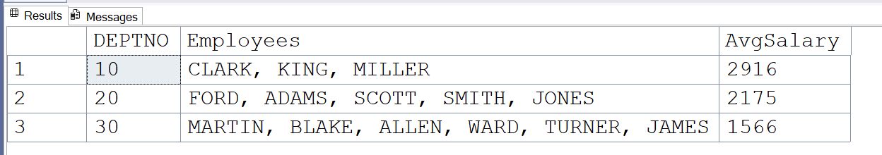

What STRING_AGG(ENAME, ', ') does:
- STRING_AGG is an aggregate function (like SUM, AVG, MAX, etc.).
- Instead of doing math, it concatenates values from multiple rows into a single string.
- ENAME is the column being aggregated (employee names).
- The second argument ', ' is the separator to place between each value.
So for each department (DEPTNO), it will:
- Collect all employee names (ENAME)
- Join them together into one single string
- Separate each name with a comma and a space.

Example 9: HAVING without WHERE
Problem: Show departments that have more than 4 employees (any salary).
SELECT DEPTNO, COUNT(*) AS EmpCount
FROM Emp
GROUP BY DEPTNO
HAVING COUNT(*) > 4;
Insight: If no row-level filter is needed, go straight to HAVING.

Example 10: Combining all — real business query
Problem: Show departments where the total salary > 3000 but only employees with salary > 1000 sort by total salary descending order.
SELECT DEPTNO, SUM(SAL) AS TotalSalary, COUNT(*) AS EmpCount
FROM emp
WHERE SAL > 1000
GROUP BY DEPTNO
HAVING SUM(SAL) >3000
ORDER BY TotalSalary DESC

Insight: This is a full SELECT flow: WHERE → GROUP BY → HAVING → ORDER BY

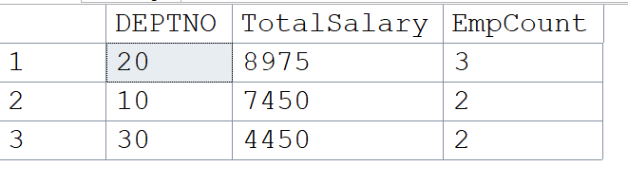

SQL Subqueries
Introduction:
- Query within a query is called as Subquery.
- The output of inner query becomes input to the outer query.
- To write a subquery there should be a common column or reference column in both tables.

Display the employees who are from Dallas or Chicago ?
Step 1: Read the query 2 or 3 times
Display the employees who are from Dallas
Step 2: Identify the how many tables required
EMP, DEPT
Step 3: Identify outer table & inner table
Outer table= Emp
Inner table = dept
Step 4: Identify the inner table column with condition
Loc = ‘Dallas’
Step 5: Solve inner query
Select * from dept where loc = ‘Dallas’
Step 6: Identify the common column/Reference column b/w 2 tables dept no
Deptno
Step 7: Solve outer query
Select * from emp where deptno
Step 8: Combine outer query & inner query
Select * from emp
Where deptno = (Select * from dept where loc = ‘Dallas’);

Error message:
Step 9:
Select * from emp
Where deptno = (select deptno from dept where loc = ‘DALLAS’)

Display the department information for smith ?
Tables: DEPT, EMP
Outer Table: DEPTNO
INNER Table: EMPNO
CONDITION ENAME=’SMITH’
SELECT * from dept
Where deptno=(SELECT deptno from emp where ename='SMITH')

Display the employees who are earning more than smith ?
SELECT * FROM EMP
WHERE SAL > (SELECT SAL FROM EMP WHERE ENAME=’SMITH’)

Display the employees who are not from DALLAS and he should be a manager
SELECT * FROM emp
WHERE DEPTNO = (SELECT DEPTNO FROM DEPT WHERE LOC NOT IN ('DALLAS'));
ERROR MESSAGE:
Subquery returned more than 1 value. This is not permitted when the subquery follows =, !=, <, <= , >, >=

Because we are using ‘=’ sign which returns only one value but we need three values so go for in operator

SELECT * FROM emp
WHERE DEPTNO in(SELECT DEPTNO FROM DEPT WHERE LOC NOT IN ('DALLAS')) AND JOB='MANAGER';

Display the employees who are joined before Jones ?
SELECT * FROM EMP
WHERE HIREDATE<(SELECT HIREDATE FROM EMP WHERE ENAME='JONES')

Display department information for all the managers ?
Outer table: dept
Inner table: emp
SELECT * FROM DEPT
WHERE DEPTNO IN(SELECT DEPTNO FROM EMP WHERE JOB='MANAGER')

Display the 3rd maximum salary employ details ?
SELECT * FROM emp WHERE sal < (SELECT MAX(sal) FROM emp WHERE sal < (SELECT
MAX(sal) FROM emp));

Types of Subqueries
a) Single-row Subqueries
These return exactly one row. Used with operators like =, >, <.
Example:
SELECT * FROM emp WHERE sal = (SELECT MAX(sal) FROM emp);

b) Multi-row Subqueries
These return multiple rows. Used with operators like IN, ANY, ALL.
Example using IN:
SELECT * FROM emp WHERE deptno IN (SELECT deptno FROM dept WHERE loc NOT IN
('DALLAS'));
c) Nested Subqueries
Subqueries inside subqueries. Useful for problems like 2nd max, 3rd max salary.
Example:
SELECT * FROM emp WHERE sal < (SELECT MAX(sal) FROM emp WHERE sal < (SELECT
MAX(sal) FROM emp));

Display empno, ename, deptno, location for all the employees who are from dallas
SELECT empno, ename, deptno, loc from emp
WHERE DEPTNO IN (SELECT DEPTNO FROM DEPT where loc in (‘DALLAS’)):
Invalid column name 'loc'.
Why does this happen?
- Look at the FROM clause
→ FROM emp
This means the outer query is only looking at the EMP table.
- What columns does EMP have?
  - empno, ename, job, mgr, hiredate, sal, comm, deptno
❌ It does not have LOC.
- But we wrote SELECT … loc
  - Here, SQL looks inside EMP for a column called LOC.
  - It doesn’t find it → error.
In the above query we are trying to display employ details and departmental details.
At any point of time using sub queries we can display only one table information based on one or more than one table conditions.

SQL Joins
1. What are Joins in SQL?
- A Join in SQL is used to combine data from two or more tables based on a related column (usually a primary key in one table and a foreign key in another).
- Think of it as “bringing together” details from different tables into one report.
Example:
- EMP table stores employee details (Empno, Ename, Job, Deptno).
- DEPT table stores department details (Deptno, Dname, Loc).
- Using a join, we can show: “Employee name with their department name and location.”

2. Why do we need Joins?
In real-world databases, data is normalized (split into multiple tables for efficiency and to avoid duplication).
- EMP only stores the department number (DEPTNO), not the department name/location.
- DEPT stores department details.
- Without joins, we would only see numbers (DEPTNO = 10, 20…) instead of meaningful info like “ACCOUNTING in NEW YORK”.
Joins solve the problem: They combine related data across tables to answer business questions.

Real world: In a company database, EMP table has employee info and DEPT table has department info.
If a manager asks:
"Show me all employees along with their department names,"
you need to pull data from both tables → that’s where JOIN comes in.

What is an INNER JOIN?
- An INNER JOIN returns only the rows that have matching values in both tables.
- In our case: Only employees whose Deptno exists in the DEPT table will be shown.
- If there is no matching department, that employee won’t appear in the result.

Syntax of INNER JOIN
SELECT e.Empno, e.Ename, e.Deptno, d.Dname, d.Loc
FROM Emp e
INNER JOIN Dept d
ON e.Deptno = d.Deptno;

Breaking it Down
a) Aliases (e and d)
- Emp e → nickname e for EMP table.
- Dept d → nickname d for DEPT table.
Instead of writing Emp.Ename, we can just write e.Ename.
This is shorter and clearer, especially when joining multiple tables.

Why e.Deptno and d.Deptno?
- Both EMP and DEPT tables have a column called Deptno.
- To avoid confusion, we must prefix column names with their table alias.
  - e.Deptno → Deptno from EMP
  - d.Deptno → Deptno from DEPT

The JOIN condition: ON e.Deptno = d.Deptno
- This is the rule that tells SQL how to connect the two tables.
- It matches employees to their departments by department number.
Without this condition, SQL would try to join every employee with every department (Cartesian product), which makes no sense.

Example Output:
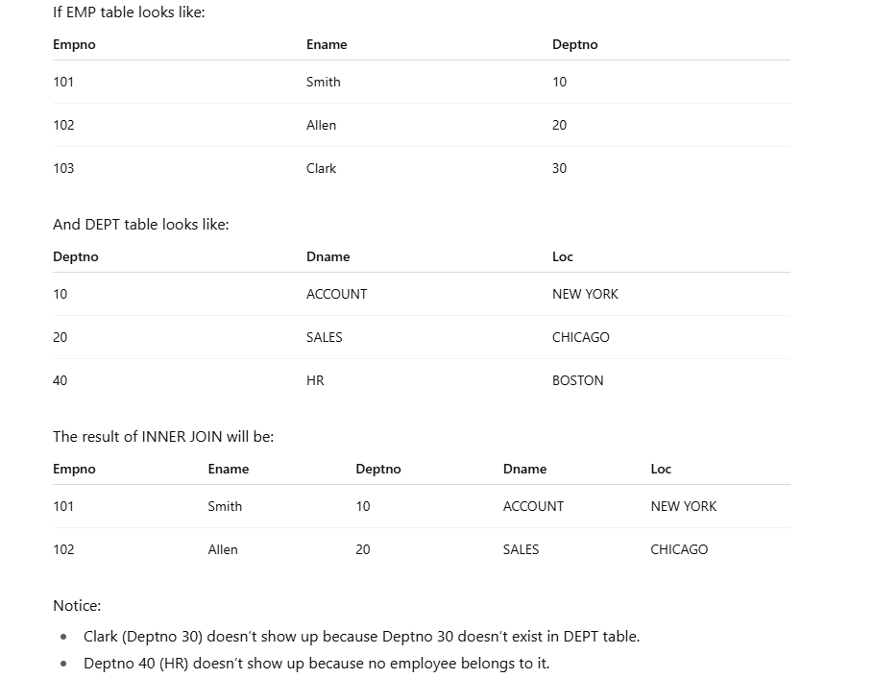

Real-World Use Cases of INNER JOIN
- HR reports: List employees with their department names.
- Sales dashboards: Show sales transactions with customer details.
- Banking: Show accounts with their branch details.
- Education: Show students with their enrolled course names.

Note: INNER JOIN returns only matching rows between two tables, based on the join condition.

LEFT JOIN (LEFT OUTER JOIN) in SQL
1. What is a LEFT JOIN?
- A LEFT JOIN returns:
  - All rows from the left table (first table you mention in the query)
  - Plus the matching rows from the right table (if any)
  - If there’s no match, you still get the row from the left table but the right-side columns will show NULL.
Think of it like: “Give me all employees (left table), and add their department details if available. If they don’t belong to a valid department, still list them, but dept info will be NULL.”

2. Syntax
SELECT e.Empno, e.Ename, e.Deptno, d.Dname, d.Loc
FROM Emp e
LEFT JOIN Dept d
ON e.Deptno = d.Deptno;

3. Breaking it Down
a) LEFT table vs RIGHT table
- Emp e = LEFT table (we are selecting from this first).
- Dept d = RIGHT table.
LEFT JOIN = keep everything from left table.
b) Condition: ON e.Deptno = d.Deptno
- Matches employees with departments using Deptno.
- If match found → department details appear.
- If no match → employee still shows up, but dept columns = NULL.

Example Output:
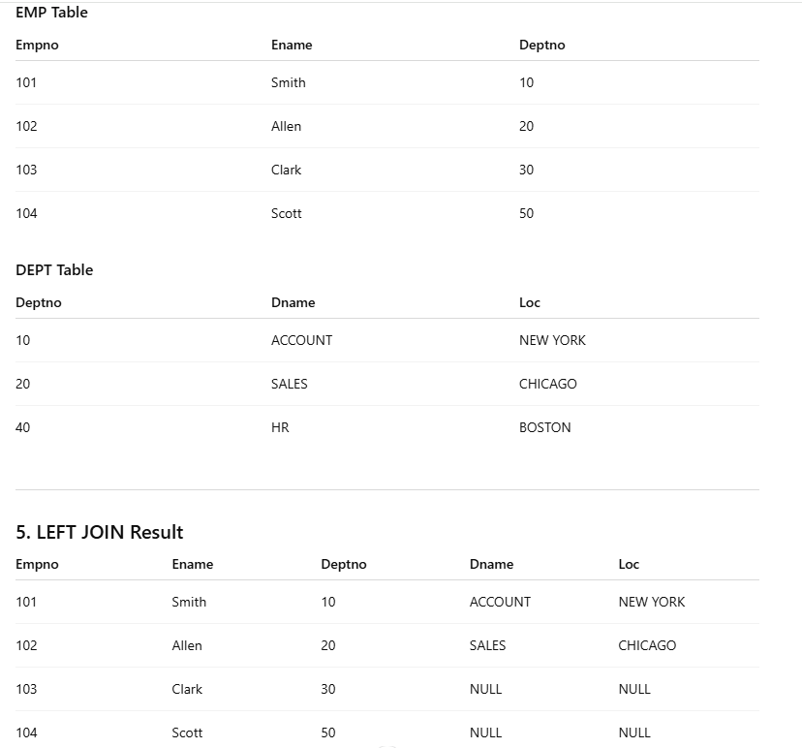

Key points:
- Clark (30) and Scott (50) are still listed, even though their departments don’t exist.
- That’s why Dname and Loc show as NULL.
- This is the main difference from INNER JOIN (which would have excluded Clark and Scott).
Real-World Use Cases of LEFT JOIN
- Show all employees, even if some don’t have a department assigned yet.
- Show all customers, even if some never placed an order.
- Show all products, even if some products have never been sold.
- In data cleaning: identify rows in left table that don’t have matching records in right table (because NULLs highlight missing matches).
Note: LEFT JOIN returns all rows from the left table, along with matching rows from the right table. If there is no match, NULLs are returned for the right table’s columns.

RIGHT JOIN (RIGHT OUTER JOIN) in SQL
1. What is a RIGHT JOIN?
- A RIGHT JOIN returns:
  - All rows from the right table (the second table in your query)
  - Plus the matching rows from the left table (if any)
  - If there’s no match, you still get the row from the right table but the left-side columns will show NULL.
Think of it like: “Give me all departments (right table), and add their employees if available. If no employees are in that department, still show the department, but employee details will be NULL.”

2. Syntax
SELECT e.Empno, e.Ename, e.Deptno, d.Dname, d.Loc
FROM Emp e
RIGHT JOIN Dept d
ON e.Deptno = d.Deptno;

Breaking it Down
a) LEFT table vs RIGHT table
- Emp e = LEFT table (employees).
- Dept d = RIGHT table (departments).
RIGHT JOIN = keep everything from right table.
b) Condition: ON e.Deptno = d.Deptno
- Matches employees with departments using Deptno.
- If match found → employees show under that dept.
- If no match → department still appears, but employee details = NULL.

Example output:

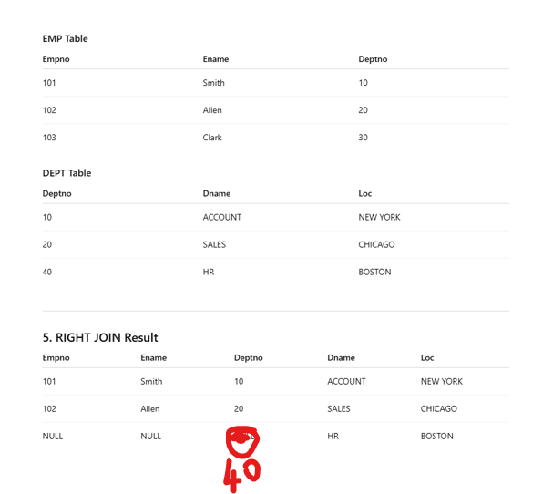

Key points:
- HR (Dept 40) still appears, even though no employees belong to it.
- That’s why Empno, Ename, Deptno (from Emp) = NULL.
- This is the main difference from INNER JOIN (which would have excluded Dept 40).
Real-World Use Cases of RIGHT JOIN
- Show all departments, even if no employees are assigned to them.
- Show all products, even if nobody purchased them.
- Show all projects, even if no employees are currently allocated.
- Useful in reporting when you care about the right-side entity coverage (e.g., every department must be listed).
Notes: RIGHT JOIN returns all rows from the right table, along with matching rows from the left table. If there is no match, NULLs are returned for the left table’s columns.

FULL OUTER JOIN in SQL
1. What is a FULL OUTER JOIN?
- A FULL OUTER JOIN returns:
  - All rows from the left table (Emp)
  - All rows from the right table (Dept)
  - Matching rows where possible
  - If there’s no match, SQL fills with NULLs for the missing side
Think of it like: “Show me all employees and all departments, even if some employees don’t belong to any department or some departments don’t have any employees.”

2. Syntax
SELECT e.Empno, e.Ename, e.Deptno, d.Dname, d.Loc
FROM Emp e
FULL OUTER JOIN Dept d
ON e.Deptno = d.Deptno;

3. Breaking it Down
- Emp e = LEFT table
- Dept d = RIGHT table
- FULL OUTER JOIN = Keep everything from both tables
- ON e.Deptno = d.Deptno = match employees to their departments
If match → data merged
If no match → NULLs fill in missing side
Example output:

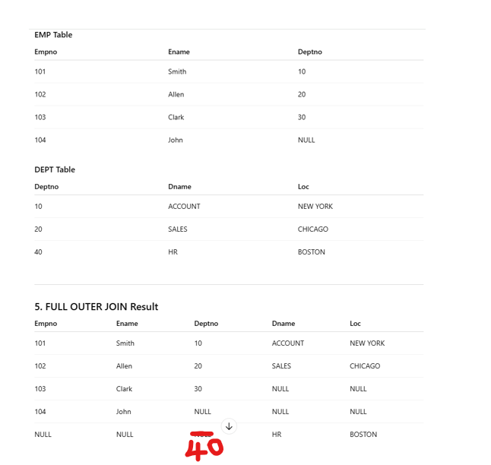

Key Observations
- Combines LEFT JOIN + RIGHT JOIN results
- Shows:
  - Matched records
  - Unmatched records from LEFT table (Emp)
  - Unmatched records from RIGHT table (Dept)
- Ensures no data is lost from either side

Real-World Use Cases
- Show all employees and all departments, even if some are unassigned.
- Show all customers and all orders, including customers who didn’t order or orders with no assigned customer (data errors).
- Show all students and all courses, even if a student isn’t enrolled or a course has zero students.

Note: FULL OUTER JOIN returns all rows from both tables. Matched rows appear together, unmatched rows show with NULLs.

CROSS JOIN in SQL
1. What is a CROSS JOIN?
- A CROSS JOIN returns the Cartesian product of two tables.
- This means every row from the first table is combined with every row from the second table.
- There’s no join condition required.
Think of it like: “Match everything with everything.”
2. Syntax
SELECT e.Empno, e.Ename, d.Deptno, d.Dname
FROM Emp e
CROSS JOIN Dept d;
3. Breaking it Down
- If Emp has 5 rows and Dept has 3 rows,
then CROSS JOIN will produce 5 × 3 = 15 rows.
- No ON condition here. It just multiplies the rows.

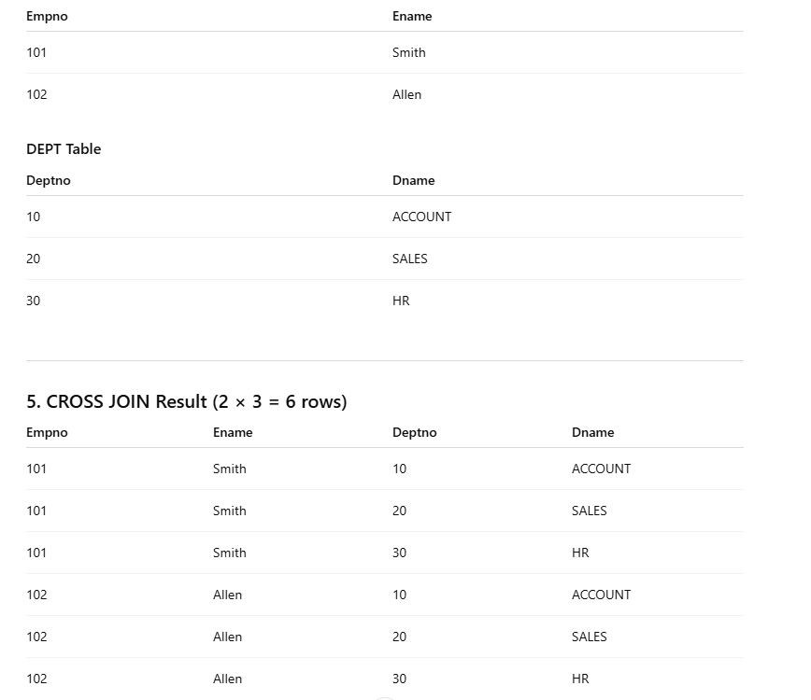

Key Observations
- No matching condition → It blindly pairs all rows.
- Useful for generating combinations, not for normal reporting.
- Can generate huge results (be careful with large tables).
Real-World Use Cases
- Test Data Generation:
E.g., create all possible combinations of dates × products × stores for reporting.
- Business Scenarios:
  - List all employees against all shifts (before actual assignment).
  - List all students against all subjects (before enrollment).

Notes: CROSS JOIN returns the Cartesian product of two tables — all combinations of rows.

Correlated Subqueries in SQL

1. What is a Subquery? (Quick Recap)
A subquery is a query inside another query.

Example
SELECT Ename, Deptno
FROM Emp
WHERE Deptno IN (SELECT Deptno FROM Dept WHERE Loc = 'NEW YORK');

Here, the inner query runs first → finds all departments in NEW YORK.
Then, the outer query fetches employees belonging to those departments.
This is a simple (non-correlated) subquery because the inner query runs independently — it doesn’t rely on the outer query’s data.

2. What is a Correlated Subquery?
A correlated subquery is one where the inner query depends on the outer query — it uses a value from the outer query.
Think of it like:
“For each row in the outer query, run the inner query to check something.”
So the inner query is executed once for every row of the outer query.

3. Why Do We Use Correlated Subqueries?
Because sometimes, you need to compare a row against data that depends on that same row.
Examples:
- Find employees who earn more than the average salary of their department.
- Find customers whose order total is above their own average spend.
- Find students who scored above their class average.
Joins are great for combining tables;
but correlated subqueries shine when you need row-by-row contextual comparisons.

4. Syntax of a Correlated Subquery
SELECT e.Empno, e.Ename, e.Sal, e.Deptno
FROM Emp e
WHERE e.Sal > (
SELECT AVG(Sal)
FROM Emp
WHERE Deptno = e.Deptno
);
Explanation:
- Outer query → selects employee info.
- Inner query → calculates average salary of the same department as each employee.
- WHERE Deptno = e.Deptno makes it correlated → the inner query depends on each row of e in the outer query.

5. Understanding Execution Flow
Outer query picks one employee (say, ALLEN, Deptno = 30).
Inner query calculates the average salary for Deptno = 30.
Outer query compares ALLEN’s salary with that average.
Repeats this for every employee.
This is why correlated subqueries are slower than normal subqueries — the inner query runs once per row.

7. EXISTS, IN, ANY, and ALL — Explained Simply
Let’s understand these four powerful operators — they often appear with subqueries (especially correlated ones).

EXISTS
Used to check if the subquery returns at least one row.

SELECT Ename, Deptno
FROM Emp e
WHERE EXISTS (
SELECT 1
FROM Dept d
WHERE d.Deptno = e.Deptno
AND d.Loc = 'NEW YORK'
);

Meaning:
Show employees whose department exists in NEW YORK.
EXISTS returns TRUE if the subquery finds even one match.
Real-World Example:
Show all customers who have made at least one order.

IN
Used to check if a value matches any value returned by the subquery.
SELECT Ename, Deptno
FROM Emp
WHERE Deptno IN (
SELECT Deptno FROM Dept WHERE Loc = 'NEW YORK'
);
Meaning:
Show employees who belong to any department located in NEW YORK.
IN → Subquery runs once.
EXISTS → Often runs for each row (correlated).
Use EXISTS when checking existence, IN when comparing values.

ANY (or SOME)
Used to compare a value against any value from the subquery.

SELECT Ename, Sal
FROM Emp
WHERE Sal > ANY (
SELECT Sal FROM Emp WHERE Job = 'CLERK'
);

Meaning:
Show employees whose salary is greater than at least one clerk.
ANY → “At least one match satisfies the condition.”

ALL
Used to compare a value against all values returned by the subquery.

SELECT Ename, Sal
FROM Emp
WHERE Sal > ALL (
SELECT Sal FROM Emp WHERE Job = 'CLERK'
);

Meaning:
Show employees whose salary is higher than every clerk’s salary.
ALL → “Must satisfy condition for every value in subquery.”

8. Real-World Use Cases
Business Need | SQL Concept Used | Example
Find employees who earn more than average of their department | Correlated Subquery | WHERE e.Sal > (SELECT AVG(Sal) FROM Emp WHERE Deptno = e.Deptno)
Find employees who belong to departments in NEW YORK | IN | WHERE Deptno IN (SELECT Deptno FROM Dept WHERE Loc='NEW YORK')
Find employees if their department exists in DEPT table | EXISTS | WHERE EXISTS (SELECT 1 FROM Dept WHERE Deptno=e.Deptno)
Find employees who earn more than any clerk | ANY | WHERE Sal > ANY (SELECT Sal FROM Emp WHERE Job='CLERK')
Find employees who earn more than all clerks | ALL | WHERE Sal > ALL (SELECT Sal FROM Emp WHERE Job='CLERK')

9. Performance Tip
- Correlated subqueries are powerful but slower — they run the inner query for each row.
- If possible, rewrite them using JOINs for better performance in large data sets.
- Use EXISTS when you only need to check for existence — it stops after the first match, making it efficient.

10. Summary in One Line
“When a subquery must look back at the outer query for each row — that’s a correlated subquery.
And when you want to control how you compare that data — you use EXISTS, IN, ANY, or ALL.”

What is Normalization?
Definition
Normalization is the process of organizing data in a database to reduce redundancy (duplicate data) and ensure data integrity (accuracy and consistency).
It’s like cleaning your room — everything has a place, nothing is duplicated, and it’s easier to find and update things later.
Why We Need Normalization
When databases grow large:
- Duplicate data wastes storage.
- Updates become inconsistent (same data repeated in multiple places).
- It’s hard to maintain integrity across tables.
Normalization ensures:
- Data is stored once.
- Relationships are maintained via keys (Primary, Foreign).
- Updates are clean and reliable.
Think of a Real-World Example
Let’s say we store employees and departments:
EmpID | EmpName | DeptName | DeptLoc
1 | John | Sales | London
2 | Mary | Sales | London
3 | Raj | HR | Delhi
4 | Tina | HR | Delhi
Problem:
- DeptName and DeptLoc are repeated for every employee.
- If “Sales” moves to “Manchester,” you must update multiple rows.
- If one row is missed → data inconsistency.
Solution: Normalize.
Normal Forms (1NF → 3NF → BCNF)

FIRST NORMAL FORM (1NF)
Problem
When a column holds multiple values or repeating groups instead of one.
Before (Not in 1NF)
StudentID | StudentName | PhoneNumbers
101 | John | 9876543210, 9123456789
102 | Mary | 9988776655

Problem Explanation:
- The column PhoneNumbers has multiple values for the same student.
- If John changes one phone number, we have to edit a part of that text manually.
- Searching or filtering by phone number becomes difficult.

After (In 1NF)
StudentID | StudentName | PhoneNumber
101 | John | 9876543210
101 | John | 9123456789
102 | Mary | 9988776655

Fix Explanation:
- We separated each phone number into its own row.
- Every cell now contains only one value → atomic (indivisible).
- Easy to search, filter, and update.

SECOND NORMAL FORM (2NF)
Rule
- Must be in 1NF.
- Every non-key column must depend on the whole key, not part of it.
Before (Not in 2NF)
StudentID | CourseID | StudentName | CourseName
101 | SQL101 | John | SQL Basics
101 | PY201 | John | Python Intro
102 | SQL101 | Mary | SQL Basics
Key = (StudentID, CourseID) → both together make a unique record.
Problem Explanation:
- StudentName depends only on StudentID.
- CourseName depends only on CourseID.
- So these columns depend on part of the key, not the whole key.
This causes duplication and update issues.
If John changes his name spelling → you must update multiple rows.

After (In 2NF)
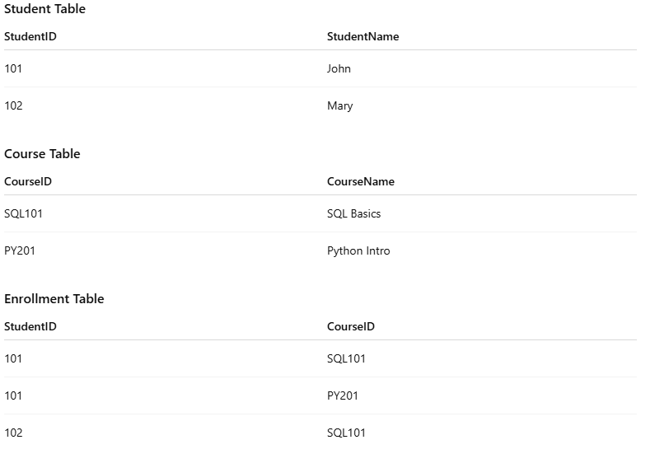
Fix Explanation:
- We split data into three tables.
- Each table focuses on one entity (Student, Course, Enrollment).
- Now no partial dependency → each non-key column depends fully on its key.

THIRD NORMAL FORM (3NF)
Rule
- Must be in 2NF.
- No transitive dependency — i.e., non-key column shouldn’t depend on another non-key column.
Before (Not in 3NF)
EmpID | EmpName | DeptID | DeptName
1 | John | D01 | HR
2 | Mary | D02 | Finance
3 | Raj | D01 | HR

Problem Explanation:
- DeptName depends on DeptID, not directly on EmpID.
- This creates duplication — “HR” repeated for every employee in that department.
- If HR department name changes → must update many rows.

After (In 3NF)
Employee Table
EmpID | EmpName | DeptID
1 | John | D01
2 | Mary | D02
3 | Raj | D01

Department Table
DeptID | DeptName
D01 | HR
D02 | Finance

Fix Explanation:
- We separated department details into a new table.
- Now DeptName is stored once, linked via DeptID.
- Data is clean, no redundancy, and easy to update.

BOYCE–CODD NORMAL FORM (BCNF)
Rule
- Stronger version of 3NF.
- For every relationship X → Y, X must be a candidate key.

Before (Not in BCNF)
Instructor | Course | Room
Smith | Database | R1
Jones | Python | R2
Smith | Database | R3

Assume:
- Each course is taught by one instructor (Instructor → Course).
- Each course happens in one room (Course → Room).
Problem Explanation:
- Instructor determines Course, but Instructor is not a key — violates BCNF.
- Same instructor can’t teach two courses easily — data inconsistency possible.

After (In BCNF)
Instructor Table
Instructor | Course
Smith | Database
Jones | Python

Course Table
Course | Room
Database | R1
Python | R2

Fix Explanation:
- Split the table so that every determinant (Instructor, Course) is a key in its own table.
- Now data is consistent and reliable.

🧾 Summary Table

Normal Form | Problem Type | Example Issue | Solution
1NF | Multiple values in one column | Phones = '9876,9123' | Split into separate rows (atomic values)
2NF | Non-key depends on part of key | StudentName depends only on StudentID | Split into Student, Course, Enrollment tables
3NF | Non-key depends on another non-key | DeptName depends on DeptID | Separate Department table
BCNF | Determinant not a candidate key | Instructor → Course but Instructor not key | Decompose into Instructor & Course tables

Denormalization (in Data Warehousing)
Definition
Denormalization = intentionally combining normalized tables to improve query performance in reporting or analytics systems.
Why Denormalize?
In OLTP (transactional systems):
- We normalize to reduce duplication and improve updates.
In OLAP / Data Warehousing:
- We denormalize to improve read performance.
- Queries join many tables → slow for analytics.
- By merging them, we reduce joins and accelerate dashboards.
Trade-off:
More redundancy → Faster reporting.
Less storage efficiency, but better performance.

Example:
Normalized structure (OLTP):
Customer(CustID, CustName)
Orders(OrderID, CustID, Amount)

To get total sales per customer:
SELECT c.CustName, SUM(o.Amount)
FROM Customer c JOIN Orders o
ON c.CustID = o.CustID
GROUP BY c.CustName;

For frequent reporting, instead of joining every time,
you can create a denormalized table:
CustID | CustName | OrderID | Amount
1 | John | 1001 | 200
1 | John | 1002 | 500
2 | Mary | 1003 | 700

Star Schema Example (Data Warehousing)
- Fact Table: Holds numeric, measurable data (Sales, Revenue).
- Dimension Tables: Describe context (Customer, Product, Time).
[DimCustomer] [DimProduct] [DimTime]
\ | /
\ | /
[FactSales]

FactSales might include:
SaleID | CustKey | ProdKey | TimeKey | Amount

Benefits:
- Fewer joins.
- Simple for Power BI / Tableau.
- Fast aggregations.

When to Normalize vs Denormalize
Use Case | Approach | Why
Banking systems | Normalize | Frequent updates, data accuracy
E-commerce checkout | Normalize | Write-heavy
Reporting / Analytics | Denormalize | Read-heavy, speed matters
Data Warehouse | Denormalize | BI dashboards need quick reads

Real-World Examples
Domain | Use Case | Description
E-commerce | Denormalized “Sales Fact” for Power BI | Combines customer, product, and transaction info for dashboards
Banking | Normalized Account & Branch tables | Prevents redundant branch info
Retail Analytics | Star Schema | Quick monthly/quarterly sales reports
HR Analytics | Denormalized Employee Master for reporting | Combines dept, role, and salary for performance reports

Summary:
“Normalization is about accuracy and consistency.
Denormalization is about speed and simplicity.
You normalize to make data clean,
and denormalize to make it fast.”

Views in SQL (Simple, Complex, and Materialized)

What is a View?
A View is like a virtual table — it doesn’t store data by itself; it just saves a query that runs when you use it.
Think of a View as a saved SELECT statement that behaves like a table.
You can SELECT from a view just like you SELECT from a table.

Why We Use Views
- To simplify complex queries.
- To restrict access (show only part of a table).
- To re-use common queries across reports.
- To hide logic and keep the database secure and clean.

Simple View
Problem Without View
You have an Employee table like this:
EmpID | EmpName | Job | Salary | DeptID
1 | John | Manager | 5000 | D01
2 | Mary | Clerk | 3000 | D02
3 | Raj | Analyst | 4000 | D01
Now, management says:
“Show only Employee Name, Job, and Salary — not Department details.”
If you query directly, everyone needs to write:

SELECT EmpName, Job, Salary
FROM Employee;

If many reports use the same query, it’s repetitive.
Also, if the HR team shouldn’t see all data, you can’t restrict easily.

Fix: Create a Simple View
CREATE VIEW Emp_Salary_View AS
SELECT EmpName, Job, Salary
FROM Employee;

Now the HR team can simply run:
SELECT * FROM Emp_Salary_View;

and see:
EmpName | Job | Salary
John | Manager | 5000
Mary | Clerk | 3000
Raj | Analyst | 4000
Explanation
- A simple view is based on one table.
- It’s read-only by default (unless you allow updates).
- You can grant permissions only on the view — securing sensitive data.

Complex View
Problem Without View
You have two tables:

Employee Table
EmpID | EmpName | Job | DeptID
1 | John | Manager | D01
2 | Mary | Clerk | D02
3 | Raj | Analyst | D01

Department Table
DeptID | DeptName | Location
D01 | HR | London
D02 | Finance | Manchester

Managers want a combined report:
“Show Employee Name, Job, Department Name, and Location.”

You’d need to join every time:
SELECT e.EmpName, e.Job, d.DeptName, d.Location
FROM Employee e
JOIN Department d ON e.DeptID = d.DeptID;
Repeating this join in every report = messy and error-prone.

Fix: Create a Complex View
CREATE VIEW Emp_Dept_View AS
SELECT e.EmpName, e.Job, d.DeptName, d.Location
FROM Employee e
JOIN Department d ON e.DeptID = d.DeptID;

Now any user can just run:
SELECT * FROM Emp_Dept_View;

Output
EmpName | Job | DeptName | Location
John | Manager | HR | London
Mary | Clerk | Finance | Manchester
Raj | Analyst | HR | London

Explanation
- A complex view is built on multiple tables (using joins or aggregations).
- Used for reports, dashboards, and analytics.
- Read-only by nature — can’t update through it easily.
- Simplifies access for analysts and BI tools (Power BI, Tableau, etc.).

Materialized View (Real Data Stored)
Problem With Normal Views
A normal view is virtual — data is not stored, only the query is.
So every time you select from it, SQL must recalculate the result.
If the query joins 5–6 big tables → slow performance for analytics or dashboards.

Fix: Use a Materialized View
Materialized View = View + Cached Data
It physically stores the result of the query for faster access.
Example:
CREATE MATERIALIZED VIEW Sales_Summary AS
SELECT Region, SUM(SalesAmount) AS TotalSales
FROM Sales
GROUP BY Region;
Data physically stored like this:
Region | TotalSales
North | 120000
South | 90000
East | 110000

Later, you can refresh it to update:
REFRESH MATERIALIZED VIEW Sales_Summary;

Explanation
- Used in data warehouses and Power BI reports.
- Stores pre-calculated results for speed.
- Can be refreshed manually or automatically (daily/hourly).
- Great for dashboards where data doesn’t change every minute.

Summary Table
Type of View | Description | Based On | Stores Data? | Use Case
Simple View | View from one table | Single table | No | Hide columns, simplify access
Complex View | View using joins/aggregations | Multiple tables | No | Reports, analytics, read-only
Materialized View | View with stored data | Any query | Yes | Fast reporting, dashboards

Key Takeaways
- Views make data access simple and secure.
- Simple View → single table, filtered columns.
- Complex View → joins, aggregations, multiple tables.
- Materialized View → physically stores results for faster reads.
- Use views to hide complexity and protect sensitive data while still giving power to the users.

SQL Indexes — Clustered vs Non-Clustered (with Examples & Performance)
What is an Index?
An index in SQL is like the index page of a book —
it helps you find information faster without reading every page.
Without an index, SQL reads every row (called a “table scan”).
With an index, SQL can jump directly to the rows it needs.

Problem Without an Index
Before — No Index (Slow Search)
Employee Table
EmpID | EmpName | Job | Salary | DeptID
1 | John | Manager | 8000 | D01
2 | Mary | Clerk | 3000 | D02
3 | Raj | Analyst | 4000 | D01
4 | Anil | Clerk | 2500 | D03
5 | Priya | HR | 3500 | D02
... | ... | ... | ... | ...
Now imagine this table has 1 million rows.

You run:
SELECT * FROM Employee WHERE EmpName = 'Raj';

What happens:
- SQL checks each row one by one (a full table scan).
- Very slow when the table is large.

After — Index Added (Fast Search)
We add an index:
CREATE INDEX idx_emp_name ON Employee(EmpName);
Now SQL doesn’t scan all rows — it jumps directly to “Raj”.
Result:
Search time goes from seconds → milliseconds.

Simple Explanation
- Think of the index like a sorted phone book.
- Without it → you read every name to find “Raj”.
- With it → you jump to the “R” section instantly.

Clustered Index
What is It?
- Physically orders the data in the table itself.
- There can be only one clustered index per table because data can be physically sorted only one way.
- Usually created automatically on the Primary Key.

Before — No Order
EmpID | EmpName | Salary
3 | Raj | 4000
1 | John | 8000
5 | Priya | 3500
2 | Mary | 3000

If you search EmpID = 5, SQL must read line by line.

After — Clustered Index on EmpID
CREATE CLUSTERED INDEX idx_empid ON Employee(EmpID);

Now the table is physically sorted like this:

EmpID | EmpName | Salary
1 | John | 8000
2 | Mary | 3000
3 | Raj | 4000
5 | Priya | 3500

When you search for EmpID, SQL can use binary search (jumping directly to the location).

Real-World Analogy
Clustered Index = Phonebook arranged alphabetically.
The data itself is in sorted order → fast lookups by that key.

Before — Without Non-Clustered Index
Manager wants to find employees by Job:
SELECT * FROM Employee WHERE Job = 'Clerk';
SQL again scans every row → slow.

After — Non-Clustered Index
CREATE NONCLUSTERED INDEX idx_emp_job ON Employee(Job);
Now SQL uses the index (sorted list of Job titles) to quickly find all rows where Job = 'Clerk',
then jumps to the actual data rows using pointers.

Job | Pointer
Analyst | → row 3
Clerk | → row 2
Clerk | → row 4
HR | → row 5
Manager | → row 1

Real-World Analogy
Non-Clustered Index = Book index at the end —
it doesn’t contain the pages themselves, just pointers to where the topic is.

Index Performance Comparison
Operation | Without Index | With Index
Searching by column value | Scans all rows (slow) | Jumps directly (fast)
Sorting | Needs to sort every time | Already sorted by index
INSERT/UPDATE | Fast | Slightly slower (index updates)
Storage | Less | More (extra structure)

When to Use Which
Type | Description | Best For | Count
Clustered Index | Physically sorts table data | Primary key, Range queries (BETWEEN, <, >) | Only 1
Non-Clustered Index | Stores pointers to data | Frequently searched columns (EmpName, Job) | Many allowed

Example in One Flow
Employee Table
CREATE TABLE Employee (
EmpID INT PRIMARY KEY, -- Clustered index by default
EmpName VARCHAR(50),
Job VARCHAR(30),
Salary INT
);

Create Non-Clustered Index
CREATE NONCLUSTERED INDEX idx_emp_job ON Employee(Job);

Search Fast
SELECT EmpName, Salary FROM Employee WHERE Job = 'Clerk';

Summary Table
Concept | Clustered Index | Non-Clustered Index
Stores Data | Yes (reorders table) | No (stores pointer)
Count per Table | 1 only | Many allowed
Storage | Same as table | Extra structure
Speed | Fastest for range/key lookups | Fast for specific column searches
Example | Primary Key (EmpID) | EmpName, Job, DeptID

Quick Real-Life Analogy
Scenario | Explanation
Clustered Index | A phonebook arranged A–Z — data itself sorted.
Non-Clustered Index | The index at the back of a textbook — points you to the page number.

Sequences & Identity Columns in SQL
Purpose
Both Sequences and Identity Columns are used to generate unique numbers automatically, often for Primary Keys (like Employee IDs, Order Numbers, etc.).
They help you avoid manually inserting unique IDs and prevent duplicates.

The Problem Without Auto Numbering
Before — Manual Entry (Error-prone)
EmpID | EmpName | Department
101 | John | HR
102 | Mary | Finance
102 | Raj | IT

Problem:
- Duplicate EmpID (102) entered by mistake
- When 100s of employees are inserted manually, duplicates or missing IDs are common.
- If someone forgets to add the next ID, it breaks relationships between tables (Foreign Keys).
After — Auto Number (Fixed)
Let SQL automatically generate unique numbers for you!
There are two main ways to do it:
- Sequence Object (used in Oracle, PostgreSQL, SQL Server 2012+)
- Identity Column (used in SQL Server, MySQL, PostgreSQL)

Sequences (Standalone Object)
What is a Sequence?
A sequence is an independent object that generates incrementing numbers.
You can use it anywhere — across multiple tables if needed.

Example (Oracle / PostgreSQL style)
CREATE SEQUENCE Emp_Seq
START WITH 1
INCREMENT BY 1;

This creates a sequence like:
Call | Value Returned
NEXTVAL | 1
NEXTVAL | 2
NEXTVAL | 3

Use Sequence While Inserting
INSERT INTO Employee (EmpID, EmpName, Department)
VALUES (Emp_Seq.NEXTVAL, 'John', 'HR');

After multiple inserts:
EmpID | EmpName | Department
1 | John | HR
2 | Mary | Finance
3 | Raj | IT

SQL automatically picks next number.
No duplicates, no manual tracking.

Real-World Example
Think of a sequence like a ticket dispenser machine at a service counter:
Every time you press the button, it gives you the next number (1, 2, 3, …).

Sequence Settings
You can customize:
CREATE SEQUENCE Order_Seq
START WITH 1000 -- First number
INCREMENT BY 10 -- Step value
MAXVALUE 9999 -- Stop at 9999
CYCLE; -- Start over when max reached

Identity Columns (Auto Number Inside Table)
What is an Identity Column?
An identity column is built into the table definition —
it auto-generates numbers whenever you insert a new row.

Example (SQL Server / MySQL Style)
CREATE TABLE Employee (
EmpID INT IDENTITY(1,1), -- Start at 1, increment by 1
EmpName VARCHAR(50),
Department VARCHAR(30)
);
Now you can insert without specifying EmpID:
INSERT INTO Employee (EmpName, Department)
VALUES ('John', 'HR'),
('Mary', 'Finance'),
('Raj', 'IT');

EmpID | EmpName | Department
1 | John | HR
2 | Mary | Finance
3 | Raj | IT

IDs auto-generated!
No duplicate or missing IDs.
Difference Between Sequence vs Identity
Feature | Sequence | Identity Column
Definition | Separate object | Part of table definition
Reuse | Can be shared by multiple tables | Belongs to one table only
Control | You can get NEXTVAL anytime | Generates only during INSERT
Syntax | Emp_Seq.NEXTVAL | IDENTITY(1,1)
Flexibility | More configurable | Simpler for one table use

Problem vs Fix Summary
Problem | Solution | Description
Duplicate IDs | Use Sequence or Identity | SQL auto-generates unique IDs
Manual tracking of IDs | Auto increment | Next value handled by DB
Errors while inserting | DB controls sequence | Prevents missing or repeating IDs
Needing custom patterns | Sequence object | Define start, increment, max, cycle

Real-World Analogy
Concept | Analogy
Sequence | A separate token machine that issues numbers for multiple counters.
Identity Column | Each counter having its own built-in number printer.

Performance & Good Practices
Use Identity columns when each table needs its own simple auto ID.
Use Sequences when multiple tables share numbering (e.g., Orders, Invoices, Receipts).
Always make the ID Primary Key to ensure uniqueness.
Don’t reset sequences frequently — they’re meant to keep history consistent.

Quick Recap
“When you don’t want to type IDs manually —
let the database do it for you.
Sequences are like ticket machines — they hand out the next number.
Identity Columns are like built-in number generators inside your table.”

Common Table Expressions (CTEs)
What is a CTE?
A Common Table Expression (CTE) is a temporary result set — a named subquery —
that you can reuse inside your main SQL query.
Think of it as a “temporary view” created inside your query — only for that query.

The Problem Without a CTE
Let’s say you have a table:
EmpID | EmpName | DeptID | Salary
1 | John | 10 | 8000
2 | Mary | 20 | 6000
3 | Raj | 10 | 5000
4 | Anita | 30 | 9000
5 | Sam | 10 | 4000

Business Requirement
Find employees who earn above the average salary in their department.
Without a CTE, you must repeat subqueries:

SELECT EmpName, DeptID, Salary
FROM Employee e
WHERE Salary >
(SELECT AVG(Salary) FROM Employee WHERE DeptID = e.DeptID);

It works,
but the inner subquery runs again and again for every employee row — making it slower and messy.

Syntax
WITH cte_name (optional_columns) AS (
SELECT query_here
)
SELECT ...
FROM cte_name
WHERE ...;

You can use multiple CTEs separated by commas:

WITH cte1 AS (...),
cte2 AS (...)
SELECT ...
FROM cte1 JOIN cte2 ...;

The Fix — Using a CTE
We can calculate once and reuse it!

WITH DeptAvg AS (
SELECT DeptID, AVG(Salary) AS AvgSal
FROM Employee
GROUP BY DeptID
)
SELECT e.EmpName, e.DeptID, e.Salary, d.AvgSal
FROM Employee e
JOIN DeptAvg d ON e.DeptID = d.DeptID
WHERE e.Salary > d.AvgSal;

Output
EmpName | DeptID | Salary | AvgSal
John | 10 | 8000 | 5666.67
Anita | 30 | 9000 | 9000.00

Explanation
- The CTE (DeptAvg) calculates average salary once per department.
- The main query joins Employee with that temporary result.
- Result = cleaner code, faster performance, and easier maintenance.

Real-World Use Case
Let’s say your manager asks:
“Give me the top 3 highest-paid employees from each department.”

Using CTEs:
WITH RankedEmp AS (
SELECT EmpID, EmpName, DeptID, Salary,
ROW_NUMBER() OVER (PARTITION BY DeptID ORDER BY Salary DESC) AS RankNo
FROM Employee
)
SELECT EmpName, DeptID, Salary
FROM RankedEmp
WHERE RankNo <= 3;

Easy to read.
No nested mess.
Can be reused in the same query.

Problem vs Fix Summary
Problem |  | Fix | Explanation
Repeated logic in subqueries |  | Use a CTE | Write once, use many times
Hard-to-read queries |  | Use named temporary blocks | Improves readability
Recomputing values |  | Use CTE to compute once | Improves performance
Real-World Analogy
Concept | Analogy
Subquery | Asking “What’s the total?” every time for each person
CTE | Calculating totals once, writing them on a whiteboard, and then referring to that board for all your answers

Real-World Example: Reporting
In Power BI or analytics pipelines, you’ll often write SQL with CTEs to:
- Calculate aggregates (totals, averages)
- Apply filters in multiple stages
- Combine multiple datasets cleanly
Makes dashboards and reports faster and easier to maintain.

STORED PROCEDURES in SQL (with Parameters, Input/Output, and Error Handling)

What is a Stored Procedure?
A Stored Procedure is a predefined block of SQL code — saved in the database — that you can execute whenever you need.
It’s like a function in programming but for SQL operations.
Instead of writing the same query again and again, you save it once and call it by name.

The Problem Without Stored Procedures
Let’s say your manager asks:
“Find total salary for a department — we’ll need it frequently for reports.”
Without a stored procedure:
You (and others) must type or paste this query every time:

SELECT SUM(Salary)
FROM Employee
WHERE DeptID = 10;

Later, for DeptID 20, 30, etc., people copy-paste the same query with different IDs.
Too much repetition
Prone to mistakes
No consistency or security

The Fix — Create a Stored Procedure
Save the logic once. Then just call it whenever needed.
Example 1: Simple Stored Procedure
CREATE PROCEDURE GetTotalSalary
AS
BEGIN
SELECT DeptID, SUM(Salary) AS TotalSalary
FROM Employee
GROUP BY DeptID;
END;

Now, anyone can simply run:
EXEC GetTotalSalary;

Easy
Consistent
Reusable

Adding Parameters (Input & Output)
Parameters make procedures dynamic and reusable.

Input Parameter Example
CREATE PROCEDURE GetDeptSalary
@Dept INT
AS
BEGIN
SELECT DeptID, SUM(Salary) AS TotalSalary
FROM Employee
WHERE DeptID = @Dept
GROUP BY DeptID;
END;

Now run:
EXEC GetDeptSalary @Dept = 10;
Fetches only Dept 10’s total salary.

Explanation
- @Dept = Input parameter → acts like a variable.
- Makes your procedure flexible for any department.

Output Parameter Example
CREATE PROCEDURE GetDeptTotal
@Dept INT,
@TotalSalary INT OUTPUT
AS
BEGIN
SELECT @TotalSalary = SUM(Salary)
FROM Employee
WHERE DeptID = @Dept;
END;

Run like this:
DECLARE @Total INT;
EXEC GetDeptTotal @Dept = 10, @TotalSalary = @Total OUTPUT;
PRINT @Total;
Now your program (or script) can capture the result in a variable.

Adding Error Handling
In real systems, procedures must handle errors gracefully —
for example, when a department doesn’t exist.

Error Handling Example
CREATE PROCEDURE GetDeptSalarySafe
@Dept INT
AS
BEGIN
BEGIN TRY
IF NOT EXISTS (SELECT 1 FROM Department WHERE DeptID = @Dept)
THROW 50001, 'Invalid Department ID!', 1;

SELECT DeptID, SUM(Salary) AS TotalSalary
FROM Employee
WHERE DeptID = @Dept
GROUP BY DeptID;
END TRY
BEGIN CATCH
SELECT ERROR_MESSAGE() AS ErrorMessage;
END CATCH
END;

Run:
EXEC GetDeptSalarySafe @Dept = 99;

Output:
Invalid Department ID!
Handles errors cleanly.
Prevents your program from crashing.

Real-World Use Cases
Use Case | What the Procedure Does
Payroll System | Calculate monthly salary and bonuses
Banking | Transfer funds securely between accounts
HR | Generate employee reports by department
E-commerce | Update stock after each order
Data Warehouse | Clean and transform data before loading

Why Stored Procedures Are Powerful
Benefit | Description
Reusability | Write once, run many times
Performance | Precompiled by SQL engine (faster)
Security | Hide logic; control access to data
Modularity | Build reusable building blocks
Error Handling | Prevents crashes and invalid updates

User-Defined Functions (UDF) vs Stored Functions – Comparison Table
Feature | User-Defined Function (UDF) | Stored Function
Definition | A custom function written by the user to reuse logic in SQL (mainly in analytics engines). | A function stored permanently inside a relational database and returns a single value.
Where used? | Analytics platforms (Databricks, Spark, Hive, BigQuery, Snowflake). | OLTP/Relational DBs (MySQL, PostgreSQL, SQL Server, Oracle).
Purpose | Data transformation, calculations, cleaning. | Enforcing business rules and returning one specific value.
Output | Can return a value or even a table (depending on system). | Always returns one value.
Performance | Can be slower (especially Python UDFs) because execution happens row-by-row. | Usually faster and optimized because DB engine compiles & caches them.
Who uses it? | Data Engineers, Data Analysts, BI Developers. | Backend Developers, DBAs, System Architects.
Stored in DB? | Not always stored inside the database; depends on platform. | Always stored in the database like a permanent object.
Can modify data (INSERT/UPDATE)? | ❌ No. | ❌ No (stored procedures can, but stored functions cannot).
Reusability | High, reused in queries across notebooks/jobs. | High, reused across SQL programs and applications.
Best Use Case | Repeating transformations in analytic workflows. | Consistent business logic in transactional databases.

