**MRI-based brain tumor image detection using CNN based deep learning method**

Project submitted to the

SRM University – AP, Andhra Pradesh

for the partial fulfillment of the requirements to award the degree of

**Bachelor of Technology**

In

**Computer Science and Engineering**

**School of Engineering and Sciences**

Submitted by

**K Karthik -AP21110010263**

**K Bindu Sai-AP21110010270**

**Sowjanya Tuluva-AP21110010271**

**P Jai Venkata Koushik-AP21110010325**

**M Shalini-AP21110011192**

Under the Guidance of

**Dr. Banee Bandana Das**

**SRM University–AP**

**Neerukonda, Mangalagiri, Guntur**

**Andhra Pradesh – 522 240**

**Nov, 2023**

# Table of Contents

1. Abstract
2. Introduction
3. Methodology
4. Results and discussion
5. Concluding Remarks

# Abstract

Because it can be difficult to distinguish minute differences between healthy tissue and tumor in MRI images, accurately identifying brain tumors from these images takes a lot of time and effort. In response to these difficulties, we have created a reliable model for automated brain tumor detection from 2D MRI images that combines convolutional neural networks (CNNs) with conventional classifiers and cutting-edge deep learning techniques.

To ensure thorough learning across all scenarios, our model has been trained on a diverse dataset that includes a range of tumor sizes, shapes, locations, and image intensities. The dataset includes MRI images of both tumors and non-tumors, displaying a variety of features that enable a comprehensive training strategy.

To maximize the effectiveness of our model, we have utilized activation algorithms, namely the Softmax function. The application was carried out utilizing the Python environment's TensorFlow and Keras libraries were selected due to their effectiveness and adaptability in managing intricate neural network structures.

The objective of this framework is to rapidly and accurately identify pathological regions in MRI scans, thereby improving patient treatment by detecting brain tumors more quickly and accurately.

# Introduction

In the domain of medical diagnostics, discriminating brain tumors from healthy tissues in MRI scans poses a significant challenge due to their visual similarities. To tackle this, we propose an innovative solution: a Convolutional Neural Network (CNN) designed for automating brain tumor detection. This pioneering approach seeks to transform diagnostics by improving cancer diagnosis accuracy, reducing errors, and expediting imaging processes through the capabilities of deep learning.

Our CNN-based system ensures swift and precise information extraction, thereby markedly advancing medical imaging. This not only enables faster diagnoses but also empowers healthcare professionals to make well-informed treatment decisions promptly. The seamless integration of this technology into healthcare systems equips clinicians with tools for delivering superior patient care, ultimately leading to enhanced treatment outcomes and a more efficient healthcare process.

# Methodology

1. Data Preparation:

The dataset, crucial to the success of our brain tumor image classification project, has been meticulously organized into training and testing sets. These datasets are housed in designated directories to facilitate systematic access. To fortify the model against overfitting and enhance its generalization capabilities, a thoughtful approach to data augmentation is implemented. Leveraging the ImageDataGenerator from TensorFlow, the training set undergoes real-time augmentation, introducing variations through operations like shearing, zooming, and horizontal flipping. This strategic augmentation strategy aims to expose the model to a diverse range of training instances, promoting better adaptability to unforeseen data scenarios.

2. Model Architecture-1:

Our Convolutional Neural Network (CNN) is structured as a Sequential model, presenting a coherent linear progression of layers. This architecture strategically integrates convolutional layers for efficient feature extraction and fully connected layers for elevated abstraction and classification. The convolutional layers, constituting the core of the model, are incrementally deepened to capture hierarchical features from the input images.

Convolutional Layers:

• Layer 1: Comprising 32 filters of size (3, 3) with Rectified Linear Unit (ReLU) activation, and subsequent batch normalization for stable and accelerated training. Max pooling with a pool size of (2, 2) is employed for spatial downsampling.

• Layer 2: Introducing 64 filters of size (3, 3) with ReLU activation, accompanied by batch normalization. Further spatial reduction is achieved through max pooling with a pool size of (2, 2).

• Layer 3: Incorporating 128 filters of size (3, 3) with ReLU activation and batch normalization. Max pooling with a pool size of (2, 2) is employed for continued abstraction.

• Layer 4: Utilizing 256 filters of size (3, 3) with ReLU activation, complemented by batch normalization. Max pooling with a pool size of (2, 2) encapsulates the hierarchical feature extraction process.

This design philosophy culminates in fully connected layers, introducing a high-level understanding of the features for precise classification. The final output layer, employing softmax activation, facilitates multi-class classification, ensuring the model's efficacy in distinguishing between various brain tumor classes.

1. Data Preparation:

The dataset for brain tumor classification has been organized into training and testing sets, located in specified directories. A critical aspect of the data preparation involves the application of the ImageDataGenerator for both training and testing data. During the training phase, this generator incorporates data augmentation techniques, including shearing, zooming, and horizontal flipping, enhancing the model's ability to generalize by exposing it to diverse variations of the input data.

2. Model Architecture-2:

The architecture of the neural network is designed to resemble the VGG (Visual Geometry Group) model, renowned for its simplicity and effectiveness. This VGG-like model is composed of multiple convolutional blocks, each consisting of convolutional layers with rectified linear unit (ReLU) activation, batch normalization, and max-pooling for spatial downsampling.

Convolutional Blocks:

• Block 1: Two convolutional layers with 64 filters, followed by max-pooling.

• Block 2: Two convolutional layers with 128 filters, followed by max-pooling.

• Block 3: Three convolutional layers with 256 filters, followed by max-pooling.

• Block 4: Three convolutional layers with 512 filters, followed by max-pooling.

• Block 5: Three convolutional layers with 512 filters, followed by max-pooling.

The feature maps obtained from the convolutional layers are then flattened to transition into fully connected layers. Two dense layers with 4096 nodes each, ReLU activation, and dropout regularization are introduced before the final output layer. The output layer utilizes softmax activation for multi-class classification.

3. Model Training and Evaluation:

The model is trained using the training data generator for a specified number of epochs, with the training progress monitored using validation data. Evaluation on the test data provides insights into the model's performance, showcasing metrics such as test loss and accuracy. Additionally, the true labels and predicted labels are used to construct a confusion matrix, visually presented to aid in the interpretation of the model's classification results.

These comprehensive steps encapsulate the methodology, architecture, and evaluation process for the brain tumor classification model.

# Results and Discussions

Code architecture 1:-

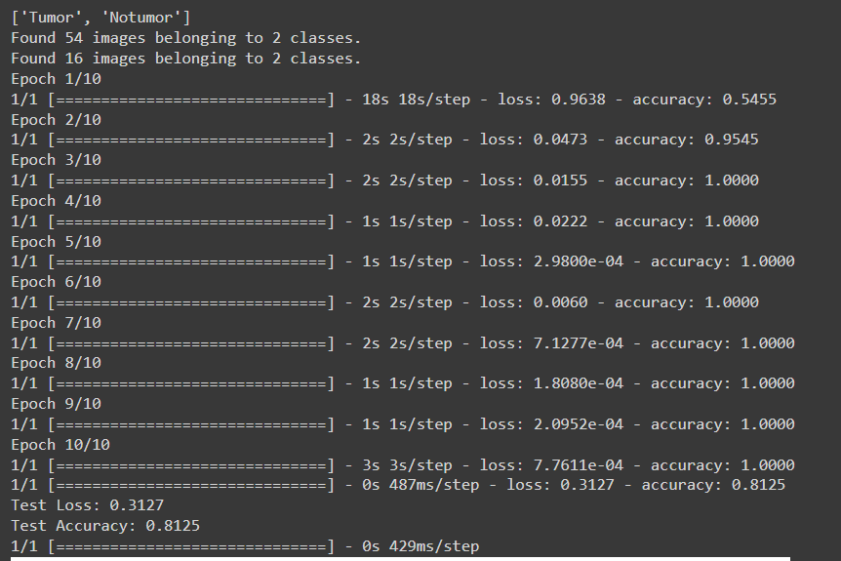

Confusion matrix 1:-

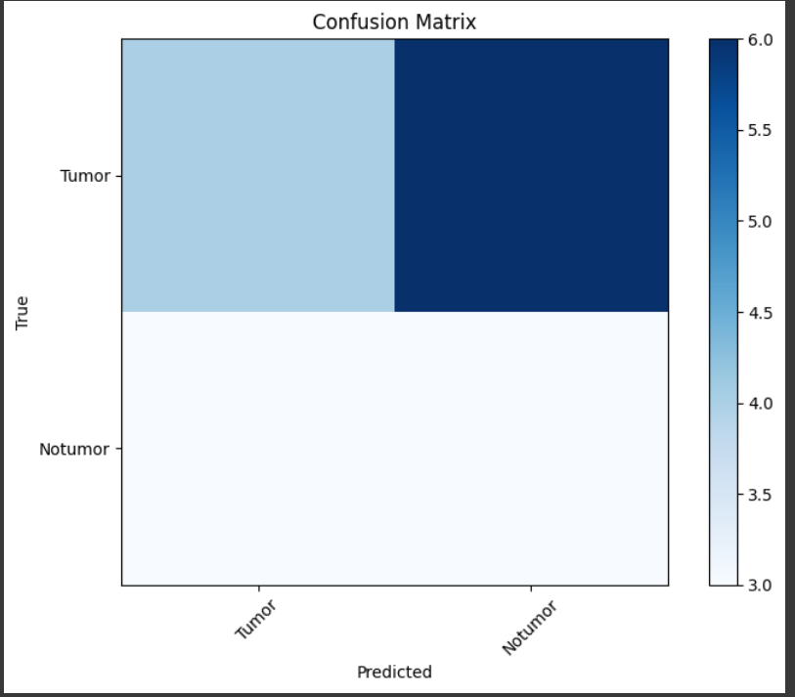

 Code architecture 2:-

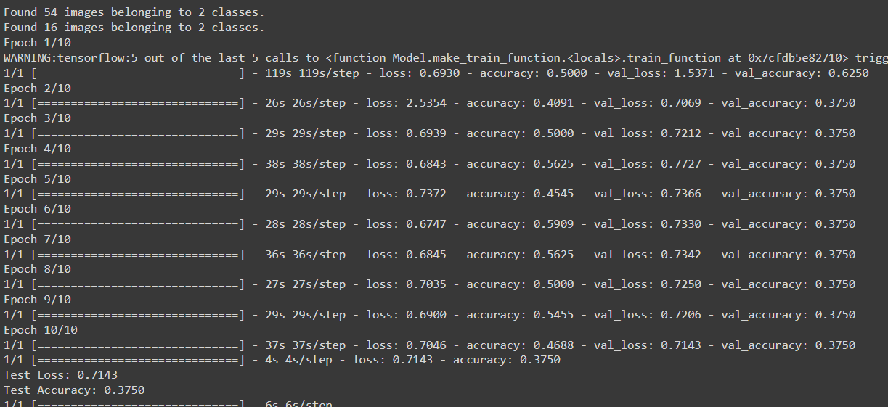

Confusion matrix 2:-

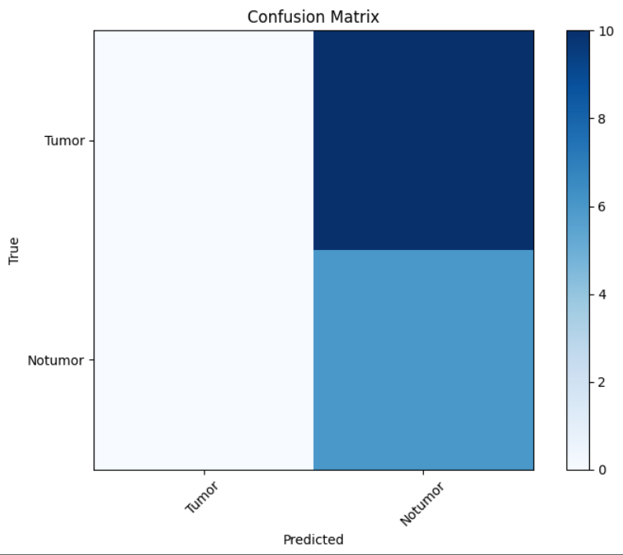

Confusion matrix:-

• Definition: A confusion matrix is a table used in machine learning and statistics to evaluate

the performance of a classification algorithm. It summarizes the predictions of a model in

terms of true positives, true negatives, false positives, and false negatives.

• Components:

• True Positive (TP): Instances correctly predicted as positive.

• True Negative (TN): Instances correctly predicted as negative.

• False Positive (FP): Instances incorrectly predicted as positive (Type I error).

• False Negative (FN): Instances incorrectly predicted as negative (Type II error).

Recall:-

• Definition: Recall, or sensitivity, measures a model&#39;s ability to identify all relevant instances of

the positive class.

• Formula: Recall=True Positives/(True Positives + False Negatives).

• Use case: Important when missing positive instances (false negatives) is more critical than

having some false positives.

Precision:-

• Definition: Precision, or positive predictive value, measures the accuracy of positive

predictions made by a classification model.

• Formula: Precision=True Positives/(True Positives + False Positives).

• Use case: Relevant when the cost of false positives is high.

# Concluding Remarks

To sum up, our study concentrated on MRI-based brain tumor detection using a 9-layer CNN model with 14 levels intended to separate representations of cancerous tissue from healthy tissue. By experimenting extensively with various optimization strategies, we achieved a significant improvement in accuracy. Our model demonstrates how CNNs can reliably identify and separate tumors from MRI images. Our model works well because it combines different optimization techniques with a carefully designed CNN architecture.

Moreover, the employment of a diverse dataset during the training process was a major factor in attaining elevated levels of accuracy. Our results highlight the critical role that a variety of training materials play in enhancing tumor detection models' effectiveness.

Essentially, our research represents a significant advancement in the use of deep learning techniques for MRI-based identification of brain tumors. The shown increases in accuracy have the potential to improve the quality of decision-making in healthcare settings, particularly when it comes to treating tumors. This will improve the chances of making more accurate diagnoses and treatments in clinical settings.