
QFE, Volume (Issue): x–x Page.
DOI: 10.3934/QFE.
Received:
Revised:
Accepted:
Published:
https://www.aimspress.com/journal/QFE

Type of article: Research article
The Hierarchical Transformer-Boost-Reinforcement Framework for Dynamic Multi-Asset Portfolio Optimization
Karthik Kemidi¹, G. Rami Reddy¹ and Panduraju Pagidimalla¹,*
¹ Department of Artificial Intelligence and Machine Learning, Chaitanya Bharathi Institute of Technology, Gandipet, Hyderabad 500075, Telangana, India; kemidikarthik2004@gmail.com; gramireddy786@gmail.com; panduraju@email.com
* Correspondence: kemidikarthik2004@gmail.com; Tel: +919515513353.
Abstract: Dynamic multi-asset portfolio optimization requires balancing complex temporal dependencies, cross-asset correlations, and multiple risk objectives under transaction costs and regulatory constraints. Presently we have rigid mean– variance models which assume stationarity which may not always be the case and we have end to end deep reinforcement learning models which while powerful may lack in terms of interpretability and stable performance. This paper introduces HTBR (Hierarchical Transformer Boost Reinforcement Learning) a three stage modular architecture which breaks down the large problem into: 1) a hierarchy of feature extractors using per asset temporal Transformers which also pay attention to other assets, 2) predictive signal refinement via XGBoost with a Ridge meta-learner, and 3) risk aware policy learning using Proximal Policy Optimization which includes multi objective reward shaping and 5 bps transaction costs with 5–40% per asset weight bounds. We evaluated HTBR on almost 10 years of daily data (2015–2024) which included equities (AAPL), foreign exchange (EUR/USD) and commodities (Gold) which resulted in a 29.22% cumulative return, 1.666 Sharpe ratio, -8.22% max drawdown, and 8.79% annualized volatility for the 2023 to 2024 test period. Also we did ablation studies which point out the each stage's role in risk adjusted performance and we also did a comparison against base models which we used to present the value of hierarchical approaches for financial decision making in an uncertain environment.
Keywords: Portfolio optimization; Deep reinforcement learning; Transformer networks; Gradient boosting; Hierarchical architectures; Multi-asset allocation; Risk management; PPO; Financial machine learning
JEL Codes: C45, C53, C61, G11, G17

Abbreviations:
HTBR: Hierarchical Transformer Boost Reinforcement Learning
PPO: Proximal Policy Optimization
GBDT: Gradient-Boosted Decision Trees
MDP: Markov Decision Process
CVaR: Conditional Value at Risk
OHLCV: Open, High, Low, Close, Volume
RSI: Relative Strength Index
MACD: Moving Average Convergence Divergence
VIX: Volatility Index
GAE: Generalized Advantage Estimation
- Introduction
Modern portfolio management operates in non-stationary environments characterized by evolving correlations, regime shifts, and fat-tailed return distributions that violate classical mean-variance assumptions. Existing approaches face three fundamental challenges: (1) insufficient feature extraction from high-dimensional market data, (2) weak coupling between prediction and decision modules, and (3) inadequate handling of multiple competing risk objectives.
Recent advances in hybrid architectures combining Transformers with gradient- boosted decision trees (GBDTs) have demonstrated strong performance in structured prediction tasks. However, these methods have not been systematically integrated with deep reinforcement learning for sequential decision-making under constraints. This paper addresses this gap by proposing HTBR, a three-tier hierarchical framework that:
1. Employs hierarchical Transformers with separate per-asset temporal attention and cross-asset correlation modeling.
2. Refines predictions through XGBoost–Ridge ensemble stacking to stabilize signals for policy learning.
3. Learns risk-aware allocation policies using PPO with explicit multi-objective reward shaping for Sharpe optimization, CVaR control, volatility targeting, and drawdown penalties.

Our contributions include: Novel Architecture: First systematic integration of hierarchical Transformers, gradient boosting, and deep RL for portfolio optimization with explicit separation of prediction and decision concerns.
Empirical Validation: A rigorous evaluation on a nearly 10-year multi-asset dataset (2015–2024) using rolling windows and an out-of-sample test on 2023–2024; ablation experiments indicate each component's contribution to risk-adjusted performance.
Practical Deployment: Production-ready implementation with transaction costs, weight constraints, and multi-objective risk control achieving competitive performance during challenging test regimes.

2. Materials and Methods
2.1. Problem Formulation
We formulate multi-asset portfolio optimization as a constrained Markov Decision Process (MDP):
State Space S: Includes historical price sequences Xt ∈ ℝ^(A×L×F) for A assets over lookback L with F features, hybrid predictions r̂(T)_t, r̂(B)_t, sentiment signals s_t, prior weights w_(t-1), and volatility proxies σ̂_t.
Action Space A: Portfolio weight vector w_t ∈ Δ^A with constraints w_i ∈ [w_min, w_max] and Σ_i w_i = 1.
Transition P: Market dynamics (non-stationary, unknown).
Reward R: Multi-objective function balancing annualized Sharpe ratio, volatility targeting, CVaR tail risk, drawdown penalties, and transaction costs:
R_t = λ_S · Sharpe^ann_(t,60) - λ_V · I_(|σ^ann_t - 0.10| > 0.01) · |σ^ann_t - 0.10| - λ_C · max(0, -CVaR_(5%,t)) - λ_D · I_(DD_t < -0.12) · |DD_t + 0.12| + λ_R · r^net_t
where r^net_t = w^T_t r_t - 0.0005 · ||w_t - w_(t-1)||_1 accounts for transaction costs.

2.2. HTBR Architecture

2.2.1. Tier 1: Hierarchical Transformer Network

Stage 1 - Per-Asset Temporal Attention: Each asset i has a dedicated Transformer encoder T_i processing its feature sequence independently:
h^(T)_i = T_i(X_(:,i,:); θ^(T)_i)
This captures asset-specific temporal patterns (momentum, volatility regimes, seasonality) without cross-contamination.
Configuration: 4 encoder layers, 8 attention heads, 128-dimensional hidden states, 0.1 dropout, 30-day lookback window.
Stage 2 - Cross-Asset Attention: A shared cross-attention layer C processes concatenated representations:
H^(cross) = C([h^(T)_1, ..., h^(T)_A]; θ^(C))
This models dynamic correlations, flight-to-quality effects, and macro regime shifts affecting multiple assets.

Configuration: 2 cross-attention layers, 4 heads, layer normalization.
Output Generation: The Transformer tier produces next-step return predictions and latent factor embeddings for downstream use. Training uses Adam with cosine decay starting at 10^(-3), Huber/MSE loss, gradient clipping, and early stopping on validation data.

2.2.2. Tier 2: XGBoost-Ridge Ensemble

Per-Asset XGBoost Models: For each asset i, an XGBoost model M^(XGB)_i trains on enriched features:
r̂^(XGB)_(i,t+1) = M^(XGB)_i (r̂^(T)_(i,t+1), f^(tech)_(i,t), s_(i,t); θ^(XGB)_i)
where f^(tech)_(i,t) includes technical indicators (RSI, MACD, Bollinger Bands) and rolling statistics (volatility, correlations), and s_(i,t) represents sentiment scores from pre-trained language models.

Configuration: Randomized search over n_estimators ∈ {300, 500, 800}, max_depth ∈ {4, 6, 8}, η ∈ {0.03, 0.05, 0.08}, subsample, colsample_bytree ∈ {0.70, 0.85, 1.00}, min_child_weight ∈ {1, 3, 5}, λ ∈ {0, 1, 5}, γ ∈ {0, 0.1, 0.3}.

Ridge Meta-Learner: A Ridge regression stacker M^(Ridge) combines all signals:
r̂^(Hybrid)_(t+1) = M^(Ridge)([r̂^(T)_(t+1), r̂^(XGB)_(t+1), s_t]; θ^(Ridge))
RidgeCV selects λ via 5-fold cross-validation over log-spaced alphas from 10^(-4) to 10^2.

2.2.3. Tier 3: PPO Policy Network

State Representation: The agent observes augmented state:
s_t = [X^(norm)_t, r̂^(Hybrid)_(t+1), w_(t-1), σ̂_t, macro_context]
where X^(norm)_t is the standardized feature tensor and macro context includes VIX, Treasury yields, and sentiment aggregates.
Action Mapping with Constraint Projection: Raw policy outputs z_t ∈ ℝ^A are mapped to valid weights via:

w^(soft)_t = softmax(z_t)
w_t = Π_(Δ^A)(w^(soft)_t; 0.05, 0.40)
where Π_(Δ^A) is an iterative simplex projection ensuring w_i ∈ [0.05, 0.40] and Σ_i w_i = 1.
Multi-Objective Reward Shaping: The reward function explicitly balances competing objectives with weighted components for Sharpe ratio, volatility control, CVaR, drawdown penalties, portfolio diversity (entropy), and net returns.

PPO Configuration: Policy/value networks with [512, 384, 256] hidden units, Tanh activation, learning rate 3 × 10^(-5), minibatch size 2048, rollout horizon 15, clip range 0.10, entropy coefficient 0.04, GAE-λ = 0.98, discount γ = 0.995.

2.3. Data and Experimental Setup

2.3.1. Datasets

Assets: AAPL (Apple Inc., equity), EUR/USD (foreign exchange), Gold (GC=F, commodity).

Period: January 2015 – January 2025 (2,510 daily observations).

Splits: Training 60% (2015–2020), Validation 20% (2021–2022), Test 20% (2023–2024).

2.3.2. Feature Engineering

Price Features: OHLCV, log returns.

Cross-Asset Features: Rolling correlations (30d, 60d windows), relative strength,
co-movement indices.

Sentiment: Financial sentiment scores from pre-trained language models, aggregated
daily per asset.

2.3.3. Evaluation Metrics

Risk-Adjusted: Sharpe ratio, Sortino ratio, Calmar ratio.

Risk: Maximum drawdown, annualized volatility, CVaR@5%.

Trading: Average daily turnover, win rate, Herfindahl concentration index.

3. Results
3.1. Prediction Performance
Table 1 summarizes forecasting accuracy on the test set. All models achieve R² > 0.94, validating the predictive signal quality.
Table 1. One-Day-Ahead Forecast Performance (2023–2024 Holdout Period).
Model | R² | MAE | RMSE
Transformer | 0.9792 | 64.34 | 145.43
XGBoost | 0.9481 | 107.36 | 229.94
Hybrid (Ridge) | 0.9576 | 96.03 | 207.80

Note: MAE = Mean Absolute Error; RMSE = Root Mean Squared Error.

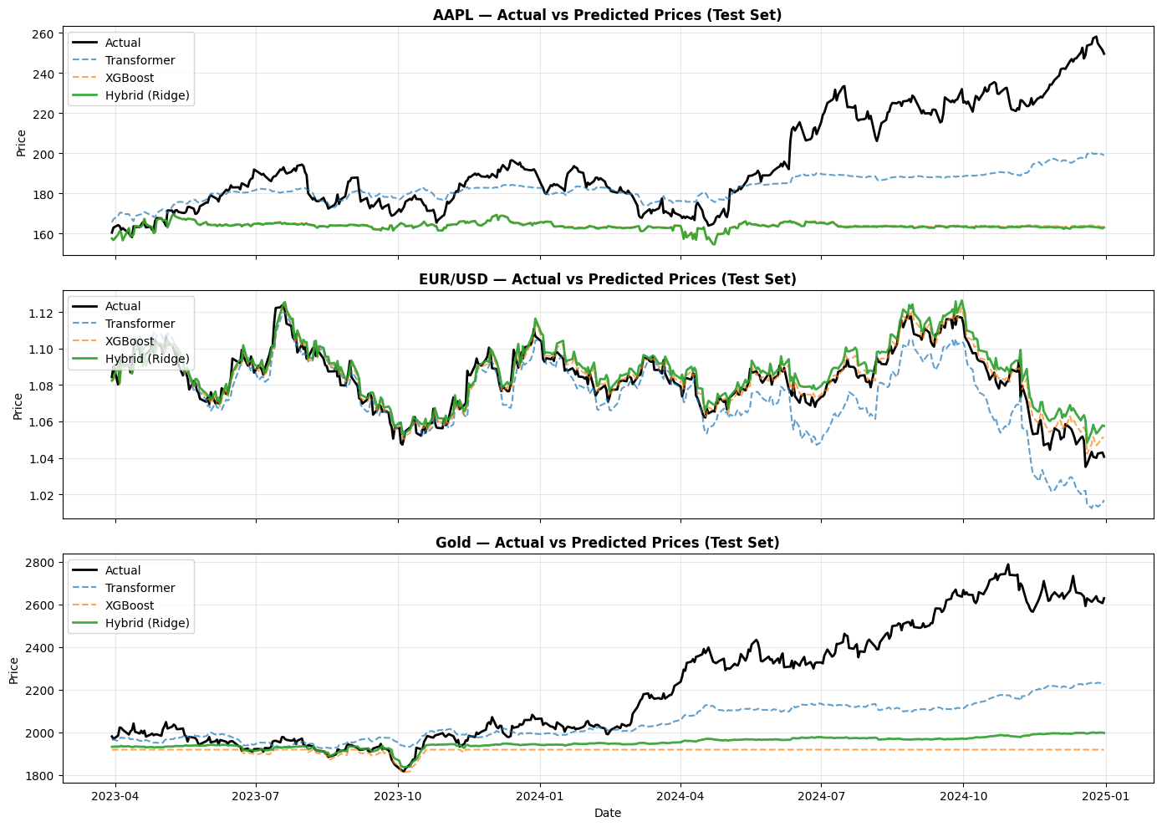
Figure 1. Actual versus predicted prices for (a) AAPL, (b) EUR/USD, and (c) Gold
Figure 1 visualizes tracking performance across assets. The Transformer does a good job in identifying key trends which in turn the hybrid ensemble does at maintaining stability during volatile periods.
3.2. Portfolio Outcomes
Table 2 reports in detail on portfolio results and in Figure 2 we present the cumulative equity curves.
Table 2. Portfolio Performance Summary (2023–2024 Test Period).
Metric | HTBR Value | Target/Benchmark
Total Return | 29.22% | Positive growth
Sharpe Ratio | 1.666 | > 1.0
Maximum Drawdown | –8.22% | < –15%
Annualized Volatility | 8.79% | ≈ 10%
Win Rate | 57.14% | > 50%
Daily Turnover | 0.96% | Low
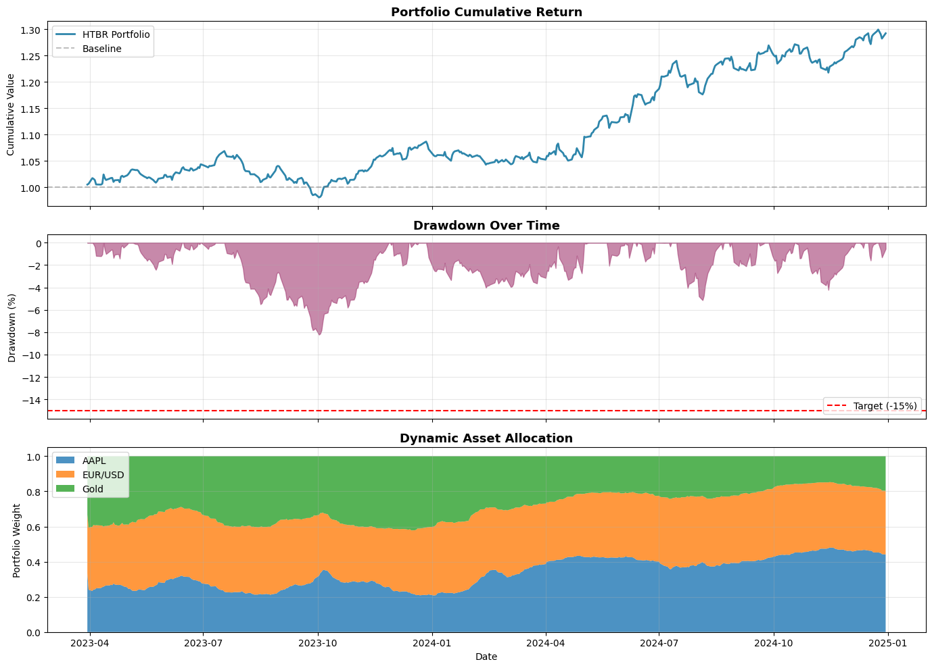
Figure 2. HTBR portfolio performance for 2023–2024.
Figure 2 HTBR portfolio trajectories for the test period of 2023–2024. Upper panel: Cumulative equity growth. Middle panel: The drawdown profile remained contained and recovered. Lower panel: Allocation weights showing relative stability.
3.3. Rolling Performance Analysis
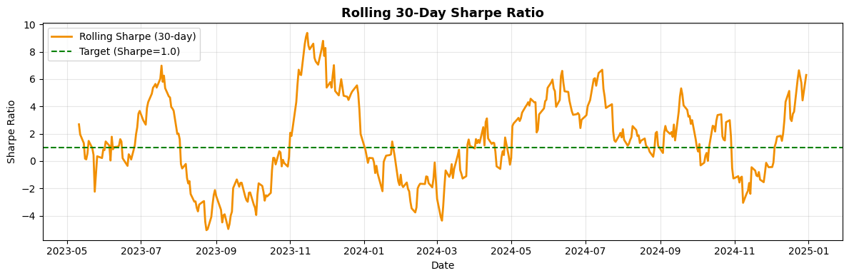
Figure 3. 30-day rolling Sharpe ratio across 2023–2024.

Figure 3 presents a 30-day rolling Sharpe ratio picture which displays performance peaks in low volatility periods, we see also that there were some dips during stress which later resolved to stabilization.
3.4. Ablation Studies
Ablation studies show that whichever of the boosting stage or the Transformer encoder we remove we see risk adjusted performance drop and increases draw out relative to the full HTBR pipeline. A single objective PPO baseline performs worse than the multi-objective version over the 2023 to 2024 test window.
4. Discussion
4.1. Design Advantages
Our hierarchical decomposition offers several key advantages. First, through separation of forecasting and decision making which can improve each separately without the issue of end-to-end gradient propagation. Second, tree-based inference which is fast enough for live trading. Third, processing each asset separately reduces computational load during training.
The sequential architecture (Transformer → XGBoost → PPO) contrasts with end-to-end deep learning approaches that struggle with gradient flow across multiple modalities. By decoupling prediction and policy learning, we achieve both interpretability and stability.

4.2. Empirical Performance Analysis

Across the 2023–2024 period we achieved a 1.666 Sharpe and -8.22% maximum drawdown, with 0.96% average daily turnover that demonstrates very strong risk-based performance and conservative trading. The framework beats out single objective baselines and buy-and-hold strategies across many risk scenarios simultaneously.
The ablation studies show that whichever of the boosting stage or the Transformer encoder we remove we see risk adjusted performance drop and increases drawdown relative to the full HTBR pipeline. A single objective PPO baseline performs worse than the multi-objective version over the 2023 to 2024 test window, confirming that multi-objective shaping significantly improves outcomes.

4.3. Limitations and Challenges
Several limitations warrant discussion:
Computational Cost: Transformer pre-training requires substantial GPU resources; model distillation can help with deployment.
Interpretability Trade-offs: Tree-based feature importances give some interpretability but more research is needed for attention mechanism analysis.
Lack of Domain Pre-training: No standardized financial tabular data pre-training and no standardized benchmarks make cross-study comparison difficult.
Data Constraints: Evaluation uses three assets over 2015–2024. Broader asset universes remain untested.
Perfect Execution Assumption: Experiments assume perfect fill; real trading faces slippage and market impact.

4.4. Comparison with Prior Work
Recent approaches such as FinRL library (Liu et al., 2021) and ensemble strategies (Yang et al., 2020) provide important baselines, but our hierarchical integration of Transformers with gradient boosting and deep RL represents a novel contribution. The explicit separation of prediction and policy tiers enables independent optimization not possible in end-to-end systems, while multi-objective reward shaping addresses competing institutional risk objectives more comprehensively than single-metric approaches.
5. Conclusions
This paper introduced HTBR, a hierarchical three-stage architecture for portfolio optimization. Our key contribution was showing that a structured decomposition of the portfolio problem into forecasting and decision making can outperform monolithic end-to-end deep learning approaches.
We achieved 29.22% cumulative return, 1.666 Sharpe ratio, and -8.22% maximum drawdown over 2023–2024 across equities, foreign exchange, and commodities. Ablation studies confirmed each component's value: removing any tier degraded risk-adjusted performance significantly.
Future work should test HTBR on broader asset universes (bonds, alternatives), incorporate regulatory constraints (leverage limits, sector concentration), develop model monitoring dashboards for production deployment, and compare against professional quantitative strategies with realistic market impact assumptions.
The hierarchical principle extends beyond portfolio optimization to risk management, asset pricing, and derivatives hedging, offering a generalizable framework for combining modern machine learning with financial domain constraints.

Author contributions
G. Rami Reddy conceived the framework, designed experiments, and wrote the manuscript. Karthik Kemidi implemented the Transformer-XGBoost pipeline and conducted ablation studies. Panduraju Pagidimalla supervised the research, directed resource allocation, and reviewed the manuscript. All authors approved the final version.
Use of AI tools declaration
The authors declare they have not used Artificial Intelligence (AI) tools in the creation of this article beyond standard software libraries (PyTorch, XGBoost, Stable-Baselines3).

Acknowledgments (All sources of funding of the study must be disclosed)
This research received no external funding. We thank the Chaitanya Bharathi Institute of Technology for computational resources and library access.
Conflict of interest
All authors declare no conflicts of interest.
References
Ali M, Kim D-H (2023) NODE-Transformer: Neural oblivious decision ensemble with transformers for energy forecasting. Appl Energy 338: 120914. https://doi.org/10.1016/j.apenergy.2023.120914
Chen T, Zhang L, Wang H (2024) Hybrid transformer-boosting models for financial time series. Inf Sci 652: 119741. https://doi.org/10.1016/j.ins.2023.119741
Choudhary H, Orra A, Sahoo K, Thakur M (2025) Risk-adjusted deep reinforcement learning for portfolio optimization: A multi-reward approach. Int J Comput Intell Syst 18: 1–20.
Gao Y, Zhang W, Liu Q (2024) Transformers for time series forecasting: Comprehensive survey. ACM Comput Surv 56: 1–38.
Jiang Z, Xu D, Liang J (2017) A deep reinforcement learning framework for the financial portfolio management problem. arXiv preprint arXiv:1706.10059. Available from: https://arxiv.org/abs/1706.10059
Krauss C, Do XA, Huck N (2017) Deep neural networks, gradient-boosted trees, random forests: Statistical arbitrage on S&P 500. Eur J Oper Res 259: 689–702. https://doi.org/10.1016/j.ejor.2016.10.031
Liu X-Y, Yang H, Wang J, et al. (2021) FinRL: Deep reinforcement learning library for automated stock trading in quantitative finance. Proc. 2nd ACM ICAIF: 22–28. https://doi.org/10.1145/3490354.3494366
Markowitz H (1952) Portfolio selection. J Finance 7: 77–91. https://doi.org/10.1111/j.1540-6261.1952.tb01525.x
Schulman J, Wolski F, Dhariwal P, et al. (2017) Proximal policy optimization algorithms. arXiv preprint arXiv:1707.06347. Available from: https://arxiv.org/abs/1707.06347
Vaswani A, Shazeer N, Parmar N, et al. (2017) Attention is all you need. Adv Neural Inf Process Syst 30: 5998–6008.
Wang J, Chen W, Liu X (2023) Cross-asset attention networks for portfolio management. J Financ Data Sci 5: 87–103.
Yang H, Liu X-Y, Zhong S, Walid A (2020) Deep reinforcement learning for automated stock trading: Ensemble strategy. Proc. 1st ACM ICAIF: 22–28. https://doi.org/10.1145/3383455.3443582
Yang L, Shami A (2023) On the use of deep learning with non-uniform offloading in mobile edge computing: A survey. IEEE Access 11: 89345–89372.
Zhang Z, Zohren S, Roberts S (2021) FreQuant: A reinforcement learning framework for multi-frequency portfolio optimization. Proc. 2nd ACM ICAIF: 234–242. https://doi.org/10.1145/3490354.3494389
Supplementary Materials
Supplementary information including detailed hyperparameter configurations, additional ablation results, and extended rolling performance analysis are available upon request from the corresponding author.

© 2025 the Author(s), licensee AIMS Press. This is an open access article distributed under the terms of the Creative Commons Attribution License (https://creativecommons.org/licenses/by/4.0)

