**SUPERVISION CERTIFICATE**

This Is to Certify That Work Presented in The Project Entitled "StockSIM" Submitted for The Partial Fulfilment of CBSE INFORMATICS PRACTICES Exam To The CBSE New Delhi Is A Bona fide Project Work Carried Out By KARTHIK, YUVRAJ SINGH, TARUN, ISHAAN Students of Class 12, Army Public School, Amritsar, Punjab Under My Guidance And Supervision.

MR. IQBAL SINGH

PGT COMPUTER SCIENCE

ARMY PUBLIC SCHOOL AMRITSAR

**ACKNOWLEDGEMENT**

I Take This Opportunity to Express My Deep Sense of Gratitude to Mr. Iqbal Singh, PGT (Computer Science), Army Public School, Amritsar for His Guidance, Advice and Support from The Beginning Of My Project Work To The Completion Of The Same. His Keen Interest in MY Project Work, Devotion of Time, And Inspiration During This Project Tenure Has Made This Work to Come in This Form.

I Also Pay Gratitude Towards Our Principal Mrs. Rajdeep Jain, Army Public School Amritsar Permitting Me to Avail Necessary Facilities of The Lab as Well as School for My Work. The Support Received from Friends During My Project Work Cannot Be Acknowledged in Words.

I Express My Deepest Affection, Appreciation and Thank to My Parents, Who Encouraged and Supported me In This Project. All Of Them Have Made Immense Contribution to My Studies and Life by Their Support, Guidance, Understanding and Sacrifices.

…………………………………

Army Public School Amritsar

**TreeMap of Project:**

.

|-- main.py

`-- data/

|-- db.csv

`-- lastbill.csv

**main.py**

**#Help text and imports**

a = """

Commands:

viewitems

add <icode> <cat> <name> <istock> <iprice> <discount>

remove <icode>

stock <icode> <change>

edit <icode> <field> <value>

newbill

viewsales

viewlastbill

savedb

exit

bill commands:

cancel

addedit <icode> <qty>

remove <icode> <qty>

use \"-\" instead of spaces in between of entries

"""

import matplotlib.pyplot as plt

import numpy as np

import datetime

import pandas as pd

import os

fields = ['icode','category','name','istock','iprice',"idiscount","isold"]

store = pd.read_csv("./data/db.csv", header=None, index_col=0,

names=['icode','category','name','istock','iprice',"idiscount","isold","netsales"], dtype={"istock":int,"iprice":float,"idiscount":float,"isold":float,"netsales":float})

last_bill = pd.read_csv("./data/lastbill.csv", header=None, index_col=0,

names=['name','qty','price',"discount","amt"])

def parse_bill(inp: str):

    y = inp.strip().split(" ")

    y[1] = y[1].upper()

    if y[0].upper() == "ADDEDIT":

        try:

            aoe_bill(y[1],int(y[2]))

        except  IndexError:

            print("Invalid input")

    elif y[0].upper() == "REMOVE":

        try:

            rem_bill_item(y[1])

        except AttributeError:

            print("Item not in bill")

    else:

        print("Invalid command")

def parse_menu(inp: str):

    x = inp.strip().split(" ")

    try:

        x[1] = x[1].upper()

    except:

        pass

    if x[0].upper() == "EXPORT":

        export_data(store)

    elif x[0].upper() == "ADD":

        add_item(x[1],x[2].replace("-"," "),x[3].replace("-"," "),

int(x[4]),float(x[5]),float(x[6]),int(x[7]),int(x[8]))

        print("New Item added!")

    elif x[0].upper() == "REMOVE":

        rem_item(x[1])

        print("Item removed!")

    elif x[0].upper() == "STOCK":

        stock(x[1],int(x[2]))

        print("Stock updated!")

    elif x[0].upper() == "EDIT":

        edit(x[1],x[2],x[3].replace("-"," "))

        print("Data edited!")

    elif x[0].upper() == "HELP":

        print(a)

    elif x[0].upper() == "VIEWITEMS":

        print(store)

    elif x[0].upper() == "NEWBILL":

        makebill()

    elif x[0].upper() == "CLS":

        os.system("cls")

    elif x[0].upper() == "EXIT":

        z = input("Do you want to save changes? (y/n): ")

        if z == "y":

            export_data(store)

            exit()

        else:

            exit()

    elif x[0].upper() == "SAVEDB":

        export_data(store)

    elif x[0].upper() == "VIEWSALES":

        viewsales()

    elif x[0].upper() == "VIEWLASTBILL":

        print(last_bill)

    else:

        print("no such command as", x[0], "try \"help\"")

#main function

def main():

    global store

    print("Welcome to CheckOutApp")

    print("Type \"help\" to get to list of all commands")

    while True:

        inx = input("> ")

        try:

            parse_menu(inx)

        except IndexError:

             print("Missing Arguments, use \"help\"")

#database commands

def stock(icode: str,change:int):

    if store.loc[icode,"istock"]+change >= 0:

        store.loc[icode,'istock'] += change

    else:

        print("Must have atleast 0 stock")

def edit(icode: int, field: str ,value: any):

    store.loc[icode,field]=value

def add_item(icode: str,cat: str,name: str,istock: int,iprice: float,

discount: float,isold: int, netsales: float):

    store.loc[icode]=[cat,name,istock,iprice,discount,isold, netsales]

def rem_item(icode: str):

    del store.loc[icode]

def export_data(df:pd.DataFrame):

    df.to_csv("./data/db.csv",header=False, index_label="icode")

#bill commands

def aoe_bill(icode: str,qty: int): # add if not present/ edit if present

    global bill

    if store.loc[icode,"istock"] >= qty:

        bill.loc[icode] = [store.loc[icode,'name'],

qty,store.loc[icode,'iprice'],

store.loc[icode,'idiscount'],0]

        bill.loc[icode,'amt'] = store.loc[icode,'iprice']*qty*(100-store.loc[icode,'idiscount'])/100

    else:

        print("\n")

        print("Not enough stock")

    print("\n")

    print(bill)

    print('\n')

def rem_bill_item(icode): # delete item from bill

    try:

        del bill.loc[icode]

    except:

        print("Item not in bill")

    print("\n")

    print(bill)

    print('\n')

def finalize_bill(): # print bill and save a copy in lastbill.csv

    global now

    print("Bill finalized")

    now = str(datetime.datetime.now().strftime("%Y-%m-%d %H:%M:%S"))

    print("Timestamp: ",now)

    print("Customer Name: ", cname)

    print("Total Amount: ",bill['amt'].sum())

    print(bill)

    for i in bill.index:

        store.loc[i,"istock"] -= bill.loc[i,'qty']

        store.loc[i,"isold"] += bill.loc[i,'qty']

        store.loc[i,"netsales"] += bill.loc[i,'amt']

    bill.to_csv('./data/lastbill.csv',index_label=cname+" "+now,header=False)

def makebill(): # billing command line

    global bill

    bill = pd.DataFrame(columns=['name','qty','price',"discount","amt"])

    global cname

    print(store)

    print("Ready for bill generation")

    cname = input("Enter customer name: ")

    while True:

        iny = input(">bill>")

        if iny.upper() == "CANCEL":

            break

        elif iny.upper() == "FINALIZE":

            finalize_bill()

            break

        parse_bill(iny)

#sales graph

def viewsales():

    plt.figure(figsize=(10,6))

    plt.subplot(1, 2, 1)

    plt.bar(store.index,store['isold'])

    plt.title("Units sold")

    plt.subplot(1, 2, 2)

    plt.barh(store.index,store['netsales']//1000)

    plt.title("Sales in thousands")

    plt.tight_layout()

    plt.show()

main()

**db.csv**

FUR1798,Furniture,Bush Somerset Collection Bookcase,17,20999.0,0.0,5.0,104995.0

OFF2365,Office Supplies,Xerox 1967,3,1199.0,0.2,0.0,0.0

EDI1949,Edibles,Apple,50,30.0,0.2,10.0,299.4

TEC1950,Technology,Cisco SPA 501G IP Phone,18,16999.0,0.2,10.0,169650.02

OFF1234,Office Supplies,Paper A4 500 bundle,70,400.0,0.0,5.0,2000.0

OFF1235,Office Supplies,Paper A4 1000 bundle,49,700.0,5.0,1.0,665.0

**lastbill.csv**

FUR1798,Bush Somerset Collection Bookcase,5,20999.0,0.0,104995.0

EDI1949,Apple,10,30.0,0.2,299.4

OFF1234,Paper A4 500 bundle,5,400.0,0.0,2000.0

OFF1235,Paper A4 1000 bundle,1,700.0,5.0,665.0

TEC1950,Cisco SPA 501G IP Phone,10,16999.0,0.2,169650.02

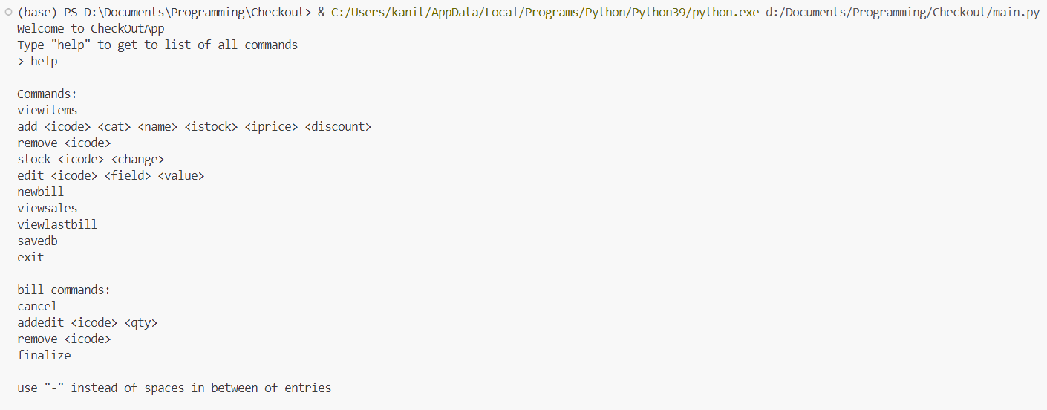

“viewitems” command

“help” command

“add” command

“remove” command

“edit” command

“addedit” command

“newbill” command

“finalize” command

“remove” command

“viewsales” command command