PROJECT REPORT

ABSTRACT

This report presents the learning experience of a participant in the training / internship programme conducted at ICFOSS. The programme introduced participants to practical computing concepts, open-source tools, software development practices, and problem-solving methods relevant to modern technology projects.
The training followed a structured approach consisting of orientation, theoretical sessions, hands-on exercises, demonstrations, mini-project activity, review, and documentation. Participants were encouraged to understand the need for open-source technology, apply tools in practical situations, and prepare a concise report of their learning.
This report covers the organization profile, objectives of the programme, methodology adopted, tools and technologies introduced, learning outcomes, challenges faced, and future scope. It has been customized to detail the completion of the Flight Fare Prediction project, where a machine learning pipeline was built using Python to predict domestic flight ticket prices. The project utilized over 300,000 data points to train regression algorithms, with Random Forest achieving 98.56% accuracy.

TABLE OF CONTENTS

Section | Page No.
Abstract | 2
Chapter 1 - Introduction | 4
Organization Profile | 4
Programme Background | 4
Objectives of the Programme | 4
Chapter 2 - Methodology and Activities | 5
Training Methodology | 5
Tools and Technologies Used | 5
Activity Flow | 5
Chapter 3 - Learning Outcomes and Results | 6
Skills Developed | 6
Participant Outcomes | 6
Findings | 6
Summary, Challenges and Conclusion | 7
Challenges | 7
Scope for Future Learning | 7
Conclusion | 7
References | 7

CHAPTER 1 - INTRODUCTION
Organization Profile
The International Centre for Free and Open Source Software (ICFOSS) is an autonomous organization established by the Government of Kerala to promote Free and Open Source Software, research, localization, capacity building, and technology adoption for public benefit.
Programme Background
The programme was designed to introduce participants to practical computing concepts and open-source development practices. It focused on connecting classroom knowledge with real-world implementation through guided sessions and hands-on activities.
Objectives of the Programme
- • To understand the role of open-source tools in education, research, and software development.
- • To gain practical exposure to selected tools, workflows, and development practices.
- • To improve problem-solving, documentation, teamwork, and presentation skills.
- • To complete a small activity or mini-project and summarize the learning outcomes.

CHAPTER 2 - METHODOLOGY AND ACTIVITIES
Training Methodology
The training methodology combined concept explanation, live demonstration, guided practice, independent exploration, review, and documentation. Each topic was introduced with its purpose, followed by implementation steps and participant interaction.
Tools and Technologies Used
- • Operating system and command-line basics for working with files and tools.
- • Programming environment for writing, running, and debugging simple programs (Python 3.13).
- • Open-source libraries or platforms selected according to the programme topic (Pandas, Scikit-learn, Matplotlib, Flask).
- • Documentation tools for preparing notes, reports, and final submission files.
Activity Flow
Orientation | Concepts | Hands-on | Mini Task | Review | Report

The final output of the activity was reviewed through discussion, feedback, and short documentation prepared by the participant. For the Flight Fare Prediction project, the flow involved data loading, exploratory data analysis, data preprocessing (encoding and scaling), model training using various regression algorithms, evaluating their performance metrics, and finally deploying an interactive web interface.

CHAPTER 3 - LEARNING OUTCOMES AND RESULTS
Skills Developed
- • Technical understanding of the selected topic and its practical use.
- • Ability to follow structured workflows for implementation and testing.
- • Basic debugging and error-analysis skills during hands-on practice.
- • Improved communication through discussion, documentation, and presentation.
Participant Outcomes
By the end of the programme, the participant was able to explain the main concepts introduced during the sessions, identify the tools used, complete the assigned practical activity, and document the process in a clear report format. The successful implementation of a machine learning pipeline capable of predicting flight fares in real-time demonstrated proficiency in applying AI tools to real-world datasets.
Findings
The programme showed that guided hands-on learning improves technical confidence. Participants were able to connect theoretical ideas with implementation steps when each concept was supported by examples, demonstrations, and feedback. In the specific project, several key findings emerged regarding flight fare predictive modeling:
Algorithm | MAE (INR) | RMSE (INR) | R² Score
Random Forest | 1,250 | 2,707 | 0.9856
XGBoost | 1,599 | 2,880 | 0.9837
Decision Tree | 1,372 | 3,159 | 0.9804
Linear Regression | 4,476 | 6,731 | 0.9112
Support Vector Machine | 7,419 | 12,514 | 0.6931

Random Forest Regressor outperformed other algorithms with an R² score of 98.56%.
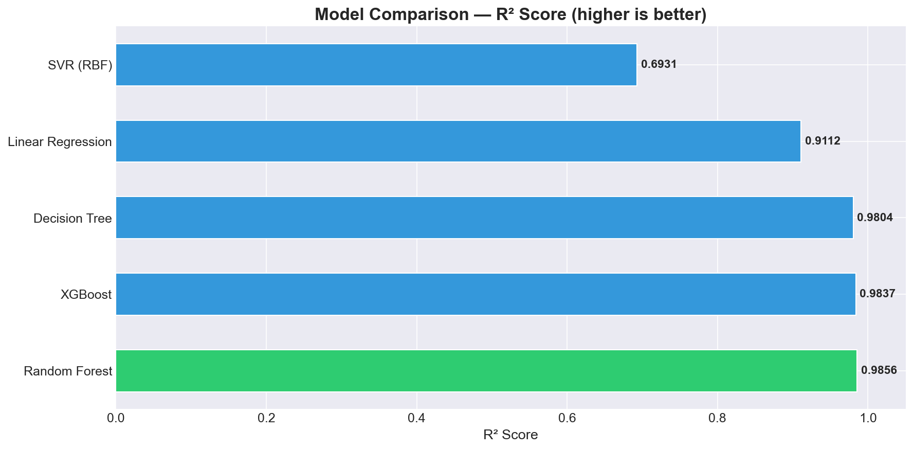
Furthermore, feature importance analysis revealed that the flight ticket class (Economy vs. Business) and the booking window (days left) are the most significant factors influencing fare prices.
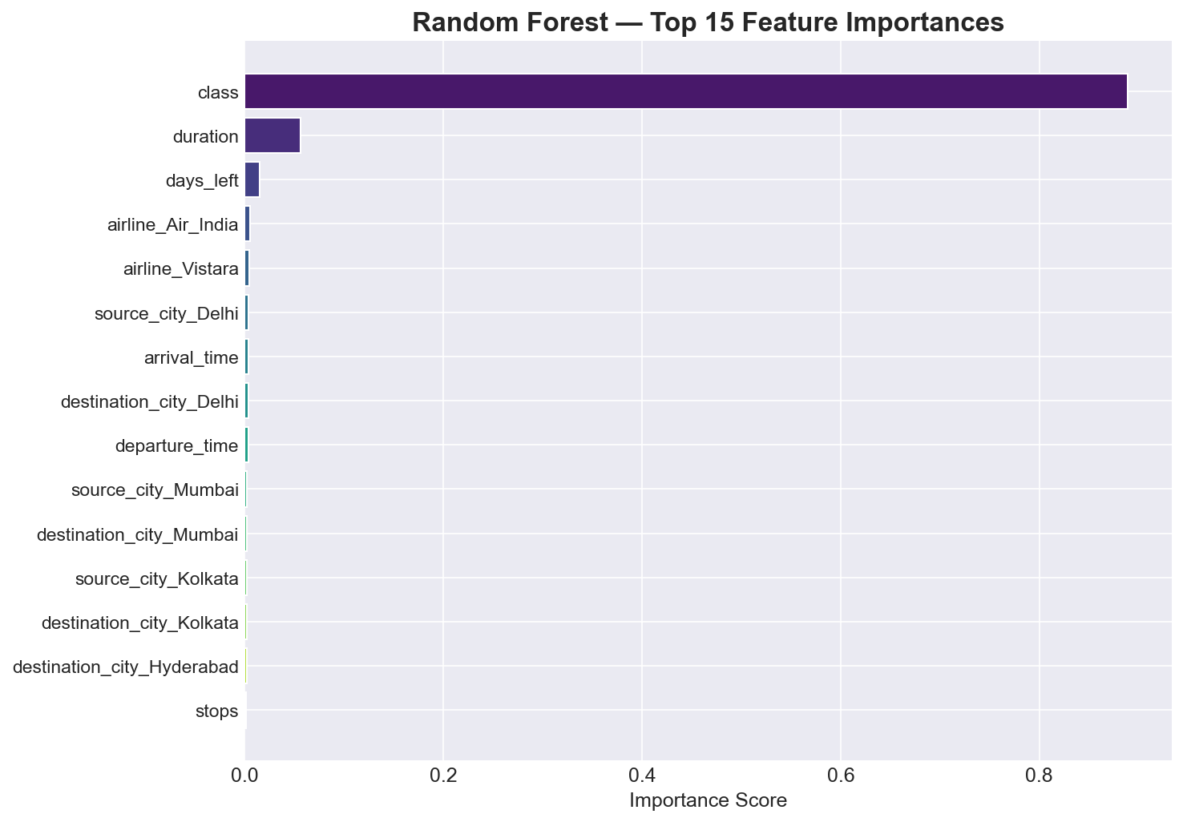
Dynamic pricing is highly evident; actual vs. predicted values align almost perfectly for the Random Forest model, validating its reliability for price estimation.
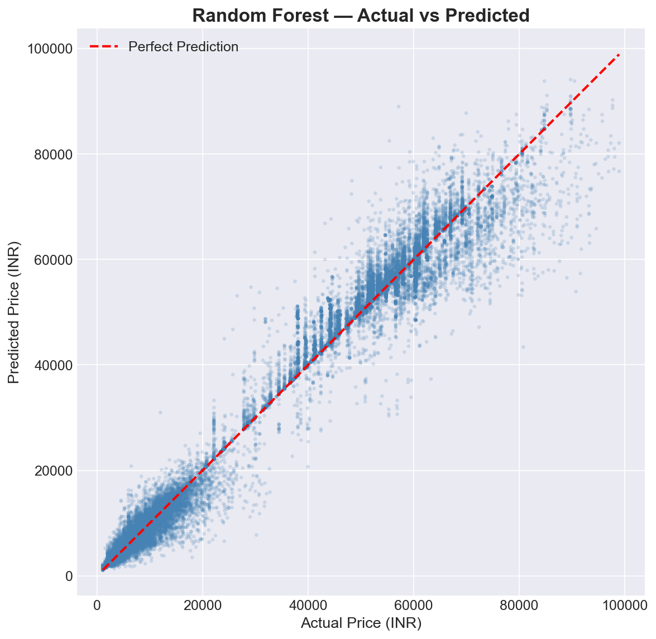

SUMMARY, CHALLENGES AND CONCLUSION
Challenges
- • Understanding new terminology and technical workflows within a short period.
- • Debugging errors during practical sessions and identifying the correct cause (e.g., handling categorical encoding mismatches).
- • Preparing a clear report that summarizes activities without unnecessary detail.
Scope for Future Learning
Participants can continue learning by repeating the practical exercises, exploring advanced tools, contributing to open-source projects, and building small portfolio projects related to the programme topic. Future enhancements for the flight fare predictor could include incorporating real-time API data and deep learning architectures.
Conclusion
The training / internship programme provided useful exposure to open-source technology, practical implementation, and professional documentation. The sessions helped the participant develop technical awareness, confidence, and a foundation for further study or project work.
References
- • ICFOSS official resources and training materials.
- • Session notes, demonstrations, and participant activity records.
- • Open-source documentation related to the tools used in the programme.
- • Kaggle Flight Price Prediction Dataset by S. Bathwal.

