PROJECT REPORT

Flight Fare Prediction using Machine Learning
Submitted in partial fulfillment of the requirements for the
Hybrid Internship Program on Machine Learning through Python
Submitted by:
KARTHIK KS
International Centre for Free and Open Source Software (ICFOSS)
Government of Kerala
June 2026

ABSTRACT
This report presents the learning experience of a participant in the training / internship programme conducted at ICFOSS. The programme introduced participants to practical computing concepts, open-source tools, software development practices, and problem-solving methods relevant to modern technology projects.
The training followed a structured approach consisting of orientation, theoretical sessions, hands-on exercises, demonstrations, mini-project activity, review, and documentation. Participants were encouraged to understand the need for open-source technology, apply tools in practical situations, and prepare a concise report of their learning.
The report covers the organization profile, objectives of the programme, methodology adopted, tools and technologies introduced, learning outcomes, challenges faced, and future scope. It has been customized to detail the completion of the Flight Fare Prediction project.
As part of the project activity, a machine learning pipeline was developed in Python to predict domestic flight ticket prices. Using a dataset of 300,153 records, basic data exploration and preprocessing were carried out. Five regression algorithms were tested, and the Random Forest Regressor was found to be the best model, achieving an R² score of 98.56%. Finally, the trained model was successfully deployed as a web application using Flask.

TABLE OF CONTENTS
Section | Page No.
Abstract | 2
Chapter 1 - Introduction | 4
Organization Profile | 4
Programme Background | 4
Objectives of the Programme | 4
Chapter 2 - Methodology and Activities | 5
Training Methodology | 5
Tools and Technologies Used | 5
Activity Flow | 5
Chapter 3 - Learning Outcomes and Results | 7
Skills Developed | 7
Participant Outcomes | 7
Findings | 7
Summary, Challenges, Future Scope and Conclusion | 9
References and Annexure | 10

CHAPTER 1 - INTRODUCTION
Organization Profile
The International Centre for Free and Open Source Software (ICFOSS) is an autonomous organization established by the Government of Kerala to promote Free and Open Source Software, research, localization, capacity building, and technology adoption for public benefit.
Programme Background
The programme was designed to introduce participants to practical computing concepts and open-source development practices. It focused on connecting classroom knowledge with real-world implementation through guided sessions and hands-on activities.
Objectives of the Programme
- To understand the role of open-source tools in education, research, and software development.
- To gain practical exposure to selected tools, workflows, and development practices.
- To improve problem-solving, documentation, teamwork, and presentation skills.
- To complete a small activity or mini-project and summarize the learning outcomes.

CHAPTER 2 - METHODOLOGY AND ACTIVITIES
Training Methodology
The training methodology combined concept explanation, live demonstration, guided practice, independent exploration, review, and documentation. Each topic was introduced with its purpose, followed by implementation steps and participant interaction.
Tools and Technologies Used
- Operating system and command-line basics for working with files and tools.
- Programming environment for writing, running, and debugging simple programs (e.g., Python 3.13, Flask).
- Open-source libraries or platforms selected according to the programme topic (e.g., Pandas, Scikit-learn, Matplotlib).
- Documentation tools for preparing notes, reports, and final submission files.
Activity Flow
Orientation | Concepts | Hands-on | Mini Task | Review | Report
The internship progressed systematically, beginning with an orientation to open-source concepts, followed by theoretical concept learning in Data Science. Participants then engaged in hands-on implementation of machine learning models. This culminated in full-scale project development, where models were trained and deployed. Finally, the work underwent peer and mentor review, leading to the formal documentation and final submission of the project.

Project Specific Methodology:
- Data Loading & Exploration: The dataset containing 300,153 flight booking records was loaded using Pandas. Initial checks were performed to understand the structure of the data.
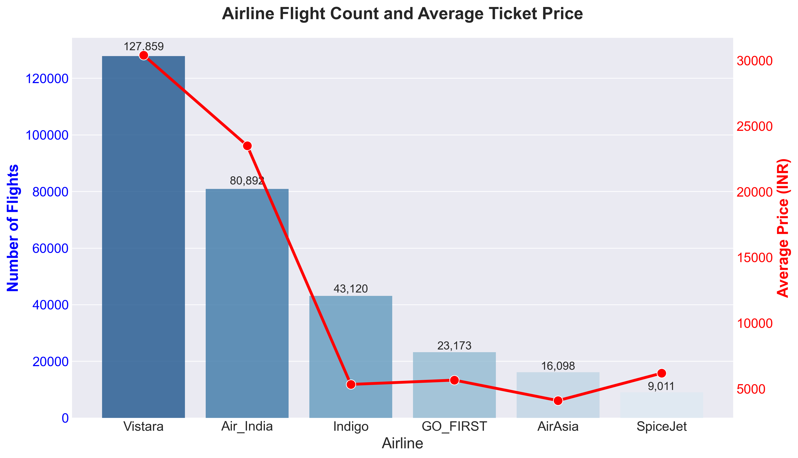
Figure 1: Airline Count and Average Price Distribution
- Exploratory Data Analysis (EDA): Graphs were created using Matplotlib and Seaborn to visualize the data. It was observed that flight duration and days left until departure strongly affect the ticket price.
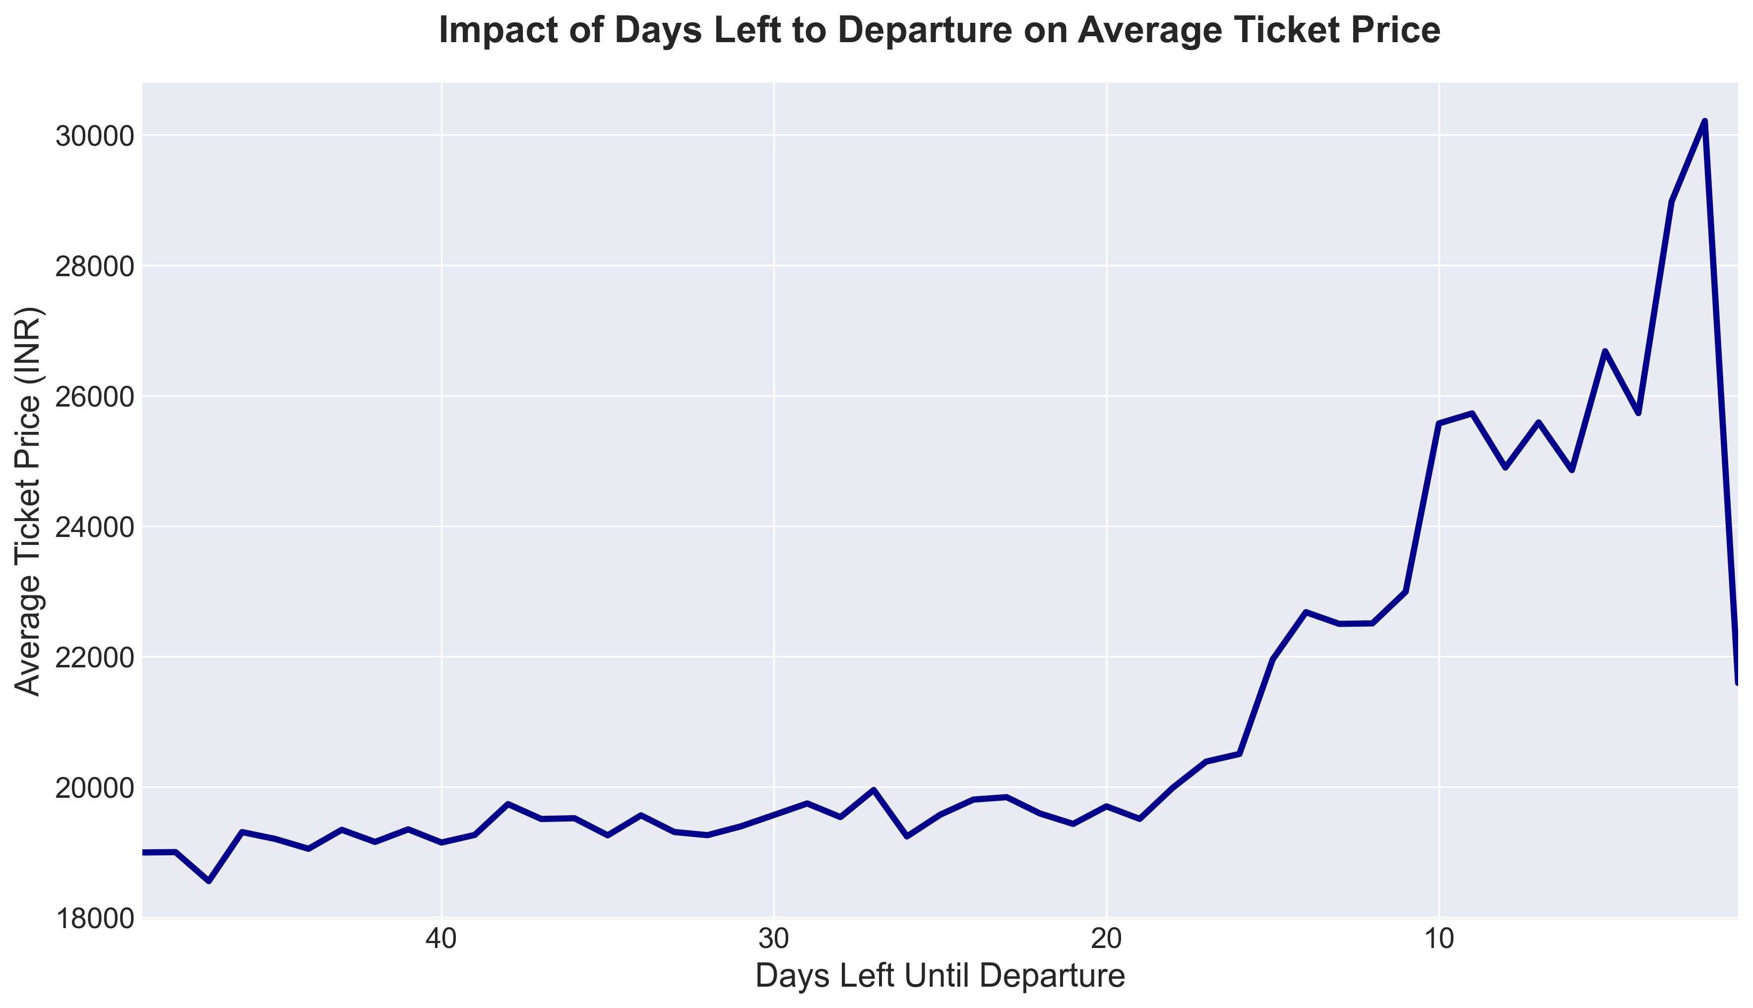
Figure 2: Impact of Days Left on Ticket Price
- Data Preprocessing: Outliers in the dataset were removed using the IQR method. Categorical data (like airlines and cities) was converted into numerical format using One-Hot Encoding and Label Encoding so the machine learning models could process it.
- Model Training: The cleaned data was split into training and testing sets. Five different regression models were trained on the data and evaluated to see which one performed the best.
- Web Application Deployment (Flask): The best performing model was saved and integrated into a simple web application using Flask, allowing users to input flight details and see the predicted price.

CHAPTER 3 - LEARNING OUTCOMES AND RESULTS
Skills Developed
- Technical understanding of the selected topic and its practical use.
- Ability to follow structured workflows for implementation and testing.
- Basic debugging and error-analysis skills during hands-on practice.
- Improved communication through discussion, documentation, and presentation.
Participant Outcomes
By the end of the programme, the participant was able to explain the main concepts introduced during the sessions, identify the tools used, complete the assigned practical activity, and document the process in a clear report format.
Findings
The programme showed that guided hands-on learning improves technical confidence. Participants were able to connect theoretical ideas with implementation steps when each concept was supported by examples, demonstrations, and feedback.

Project Specific Findings:
Algorithm | MAE (INR) | RMSE (INR) | R² Score
Random Forest | 1,250 | 2,707 | 0.9856
XGBoost | 1,599 | 2,880 | 0.9837
Decision Tree | 1,372 | 3,159 | 0.9804
Linear Regression | 4,476 | 6,731 | 0.9112
Support Vector Machine | 7,419 | 12,514 | 0.6931
The Random Forest algorithm provided the best results, achieving an R² score of 98.56%. It also had the lowest errors, with a Mean Absolute Error (MAE) of INR 1,250. Random Forest performed better than standard linear models because it could handle the complex patterns in the airline pricing data more effectively.
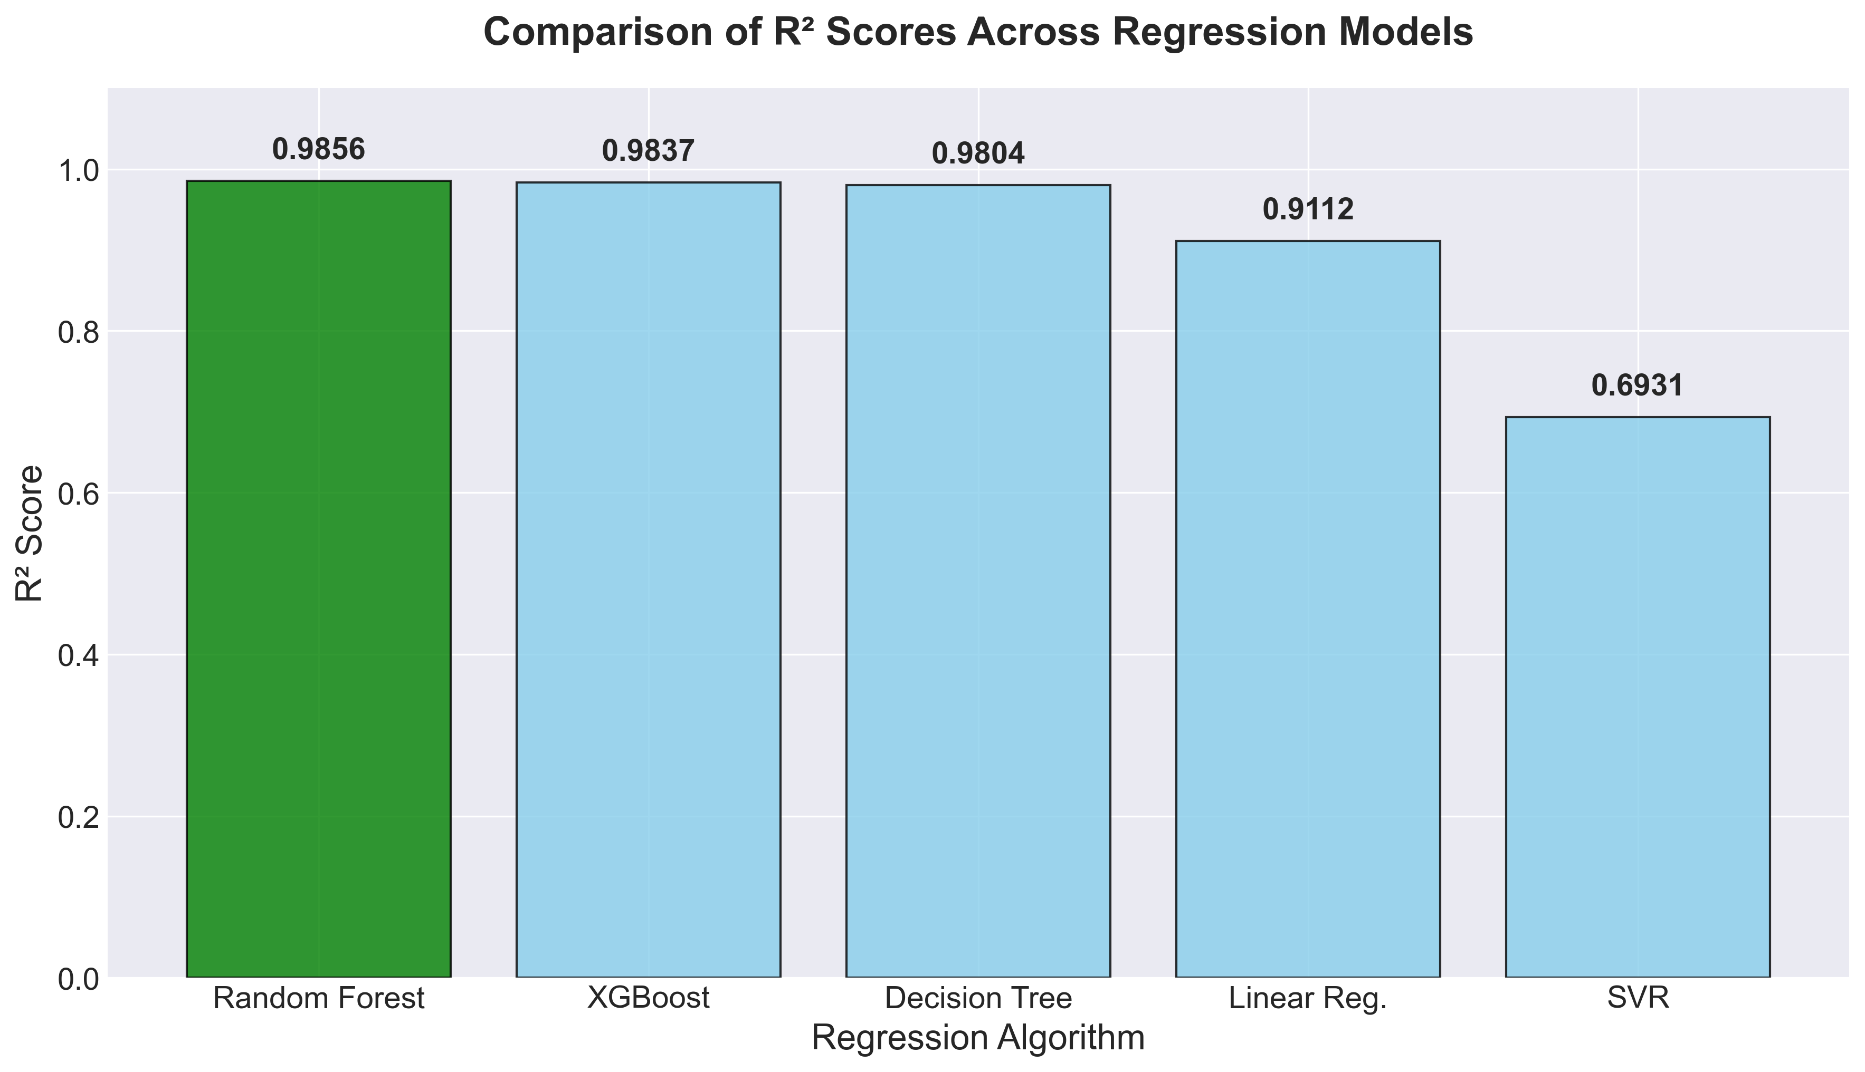
Figure 3: R² Score Comparison Across Models
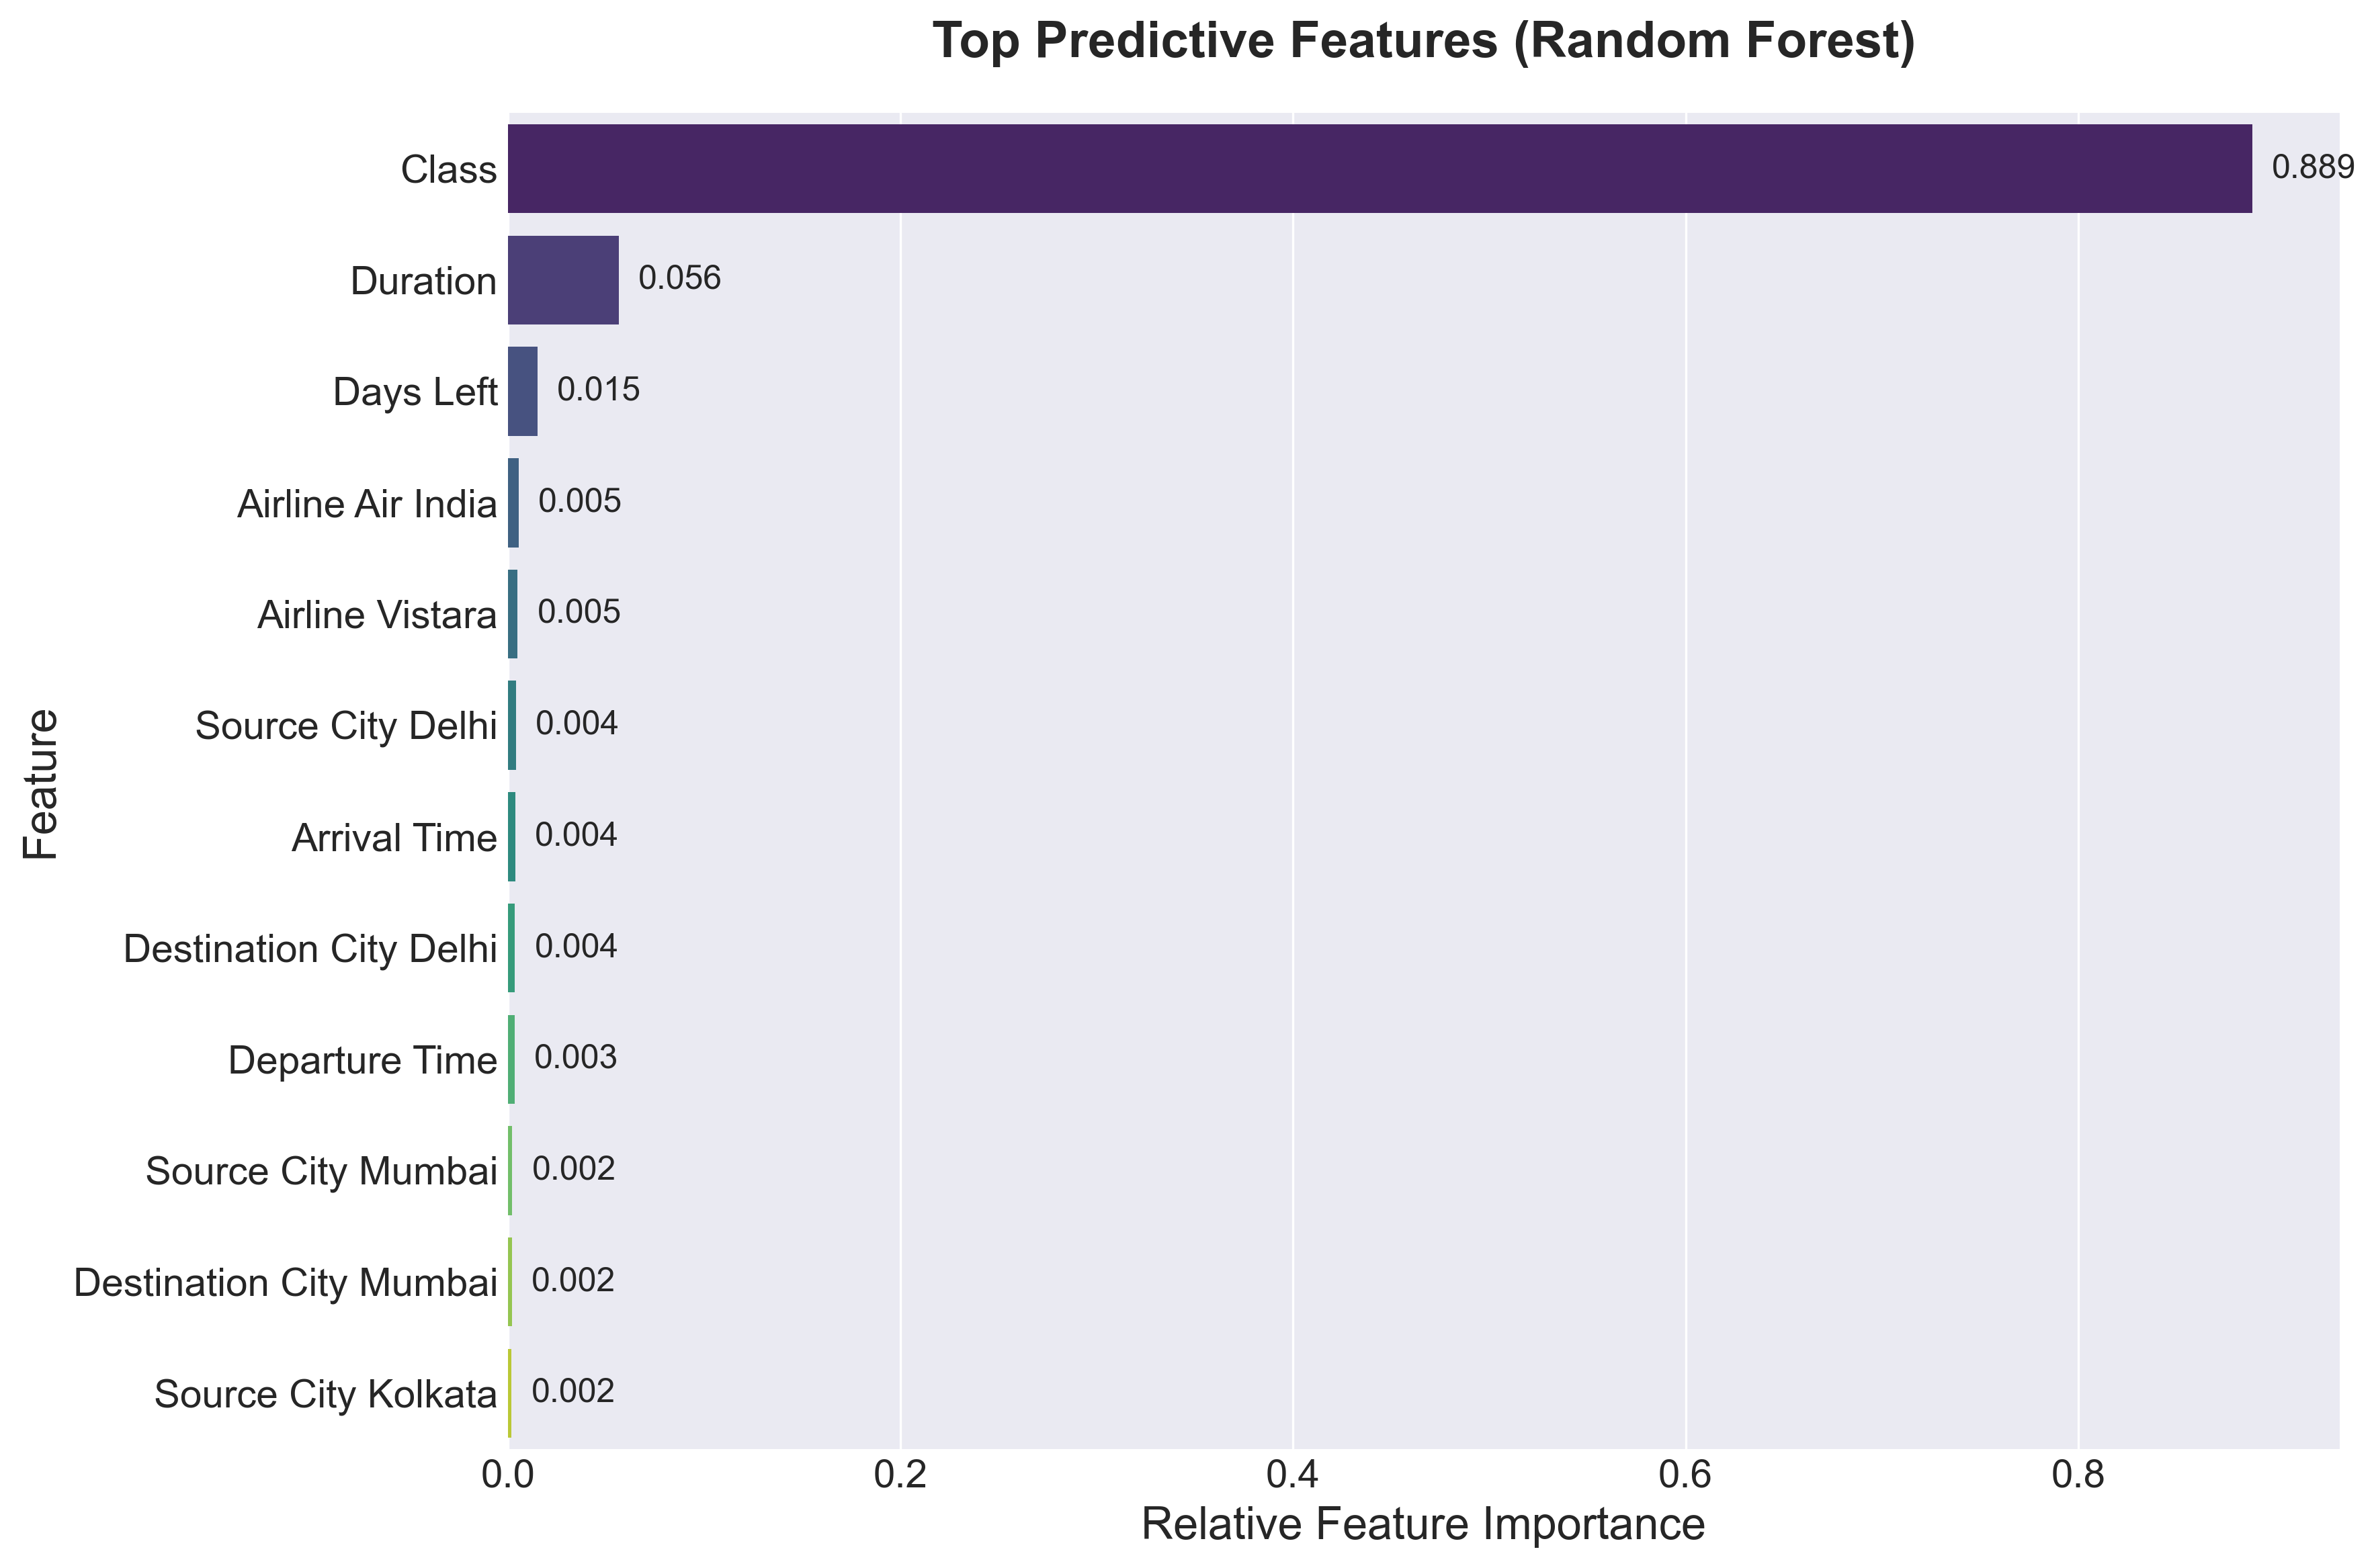
Figure 4: Feature Importance (Random Forest)

SUMMARY, CHALLENGES AND CONCLUSION
Challenges
- Training machine learning models on a large dataset of over 300,000 records took a significant amount of time and computer memory.
- Converting text data like city names and airlines into numbers resulted in many new columns, making the data slightly harder to manage.
- Connecting the trained Python model to the Flask web page so that it could predict prices smoothly without errors.
Scope for Future Learning
In the future, the project could be improved by connecting it to live flight data APIs instead of using a static CSV file. The web application could also be hosted on the cloud (like AWS or Google Cloud) so anyone can access it on the internet. Finally, trying out deep learning techniques might improve the prediction accuracy even more.
Conclusion
The training / internship programme provided useful exposure to open-source technology, practical implementation, and professional documentation. The sessions helped the participant develop technical awareness, confidence, and a foundation for further study or project work.

REFERENCES AND ANNEXURE

References
- ICFOSS official resources and training materials.
- Session notes, demonstrations, and participant activity records.
- Open-source documentation related to the tools used in the programme (Python, Scikit-learn, Flask).
- Flight Price Prediction Dataset from Kaggle.

Annexure A: Web Application Screenshots
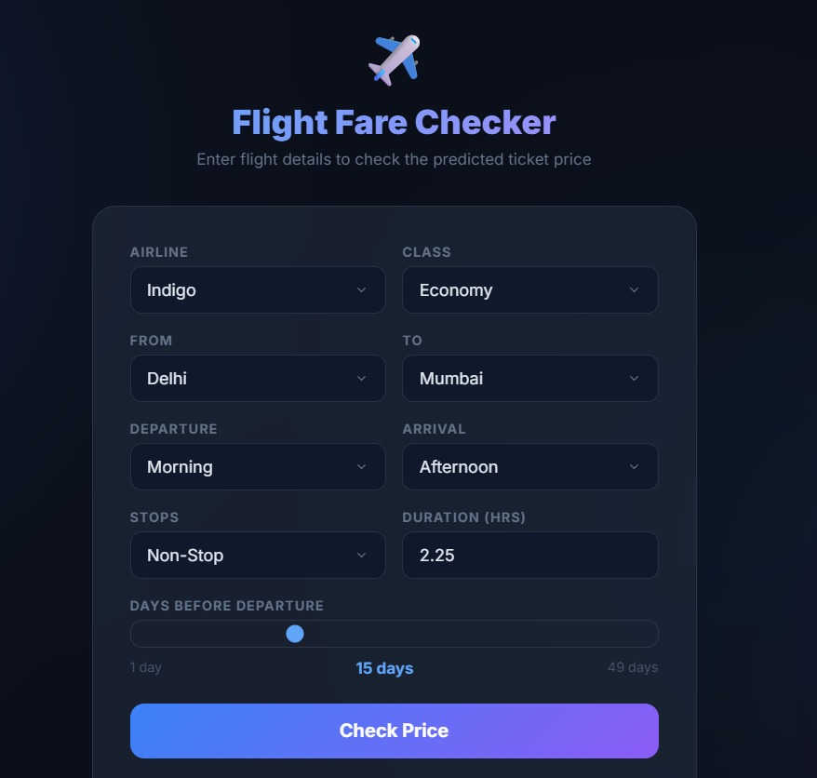
Figure 5: Flask Web Application - Input Interface
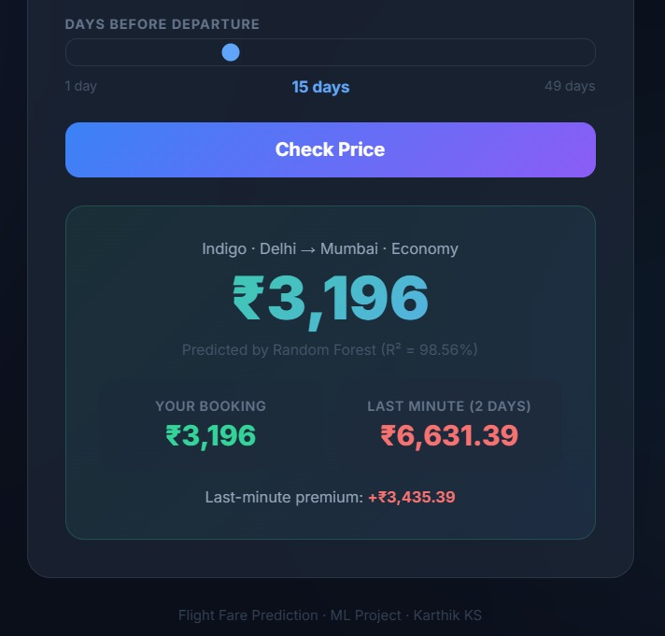
Figure 6: Flask Web Application - Prediction Result

Annexure B: Core Code Implementation
Snippet 1: Data Preprocessing (Encoding & Scaling)
from sklearn.preprocessing import StandardScaler
import pandas as pd
# Apply One-Hot Encoding to categorical nominal features
df = pd.get_dummies(df, columns=['airline', 'source_city', 'destination_city'])
# Scale numerical features
scaler = StandardScaler()
df[['duration', 'days_left']] = scaler.fit_transform(df[['duration', 'days_left']])
Snippet 2: Model Training (Random Forest)
from sklearn.ensemble import RandomForestRegressor
from sklearn.metrics import mean_absolute_error, r2_score
# Train Random Forest Regressor
rf_model = RandomForestRegressor(n_estimators=100, random_state=42, n_jobs=-1)
rf_model.fit(X_train, y_train)
# Evaluate model performance
y_pred = rf_model.predict(X_test)
print(f'R2 Score: {r2_score(y_test, y_pred)}')
Snippet 3: Flask Route for Prediction Inference
@app.route('/predict', methods=['POST'])
def predict():
features = process_input(request.form) # Custom preprocessing function
predicted_price = model.predict(features)[0]
return jsonify({'predicted_price': round(predicted_price, 2)})

