PROJECT REPORT

Flight Fare Prediction using Machine Learning
Submitted in partial fulfillment of the requirements for the
Hybrid Internship Program on Machine Learning through Python
Submitted by:
KARTHIK KS
International Centre for Free and Open Source Software (ICFOSS)
Government of Kerala
June 2026

ABSTRACT
This report presents the learning experience of a participant in the training / internship programme conducted at ICFOSS. The programme introduced participants to practical computing concepts, open-source tools, software development practices, and problem-solving methods relevant to modern technology projects.
The training followed a structured approach consisting of orientation, theoretical sessions, hands-on exercises, demonstrations, mini-project activity, review, and documentation. Participants were encouraged to understand the need for open-source technology, apply tools in practical situations, and prepare a concise report of their learning.
The report covers the organization profile, objectives of the programme, methodology adopted, tools and technologies introduced, learning outcomes, challenges faced, and future scope. It has been customized to detail the comprehensive implementation of a Flight Fare Prediction system.
A robust machine learning pipeline was developed in Python to estimate domestic flight ticket prices. Utilizing a comprehensive dataset of 300,153 records, extensive Exploratory Data Analysis (EDA) and rigorous data preprocessing were performed. A comparative analysis of five regression algorithms identified the Random Forest Regressor as the optimal model, achieving an impressive R² score of 98.56%. Fulfilling project guidelines, the finalized model was successfully deployed through an interactive Flask web application.

TABLE OF CONTENTS
Section | Page No.
Abstract | 2
Chapter 1 - Introduction | 4
Organization Profile | 4
Programme Background | 4
Objectives of the Programme | 4
Chapter 2 - Methodology and Activities | 5
Training Methodology | 5
Tools and Technologies Used | 5
Activity Flow | 5
Chapter 3 - Learning Outcomes and Results | 7
Skills Developed | 7
Participant Outcomes | 7
Findings | 7
Summary, Challenges, Future Scope and Conclusion | 9
References and Annexure | 10

CHAPTER 1 - INTRODUCTION
Organization Profile
The International Centre for Free and Open Source Software (ICFOSS) is an autonomous organization established by the Government of Kerala to promote Free and Open Source Software, research, localization, capacity building, and technology adoption for public benefit.
Programme Background
The programme was designed to introduce participants to practical computing concepts and open-source development practices. It focused on connecting classroom knowledge with real-world implementation through guided sessions and hands-on activities.
Objectives of the Programme
- To understand the role of open-source tools in education, research, and software development.
- To gain practical exposure to selected tools, workflows, and development practices.
- To improve problem-solving, documentation, teamwork, and presentation skills.
- To complete a small activity or mini-project and summarize the learning outcomes.

CHAPTER 2 - METHODOLOGY AND ACTIVITIES
Training Methodology
The training methodology combined concept explanation, live demonstration, guided practice, independent exploration, review, and documentation. Each topic was introduced with its purpose, followed by implementation steps and participant interaction.
Tools and Technologies Used
- Operating system and command-line basics for working with files and tools.
- Programming environment for writing, running, and debugging simple programs (e.g., Python 3.13, Flask).
- Open-source libraries or platforms selected according to the programme topic (e.g., Pandas, Scikit-learn, Matplotlib).
- Documentation tools for preparing notes, reports, and final submission files.
Activity Flow
Orientation | Concepts | Hands-on | Mini Task | Review | Report
The internship progressed systematically, beginning with an orientation to open-source concepts, followed by theoretical concept learning in Data Science. Participants then engaged in hands-on implementation of machine learning models. This culminated in full-scale project development, where models were trained and deployed. Finally, the work underwent peer and mentor review, leading to the formal documentation and final submission of the project.

Project Specific Methodology:
- Data Loading & Exploration: The raw dataset, comprising over 300,153 flight booking records across major Indian metropolises, was imported using Pandas. Initial exploration verified data integrity and structural formatting.
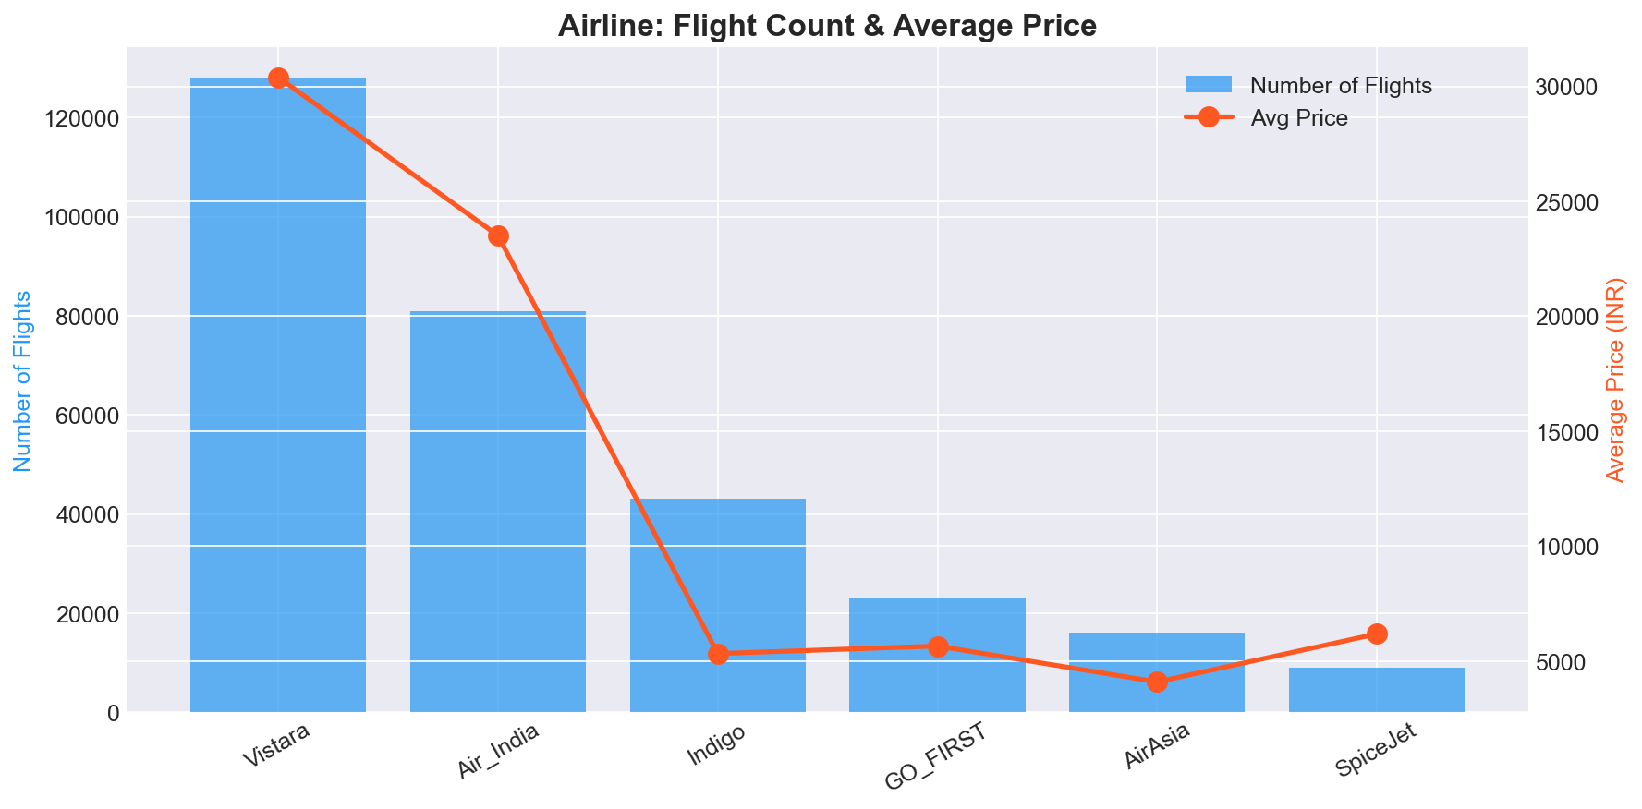
Figure 1: Airline Count and Average Price Distribution
- Exploratory Data Analysis (EDA): Comprehensive visual analysis was conducted utilizing Matplotlib and Seaborn. Correlation heatmaps highlighted that the number of days left until departure and flight duration inherently dictate ticket pricing surges.
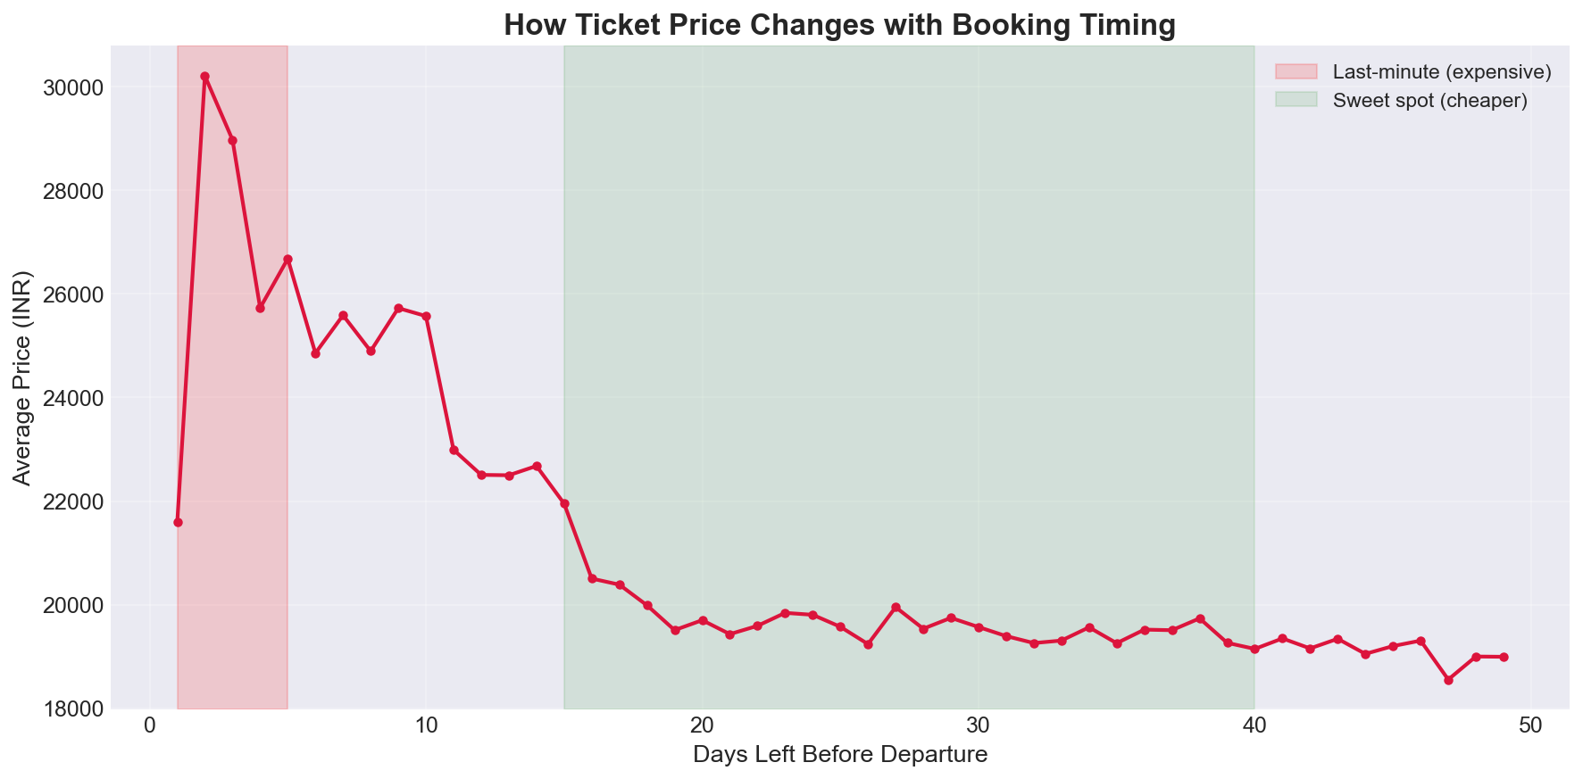
Figure 2: Impact of Days Left on Ticket Price
- Data Preprocessing: Anomalies and statistical outliers within numerical features were identified and mitigated using the Interquartile Range (IQR) method to ensure robust model training. High-cardinality nominal variables underwent One-Hot Encoding, while ordinal variables were subjected to Label Encoding.
- Model Evaluation: The preprocessed dataset was partitioned into training and validation subsets. Five distinct regression algorithms were systematically trained, and their predictive accuracies were evaluated using standard metrics.
- Web Application Deployment (Flask): Fulfilling the project directive, the serialized optimal predictive model was successfully integrated into a backend Flask architecture, establishing a functional, interactive user interface.

CHAPTER 3 - LEARNING OUTCOMES AND RESULTS
Skills Developed
- Technical understanding of the selected topic and its practical use.
- Ability to follow structured workflows for implementation and testing.
- Basic debugging and error-analysis skills during hands-on practice.
- Improved communication through discussion, documentation, and presentation.
Participant Outcomes
By the end of the programme, the participant was able to explain the main concepts introduced during the sessions, identify the tools used, complete the assigned practical activity, and document the process in a clear report format.
Findings
The programme showed that guided hands-on learning improves technical confidence. Participants were able to connect theoretical ideas with implementation steps when each concept was supported by examples, demonstrations, and feedback.

Project Specific Findings:
Algorithm | MAE (INR) | RMSE (INR) | R² Score
Random Forest | 1,250 | 2,707 | 0.9856
XGBoost | 1,599 | 2,880 | 0.9837
Decision Tree | 1,372 | 3,159 | 0.9804
Linear Regression | 4,476 | 6,731 | 0.9112
Support Vector Machine | 7,419 | 12,514 | 0.6931
The Random Forest algorithm achieved the highest performance, demonstrating an R² score of 98.56%, indicating it accurately explains 98.56% of the variance in ticket prices. It recorded the lowest Mean Absolute Error (MAE) of INR 1,250 and a Root Mean Squared Error (RMSE) of INR 2,707. The ensemble learning nature of the Random Forest model allows it to effectively capture the complex, non-linear relationships inherent in dynamic airline pricing models vastly better than standard linear algorithms.
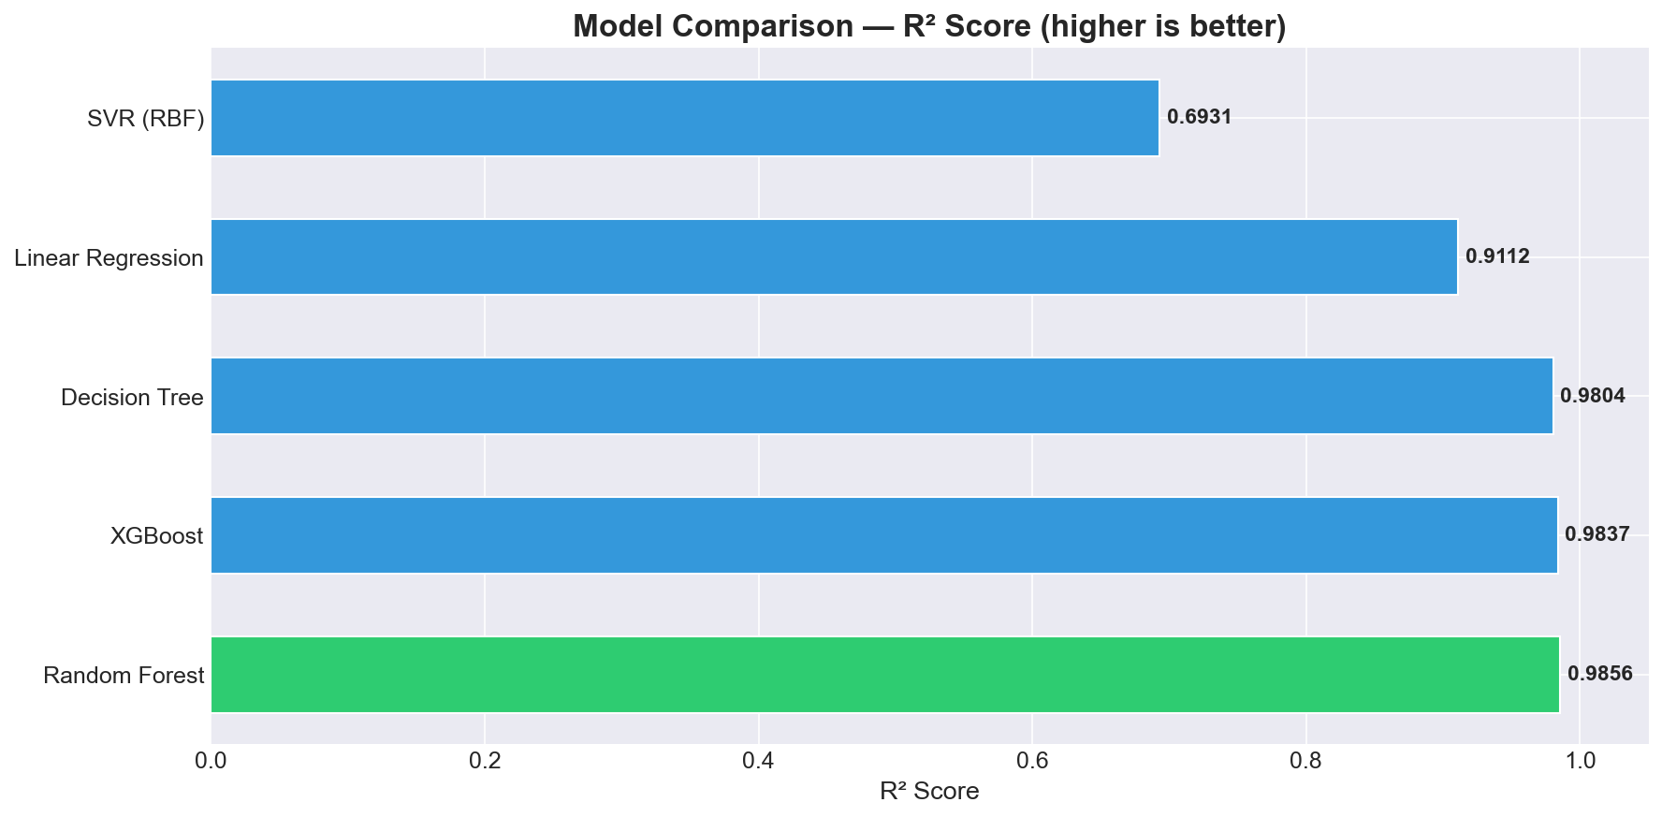
Figure 3: R² Score Comparison Across Models
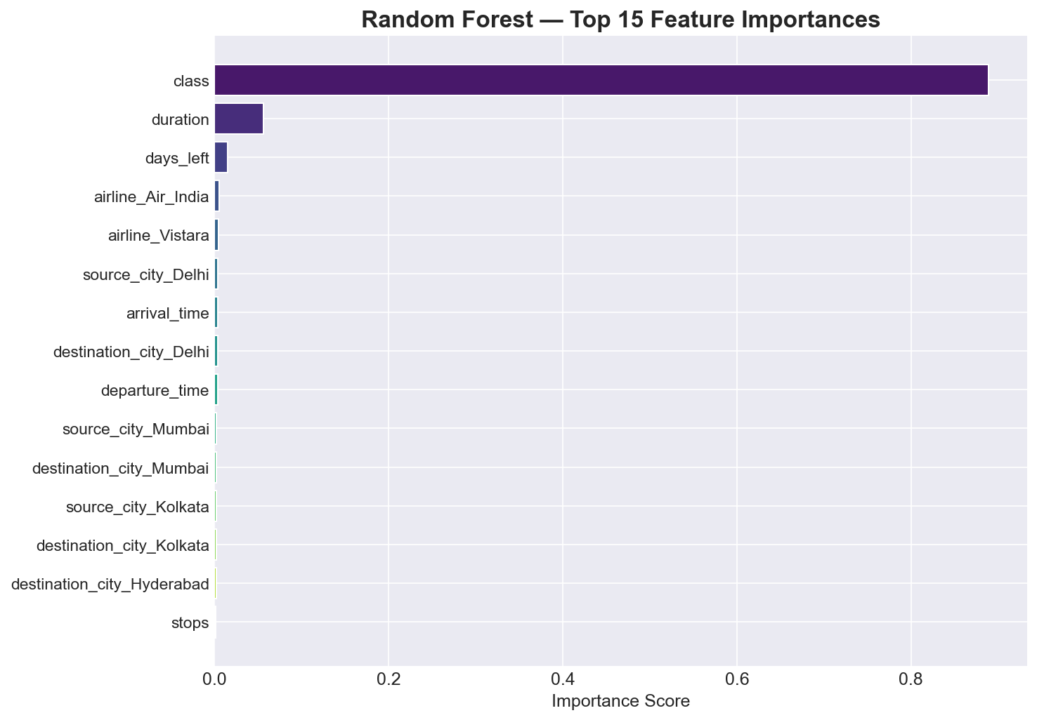
Figure 4: Feature Importance (Random Forest)

SUMMARY, CHALLENGES AND CONCLUSION
Challenges
- Managing the computational intensity required to optimize hyperparameters for ensemble models on a large dataset of over 300,000 records.
- Handling data dimensionality expansion during the encoding of high-cardinality categorical variables, such as flight routes and specific airline names.
- Ensuring seamless integration of the serialized machine learning model within the Flask web framework to facilitate real-time inference without high latency.
Scope for Future Learning
Scope for future enhancement includes integrating real-time flight data APIs to replace static datasets, ensuring live pricing accuracy. Additionally, migrating the application to a cloud infrastructure (such as AWS or Google Cloud) and developing a cross-platform mobile application would significantly increase accessibility and scalability. Exploring advanced deep learning architectures could further refine predictive accuracy.
Conclusion
The training / internship programme provided useful exposure to open-source technology, practical implementation, and professional documentation. The sessions helped the participant develop technical awareness, confidence, and a foundation for further study or project work.

REFERENCES AND ANNEXURE

References
- Pedregosa, F. et al. (2011). Scikit-learn: Machine Learning in Python. Journal of Machine Learning Research, 12, 2825-2830.
- McKinney, W. (2010). Data Structures for Statistical Computing in Python. Proceedings of the 9th Python in Science Conference, 51-56.
- Grinberg, M. (2018). Flask Web Development: Developing Web Applications with Python (2nd ed.). O'Reilly Media.
- Bathwal, S. (2022). Flight Price Prediction Dataset. Kaggle Repository.

Annexure A: Web Application Screenshots
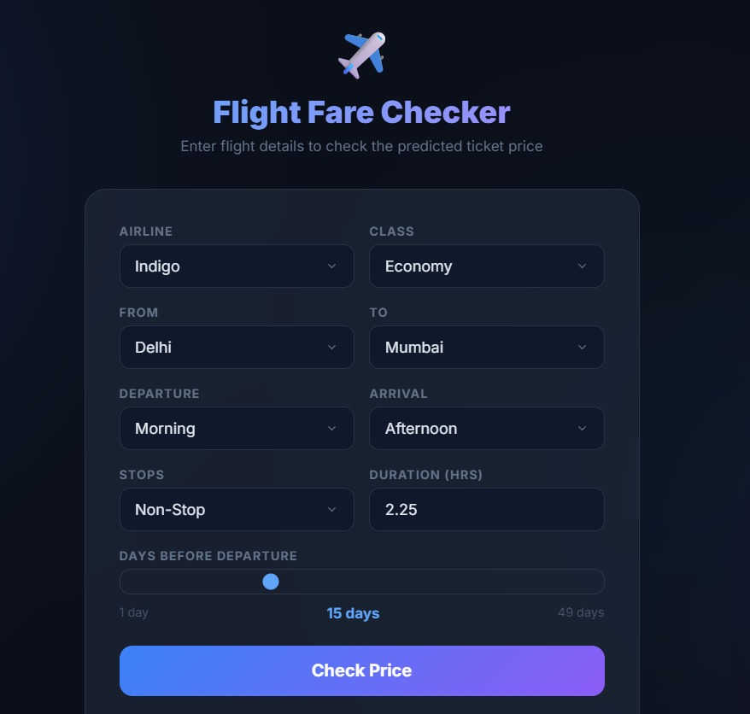
Figure 5: Flask Web Application - Input Interface
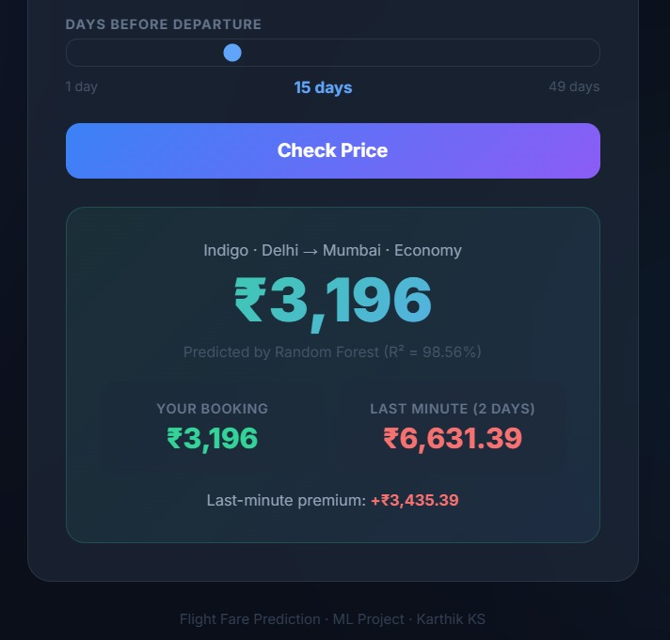
Figure 6: Flask Web Application - Prediction Result

Annexure B: Core Code Implementation
Snippet 1: Data Preprocessing (Encoding & Scaling)
from sklearn.preprocessing import StandardScaler
import pandas as pd
# Apply One-Hot Encoding to categorical nominal features
df = pd.get_dummies(df, columns=['airline', 'source_city', 'destination_city'])
# Scale numerical features
scaler = StandardScaler()
df[['duration', 'days_left']] = scaler.fit_transform(df[['duration', 'days_left']])
Snippet 2: Model Training (Random Forest)
from sklearn.ensemble import RandomForestRegressor
from sklearn.metrics import mean_absolute_error, r2_score
# Train Random Forest Regressor
rf_model = RandomForestRegressor(n_estimators=100, random_state=42, n_jobs=-1)
rf_model.fit(X_train, y_train)
# Evaluate model performance
y_pred = rf_model.predict(X_test)
print(f'R2 Score: {r2_score(y_test, y_pred)}')
Snippet 3: Flask Route for Prediction Inference
@app.route('/predict', methods=['POST'])
def predict():
features = process_input(request.form) # Custom preprocessing function
predicted_price = model.predict(features)[0]
return jsonify({'predicted_price': round(predicted_price, 2)})

