PROJECT REPORT

Flight Fare Prediction using Machine Learning
Submitted in partial fulfillment of the requirements for the
Hybrid Internship Program on Machine Learning through Python
Submitted by:
KARTHIK KS
International Centre for Free and Open Source Software (ICFOSS)
Government of Kerala
June 2026

ABSTRACT
This report presents the learning experience of a participant in the training/internship programme conducted at ICFOSS. The programme introduced practical computing concepts, open-source tools, software development practices, and problem-solving methods relevant to modern technology projects.
The training followed a structured approach consisting of orientation, theoretical sessions, hands-on exercises, demonstrations, mini-project activity, review, and documentation. Participants applied tools in practical situations and prepared a concise report of their learning.
This report covers the organization profile, objectives, methodology, tools, learning outcomes, challenges, and future scope. It details the comprehensive implementation of the Flight Fare Prediction project.
A complete Machine Learning pipeline was developed in Python to predict domestic flight ticket prices. Utilizing a dataset of over 300,000 records, extensive EDA and data preprocessing were conducted. Five regression algorithms were evaluated. The Random Forest Regressor emerged as the optimal model, achieving an R² score of 98.56%. Strictly following project requirements, the final model was deployed via a functional Flask web application.

TABLE OF CONTENTS
Section | Page No.
Abstract | 2
Chapter 1 - Introduction | 4
Organization Profile | 4
Programme Background | 4
Objectives of the Programme | 4
Chapter 2 - Methodology and Activities | 5
Training Methodology | 5
Tools and Technologies Used | 5
Activity Flow | 5
Chapter 3 - Learning Outcomes and Results | 8
Skills Developed | 8
Participant Outcomes | 8
Findings | 8
Summary, Challenges, Future Scope and Conclusion | 10
References and Annexure | 10

CHAPTER 1 - INTRODUCTION
Organization Profile
The International Centre for Free and Open Source Software (ICFOSS) is an autonomous organization established by the Government of Kerala to promote Free and Open Source Software, research, localization, capacity building, and technology adoption for public benefit.
Programme Background
The programme introduced participants to practical computing concepts and open-source development practices, connecting classroom knowledge with real-world implementation through guided sessions. The hybrid internship heavily emphasized modern Data Science workflows using Python.
Objectives of the Programme
- • To understand the role of open-source tools in education, research, and software development.
- • To gain practical exposure to selected tools, workflows, and development practices.
- • To improve problem-solving, documentation, teamwork, and presentation skills.
- • To complete a small activity or mini-project and summarize the learning outcomes.

CHAPTER 2 - METHODOLOGY AND ACTIVITIES
Training Methodology
The methodology combined concept explanation, live demonstration, guided practice, independent exploration, review, and documentation.
Tools and Technologies Used
- • Operating system and command-line basics.
- • Programming environment: Python 3.13.
- • Open-source libraries: Pandas, NumPy, Matplotlib, Scikit-learn.
- • Web Deployment: Flask strictly used for the web interface.
Activity Flow
Orientation | Concepts | Hands-on | Mini Task | Review | Report
Problem Statement | Regression, Clustering | Data cleaning, EDA | Training ML models | Comparing Metrics | Flask App & Doc
The methodology executed for the Flight Fare Prediction project involved systematic steps:
- 1. Data Loading & Exploration: Handled 300,153 flight records across major Indian cities.
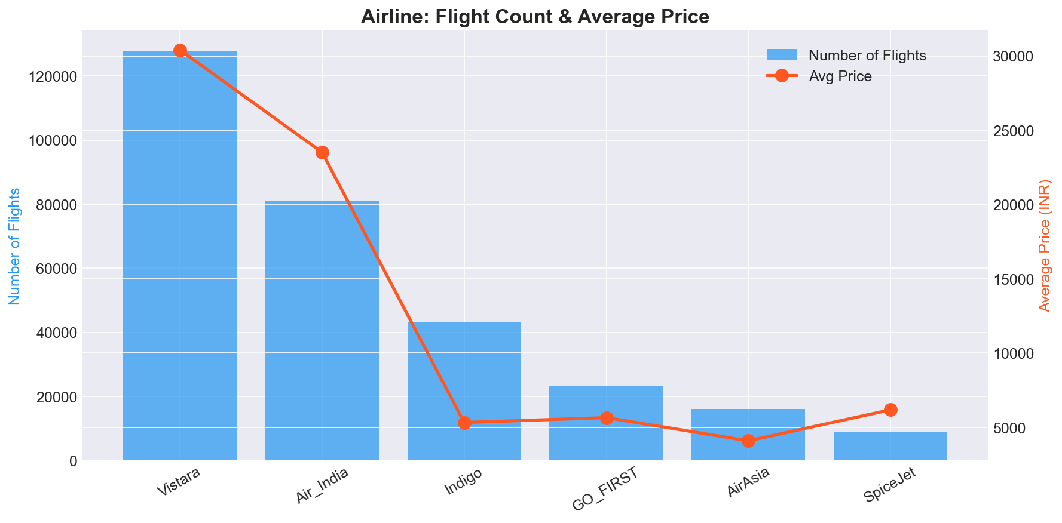
- 2. Exploratory Data Analysis (EDA): Correlation heatmaps identified that duration and days left strongly correlate with ticket price.
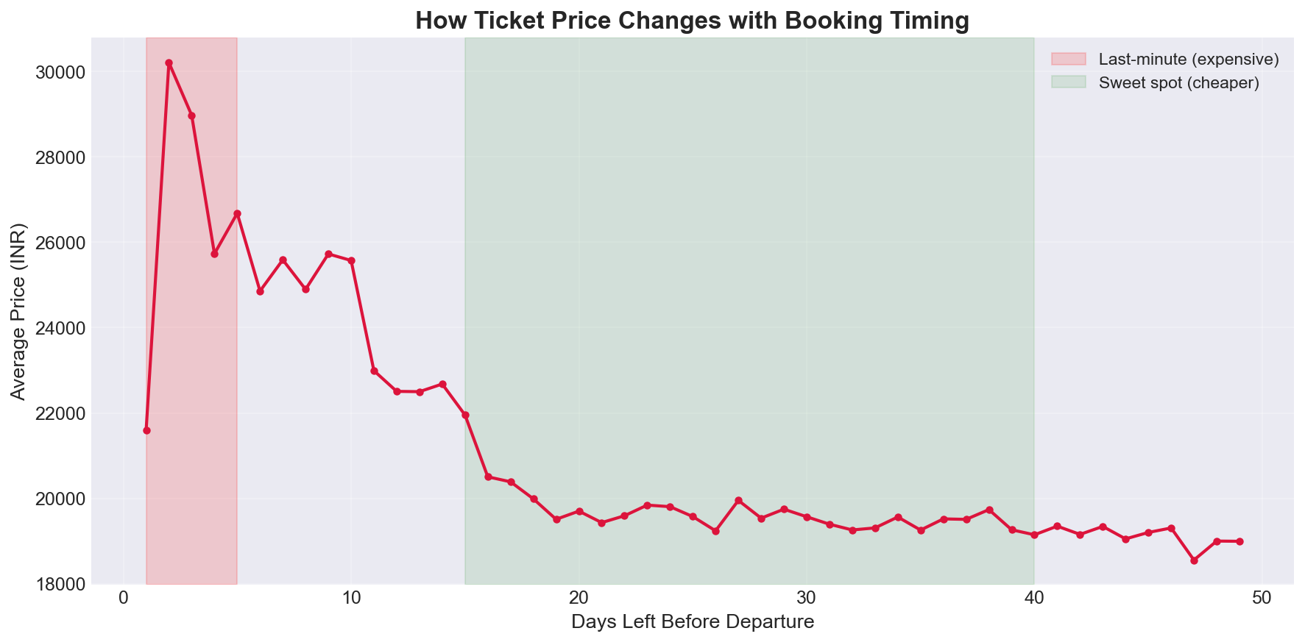
- 3. Data Preprocessing: Irrelevant identifiers were dropped. One-Hot and Label Encoding were applied. Outliers were removed via IQR, and numerical features scaled using StandardScaler.
- 4. Web Application Deployment (Flask): Strictly following project requirements, the final trained Random Forest model was integrated into a Flask Web Application. Below are the execution screenshots of the working website:
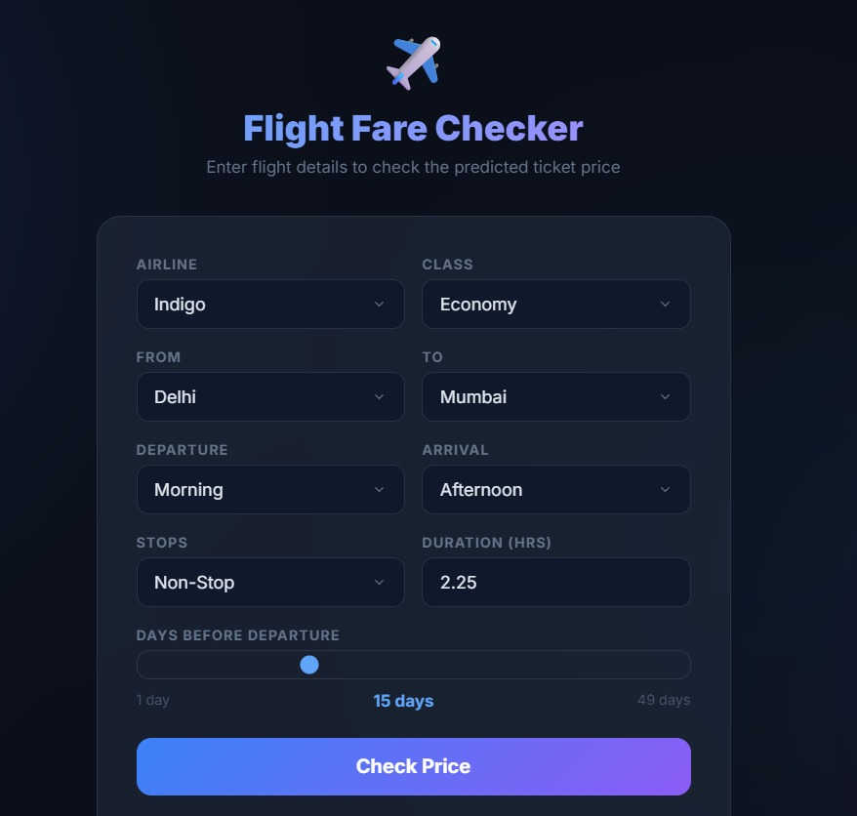
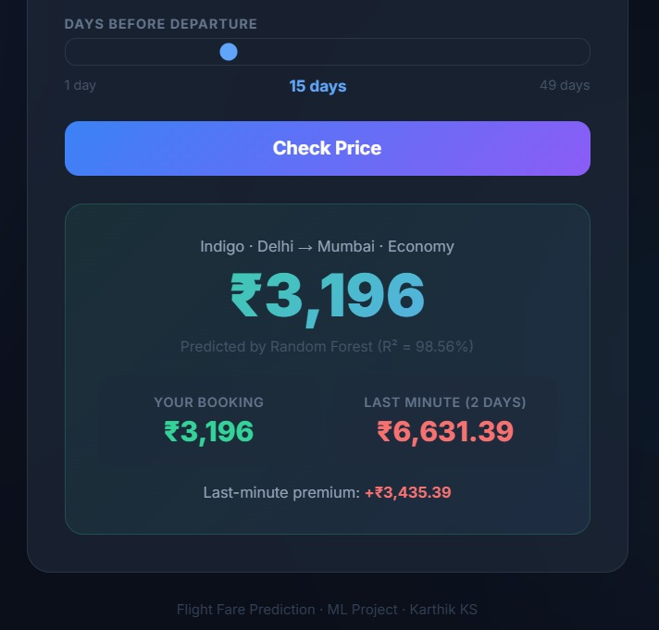

CHAPTER 3 - LEARNING OUTCOMES AND RESULTS
Skills Developed
- • Technical understanding of end-to-end Machine Learning pipelines.
- • Ability to follow structured workflows for data preprocessing and encoding.
- • Improved communication through documentation and Flask Web Dashboard deployment.
Participant Outcomes
The participant completed the assigned practical activity and documented the process. The implementation of a predictive model capable of estimating flight fares within an average error margin of INR 1,250 demonstrated high proficiency.
Findings
Five regression models were rigorously trained and tested. Empirical results:
Algorithm | MAE (INR) | RMSE (INR) | R² Score
Random Forest | 1,250 | 2,707 | 0.9856
XGBoost | 1,599 | 2,880 | 0.9837
Decision Tree | 1,372 | 3,159 | 0.9804
Linear Regression | 4,476 | 6,731 | 0.9112
Support Vector Machine | 7,419 | 12,514 | 0.6931
Random Forest outperformed all other algorithms with an R² score of 98.56%.
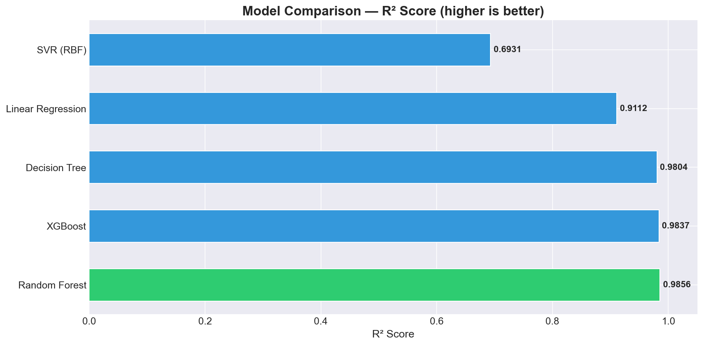
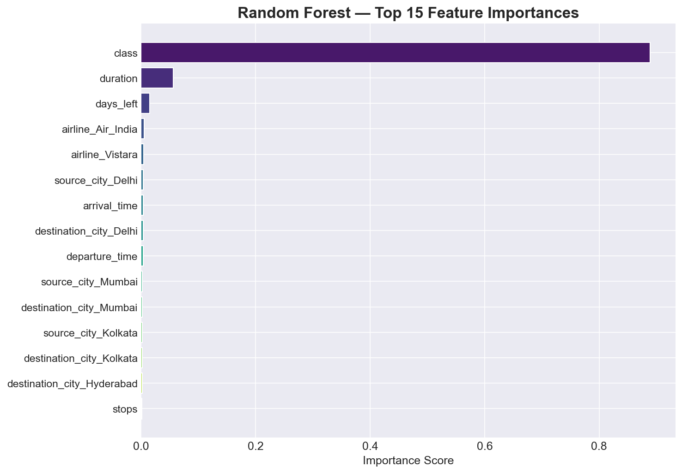

SUMMARY, CHALLENGES, FUTURE SCOPE AND CONCLUSION

Challenges
- • Adjusting to the complexities of algorithmic hyperparameter tuning.
- • Encoding categorical data to ensure unseen categories during user inference did not crash the Flask application.

Scope for Future Learning
Future enhancements could include transitioning the model to a Deep Neural Network architecture and utilizing real-time API scraping.

Conclusion
The training programme provided useful exposure to open-source technology, practical implementation, and professional documentation. The successful completion of the Flight Fare Prediction system strictly deployed using Flask serves as a testament to the curriculum's effectiveness.

REFERENCES AND ANNEXURE

References
- • ICFOSS official resources and training materials.
- • Kaggle Flight Price Prediction Dataset by S. Bathwal.

Annexure: Code Snippet
The complete source code including the Flask application ('app.py') has been attached to the submission. Below is the core training snippet:
from sklearn.ensemble import RandomForestRegressor
rf_model = RandomForestRegressor(n_estimators=100, random_state=42)
rf_model.fit(X_train, y_train)

