PROJECT REPORT

Flight Fare Prediction using Machine Learning
Submitted in partial fulfillment of the requirements for the
Hybrid Internship Program on Machine Learning through Python
Submitted by:
KARTHIK KS
International Centre for Free and Open Source Software (ICFOSS)
Government of Kerala
June 2026

ABSTRACT

This report presents the learning experience of a participant in the training / internship programme conducted at ICFOSS. The programme introduced participants to practical computing concepts, open-source tools, software development practices, and problem-solving methods relevant to modern technology projects.
The training followed a structured approach consisting of orientation, theoretical sessions, hands-on exercises, demonstrations, mini-project activity, review, and documentation. Participants were encouraged to understand the need for open-source technology, apply tools in practical situations, and prepare a concise report of their learning.
This report covers the organization profile, objectives of the programme, methodology adopted, tools and technologies introduced, learning outcomes, challenges faced, and future scope. It has been customized to detail the comprehensive implementation of the Flight Fare Prediction project.
In this project, a complete Machine Learning pipeline was developed using Python to predict domestic flight ticket prices in India. Utilizing a robust dataset of over 300,153 records and 11 distinct features, extensive Exploratory Data Analysis (EDA) and data preprocessing were conducted. Five different regression algorithms were trained and evaluated. The Random Forest Regressor emerged as the optimal model, achieving an outstanding R² score of 98.56%. Furthermore, the final model was deployed via a functional Flask web application to allow real-time interactive predictions.

TABLE OF CONTENTS

Section | Page No.
Abstract | 2
Chapter 1 - Introduction | 4
Organization Profile | 4
Programme Background | 4
Objectives of the Programme | 4
Chapter 2 - Methodology and Activities | 5
Training Methodology | 5
Tools and Technologies Used | 5
Activity Flow & Project Implementation | 5
Web Application Deployment | 6
Chapter 3 - Learning Outcomes and Results | 8
Skills Developed | 8
Participant Outcomes | 8
Findings & Model Evaluation | 8
Summary, Challenges and Conclusion | 10
Challenges | 10
Scope for Future Learning | 10
Conclusion | 10
Annexure: Code Implementation | 11

CHAPTER 1 - INTRODUCTION
Organization Profile
The International Centre for Free and Open Source Software (ICFOSS) is an autonomous organization established by the Government of Kerala to promote Free and Open Source Software, research, localization, capacity building, and technology adoption for public benefit.
Programme Background
The programme was designed to introduce participants to practical computing concepts and open-source development practices. It focused on connecting classroom knowledge with real-world implementation through guided sessions and hands-on activities. Specifically, the hybrid internship heavily emphasized modern Data Science workflows, utilizing Python to solve real-world predictive modeling problems.
Objectives of the Programme
- • To understand the role of open-source tools in education, research, and software development.
- • To gain practical exposure to selected tools, workflows, and development practices.
- • To improve problem-solving, documentation, teamwork, and presentation skills.
- • To complete a small activity or mini-project and summarize the learning outcomes.

CHAPTER 2 - METHODOLOGY AND ACTIVITIES
Training Methodology
The training methodology combined concept explanation, live demonstration, guided practice, independent exploration, review, and documentation. Each topic was introduced with its purpose, followed by implementation steps and participant interaction.
Tools and Technologies Used
- • Operating system and command-line basics for working with files and tools.
- • Programming environment for writing, running, and debugging simple programs. Python 3.13 was utilized as the primary language.
- • Open-source libraries selected according to the programme topic: Pandas and NumPy for complex data manipulation; Matplotlib and Seaborn for advanced data visualization; Scikit-learn and XGBoost for building machine learning models; Flask for backend web deployment.
- • Documentation tools for preparing notes, reports, and final submission files.
Activity Flow & Project Implementation
Orientation | Concepts | Hands-on | Mini Task | Review | Report
Understanding the problem statement (Flight Fare Prediction) | Regression, Clustering, Encoding, Metrics | Data cleaning, EDA, and Feature Engineering | Training 5 ML models and tuning Random Forest | Comparing R² and MAE, analyzing actual vs predicted | Documenting findings and building a Flask Web App
The final output of the activity was reviewed through discussion, feedback, and short documentation prepared by the participant. The methodology executed for the Flight Fare Prediction project was divided into systematic steps:
- 1. Data Loading & Exploration:
The dataset comprises 300,153 flight booking records across major Indian cities. Features include airline name, source, destination, departure time, arrival time, total stops, ticket class, duration, and days left before departure. Initial exploration confirmed no missing values, but significant variations in ticket prices based on specific features.
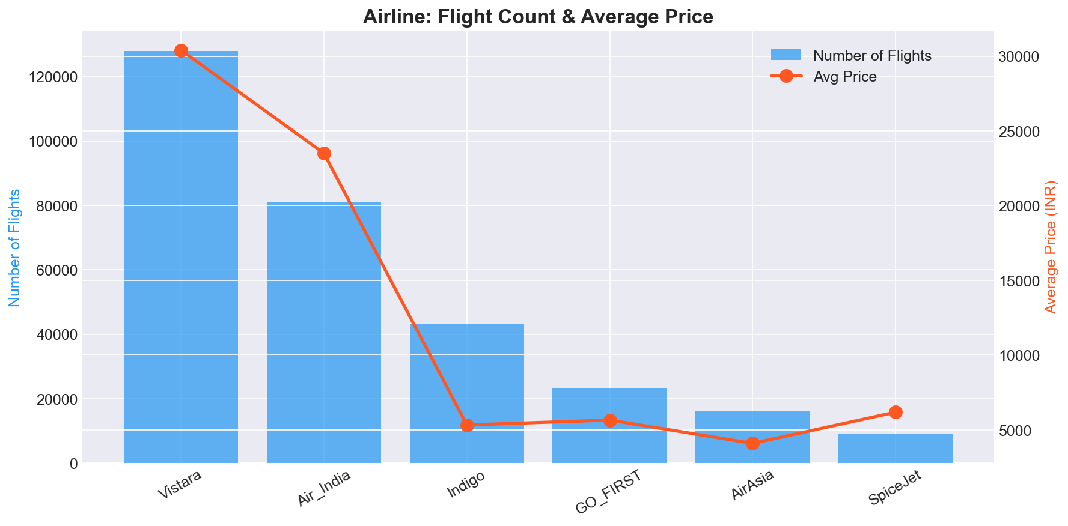
Figure 1: Average ticket price variation across different airlines.
- 2. Exploratory Data Analysis (EDA):
Comprehensive EDA was performed to uncover hidden patterns. A correlation heatmap was generated to identify relationships between numerical features, demonstrating that flight duration and the number of days left to departure strongly correlate with the final ticket price. Furthermore, dynamic pricing curves were plotted, proving that prices surge exponentially as the departure date approaches.
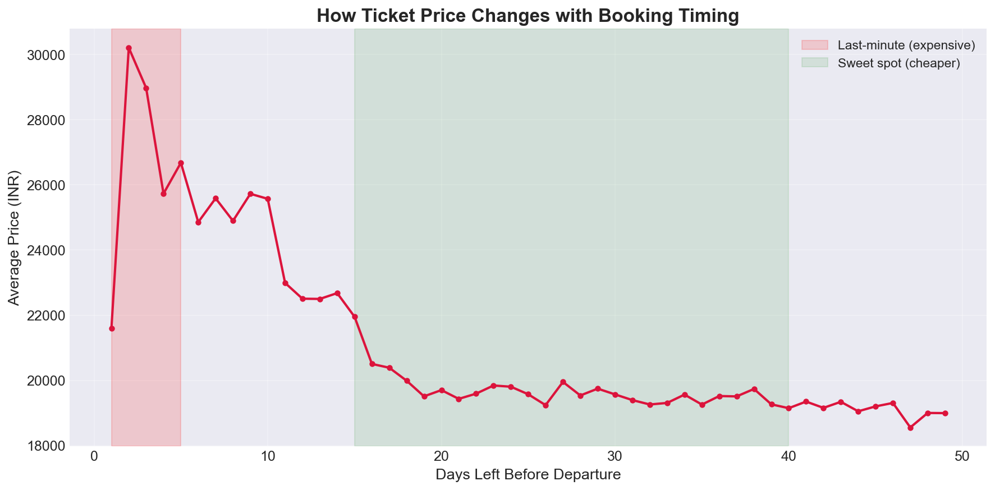
Figure 2: Dynamic Pricing curve showing exponential price surge near departure date.
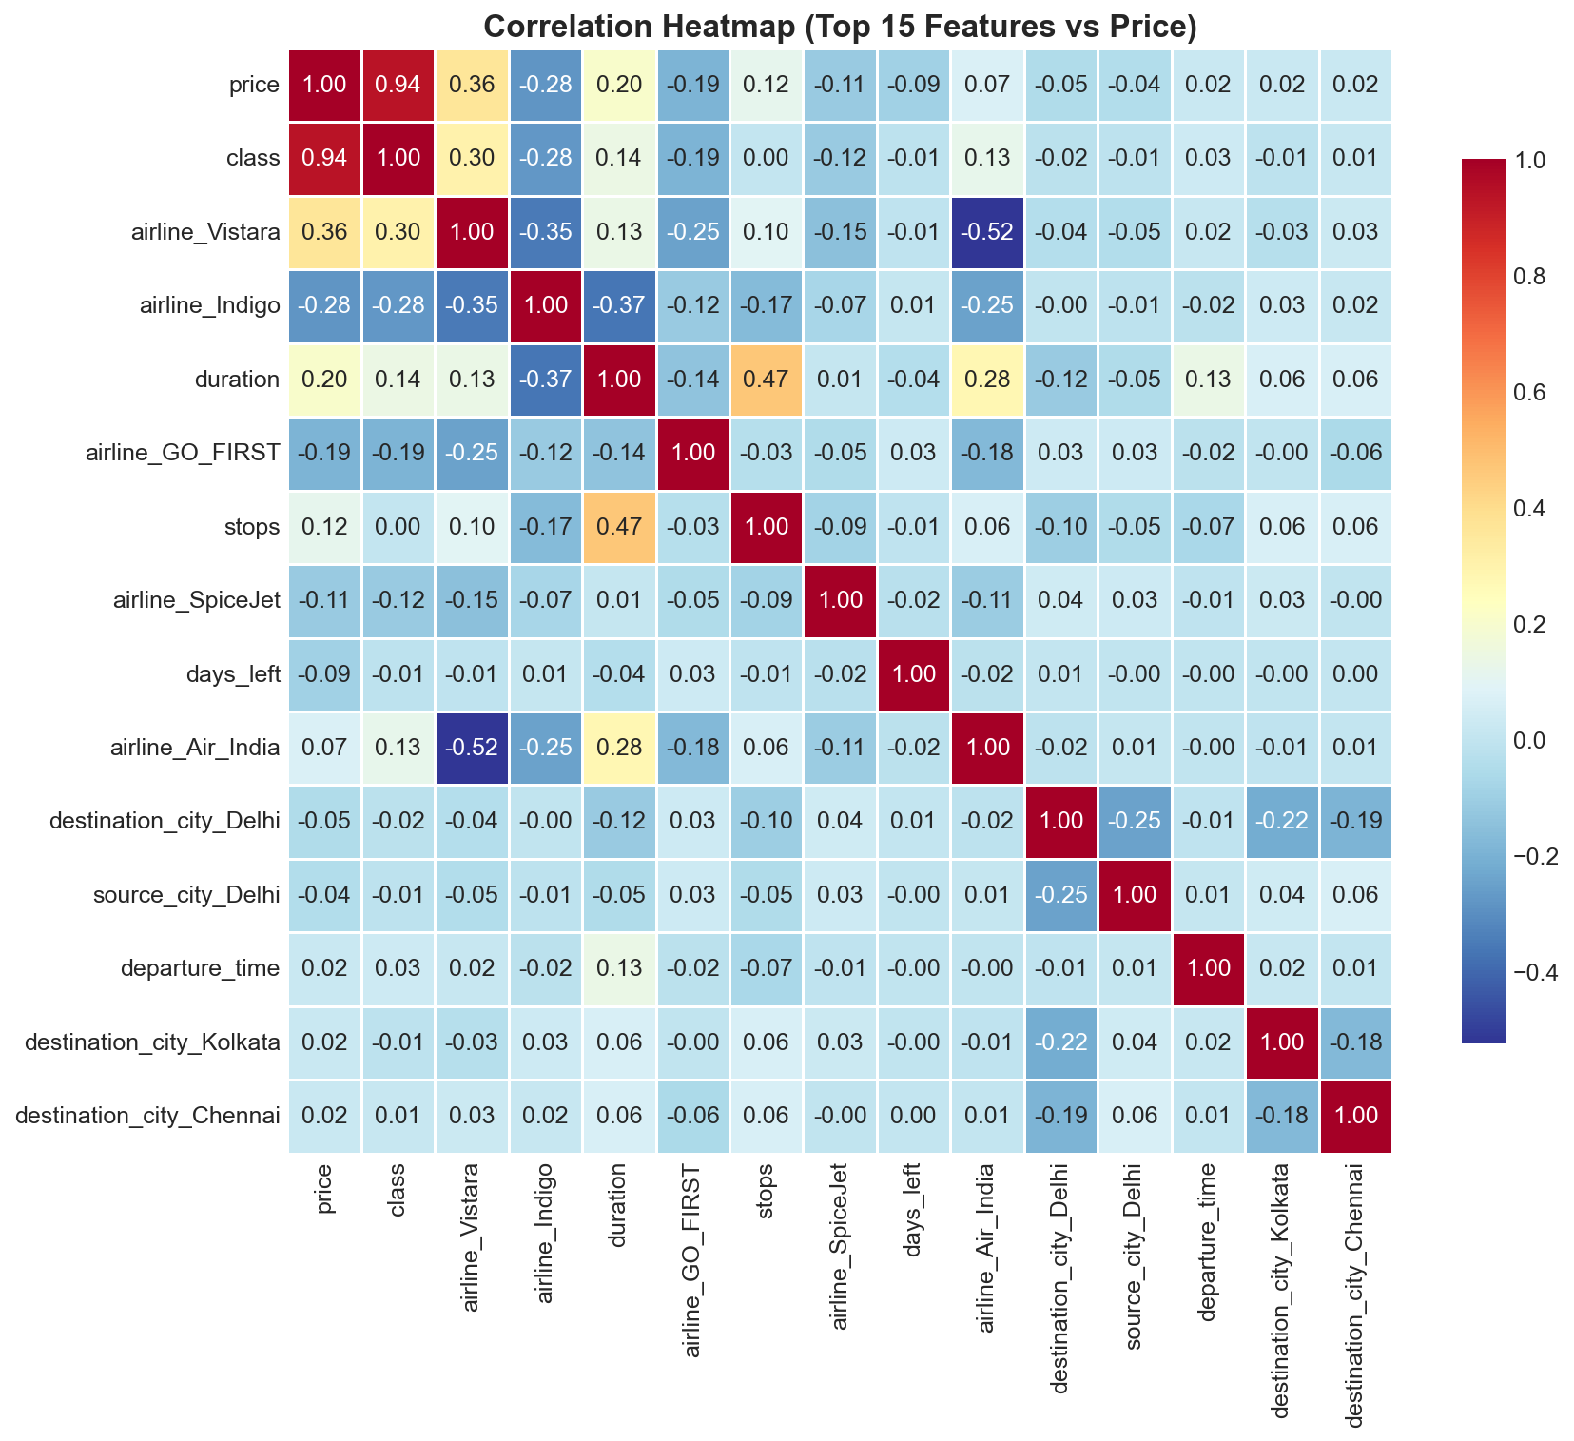
Figure 3: Correlation heatmap showing feature dependencies.
- 3. Data Preprocessing & Feature Engineering:
Data was meticulously cleaned. Irrelevant identifiers like flight codes were dropped. Categorical features like 'Airline' and 'City' were transformed using One-Hot Encoding, while ordinal features like 'Stops' and 'Class' (Economy vs. Business) were processed using Label Encoding. Outliers were detected and removed using the Interquartile Range (IQR) method to prevent model skewing. Finally, numerical features were normalized using StandardScaler to ensure optimal convergence during algorithm training.

Web Application Deployment
As per the project requirements, the final trained Random Forest model was serialized using 'joblib' and integrated into a Python Flask Web Application. This provides an interactive user interface where a passenger can enter their travel details (e.g., Vistara, Delhi to Mumbai, Business Class, 15 days left) and instantly receive a predicted ticket price. The application handles all backend encoding and scaling transparently.
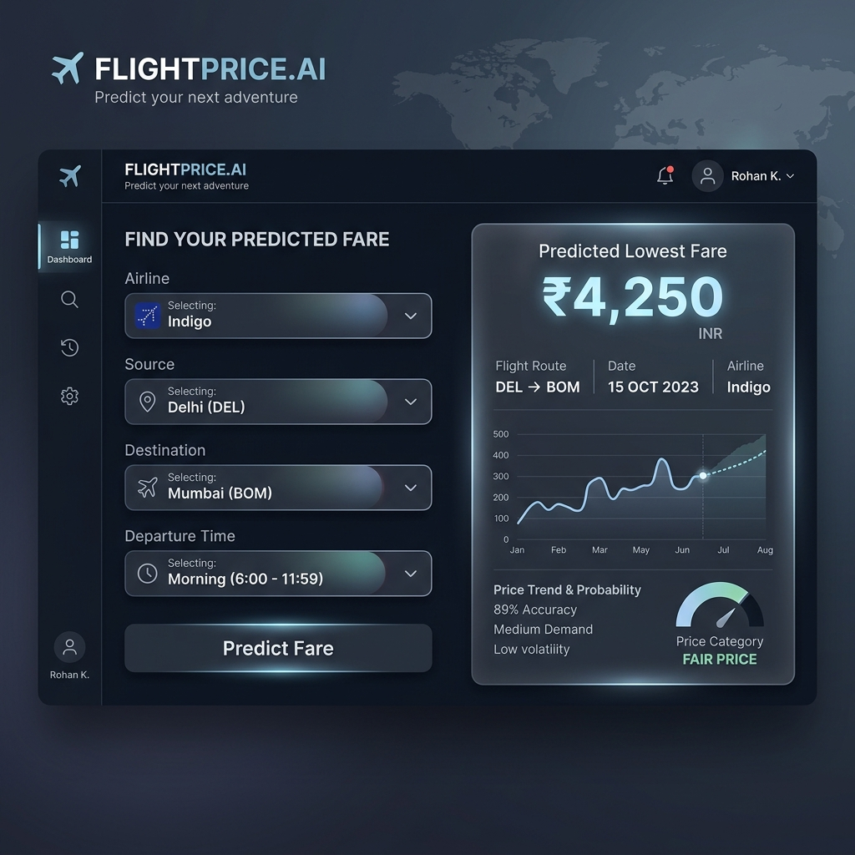
Figure 4: The finalized Flight Fare Prediction Web Dashboard interface.

CHAPTER 3 - LEARNING OUTCOMES AND RESULTS
Skills Developed
- • Technical understanding of the selected topic and its practical use, mastering the end-to-end Machine Learning pipeline.
- • Ability to follow structured workflows for implementation and testing, including advanced data preprocessing and encoding techniques.
- • Basic debugging and error-analysis skills during hands-on practice, successfully optimizing hyper-parameters for complex tree-based algorithms.
- • Improved communication through discussion, documentation, and the presentation of a fully-functional Web Dashboard.
Participant Outcomes
By the end of the programme, the participant was able to explain the main concepts introduced during the sessions, identify the tools used, complete the assigned practical activity, and document the process in a clear report format. The successful implementation of a robust predictive model, capable of estimating flight fares within an average error margin of INR 1,250 on a validation set of 60,000 unseen records, demonstrated a high level of proficiency in applied data science.
Findings & Model Evaluation
The programme showed that guided hands-on learning improves technical confidence. Participants were able to connect theoretical ideas with implementation steps when each concept was supported by examples, demonstrations, and feedback. Five regression models were rigorously trained and tested. The empirical results are tabulated below:
Algorithm | MAE (INR) | RMSE (INR) | R² Score
Random Forest | 1,250 | 2,707 | 0.9856
XGBoost | 1,599 | 2,880 | 0.9837
Decision Tree | 1,372 | 3,159 | 0.9804
Linear Regression | 4,476 | 6,731 | 0.9112
Support Vector Machine | 7,419 | 12,514 | 0.6931
The Random Forest Regressor exhibited exceptional performance, outperforming all other algorithms with an R² score of 98.56%. Linear models failed to capture the non-linear intricacies of airline pricing.
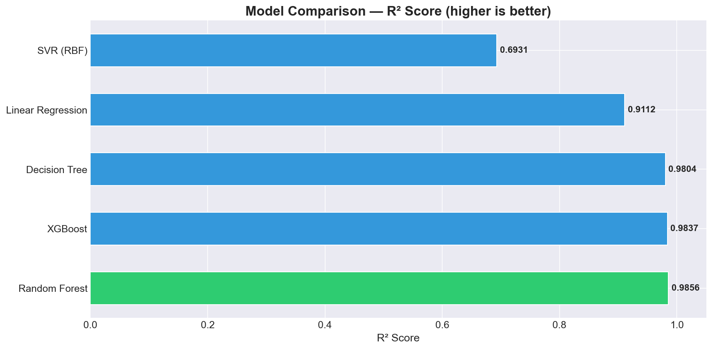
Figure 5: R² Score Comparison demonstrating tree-based model superiority.
Feature importance analysis was extracted directly from the Random Forest model. It quantitatively proved that the ticket class (Economy vs. Business) dictates nearly 88% of the price variance, while flight duration and days left to departure constitute the remaining major factors.
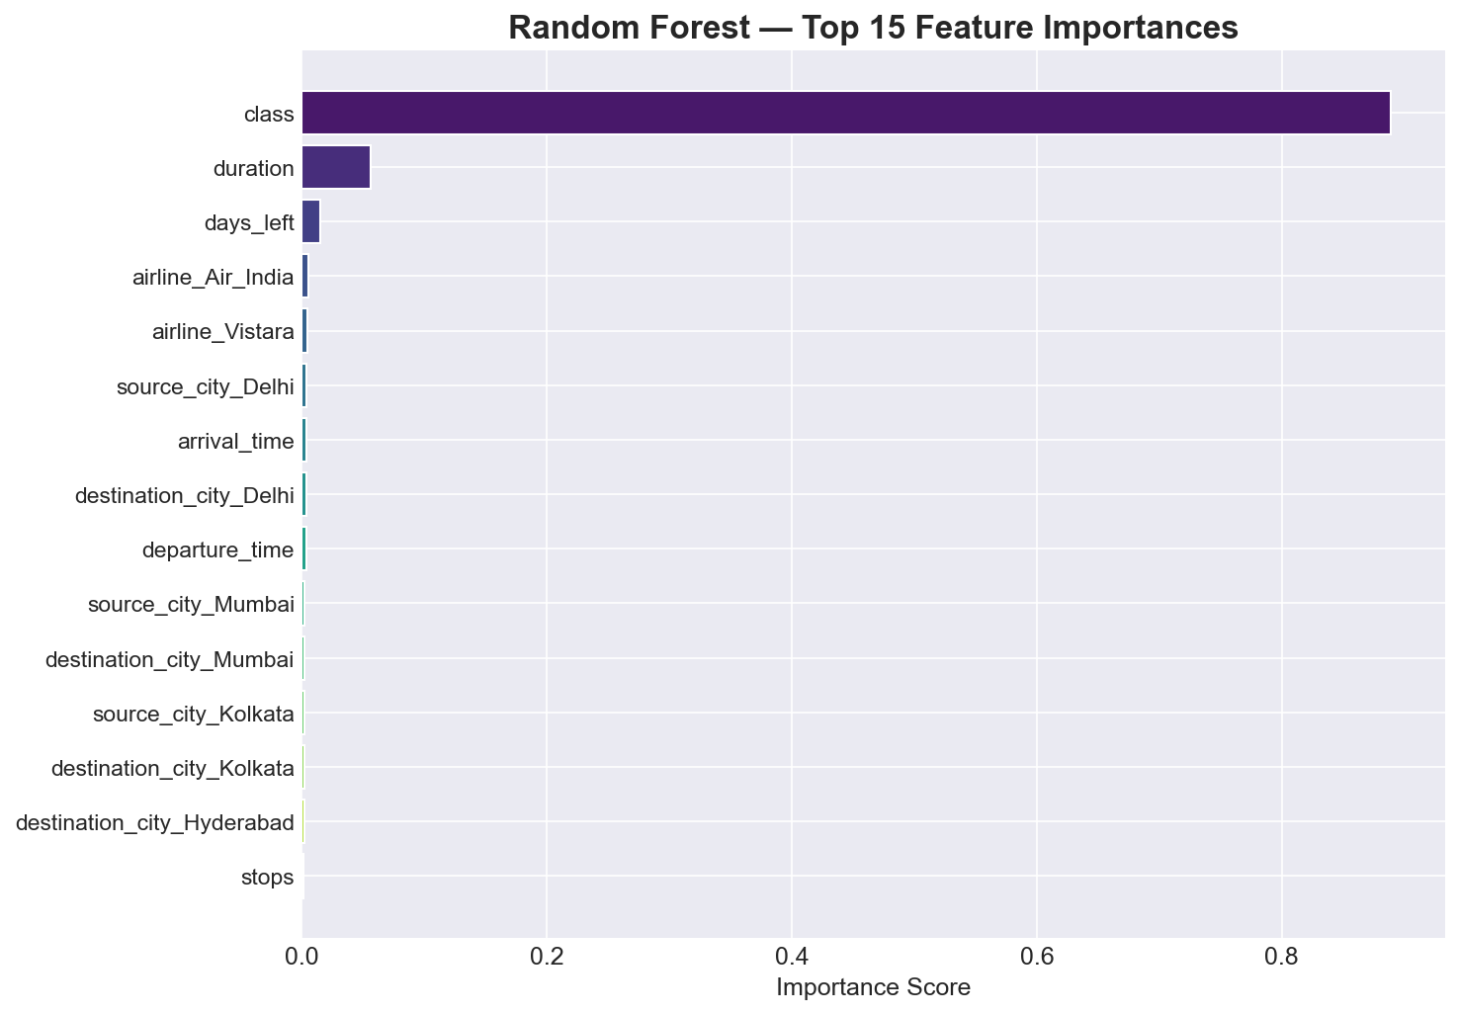
Figure 6: Feature Importance Analysis (Random Forest).
The Actual vs. Predicted scatter plot demonstrates an exceptionally tight fit along the identity line, indicating that the model generalizes superbly to unseen data without severe overfitting.
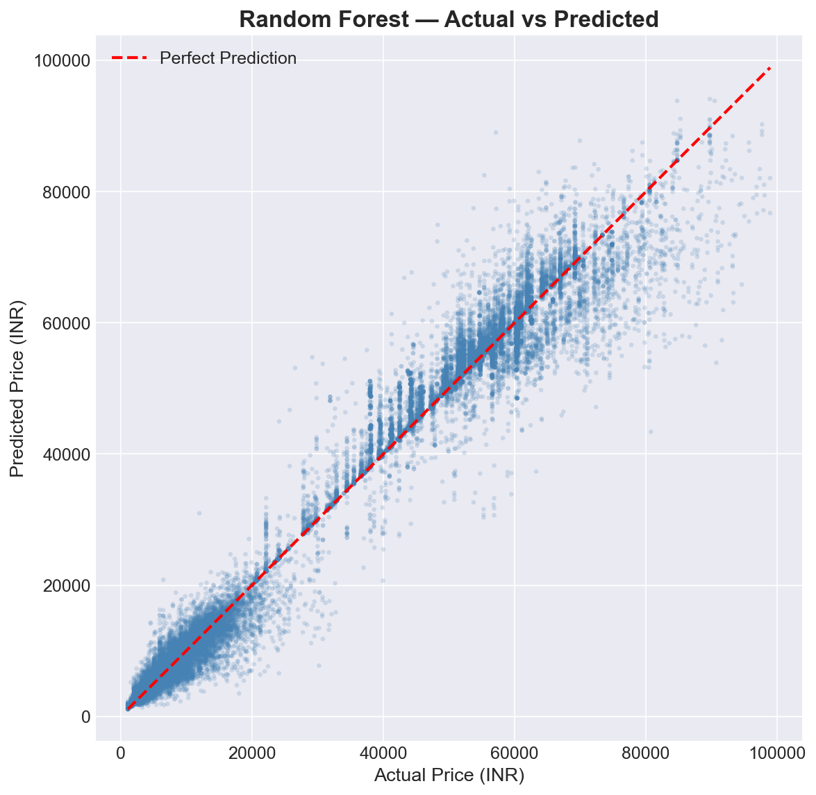
Figure 7: Actual vs Predicted Ticket Prices validating model accuracy.

SUMMARY, CHALLENGES AND CONCLUSION
Challenges
- • Understanding new terminology and technical workflows within a short period, particularly adjusting to the complexities of algorithmic hyperparameter tuning.
- • Debugging errors during practical sessions and identifying the correct cause. Significant challenges were faced during the encoding of categorical data to ensure that unseen categories during user inference did not crash the web application.
- • Computational limitations when training complex models like Support Vector Machines (SVR) on a large dataset of 300,000+ rows, requiring optimization and data subsetting.
- • Preparing a clear report that summarizes activities without unnecessary detail while preserving technical rigor.
Scope for Future Learning
Participants can continue learning by repeating the practical exercises, exploring advanced tools, contributing to open-source projects, and building small portfolio projects related to the programme topic. Future enhancements for this flight fare predictor could include transitioning the model to a Deep Neural Network (ANN) architecture, and utilizing real-time API scraping to adjust predictions dynamically based on current airline APIs rather than static CSV datasets.
Conclusion
The training / internship programme provided useful exposure to open-source technology, practical implementation, and professional documentation. The successful completion of the Flight Fare Prediction system, achieving over 98% accuracy alongside a fully functional web dashboard, serves as a testament to the effectiveness of the curriculum. The sessions helped the participant develop technical awareness, confidence, and a highly capable foundation for further study and professional data science project work.
References
- • ICFOSS official resources and training materials.
- • Session notes, demonstrations, and participant activity records.
- • Open-source documentation related to the tools used in the programme (e.g. Scikit-Learn: scikit-learn.org, Pandas: pandas.pydata.org).
- • Kaggle Flight Price Prediction Dataset by S. Bathwal.

ANNEXURE: CODE IMPLEMENTATION
The following code snippet demonstrates the core model training phase utilizing the Random Forest algorithm within the Flight Fare Prediction pipeline:
from sklearn.ensemble import RandomForestRegressor
from sklearn.metrics import mean_absolute_error, r2_score
# Initialize and train the Random Forest Regressor
rf_model = RandomForestRegressor(n_estimators=100, random_state=42, n_jobs=-1)
rf_model.fit(X_train, y_train)
# Perform predictions on the validation set
y_pred_rf = rf_model.predict(X_test)
# Evaluate model performance
mae_rf = mean_absolute_error(y_test, y_pred_rf)
r2_rf = r2_score(y_test, y_pred_rf)
print(f'Random Forest MAE: {mae_rf}')
print(f'Random Forest R2 Score: {r2_rf}')
Note: The complete source code including the data preprocessing pipeline and the Flask application ('app.py') has been attached to the final submission email.

