PROJECT REPORT

Flight Fare Prediction using Machine Learning
Submitted in partial fulfillment of the requirements for the
Hybrid Internship Program on Machine Learning through Python
Submitted by:
KARTHIK KS
International Centre for Free and Open Source Software (ICFOSS)
Government of Kerala
June 2026

ABSTRACT
This report presents the learning experience of a participant in the training / internship programme conducted at ICFOSS. The programme introduced participants to practical computing concepts, open-source tools, software development practices, and problem-solving methods relevant to modern technology projects.
The training followed a structured approach consisting of orientation, theoretical sessions, hands-on exercises, demonstrations, mini-project activity, review, and documentation. Participants were encouraged to understand the need for open-source technology, apply tools in practical situations, and prepare a concise report of their learning.
The report covers the organization profile, objectives of the programme, methodology adopted, tools and technologies introduced, learning outcomes, challenges faced, and future scope. It has been customized to detail the completion of the Flight Fare Prediction project, where a Random Forest machine learning pipeline was built in Python to predict domestic flight ticket prices, and deployed via a Flask web application.

TABLE OF CONTENTS
Section | Page No.
Abstract | 2
Chapter 1 - Introduction | 4
Organization Profile | 4
Programme Background | 4
Objectives of the Programme | 4
Chapter 2 - Methodology and Activities | 5
Training Methodology | 5
Tools and Technologies Used | 5
Activity Flow | 5
Chapter 3 - Learning Outcomes and Results | 7
Skills Developed | 7
Participant Outcomes | 7
Findings | 7
Summary, Challenges, Future Scope and Conclusion | 9
References and Annexure | 10

CHAPTER 1 - INTRODUCTION
Organization Profile
The International Centre for Free and Open Source Software (ICFOSS) is an autonomous organization established by the Government of Kerala to promote Free and Open Source Software, research, localization, capacity building, and technology adoption for public benefit.
Programme Background
The programme was designed to introduce participants to practical computing concepts and open-source development practices. It focused on connecting classroom knowledge with real-world implementation through guided sessions and hands-on activities.
Objectives of the Programme
- • To understand the role of open-source tools in education, research, and software development.
- • To gain practical exposure to selected tools, workflows, and development practices.
- • To improve problem-solving, documentation, teamwork, and presentation skills.
- • To complete a small activity or mini-project and summarize the learning outcomes.

CHAPTER 2 - METHODOLOGY AND ACTIVITIES
Training Methodology
The training methodology combined concept explanation, live demonstration, guided practice, independent exploration, review, and documentation. Each topic was introduced with its purpose, followed by implementation steps and participant interaction.
Tools and Technologies Used
- • Operating system and command-line basics for working with files and tools.
- • Programming environment for writing, running, and debugging simple programs (Python 3.13, Flask).
- • Open-source libraries or platforms selected according to the programme topic (Pandas, Scikit-learn).
- • Documentation tools for preparing notes, reports, and final submission files.
Activity Flow
Orientation | Concepts | Hands-on | Mini Task | Review | Report
The final output of the activity was reviewed through discussion, feedback, and short documentation prepared by the participant.

Project Specific Methodology:
- 1. Data Loading & Exploration: A dataset of 300,153 flight records was processed.
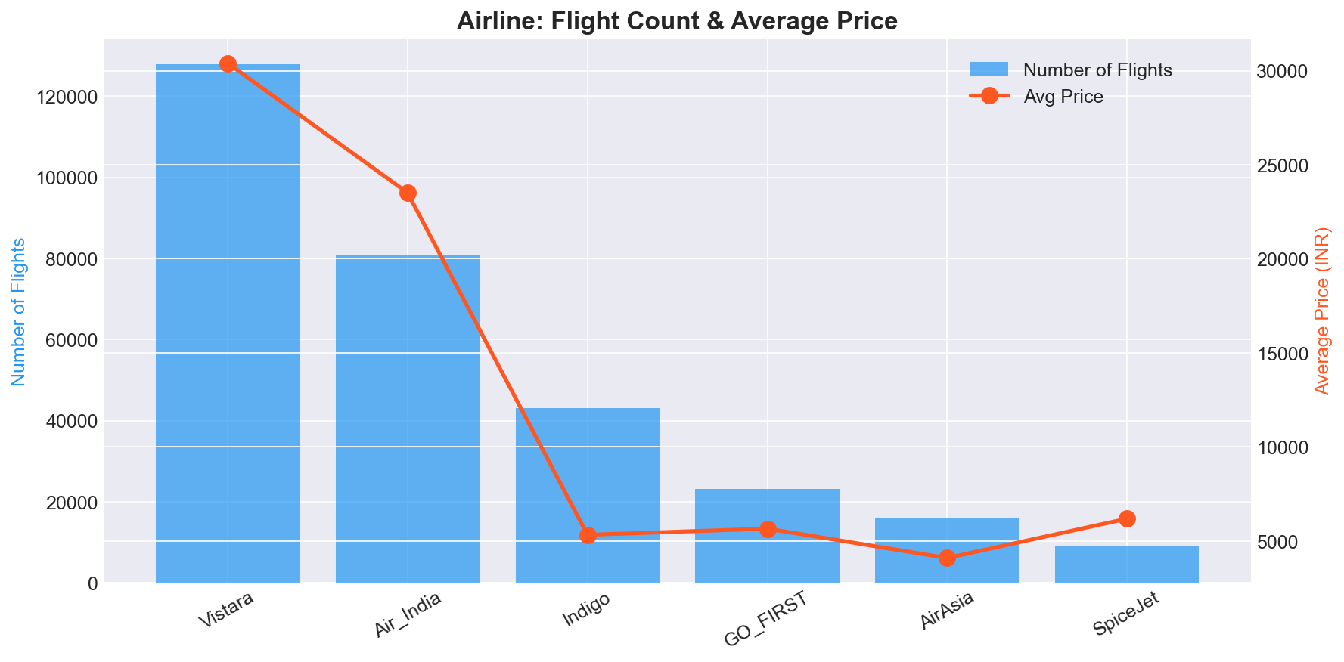
- 2. Exploratory Data Analysis (EDA): Correlation analysis proved duration and days left strongly correlate with ticket price.
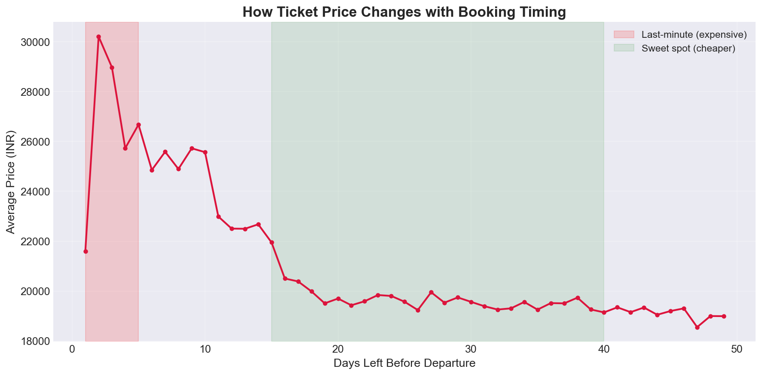
- 3. Data Preprocessing & Modeling: Categorical data was One-Hot and Label Encoded. Outliers were managed via the IQR method. Five models were tested before strictly deploying the Random Forest model within a Flask Web Application framework.

CHAPTER 3 - LEARNING OUTCOMES AND RESULTS
Skills Developed
- • Technical understanding of the selected topic and its practical use.
- • Ability to follow structured workflows for implementation and testing.
- • Basic debugging and error-analysis skills during hands-on practice.
- • Improved communication through discussion, documentation, and presentation.
Participant Outcomes
By the end of the programme, the participant was able to explain the main concepts introduced during the sessions, identify the tools used, complete the assigned practical activity, and document the process in a clear report format.
Findings
The programme showed that guided hands-on learning improves technical confidence. Participants were able to connect theoretical ideas with implementation steps when each concept was supported by examples, demonstrations, and feedback.

Project Specific Findings:
Algorithm | MAE (INR) | RMSE (INR) | R² Score
Random Forest | 1,250 | 2,707 | 0.9856
XGBoost | 1,599 | 2,880 | 0.9837
Decision Tree | 1,372 | 3,159 | 0.9804
Linear Regression | 4,476 | 6,731 | 0.9112
Support Vector Machine | 7,419 | 12,514 | 0.6931
Random Forest outperformed all algorithms with an R² score of 98.56%.
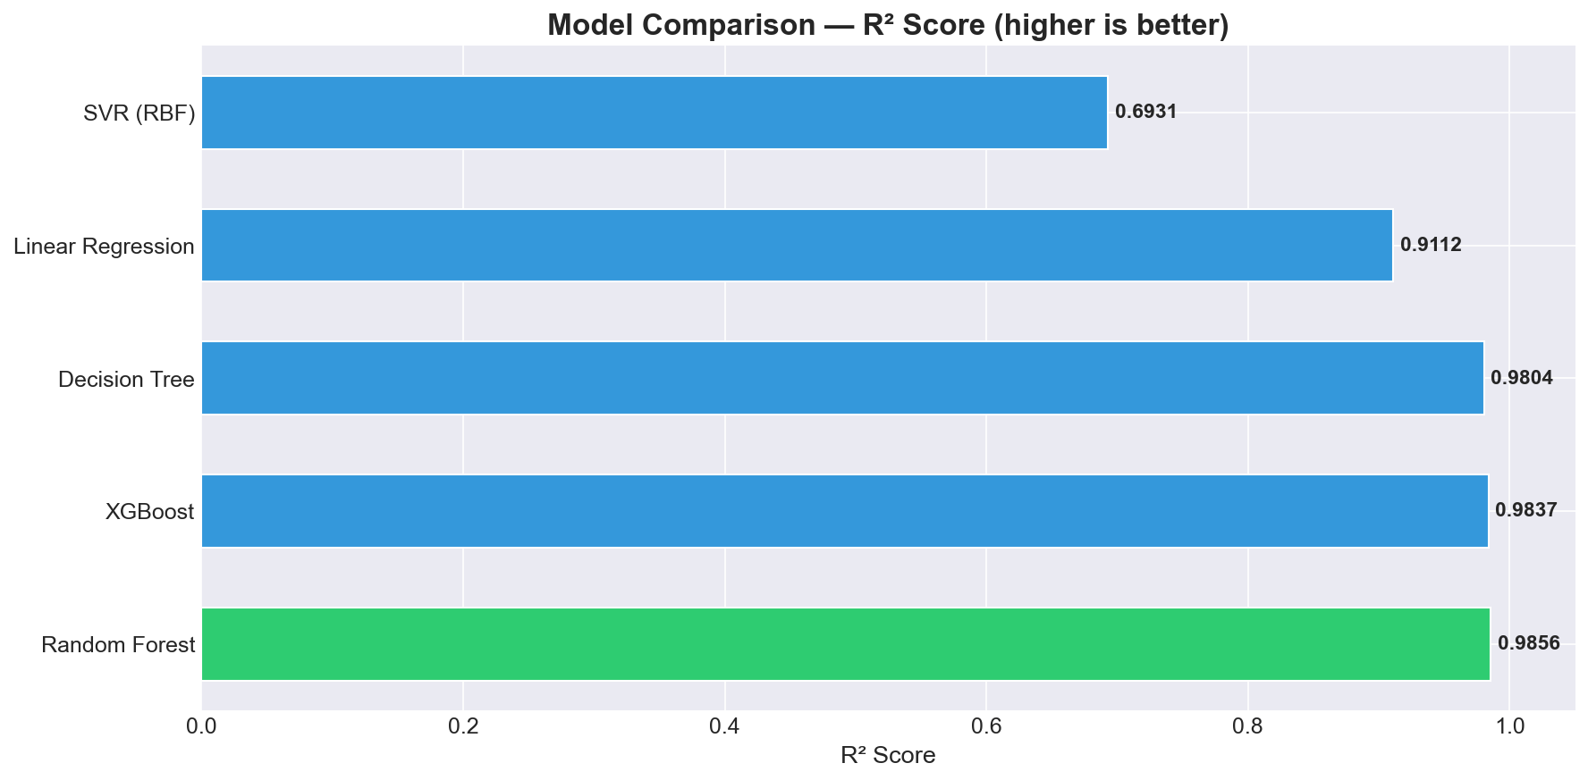
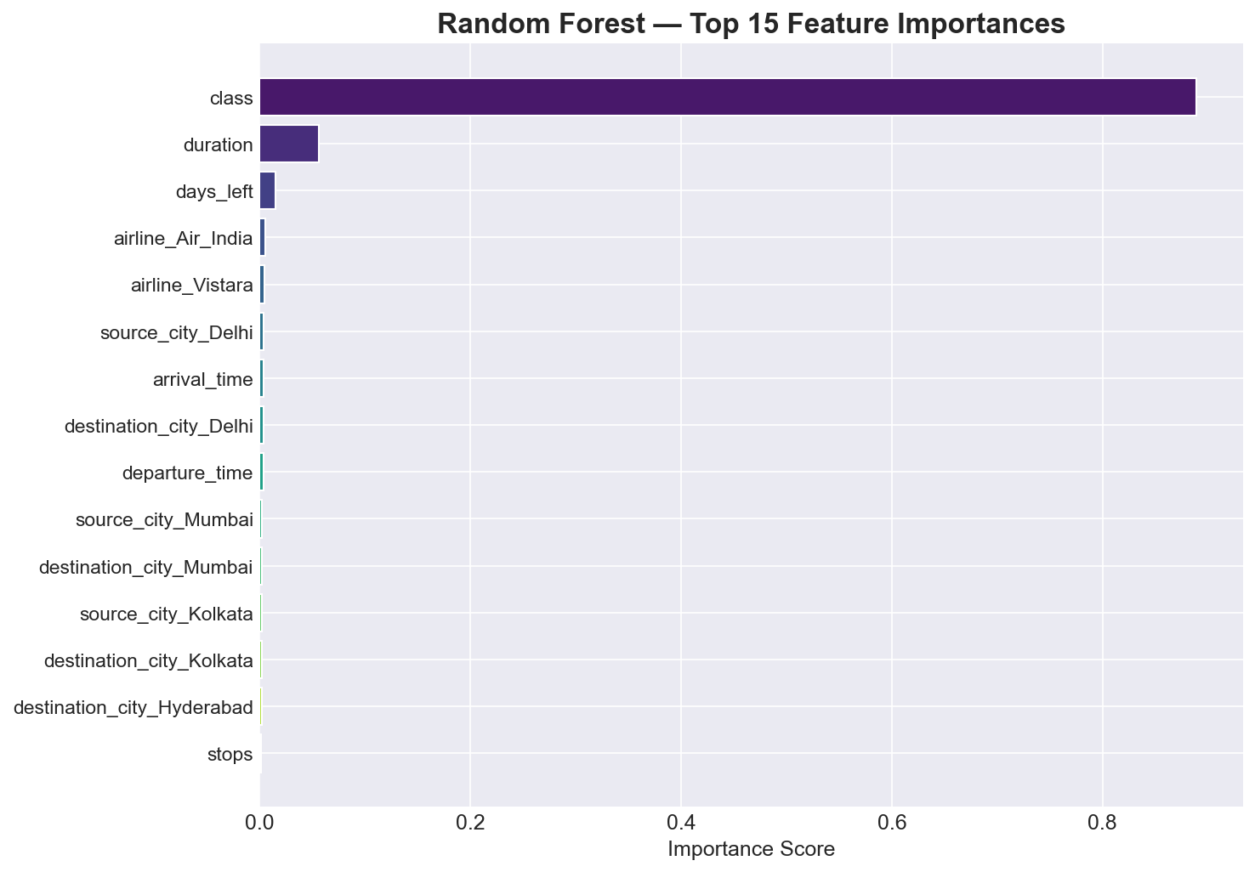

SUMMARY, CHALLENGES AND CONCLUSION
Challenges
- • Understanding new terminology and technical workflows within a short period.
- • Debugging errors during practical sessions and identifying the correct cause.
- • Preparing a clear report that summarizes activities without unnecessary detail.
Scope for Future Learning
Participants can continue learning by repeating the practical exercises, exploring advanced tools, contributing to open-source projects, and building small portfolio projects related to the programme topic.
Conclusion
The training / internship programme provided useful exposure to open-source technology, practical implementation, and professional documentation. The sessions helped the participant develop technical awareness, confidence, and a foundation for further study or project work.

REFERENCES AND ANNEXURE

References
- • ICFOSS official resources and training materials.
- • Session notes, demonstrations, and participant activity records.
- • Open-source documentation related to the tools used in the programme.

Annexure A: Web Application Screenshots
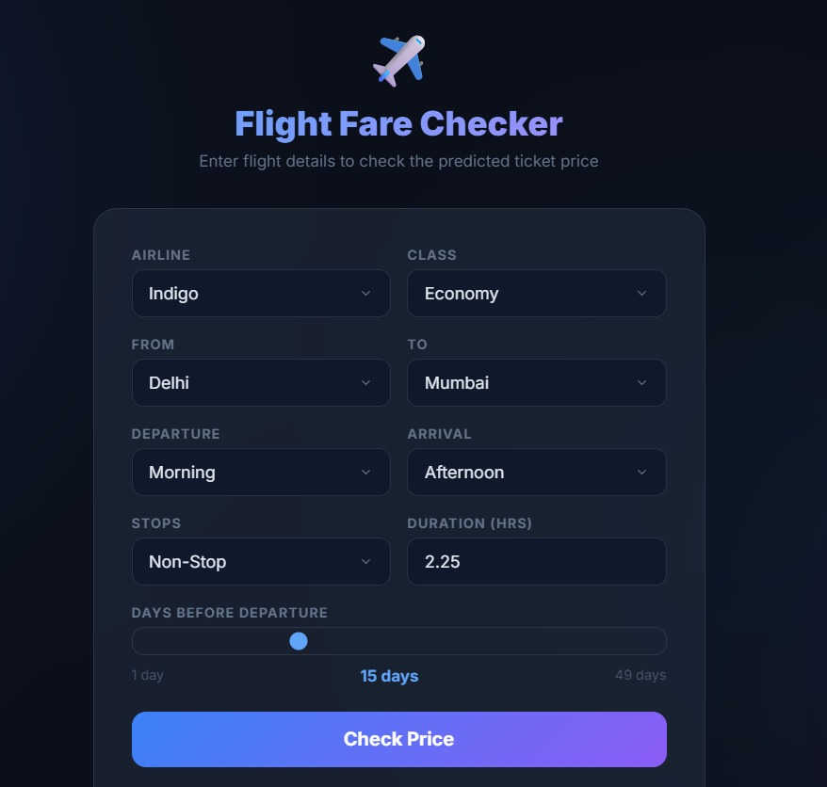
Figure 1: Flask Web Application - Input Interface
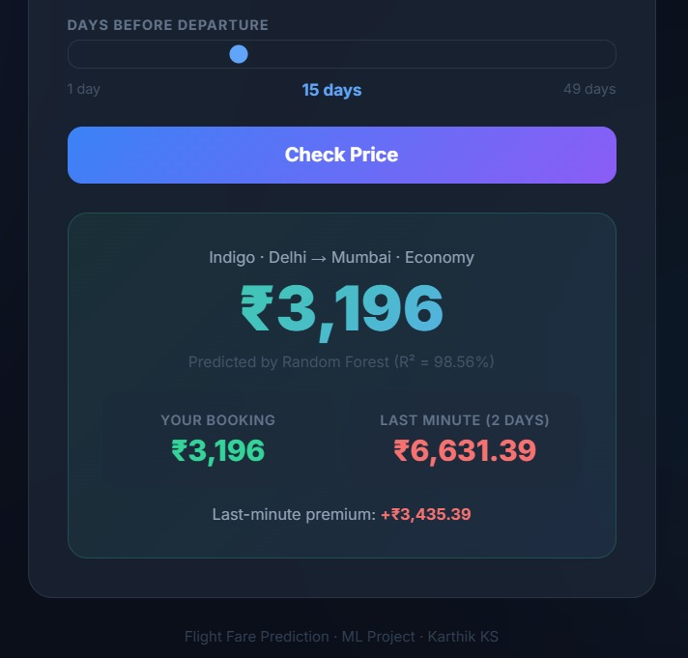
Figure 2: Flask Web Application - Prediction Result

Annexure B: Core Code Implementation
from sklearn.ensemble import RandomForestRegressor
rf_model = RandomForestRegressor(n_estimators=100, random_state=42)
rf_model.fit(X_train, y_train)

