Logo, Name On top left.

Functions
- Give Macro Calculator
- Tdee Calculator
- Bmi ratio Calculator
- Bmr
- User Input for Personal data Height, Bw , Sex,
- Fitness goals === Fit , absolutely Jacked (muscular + lean), Athletic muscular (lean ),Bodybuilder kind of physique , model lvl lean.
- Yoga Lessons.
- Pilates
- Subscription.
- Offers + Bundles
- Different Sections for Each Function else One page + merging Many functions.
- We can Lunch a Message Bot in Side , like where we See , for
- Fat loss , Muscle Gain , Weight maintenance
- Not on top but little below the header , Before And after transformations page , so that it tempts the Users to take Premium
- Building a Customed timetable according to user needs , using Ai , built in ai tool for the app,

Free Bundle
- Packs 3+ For Free
- Just Giving a rough Macros on top to Satisfy Customer
- Giving the Tdee , basic functions
- X meal plans , no follow ups , no Trainer Meetups virtual ,
Premium Bundle
- 6+ Functions + Diet Chart + Weekly Follow ups , by fitness trainer
- Private Discord Hub for Members only
- In discord Hub Weekly Hurdles , Where Coach and other members have Monthly twice , Team Mettings online For Socializing and Team Synergy
- Book A trial Premium Free for 14 days then pay +(xx) fee
- Personalized meal plans and workout schedules
- Building type of diet regarding user Preference , Vegan / non veg eater
- High protein diet === Choosing options of meat , vegetables , Seeds, beans , Fibre , Type of carbs
- Moderat eprotein diet == preferred options for , Carbs , Meat , Fibre , Legumes , beans , , little snacking.
- Customised plans , Workout + Diet .

Footer
Fake Address of Location , Contact info of Company , and shar holder list in that footer
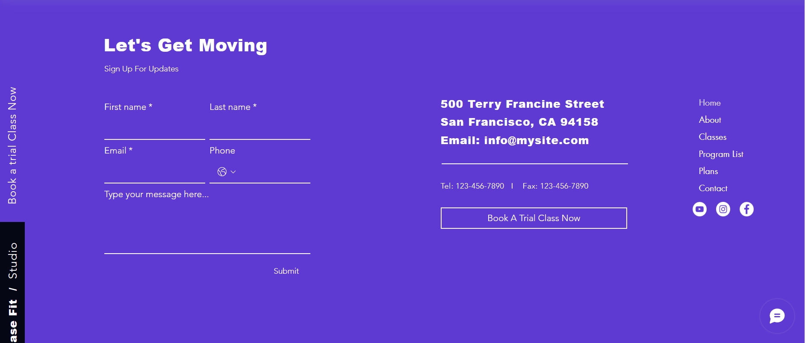
Big Footer , With Social Links === Yt , Insta , Facebook , Twitter , Discord links ,

Example Templates
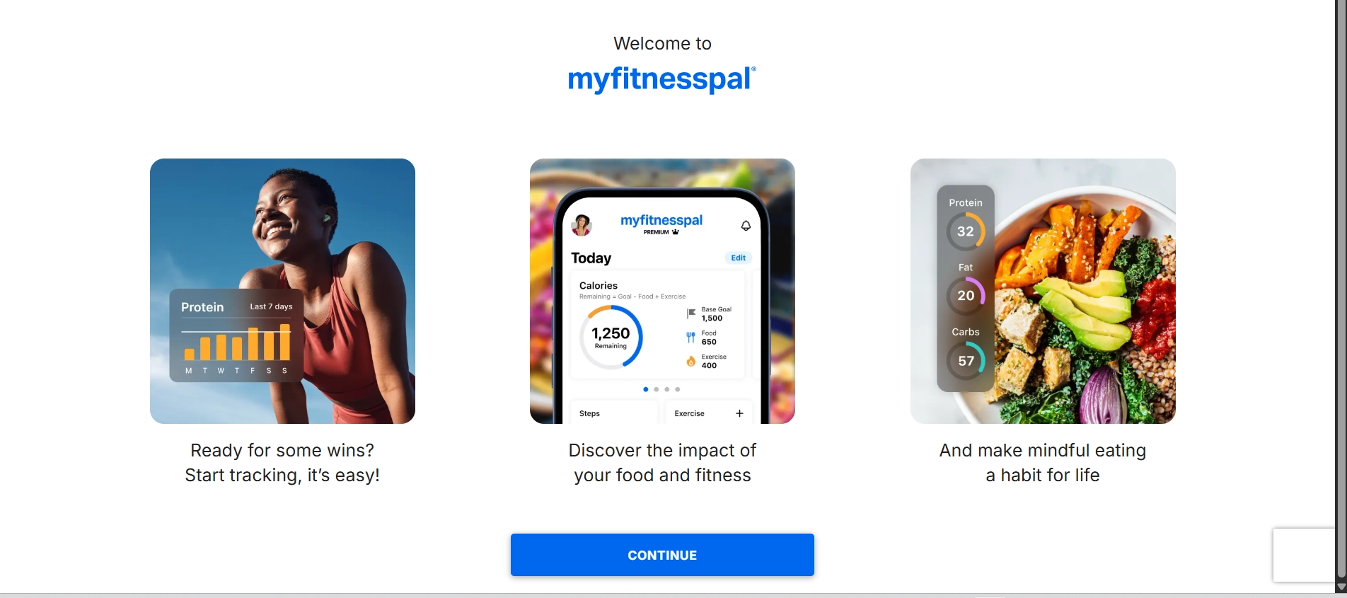
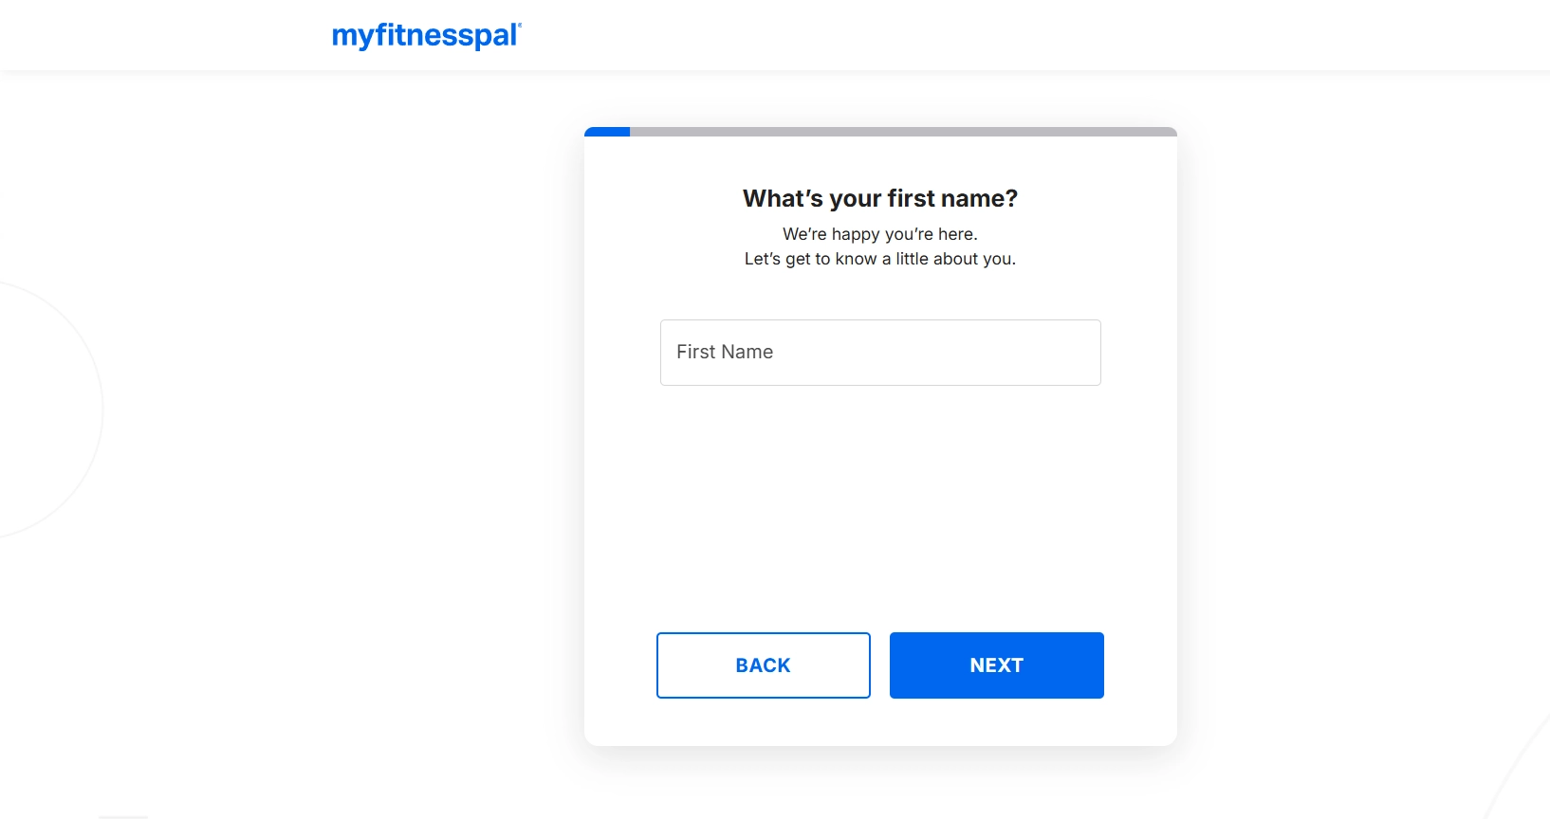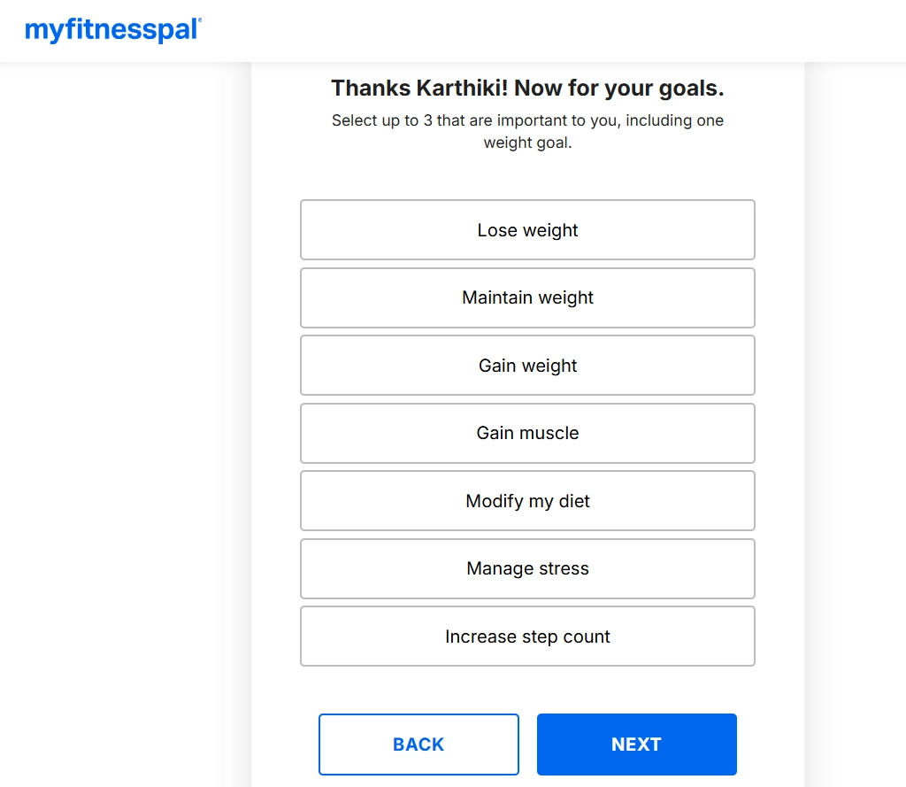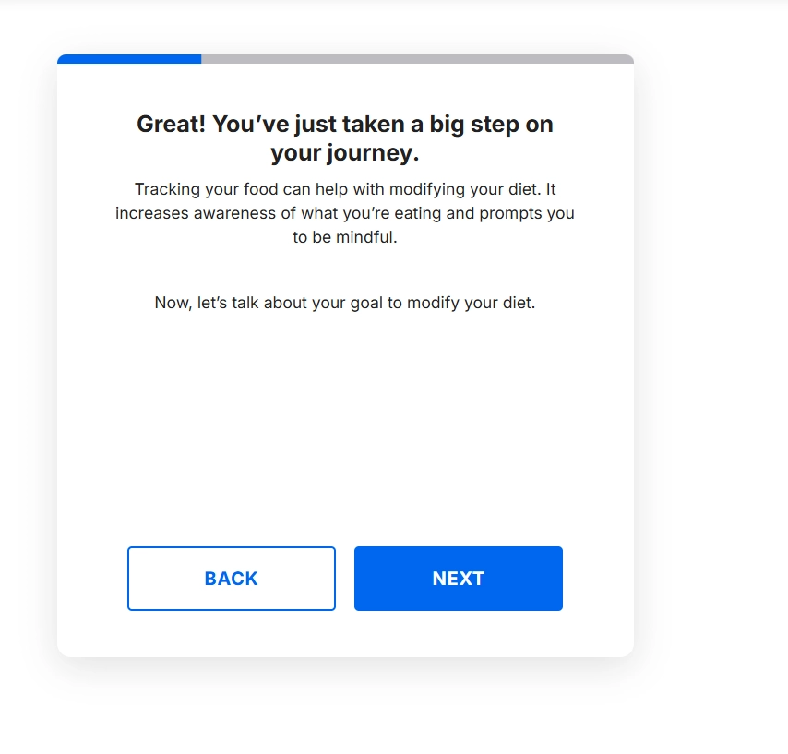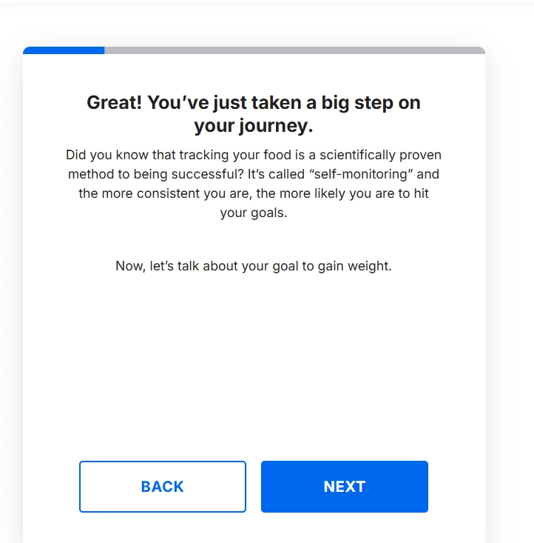

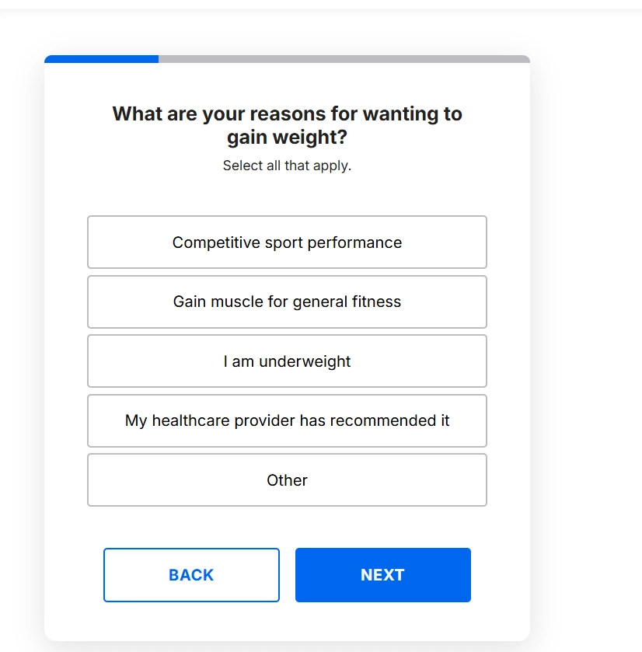

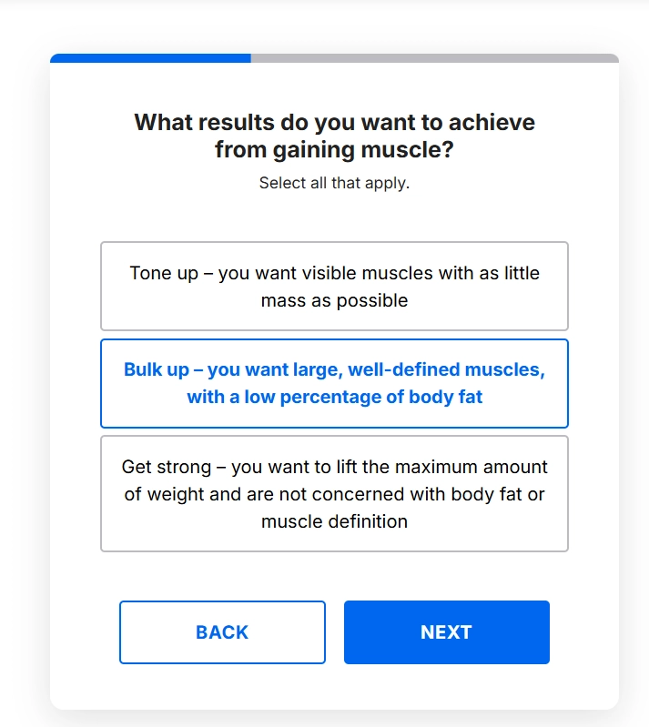
There We need to Create a Separate section where we show people or user the success rate of people who use our service/product kind of a proof.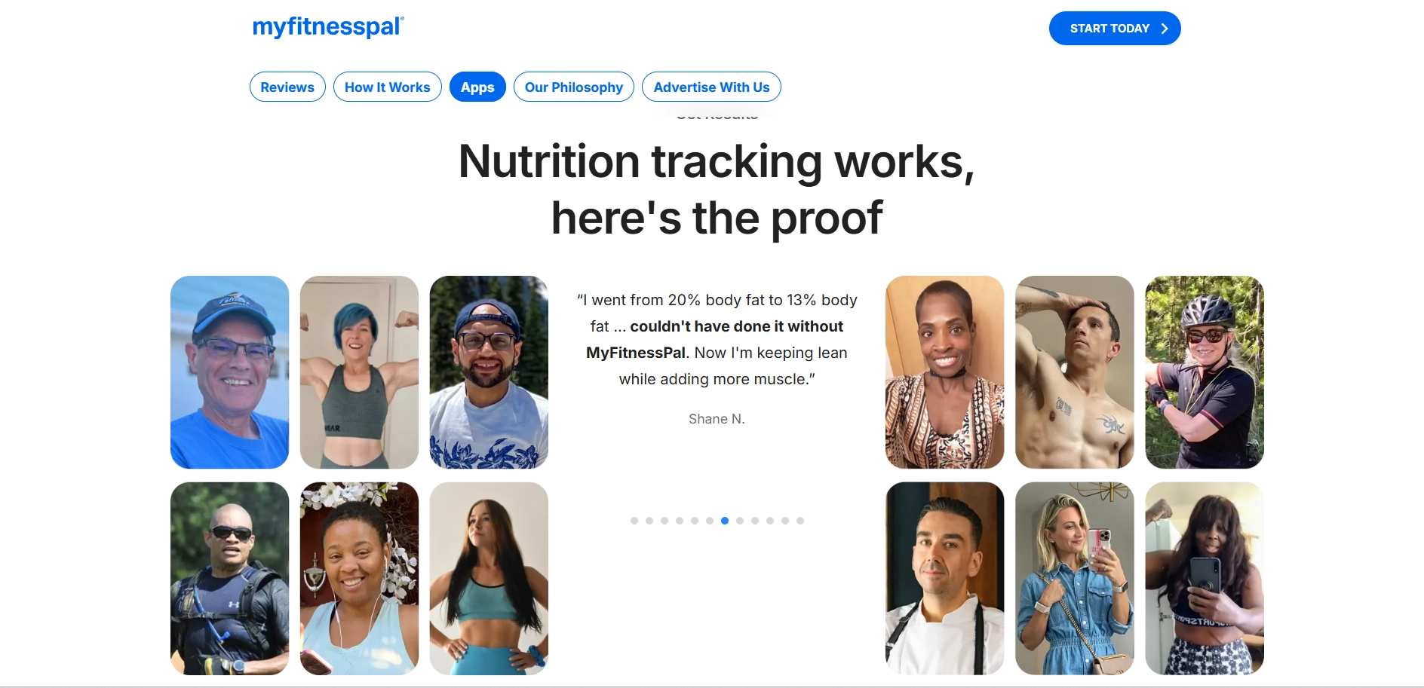

Here it’s mostly the part where we appreciate our Web app and then we give some motivational quotations .
