**SOLID Principles**:

* **S** -SRP single Responsibility Principle-One Class should have single implementation -Don't add exception handle in same class.
* **O**-Open Closed Principle -It should be Extendable but should not modify -Abstract Virtual Override
* **L** -Liskov Substitute Principle - Create different interface and call
* **I** -Interface Segregation Principle -Implement only required don't force to use all and unwanted implementations.
* **D** -Dependency Inversion Principle -High Level model should not depend low level model

**IoC**-IoC says that a component should not depend directly upon any another component, it should rather depend upon an abstraction or Interface.

Class A -----> Class B

Class A ---Abstraction [Interface, Abstract] ----Class B

**what is DI**?-Constructor Inj ,Property Inj?

What is components? Common code for all

what is repository? Controller -dbcontect-sql server ,split dbcontext seperate layer one repository per model or generic reps

Microsoft .NET Framework:

1.What is CLR ?

-CLI

-Portable Execution

-MSIL

-Native Code(JIT)

-Machine Code

2.Managed Code and Unmanaged Code

3.What is GAC(**Global Assembly Cache**)-To store assembly in c drive-Stores the .net assemblies which are shared between multiple application

4.Tool used to see IL Code ? IDASM.exe

5.Net assembly’s metadata is stored in which file-Manifest

6.root namespace for fundamental types in .Net framework-System. Object

Oops Concept:

1.What is Value Type and Reference Type.

2.Access Modifier Keywords ? Default ?

3.use of this keyword?

4.What is Assembly?

5.what is Var ?

6.What is Struct ? use of struct ? val type or ref type? access specify? inherit?

7.What is enum?

8.What is string and string builder ? how value stored in RAM (stack and Heap)

9.What is Stack ? Push ,Pop,Peek,Clear,Contains? It will allow null ?

10.what is Queue? Enqueue ,DeQueue,Peek,Contains,Clear?

11.what is Hashtable ? Key Value Pair -Slow compare to Dic becz of hashcode keys

Hashtable ht = new Hashtable();

ht.Add(1, "One");

12.What is Dictionary ?

Dictionary<int, string> dict = new Dictionary<int, string>();

dict.Add(1,"One");

13.What is Interface ?

14.What is Delegate? Event Hand,Callback,passing as parameter

15.what is Event ? Publisher,Subscriber?

16.What is Generics? Avoids boxing/unboxing

17.What is Partial Class ? Same Assembly ,same access specifier -- .aspx and .cs

18.What is Static ? non Parametrized Constructor ? Only One constructor?just calculate don't assign value to property

19.What is Anonymous Method ? public delegate void Print(int value);Print prnt = delegate(int val) {};prnt(100);

20.What is Nullable Type? Nullable<int> i = null;

21.What is Extension Method ? .ToString(),.GetType()

22.What is Anonymous Type? Var

23.What is Wrapper Class(Encapsulate) Runtime and Compile time

24.What is Sealed Class? can't inherit and performance improv in CLR

25.What is Garbage Colection ? Managed Heap -Stroing Format Gen 0 and 1 Single Seg ,Gen 2 Group-(Gen 1 Newly created object,short storage like temp data)-

To call GC-**GC.Collect()**

method notifies garbage collector not to call finalize-**GC.SuppressFinalize()**

(Gen 2 -Promoted from Gen1 like static var)

26.What is Abstract class? Virtual and Override?

27.Constructor and Destructor ? When Destructor will invoke ? ~ Symbol

28.What is Polymorphism? One interface-Multiple Form ,Static(Compile) Dynamic(Run)

Static: Func Overloading,Operator Overloading

Dyamic: Abstract ,Virtual,Override

29.What is Encapsulations? Access Specifier

30.What is thread? main thread ? Unstarted,Ready,Not Runnable,Dead

31.What is Reflection ? Late Binding,Obtaining information at run time.

32.What is constant?Should assign value otherwise it will through error in compile time and we can't change the value.

33.What is ReadOnly ? We can change or assign value in run time.using non static constructor

34.What is Boxing and UnBoxing?

35.What is Impersonation ?

36.What is LDAP Authentication?

State Management Techniques:

1.What is Cache? Page,Frag,Data Cache? Duration,VarByParam,VarByBrowser

2.What is Cookies ? Persistent,Non Persistent ? Where it is storing ?Max Limit of Cookies 20 ? how to add expire day HTTPCookies? App fabric?

3.What is Session ?In-Proc(Memory Object),State Server(Out-Proc)[Aspnet_state.exe],SQL Server

4.What is Viewstate?

5.What is Hidden Field?

ASP.NET Web Form:

1.What is round trip?

2.Response.Redirect() ? Server.Transfer() ? 302 and 200 Code?

3.What is skin file ? how to apply theme for application?

6.What is Query String?

7.what is localization and globalization?

8.what is webconfig file?

9.what is master page ?

10.what is tracing?

11.what is the use of Global.asax

12.Types Of Authentication? Windows,Form,Passport?

13.ASP.NET Life Cycle?

14.what is IsPostback()

15.What is HTTP handler? Page Handler(.aspx),User Control(.ascx),WebService Control(.asmx),trace(.axd)

16.Navigation Techniques in ASP.NET ?

17.Diff Bw Web config and Machine Config?

18.Components of ADO.NET ? DataSet,DataReader,DataAdapter,Command,Connection?

19.ExecuteScalar(Select),Execute Non Query(Insert)?

What is Cyclomatic Complexity?

MVC:

1.What is MVC ? Explain Model,View,Controller ? Adv ? Compare with ASP.NET Web Form ?

2.MVC life cycle?

3.What is routeconfig ? how to specify route ? how to register?

4.Action Methods and return type?

5.Action Selectors? ActionName,NonAction,ActionVerb(AcceptVerb)?

6.Model Binding? Include,Exclude?FormCollection,Request,Collection(Complex)?

7.Filters? Authorization[Authorize,RequireHTTPS],Action[OnActionExecuting,Executed],Result[OutputCache],Exception[HandleError]? Action Method Level ,Controller Level?

8.Attribute based Routing?[Route("products/{id?}")]

9.What is Model ?

10.What is View?

11.What is View Bag,View Data,Temp Data?

12.Layout ? Partial View?

13.what is data annodation ? types of validation ?

14.what is Areas?

15.MVC Scaffolding?

16.what is output cache?

17.what is bundling and minification?

18.what is primitive and complext type ?

19.what is modelstate.isvalid-To check there is any error?

20.what is antiforiegnkey token?

21.HTML helper class? TextBox and TextboxFor?

22.How to handle Error? Action Method ,Controller,Global Level?

23.What is View Start?

24.What is ActionLink?

25.What is CSRF(Cross Site Request Forgery)

26.What is Route Constraints?

27.MVC Validations?

ModelState.AddError("Name","Please Enter a Name");

Data Annodatiopns?

Client Side Validation? UnobtrusiveJavascriptEnabled in appsetting ,add required jquery script and call in view

28.HTML.BeginForm()

29.How to specify the Layout in view page ?RendorBody(),RenderSection()?

30.What is partial view ? render in view RenderPartialView().

31.What is _ViewStart() ? Use ?

Web API

Entity Framework

Linq

SQL Server

**Improve Performance:**

1.Set debug=false in web.config

requires the pdb information

2.Turn off Tracing unless until required

3.Choose Session State management carefully

In Proc

Out Proc

SQL

4.Deploy Mode

Release Build mode dont use Debug Build

5.Disable View State of a Page if possible

Memory and Serialization is required

6.Avoid Response.Redirect

Round Trip use server.transfer

7.Use StringBuilder to concatenate strings

8.Use Client-side Scripts for validations

9.Use Page.ISPostBack

10.Do Ajax calls instead of ASP.NET code behind code

**Linq:**

String [] StudentName={"Karthik","Arun","Sai"};

Comprehension:

var name=from std in StudentName WHERE std.length>5 SELECT std;

Lambda:

var name=StudentName.Where(a=>a.length>5).FirstOrDefault();

var name=from std in StudentName WHERE std.length>5 order by std.name SELECT std

int count=(from std in StudentName WHERE std.length>5 order by std.name SELECT std).count()

var filteredResult = from s in studentList

where s.Age > 12

where s.Age < 20

select s;

var filteredResult = studentList.Where(s => s.Age > 12).Where(s => s.Age < 20);

OfType in Query Syntax:

Use OfType operator to filter the above collection based on each element's type

IList mixedList = new ArrayList();

mixedList.Add(0);

mixedList.Add("One");

mixedList.Add("Two");

mixedList.Add(3);

mixedList.Add(new Student() { StudentID = 1, StudentName = "Bill" });

var stringResult = from s in mixedList.OfType<string>()

select s;

var intResult = from s in mixedList.OfType<int>()

select s;

var orderByResult = from s in studentList

orderby s.StudentName

select s;

var studentsInAscOrder = studentList.OrderBy(s => s.StudentName);

var thenByResult = studentList.OrderBy(s => s.StudentName).ThenBy(s => s.Age);

var thenByDescResult = studentList.OrderBy(s => s.StudentName).ThenByDescending(s => s.Age);

Joins:

IList<string> strList1 = new List<string>() {

"One",

"Two",

"Three",

"Four"

};

IList<string> strList2 = new List<string>() {

"One",

"Two",

"Five",

"Six"

};

var innerJoin = strList1.Join(strList2,

str1 => str1,

str2 => str2,

(str1, str2) => str1);

var innerJoin = from s in studentList // outer sequence

join st in standardList //inner sequence

on s.StandardID equals st.StandardID // key selector

select new { // result selector

StudentName = s.StudentName,

StandardName = st.StandardName

};

Let:

var lowercaseStudentNames = from s in studentList

where s.StudentName.ToLower().StartsWith("r")

select s.StudentName.ToLower();

var lowercaseStudentNames = from s in studentList

let lowercaseStudentName = s.StudentName.ToLower()

where lowercaseStudentName.StartsWith("r")

select lowercaseStudentName;

SP Tuning:

Why Tune

-SP Time Out

-Delay

-Deadlock

-More Disk Read

**1. Parameter Sniffing (recompile)**

@in_SetupId int

Declare @local_SetupId int =@in_SetupId

Select UserId from UserDetail where SetupId=@local_SetupId

**2.Dont Use * SELECT Only required Column**

**3.Create non clustered index on temp table**

Create NonClusteredIndex IDX_TP4 On #TempProductHierarchy(ProductId)

**4.WITH NO LOCK**

SELECT * FROM Table WITH(NOLOCK)

**5.USE Exits and NOT Exists Instead of IN and NOT IN**

**6.USE Local Var to save function return value**

**7.Use TRY CATCH Block**

**8.USE SET NO COUNTS**

Whenever we write any procedure and execute it a message appears in message window that shows number of rows affected with the statement written in the procedure.

**9.Prevent to use DDL inside the sp CREATE ,ALTER,DROP,TRUNCATE**

**10.USE ALIAS**

**11.Avoid Function on RHS**

Select * from Promotion where YEAR(StartDate)=2015 and MONTH(StartDate)=6

Select* From Promotion Where StartDate between '6/1/2015' and '6/30/2015'

**12.Full Qualified Procedure Name**

Schemaname.sp name

Sp name should not be start with pr_spname

Because it will first search in master db then come to actual db

**13.Dont Use Temp Table use local variable type “table”**

**14.Dont Use CURSOR in SP USE WHILE LOOP**

**15.Avoid Sub Query use INNER JOINS**

**16.Choose Appropriate Data Type to store values**

**17.Try To avoid nchar and nvacrchar –double memory**

**18.Use UNION ALL instead of UNION**

**19.Use Schema Name before all sp name**

**20.Use CASE statement avoid Nested If condition**

**SQL :**

**SQL :**

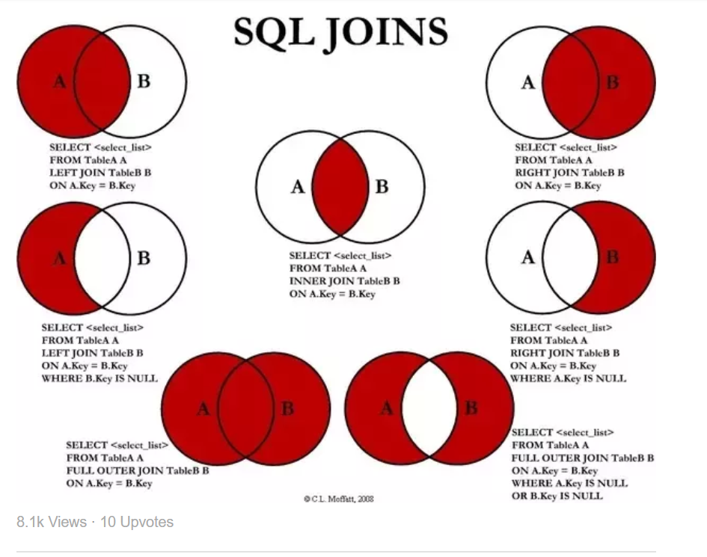

1.Inner Join –Join

2.Left Join-Left Outer Join

3.Right Join –Right Outer Join

4.Full Outer Join

5.ORDER BY

6.Operator >,<,>=,<=,!=

7.WHERE 1=1

From Coding based on condition it will add condition with ‘AND’ ‘OR’ Condition.

It will always be ‘TRUE’

8.DISTINCT

9.MIN ,MAX

10.Avg, SUM,Count

11.NOT

select * from Student WHERE Name ! ='Karthik'

select * from Student WHERE not Name='Karthik'

12.BETWEEN ,NOT BEETWEEN

13.IN Cond

14.LIKE ‘ aa%’ ‘%ss’,’%ss%’

15.IS NULL ,IS NOT NULL

16.Group By SUM ,AVG,Count

17.HAVING

Filter with Group By Result Set

select SUM(Mark1) as mark,StudId as mark1sum from Mark GROUP BY StudId HAVING StudId>1

17.Alias

* An Alias is a shorthand for a table or column name.
* JOINS
* An Alias only exists for the duration of the query.

18. Self-Join

**SELECT column-names FROM table-name T1 JOIN table-name T2 WHERE condition**

**19.** Union

Combines the two query result **SELECT column-names FROM table-name UNION SELECT column-names FROM table-name**

18. Sub Query

Select * From Table1 WHERE ID IN( SELECT ID FROM Table2)

19.ANY ,ALL

20.SELECT INTO

select * INTO marktemp FROM Mark

21.Insert INTO

INSERT INTO marktemp(Mark1,mark2,mark3,studid) SELECT Mark1,mark2,mark3,studid from Mark

22.SQL Injection

-Code Injection Technique

-It is the replacement of malicious code in sql string

-web hacking tech

- run malicious SQL queries against a database server

23.WHERE And INNER JOIN Cond

First WHERE will get execute

THEN INNER JOIN will get execute

Query Order Processing:

1. FROM

2. WHERE

3. GROUP BY

4. HAVING

5. SELECT

6. ORDER BY

24.UNION ,UNION ALL,INTERSECT

25.CASE Statement

26.WHILE LOOP

27.CURSOR

28.SQL Query to find second highest salary of Employee  
  
SELECT max(salary) from employee where salary not in (select max(salary) from employee))

29.Find Max salary from each dept

SELECT deptID,MAX(Salary) from Employee Group By DeptId.

30.Write an SQL Query to find an employee whose Salary is equal or greater than 10000.

SELECT EmpName from employee where salary>=1000

31.Find Employee Name Start With and End With and Contains

SELECT * FROM Employee WHERE name like ‘S%’

SELECT * FROM Employee WHERE name like ‘%S’

SELECT * FROM Employee WHERE name like ‘%S%’

32.Get Year From the Date

SELECT Year(GetDate()) as “Year”

33.How to find duplicate records in table.

Select * from employee e1 where rowed=(select max(rowid) from employee e2 where e1.empno=e2.empno)

34.PIVOT

35.What is SQL Profiler.

**Web Service:**

why wcf

interoperable service

dot net web service

-.asmx file ext

- WebMethod top of all methods

- Add Web Service in Web Appl

- http protocol ,xml message format

- webservicenameSoapClient obj creation and call method

dot net remote service

-Class Library

-MarshalByObject

-Add reference class library

-Invoke

RemotingService

TcpChannel with port no 8080

-tcp protocol,binary message format

wcf-all communication

Different End Point

Sys.servicemodel dll ref

HelloSer.cs

using IHelloSer interface

Implementing interface method

IHelloSer.cs

Interface -decrotated with ServiceContract

Method decorated with -OperationContract

Creating End Point in config file:

<system.servicemodel>

<binding>

<service>

name

end point -

address -Hello Service

binding -basicHTTPBinding

Contract-InterfaceName

<netTCPBinding>

binding-netTCTBinding

Meta Data Excchnage

<endpoint address="mex" binding="mexHTTPBinding"

contract="IMetaDataEcch">

<host>

<baseaddress>

<add baseaddress="http//localhost:8080"> /HelloService

<add baseaddress="net.tcp//localhost:8080">

</host>

<behaviors>

httpGetEnabled -True

</behaviors>

Web Api:

[HttpGet]

[Route("api/Promotion/GetInvestmentDetails/{investmentTypeId}")]

Browser

mobile app

Desktop app

IOT's Internet of things having ip address

RESTFul

representation of statefull service

stateless

cacheable

uniform interface

/Employee GET Get the list

/Employee/1 GET Get Employee record of 1

/Employee POST New

/Employee/1 PUT Update

/Employee/1 DELETE

HATEOS(Hypermedia as the engine of application state)

Request Verb

Request Header-Response method(XML)

Request Body-data send to the server

Response Body-data format

Response Status Code-404 not found,200 ok,204 no content

Accept:application/json

Accept:application/xml

Accept:application/json,application/xml

quality factor q=0.4

Default format return is JSON

WCF :

With multile end point (Java and .net) HTTP ,TCP

SOAP Based service Binding

Performance Low

Web API:

Lightweight

Not required any data contract and configuration like wcf

Feature WEB API WCF

Content format Any media format SOAP+XML

Service interface URL Patterns, HTTP methods Service contracts

State management Stateless Stateless with Per Call

Caching mechanism Built in to HTTP Prefer application control Handled by application

Error handling HTTP status codes filters, exceptions Faults, behaviors

Types Opt-out Opt-in