**Results:**

• What are the most dangerous NYC borough / area for a bicycle rider? Use visualization.

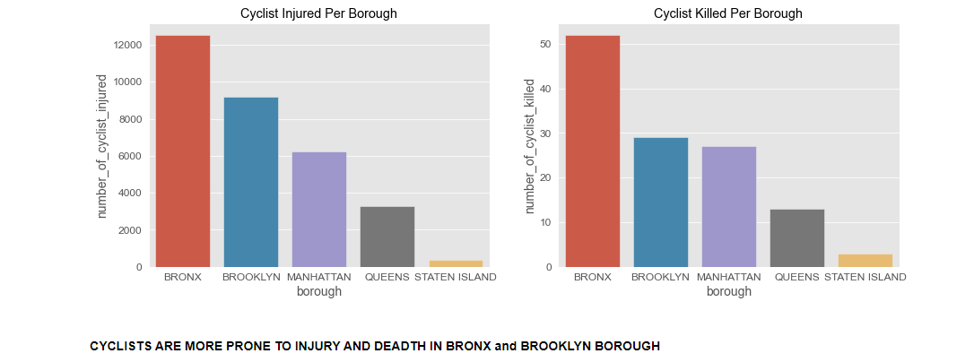

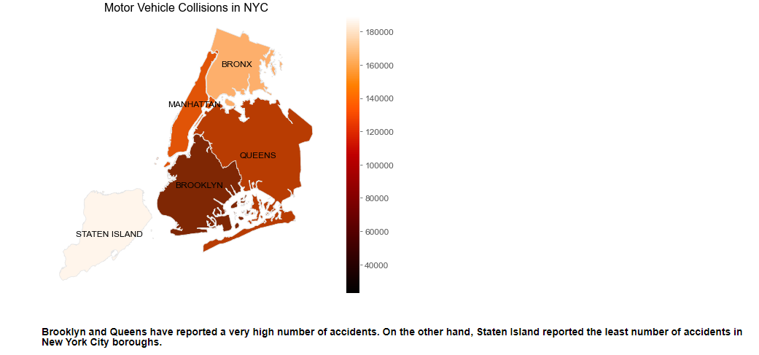

• What would you change in the locations of bike stations to increase safety? Use visualization.

**Since the dataset is huge and there’s a limitation on the resources, I have performed the analysis on the Manhattan Borough. The same can be performed on the other Borough.**

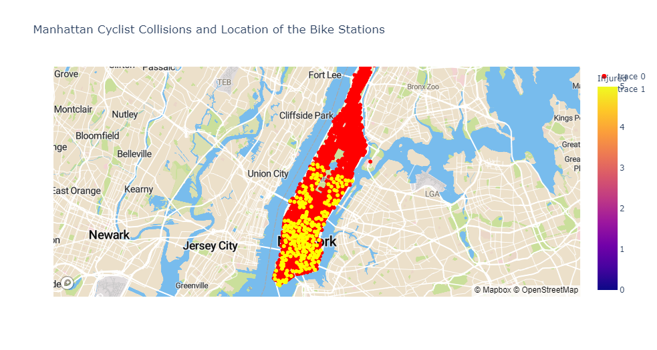

**There are over 18 Bike Stations which can be identified from the coordinates in close proximity (15 meters and less) to the collision location. Hence to increase the safety we can relocate these 15 bike stations away from the Collision Locations.**

• Where can an accident occur and how close is this from the nearest bike station? Create a predictive model.

**Predictive model for the accidents in the future years.**

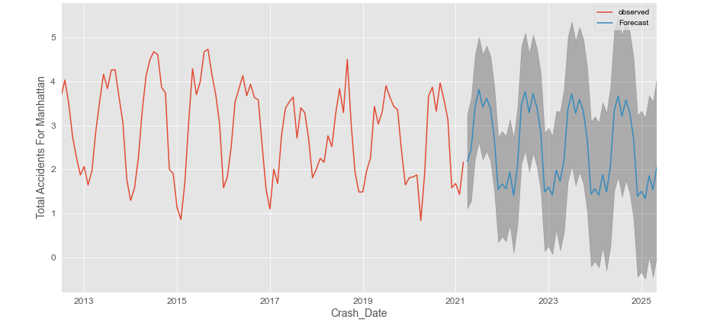

• Extra questions: What other interesting patterns do you find in the data? What other data sources would be interesting to correlate?

**The following patters were found in the data.**

1. **Brooklyn and Queens have reported a very high number of accidents. On the other hand, Staten Island reported the least number of accidents in New York City boroughs.**
2. **ROAD ACCIDENTS ARE MORE FREQUENT IN BROOKLYN, QUEENS AND MANHATTAN**
3. **STATEN ISLAND HAS THE LOWEST ACCIDENT RATE**
4. **CYCLISTS ARE MORE PRONE TO INJURY AND DEADTH IN BRONX and BROOKLYN BOROUGH**
5. **The highest number of people killed per day on a car accident is 8 on october 2017**
6. **There are approximately 555 road accidents in a day.**
7. **There are approximately:**

**199,879 Road Accidents per year**

**16,657 Road Accidents per month**

**3887 Road Accidents per week**

**555 Road Accidents per day**

**23 Road Accidents per hour**

**2 Road Accidents per 5 minutes**

1. **Top 10 Reasons for Accidents**

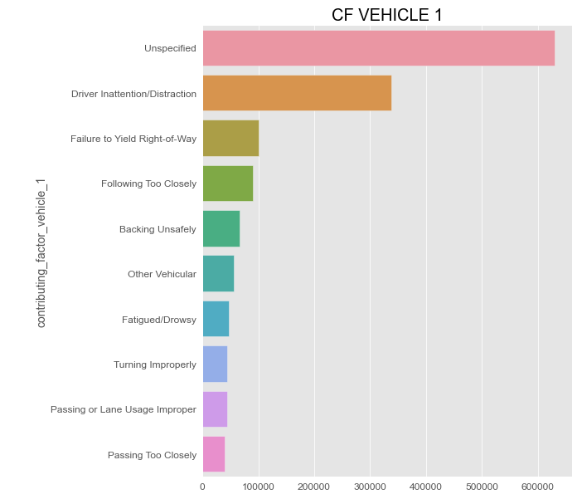

**We could consider the Population information data in each of the borough and the weather data for all the years to predict the accidents better.**

• Extra questions: What better could you have done with respect to the current model. –

1. **Use a different method to fill in the Zip code and Borough Information faster as the current method is time consuming.**
2. **Use geospatial mapping to map the street and the accident coordinated in order to find the street level data.**
3. **Use the Weather data to find the correlation between the accidents and the Weather.**
4. **Group the coordinated on a certain radius and run a classification model to find the hotspots of accidents specific locations.**