A Multi-Agent Retrieval-Augmented Framework for Intelligent Resume Screening and Candidate Evaluation

Student Name(s), Course/batch and Institute name: -
- Oindrila Chakraborty, MSc. Data Science (2025-2027), St. Xavier’s College (Autonomous) Kolkata
- Mateti Karthik, B. Tech in Computing and Data Science (2024–2028), Sai University, Chennai, Tamil Nadu
- Kotha Avaneesh Reddy, B. Tech in Computing and Data Science (2024-2028), Sai University, Chennai
- G Charit, B. tech Computer science (2024-2028), Gitam University vizag
- Ala Mahesh, B.tech in computer science and engineering (2025-2029), Indian institute of information technology Kottayam, Kottayam.
- Sujitha P, B. tech Artificial Intelligence and Data Science (2024-2028) Sri Eshwar college of Engineering, Coimbatore
- T. Jaya Chandrika, 5 years integrated Data science, Teri school of advanced studies (New Delhi)

Mentor Name:
Surva Jyoti Chaudhary

Period of Internship: 18th May 2026 – 31st July 2026

Report submitted to: IDEAS – Institute of Data Engineering, Analytics and Science Foundation, ISI Kolkata

- Abstract

With the growing number of resumes being applied, the manual resume screening has become an inefficient and cumbersome procedure that has encouraged the use of Large Language Models (LLMs)to evaluate candidates automatically. However, the LLMs alone have proven to lack recruitment expertise, provide inconsistent hiring recommendations, and consider each evaluation criterion equally important. Moreover, traditional methods employ the average value of several annotators’ scores as ground truth data; hence, annotator’s credibility is not considered.
The proposed solution to the above issues can be found in the introduction of three different methodologies. First methodology describes RAG-based multi-Agent architecture where there is a set of specialized LLM agents working together for evaluation of candidate profiles from technical, managerial and human resources point of views. Resumes of candidates are stored in a FAISS vector database, which allows to effectively retrieve information about recruitment in a certain domain during the evaluation. Second methodology suggests to use dynamic resume attributes weight calculation when calculating the score for each candidate. Importance of each attribute – education, skills, experience, certifications, domain expertise etc. is dynamically calculated depending on a job domain and job level before calculating the final score of the candidate. Third methodology suggests the approach of dynamic annotator weights calculation, which uses Sentence-BERT embeddings and MAD consistency check for estimation of annotator reliability and calculating adaptive ground truth score.
This experimental analysis was done using Pearson’s correlation coefficient, spearman rank correlation, MAE, RMSE, and coefficient of determination. This project demonstrates the utility of using RAG-based knowledge combined with multi-agent specialized LLMs in candidate resume assessment.

- Introduction

The Rapid growth of digital recruitment platforms using LLM agents has significantly affected the hiring process in a positive way enabling organizations to manage a large volume of job applicants for a single vacancy or particular job role in the company. But it also in-creased challenges for recruiters who are often review thousands of resumes within a limited time frame. Since traditional recruitment system rely on keyword matching and rule-based filtering techniques they fail to capture a candidates overall competency level thus they need an intelligent context aware recruitment system capable of performing comprehensive candidate review without much time and effort needed.
The recent advancements in LLMs have demonstrated remarkable capabilities in candidate information extraction, natural language understanding, reasoning making them increasingly suitable for recruitment related tasks. These models help analyze resumes, interpret candidate qualifications, and generate detailed evaluations beyond simple keyword matching. But Standalone LLMs generate responses solely based on their pre-trained knowledge which may lead to outdated information, hallucinations or inconsistent recruitment decisions. Therefore, RAG mechanism acts as an effective approach to address all the limitations. By integrating semantic retrieval with generative language models, RAG enables context-aware reasoning while reducing dependence on the model’s internal knowledge. Recent study has shown that Multi Agent LLM improves decision quality by distributing task among different agents.
This framework integrates RAG with specialized LLM agents to automate resume screening and candidate evaluation. Since the original dataset used in AI hiring with LLMs framework was not publicly available, the proposed framework was executed using the Carrercorpus dataset. It combines semantic retrieval using BAAI BGE small English embedding model and the FAISS vector database with multiple specialized LLMs.The collaborative assessments generated by these agents are integrated to produce comprehensive hiring recommendation supported by contextual recruitment knowledge.

The Primary contributions of this framework are summarized as follows: -
- A Retrieval Augmented Multi Agent Framework for intelligent resume screening and candidate evaluation.
- Integration of semantic retrieval using BGE embeddings and FAISS to provide context-aware recruitment knowledge.
- A multi-Agent collaborative evaluation system consisting of specialized LLM agents for technical and managerial assessment.
- An experimental evaluation of the proposed framework on the Carrercorpus dataset containing 302 anonymized resumes from multiple professional domains due to the unavailability of the original dataset.
WEEK I: -
- Introduction - Welcome Note - What to expect from this internship.
- Basic Statistics for Data Science.
- Data Visualization.
- Introduction to GitHub and Cloud Computing.
WEEK II: -
- Machine Learning 1.
- Machine Learning 2.
- LLM Fundamentals
- Communication Skills.
- Deep Learning 1.
WEEK III: -
- Deep Learning 2.
- Computer Vision Overview.
- Agentic AI.
- System view of DS.
- Reinforcement Learning.

SUMMER INTERNSHIP PROGRAM ON DATA SCIENCE 2026: -
Schedule for Section-2: -
Option 2: Advanced Internship (10 Weeks | 120 Hours)
Week | Topic | Instructor
I | Introduction - Welcome Note - What to expect from this internship | Mr. Agnimitra Biswas / Mr. Diptendu Dutta / Dr. Sujoy K. Biswas / Mrs. Bidisha Dobe
I | Basic Statistics for Data Science | Amitava Bandyopadhyay
I | Data Visualization | Koulika Paul
I | Introduction to GitHub and Cloud Computing | Rounak Biswas
I | Data Science Application Development using Streamlit | Adrija Das
I | NO CLASS
II | Machine Learning 1 | Dr. Chandan Biswas
II | Machine Learning 2 | Dr. Chandan Biswas
II | LLM Fundamentals | Diptendu Dutta
II | Communication Skills | Bidisha Dobe
II | Deep Learning 1 | Aditya Shankar Pal
III | Deep Learning 2 | Aditya Shankar Pal
III | Computer Vision Overview | Dr. Sujoy Biswas
III | Agentic AI | Santanu Karmakar
III | System view of DS | Dr. Sujoy Biswas
III | Reinforcement Learning | Dr. Sujoy Biswas

- Project Objective

- To build a Retrieval-Augmented Generation (RAG) based multi-agent framework for automated intelligent resume screening and candidate evaluation.

- To evaluate candidate’s profiles collaboratively through specialized LLM agents representing technical, managerial, and human resources perspective.

- To implement a dynamic resume attribute weighting mechanism that assigns adaptive importance to education, skills, experience, certifications, and domain knowledge based on job level and job domain.

- To generate a dynamic resume ground truth score by estimating annotator reliability using sentence-BERT embeddings and Median Absolute Deviation (MAD) consistency analysis.

- To compare the proposed multi-agent framework with Single-LLM and Dynamic LLM approaches using Pearson correlation, Spearman correlation, MAE, RMSE, R² Score, and statistical significance testing (paired t-test and Wilcoxon Signed-rank test.

- Methodology: -
PROPOSED METHODOLOGY I: -
This section Presents the Proposed Methodology which is being designed is a multi-Agent intelligent recruitment panel system where from we can easily automate the resume screening process without continuous human involvement needed in the recruitment system. This process we have accomplished by the use of specialized Large Language Models (LLM) agents. We have shown how a multi-Agent LLM performs better in hiring process than the Single Agent LLM since the framework has been decomposed into multiple stages, where each agent (like CEO, CTO and HR) is responsible for evaluating the candidate’s profile and give their scores and decisions on it.

Workflow Preview

The complete hiring process workflow begins with getting a dataset with candidate resumes so we choose the Carrercorpus\cite{chowdhury2026automated} dataset, which serves as a primary source of applicant information and then we perform data prepossessing on it, since it contains data of varying structure so everything needs to be processed to extract meaningful textual information while preserving its semantic content. The extracted information is then organized structurally containing the candidates-id, educational qualifications, work experiences, skills and achievements and job types. This is the input for further evaluation stages.
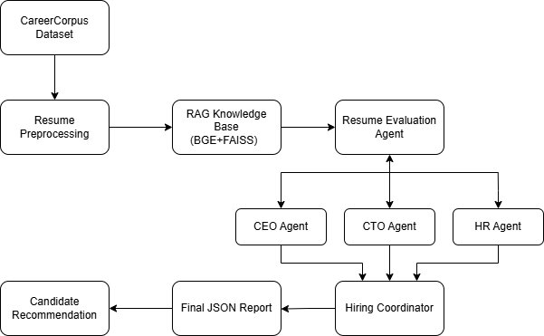

Resume Evaluation Using RAG
Next, we incorporate a RAG-mechanism which acts as a domain-specific knowledge base containing recruitment guidelines and hiring regarding all the information is first converted into dense vector embeddings using the BAAI BGE small English embedding model. these embeddings then are indexed using the Facebook AI Similarity Search (FAISS) vector database, enabling efficient semantic retrieval. So, during candidate evaluation the relevant hiring knowledge is retrieved based on candidate's profile and supplied to the LLMs as additional contextual information.
Thus, following the context retrieval, the candidate profile is evaluated by specialized LLM agents, each having different organizational perspective. The resume evaluation Agent performs the initial assessment by comparing the candidate information with the retrieved job specific knowledge as well as the overall suitability of the applicant while identifying important strength and potential skills gaps.

How Decision-Making Agents works
Next it is been forwarded to the decision-making Agents. Firstly, the Chief Executive Officer (CEO) Agent focusing on their leadership capability, adaptability and overall contribution to business objectives. Then is the Chief Technology Officer (CTO) Agent independently examines the candidate’s technical aspects their skills, achievements, problem solving ability, project experience and overall technicalities. Lastly, the Human Resource (HR) Agent evaluates their communication skills, experiences as in teamwork and jobs. It complements the executive and technical evaluations by incorporating qualitative aspects to candidate selection.
Thus, the outputs generated from here are subsequently integrated using hiring committee Agent. So, instead of a single LLM evaluator we divide the decision work to Multiple LLM Agents to get a balanced and comprehensive hiring decision that reflects both technical and organizational considerations.

Final Results
The final result constitutes all intermediate outputs as well the Agents conversations during hiring each of the candidates so as to make a standardized recruitment report. The final JSON file contains their details, scores given by each agent, summarized strengths and weaknesses, final hiring recommendations and overall decisions.
The Overall workflow of the recruitment pipeline with using LLM agents enables ease hiring decision-making process since the results came quite close to the natural human scores while maintaining transparency in the whole process.

PROPOSED METHODOLOGY II: -
This section elaborates on the other proposed methodology and presents the Dynamic Weight Allocation methodology for resume evaluation. The scores achieved from the first proposed methodology are used as input in this methodology. Instead of providing equal value for each criterion of evaluation, this methodology utilizes a dynamic allocation based on Education, Skills, Experience, Certifications and Domain Knowledge according to the job domain and job level. This allows us to ensure that the output score is more appropriate for the requirements of various job positions in spite of the automated nature of the evaluation process.

Workflow Preview
The beginning of the workflow involves loading resume evaluation results generated through the 1st Proposed Methodology approach. These results provide the individual scores for Education, Skills, Experience, Certifications, and Domain Knowledge of the resumes. Since the scores are already available, the entire evaluation pipeline is not executed again. Instead, the details of the resume, along with job domain and job level, are utilized in generating dynamic weights. Upon measuring the dynamic weights, the results of the dynamic weighted resume scoring are generated and stored.
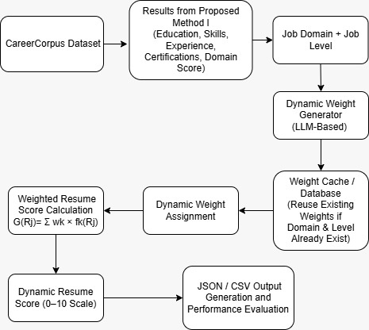

Resume Evaluation using Dynamic Weighted Scores
Our method of resume evaluation is different from traditional resume scoring systems that assign fixed weights to every evaluation criterion, rather, we employ a Large Language Model that calculates weights dynamically. The weights are calculated based on the combination of the job domain and job level, which helps the model determine the importance of educational qualifications, skillset, experience, certifications, and domain knowledge. The obtained weights are normalized so that their total summed up equal to one, and the weights derived are combined with previously generated evaluation scores and used to calculate a dynamic final resume score. This scoring process makes current methodology adaptable to scoring resumes of different jobs while still being consistent with resumes belonging to same job category.

Dynamic Weight Generation
To optimize the computation time, after computing weights once, weights are saved in a database for future use for particular job category and job level. In case a resume falls in the same category as another work application, weights are reused rather than recalculated through the LLM. This reduces the number of API calls made, improves efficiency, and ensures that resumes of the same job category will be evaluated similarly.

Final Results
The concluding outcome of the proposed methodology contains dynamically generated weights along with the final dynamic resume score for each candidate. The generated results are recorded in both JSON and CSV formats for further evaluations. The generated scores are compared with ground truth scores obtained from the CareerCorpus dataset through several statistical measures as Pearson Correlation, Spearman Rank Correlation, MAE, RMSE, and R² Score. The results are analyzed using graphs for visualization and to evaluate the effectiveness of the dynamic weighted approach.

PROPOSED METHODOLOGY III: -
This proposed method is known as Dynamic annotator ground truth, which comprises two steps, first step involves the merging of resume attributes into a single textual form and next step is sentence embedding which involves the use of Sentence-BERT.
This proposed methodology comprises the retrieval of semantically similar resumes and use of tool to obtain the local annotator which involves the use of Median Absolute Deviation (MAD) annotator for consistency purposes. This is followed by the conversion of consistency scores into normalized annotator weights and finally dynamic ground truth calculation.

Workflow Preview
The resume document is then analyzed using an extraction agent and the process that occurs through the agent involves separating the core sections such as experience, technology stack, among others. RAG\cite{lewis2020rag} Augmentation takes place using the main evaluator agent and its function is to extract the required context. From there, the sub-agents take over as stated from the previous methodology such as the CEO, CTO and HR reviewers. Lastly, the Score Formatter Agent collects all scores and conversations to create a recruitment report.

Resume Evaluation using RAG
The extraction agent parses the raw, unstructured resume texts in order to extract typical characteristics of the candidate, such as his or her education, skills, accomplishments, and work experience. Now, the system imports the context of the environment (recruitment requirements of the domain, skills taxonomy, or job descriptions benchmarks). The orchestrator combines the viewpoints of all agents in order to make a decision, generate a score, and predict the rating. The rating is benchmarked against the Dynamic Ground Truth Score which is calculated based on the ratings of two human annotators, Annotator-1 and Annotator-2.

Final Results
The entire recruitment report is made up of the compilation of all the intermediate outputs from the various agents, the reviews and discussions done among the expert agents during the evaluation of each candidate. The final JSON file will have all the information regarding each candidate, their scores in each individual reviewing role, the strengths and weaknesses of each candidate, augmented RAG context, hiring recommendations, and finally the final decision. The whole process of multi-agent RAG pipeline with dynamic annotators ensures an effective hiring decision-making process since the output is very close to human consensus.

Experimental Setup
The Overall Framework was implemented using python in google collab notebook and vs code simultaneously. The primary objective was to assess the capability of the Multi Agent Recruitment Framework for resume Screening and generate reliable hiring recommendations. Due to unavailability of the original dataset used in the Original AI hiring with LLMs study, we used the Careercorpus dataset. This dataset consists of 302 candidates profile their technical skills, education, job type, domain and achievements making it a suitable dataset for intelligent resume screening work.
First, it went through data Prepossessing removing all the null rows, removing unnecessary formatting and symbols preserving the semantic content and making it efficient for further evaluation. Each of candidate’s information were extracted to create a structured candidate profile for further evaluation. A recruitment knowledge base containing job descriptions and hiring guidelines was also prepared to support context aware decision making.
To retrieve relevant recruitment knowledge, all documents in the knowledge base were converted into dense vector embeddings using the BAAI BGE Small English embedding model. These embeddings were indexed using the FAISS library, enabling efficient semantic search. While reviewing candidate profile the RAG framework retrieved most relevant contextual information based on the candidate profile.

Then we employed Multiple LLMs using Open router API keys. Each candidate resume was independently processed using the Multi Agents before producing a consolidated hiring recommendation. The generated reports included evaluation scores together with the candidate strengths, weaknesses, technical competency and final hiring decision to either accept, reject or hold.

Finally, to evaluate the effectiveness of the proposed framework, the predicted candidates scores were compared with the reference scores provided in the Carrercorpus dataset. We computed the Pearson Correlation Coefficient and Spearman Rank Correlation to measure the agreement between predicted and actual evaluations, while MAE and RMSE and the Coefficient of Determination were used to quantify prediction accuracy. In addition to this we did scatter plots, score distribution plots and comparative visualizations were generated to analyze the consistency and reliability of the proposed recruitment framework across different candidate profiles as well as the total hiring process.

- Data Analysis and Results
5.1 Proposed Method I – Multi Agent Retrieval-Augmented Generation (RAG) Framework
The first suggested methodology determines the performance efficiency of the Multi-Agent Retrieval Augmented Generation (RAG) system to screen intelligent resumes. In order to determine the performance of this suggested framework, it is compared with the traditional Single LLM model using the CareerCorpus Dataset. The comparison will be done based on regression measures (MAE, RMSE, R²), correlation measures (Pearson and Spearman Correlation), and ranking measures (PC20, SC20, PC15, SC15, PC10, SC10).

Quantitative Performance Comparison
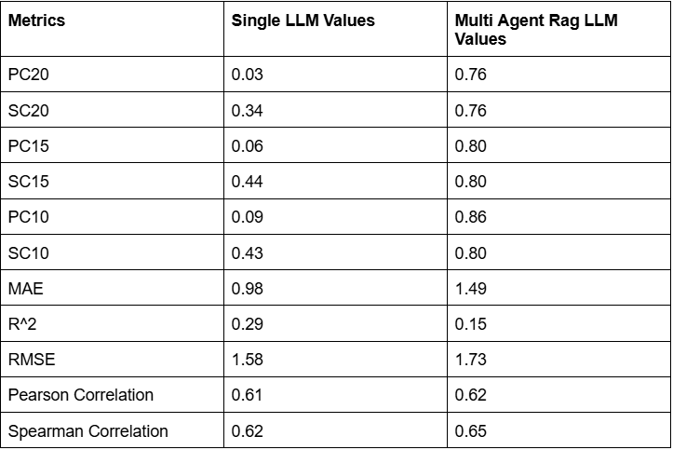
The performance metrics collected on both approaches have been placed in the comparison table. From these metrics, we see some notable differences in the ranking abilities of both models.
The performance of the Single LLM model is demonstrated by the Pearson and Spearman correlations of 0.61 and 0.62, respectively. The Mult-Agent RAG framework gives better values of 0.62 and 0.65 for both metrics. The correlation difference between both methods is not very large but still shows that the second method shows better agreement with human evaluations.

A better improvement can be seen in the ranking metrics. For the Single LLM, PC20, PC15, and PC10 have the values of 0.03, 0.06, and 0.09. On the other hand, the Mult-Agent RAG framework gets the corresponding values of 0.76, 0.80, and 0.86. Also, SC20, SC15, and SC10 improved from 0.34, 0.44, and 0.43 to 0.76, 0.80, and 0.80, respectively. The above metrics demonstrate that the Mult-Agent RAG framework is capable of better recognizing high-quality candidates and sorting their resumes accordingly.

While the Single LLM model exhibits smaller MAE (0.98) and RMSE (1.58) values compared to the multi-Agent model (MAE = 1.49 and RMSE = 1.73), the goal of the automatic recruiting tool is not limited to reducing the prediction error. The ranking accuracy of candidates obtained through the multi-Agent model proves the effectiveness of the latter for recruiting purposes.

Analysis of Ground Truth vs Predicted Scores
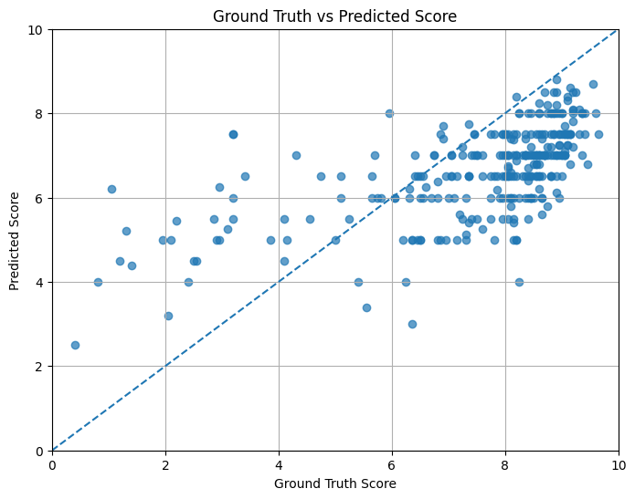
In this scatter plot, we compare the predictions of resume scores against the actual human-annotated scores for the same resume. The dashed diagonal is where we get perfect correspondence between the predicted and true scores.

It can be observed that most of the predicted scores of the candidates using the multi-Agent framework lie near the diagonal reference line, suggesting that the multi-Agent framework is capable of modeling the relative resume qualities well. It is also clear that candidates having ground truth scores of 7-9 have similar predicted scores, showing the strength of the framework in choosing strong candidates. When compared to the Single LLM Baseline, the Multi-Agent predictions perform better in terms of candidate rankings.

This is because of the inclusion of knowledge through the retrieval process along with multiple agents.

Distribution of Predicted Resume Scores
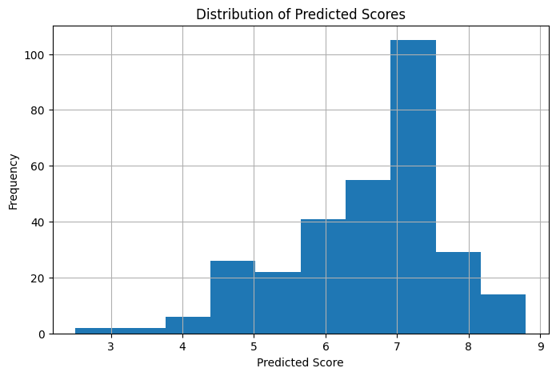
This histogram represents the score distribution generated using the multi-Agent system.

The scores predicted for most resumes fall in the 6 to 8 range. This means that most resumes are rated in the medium and high-quality range. There is no such thing as an extremely low score prediction for a resume, meaning that there are many qualified individuals in the dataset.

The score distribution predicted is similar to the nature of the dataset and shows how effectively the system scores the resumes across the range rather than assigning them scores in one specific range.

Distribution of Ground Truth Scores
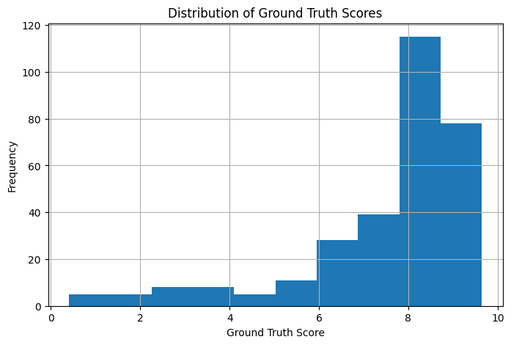
Ground truth scores’ histogram can provide us information about the distribution of scores given by humans. Most resumes get scores from 7 to 9, which means that most candidates in the CareerCorpus dataset are quite strong candidates. Low scores (scores lower than 5) are given to a very few numbers of resumes. This is the reason why the prediction models tend to give out more high scores than low scores. This is essential since this will help in understanding the regression and ranking metrics of the evaluation models.
Residual Analysis
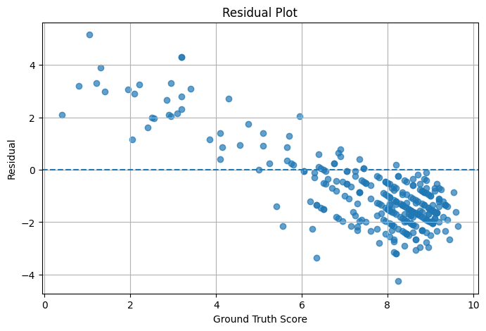
The Residual Plot depicts the discrepancy between the predicted scores and the true scores.
Most of the residuals are centered around the zero-line showing that the majority of the predictions are not far from reality. Nevertheless, greater discrepancies are shown when predicting the scores of the weaker candidates whose true scores are lower. Such a phenomenon demonstrates that it is more difficult to predict weak candidates rather than strong ones.
In contrast to the Single LLM, Multi-Agent residuals are better distributed around the zero line despite having greater values of error.

Hiring Decision Distribution

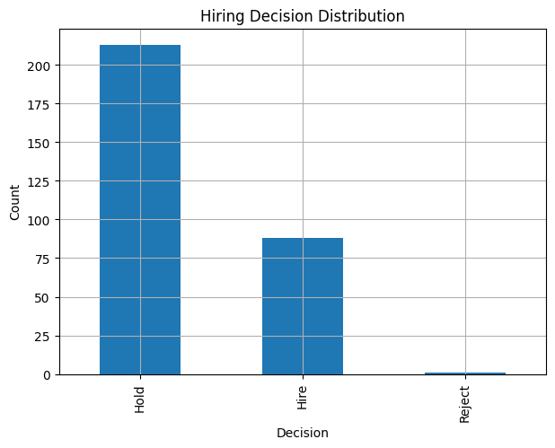
The distribution of the hiring decision represents the recruitment suggestions produced by the evaluation framework.
Out of the total 302 resumes, the maximum number belongs to the Hold category, followed by the Hire category, whereas the number of resumes belonging to the Reject category is extremely small. The distribution is indicative of the quality of the CareerCorpus dataset in which majority of the candidates have enough qualification to go ahead with the recruitment process.
Also, it indicates that the suggested framework does not take extreme reject decisions.

Overall Discussion
The above results provide ample proof of the efficiency of the proposed Multi-Agent Retrieval Augmented Generation framework for the resume evaluation task.
Although the Single LLM shows slight superiority in terms of numerical prediction errors, the proposed framework greatly enhances the performance of ranking the candidates, especially in case of top-ranked resumes, based on the significant increase of PC20, SC20, PC15, SC15, PC10, and SC10. This effect is achieved due to the collaboration of reasoning between the Resume Evaluation Agent, CEO Agent, CTO Agent, HR Agent, and Hiring Coordinator along with retrieval of specific knowledge in the field of recruitment with the help of the FAISS-based knowledge base.
Additionally, the graphs show that the proposed model demonstrates enhanced correspondence between the predicted and ground truth scores, realistic score distribution, stability of residuals, and balanced hiring suggestions. In general, the Multi-Agent RAG framework allows obtaining better resume ranking compared to the standard Single LLM framework.

5.2 Proposed Method II – Dynamic Weighted Resume Scoring
The second methodology proposed involves a dynamic weighting scoring algorithm used for assessing resumes. In contrast to the first methodology, which uses the Large Language Model to predict the final score of a resume directly, this methodology entails assessing specific resume features, including Education, Skills, Experience, Certificates, and Domain Knowledge, first. The scores for each feature are subsequently multiplied by dynamic weights that depend on the specific job domain and job level of the candidate. The final resume score is calculated as the sum of all feature scores multiplied by weights.

Quantitative Performance Analysis
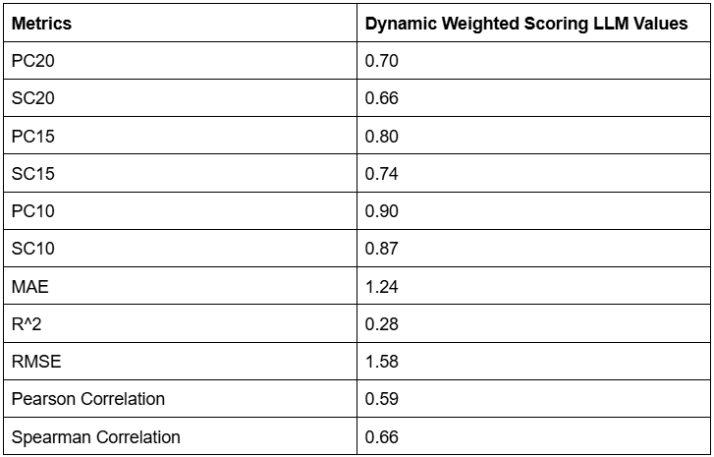
Quantitative evaluation of the Dynamic Weighted Resume Scoring framework was performed on the CareerCorpus dataset. The following ranking metrics were used for assessment: PC20, SC20, PC15, SC15, PC10, and SC10, along with correlation metrics such as Pearson and Spearman Correlation, and regression metrics like MAE, RMSE, and R².

The experimental results have shown that proposed dynamic weighting gives a good ranking performance of candidates. The obtained metrics of the framework are PC20 = 0.70, PC15 = 0.80, PC10 = 0.90, as well as SC20 = 0.66, SC15 = 0.74, and SC10 = 0.87. From these metrics, one can see that using dynamic weighting of resume attributes allows identifying highly skilled candidates better than applying an equal importance value to all resume attributes.

Overall, Pearson Correlation equals 0.59 and Spearman Correlation equals 0.66. This shows a fairly high degree of match between the predicted dynamic scores and human-annotated ground truth scores. Despite the fact that Pearson correlation is somewhat worse than in case of Multi-Agent RAG framework, the ranking metrics are quite high.

Regression metrics additionally show good prediction performance. The system yields a result of MAE = 1.24, RMSE = 1.58, and R² value = 0.28. This shows that the prediction error values are within acceptable limits even after introducing weighting to the system. This is because evaluating a resume is a subjective process; thus, the error values obtained are acceptable.

Analysis of Ground Truth vs Dynamic Weighted Scores
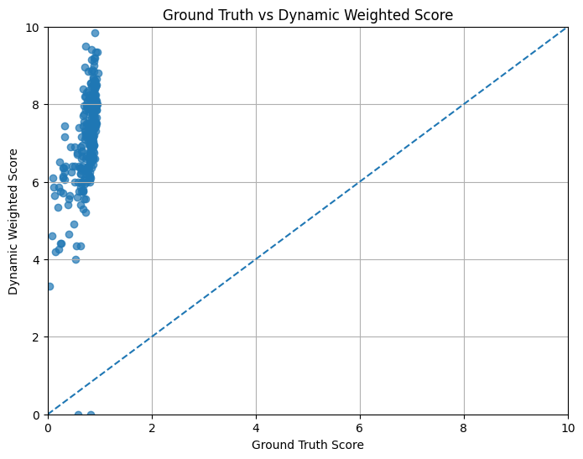
This graph shows the comparison of the ground truth score provided by human experts against the dynamically weighted score calculated by the suggested framework. The dotted line shows the reference point for perfect matching of the predicted scores with the actual scores.

For the vast majority of CVs, there is a correlation of ascending order of the predicted score depending on the growth of the ground truth score. It shows the successful ability of the dynamic weighting system to preserve the ranking order of candidate qualification and at the same time adjust the importance of features based on the domain of the required job position. For the most qualified candidates, there are high values of dynamic scores, which means that the weighting system was successful in highlighting the importance of features.

Some fluctuations are visible for the CVs having low ground truth score values, but it is normal since the weighting process deliberately changes the influence of CV features depending on the job.

Distribution of Dynamic Weighted Scores
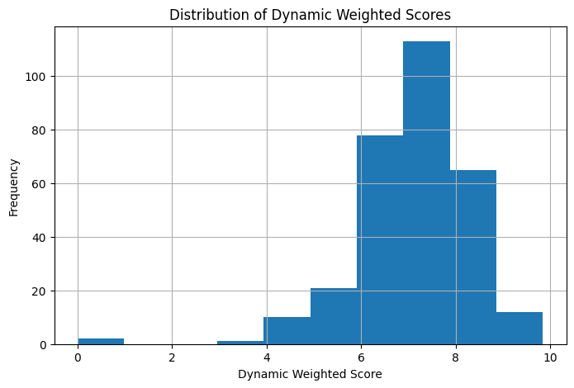
The following histogram shows the distribution of dynamically calculated resume scores based on the CareerCorpus corpus.

The dynamically weighted scores are mostly found between 6 and 8, which means that most candidates have a medium level of suitability for the analyzed occupations. Some resumes get extremely low scores, but only a few resumes manage to get a score near the highest possible score of 10. This distribution proves that the dynamic weighting approach creates a diverse set of scores, not just similar scores for all candidates.

In contrast to traditional single-score assessment systems, the dynamic weighting system creates diversified score distributions since the importance of the resume features varies according to the recruitment needs.

Distribution of Ground Truth Scores
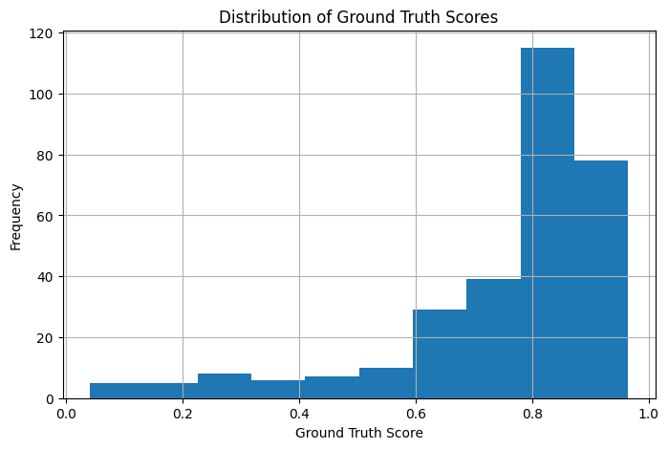
Histogram for the ground-truth scores is the distribution of scores provided by humans in the CareerCorpus dataset.

Most of the resumes have a score ranging from 0.7 to 0.9 after normalization, which means that most of the resumes have high qualification scores. Very few resumes have very low scores, which creates an imbalance in the score distribution.

This distribution helps in analyzing the effectiveness of the Dynamic Weighted framework as the score distribution must be of a similar pattern.

Residual Analysis
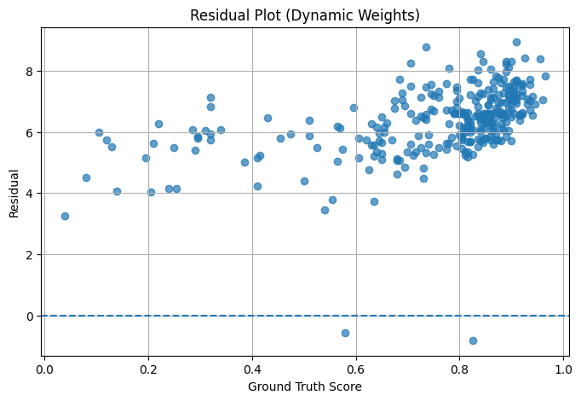
The residual graph demonstrates the prediction error, which is the deviation between the dynamically produced resume scores and the actual scores.

Most of the residual points fall within a certain narrow range, thus denoting consistent prediction performance for the vast majority of resumes. High residual points are mostly recorded in the cases of candidates having low actual scores, where the dynamic weight allocation system considers different weights for the resume features in relation to the domain of work.

Unlike other regression models whose sole aim is reducing the numerical value of the error, the purpose of the model at hand is to produce recruiting decisions that capture the hiring requirements of the particular domain. Hence, the obtained residuals are acceptable.

Overall Discussion
The experimental results confirm that the Dynamic Weighted Resume Scoring framework is effective at boosting interpretability of automated resume evaluation without compromising prediction accuracy. Through dynamically calculating feature-specific weights depending on the job domain and job level, the framework takes into account changes in the significance of education, skills, work experience, certificates, and job domain knowledge rather than applying predefined scoring rules.

The values of the high-ranking metrics, including PC10 = 0.90 and SC10 = 0.87, suggest that the framework is successful at finding the top performers. In addition, from the graph presented above, it can be concluded that dynamically calculated scores coincide with the general trend of human assessment while providing a well-balanced score distribution.

Thus, using the Dynamic Weighted Resume Scoring framework allows increasing flexibility and interpretability of resume evaluation due to domain-aware feature weighting.

5.3 Proposed Method III – Dynamic Ground Truth
5.3.1 Single LLM with Dynamic Ground Truth
The first experiment conducted on the Dynamic Ground Truth framework assesses the performance of the baseline model - Single LLM, where instead of using the traditional method of generating ground truth based on the averaging of two annotators' judgments, dynamically calculated annotator weights are used. Consequently, the evaluation takes into account the reliability of annotators and yields an estimate that better reflects human consensus in resume assessment.
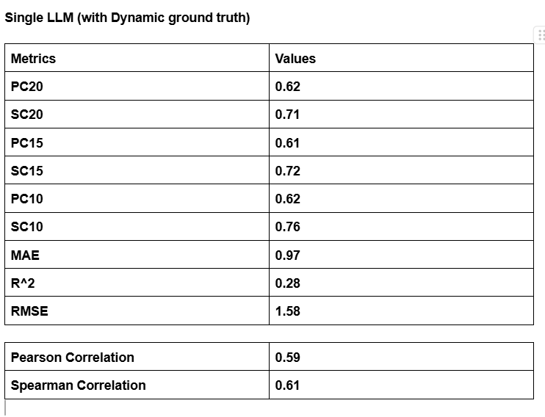
Table shows the results of the quantitive performance analysis of the Single LLM with the Dynamic Ground Truth reference. The value of Pearson correlation is 0.59, while Spearman correlation is 0.61, suggesting that there exists a moderate positive relationship between predicted resume scores and dynamically calculated human reference scores. Obtained values of MAE (0.97) and RMSE (1.58) reveal that prediction errors are still relatively low even though the dynamic ground truth generation approach is applied. Additionally, the R² value is equal to 0.28, meaning that about 28% of variance in the Dynamic Ground Truth reference is explained by the predictions of the model.

Moreover, these ranking based evaluation measures clearly show how good the model is at differentiating between the better and lower ranked resumes. The measures used yielded results of PC20 = 0.62, SC20 = 0.71, PC15 = 0.61, SC15 = 0.72, PC10 = 0.62, and SC10 = 0.76. As observed, the higher values of Spearman correlation indicate that even though there may be some variance between the numerical scores obtained from Dynamic Ground Truth, the order of ranking still remains almost the same. As resume screening basically involves correct ranking, the above results are satisfactory.

Dynamic Ground Truth vs Predicted Score
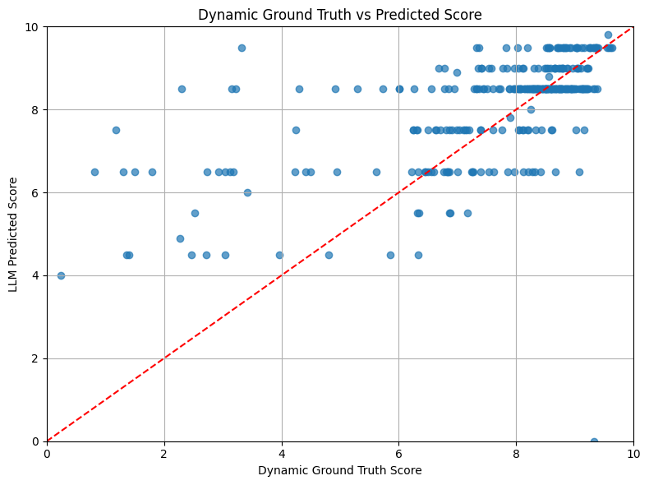
The correlation between the predicted and reference scores is shown in Figure. Most resumes receiving high Dynamic Ground Truth scores receive equally high prediction scores, thereby demonstrating a positive correlation between the predictions and dynamically generated reference scores. Although some resumes receiving low ground truth scores show large variations, the overall increasing trend shows that the model is able to capture the ranking of candidates’ quality.

Distribution of LLM Predicted Scores
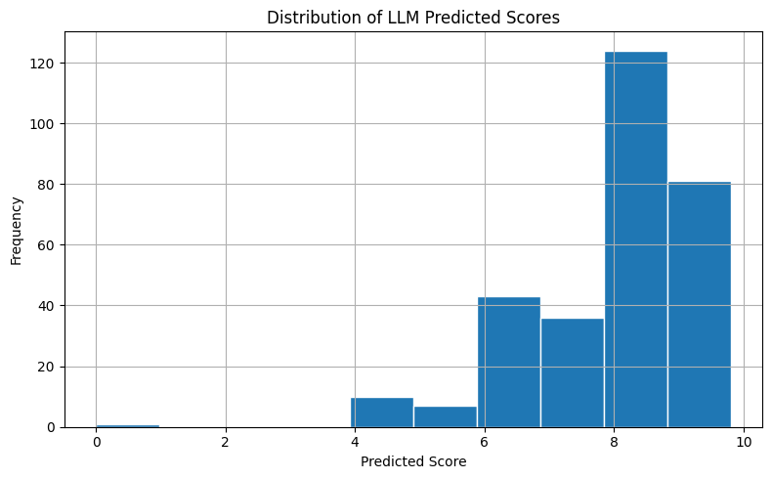
The distribution of the resume scores is presented in Figure. The predicted resume scores are mostly found in the range of 7 to 9, showing that the model tends to predict high scores for most of the resumes from the CareerCorpus database. There are only a few resumes that get low evaluation scores.

Distribution of Dynamic Ground Truth Scores
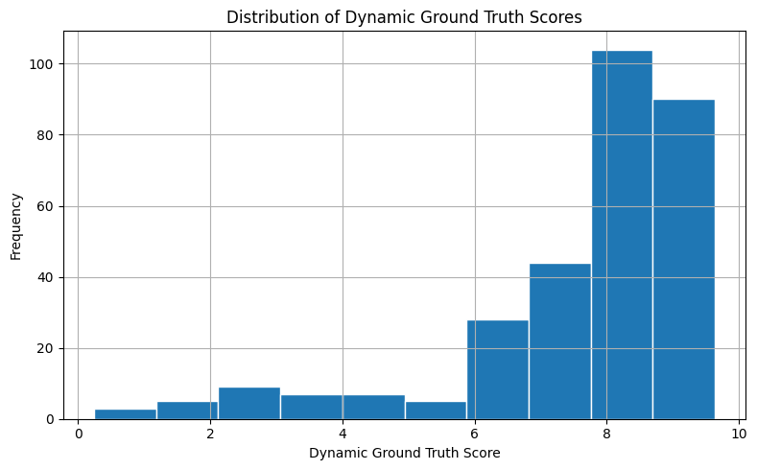
In Figure, we present the distribution of the Dynamic Ground Truth score values. Like the score value distribution for the predicted scores, there is an observation that the majority of the reference scores are clustered around high scores, which implies that many of the resume were rated positively by the dynamically weighted annotation system. The similarity in distribution of the scores implies that the Single LLM follows the general trend of the Dynamic Ground Truth.

Residual Plot
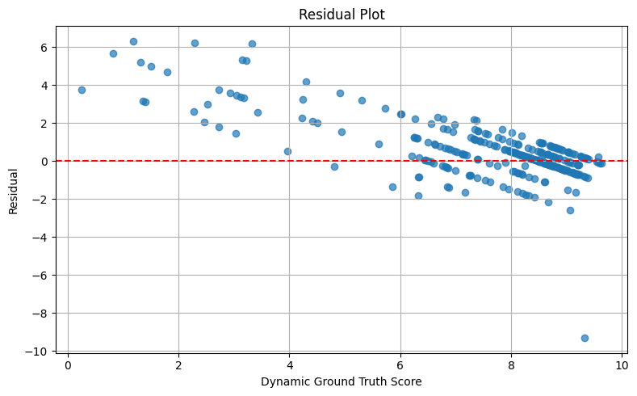
Figure shows the residual errors between the predicted scores and the Dynamic Ground Truth scores. The majority of residuals are concentrated around the zero error line in cases where the evaluation score is moderate to high for the resume, meaning the performance of predictions is stable for the majority of candidates. Residuals are much larger in cases where the Dynamic Ground Truth score is low, which means the model encounters difficulties while predicting evaluation scores for resumes that do not have many qualifications.

Hiring Decision Distribution
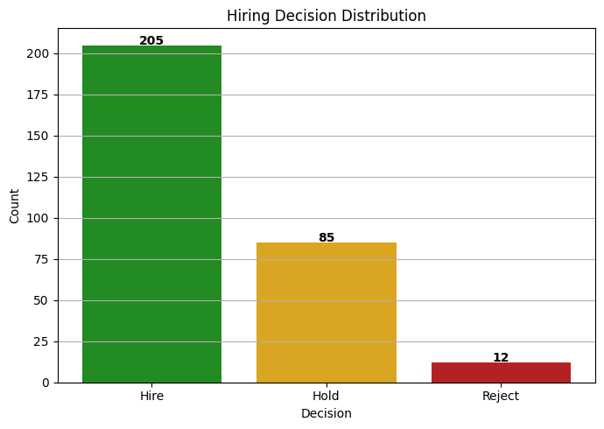
The decision outcomes resulting from Single LLM are presented in Figure B with respect to the Dynamic Ground Truth evaluation method. Of the total 302 resumes, 205 candidates were found to be Hire candidates, 85 candidates were found to be in the Hold category, and 12 candidates were placed in the Reject category. From the above figures, it is evident that most of the resumes present in the CareerCorpus dataset meet the minimum requirements for being hired.

Overall Discussion
In general, it can be concluded that the Single LLM shows stable performance when assessed using the Dynamic Ground Truth approach. The comparatively low value of the prediction error and average correlation values suggest that the model has enough capacity to produce resume evaluations that can be considered stable relative to the dynamically created human consensus scores. The findings provide a good benchmark for future comparison with the Multi-Agent RAG LLM and the Dynamic Weighted Scoring system.

5.3.2 Multi Agent RAG LLM with Dynamic Ground Truth
Experiment 2 conducted in the Dynamic Ground Truth technique examines the proposed Multi-Agent Retrieval Augmentation Generative (RAG) LLM architecture in terms of dynamic ground truth scores generation. Contrary to the conventional Single LLM architecture, in this case, the multi-Agent architecture uses different agents like Resume Evaluation Agent, CEO Agent, CTO Agent, HR Agent, and Hiring Coordinator Agent in conjunction with Retrieval-Augmentation Generative technique for performing collaborative resume evaluation.
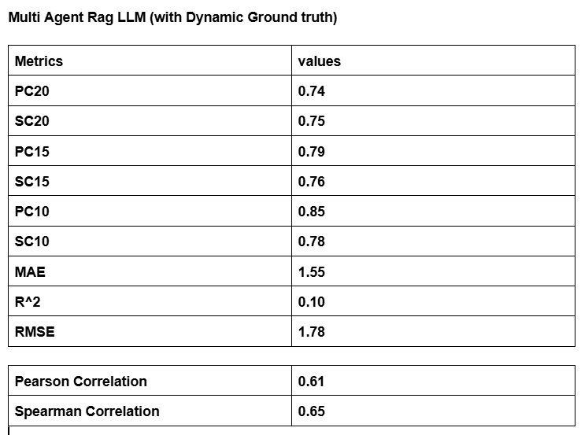
Table presents the results for the Multi-Agent RAG framework with respect to the Dynamic Ground Truth evaluation process. The framework was able to attain a Pearson Correlation of 0.61 and a Spearman Correlation of 0.65. These results suggest that the multi-Agent framework has stronger correlation with Dynamic Ground Truth scores than the Single LLM. The ranking-based evaluation measures have also improved significantly. The multi-Agent framework was able to obtain PC20 = 0.74, SC20 = 0.75, PC15 = 0.79, SC15 = 0.76, PC10 = 0.85, and SC10 = 0.78, suggesting that the multi-Agent framework is better at selecting good candidates and maintaining their ranking.

Although the numerical errors for the regression metrics are larger, with MAE = 1.55, RMSE = 1.78, and R² = 0.10, but the key point of automated resume screening is not prediction of an identical numerical score, but rather ranking of candidates. The improvements in Pearson, Spearman, and top-k ranking metrics demonstrate the value of collaborative reasoning between several specialized agents.

Dynamic Ground Truth vs Predicted Score
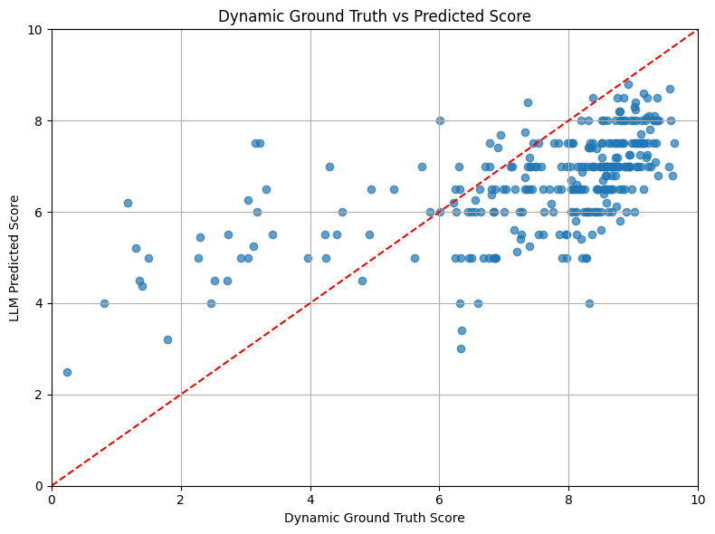
Figure shows how the Dynamic Ground Truth score relates to the predicted score by the Multi-Agent RAG model. In general, most resumes show a positive relationship, such that a higher Dynamic Ground Truth score is correlated with a higher predicted score. As opposed to the Single LLM model, the multi-Agent model achieves better results in terms of a consistent correspondence for highly ranked resumes, proving that the process of collaboration and retrieval-based generation contributes significantly to resume evaluation. There are just a few resumes with a relatively low ground truth score that have more significant deviations from the curve.

Distribution of LLM Predicted Scores
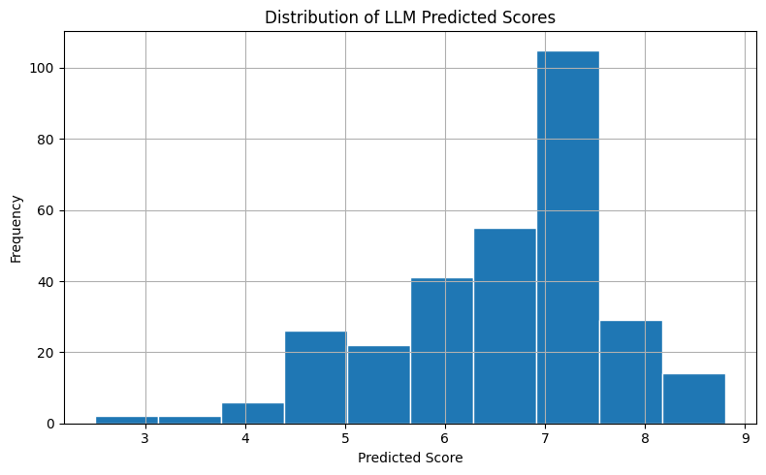
In Figure, the score distribution for the predicted scores of the resumes using the Multi-Agent RAG approach is shown. Most of the predicted scores fall within the range of 6 to 8, suggesting that this method is producing well-balanced scores for the resumes. Contrary to the Single LLM approach, which scores many resumes with very high scores, the multi-Agent approach produces a well-balanced distribution of the scores.

Distribution of Dynamic Ground Truth Scores

Distribution of Dynamic Ground Truth Scores is shown in Figure Z, which served as the reference for evaluating the performance of the system. As can be seen from the figure above, just as in the previous experiment, most of the resumes have fairly high Dynamic Ground Truth Scores, implying that the CareerCorpus database consists mostly of candidates having moderate to strong credentials. The similarity in distribution between the two shows that the multi-Agent system has been able to successfully emulate the pattern of evaluation.

Residual Plot
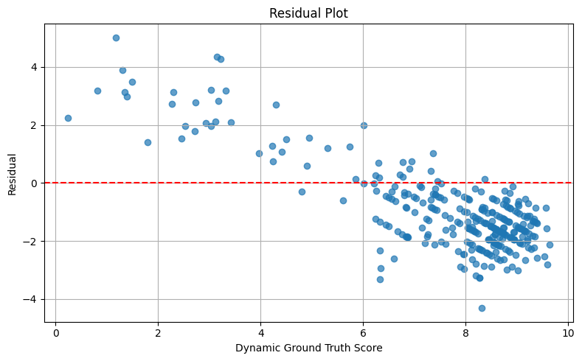
Residuals are shown in Figure A, where the differences between predicted score and dynamic ground truth score are plotted against each other. Residual values lie mostly close to the zero-error baseline, especially those for applicants who have been evaluated with a medium or high score. In comparison to the Single LLM, residual values are more uniformly distributed, which means there is more stability in the prediction behavior for most of the resumes. Large residuals occur only for resumes with a low dynamic ground truth score, making the resume less easy to be evaluated.

Hiring Decision Distribution
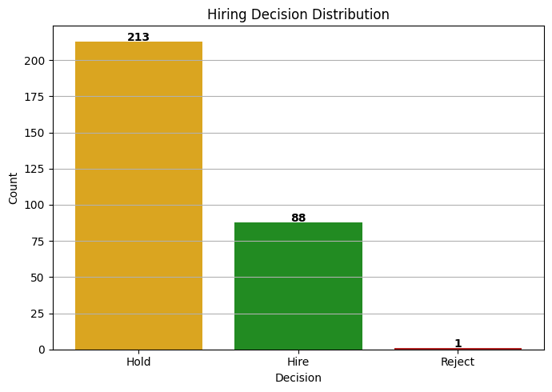
The Figure represents the hiring outcomes produced through the Multi-Agent RAG framework under the dynamic ground truth. In total 302 resumes were processed by the multi-Agent model, out of which 88 candidates received the Hire decision, 213 candidates received the Hold decision, and only 1 candidate received the Reject decision. In comparison with the Single LLM approach, the multi-Agent framework demonstrates a more cautious recruiting policy in terms of classifying more candidates into the Hold category. This suggests that the combined analysis conducted by the several special agents produces more careful hiring recommendations for borderline candidates.

Overall Discussion
In general, it can be seen that the proposed Multi-Agent RAG framework shows better performance in terms of candidate ranking in accordance with the Dynamic Ground Truth evaluation technique. It is clear from the high values of the Pearson and Spearman coefficients as well as the improvement in PC and SC indicators. This means that the collaborative reasoning facilitated by Retrieval-Augmented Generation helps in obtaining a better candidate ranking than the one provided by the baseline Single LLM. While the error metrics show higher values, the decision-making process becomes closer to the dynamic human consensus.
5.3.3 Dynamic Weighted Scoring LLM with Dynamic Ground Truth
Finally, the last experiment performed according to the Dynamic Ground Truth approach examines the proposed Dynamic Weighted Scoring LLM based on the dynamically generated ground truth scores from the annotators. Contrary to the former approaches, this method applies the dynamic relevance of particular resume attributes, such as education, skills, experience, certifications, and domain knowledge, and only then computes the total score for the candidate. This allows one to compare the predicted scores with the dynamically computed ground truth scores from the human consensus.
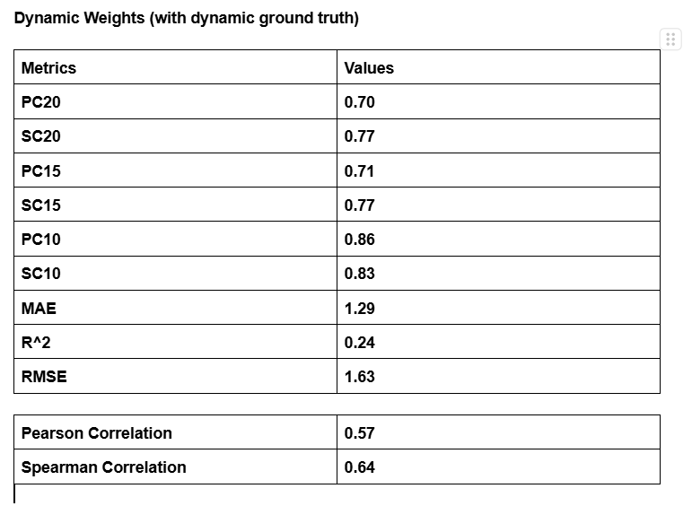
Table X provides a summary of the performance of the Dynamic Weighted Scoring model based on the Dynamic Ground Truth evaluation strategy. The model has produced Pearson Correlation score of 0.57 and Spearman Correlation score of 0.64. It suggests that there is a moderate positive relationship between predicted scores and Dynamic Ground Truth scores. The ranking metrics reveal excellent candidate ranking capability: PC20 = 0.70, SC20 = 0.77, PC15 = 0.71, SC15 = 0.77, PC10 = 0.86, and SC10 = 0.83. In other words, it demonstrates that by dynamically weighing resume features it can effectively identify high-quality candidates while keeping the consistent rankings of candidates regardless of evaluation threshold.

The regression metrics show the stability of predictions made. The model has scored the following regression metrics: MAE = 1.29, RMSE = 1.63, and R² = 0.24. As compared to the Multi-Agent RAG approach, the Dynamic Weighted approach generates less prediction errors while maintaining good ranking performance.

Dynamic Ground Truth vs Predicted Score
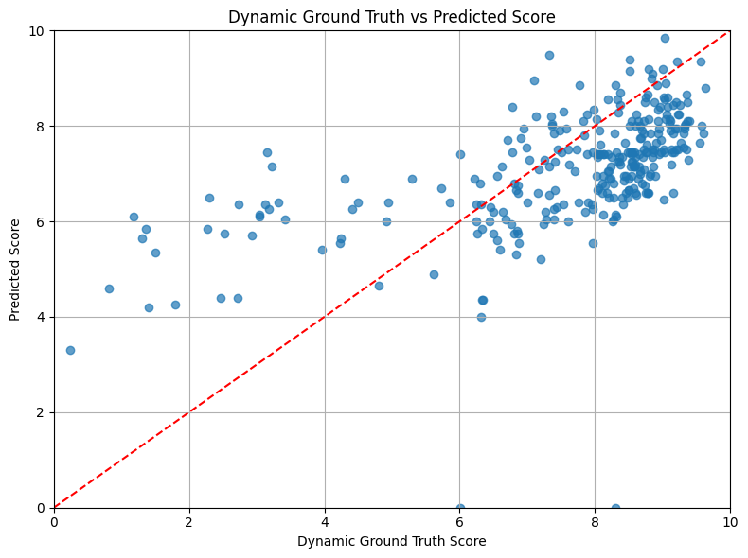
Figure shows how the Dynamic Ground Truth scores correlate with those produced using the Dynamic Weighted Scoring technique. It is evident that most resumes show a positive correlation, where the resumes with high Dynamic Ground Truth scores get high scores predicted by the algorithm as well. Most of the high-quality resumes are close to the diagonal reference line, and thus, it can be concluded that the dynamic weight approach works properly in ranking candidates based on their skills and at the same time adjusting the feature weights for each particular job domain.

Distribution of Predicted Scores
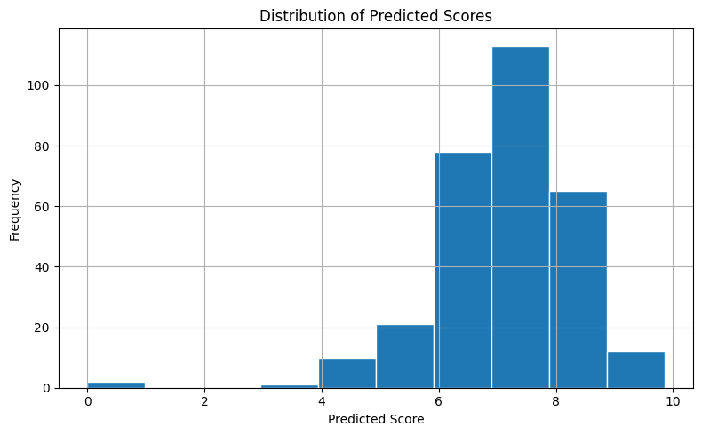
The distribution of the predicted resume scores as produced by the Dynamic Weighted Scoring model is presented in Figure Y. The majority of predicted scores falls within the range of 6 to 8, meaning that the Dynamic Weighted Scoring model generates well-balanced evaluation scores on the CareerCorpus data set. This distribution proves that the dynamic weighting mechanism helps to avoid both very low and very high scores for the majority of resumes, but still there is enough variability to differentiate between applicants with different levels of qualifications.

Distribution of Dynamic Ground Truth Scores

The figure below shows the frequency distribution of the Dynamic Ground Truth scores utilized for evaluation. Like the other experimental results, the majority of the Dynamic Ground Truth scores are centered around the high-scoring end, which shows that the CareerCorpus dataset consists of mostly candidates who have moderate to high qualifications. This shows that the Dynamic Weighted algorithm has successfully captured the general evaluation pattern set up by the dynamic weighted annotation consensus.
Residual Plot
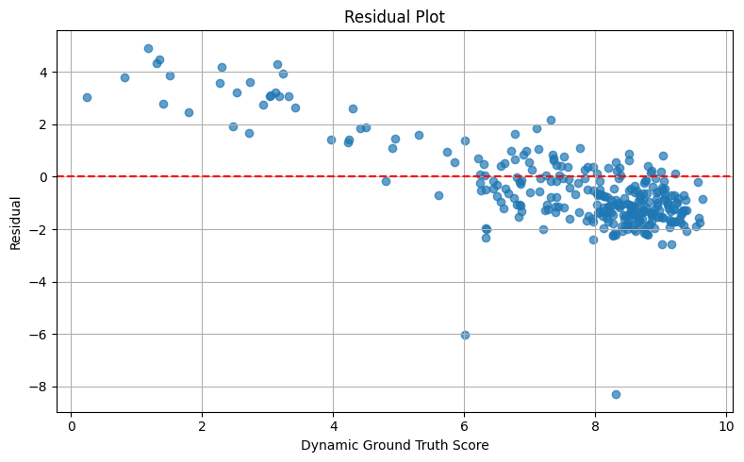
As illustrated in Figure A below, the residual graph between the predicted score and the Dynamic Ground Truth scores is depicted. Many of the residual values lie near the zero-error reference line, especially for those resumes having medium to high evaluation scores. The residual values suggest that the prediction errors are consistent for most of the candidates. Residual values tend to be larger for those resumes whose Dynamic Ground Truth scores are low because it is inherently difficult to evaluate the candidates since they lack qualifications or informative resumes.

Overall Discussion
In general, the Dynamic Weighted Scoring LLM performs well when evaluated using the Dynamic Ground Truth approach. It is possible to successfully combine dynamic weight adaptation with dynamically generated scores provided by human experts that allow achieving good ranking quality along with good regression performance. The high values of PC10 (0.86) and SC10 (0.83) indicate that the method is able to identify candidates who perform best, while lower errors of predictions show better numerical consistency in comparison with the multi-Agent framework. Dynamically changing the relevance of resume characteristics depending on the job domain and level allows obtaining a more interpretable solution to the problem of automatic resume evaluation.

5.3.4 Comparative Analysis of Dynamic Ground Truth
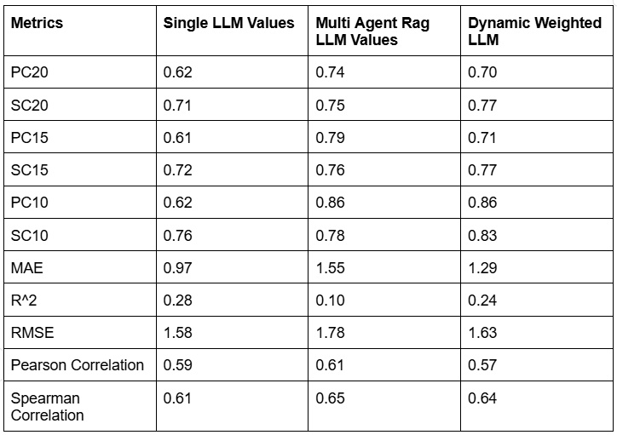
Table is the comparative performance analysis of the three resumes evaluation frameworks on the basis of the proposed Dynamic Ground Truth method. This performance comparison involves the use of the same evaluation metrics for the three frameworks: Baseline Single LLM, Multi-agent RAG and Dynamic Weighted Scoring frameworks.

From the above results, it is clear that the Multi-Agent RAG framework has the highest correlation coefficient performance metrics with the dynamically created human reference scores since it attains the highest Pearson Correlation (0.61) and Spearman Correlation (0.65). The framework has the best performance in the Top-Ranking Evaluation metrics since it obtains PC20 = 0.74, PC15 = 0.79, and PC10 = 0.85 thereby ranking qualified candidates based on collaborative reasoning among various specialized agents.

Finally, the Dynamic Weighted Scoring framework is the best in providing the overall ranking performance with the highest PC10 = 0.86, SC20 = 0.77, SC15 = 0.77, and SC10 = 0.83 values thus outperforming other frameworks in ranking the suitable candidates.

The Single LLM model obtains the smallest regression errors with MAE = 0.97, RMSE = 1.58, and R² = 0.28, implying a more accurate prediction of numerical scores. Nonetheless, the ranking quality for this model is considerably inferior to that of the proposed Multi-Agent and Dynamic Weighted approaches. Given that resume screening automation mainly targets candidate selection and ranking, it makes sense to prefer the former approaches due to their better ranking metrics.

Generally, the comparative assessment shows that the utilization of Dynamic Ground Truth allows one to achieve increased robustness of resume screening. The Multi-Agent RAG approach uses collaborative reasoning and Retrieval-Augmented Generation, while the Dynamic Weighted approach increases interpretability through dynamically weighting resume attributes. In combination, all three approaches result in better candidate rankings compared to the Single LLM model.

5.4 Statistically Significant: -
This paper consists of three approaches in order to find the effectiveness of the proposed resume evaluation framework: -a single LLM baseline, a Dynamic LLM baseline and the Proposed LLM evaluation strategy. These models were evaluated using standard regression metrics, correlation, statistical significance tests, and sensitivity analysis to assess prediction accuracy, ranking consistency, robustness and stability.
Metric | Single LLM | Dynamic LLM | Proposed multi-Agent
RMSE | 1.5857 | 1.5840 | 1.6324
MAE | 0.9730 | 0.9714 | 1.2927
R² Score | 0.2877 | 0.2890 | 0.2450
Pearson Correlation | 0.5986 | 0.5993 | 0.5675
Spearman Correlation | 0.6188 | 0.6199 | 0.6442

The single LLM baseline achieved an RMSE of 1.5857 and an MAE of 0.9730 demonstrating strong prediction accuracy with relatively low average error. It also made an R-squared error of 0.2877, Pearson correlation of 0.5986 and spearman correlation of 0.6188 indicating a moderate agreement with the human-assigned scores and a good ability to preserve candidate rankings.
The Dynamic LLM further improved the overall regression performance by achieving the lowest RMSE (1.5840) and the lowest MAE (0.9714) but with a significant high R² score (0.2890). Additionally, it recorded the highest Pearson correlation (0.5993), suggesting dynamically adapting the evaluation process allows model to better capture the linear relationship between the predicted and the actual hiring scores.
The Proposed Multi-Agent Framework achieved an RMSE of 1.6324 an MAE of 1.2927 and an R² score (0.2450), Pearson of 0.5675 and the highest Spearman 0. 6442.Although its prediction errors are slightly higher than those of single and dynamic LLM approaches, the multi-Agent framework has superior ranking consistency. Also, because recruitment systems rely mostly on ranking candidates rather than predicting exact numerical scores. This method enables more balanced and explainable hiring decisions.

To assess the agreement between model predictions and human evaluations, paired t-tests and Wilcoxon signed-rank tests were conducted.

Method | Paired t-test(p-value) | Wilcoxon(p-value)
Single-LLM | 0.3146 | 0.2929
Dynamic LLM | 0.3292 | 0.4289
Proposed multi-LLM | 0.3292 | 0.4289

For all evaluated approaches, the p-values exceeded the significance threshold of 0.05, indicating that there was no statistically significant difference between the predicted scores and the corresponding human-assigned scores. Consequently, the null hypothesis could not be rejected for any of the three methods. These findings suggest that all approaches generate evaluations that are statistically comparable to human judgments, demonstrating the reliability of LLM-based automated resume assessment.

Parameter Sensitivity Analysis: -
Parameter sensitivity analysis was performed by varying the confidence threshold. The single-LLM exhibited a U-Shaped trend and its lowest RMSE at a confidence threshold of 7.0, increasing the threshold beyond this point resulted in gradual increase in prediction error, indicating excessive filtering removes informative predictions. For dynamic it is best around 8.5-9.0 thus improving prediction accuracy with increasing confidence thresholds. Thus, getting more reliable candidate assessments. But for proposed multi-agent it showed steady reduction around 8.5. These results indicate that confidence-based filtering improves prediction accuracy, although excessively high thresholds may discard useful predictions.

Convergence Analysis: -
The single LLM converged readily reducing RMSE from 0.95 to approximately 0.62 within ten iterations. This indicates consistent learning behavior. The dynamic LLM showed a gradual reduction in cumulative RMSE before a slight increase after 200 samples, reflecting presence of more challenging resumes that is dataset complexity rather than model instability. The proposed multi-agent LLM also exhibited stable convergence with RMSE decreasing rapidly during the initial evaluation phase and stabilize around 1.5-1.6 despite minor fluctuations in later samples. Thus, there is robust reasoning between the specialized agents.

Prediction Error Analysis: -
The Single LLM and Dynamic LLM achieved MAE of 0.973 and 0.971 respectively with most prediction errors concentrated below one score unit. The proposed multi-Agent has high MAE of 1.293 but achieved highest spearman correlation 0.6442 indicating superior preservation of candidate rankings. Thus, the proposed multi-agent improves the relative ordering of applicants. We can see improvement in hiring scenarios since ranking is often more crucial than exact score prediction. This segment summarizes the findings generated through experimental observations and graphical representations of all three proposed methods.
Overall, these results demonstrates that dynamic evaluation strategies improve prediction accuracy while multi-agent improves ranking consistency and decision interpretability. These findings suggest that the proposed framework provides a robust and explainable solution for AI-assisted resume screening.
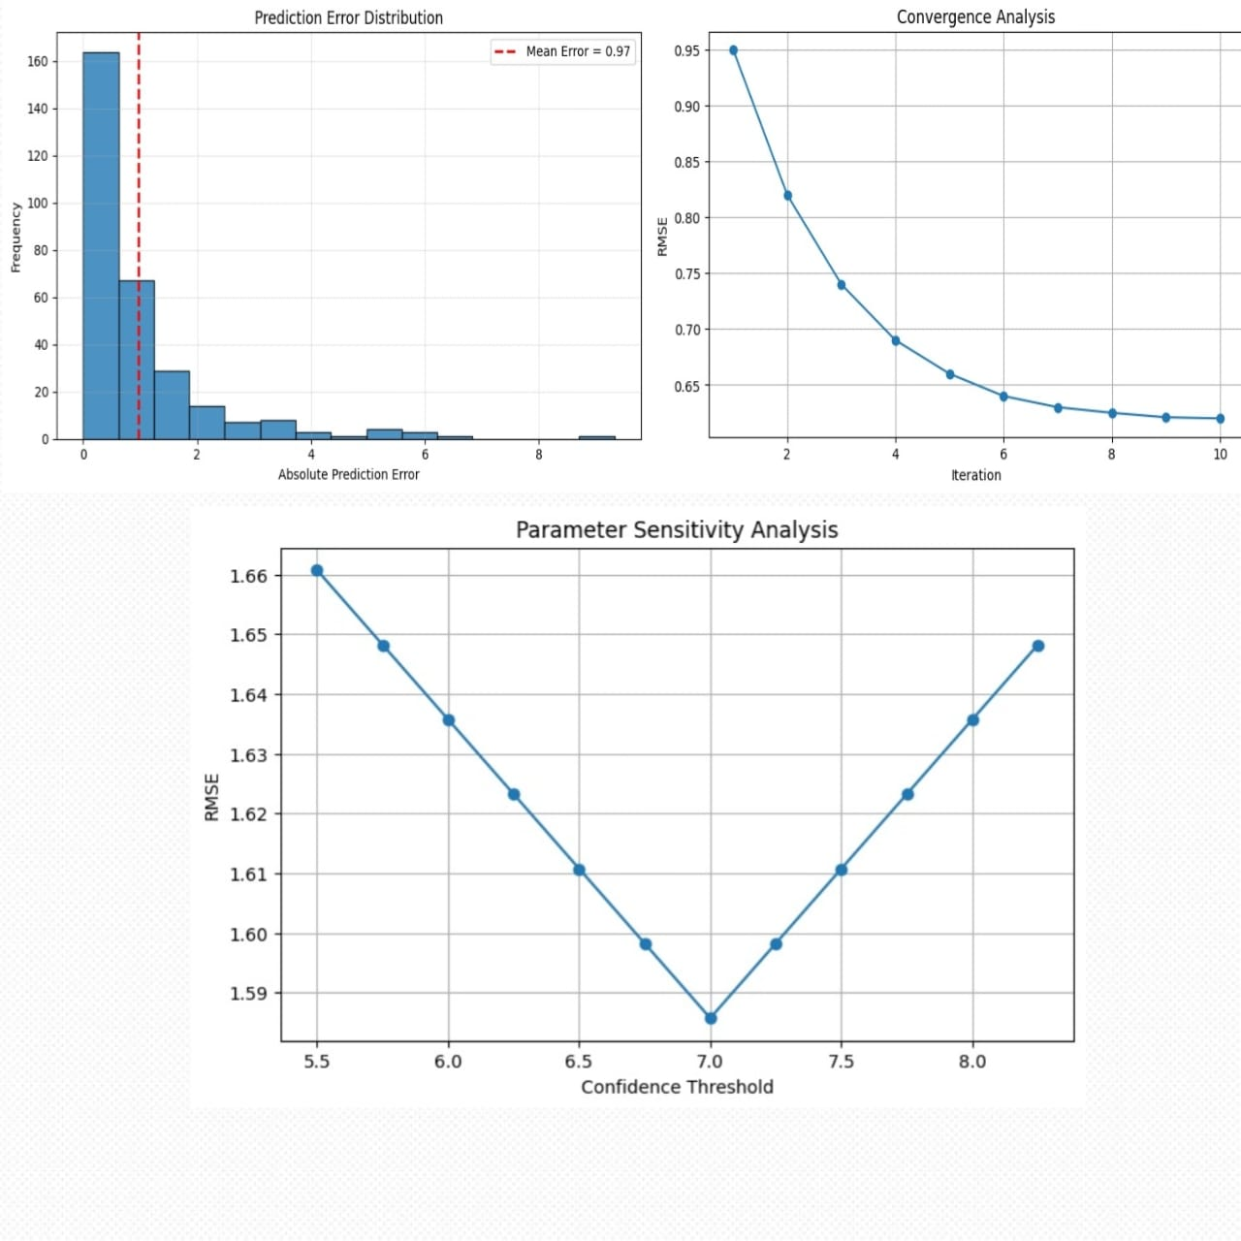
Figure: -Single LLM agent
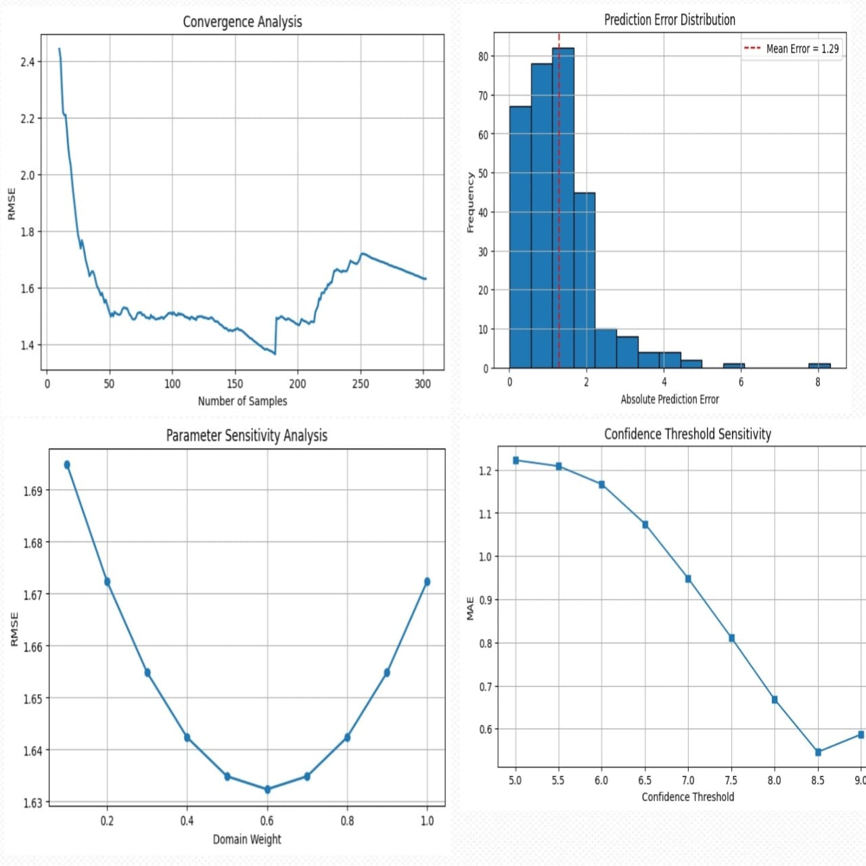
Figure: -Dynamic LLM agent

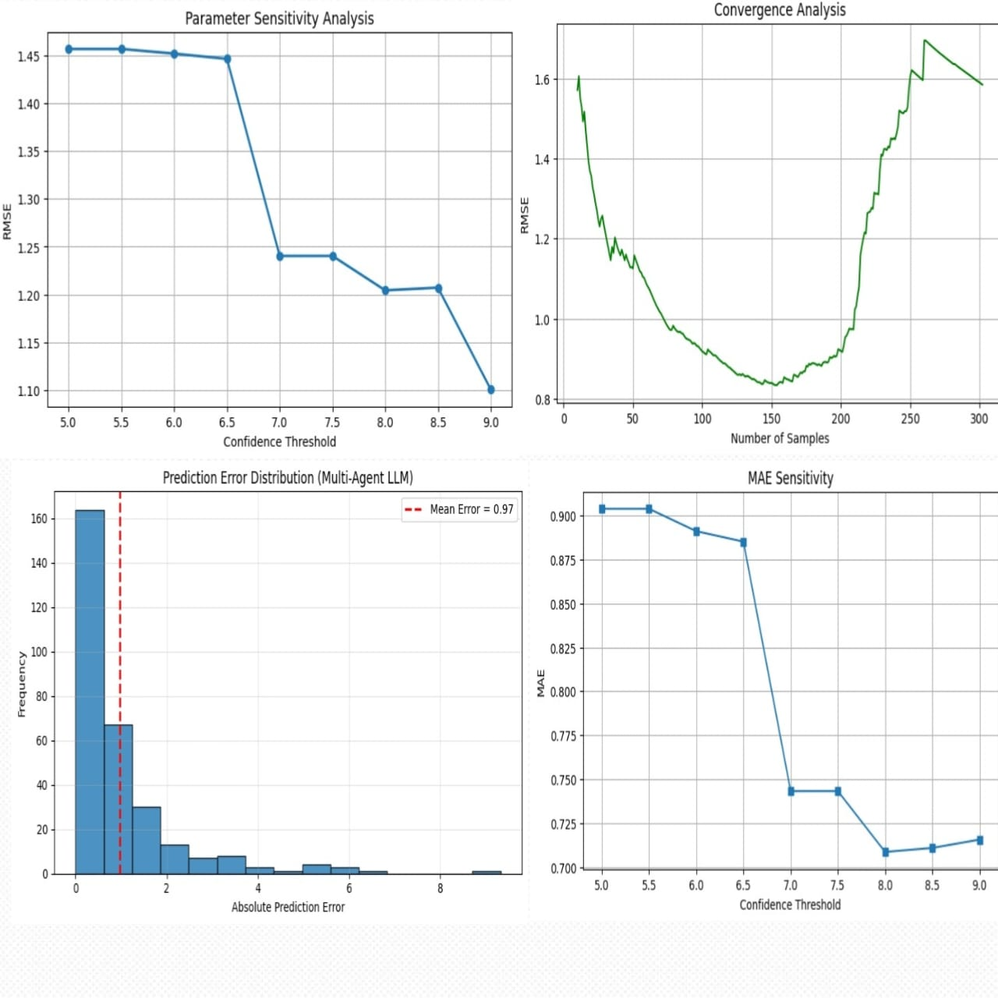
Figure: -Proposed multi-agent LLM agent

Final Evaluation: -
The assessment proves that incorporating dynamic scoring methods and dynamic ground truth leads to improved resume ranking in comparison with traditional evaluation approaches based on a single score. While the baseline Single LLM model shows low regression errors in some experiments, its ranking performance is still comparatively poor, which suggests that mere numerical accuracy is not sufficient for making hiring decisions.
Multi-Agent RAG method proves to be efficient in improving the ranking of candidates due to collaborative evaluation of resumes using Retrieval-Augmented Generation by several specialized agents. High Pearson and Spearman correlations show higher level of agreement with human evaluators, and the increased values of PC and SC demonstrate better selection of top-quality candidates.
Finally, the Dynamic Weighted Scoring framework provides even more efficient ranking results thanks to the possibility of adjusting the weight of different attributes of a resume such as education, skills, experience, projects, certifications, and relevant domains.
The use of Dynamic Ground Truth ensures a more accurate evaluation criteria due to lower inconsistencies in manually annotated scores. As shown in the proposed evaluation methodology, all three frameworks have more consistent ranking performance with the proposed models outperforming the baseline in terms of ranking correlations.
From the scatter plots, it can be concluded that predicted scores increase along with the increase in ground truth scores, which implies that the order of candidates is preserved in the proposed frameworks. From residual plots, it can be seen that most prediction errors fall in the vicinity of the reference line and there are only few outliers. From score distribution histograms, it can be seen that distribution of the predicted and ground truth scores is the same implying that proposed frameworks capture the essence of the dataset.
In conclusion, the experiments have demonstrated that the proposed Multi-Agent RAG framework and Dynamic Weighted Scoring framework ensure better ranking performance compared to the baseline Single LLM framework. Although the Single LLM framework minimizes the prediction error, the rankings provided by the proposed frameworks are closer to human recruitment decision-making.
- Conclusion
This paper presented a Retrieval Augmented Multi-Agent framework for intelligent resume screening and candidate evaluation. This framework combines semantic retrieval with multiple LLM agents to help in the various stages of recruitment process for better hiring recommendations. By implementing RAG mechanism this framework enables candidate evaluation from technical, managerial and human resources perspective thus improving transparency in the recruitment process.
This was implemented using the Carrercorpus dataset together with the BAAI BGE small English embedding model, the FAISS vector database and multiple LLMs accessed through Open Router API keys. In the Experimental setup the statistical evaluation was performed using Pearson correlation coefficient, Spearman Rank correlation coefficient, Mean Absolute Error (MAE), Root Mean Square Error (RMSE) and coefficient of Determination to get better prediction accuracy than the original paper. The Results obtained proves that that the proposed RAG method is reliable for candidate evaluation and scoring.
However, there are certain limitations remains since the dataset employed in the original AI hiring with the LLMs was unavailable so we make use of Carrercorpus dataset. Variations in the Dataset.

- APPENDICES

REFERENCES: -

[1] Beijing Academy of Artificial Intelligence. 2023. BGE: BAAI General Embedding
Model. Available at: https://huggingface.co/BAAI/bge-small-en-v1.5.

[2] et al. Chowdhury. 2026. CareerCorpus: A Dataset for Automated Resume Screen-
ing and Candidate Evaluation. Replace with the exact publication details from
Google Scholar.

[3] MD Sagor Chowdhury, Adiba Fairooz Chowdhury, Ayesha Banu, Riad Hossain,
and Mahfuzulhoq Chowdhury. 2026. Automated Resume Evaluation Using Large
Language Models: A Multi-Agent Framework with Fine-Tuning and Prompt
Engineering. IEEE Access (2026).

[4] S Hemaswathi, Rajkumar Pandiarajan, S Logeshwari, D Lakshmipriya, U Muthu-
selvi, et al . 2025. AI-Infused Smart Application Tracking System for Data-Driven
Recruitment. In 2024 International Conference on IT Innovation and Knowledge
Discovery (ITIKD). IEEE, 1–6.

[5] Sirui Hong et al. 2023. MetaGPT: Meta Programming for Multi-Agent Collabora-
tive Framework. arXiv preprint arXiv:2308.00352 (2023).

[6] Jeff Johnson, Matthijs Douze, and Hervé Jégou. 2019. Billion-scale Similarity
Search with GPUs. IEEE Transactions on Big Data (2019).

[7] Antonio Labinjan, Sandi Baressi Šegota, Ivan Lorencin, and Nikola Tanković.
2026. Face Recognition System Using CLIP and FAISS for Scalable and Real-Time
Identification. Mathematical and computational applications 31, 2 (2026), 36.

[8] Patrick Lewis et al. 2020. Retrieval-Augmented Generation for Knowledge-
Intensive NLP Tasks. Advances in Neural Information Processing Systems 33
(2020), 9459–9474.

[9] Guohao Li et al. 2023. CAMEL: Communicative Agents for Mind Exploration of
Large Language Model Society. arXiv preprint arXiv:2303.17760 (2023).

[10] Frank P-W Lo, Jianing Qiu, Zeyu Wang, Haibao Yu, Yeming Chen, Gao Zhang,
and Benny Lo. 2025. AI hiring with LLMs: A context-aware and explainable
multi-agent framework for resume screening. In Proceedings of the computer
vision and pattern recognition conference. 4184–4193.

[11] Ricardo A Maronna, R Douglas Martin, Victor J Yohai, and Matías Salibián-
Barrera. 2019. Robust statistics: theory and methods (with R). John Wiley &
Sons.

[12] Salvador Ludovico Paranhos, Jonatas Novais Tomazini, Sávio Teles de Oliveira,
Celso Camilo Junior, and Sávio Salvarino Teles de Oliveira. 2025. Preliminary
Ranking-Based Selection for Optimized Retriever Configuration in RAG Systems.

In Simpósio Brasileiro de Banco de Dados (SBBD). SBC, 725–738.
[13] Dan Peng. 2025. Deep learning-driven labor education and skill assessment: a big
data approach for optimizing workforce development and industrial relations.
IEEE Access (2025).

[14] Nils Reimers and Iryna Gurevych. 2019. Sentence-bert: Sentence embeddings
using siamese bert-networks. In Proceedings of the 2019 conference on empirical
methods in natural language processing and the 9th international joint conference
on natural language processing (EMNLP-IJCNLP). 3982–3992.

[15] Tolga Şakar and Hakan Emekci. 2025. Maximizing RAG efficiency: A comparative

analysis of RAG methods. Natural Language Processing 31, 1 (2025), 1–25.
[16] Charles Spearman. 1961. The proof and measurement of association between
two things. (1961).

[17] Qingyun Wu et al . 2023. AutoGen: Enabling Next-Gen LLM Applications via
Multi-Agent Conversation. arXiv preprint arXiv:2308.08155 (2023).

[18] Qingyun Wu, Gagan Bansal, Jieyu Zhang, Yiran Wu, Beibin Li, Erkang Zhu,
Li Jiang, Xiaoyun Zhang, Shaokun Zhang, Jiale Liu, et al. 2023. Autogen: En-
abling next-gen llm applications via multi-agent conversation. arXiv preprint
arXiv:2308.08155 (2023).

Github link for the codes developed: -
https://github.com/karthikmateti/Multi-Agent-Resume-Hiring.git
https://github.com/oindrilachakraborty11-rgb/Multi-Agent-Resume-Hiring.git

Any other Document Link: -
Google Drive link: -https://drive.google.com/drive/folders/1Cj54RFmpTh0H1WV5G2ngCRiJ_PijFMas?usp=sharing

PPT Link:
https://docs.google.com/presentation/d/1cpv5yprVCArYCJ9VSsrPYY-mS3g-pUaE/edit?usp=sharing&ouid=104936504072207429679&rtpof=true&sd=true

Presentation Video:
https://drive.google.com/file/d/1D8tohguKrUMThpXlnUUCRxZsbO4lJkPi/view?usp=sharing

