**PART 1:** Partitioning the dataset into train / test sets using a 70/30 split.

**Code:**

dat = read.csv("**E:/AML - BUAN 6341/hour.csv**", header = TRUE)

train_data = dat[1:round(0.7*nrow(dat)),]

test_data = dat[(round(0.7*nrow(dat))+1):nrow(dat),]

**PART 2:** Designing a linear regression model using the built-in package (**lm**) to model the count of bike rentals

**Code:**

model <- lm(cnt~yr + holiday+ workingday+ temp+ atemp+ hum+ windspeed+ season_1+ season_2+ season_3+ season_4+ mnth_1+ mnth_2+ mnth_3+ mnth_4+ mnth_5+ mnth_6+ mnth_7+ mnth_8+ mnth_9+ mnth_10+ mnth_11+ mnth_12+ hr_0+ hr_1+ hr_2+ hr_3+ hr_4+ hr_5+ hr_6+ hr_7+ hr_8+ hr_9+ hr_10+ hr_11+ hr_12+ hr_13+ hr_14+ hr_15+ hr_16+ hr_17+ hr_18+ hr_19+ hr_20+ hr_21+ hr_22+ hr_23+ weekday_6+ weekday_0+ weekday_1+ weekday_2+ weekday_3+ weekday_4+ weekday_5+weathersit_1+ weathersit_2+ weathersit_3+ weathersit_4, data = train_data)

**Regression equation:**

-31.149 + 82.242 yr - 5.685 holiday + 12.412 workingday + 120.304 temp + 124.956 atemp - 63.729 hum - 41.947 windspeed - 49.789 season_1 - 24.384 season_2 - 13.907 season_3 - 15.841 mnth_1 - 11.927 mnth_2 + 3.175 mnth_3 + 2.653 mnth_4 + 15.558 mnth_5 -4.243 mnth_6 - 39.440 mnth_7 - 23.907 mnth_8 + 1.541 mnth_9 + 5.445 mnth_10 - 6.173 mnth_11 - 26.797 hr_0 - 40.754 hr_1 - 47.463 hr_2 - 56.690 hr_3 - 59.560 hr_4 - 45.545 hr_5 + 3.640 hr_6 + 114.897 hr_7 + 238.701 hr_8 + 115.812 hr_9 + 66.533 hr_10 + 87.422 hr_11 + 120.134 hr_12 + 117.928 hr_13 + 103.904 hr_14 + 111.679 hr_15 + 162.304 hr_16 + 293.987 hr_17 + 268.684 hr_18 + 174.400 hr_19 + 104.605 hr_20 + 64.908 hr_21 + 34.501 hr_22 + 10.838 weekday_6 -10.543 weekday_1 -7.571 weekday_2 - 9.381 weekday_3 - 5.424 weekday_4 + 57.190 weathersit_1 + 44.839 weathersit_2 - 5.597 weathersit_3

**PART 3:** Implementing the gradient descent algorithm with batch update rule and computing the cost function

**Note:** The code for Cost Function method and Gradient Descent algorithm implementation is attached as part of the R file.

**Initial Parameter values:**

**Betas:** Random float numbers between 0 and 1

**Learning rate (alpha):** 0.01

**Cost function delta threshold:** 0.1

**EXPERIMENTATION:**

**1. Varying alpha values for training and test data sets.**

Initially the learning rate value is set to **0.01** and been progressively increased till the cost function failed to converge (Cost func. = Infinity value)

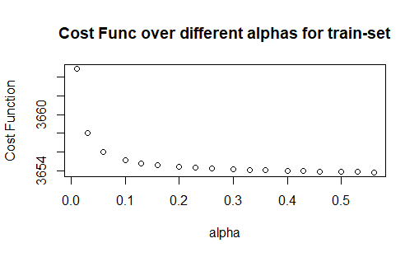

For **training data-set**, the cost function reaches its **minimum** value of **3653.848** at **alpha = 0.56** from 3664.866 at alpha = 0.01 and finally reaches Infinity at alpha = 0.6

The **ideal alpha rate** would be around **0.56** as it gives us the minimum cost function value before finally losing to converge.

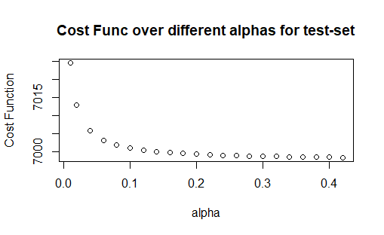

For **testing data-set**, the cost function reaches its **minimum value of 6998.464** at **alpha = 0.42** from 7024.536 at alpha = 0.01 and finally reaches Infinity at alpha = 0.43

The **ideal alpha rate** would be around **0.42** as it gives us the minimum cost function value before finally losing to converge.

**2. Varying threshold values for training and test data sets.**

Initially the threshold value is set to 0.1 and been progressively increased till the cost function failed to minimize further (reaching its minimum possible value and staying constant with increased iterations)

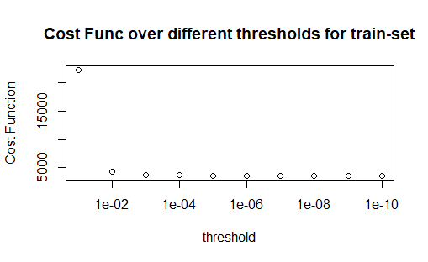

For **training data-set**, the cost function reaches its **minimum value of 3653.848** at **threshold = 1e-06** from 22155.279 at threshold = 0.1 before settling at a constant value.

The **ideal threshold rate** would be around **1e-06** (0.000001) for the same reason stated above.

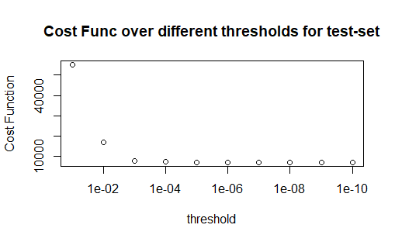

For **testing data-set**, the cost function reaches its **minimum value of 6997.588** at **threshold = 1e-07** from 55080.281 at threshold = 0.1 before settling at a constant value.

The **ideal threshold rate** would be around **1e-07** (0.0000001) for the same reason stated above.

**Plotting train and test errors as a function of number of gradient descent iterations:**

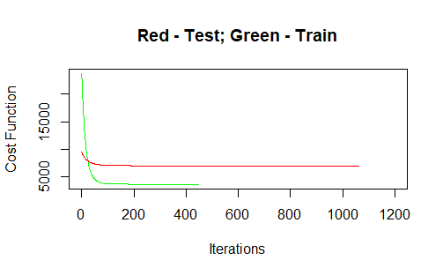

**3.** Three randomly chosen attributes are **season, mnth, weekday.**

|  |  |  |  |
| --- | --- | --- | --- |
| **Cost Function Value** | | | |
| **Train Data set** | | **Test Data set** | |
| **All variables** | **3 random variables** | **All variables** | **3 random variables** |
| **3653.848** | **10824.4814902858** | **6997.588** | **22863.4185023358** |

As we can see from the above results, the cost function value at convergence is much higher for both the train and test data sets of 3-random variable models as opposed to the All-variable model. This proves that **the random model is inefficient**.

**4.** The three cherry-picked features are **hr, temp, weathersit.**

|  |  |  |  |
| --- | --- | --- | --- |
| **Cost Function Value** | | | |
| **Train Data set** | | **Test Data set** | |
| **3 chosen variables** | **3 random variables** | **3 chosen variables** | **3 random variables** |
| **4508.65376457778** | **10824.4814902858** | **7741.47621012051** | **22863.4185023358** |

These chosen features proved to explain/predict the dependent variable **better than those randomly chosen ones**. This is evident from the **lower cost function convergence values** (lowered by about 60%) produced by these features.

|  |  |  |  |
| --- | --- | --- | --- |
| **Cost Function Value** | | | |
| **Train Data set** | | **Test Data set** | |
| **All variables** | **3 chosen variables** | **All variables** | **3 chosen variables** |
| **3653.848** | **4508.65376457778** | **6997.588** | **7741.47621012051** |

**The all-variables model outperformed this cherry-picked feature model by a small margin since it has more explanatory features.**

**Discussion:**

**The final linear regression equation done using gradient descent algorithm with all parameters:**

**26.9047505 + 82.8108614 yr - 6.8786185 holiday + 11.2531240 workingday + 121.8793333 temp + 117.0401528 atemp - 64.4736125 hum - 39.0775359 windspeed - 18.1087756 season_1 + 6.1117109 season_2 + 12.3936464 season_3 + 29.3267964 season_4 - 11.2621997 mnth_1 - 6.9598018 mnth_2 + 9.1091751 mnth_3 + 9.8417677 mnth_4 + 23.6662218 mnth_5 + 6.1676803 mnth_6 - 25.4455528 mnth_7 - 10.3406643 mnth_8 + 13.8663059 mnth_9 + 14.4715255 mnth_10 + 2.3975061 mnth_11 + 7.2564381 mnth_12 - 104.5872659 hr_0 - 118.5902422 hr_1 - 125.2641255 hr_2 - 134.5056557 hr_3 - 137.4225100 hr_4 - 123.4309185 hr_5 - 74.2737114 hr_6 + 36.9571346 hr_7 + 160.7559598 hr_8 + 37.8427540 hr_9 - 11.4048074 hr_10 + 9.5630073 hr_11 + 42.2871549 hr_12 + 40.1234013 hr_13 + 26.1130632 hr_14 + 33.8974388 hr_15 + 84.4811297 hr_16 + 216.1725723 hr_17 + 190.8165082 hr_18 + 96.5886076 hr_19 + 26.8491272 hr_20 - 12.8289479 hr_21 - 43.2639760 hr_22 - 77.7670516 hr_23 + 17.4327873 weekday_6 + 6.6560672 weekday_0 - 2.6880381 weekday_1 + 0.4270127 weekday_2 - 1.4426286 weekday_3 + 2.4746816 weekday_4 + 7.7476757 weekday_5 + 34.7919430 weathersit_1 + 22.6935247 weathersit_2 - 27.9098806 weathersit_3 - 0.8527864 weathersit_4**

**Interpretation:**

1. The intercept value is 26.9047505. This means that **approximately 27 bikes get rented when all the features are not considered** (all feature variables set to zero).
2. Features such as “**workingday**”, “**temp**”, “**atemp**”, “**yr**” shows a **positive impact** on the number of bikes rented (Thanks to their positive coefficient values)
3. Features such as “**holiday**”, “**hum**”, “**windspeed**” shows a **negative impact** on the bike rental count variable due to their negative coefficient values.
4. **Clear, Few clouds and Misty conditions increases** the count value whereas, **light snow or heavy rains go against** the bike rental count.

**Important features:**

Since the requirement is to predict the number of bike rental count given an hour, I think that the variable **“hr” plays a very important role** in predicting the same. Also, the variables “**temp**” and “**weathersit**” contributes more in explaining the dependent variable with **high coefficients**.

**Further steps:**

1. There is a suspect of this model being heteroskedastic (error term might be varying with feature values). We can run a robust standard error linear regression model for better prediction.
2. We can also look for non-linear regression models and see how those fit the data.
3. Finally, it would be better to gather more explanatory variables to better explain the variance in the dependent variable.