**Contents Pg.no**

Assignment 2 : Topics in Electronics

1. Introduction …………………………………………………………………2

2. Circuit Diagram……………………………………………………………...3

3. Small Signal Circuit Diagram…….…………………………………………4

4. Computing DC Operating Point………………………………...…………...5

5. Transient time domain simulation using HiSpice - Matlab Interface ….……7

6. Input Output Response………………………..……………………………..8

Assignment 2 : Topics in Electronics

**Introduction**

The objective of this assignment is to get deeper understanding about the process in computing the DC point of a non-linear circuit and for studying the steady state and transient analysis of non- linear systems.

MATLAB Hi-Spice interface is used for computing the DC points and the response of the system. The same has been discussed in depth in the document.

**Circuit Diagram**

Assignment 2 : Topics in Electronics

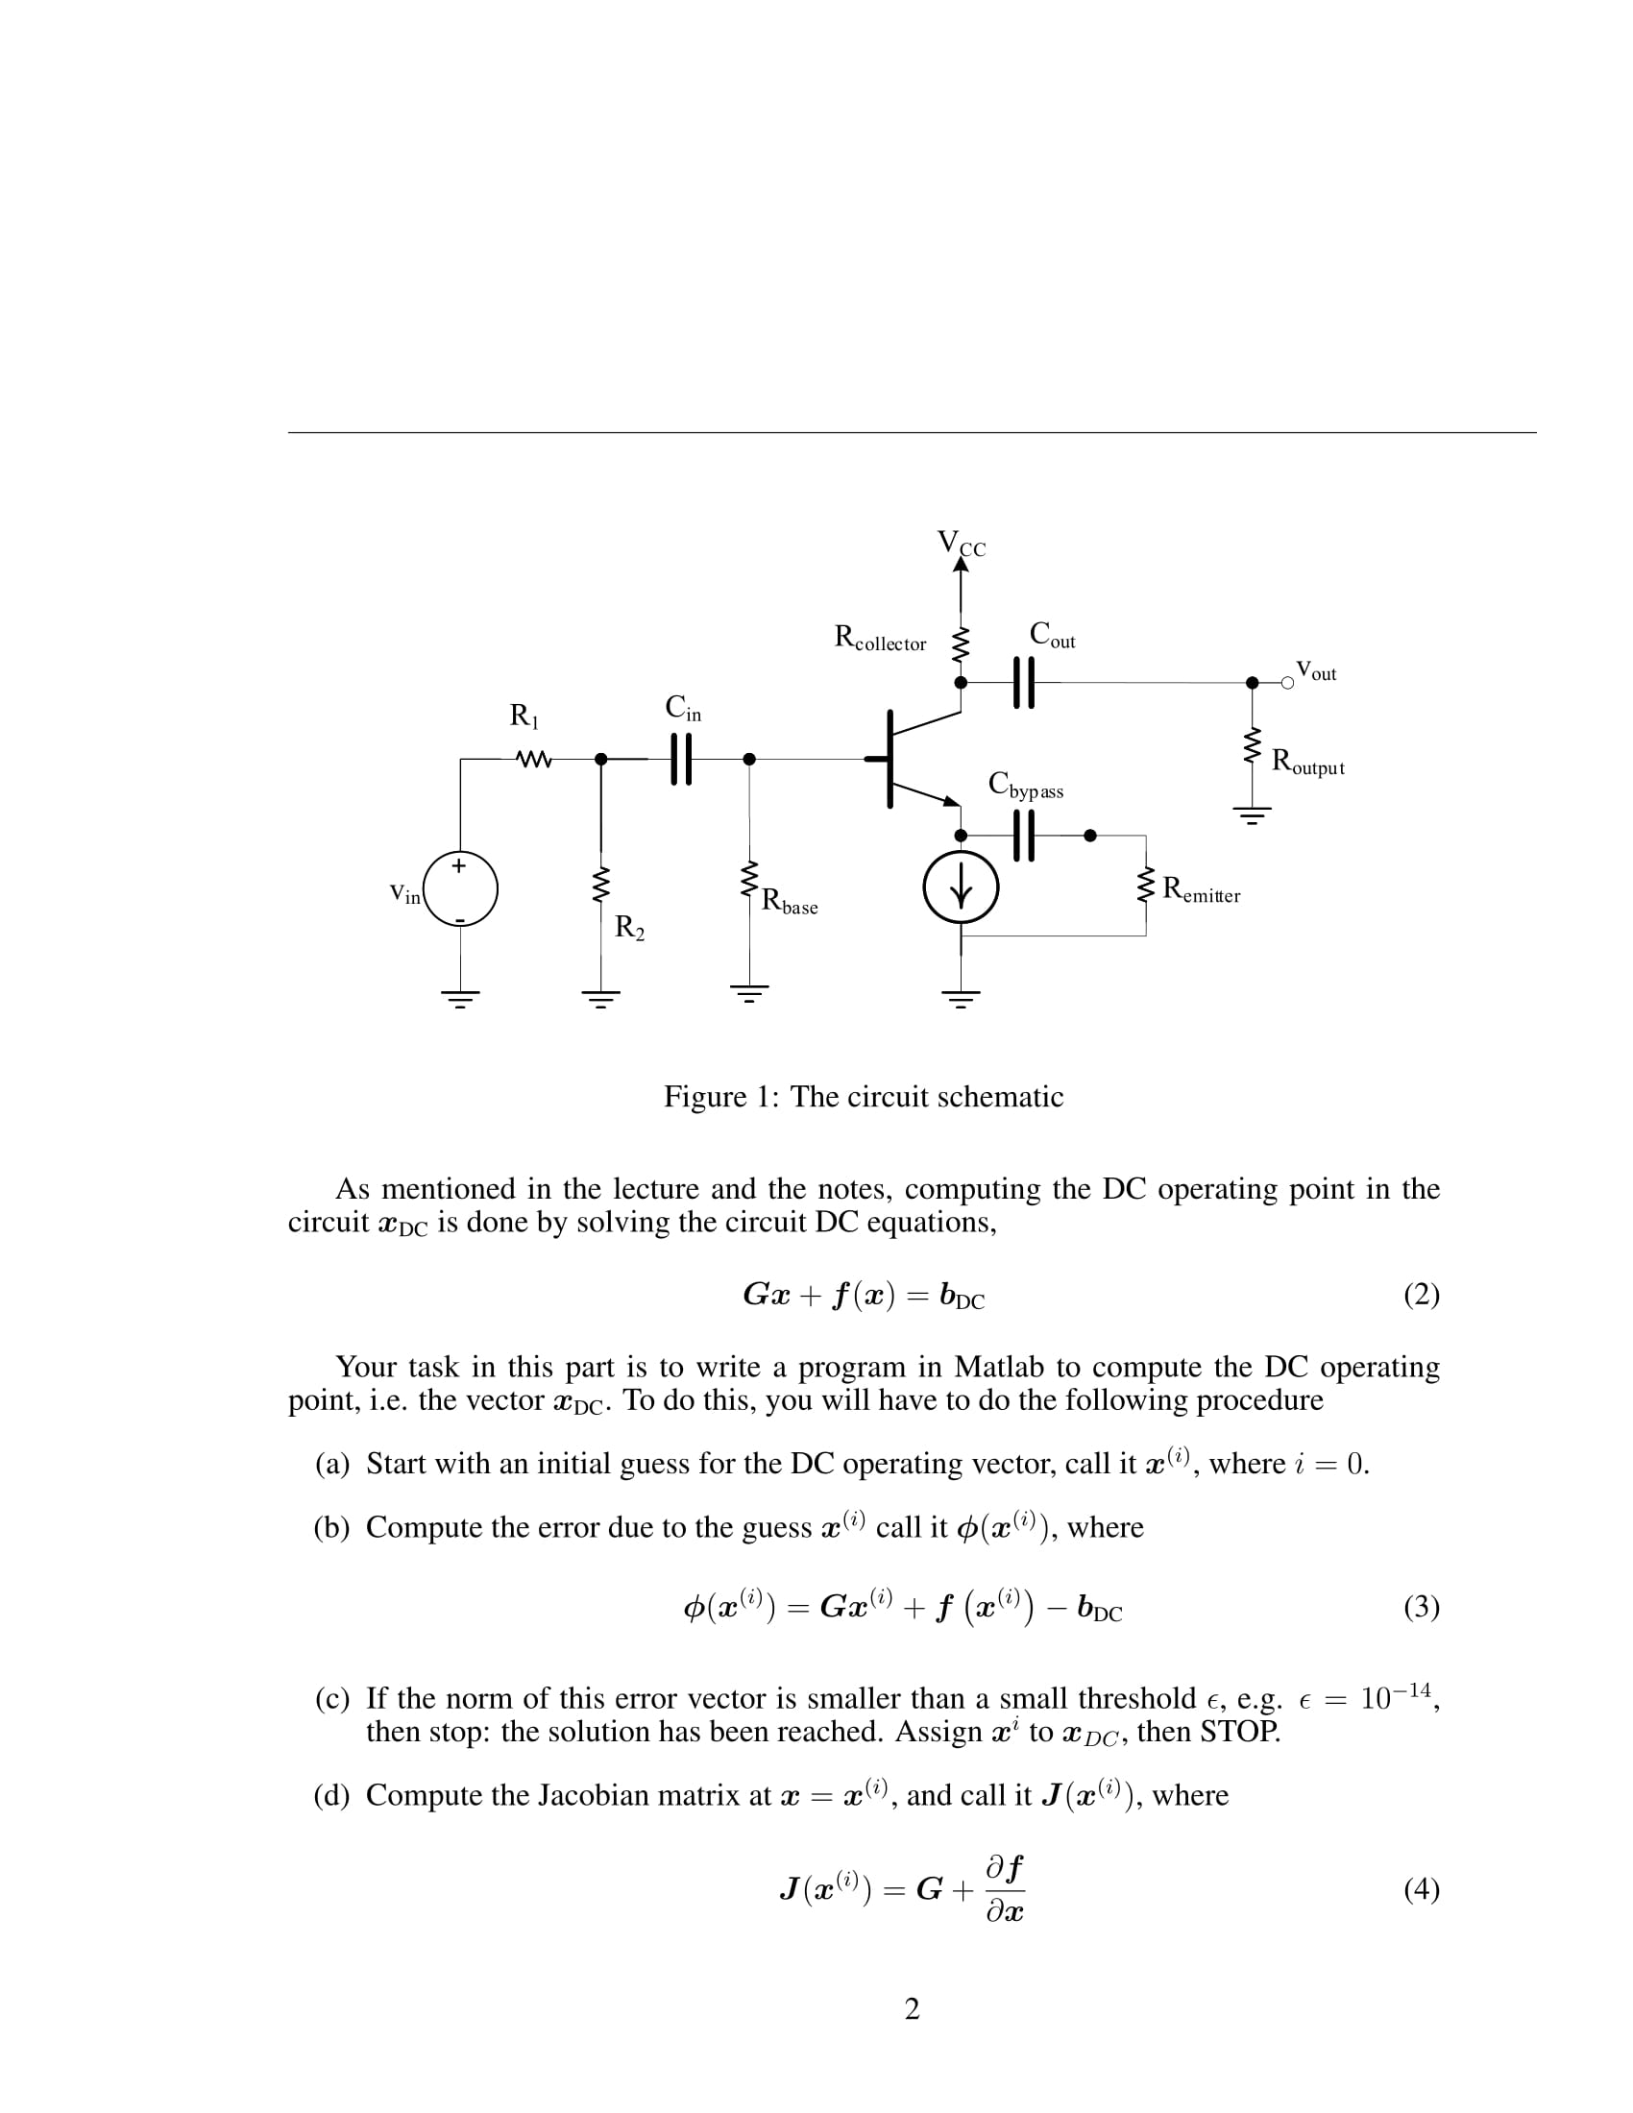

Fig.1 Common Emitter Amplifier

The single stage common emitter amplifier circuit shown above uses “Voltage Divider Biasing”. This type of biasing uses two resistors as a potential divider network across the supply with their centre point supplying the required base bias voltage to the transistor. Voltage divider biasing is commonly used in the design of BJT amplifier circuits.

This method of biasing the transistor greatly reduces the effects of varying Beta, ( *β* ) by holding the Base bias at a constant steady voltage level allowing for best stability. The quiescent Base voltage (Vb) is determined by the potential divider network formed by the two resistors, R1, R2, Rbase as shown in the figure.

The capacitors Cin and Cout are coupling capacitors and are used to couple the voltages from a previous stage to this stage and also to couple the output of this stage to the next stage. It also blocks all the DC components. Cbypass is the bypass capacitor which allows all the current to flow through thus reducing the voltage drop at the emitter terminal.

Assignment 2 : Topics in Electronics

**Small Signal Circuit Diagram**

Assignment 2 : Topics in Electronics

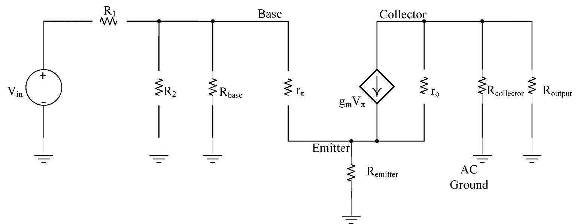

Rin = R2 || Rbase || rπ

vin= vsig Rin Rin+ Rsig

Rin = Rc || ro

vo= -*gm*vπ (RC || RL || ro)

Fig.2 Small Signal Equivalent Circuit

AC Analysis of any network is done by flowing steps

* Identifying all the DC Voltage sources and replacing it by short circuit.
* Identifying all the DC Current sources and replacing it by open circuit.
* All the capacitors are replaced by short circuit.

vin(*t*)= 0.01 cos (2 × π × 5 × 10­6 × *t*)

*β* = 100

o= -*gm* π (*R*C || *R*L || ro)

=

**Computing DC Operating Point**

Assignment 2 : Topics in Electronics

Assignment 2 : Topics in Electronics

The DC operating point *x*DC can be manually computed by solving the equation

*Gx + f* (*x*) = *b*DC

It uses the Newton Raphson method for computing the *ϕ(x(i))* at the instant i where initially *i*=0;

A threshold ϵ = 10-14 is set and the norm of the error *ϕ(x(i))* is calculated using the equation

*ϕ(x(i))= Gx(i) + f* (*x(i)*) - *b*DC

If the norm of the error *ϕ(x(i))* is smaller than the ϵ then the iteration is stopped and the new *x* obtained is the initial point at *t=0.*

If the error is grater than the threshold, Jacobian of the matrix at *x=x(i)* and is called as the *J*(*x(i)*)

*J*(*x(i)*) = *G + ∂f / ∂x*

Where *∂f / ∂x* is the partial derivatives. The initial guess is updated using the following equation

*x(i+1)­­­­=x(i) – J -1 ϕ(x(i))*

The process is again repeated by the *x* in the equation until the norm of the error is less than the threshold.

A program involving a function to compute DC point has been included. The function is given the name ‘compute_DC_point’.

function [xDC] = compute_DC_point(x_initial_guess)

**Transient time domain simulation using HiSpice - Matlab Interface**

Assignment 2 : Topics in Electronics

In the computer-aided analysis of nonlinear circuits with periodic inputs and a stable periodic response the transient-state periodic response is found for a given initial state by using the TR method of the system equations until the response becomes periodic and steady.

The trapezoidal rule is the continuation of the NR method by getting the initial point x_DC in the system of equations.



Here the *h* is the step size which is equal to the difference between the two time-points of the curve. TR method is used for approximation of the output response of a system for a given input.

TR method is implemented using MATLAB by getting the initial point x_DC using the function compute_DC_point and then the step size *h* calculated using the formula

*h = T / 50*

The input for the system is clocked at 5MHz.

T= 1/*f*  sec

The resistors and the capacitor stamps are computed to be used in the program for computation.

The nonlinear function vector f(x) , source vector b and the Jacobin of the vector *J(f(x))* is computed for time *t=*0;

To calculate the new value of ‘x’, the TR iterations are done using the equation

and the norm of the vector is compared with a threshold as earlier to continue or stop the iteration process.

*J(x(i+1))= C + (H/2) × J(x(i))*

*x(i+1) = x(i)­* - *J(x(i+1)) × ϕ (x(i))*

A function has been implemented using MATLAB to find the transient response of a given nonlinear system.

Assignment 2 : Topics in Electronics

function x_transient = compute_TR_time_response(x_0,...time_points,...output_node_name)

**Input Output Response**

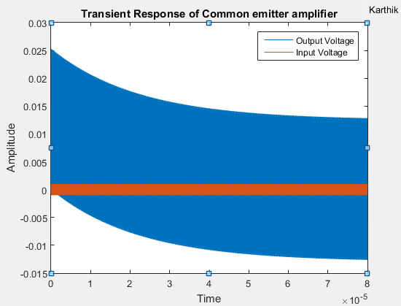

Fig.3 Transient IO Response

The amplifier is designed to work with a voltage gain of 12.6. Initially the system is in the transient state. After a considerable amount of time of around

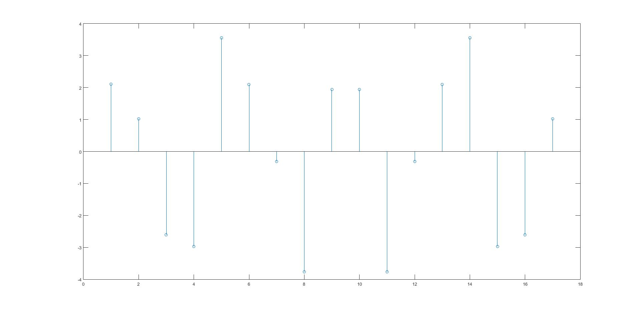

Assignment 2 : Topics in Electronics

Fig.4 FFT of the Ouput

The number of cycles ‘T’ depends on the step size H and the as the step size increases the number of iterations to reduce the error increases but the iterations to caluculate the voltage at specific points decreases. Smaller the step size accurate the resuslts will be. Taking an example at T= 1/ 4 x 105 takes 400,000 cycles to to compute.