**University of Ottawa**

Master of Engineering  
Electrical and Computer Engineering

Assignment 1  
ELG7132D

**Topics in Electronics I: Simulation of Radio Frequency Circuits**

Submitted by  
  
**Karthik M Prakash**University ID: 300037618

**Contents Pg.no**   
1. Introduction …………………………………………………………………3

2. Circuit Diagram……………………………………………………………...4

3. Equivalent Circuit Model……………………………………………………5

4. G Matrix……………………………………………………………………..6

5. C Matrix……………………………………………………………………..7

6. Source Vector………………………………………………………………..8

7. Function Vector……………………………………………………………...9

8. Nodes and their Indices…………………………………………………….10

**Introduction**

The objective is to get familiarized with the HiSPICE- Matlab interface as a tool to used extract the circuit mathematical structures which is done through executing simple commands to access the mathematical constructs describing the circuit.

**Circuit Diagram**

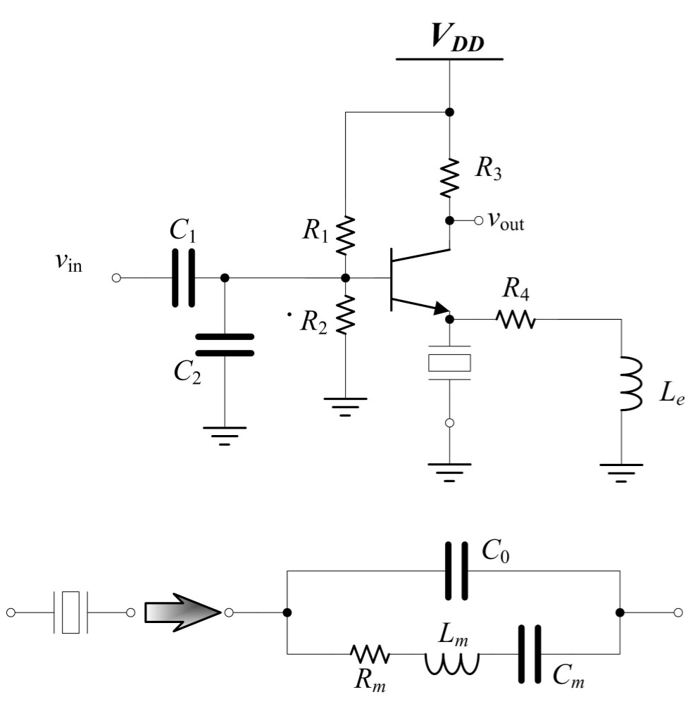

Fig.1.1 Crystal Equivalent model

Fig.1 Tuned Amplifier Circuit

**Equivalent Circuit Model**



Fig.1.2 Equivalent Model of Tuned Amplifier

|  |  |  |  |  |  |  |  |  |  |  |  |  |  |  |  |  |  |  |
| --- | --- | --- | --- | --- | --- | --- | --- | --- | --- | --- | --- | --- | --- | --- | --- | --- | --- | --- |
|  | 0 |  | -1/R3  -1/R1 | 0 | 0 | 0 | 0 | 0 | 0 | 0 | 0 | 0 | 1 | 0 | 0 | 0 | 0 | 0 |
| 0 | 0 | 0  -1/R1+1/R2+1/Rb | 0 | 0 | 0 | 0 | 0 | 0 | 0 | 0 | 0 | 0 | 0 | 1 | 0 | 0 | 0 | 0 |
|  | -1/R1  0 |  | 0 | 0 | 0 | 0 | -1/Rb | 0 | 0 | 0 | 0 | 0 | 0 | 0 | 0 | 0 | 0 | 0 |
|  | 0  -1/R3 | 0 | 1/R3+1/Rc | 0 | 0 | 0 | 0 | 0 | 0 | -1/Rc | 0 | 0 | 0 | 0 | 0 | 0 | 0 | 0 |
| 0 | 0 | 0 | 0 | 1/Re+1/Rm+1/R4 | -1/R4 | 0 | 0 | 0 | 0 | 0 | -1/Re | 1/Rm | 0 | 0 | 0 | 0 | 0 | 0 |
| 0 | 0 | 0 | 0 | -1/R4 | 1/R4 | 1/Rb | 0 | 0 | 0 | 0 | 0 | 0 | 0 | 0 | 0 | 0 | 0 | 0 |
| 0 | 0 | -1/Rb | 0 | 0 | 0 | 0 | 0 | 0 | 0 | 0 | 0 | 0 | 0 | 0 | 0 | -0.02 | -0.99 | 0 |
| 0 | 0 | 0 | 0 | 0 | 0 | 0 | 0 | 0 | 0 | 0 | 0 | 0 | 0 | 0 | 0 | 1 | 0 | 0 |
| 0 | 0 | 0 | 0 | 0 | 0 | 0 | 0 | 0 | 0 | 1/Rc | 0 | 0 | 0 | 0 | 0 | 0 | 0 | 0 |
| 0 | 0 | 0 | -1/Rc | 0 | 0 | 0 | 0 | 0 | 0 | 0 | 0 | 0 | 0 | 0 | 0 | -1 | 0.99 | 0 |
| 0 | 0 | 0 | 0 | -1/Re | 0 | 0 | 0 | 0 | 0 | 0 | 1/Re | 0 | 0 | 0 | 0 | 0.02 | -1 | 0 |
| 0 | 0 | 0 | 0 | -1/Rm | 0 | 0 | 0 | 0 | 0 | 0 | 0 | 1/Rm | 0 | 0 | 0 | 0 | 0 | 1 |
| 0 | 0 | 0 | 0 | 0 | 0 | 0 | 0 | 0 | 0 | 0 | 0 | 0 | 0 | 0 | 0 | 0 | 0 | -1 |
| 0 | 0 | 0 | 0 | 0 | 0 | 0 | 0 | 0 | 0 | 0 | 0 | 0 | 0 | 0 | 0 | 0 | 0 | 0 |
| 1 | 1 | 0 | 0 | 0 | 0 | 0 | 0 | 0 | 0 | 0 | 0 | 0 | 0 | 0 | 0 | 0 | 0 | 0 |
| 0 | 0 | 0 | 0 | 0 | 0 | 0 | 0 | 0 | 0 | -1 | -1 | 0 | 0 | 0 | 0 | 0 | 0 | 0 |
| 0 | 0 | 0 | 0 | 0 | 0 | 0 | 0 | 0 | 0 | 0 | 0 | 0 | 0 | 0 | 0 | 0 | 0 | 0 |
| 0 | 0 | 0 | 0 | 0 | 0 | 0 | 0 | 0 | 0 | 0 | 0 | 0 | 0 | 0 | 0 | 0 | 0 | 0 |
| 0 | 0 | 0 | 0 | 0 | 0 | 0 | 0 | 0 | 0 | 0 | 1 | -1 | 0 | 0 | 0 | 0 | 0 | 0 |

**G – Matrix**

The G-Matrix is formed by considering all the resistors. In a closed network with various linear and nonlinear elements the G matrix represents the presence of resistors between various node.

1/R1+1/R3

|  |  |  |  |  |  |  |  |  |  |  |  |  |  |  |  |  |  |  |
| --- | --- | --- | --- | --- | --- | --- | --- | --- | --- | --- | --- | --- | --- | --- | --- | --- | --- | --- |
| 0 | 0 | 0 | 0 | 0 | 0 | 0 | 0 | 0 | 0 | 0 | 0 | 0 | 0 | 0 | 0 | 0 | 0 | 0 |
| 0 | **C1** | **-C1** | **Ccx+C1+C2**  0 | 0 | 0 | 0 | 0 | 0 | 0 | 0 | 0 | 0 | 0 | 0 | 0 | 0 | 0 | 0 |
| 0 | **-C1** |  | 0 | 0 | 0 | 0 | 0 | 0 | **-Ccx** | 0 | 0 | 0 | 0 | 0 | 0 | 0 | 0 | 0 |
| 0 | 0 | 0 | 0 | 0 | 0 | 0 | 0 | 0 | 0 | 0 | 0 | 0 | 0 | 0 | 0 | 0 | 0 | 0 |
| 0 | 0 | 0 | 0 | **C0** | 0 | 0 | 0 | 0 | 0 | 0 | 0 | 0 | 0 | 0 | 0 | 0 | 0 | 0 |
| 0 | 0 | 0 | 0 | 0 | 0 | 0 | 0 | 0 | 0 | 0 | 0 | 0 | 0 | 0 | 0 | 0 | 0 | 0 |
| 0 | 0 |  | 0 | 0 | 0 | **Cc+Ce** | 0 | 0 | **-Cc** | **-Ce** | 0 | 0 | 0 | 0 | 0 | 0 | 0 | 0 |
| 0 | 0 | 0 | 0 | 0 | 0 | 0 | 0 | 0 | 0 | 0 | 0 | 0 | 0 | 0 | 0 | 0 | 0 | 0 |
| 0 | 0 | 0 | 0 | 0 | 0 | 0 | 0 | 0 | 0 | 0 | 0 | 0 | 0 | 0 | 0 | 0 | 0 | 0 |
| 0 | 0 | **-Ccx** | 0 | 0 | 0 | **-Cc** | 0 | 0 | **Ccx+Ce** | 0 | 0 | 0 | 0 | 0 | 0 | 0 | 0 | 0 |
| 0 | 0 | 0 | 0 | 0 | 0 | **-Ce** | 0 | 0 | 0 | 0 | 0 | 0 | 0 | 0 | 0 | 0 | 0 | 0 |
| 0 | 0 | 0 | 0 | 0 | 0 | 0 | 0 | 0 | 0 | **Ce** | 0 | 0 | 0 | 0 | 0 | 0 | 0 | 0 |
| 0 | 0 | 0 | 0 | 0 | 0 | 0 | 0 | 0 | 0 | 0 | 0 | **Cm** | 0 | 0 | 0 | 0 | 0 | 0 |
| 0 | 0 | 0 | 0 | 0 | 0 | 0 | 0 | 0 | 0 | 0 | 0 | 0 | 0 | 0 | 0 | 0 | 0 | 0 |
| 0 | 0 | 0 | 0 | 0 | 0 | 0 | 0 | 0 | 0 | 0 | 0 | 0 | 0 | 0 | 0 | 0 | 0 | 0 |
| 0 | 0 | 0 | 0 | 0 | 0 | 0 | 0 | 0 | 0 | 0 | 0 | 0 | 0 | 0 | **Lc** | 0 | 0 | 0 |
| 0 | 0 | 0 | 0 | 0 | 0 | 0 | 0 | 0 | 0 | 0 | 0 | 0 | 0 | 0 | 0 | 0 | 0 | 0 |
| 0 | 0 | 0 | 0 | 0 | 0 | 0 | 0 | 0 | 0 | 0 | 0 | 0 | 0 | 0 | 0 | 0 | 0 | 0 |
| 0 | 0 | 0 | 0 | 0 | 0 | 0 | 0 | 0 | 0 | 0 | 0 | 0 | 0 | 0 | 0 | 0 | 0 | Lm |

**C- Matrix**

The C-Matrix is formed by considering all the capacitors and the inductors. In a closed network with various linear and nonlinear elements the C-matrix represents the presence of capacitors and the inductors between various node.

**Source Vector *b(t)***

|  |
| --- |
| 0 |
| 0 |
| 0 |
| 0 |
| 0 |
| 0 |
| 0 |
| 0 |
| 0 |
| 0 |
| 0 |
| 0 |
| 0 |
| Vdd |
| Vin |
| 0 |
| Vdc |
| Vde |
| 0 |

b(t) *=*

The source vector represents the various voltage sources present in a network. It also denotes the node at which the source is present.

**Function Vector *f(x(t))***

|  |
| --- |
| 0 |
| 0 |
| 0 |
| 0 |
| 0 |
| 0 |
| g(V8-V7) + g(V9-V7) |
| -g(V8-V7) |
| g(V9-V7) |
| 0 |
| 0 |
| 0 |
| 0 |
| 0 |
| 0 |
| 0 |
| 0 |
| 0 |
| 0 |

f(x(t)) ***=***

**Nodes and their indices**

|  |  |
| --- | --- |
| Node Label | Index Assigned by Hi-Spice |
| ndd | 1 |
| nVin | 2 |
| n1 | 3 |
| nVo | 4 |
| A1 | 5 |
| n3 | 6 |
| xQ.n01 | 7 |
| xQ.n02 | 8 |
| xQ.n03 | 9 |
| xP.n04 | 10 |
| xQ.n05 | 11 |
| xCrystal.nC | 12 |
| xCrystal.C1 | 13 |
| Vdd | 14 |
| Vin | 15 |
| Le | 16 |
| Vdc | 17 |
| Vde | 18 |
| Lm | 19 |

Table 1: Nodes in the network and their corresponding indices