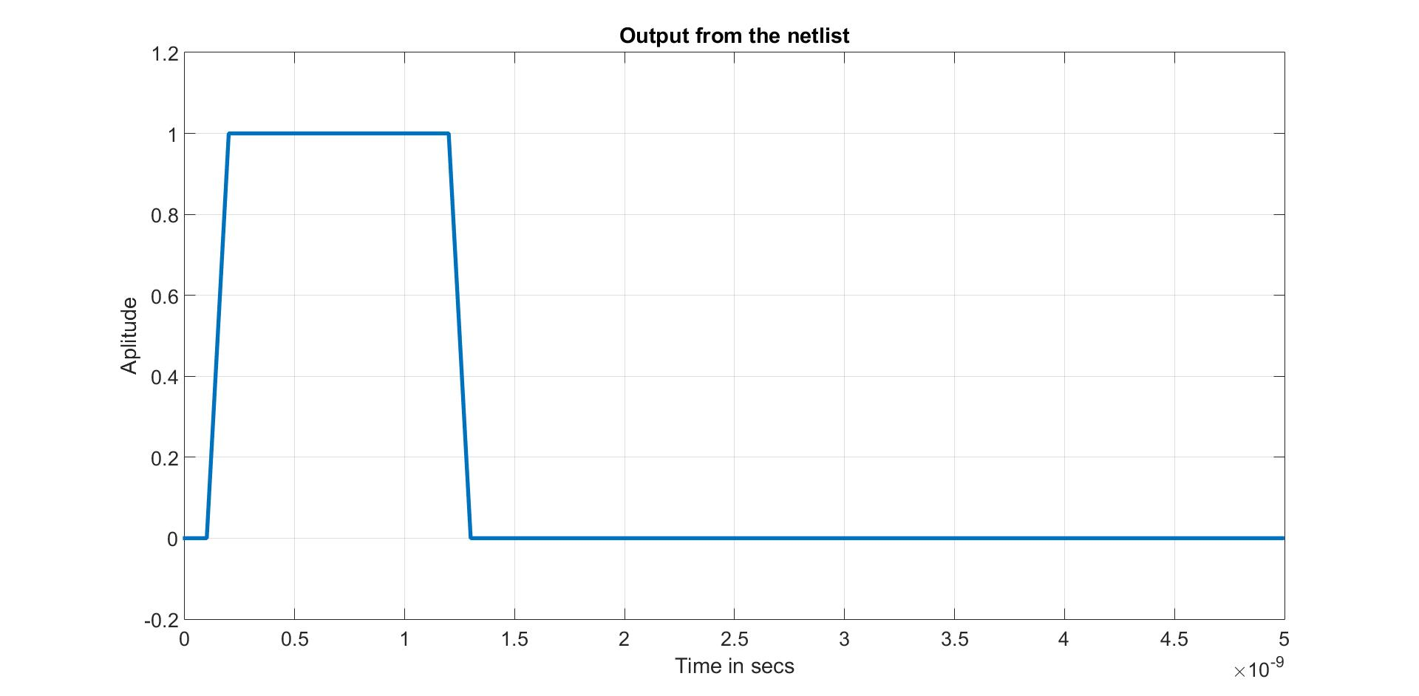

**Trace from the Netlist**

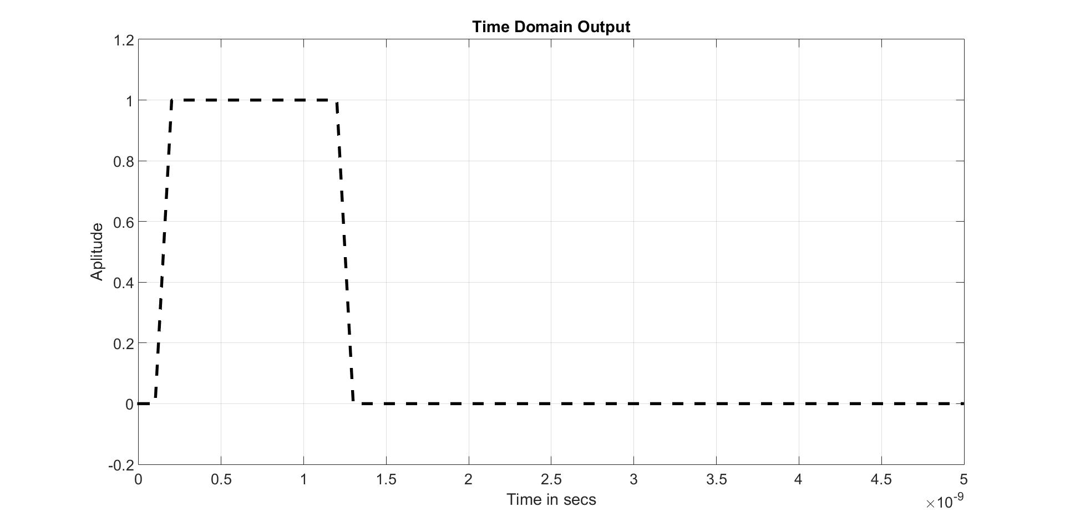**Trace from the Fourier Coefficients**

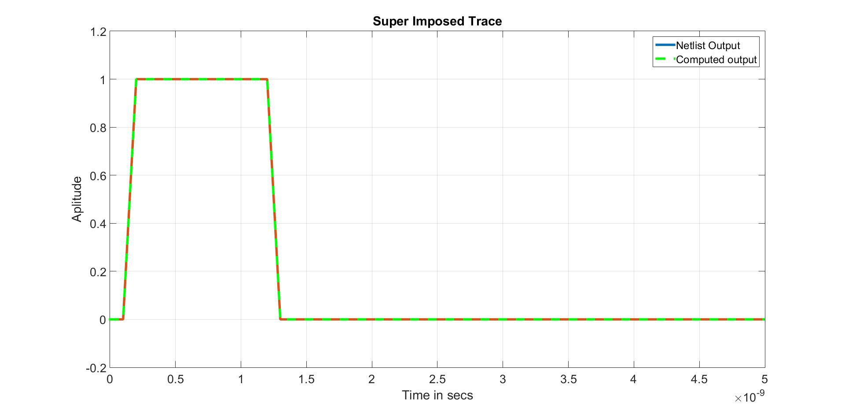**Superimposed Trace of the Source Coefficients**