**Topics in Electronics I: Simulation of Radio Frequency Circuits**

**Newton Shooting Method**

Newton Shooting Method is all about solving a boundary value problem by reducing it to the solution of an initial value problem. It is similar to shoot out trajectories at different directions till we find a boundary value to get the perfect trajectory.

In this approach we are using the backward Euler to compute the initial condition for the Newton Shooting method.

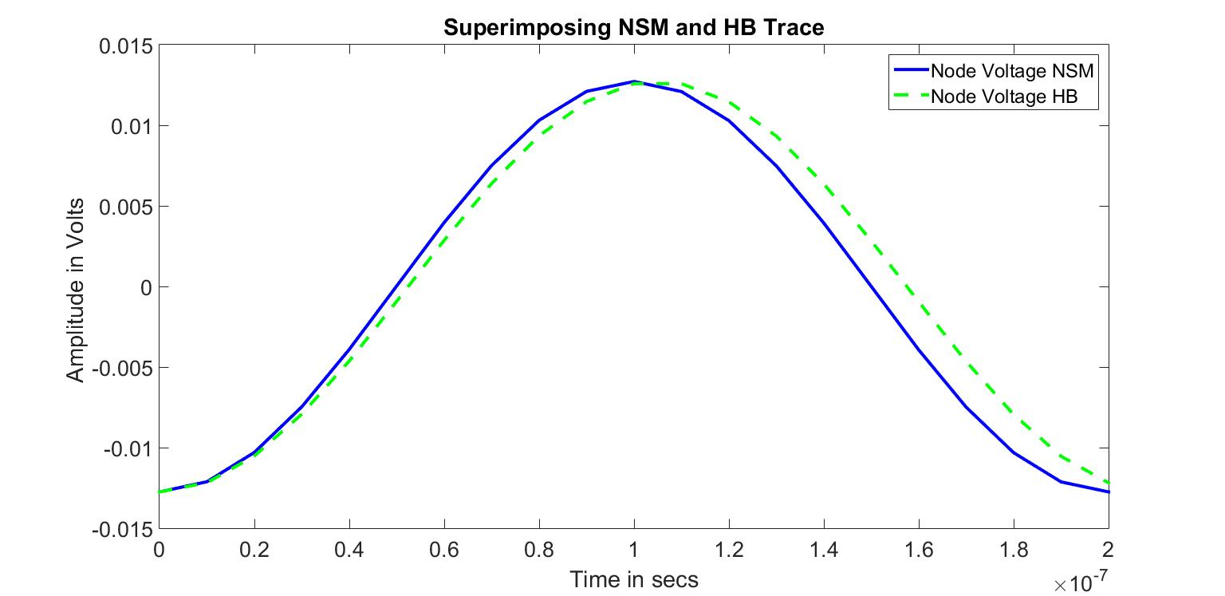

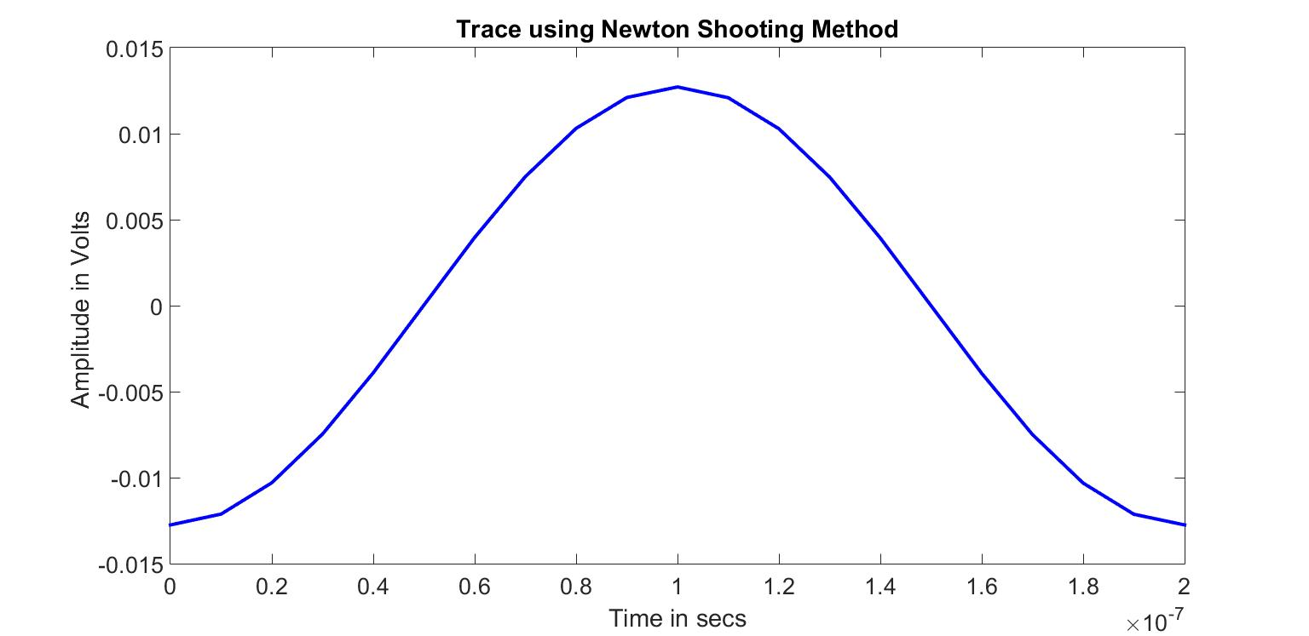

**Topics in Electronics I: Simulation of Radio Frequency Circuits**

