1. Sketch of two-dimensional grid showing of the box-truncated frequency spectrum

for *K1* = 3, and *K2* = 5.

K1

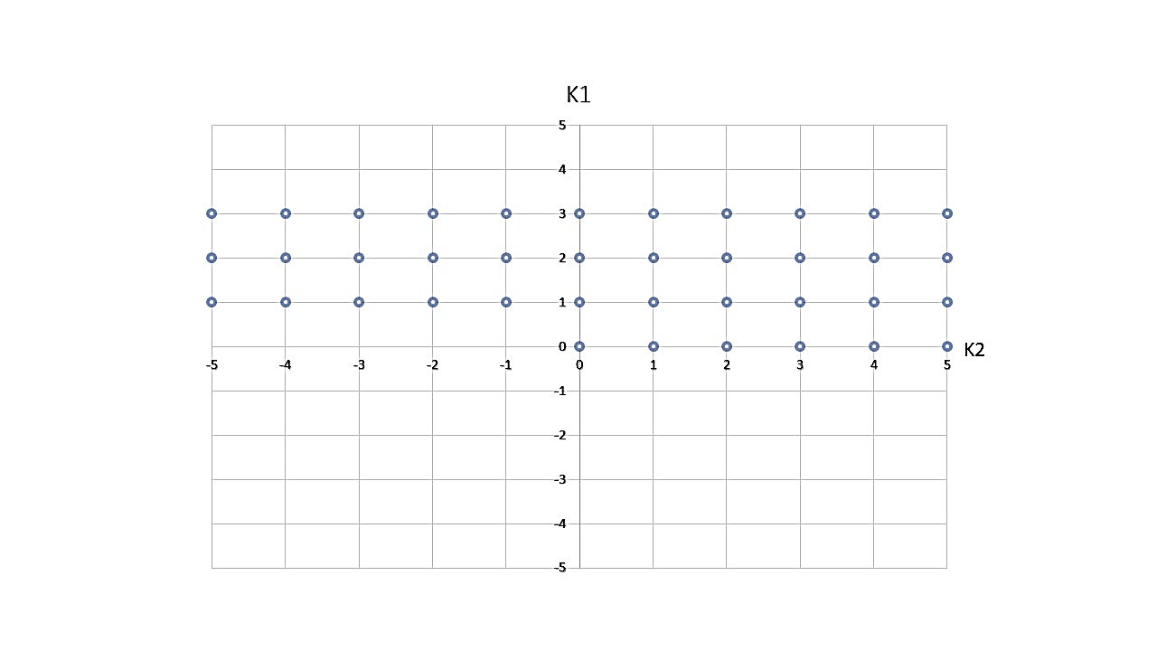

K2

Fig1: Two-Dimensional Grid of Box Truncated Spectrum for K1=3 and K2=5

1. Set of Unique frequencies obtained through the box truncation scheme, including

the DC frequency is given in the following table:

|  |  |  |  |
| --- | --- | --- | --- |
| Index | k2 | k1 | ω |
| 0 | 0 | 0 | 0 |
| 1 | 1 | 0 | |ω2| |
| 2 | 2 | 0 | |2ω2| |
| 3 | -2 | 1 | |ω1-2ω2| |
| 4 | -1 | 1 | |ω1- ω2| |
| 5 | 0 | 1 | |ω1| |
| 6 | 1 | 1 | |ω1+ω2| |
| 7 | 2 | 1 | |ω1+2ω2| |
| 8 | -2 | 2 | |2ω1- 2ω2| |
| 9 | -1 | 2 | |2ω1- ω2| |
| 10 | 0 | 2 | |2ω1| |
| 11 | 1 | 2 | |2ω1+ω2| |
| 12 | 2 | 2 | |2ω1+2ω2| |

1. From the given netlist, it can be observed that AC source currents enter through the node ‘VL01’, VL02’, ‘VRF1’, ‘VRF1’which corresponds node index number 46,47,48 and 49. Also, the DC component ‘vdd1’, ‘vdd2’ and current source ‘I0’ enters through node number 44, 45 and 03. For numerical value, absolute value is taken. The format used for to represent co-efficient of source vector is followed:

Non - zero entries of the B vector ordered in Harmonic-major/node-minor is given in the following table:

|  |  |
| --- | --- |
| Index of Non-Zero Entries | Numeric Values (Absolute value) |
|  | 0.01 |
|  | 15 |
|  | 15 |
|  | 0.0125 |
|  | 0.0125 |
|  | 0.125 |
|  | 0.125 |

d) Artificial Frequency Mapping  
 P = | k1 + k2 (2K1+1) |

|  |  |  |  |  |  |
| --- | --- | --- | --- | --- | --- |
|  | Ω­M | | **˄M** | | |
| Index | P | ω | k1 | k2 | Ω |
| 0 | 0 | 0 | 0 | 0 | 0 |
| 1 | 1 | 1λ0 | 1 | 0 | |ω1| |
| 2 | 2 | 2 λ0 | 2 | 0 | |2ω1| |
| 3 | 3 | 3 λ0 | 2 | -1 | |2ω1- ω2| |
| 4 | 4 | 4 λ0 | 1 | -1 | |ω1- ω2| |
| 5 | 5 | 5 λ0 | 0 | 1 | |ω2| |
| 6 | 6 | 6 λ0 | 1 | 1 | |ω1+ω2| |
| 7 | 7 | 7 λ0 | 2 | 1 | |2ω1+ω2| |
| 8 | 8 | 8 λ0 | 2 | -2 | |2ω1- 2ω2| |
| 9 | 9 | 9 λ0 | 1 | -2 | |ω1-2ω2| |
| 10 | 10 | 10 λ0 | 0 | 2 | |2ω2| |
| 11 | 11 | 11 λ0 | 1 | 2 | |ω1+2ω2| |
| 12 | 12 | 12 λ0 | 2 | 2 | |2ω1+2ω2| |

(e) Permutation Matrix

*ρ =*

