SafetyPool: Guided Exploration for Deep Reinforcement Learning
Sai Durga Karthik Nandiraju
Manolo Dulva Hina
Abstract
Exploration is necessary in deep reinforcement learning, but random actions can create avoidable collisions in driving simulations. We present SafetyPool, a Deep Q-Network (DQN) training framework that stores local evidence about previously visited states and uses this evidence to block actions associated with near-term hazards during exploration. The learned network is evaluated without a safety mask, so test performance measures the frozen policy rather than an external controller. We compare SafetyPool against Epsilon-Greedy DQN, NoisyNet DQN, and DQN with Random Network Distillation in MetaDrive and HighwayEnv. Each environment-specific analysis uses 23 matched training seeds, 500 training episodes, and 300 test episodes per seed. Collision Restricted Mean Survival Time (RMST) through the fixed 500-step test window is the sole reported outcome. In MetaDrive, SafetyPool obtains a Collision RMST interquartile mean (IQM) of 229.8 steps, compared with 91.4, 92.1, and 91.6 for the baselines. In the matched 23-seed Highway subset, the corresponding IQMs are 122.15, 5.79, 5.68, and 6.44 steps. Paired Wilcoxon comparisons remain significant against all three baselines after Holm correction in both environment-specific analyses.

Introduction
Reinforcement learning (RL) trains an agent by allowing it to interact with an environment and learn from rewards and penalties (Sutton and Barto 2018). Deep reinforcement learning (DRL) uses a neural network to represent the agent’s decision rule. In autonomous-driving research, DRL can discover behaviours that are difficult to specify manually, but learning requires exploration: the agent must sometimes try an action whose outcome is uncertain. A randomly selected steering or acceleration command may therefore cause an autonomous vehicle collision or send the vehicle off the road.
This paper investigates whether exploration can be guided by state-specific safety evidence. The proposed algorithm, SafetyPool, extends a Deep Q-Network (DQN). During training, SafetyPool groups similar observations into state pools, records which actions have produced sufficient safe or hazardous evidence, and prevents well-supported hazardous actions from being selected. During testing, this intervention is removed and the frozen DQN selects the action with the largest predicted action-value. This separation matters: a test-time shield can make a weak policy appear safe, whereas our evaluation asks whether guided training changes the policy itself.
We address the following research questions:
- RQ1: Does SafetyPool delay or prevent autonomous vehicle collisions relative to common exploration baselines?
- RQ2: Are the observed improvements consistent across random seeds and statistically supported?
- RQ3: How should the Collision RMST improvement be interpreted?
The contributions of this paper are as follows:
- an evidence-guided exploration mechanism that separates temporary state candidates, promoted state pools, retired pools, and a bounded hazard memory;
- environment-specific evaluations in MetaDrive and HighwayEnv over 23 matched seeds and 6,900 test episodes per method, against Epsilon-Greedy DQN, NoisyNet DQN, and DQN with Random Network Distillation (RND); and
- a Collision RMST analysis supported by robust aggregation, confidence intervals, and matched-seed tests.
The rest of this paper is structured as follows. Section 2 discusses the background and related work. Section 3 presents SafetyPool, Section 4 describes the experimental design, and Section 5 reports and discusses the results. Section 6 concludes the paper and outlines future work.

Background and Related Work

Value-based reinforcement learning and exploration
An RL problem is commonly formalised as a Markov decision process (MDP), consisting of states, actions, transition probabilities, rewards, and a discount factor (Sutton and Barto 2018). Q-learning estimates the expected discounted return of choosing action $a$ in state $s$ (Watkins and Dayan 1992). A DQN approximates this action-value function, $Q\left(s,a\right)$, with a neural network (Mnih et al. 2015). Double DQN reduces overestimation (Hasselt, Guez, and Silver 2016); duelling networks separate state value from action advantage (Wang et al. 2016); prioritised replay samples informative transitions more frequently (Schaul et al. 2016); and Rainbow combines several such improvements (Hessel et al. 2018).
Exploration methods decide how the learner gathers experience. Epsilon-Greedy chooses a random action with probability $ϵ$. NoisyNet injects learned noise into network parameters (Fortunato et al. 2018). RND supplies intrinsic reward when a fixed random network is difficult for a predictor to imitate (Burda et al. 2018). Other approaches use visitation counts (Bellemare et al. 2016), prediction error (Pathak et al. 2017), and bootstrapped value functions (Osband et al. 2016). These methods promote novelty or uncertainty; they do not necessarily distinguish an informative action from a repeatedly hazardous one.
SafetyPool advances this line of work by making empirical state–action outcomes part of the exploration decision rather than relying only on novelty, uncertainty, or a fixed constraint. It guides the experiences collected by the DQN during training while leaving the learned policy to act independently during evaluation. Table 1 positions SafetyPool relative to representative exploration and safety approaches by comparing their training-time exploration, source of safety knowledge, and evaluation behaviour.
Table 1. Relationship between SafetyPool and representative exploration and safety approaches. Evaluation behaviour shows whether the learned policy acts directly or an auxiliary mechanism may override it.
Approach | Training guidance | Safety knowledge and evaluation role
Epsilon-Greedy | Random action with probability $ϵ$ | No safety knowledge; learned DQN acts directly during evaluation
NoisyNet | Learned parameter noise | No safety knowledge; learned DQN acts directly during evaluation
RND | Prediction-error novelty bonus | No safety knowledge; learned DQN acts directly during evaluation
Formal shield | Base explorer constrained by logical rules | Hand-specified safety rules; shield may override the policy
Recovery policy | Base policy plus recovery controller | Learned risk model; recovery controller may override the policy
SafetyPool | Matched-state outcome evidence guides selection among safe and unknown actions | Empirical action outcomes; SafetyPool is disabled and the frozen DQN acts directly during evaluation

Safety mechanisms
Safe RL includes constrained optimisation, risk-sensitive objectives, external shields, recovery policies, and action correction (García and Fernández 2015). Constrained MDPs represent safety as an explicit cost budget (Altman 1999); constrained policy optimisation seeks approximately feasible policy updates (Achiam et al. 2017). Shielding rejects actions that violate a formal safety specification (Alshiekh et al. 2018), while safety layers correct continuous actions using learned constraints (Dalal et al. 2018). Recovery RL learns a separate policy for leaving unsafe regions (Thananjeyan et al. 2021), and Lyapunov methods enforce stability-style constraints (Chow et al. 2018). In contrast, SafetyPool uses empirical, local evidence to guide exploration only during training. It neither assumes a formal vehicle-dynamics model nor uses an external test-time shield.

Autonomous-driving simulation and evaluation
DRL has been widely explored for autonomous driving (Kiran et al. 2022; Sallab et al. 2017; Kendall et al. 2019). MetaDrive supports configurable procedural driving scenarios and standardised agent interaction (Li et al. 2023), while HighwayEnv provides a lane-based highway simulator with controllable traffic and vehicle dynamics. Reward shaping can accelerate learning by providing informative feedback when the original reward is sparse. However, poorly designed shaping terms can redirect the policy toward maximising a proxy reward instead of the intended driving objective (Ng, Harada, and Russell 1999). We therefore evaluate collision-free time directly rather than using reward as the outcome.
Reliable RL comparisons require more than a mean over a few runs. Henderson et al. document sensitivity to implementation and random seeds (Henderson et al. 2018); Agarwal et al. recommend robust aggregate statistics such as the interquartile mean (IQM) and stratified bootstrap confidence intervals (Agarwal et al. 2021); Colas et al. discuss appropriate statistical testing (Colas, Sigaud, and Oudeyer 2019); and Patterson et al. emphasise transparent empirical design (Patterson et al. 2024). Our analysis combines robust aggregation with matched-seed paired tests because the IQM limits the influence of unusually high or low seed outcomes, while pairing compares methods under the same training randomisations. Together, these choices make the comparison more sensitive to method differences and less sensitive to seed-specific variation.

Methodology

Base learner
The agent receives a vector observation $s_{t}$ at time $t$ and selects one of nine discrete actions formed by three steering choices and three throttle/brake choices. A DQN with parameters $θ$ predicts one action-value for each action. The temporal-difference target is
$$y_{t}=r_{t}+γ\left(1−d_{t}\right)\max_{a′}Q_{θ^{−}}\left(s_{t+1},a′\right),$$
where $r_{t}$ is the reward, $γ=0.99$ is the discount factor, $d_{t}$ is one when the episode ends, and $θ^{−}$ denotes the target network. The online network minimises the squared difference between $y_{t}$ and $Q_{θ}\left(s_{t},a_{t}\right)$. Optimisation uses Adam (Kingma and Ba 2015), whose adaptive learning rates are based on first- and second-moment estimates. Neural-network gradients are computed by back-propagation (Rumelhart, Hinton, and Williams 1986).

State candidates, active pools, and hazard memory
SafetyPool maintains bounded memory at three levels.
Candidate states are newly observed state regions. A candidate must be revisited four times before promotion, which reduces the chance that a single noisy observation creates a permanent rule. At most 150 candidates are retained; eviction begins above a soft limit of 125.
Active state pools are promoted regions with action-level evidence. A pool stores a representative state, visit counts, observed outcomes, and whether each action is currently considered safe, hazardous, or insufficiently known. The active collection is capped at 500 pools. Retired pools preserve summaries of displaced regions.
Hazard memory retains up to 125 hazardous summaries even when their original pools are removed. This makes repeated severe outcomes less likely to be forgotten simply because memory capacity is reached.
Two observations are considered for the same region only when they pass both a directional and a magnitude gate. Directional similarity is measured by cosine similarity,
$$cos\left(x,z\right)=\frac{x^{⊤}z}{∥x∥_{2}∥z∥_{2}},$$
and magnitude discrepancy is measured by root-mean-square (RMS) difference. Candidate matching requires cosine similarity of at least 0.90 and RMS difference of at most 0.25; active-pool matching uses 0.90 and 0.20. Thresholds are calibrated from up to 3,000 observed states, with at most 20,000 state pairs.

Evidence-guided action selection
For a matched pool, an action is blocked only after its recorded outcomes provide sufficient hazard evidence. Safety confirmation requires at least two supporting visits and checks a five-step horizon with a minimum progress threshold of 0.01. Blocking persists for a short warning window of two decisions. If no state matches, if evidence is missing, or if all evidence is inconclusive, the algorithm falls back to the base exploration rule rather than inventing a safety label.
Training proceeds in three interpretable stages:
- Initial evidence collection. The learner attempts non-blocked actions in matched regions so that each locally available action receives evidence.
- Guided learning. For the main training phase, approximately 80% of eligible choices use the DQN-preferred safe action and 20% explore an action that remains unknown. If no unknown action exists, the greedy safe action is used.
- Policy consolidation. In the final 20% of training, pool-based action selection is disabled and the DQN acts greedily. This phase forces the neural policy to operate without continued assistance from the state memory.
If every action is blocked, SafetyPool selects the action with the least recorded risk; otherwise the vehicle could become undefined at the exact moment a decision is required. During testing, all state-pool masks and safety scans are disabled. The final trained network is frozen and uses $arg\max_{a}Q_{θ}\left(s,a\right)$ at every step.

Experimental Design

Environments, methods, and protocol
Experiments use MetaDrive (Li et al. 2023) and HighwayEnv. MetaDrive uses three procedural map blocks, traffic density 0.2, and nine discrete controls. HighwayEnv uses the highway-v0 environment, a flattened normalised Kinematics observation, traffic density 0.2, and the same nine-action acceleration–steering grid. Collisions and leaving the road receive penalties of 50. Each method is trained for 500 episodes and tested for 300 episodes through a fixed 500-step observation horizon. Training uses a replay capacity of 50,000, batch size 64, learning rate $5×{10}^{−5}$, hidden width 128, discount factor 0.99, and target-network update interval 1,000. Testing is deterministic, starts from scenario seed 100000, freezes the network, and uses greedy DQN actions without SafetyPool lookup or masking.
The MetaDrive analysis uses 23 matched training seeds: 3, 5, 7, 9, 13, 17, 19, 29, 31, 33, 38, 42, 45, 48, 54, 63, 67, 69, 77, 85, 94, 108, and 111. The Highway subset analysis uses 23 matched training seeds: 3, 5, 7, 9, 13, 17, 27, 33, 38, 42, 45, 48, 54, 63, 65, 67, 69, 73, 76, 77, 93, 108, and 111. Within each environment, the same seed list and test scenarios are used for SafetyPool, Epsilon-Greedy DQN, NoisyNet DQN, and DQN+RND. Each environment–method combination therefore contributes 6,900 test episodes. The Highway analysis is explicitly reported as the matched 23-seed subset supplied with the reproducibility archive.

Outcome measures
Collision Restricted Mean Survival Time (RMST) is the sole outcome reported in this study. A collision event occurs when the controlled ego vehicle strikes another vehicle or a road object. The first collision time is treated as the event time. An episode without a collision during observation is right-censored: it contributes all observed collision-free time, but the analysis does not extrapolate beyond the fixed horizon. The Kaplan–Meier estimator (Kaplan and Meier 1958) calculates the probability of remaining collision-free at each step. Collision RMST is the area under the estimated survival function up to $τ=500$:
$$RMST\left(500\right)=\int_{0}^{500}{\hat{S}}\left(t\right) dt,$$
where $\hat{S}\left(t\right)$ is the estimated probability of remaining collision-free through step $t$. Higher RMST is better. Its units are environment steps, so an RMST of 229.8 represents about 229.8 collision-free steps on average within the common observation window (Royston and Parmar 2013). The estimate uses both early collision events and right-censored episodes.
The fixed horizon gives every method the same observation window and prevents extrapolation beyond the collected data. A collision at step 40 contributes much less collision-free time than one at step 400. An episode without a collision contributes its complete observed duration and is censored at the horizon. A method obtains a larger RMST when collisions occur later or when more episodes remain collision-free throughout observation.

Statistical analysis
For each method, we aggregate the 23 seed-level results with IQM, which sorts the seed values, discards the lowest and highest quarters, and averages the central half. IQM is more resistant to unusually good or bad seeds than the ordinary mean (Agarwal et al. 2021). A 95% confidence interval (CI) is obtained by resampling the 23 seeds with replacement, recomputing the IQM for each bootstrap sample, and taking the 2.5th and 97.5th percentiles (Efron 1979).
For SafetyPool-versus-baseline inference, we apply a two-sided Wilcoxon signed-rank test to the matched seed-level Collision RMST values (Wilcoxon 1945). For each environment, the three SafetyPool-versus-baseline p-values are corrected together using Holm’s step-down method (Holm 1979). We call a comparison statistically supported when the corrected p-value is below 0.05.
The paired design compares methods trained with the same seed. It therefore asks whether SafetyPool tends to improve on a baseline under matched training randomisation, rather than comparing unrelated collections of runs. The IQM summarises the central half of the 23 seed results, the bootstrap interval describes uncertainty in that aggregate, and the paired test evaluates the direction and consistency of the seed-level differences.

Results and Discussion

Collision RMST outcomes
Table 2 reports Collision RMST only. In MetaDrive, SafetyPool’s IQM is 229.8 steps, compared with approximately 91–92 steps for every baseline. In the matched 23-seed Highway subset, SafetyPool reaches 122.15 steps, compared with 5.79 for Epsilon-Greedy, 5.68 for NoisyNet, and 6.44 for RND. Figures 1 and 2 show the environment-specific aggregate estimates.
Table 2. Collision RMST over 23 matched seeds in each environment: IQM with seed-bootstrap 95% CI. Higher is better.
Environment | SafetyPool | Epsilon-Greedy | NoisyNet | RND
MetaDrive | 229.8 [151.1, 333.6] | 91.4 [91.0, 93.1] | 92.1 [87.7, 129.8] | 91.6 [90.9, 93.2]
HighwayEnv matched subset | 122.15 [6.63, 310.14] | 5.79 [5.64, 46.57] | 5.68 [5.66, 6.54] | 6.44 [5.68, 120.67]
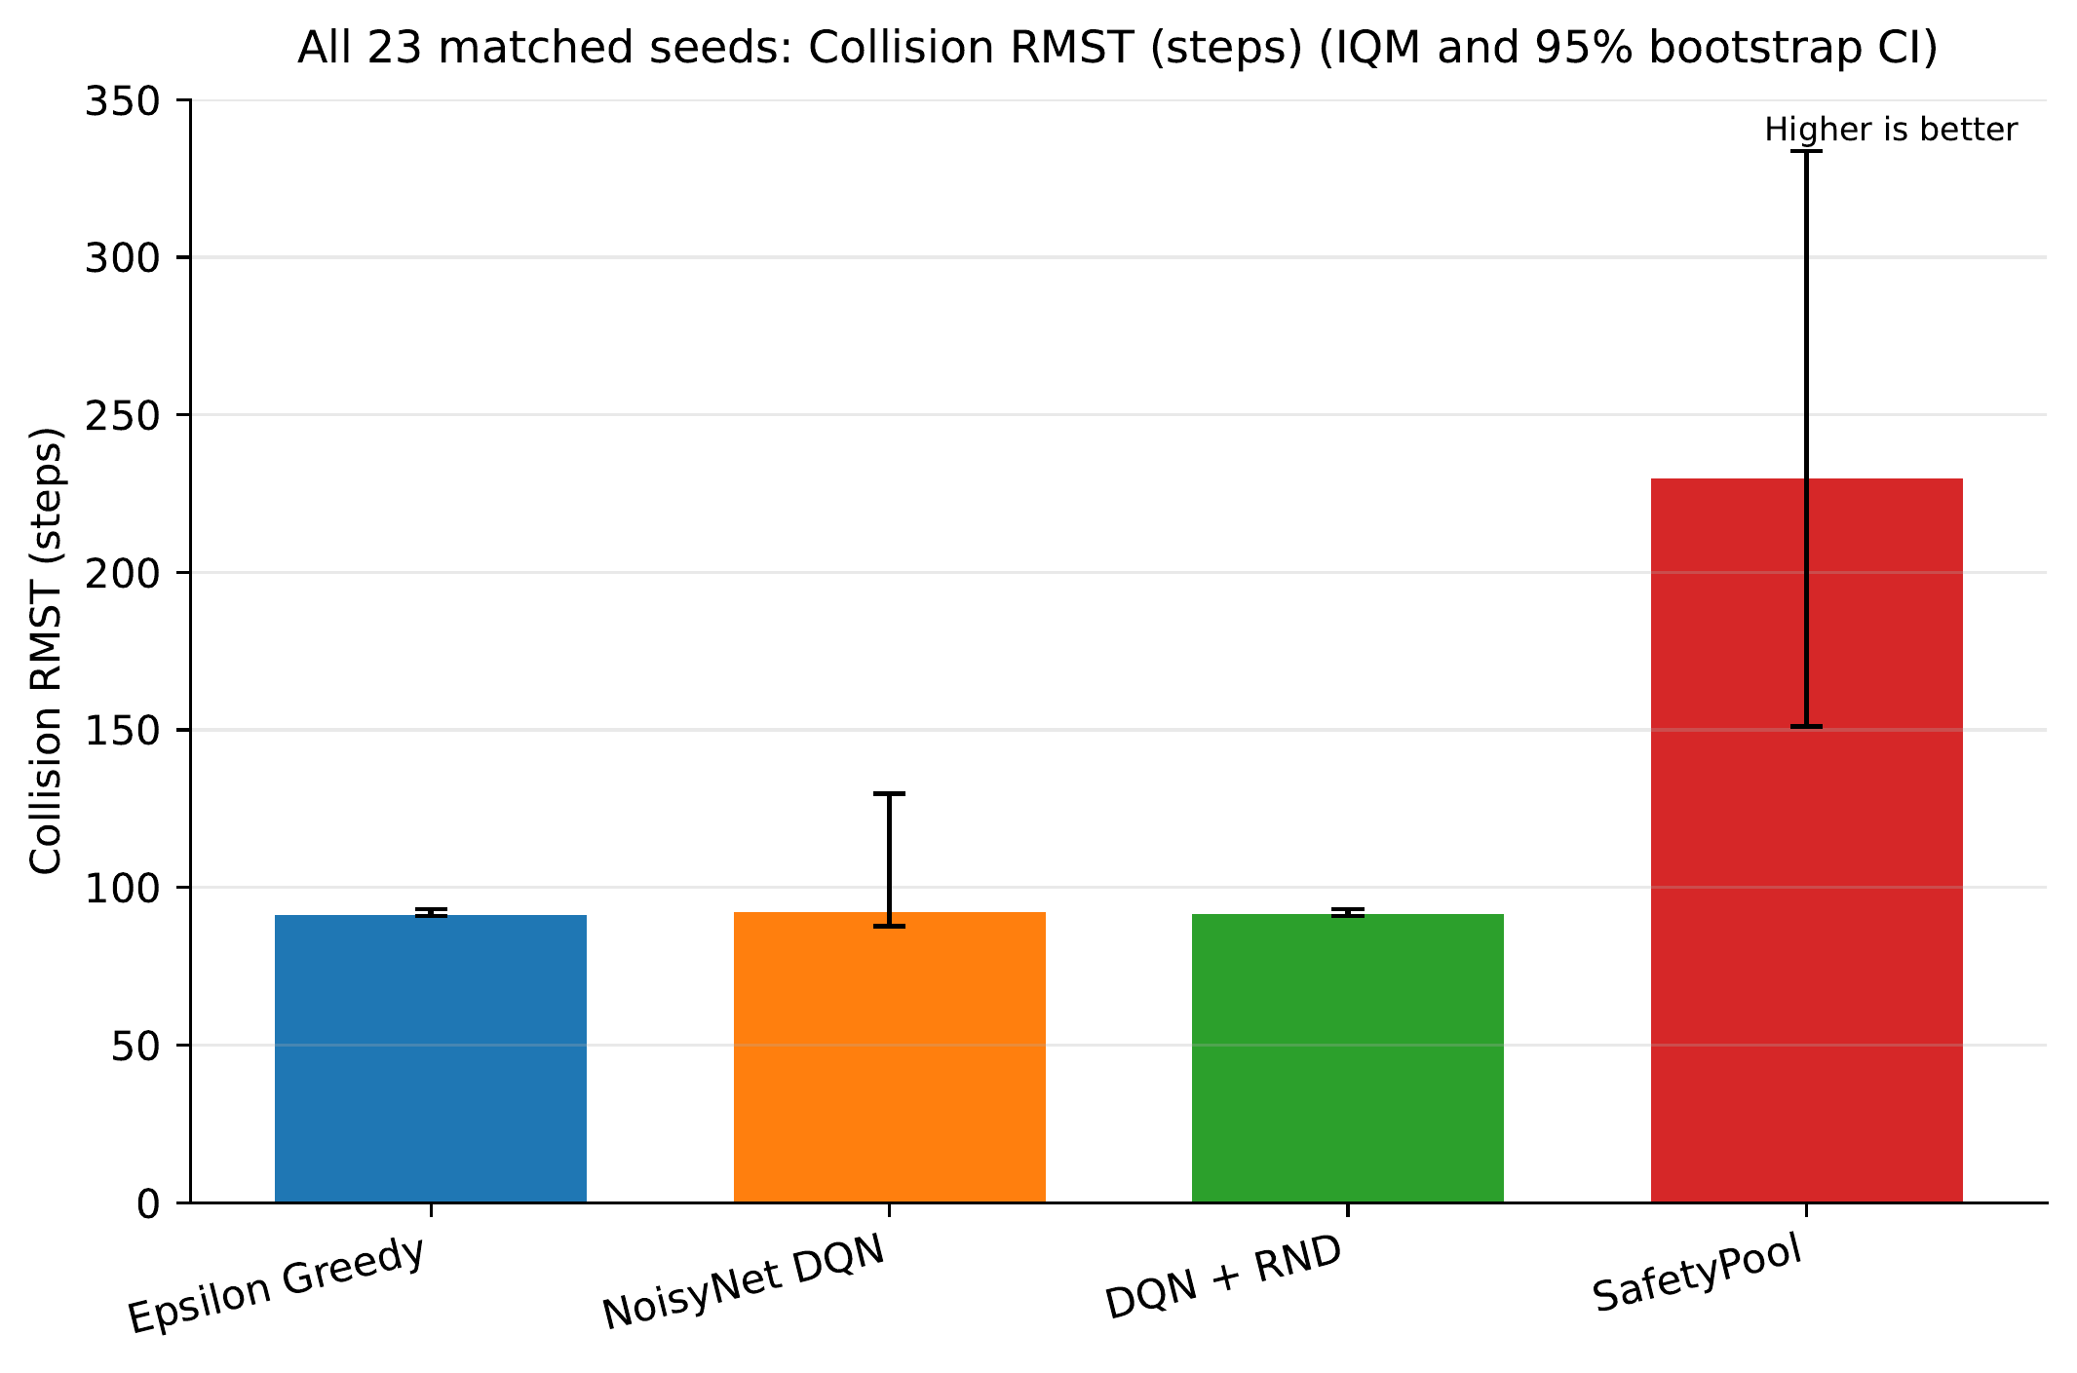
Figure 1. MetaDrive Collision RMST across 23 matched seeds. Bars show IQMs and error bars show seed-bootstrap 95% CIs. Higher is better.
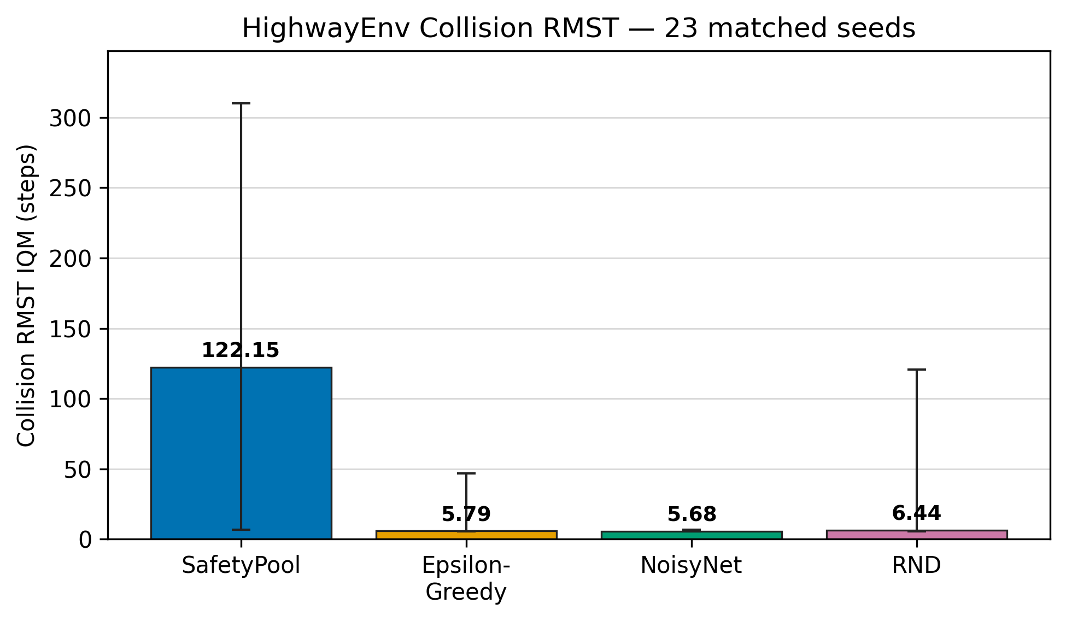
Figure 2. HighwayEnv Collision RMST in the matched 23-seed subset. Bars show IQMs and error bars show seed-bootstrap 95% CIs. Higher is better.
Table 3 gives the Holm-corrected matched-seed comparisons. In MetaDrive, SafetyPool is supported against all three baselines with corrected p-values of 0.000024, 0.001885, and 0.000024. The Highway subset result is also supported against all three baselines, with corrected p-values of 0.0174, 0.0174, and 0.0171.
Table 3. Collision RMST matched-seed tests. Values are Holm-corrected two-sided Wilcoxon p-values.
Environment | vs Epsilon-Greedy | vs NoisyNet | vs RND
MetaDrive | 0.000024 | 0.001885 | 0.000024
HighwayEnv matched subset | 0.0174 | 0.0174 | 0.0171
All inferential tests include every seed in the environment-specific lists in Sect. 4.1. The Highway intervals are wide because seed-level performance is heterogeneous. The paired tests and aggregate intervals answer different questions: the paired tests use within-seed differences, while the intervals quantify uncertainty in each separate IQM. The Highway result should therefore be read as evidence for the stated matched 23-seed subset, not as a claim about every seed available in the larger uploaded archive.

Behaviour of the state memory
Runtime logs show state-pool and action-mask activity during the evidence-collection and guided phases, while the final consolidation phase deliberately removes pool-based action selection. This schedule transfers control to the learned network before the frozen-policy test and confirms that the guided-exploration mechanism was active during training.

Answers to the research questions
- RQ1: SafetyPool increases Collision RMST relative to all three baselines in both environment-specific 23-seed analyses.
- RQ2: The paired Collision RMST improvement is supported for all three baseline comparisons after Holm correction in MetaDrive and in the matched Highway subset.
- RQ3: The result means that SafetyPool delays the first collision or remains collision-free for longer within the same fixed observation horizon.
The likely mechanism is selective experience acquisition. Unlike novelty-based exploration, SafetyPool records local action outcomes and directs exploration toward actions that remain unknown without repeatedly selecting actions supported as hazardous. The final pure-DQN phase then transfers control from explicit memory to the value network.

Conclusion and Future Work
This study evaluated SafetyPool, an evidence-guided exploration method for a DQN driving agent. In MetaDrive, SafetyPool increases Collision RMST from approximately 91–92 baseline steps to 229.8 steps over 23 matched seeds. In the matched 23-seed Highway subset, SafetyPool obtains 122.15 steps compared with 5.79, 5.68, and 6.44 for Epsilon-Greedy, NoisyNet, and RND. Every environment-specific paired comparison is supported after Holm correction. These results show that guided exploration can extend collision-free operation after the safety memory is removed and the frozen DQN acts independently.
Future work will pre-register and evaluate broader Highway seed sets, repeat the analysis across additional traffic configurations, and tune candidate-promotion visits, root-mean-square (RMS) distance thresholds, hazard-pool settings, and eviction criteria. Maximum-step completion, collisions per 1,000 steps, route completion, out-of-road events, and computational cost will be evaluated as separate secondary outcomes rather than mixed with the Collision RMST claim. We will also study additional safety metrics informed by recent safe-learning and safety-critical driving research (Brunke et al. 2022; Zhao, He, and Liu 2022; Ji et al. 2023, 2024; Zhang et al. 2023).

Data Availability
The accompanying reproducibility folder contains the exact SafetyPool policies, Highway and MetaDrive frameworks, collision-event episode data, seed-level Collision RMST tables, analysis code, figures, and environment records. The environment-specific 23-seed lists are given in Sect. 4.1.

Ethical and Safety Statement
The experiments are simulation-only. Future physical testing should use independent supervision, controlled facilities, formal risk assessment, and applicable transport and research requirements.
Achiam, Joshua, David Held, Aviv Tamar, and Pieter Abbeel. 2017. “Constrained Policy Optimization.” In Proceedings of the 34th International Conference on Machine Learning, 22–31.
Agarwal, Rishabh, Max Schwarzer, Pablo Samuel Castro, Aaron C. Courville, and Marc G. Bellemare. 2021. “Deep Reinforcement Learning at the Edge of the Statistical Precipice.” Advances in Neural Information Processing Systems 34: 29304–20.
Alshiekh, Mohammed, Roderick Bloem, Ruediger Ehlers, Bettina Könighofer, Scott Niekum, and Ufuk Topcu. 2018. “Safe Reinforcement Learning via Shielding.” In Proceedings of the AAAI Conference on Artificial Intelligence. Vol. 32.
Altman, Eitan. 1999. Constrained Markov Decision Processes. Chapman; Hall/CRC.
Bellemare, Marc G., Sriram Srinivasan, Georg Ostrovski, Tom Schaul, David Saxton, and Rémi Munos. 2016. “Unifying Count-Based Exploration and Intrinsic Motivation.” In Advances in Neural Information Processing Systems. Vol. 29.
Brunke, Lukas, Melissa Greeff, Adam W. Hall, et al. 2022. “Safe Learning in Robotics: From Learning-Based Control to Safe Reinforcement Learning.” Annual Review of Control, Robotics, and Autonomous Systems 5: 411–44.
Burda, Yuri, Harrison Edwards, Amos Storkey, and Oleg Klimov. 2018. “Exploration by Random Network Distillation.” arXiv Preprint arXiv:1810.12894.
Chow, Yinlam, Ofir Nachum, Edgar Duenez-Guzman, and Mohammad Ghavamzadeh. 2018. “A Lyapunov-Based Approach to Safe Reinforcement Learning.” In Advances in Neural Information Processing Systems. Vol. 31.
Colas, Cédric, Olivier Sigaud, and Pierre-Yves Oudeyer. 2019. “A Hitchhiker’s Guide to Statistical Comparisons of Reinforcement Learning Algorithms.” arXiv Preprint arXiv:1904.06979.
Dalal, Gal, Krishnamurthy Dvijotham, Matej Vecerik, Todd Hester, Cosmin Paduraru, and Yuval Tassa. 2018. “Safe Exploration in Continuous Action Spaces.” In Safe Artificial Intelligence Workshop at AAAI.
Efron, Bradley. 1979. “Bootstrap Methods: Another Look at the Jackknife.” The Annals of Statistics 7 (1): 1–26.
Fortunato, Meire, Mohammad Gheshlaghi Azar, Bilal Piot, et al. 2018. “Noisy Networks for Exploration.” In International Conference on Learning Representations.
García, Javier, and Fernando Fernández. 2015. “A Comprehensive Survey on Safe Reinforcement Learning.” Journal of Machine Learning Research 16: 1437–80.
Hasselt, Hado van, Arthur Guez, and David Silver. 2016. “Deep Reinforcement Learning with Double q-Learning.” In Proceedings of the AAAI Conference on Artificial Intelligence. Vol. 30.
Henderson, Peter, Riashat Islam, Philip Bachman, Joelle Pineau, Doina Precup, and David Meger. 2018. “Deep Reinforcement Learning That Matters.” Proceedings of the AAAI Conference on Artificial Intelligence 32.
Hessel, Matteo, Joseph Modayil, Hado van Hasselt, et al. 2018. “Rainbow: Combining Improvements in Deep Reinforcement Learning.” In Proceedings of the AAAI Conference on Artificial Intelligence. Vol. 32.
Holm, Sture. 1979. “A Simple Sequentially Rejective Multiple Test Procedure.” Scandinavian Journal of Statistics 6 (2): 65–70.
Ji, Jiaming, Borong Zhang, Jiayi Zhou, et al. 2023. “Safety Gymnasium: A Unified Safe Reinforcement Learning Benchmark.” In Advances in Neural Information Processing Systems. Vol. 36.
Ji, Jiaming, Jiayi Zhou, Borong Zhang, et al. 2024. “OmniSafe: An Infrastructure for Accelerating Safe Reinforcement Learning Research.” Journal of Machine Learning Research 25 (285): 1–6.
Kaplan, Edward L., and Paul Meier. 1958. “Nonparametric Estimation from Incomplete Observations.” Journal of the American Statistical Association 53 (282): 457–81.
Kendall, Alex, Jeffrey Hawke, David Janz, et al. 2019. “Learning to Drive in a Day.” In International Conference on Robotics and Automation, 8248–54.
Kingma, Diederik P., and Jimmy Ba. 2015. “Adam: A Method for Stochastic Optimization.” International Conference on Learning Representations.
Kiran, B. Ravi, Ibrahim Sobh, Victor Talpaert, et al. 2022. “Deep Reinforcement Learning for Autonomous Driving: A Survey.” IEEE Transactions on Intelligent Transportation Systems 23 (6): 4909–26.
Li, Quanyi, Zhenghao Peng, Lan Feng, Qihang Zhang, Zhenghai Xue, and Bolei Zhou. 2023. “MetaDrive: Composing Diverse Driving Scenarios for Generalizable Reinforcement Learning.” IEEE Transactions on Pattern Analysis and Machine Intelligence 45 (3): 3461–75. https://doi.org/10.1109/TPAMI.2022.3190471.
Mnih, Volodymyr, Koray Kavukcuoglu, David Silver, et al. 2015. “Human-Level Control Through Deep Reinforcement Learning.” Nature 518: 529–33.
Ng, Andrew Y., Daishi Harada, and Stuart Russell. 1999. “Policy Invariance Under Reward Transformations: Theory and Application to Reward Shaping.” In Proceedings of the 16th International Conference on Machine Learning, 278–87.
Osband, Ian, Charles Blundell, Alexander Pritzel, and Benjamin Van Roy. 2016. “Deep Exploration via Bootstrapped DQN.” In Advances in Neural Information Processing Systems. Vol. 29.
Pathak, Deepak, Pulkit Agrawal, Alexei A. Efros, and Trevor Darrell. 2017. “Curiosity-Driven Exploration by Self-Supervised Prediction.” In Proceedings of the 34th International Conference on Machine Learning, 2778–87.
Patterson, Andrew, Samuel Neumann, Martha White, and Adam White. 2024. “Empirical Design in Reinforcement Learning.” Journal of Machine Learning Research 25: 1–63.
Royston, Patrick, and Mahesh K. B. Parmar. 2013. “Restricted Mean Survival Time: An Alternative to the Hazard Ratio for the Design and Analysis of Randomized Trials.” BMC Medical Research Methodology 13 (152).
Rumelhart, David E., Geoffrey E. Hinton, and Ronald J. Williams. 1986. “Learning Representations by Back-Propagating Errors.” Nature 323: 533–36.
Sallab, Ahmad El, Mohammed Abdou, Etienne Perot, and Senthil Yogamani. 2017. “Deep Reinforcement Learning Framework for Autonomous Driving.” Electronic Imaging 2017 (19): 70–76.
Schaul, Tom, John Quan, Ioannis Antonoglou, and David Silver. 2016. “Prioritized Experience Replay.” In International Conference on Learning Representations.
Sutton, Richard S., and Andrew G. Barto. 2018. Reinforcement Learning: An Introduction. 2nd ed. MIT Press.
Thananjeyan, Brijen, Ashwin Balakrishna, Suraj Nair, et al. 2021. “Recovery RL: Safe Reinforcement Learning with Learned Recovery Zones.” In IEEE International Conference on Robotics and Automation, 2771–78.
Wang, Ziyu, Tom Schaul, Matteo Hessel, Hado van Hasselt, Marc Lanctot, and Nando de Freitas. 2016. “Dueling Network Architectures for Deep Reinforcement Learning.” In Proceedings of the 33rd International Conference on Machine Learning, 1995–2003.
Watkins, Christopher J. C. H., and Peter Dayan. 1992. “Q-Learning.” Machine Learning 8: 279–92.
Wilcoxon, Frank. 1945. “Individual Comparisons by Ranking Methods.” Biometrics Bulletin 1 (6): 80–83.
Zhang, Li, Zhenghao Peng, Quanyi Li, and Bolei Zhou. 2023. “CAT: Closed-Loop Adversarial Training for Safe End-to-End Driving.” In Proceedings of the 7th Conference on Robot Learning, 229:2357–72.
Zhao, Weiye, Tairan He, and Changliu Liu. 2022. “Model-Free Safe Control for Zero-Violation Reinforcement Learning.” In Proceedings of the 5th Conference on Robot Learning, 164:784–93.

