FINAL PROJECT REPORT

Date | 15/7/2026
Team ID | SWTID-2026-9500
Project Name | AI Powered Debt Relief & Financial Recovery Platform
Maximum Marks

AI Powered Debt Relief & Financial Recovery Platform (FinRelief AI)
Google Cloud Generative AI Virtual Internship
1. INTRODUCTION
1.1 Project Overview
The AI Powered Debt Relief & Financial Recovery Platform (FinRelief AI) is an AI-based web application that helps users manage debts and improve their financial health. It analyses income, expenses, loans, and repayment details to provide personalized debt repayment plans, budgeting suggestions, settlement recommendations, and financial recovery guidance.
The platform is built using FastAPI, Python, Google Gemini AI, SQLite/PostgreSQL, and a responsive web interface. It enables users to monitor their financial status, prioritize debts, and make informed financial decisions through AI-powered recommendations.

1.2 Purpose
The project aims to:
- Analyses user's financial information using AI.
- Provide personalized debt repayment strategies.
- Recommend budgeting and savings plans.
- Improve financial planning and stability.
- Help users prioritize loan repayments.
- Generate financial recovery recommendations.
- Demonstrate AI applications in FinTech.

2. IDEATION PHASE
2.1 Problem Statement
Many individuals struggle to manage multiple loans, credit card debts, and monthly expenses. Existing financial tools provide only basic calculations and lack personalized financial guidance. FinRelief AI addresses this problem by analyzing financial data using AI and generating customized debt repayment plans, budgeting advice, and financial recovery strategies.

2.2 Empathy Map Canvas
Think & Feel
- Wants to become debt-free.
- Feels stressed about repayments.
- Needs financial guidance.
Hear
- Advice from banks and family.
- Financial tips from experts.
See
- Loan reminders.
- Increasing expenses.
- Budgeting applications.
Say & Do
- Track expenses.
- Search repayment methods.
- Compare loan options.
Pain Points
- Multiple debts.
- High interest rates.
- Financial stress.
Gains
- AI repayment plans.
- Better budgeting.
- Improved financial stability.

2.3 Brainstorming
Selected project features:
- AI Debt Analysis
- Debt Repayment Recommendation
- Budget Planning
- Expense Tracking
- Financial Recovery Roadmap
- User Dashboard
- Secure Data Storage

3. REQUIREMENT ANALYSIS
3.1 Customer Journey Map
User Flow:
Registration → Login → Enter Financial Details → AI Analysis → Debt Recommendation → Dashboard → Progress Tracking

3.2 Solution Requirements
Functional Requirements
- User Registration & Login
- Financial Profile Management
- Debt Analysis
- Budget Planning
- AI Recommendations
- Progress Dashboard
- REST API Integration
- Database Management

3.3 Data Flow Diagram
User → Web Application → FastAPI Backend → AI Engine (Gemini) → Database → Dashboard Output

3.4 Technology Stack
Layer | Technology
Frontend | HTML5, CSS3, JavaScript, Jinja2
Backend | FastAPI
AI Model | Google Gemini 1.5 Pro
Database | SQLite / PostgreSQL
Server | Uvicorn
Language | Python 3.11+
IDE | Visual Studio Code

4. PROJECT DESIGN
4.1 Problem Solution Fit
Customers
- Individuals with debt
- Salaried employees
- Small business owners
Problems
- Multiple debts
- Poor budgeting
- Financial stress
Solution
FinRelief AI provides AI-based financial analysis, debt repayment recommendations, budgeting guidance, and recovery planning to improve financial stability.

4.2 Proposed Solution
Key Features
- AI Debt Analysis
- Personalized Repayment Plans
- Budget Planning
- Expense Tracking
- Financial Recovery Guidance
- Savings Recommendations
- Secure Dashboard

4.3 Solution Architecture
User → Frontend → FastAPI Backend → Google Gemini AI → SQLite Database → Dashboard

5. PROJECT PLANNING & SCHEDULING
Sprint 1
- Problem Identification
- Requirement Analysis
- Technology Selection
- Project Planning
Sprint 2
- Frontend Development
- Backend Development
- Database Design
- API Development
Sprint 3
- AI Integration
- Debt Analysis Module
- Recommendation Engine
- Dashboard Development
Sprint 4
- Testing
- Performance Optimization
- Deployment
- Documentation

6. FUNCTIONAL & PERFORMANCE TESTING
Functional Testing
Modules Tested:
- Registration & Login
- Financial Data Entry
- AI Debt Analysis
- Repayment Recommendation
- Budget Planning
- Dashboard
- Database
- REST APIs
Result: All test cases passed successfully.
Performance Testing
Tested:
- Response Time
- API Performance
- Database Performance
- Concurrent Requests
- Dashboard Loading
Average Response Time: 2–4 Seconds
Reference Of My Project Photos:
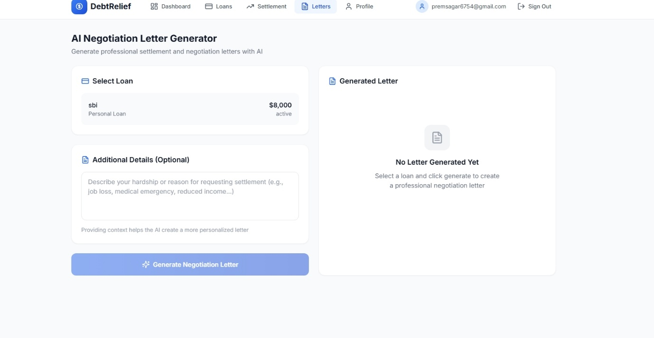

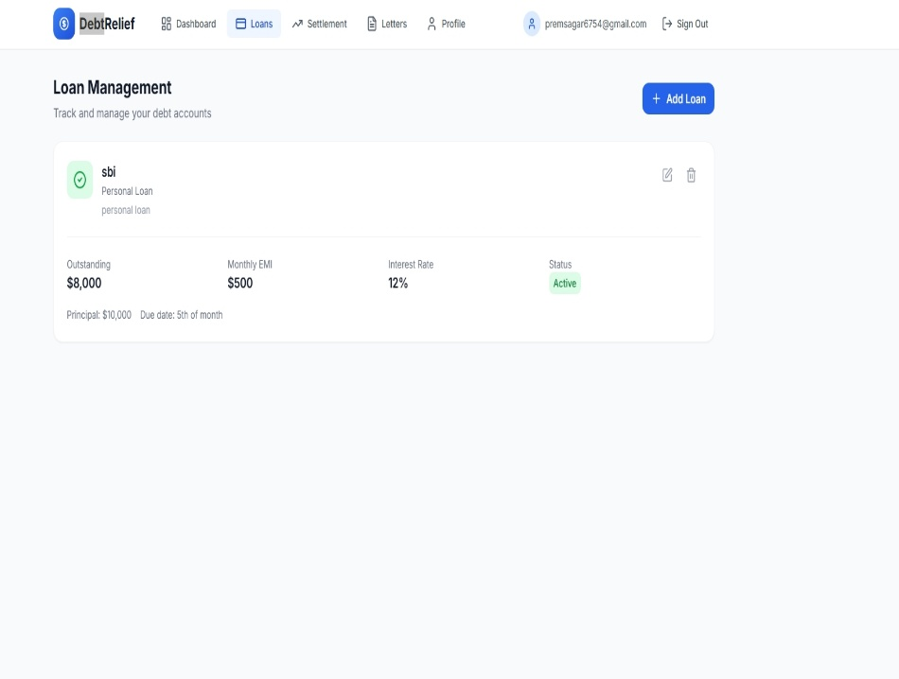

8. ADVANTAGES & DISADVANTAGES
Advantages
AI-powered debt analysis
Personalized repayment recommendations
Smart budget planning
Easy-to-use interface
Secure financial data management
Real-time financial insights
Faster financial decision-making
Financial recovery guidance
Progress tracking dashboard
Scalable and modular architecture
Disadvantages
Requires internet connection for AI services
Accuracy depends on user-provided financial data
AI recommendations may require expert validation
External API availability may affect performance
Limited offline functionality

7. RESULTS
7.1 Output Screenshots
Include screenshots of:
- Home Page
- Login Page
- User Dashboard
- Financial Profile
- AI Debt AnalysIS
- Debt Repayment Recommendation
- Budget Planning
- Financial Recovery Roadmap
- Progress Dashboard
- Database Records
- API Testing (Swagger UI)
- Final Application Output-

