**Pizzeria**











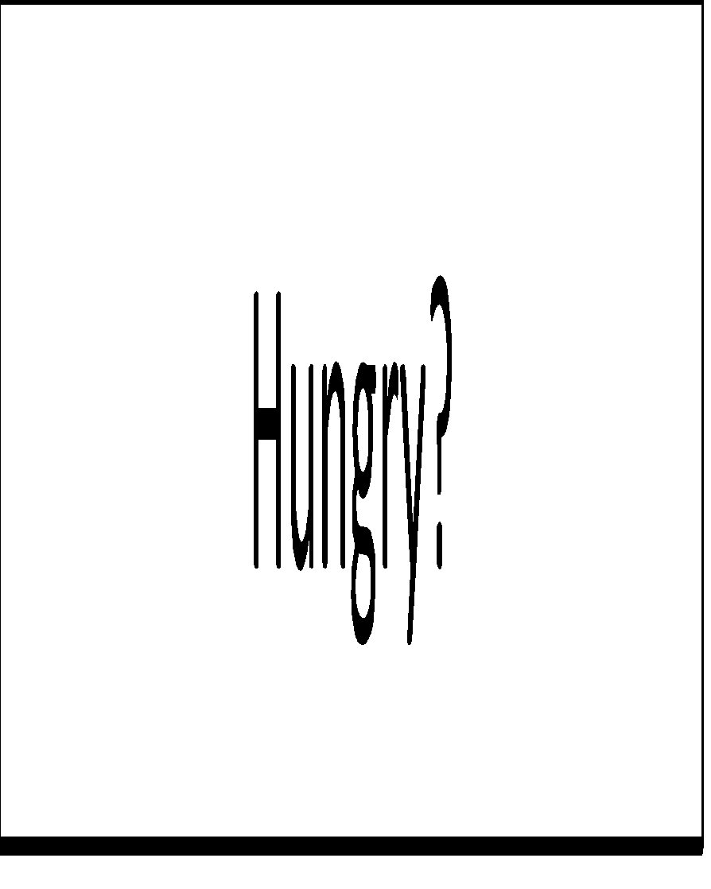























* This app allows user to order a pizza online. Users can select between Store pickup and home delivery.
* Store pickup schedules a pickup time for the user.
* Keeping in mind the social distancing norms, the app will display a message at checkout to remind users to wear a mask when they show up.
* While **Pickup activity** will help schedule pickup time, the **delivery** **activity** on the other hand asks the user to enter their home address.
* After that the user is required to select size, crust type and type pizza.
* The user can add extra items to the order like cheese, sauce and veggies in the **Add-On activity.**
* **Finally,** checkout Activity page calculates the total amount .
* **Further,** details will be added in the project. This is abstract model.