**Pizzeria-** freshly baked pizza at your doorstep

**Author: Karthik Nimma**

**101650589**

The app allows you to order a pizza online which is delivered at you doorstep. It has a very clean interface. The app allows you to make selections at every stage so that you can customize your pizza based on your preference. The pizza has a base price fixed and changes if any add-ons are included.

Supported Android version: Jellybean or higher

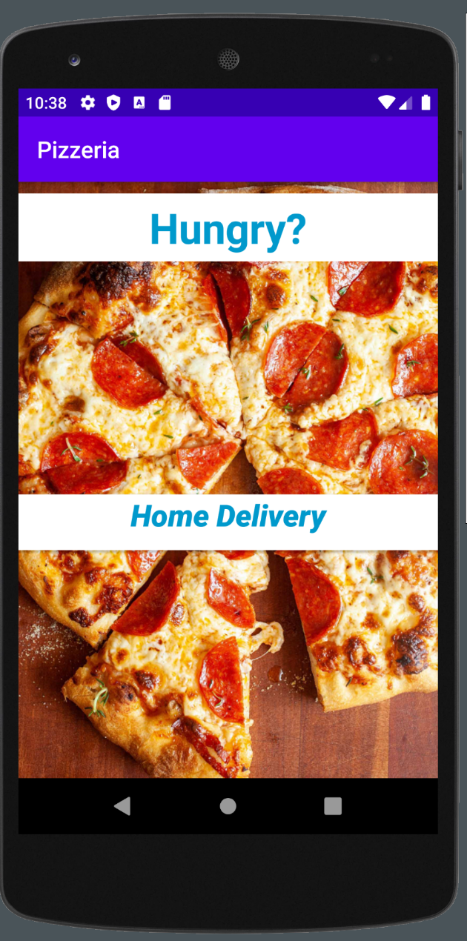

The main page of the app has a single button **Home Delivery** which when clicked will open the next page.

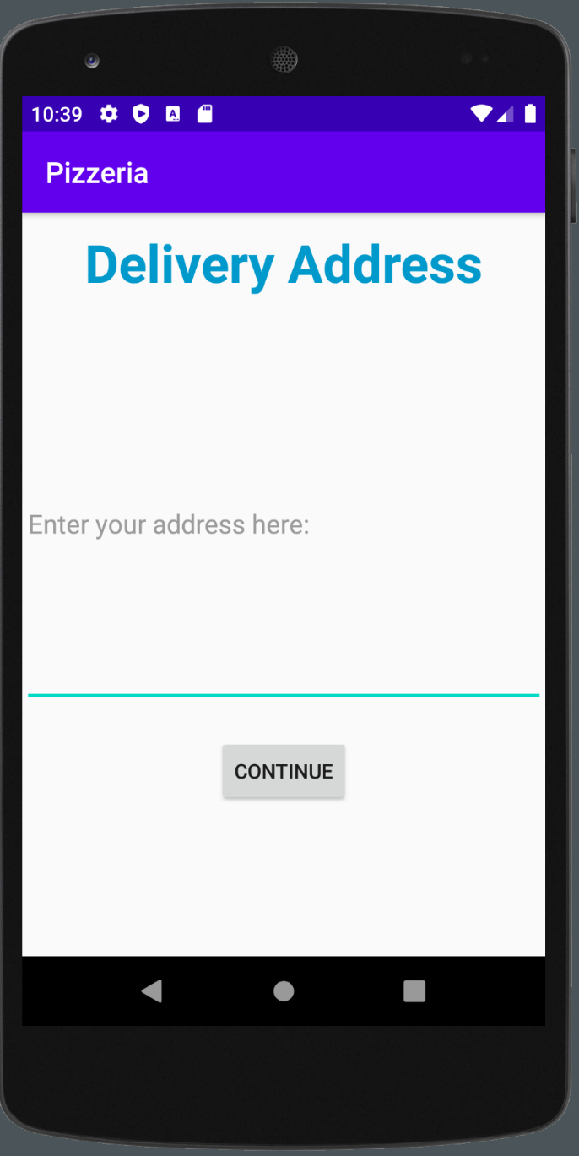

This page allows you to enter your home address. The **Continue** button attaches the address to the intent and sends it to the next activity page.

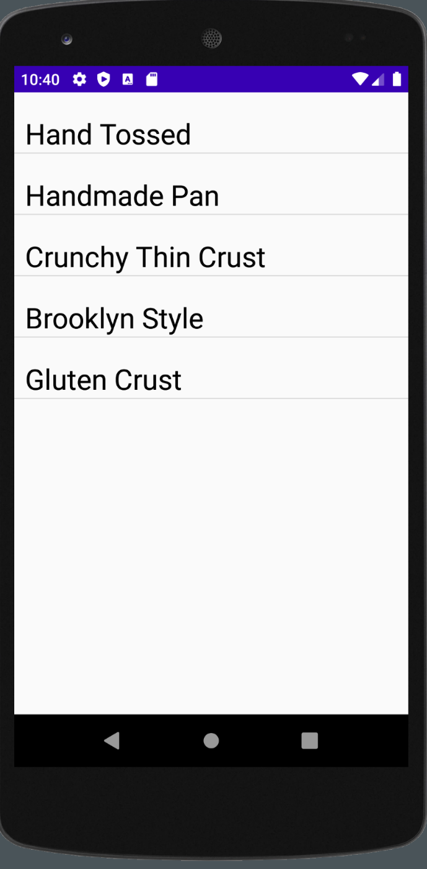

You can choose from different type of crusts. The list is populated by using the list adapter of the List Activity class.

It is a convenient way to display a list of options without manually coding each line.

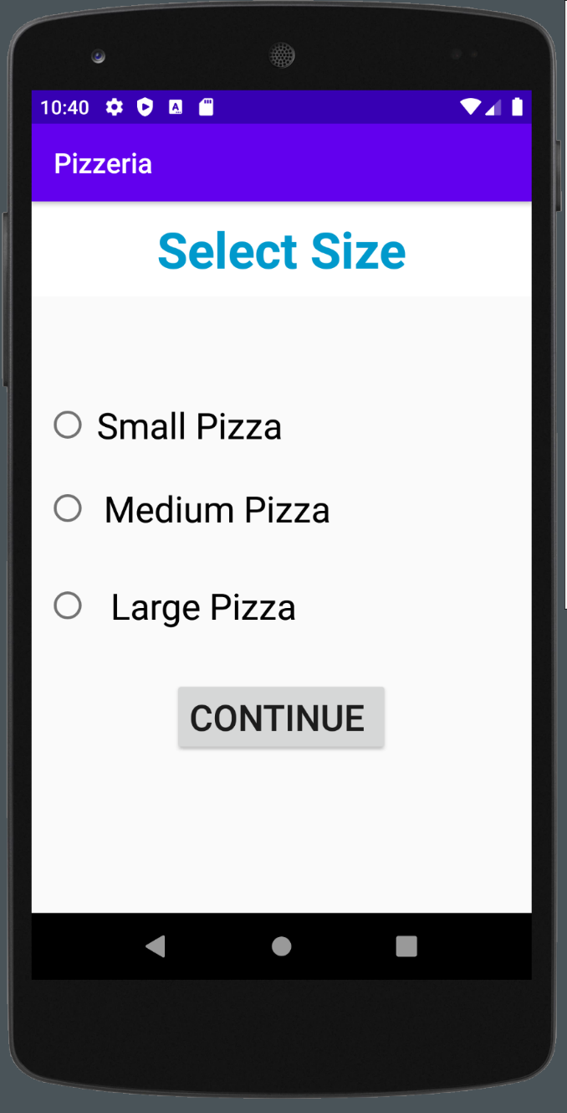

**Radio Buttons** are very useful when you want the user to select just one of the choices provided. By default, the radio buttons are unchecked. Click Continue to move on

e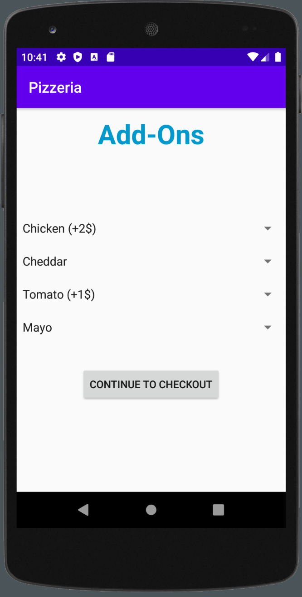

The **ADD-On** page allows you to add multiple preferences to your order. Each add on can have price associated with it. In this case, just meat and veggies are chargeable. Or you can just move on to the next page if you don’t want any.

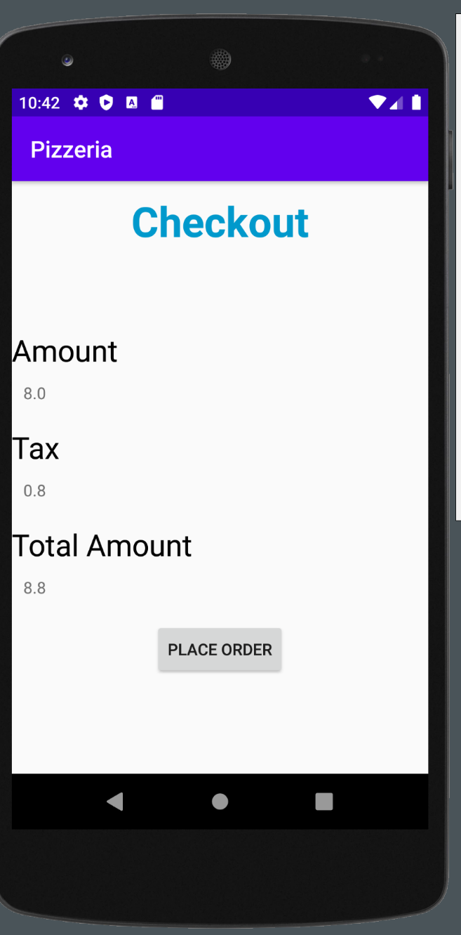

The checkout page calculates the final price of the pizza based on your selections based on your selections. The tax in this case is calculated at 10 percentage. Once you confirm the price, you can click on place order.

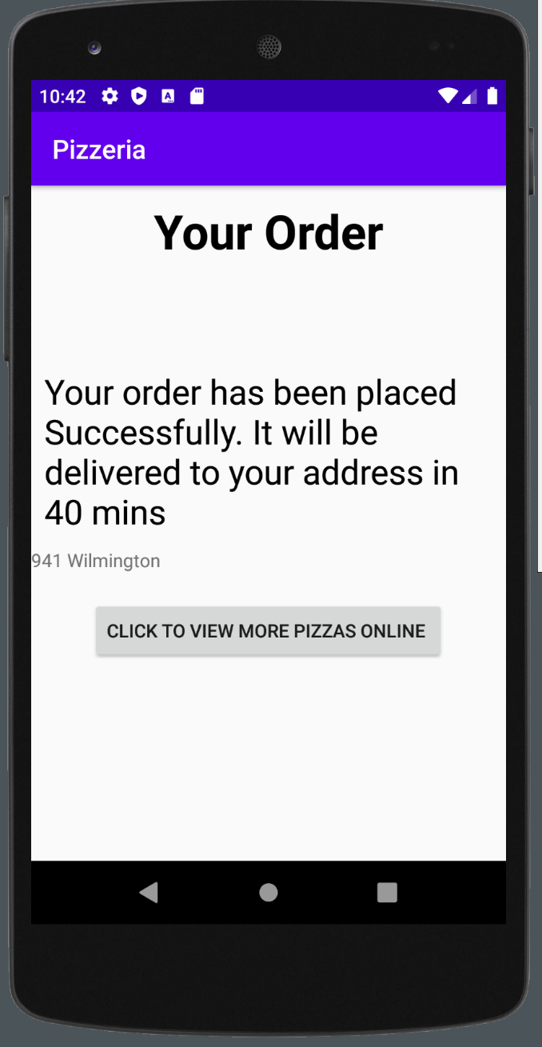

This is the last page. Your address is mentioned in the screen. There is an additional button which opens a webpage showing different types of pizzas.