Exp No : 9
ULTRASONIC SENSOR IN PROTEUS USING ARDUINO
AIM :
To write an Embedded C Program for ULTRASONIC SENSOR IN PROTEUS USING ARDUINO.
SOFTWARE REQUIRED :
- Proteus 8 software
- Arduino IDE software
PROGRAM :
//Program Sketch
int trig=10;
int echo=9;
long duration;
int cm;
void setup({
//put your setup code here,to run once:
pinMode(trig,OUTPUT);
pinMode(echo,INPUT);
Serial.begin(9600);
void loopO{
//Sketch to calculate ultrasonic distance
digitalWrite(trig,LOW);
delayMicroseconds(10);
digitalWrite(trig,HIGH);
delayMicroseconds(10);
digitalWrite(trig,LOW);
delayMicroseconds(10);
duration =pulseln(echo,HIGH);
cm=(duration/2)*0.034;
//Print Value on Serial Monitor
Serial.print("Distance=");
Serial.print(cm);
Serial.println("cm");
Circuit Diagram:
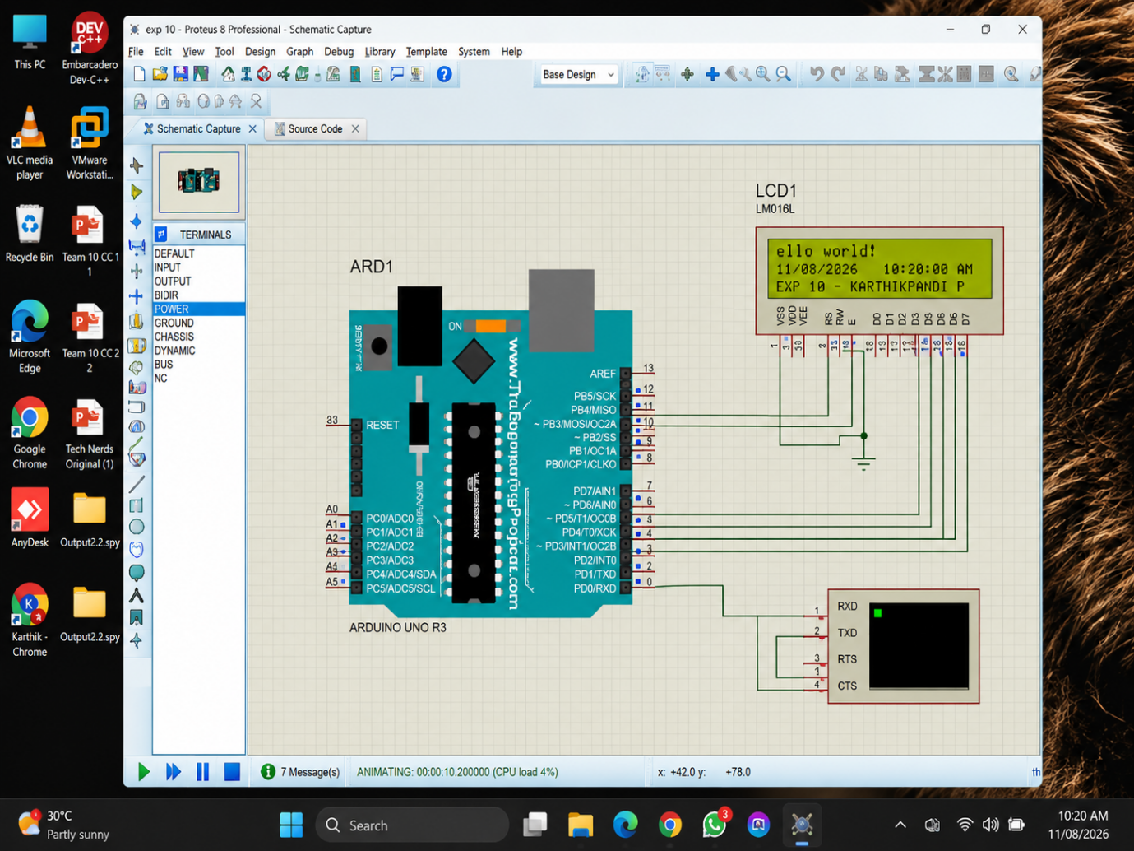

RESULT :
Thus the program has been successfully verified and executed.

