Exp No : 10
PIR SENSOR IN PROTEUS USING ARDUINO
AIM :
To write an Embedded C Program for PIR SENSOR IN PROTEUS USING ARDUINO.
SOFTWARE REQUIRED :
- Proteus 8 software
- Arduino IDE software
PROGRAM :
int Status=13;
//Digital pin D6
int sensor =12;
//Digital pin D7
void setupO{Serial.begin(9600);
pinMode(sensor,INPUT);
//declare sensor as input
pinMode(Status,OUTPUT);
//declare LED as output
void loopO{
long state =digitalRead(sensor);
Serial.println(state);
if(state==HIGH){
digitalWrite (Status,HIGH);
Serial.println("Motion detected!");
delay(1000);
}else{
digitalWrite(Status,LOW);
Serial.println("Motion absent!");
delay(1000);
}
}
Circuit Diagram:
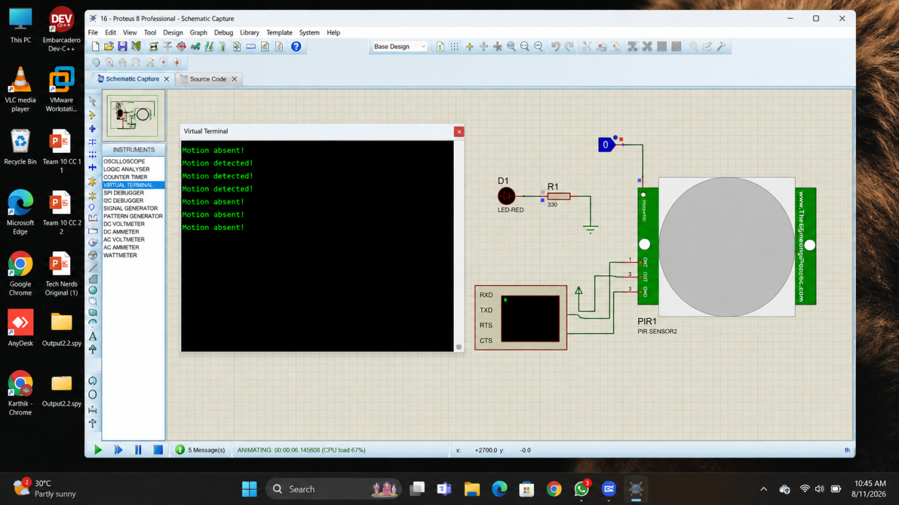

RESULT :
Thus the program has been successfully verified and executed.

