Exp No : 6
ARDUINO TO 16x2 LCD DISPLAY USING PROTEUS
AIM :
To write an Embedded C Program for ARDUINO TO 16x2 LCD DISPLAY USING PROTEUS
SOFTWARE REQUIRED :
- Proteus 8 software
- Arduino IDE software
PROGRAM :
Arduino to 16x2LCD Display using Proteus
#include<LiquidCrystal.h>
LiquidCrystal lcd(7,8,9,10,11,12);
//your PWM numbers may be different
void setup(){
lcd.begin(16,2);
lcd.print("put your message here");
}
void loop(){
for(int i=0;1<13;i++)
}
lcd.scrollDisplayLeft();delay(700);
}
}

Circuit Diagram:

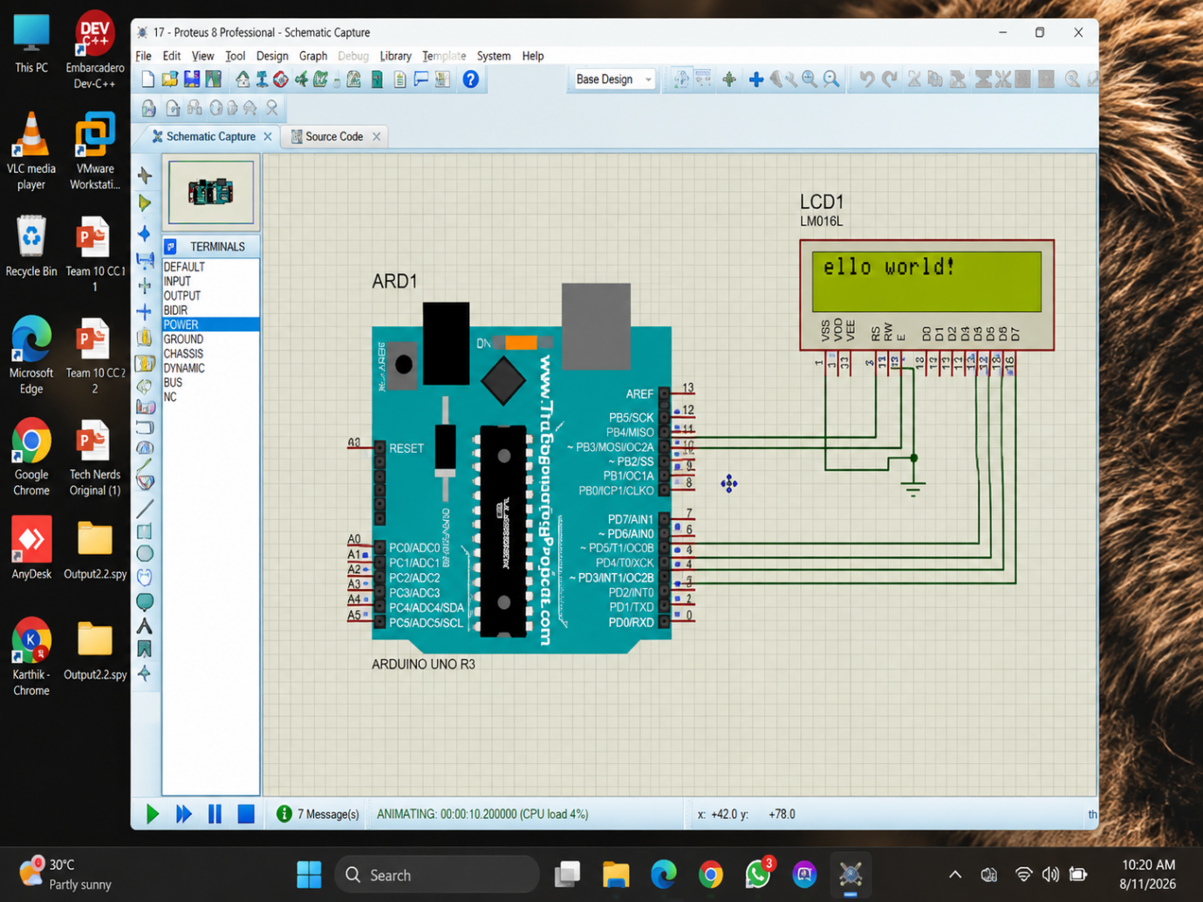

RESULT :
Thus the program has been successfully verified and executed.

