Exp No : 7
SERIAL COMMUNICATION USING ARDUINO WITH PROTEUS
AIM :
To write an Embedded C Program for SERIAL COMMUNICATION USING ARDUINO WITH PROTEUS
SOFTWARE REQUIRED :
- Proteus 8 software
- Arduino IDE software
PROGRAM :
void setup()
Serial.begin(9600);//send and receive at 9600 baud
}
int number=0;
void loop()
{
Serial.print("Number is ");
Serial.println(number);//print the number
delay(500);//delay half second between numbers
number++;//to the next number
}

Circuit Diagram:
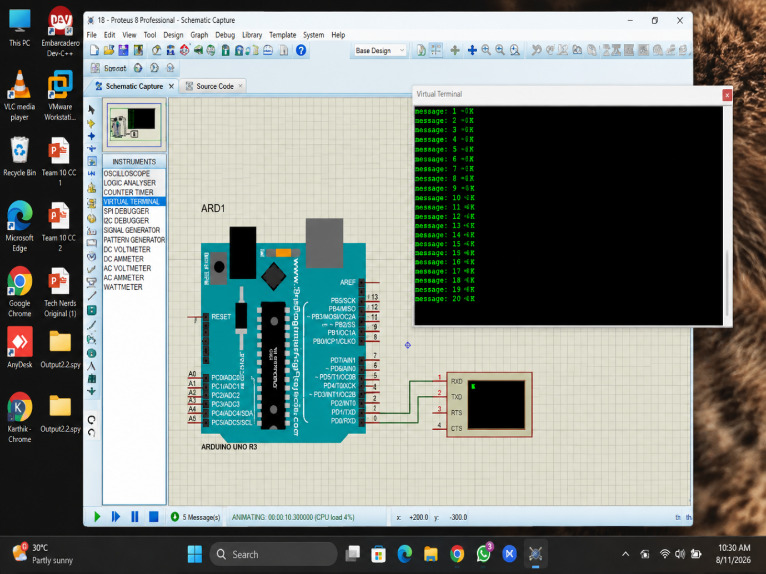

RESULT :
Thus the program has been successfully verified and executed.

