Exp No : 8
GAS SENSOR MQ-2 IN PROTEUS USING ARDUINO
AIM :
To write an Embedded C Program for GAS SENSOR MQ-2 IN PROTEUS USING ARDUINO
SOFTWARE REQUIRED :
- Proteus 8 software
- Arduino IDE software
PROGRAM :
#define GreenLed 13
#define Sensor A0
void setup({pinMode(13,OUTPUT);
pinMode(12,OUTPUT);
pinMode(A0,INPUT);
Serial.begin(9600);
void loopO{
int value =analogRead(A0);
Serial.print("Analogic Value coming from the sensor:");
Serial.println(value);
delay(100);
if(value>600){
digitalWrite(13,HIGH);
ese{digitalWrite(13,LOW);
delay(20);

Code for MQ6 sensor:
int mq6Pin=A0;
//MQ-5 analog pin connected to A0
void setup({Serial.begin(9600);
void loop0{int sensorValue =analogRead(mq5Pin);
Serial.print("MQ5 Sensor Value:");
Serial.printIn(sensorValue);
delay(1000);//1-second delay

Circuit Diagram:
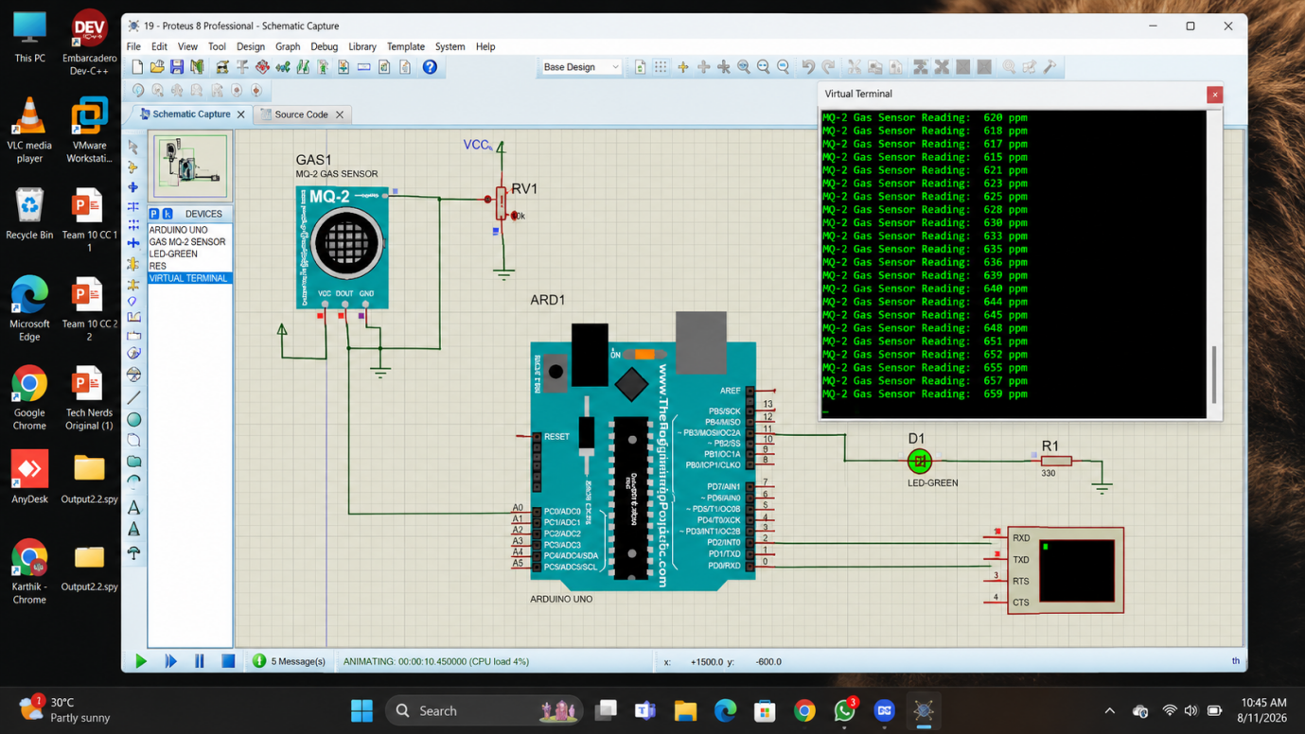

RESULT :
Thus the program has been successfully verified and executed.

