Exp No : 5
ARDUINO BASED MANUAL ELECTRONIC COUNTER USING PROTEUS
AIM :
To write an Embedded C Program for ARDUINO BASED MANUAL ELECTRONIC COUNTER USING PROTEUS
SOFTWARE REQUIRED :
- Proteus 8 software
- Arduino IDE software
PROGRAM :
int x0,x1,x2,x3,x4,x5,x6,x7,x8,x9;
int delay_time = 200;

void setup() {
// configure pin12 as an input and enable the internal pull-up resistor
pinMode(12, INPUT_PULLUP);

pinMode(1, OUTPUT);
pinMode(2, OUTPUT);
pinMode(3, OUTPUT);
pinMode(4, OUTPUT);
pinMode(5, OUTPUT);
pinMode(6, OUTPUT);
pinMode(7, OUTPUT);
}

void loop() {
// read the pushbutton value into a variable
int sensorVal = digitalRead(12);

if (sensorVal == LOW) {
x0 = true;
}

while (x0) {
zero();
sensorVal = digitalRead(12);
if (sensorVal == LOW) {
x1 = true;
x0 = false;
}
}

while (x1) {
one();
sensorVal = digitalRead(12);
if (sensorVal == LOW) {
x2 = true;
x1 = false;
}
}

while (x2) {
two();
sensorVal = digitalRead(12);
if (sensorVal == LOW) {
x3 = true;
x2 = false;
}
}

while (x3) {
three();
sensorVal = digitalRead(12);
if (sensorVal == LOW) {
x4 = true;
x3 = false;
}
}

while (x4) {
four();
sensorVal = digitalRead(12);
if (sensorVal == LOW) {
x5 = true;
x4 = false;
}
}

while (x5) {
five();
sensorVal = digitalRead(12);
if (sensorVal == LOW) {
x6 = true;
x5 = false;
}
}

while (x6) {
six();
sensorVal = digitalRead(12);
if (sensorVal == LOW) {
x7 = true;
x6 = false;
}
}

while (x7) {
seven();
sensorVal = digitalRead(12);
if (sensorVal == LOW) {
x8 = true;
x7 = false;
}
}

while (x8) {
eight();
sensorVal = digitalRead(12);
if (sensorVal == LOW) {
x9 = true;
x8 = false;
}
}

while (x9) {
nine();
sensorVal = digitalRead(12);
if (sensorVal == LOW) {
x0 = true;
x9 = false;
}
}
}

void zero() {
for (int i = 1; i < 7; i++) {
digitalWrite(i, HIGH);
digitalWrite(7, LOW);
}
delay(delay_time);
}

void one() {
digitalWrite(1, LOW);
digitalWrite(2, HIGH);
digitalWrite(3, HIGH);
digitalWrite(4, LOW);
digitalWrite(5, LOW);
digitalWrite(6, LOW);
digitalWrite(7, LOW);
delay(delay_time);
}

void two() {
digitalWrite(1, HIGH);
digitalWrite(2, HIGH);
digitalWrite(3, LOW);
digitalWrite(4, HIGH);
digitalWrite(5, HIGH);
digitalWrite(6, LOW);
digitalWrite(7, HIGH);
delay(delay_time);
}

void three() {
digitalWrite(1, HIGH);
digitalWrite(2, HIGH);
digitalWrite(3, HIGH);
digitalWrite(4, HIGH);
digitalWrite(5, LOW);
digitalWrite(6, LOW);
digitalWrite(7, HIGH);
delay(delay_time);
}

void four() {
digitalWrite(1, LOW);
digitalWrite(2, HIGH);
digitalWrite(3, HIGH);
digitalWrite(4, LOW);
digitalWrite(5, LOW);
digitalWrite(6, HIGH);
digitalWrite(7, HIGH);
delay(delay_time);
}

void five() {
digitalWrite(1, HIGH);
digitalWrite(2, LOW);
digitalWrite(3, HIGH);
digitalWrite(4, HIGH);
digitalWrite(5, LOW);
digitalWrite(6, HIGH);
digitalWrite(7, HIGH);
delay(delay_time);
}

void six() {
digitalWrite(1, HIGH);
digitalWrite(2, LOW);
digitalWrite(3, HIGH);
digitalWrite(4, HIGH);
digitalWrite(5, HIGH);
digitalWrite(6, HIGH);
digitalWrite(7, HIGH);
delay(delay_time);
}

void seven() {
digitalWrite(1, HIGH);
digitalWrite(2, HIGH);
digitalWrite(3, HIGH);
digitalWrite(4, LOW);
digitalWrite(5, LOW);
digitalWrite(6, LOW);
digitalWrite(7, LOW);
delay(delay_time);
}

void eight() {
digitalWrite(1, HIGH);
digitalWrite(2, HIGH);
digitalWrite(3, HIGH);
digitalWrite(4, HIGH);
digitalWrite(5, HIGH);
digitalWrite(6, HIGH);
digitalWrite(7, HIGH);
delay(delay_time);
}

void nine() {
digitalWrite(1, HIGH);
digitalWrite(2, HIGH);
digitalWrite(3, HIGH);
digitalWrite(4, HIGH);
digitalWrite(5, LOW);
digitalWrite(6, HIGH);
digitalWrite(7, HIGH);
delay(delay_time);
}
CIRCUIT DIAGRAM :
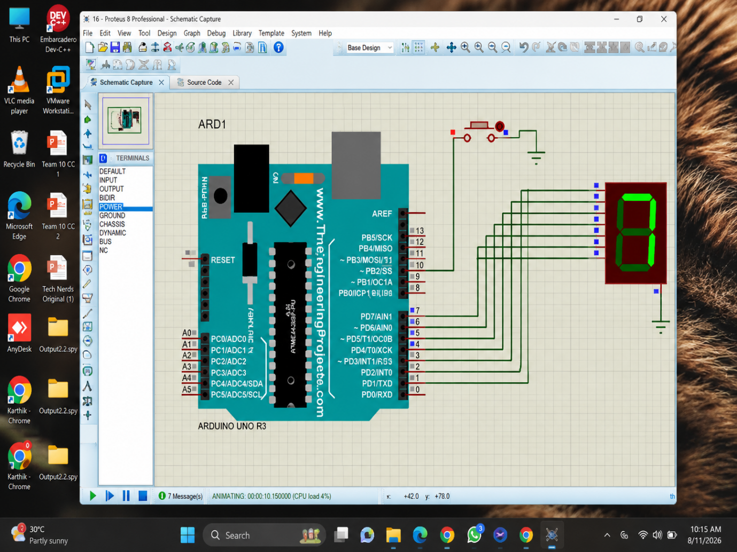
RESULT :
Thus the program has been successfully verified and executed.

