Goodrich Development Networks

Functional Spec Requirements: Intern Masters Database

**Revision 003**

Author: Ryan Goodrich

|  |  |  |  |
| --- | --- | --- | --- |
| **No.** | **Date** | **Description of Change** | **Author** |
| 1. | 9/23/2019 | Process Flow XIII  User: Champion / Sponsor / Intern  Task: Initial Client Upload and the process for adding people from new clients into the system | Ryan Goodrich |
| 2. | 9/23/2019 | Process Flow XIV  User: Champion / Sponsor / Intern  Task: Log-In Screen | Ryan Goodrich |
| 3. | 9/24/2019 | Process Flow / Spec Requirements XV  User: The Super User  Task: System Requirements | Ryan Goodrich |
| 4. | 9/24/2019 | Process Flow / Spec Requirements XVI  User: The Program Champion  Task: System Requirements | Ryan Goodrich |
| 5. | 9/24/2019 | Process Flow / Spec Requirements XVII  User: The Intern  Task: System Requirements | Ryan Goodrich |
| 6. | 9/24/2019 | Process Flow / Spec Requirements XVIII  User: The Sponsor  Task: System Requirements | Ryan Goodrich |
| 7. | 9/24/2019 | Process Flow / Spec Requirements XIX  User: The Super User  Task: The Super User Dashboard | Ryan Goodrich |
|  |  |  |  |
|  |  |  |  |
|  |  |  |  |
|  |  |  |  |

Process Flow I

User: Champion

Task: Intern Program Setup

|  |  |  |
| --- | --- | --- |
| **No.** | **Task** | **Manual or System Generated** |
| 1. | Champion registers new interns into the Intern Masters System (Name, Email, Phone) | Manual |
| 2. | Interns (students) receive a custom invitation from the Champion welcoming them into the program with link to where they can start working on their own profiles and complete their pre-start survey.   1. Custom Letter -or- 2. Standard letter. | System Generated |
| 3. | Message includes their log-in information and a link to the pre-start survey (customized by the client/Champion) prior to the start of their internship | System Generated |
| 4. | Intern sets up their profile |  |
| 5. | Intern completes their pre-start survey |  |
| 6. | Intern clicks “Save” |  |
| 7. | System notifies the program champion that the intern has completed the tasks and then adds it to the action item cue for the champion to review. |  |
| 8. | Champion reviews the survey and then builds out the intern’s experience blueprint. |  |
| 9. | Champion finalizes the intern experience blueprint (networking interviews and growth experiences). |  |
| 10. | Notification is sent to the intern informing them that the champion has assigned networking interviews and growth experiences, as well as projects if they have been accumulated by that point. |  |

Process Flow II

User: Champion / Sponsor

Task: Request to the Organization for Projects

|  |  |  |
| --- | --- | --- |
| **No.** | **Task** | **Manual or System Generated** |
| 1. | Champion logs into the Intern Masters System |  |
| 2. | Champion goes to the “Project Pipeline” page. |  |
| 3. | Champion clicks on “Request Projects”. |  |
| 4. | System shows a standard email template for requesting projects from the organization. |  |
| 5. | Standardized email template has edit capability. |  |
| 6. | Champion modifies text |  |
| 7. | Champion clicks “Submit” |  |
| 8. | System generates an email to all members of the Champion’s function (or to selected parties) with a clickable link where they can set up their Sponsor profiles and submit a project request for the interns. |  |
| 9. | Sponsor clicks on link. |  |
| 10. | System takes the sponsor to where they can log-in. |  |
| 11. | After login, the sponsor submits the project. |  |
| 12. | System sends a notification to the program champion informing him that a project has been submitted. |  |
| 13. | Submitted projects are added to the activity cue on the Program Champion’s profile. |  |

Process Flow III

User: Champion / Sponsor

Task: Project Approval after Submission

|  |  |  |
| --- | --- | --- |
| **No.** | **Task** | **Manual or System Generated** |
| 1. | Sponsor submits project within the system |  |
| 2. | Project added to the Champion’s activity feed. |  |
| 3. | Champion clicks on “view details” |  |
| 4. | Champion reviews submission to ensure all necessary information is there. |  |
| 5. | Champion reviews submission to ensure the quality of the project. |  |
| 6. | Champion approves / rejects submission |  |
|  | **IF project is approved** |  |
| 7. | Champion assigns the project to an intern |  |
| 8. | Project is added to the intern’s profile page. |  |
| 9. | Project added to the sponsor profile page as a submitted project |  |
| 10. | Email notification sent to sponsor informing him/her of approval and assignment. |  |
|  | **IF project is rejected** |  |
| 11. | Submission rejected by Champion |  |
| 12. | Champion provides reason for the rejection by adding comments to the Comments Section (like an audit trail) of the project’s history. |  |
| 13. | The sponsor is notified of the rejection through email with comments from the champion with a link to the form for resubmission. |  |
| 14. | Project returns to sponsor’s activity feed. |  |
| 15. | Sponsor resubmits the project and repeats this process until it is approved. |  |

Process Flow IV

User: Champion / Intern

Task: Networking Blueprint

|  |  |  |
| --- | --- | --- |
| **No.** | **Task** | **Manual or System Generated** |
| 1. | Champion receives pre-start survey from intern |  |
| 2. | Opening the survey creates a double-pain view:   1. On the left is the Completed Survey Form 2. On the right is the Intern’s editable Profile    1. Survey Form includes:       1. Areas of Interest       2. Potential Growth Experiences    2. Intern’s editable Profile includes;       1. Areas of Interest       2. Potential Growth Experiences |  |
| 3. | Champion reviews areas of interest. |  |
| 4. | Champion clicks “import” after reviewing areas of interest. |  |
| 5. | Areas of interest are added to the intern profile  Example: If the Intern has selected Procurement, Marketing and M&A as their areas of interest, it would automatically be imported into their profile at that point. |  |
| 6. | Champion clicks on “Procurement” in the Intern’s Editable Profile |  |
| 7. | “Select Interviews” appears in a popup window. The pop up shows a list of employees from procurement:  Example: The Procurement function will have provided a list of employees that will be entered into the system for this purpose. The information includes:   1. Name 2. Title 3. Area of Expertise 4. Functional Assignment 5. Location 6. Email 7. Phone |  |
| 8. | Champion looks through the names provided and clicks on the “boxes” of each name he/she would like the intern to interview. |  |
| 9. | Champion clicks “Save” |  |
| 10. | Interviews are assigned and added to the corresponding intern’s profile. |  |
| 11. | No notification is provided to the employees assigned to be interviewed by the intern. |  |
| 12. | System notification goes to the intern and the interviews are added to their profile. |  |
| 13. | Process is repeated for each functional area the intern has selected in their pre-start survey. |  |
| 14. | At any point, the intern may add additional networking interviews outside of this process. |  |

Process Flow V

User: Champion / Intern

Task: Assignment of Growth Experiences

|  |  |  |
| --- | --- | --- |
| **No.** | **Task** | **Manual or System Generated** |
| 1. | Champion receives survey from intern |  |
| 2. | Champion assigns networking blueprint |  |
| 3. | Champion goes to “Desired Experiences” section of the pre-start survey. |  |
| 4. | Intern will have selected different types of “Desired Experiences” they are interested in having. |  |
| 5. | The Champion clicks on each “Desired Experience” the intern has selected. |  |
| 6. | After the click, a pop up window with additional information on “Growth Experiences” pops up and up to 10 growth experiences can be selected at a time for each intern |  |
| 7. | **The Champion would click on “box” of each growth experience to add to the intern’s profile.** |  |
| 8. | Champion clicks on “save” |  |
| 9. | The Growth Experience is added to the intern’s profile. |  |
| 10. | The system generates a notification to the Intern’s activity feed letting them know that Growth Experiences have been assigned to them. |  |

Process Flow VI

User: Intern / Champion

Task: Intern Adds Project

|  |  |  |
| --- | --- | --- |
| **No.** | **Task** | **Manual or System Generated** |
| 1. | Intern clicks on “Project Pipeline” link. |  |
| 2. | Intern can then view the list of submitted projects, which are available, and who (if applicable) they have been assigned to. |  |
| 3. | Intern selects projects they would like to manage. |  |
| 4. | Intern clicks on “request project”. |  |
| 5. | Project request notification goes to the Champion |  |
| 6. | Champion approves or rejects. Champion can add comments explaining his/her decision at that time. |  |
| 7. | **If approved, the project is added to the intern’s profile.** |  |
| 8. | If rejected, the project remains unassigned and the intern is notified that the champion has rejected the project request. |  |

Process Flow VII

User: Intern / Champion

Task: Intern Adds Networking Interview

|  |  |  |
| --- | --- | --- |
| **No.** | **Task** | **Manual or System Generated** |
| 1. | Intern clicks on “Networking” link. |  |
| 2. | Intern reviews names, titles and profiles of employees in each function. |  |
| 3. | Intern clicks “Add boxes” to add employees to his/her networking blueprint. |  |
| 4. | Intern clicks on “save” |  |
| 5. | Notification that the intern has added additional networking assignments goes to the Champion |  |
| 6. | New interviews are then added to the intern’s profile. |  |

Process Flow VIII

User: Intern / Champion

Task: Intern Adds Growth Experience

|  |  |  |
| --- | --- | --- |
| **No.** | **Task** | **Manual or System Generated** |
| 1. | Intern clicks on “Growth Experience” link. |  |
| 2. | Intern is presented with a search bar   1. View all Growth Experiences – or- 2. View Growth Experiences by Category |  |
| 3. | Intern selects a category |  |
| 4. | Intern reviews the growth experiences found in the system |  |
| 5. | Intern selects up to 10 Growth Experiences at a time by clicking on the “add box” and hitting save. (Meaning, they can have 10 active and open Growth Experiences at a time. Once they mark one as complete, they can add an additional one, UNLESS they have a project on their profile that is flagged as “AT RISK”. |  |
| 6. | Champion is notified that the Growth Experiences have been added to the intern’s profile. |  |
| 7. | **Growth Experiences are then added to the intern’s profile page.** |  |

Process Flow IX

User: Sponsor / Champion

Task: Sponsor makes themselves available for Networking and Mentor Assignment

|  |  |  |
| --- | --- | --- |
| **No.** | **Task** | **Manual or System Generated** |
| 1. | Sponsor visit their profile |  |
| 2. | Sponsor clicks on the “mentor flag” and the “Networking Flag” |  |
| 3. | When the “flags” turn green, the sponsor becomes available for mentoring and interview assignment in the system. |  |
| 4. | The system notifies the program champion. |  |
| 5. | The program champion will see the change in their activity feed. |  |
| 6. | The champion will assign the mentor to an intern. |  |
| 7. | Champion can choose to put the mentor assignment on “hold” |  |
| 8. | If “Hold” is selected, then the sponsor receives an automated message informing them of the “hold” |  |
|  |  |  |

Process Flow X

User: Intern / Sponsor / Champion

Task: Tracking and Updating an assigned Intern Project

|  |  |  |
| --- | --- | --- |
| **No.** | **Task** | **Manual or System Generated** |
| 1. | Champion assigns a project to an intern |  |
| 2. | Intern is notified in the system and the project is added to their Intern Profile |  |
| 3. | Intern clicks on “View details” |  |
| 4. | Intern reviews goals, objectives, and deliverables. |  |
| 5. | Intern clicks on “Accept project” |  |
| 6. | Project status moves from “Unassigned” to “In Process” |  |
| 7. | To update the project, the intern can open it from their profile page and add comments or supporting activities (similar to Monday.com) |  |
| 8. | All comments are logged and the intern comments and updates are notified to the sponsor. |  |
| 9. | Intern can select how the project is going:   1. On time 2. Behind schedule 3. At risk    1. Status markers are visible and color coded on the intern profile. |  |
| 10. | Each intern can open the project and add attachments |  |
| 11 | For every attachment, the sponsor is notified. |  |
| 12. | The intern can choose to request feedback from the sponsor at any point during the project. |  |
| 13. | Upon project completion, the intern will change the project status form In Progress to complete. The sponsor will be notified of the change.` |  |
| 14. | The sponsor will receive a notification and then will open up the project to confirm or reject (with comments) the status of the project. |  |
| 15. | When sponsor confirms completion, there will be a notification sent to the champion and the intern and the project will be marked as complete on the intern’s profile. |  |
| 16. | Depending on if this is the 1st, 2nd, 3rd, 4th, 5th, etc. project completed by the intern, a badge will be posted onto the Badges section of the intern’s profile. |  |

Process Flow XI

User: Intern / Champion

Task: Award of Badges

|  |  |  |
| --- | --- | --- |
| **No.** | **Task** | **Manual or System Generated** |
| 1. | Interns will receive badges for the completion of specific milestones and growth experiences |  |
| 2. | Upon completion of a milestone or growth experience in the system, a badge will be added to the responsible intern’s profile. |  |
| 3. | Badge will be issued upon the marked completion of a task within the system. |  |
| 4. | For a completed growth experience, the intern will provide evidence in the comments section of the growth experience before requesting it be marked complete. |  |
| 5. | When requesting a Growth Experience be changed to “complete” status, the champion will be notified, in which they will approve the status change. |  |

Process Flow XII

User: Intern / Champion / Sponsor

Task: Providing Feedback

|  |  |  |
| --- | --- | --- |
| **No.** | **Task** | **Manual or System Generated** |
| 1. | On the champion & sponsor profiles, there will be two ways for each to provide feedback on an intern. |  |
| 2. | **Champion** |  |
| 3. | There will be a feedback button underneath the picture of each intern on the champions profile page. |  |
| 4. | The champion will click on that icon to provide feedback specific to that intern. |  |
| 5. | If the champion has submitted a project for the intern to complete, they may do so via the project feedback button in the submitted project. |  |
| 6. | On the champion’s landing page, there will also be a link to the “Feedback table”. |  |
| 7. | The Champion can click there, where they can view or add any feedback for each and every intern. |  |
| 8. | All information in the Feedback table can be exported for use in the hiring process. |  |
|  | Sponsor |  |
| 9. | Sponsors can provide feedback on an intern through the project feedback button. |  |
| 10. | Once clicked, they fill out the feedback form. |  |
| 11. | Sponsor can click the option (copy intern) and choose to CC them on the feedback. |  |
| 12. | If they do not choose that option, the feedback will be added to the feedback table (which is only visible to the champion) and the champion will be notified that feedback has been provided. |  |

Process Flow XIII

User: Champion / Sponsor / Intern

Task: Initial Client Upload

|  |  |  |
| --- | --- | --- |
| **No.** | **Task** | **Manual or System Generated** |
| 1. | When Intern Masters Receives a client, we will ask them for an excel file with all of the employees they want entered into the system. |  |
| 2. | The file shall include:   1. First Name 2. Last Name 3. Department 4. Title 5. Location 6. Phone 7. Email 8. And the proper designation of    1. Program Owner    2. Champion    3. Sponsor    4. Intern |  |
| 3. | Once the client has provided Intern Masters with this file, Wattabyte will upload the client information in the Intern Masters database which will designate accounts for each member and will distribute the log-in information to all employees. |  |
| 4. | Employees will receive a welcome message with a link to the log in where they can log-in and begin setting up their accounts. |  |

Process Flow XIV

User: Champion / Sponsor / Intern

Task: Log-In Screen

|  |  |  |
| --- | --- | --- |
| **No.** | **Task** | **Manual or System Generated** |
| 1. | When logging in to the Intern Masters system, the user will enter their corporate email as their user name. |  |
| 2. | When logging in for the first time, they will use their system generated password |  |
| 3. | After initial log-in, the user will be asked to change their password. |  |
| 4. | The log-in screen will also have a button that allows the employee to unhide the password that they’ve entered. |  |
| 5. | There will be a “forgot password” option on the log-in screen. |  |
| 6. | If the user clicks on Forgot Password, the system will ask them for their email to confirm their account. |  |
| 7. | The user will enter their email address. |  |
| 8. | The system will then send an email to the employee with a link to update their password. |  |
| 9. | For convenience, users will be able to enter their most previous password as their new password. |  |

Process Flow / Spec Requirements XV

User: The Super User

Task: System Requirements

*The Super User controls all of the client’s intern programs. This will be someone from HR who can add additional program champions who would then run the intern programs within the function.*

*Program Organization Structure example:*

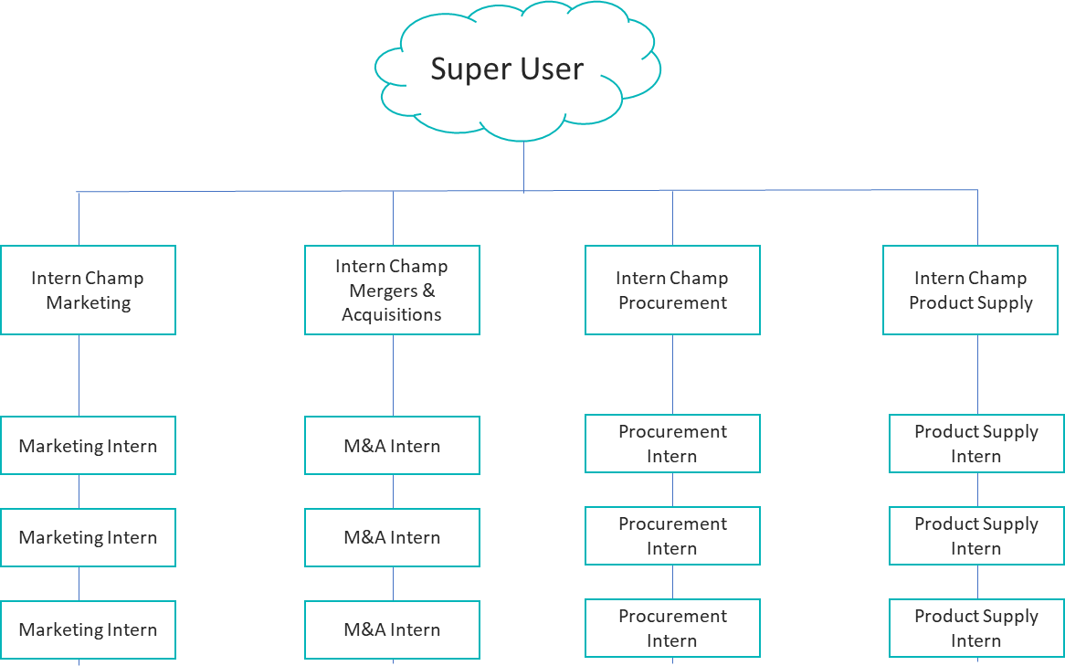

The Super User can:

|  |  |  |
| --- | --- | --- |
| **No.** | **Task** | **Manual or System Generated** |
| 1. | Dictate / Recommend which colleges and universities to go to (New Dashboard we’ll create) |  |
| 2. | Set the recruiting calendar (We’ll be at this college or university on this date and at this time) |  |
| 3. | Flag universities for different disciplines (i.e. Arizona State, Strong in Supply Chain Management) |  |
| 4. | Add program champions within the system, or move an employee from a sponsor role into a champion role. |  |
| 5. | Add new employees into the system. |  |
| 6. | Direct message program champions |  |
| 7. | Submit news and additional communications that all Program Champions see (Program Champion community – new interface to be designed) |  |
| 8. | Assign tasks to Program Champions |  |
| 9. | Upload resources & links to the program champion network. |  |
| 10. | Add interns underneath (reporting to) a program champion |  |
| 11. | Message and Assign tasks to interns. |  |
| 12. | Distribute and manage surveys within the system (Not the pre-start survey, but surveys to interns, champions and sponsors asking for ways to improve the program) |  |
| 13. | Review and Report on Analytics:   1. Qty of interns in the program 2. Qty of projects they’re working on 3. % of projects that are progressing on schedule 4. % of projects that are marked complete 5. % of projects that are at risk 6. No. of interviews conducted 7. % of assigned interviews completed 8. Feedback reports from the interns 9. Performance reports on each intern    1. Projects Completed    2. Interviews Completed    3. Growth Experiences Completed    4. Badges accumulated    5. Feedback from Sponsors and Champions |  |
| 14. | Schedule a “Recruiting event” at a University that interns, sponsors, and champions can register for.   1. Registering for the event should create an .ics file that the participants can use to add the event to their calendar. |  |
|  |  |  |

Process Flow / Spec Requirements XVI

User: The Program Champion

Task: System Requirements

*Program Champions manage the intern program for their function. They can create “recruiting events” and share them with the Super User, other Champions, Sponsors, and Interns. External to the system, they are responsible for posting their job descriptions, recruiting, interviewing, selection, offering, and managing the interns in their program. They are also the managers of the intern program for their function, and are the ones who finalize each assignment given to an intern.*

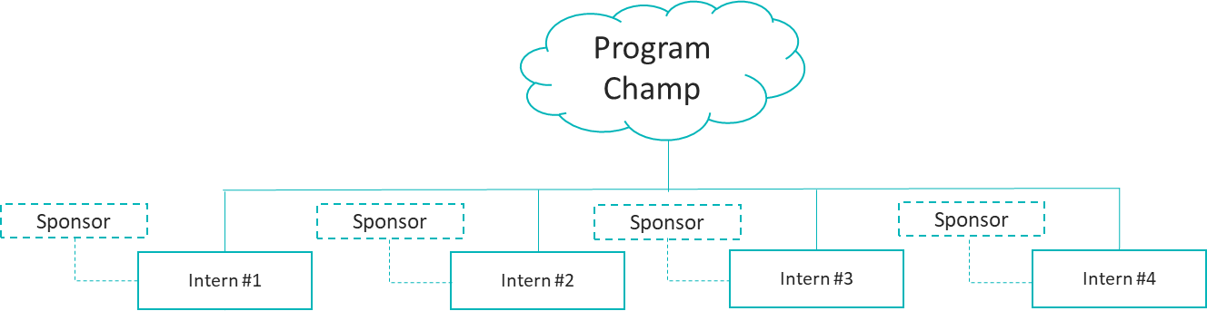

*They will do everything in their power to ensure that interns who stand out have an unbiased opportunity to convert from an intern into a full-time employee.*

The Program Champion can:

|  |  |  |
| --- | --- | --- |
| **No.** | **Task** | **Manual or System Generated** |
| 1. | Create “Recruiting events” in the system at Universities flagged as target universities. |  |
| 2. | Invite anyone within the community to go to that event with them. |  |
| 3. | Enter interns who report directly into them, into the system. |  |
| 4. | Can assign projects and networking interviews to each intern. |  |
| 5. | Can assign growth experiences to each intern. |  |
| 6. | Send pre-start surveys to each intern. |  |
| 7. | Can submit project requests to sponsors. |  |
| 8. | Can approve projects submitted by sponsors |  |
| 9. | Can send direct messages to all community members |  |
| 10. | Can assign tasks to all community members |  |
| 11. | Can provide feedback on all community members |  |
| 12. | Can distribute and manage surveys within the system (Not the pre-start survey, but surveys to sponsors and interns asking for ways to improve the program. |  |
| 13. | Print or create Intern Performance Reports   1. Projects Completed 2. Interviews Completed 3. Growth Experiences Completed 4. Badges accumulated   Feedback from Sponsors and Champions |  |
| 14. | Make a “Hire to FTE” recommendation for an intern at the end of the program. Also can make a “Do not proceed” recommendation for other interns who they do not feel are a good fit. |  |
|  |  |  |

Process Flow / Spec Requirements XVII

User: The Intern

Task: System Requirements

*The Intern is an undergraduate or graduate student who has agreed to work for the client for a short-term duration of between 3-6 months with a goal of being offered a full-time position upon graduation.*

*The intern has a direct reporting relationship (R-Line) with the program champion but additional indirect reporting lines (A-Lines) to sponsors who have assigned him/her projects.*

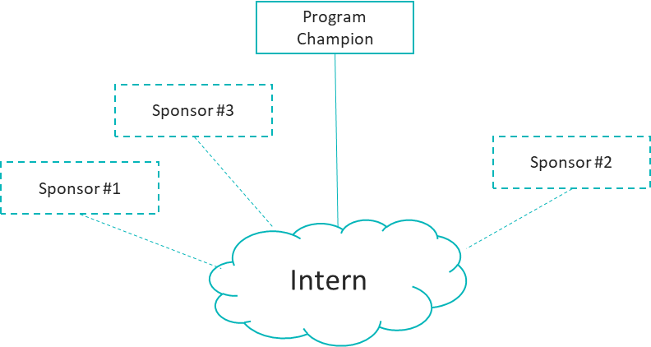

The Intern Can:

|  |  |  |
| --- | --- | --- |
| **No.** | **Task** | **Manual or System Generated** |
| 1. | Manage networking assignments |  |
| 2. | Add Networking assignments |  |
| 3. | Change Networking assignment status |  |
| 4. | Leave feedback or comments on the networking interview assignment |  |
| 5. | Add more interviews to their cue. |  |
| 6. | Manage project assignments. |  |
| 7. | Update project assignments with comments, activities and files. |  |
| 8. | The intern can add activities within each project assignment:   1. Example: task 1, connect with stakeholders 2. Example: task 2, do a market analysis, etc. |  |
| 9. | Request the status of projects be changed. |  |
| 10. | Leave feedback on project assignments |  |
| 11. | Leave feedback on sponsors |  |
| 12. | Leave feedback on the champion |  |
| 13. | Request to have additional projects added to their cue. |  |
| 14. | Manage their growth experiences |  |
| 15. | Update Growth Experiences with comments, feedback, and attachments. |  |
| 16. | Request that growth experiences status be changed to completed. |  |
| 17. | Upload video blogs |  |
| 18. | Upload news articles |  |
| 19. | Complete their profile. |  |
| 20. | Update their MBTI, HBDI, Emergentics, Mind Maps, and The Core section of their intern profiles. |  |
| 21. | Identify the areas of the business they want to learn about. |  |
| 22. | Access the slide deck design lab |  |
| 23. | Complete weekly status reports. |  |
| 24. | Identify the areas of the business they want to learn about. |  |
| 25. | Complete the pre-start survey |  |
| 26. | Post comments and questions to the intern community. |  |
| 27. | Invite sponsors to submit projects on their behalf. |  |
| 28. | View all profiles within the Intern Masters community for their company. Including Champions, Sponsors, and Interns. |  |

Process Flow / Spec Requirements XVIII

User: The Sponsor

Task: System Requirements

*Sponsors are full-time employees (any employee in the company) who has been invited to submit projects by the program champion or by the intern. They act as an A-Line manager, coach, and mentor for each intern.*

The Sponsor Can:

|  |  |  |
| --- | --- | --- |
| **No.** | **Task** | **Manual or System Generated** |
| 1. | Access the sponsor community page (new landing page I need to create) |  |
| 2. | Post comments on the sponsor community page |  |
| 3. | View the profiles of all community members (including program champions and interns) |  |
| 4. | Submit projects to the program champion for the intern community. |  |
| 5. | Send messages to all community members. |  |
| 6. | Provide feedback on each intern related to their projects. |  |
| 7. | Make themselves available as a “Mentor” by turning the Mentor flag on their profile. |  |
| 8. | Assign project related tasks to each intern |  |
| 9. | Review and approve status change requests made by the intern |  |
| 10. | Respond to surveys submitted by members of the intern community (super users, champions, etc) |  |
| 11. | Make a recommendation to the program champion regarding the intern’s future with the company:   1. Recommend Full Time Hire 2. Recommend Do Not Pursue at this time. |  |

Process Flow / Spec Requirements XIX

User: The Super User

Task: The Super User Dashboard

*The Super-User Dashboard is a feature that is of critical importance to potential clients. Here, the Super User (an HR employee) can choose their target universities, set their recruiting calendar, access intern program managers, involve employees as sponsors, engage with the intern community, add projects, upload news and videos, run analytics, send out surveys, update growth experiences, and request support.*

Visual on next page.

The Super-User Dashboard Must include:

|  |  |  |
| --- | --- | --- |
| **No.** | **Task** | **Manual or System Generated** |
| 1. | Editable banner image |  |
| 2. | Editable Primary photo |  |
| 3. | The Name and contact information for the Super User |  |
| 4. | An Identifier showing, they are the Super User |  |
| 5. | An Intern Contact flag, letting interns know they are free to contact that person. |  |
| 6. | A mentorship availability flag showing interns that the super user is available for mentoring |  |
| 7. | A Pending Activities List showing all actions the Super User is responsible for:   1. Approval of recruiting event requests 2. Approval of Target University Requests 3. Requests for assignment of new Program Champions in the system |  |
| 8. | A series of “Hot” Action Buttons:   1. Assign Task – Form opens up and the Super User can assign a task to anyone in the Intern Masters Community. 2. Announcement – Communication Form opens up for the Super User to make an immediate announcement that would be emailed to the community and featured on the intern masters News & Media page. 3. Add Growth Experience – Any time the Super User is feeling creative, they can add a new Growth Experience. All submissions will be sent to Intern Masters for review and a decision on whether or not to standardize the new Growth Experience for additional clients 4. Submit Community Event – Allows the Super User to register an event with an .ics file that will be sent out to everyone in the intern masters community. |  |
| 9. | A Search Bar that allows the Super User to search by:   1. Name 2. Department 3. Champion 4. Sponsor 5. Intern |  |
| 10. | A Latest Activity Feed showing all of the intern community activities that have taken place during the week. |  |
| 11. | A My Profile link that allows the Super User to update their viewable profile (the profile that is visible to sponsors, champions, and interns |  |
| 12. | A link to a new page called “Universities”   1. This is where the Super User will identify all of the Universities that the company is targeting for recruiting. 2. The Super User will be able to update points of contact at each university, what major they’re looking to recruit, and add various notes and comments regarding the school. 3. The Super User will also be able to link each school’s profile to their on-campus recruiting calendar and their job boards. |  |
| 13. | A link to a new page called “Recruiting Calendar”   1. This page allows the Super User to identify by calendar, which schools they are going to and when, plus identify if they need any support from Program Champions and Sponsors, with the ability to invite community members to join them. |  |
| 14. | A link to a new page called the Champion Community   1. The champion community is where Program Champions are provided news and content on how to manage their programs. 2. It also is a comprehensive visual list of all of the Intern Program Champions within the company. |  |
| 15. | A link to a new page called the Sponsor Community   1. The Sponsor community is where Intern Sponsors are provided news and content, as well as instruction on how to submit projects and mentor the interns who are working on projects for them. 2. It also is a comprehensive visual list of all of the intern project sponsors within the company. |  |
| 16. | A link to a new page called the Intern Community   1. The intern community is where Interns are provided news and content, as well as instruction on how to navigate their intern program. 2. It’s also where all their video blogs and news articles are stored. 3. Interns can post questions and announcements to each other and use the board as an informal way of communicating with each other. |  |
| 17. | A link to the company intern project pipeline. All projects submitted across all functions.   1. With the ability to add additional projects and assign them accordingly. |  |
| 18. | A Link to the News & Media page where the Super User will control all of the content generated for the program from an administrative perspective.   1. Choose intern Masters content to feature 2. Choose Intern blogs to feature 3. Feature Internal articles and news 4. Showcase intern video blogs and promotional materials |  |
| 19. | Access the Analytics and Feedback page where they will be able to run reports and see quantifiable data.   1. The Super User will also be able to run Hiring reports on each intern to evaluate them for direct hire opportunities. |  |
| 20. | A link to the Community Surveys page where the Super User can set up and distribute a survey regarding the intern masters program to all community members. (Recommend inserting survey monkey or Qualtrics if we can do a bolt in) |  |
| 21. | A link to the Client’s Growth Experience list, where the Super User can add additional growth experiences for interns to select. |  |
| 22. | A link to request support on any technical issues direct to Wattabyte. |  |

