ASSIGNMENT 18.2

**Input Datasets:**

We have an airline data with us:

**user details:**

user_id, name, age

**holidays:**

user_id, src, dest, travel_mode, distance, year_of_travel

**transport:**

travel_mode, cost_per_unit

Here are the datasets which we will be using for this assignment in all problems. It has been kept in local file system:

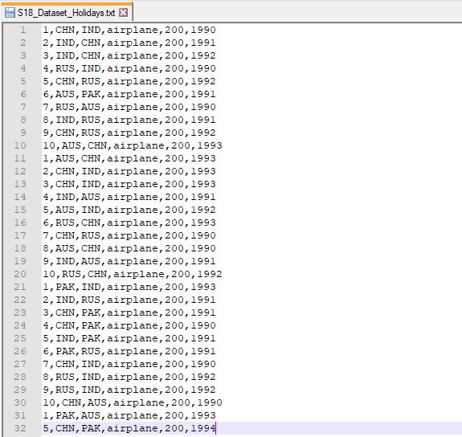

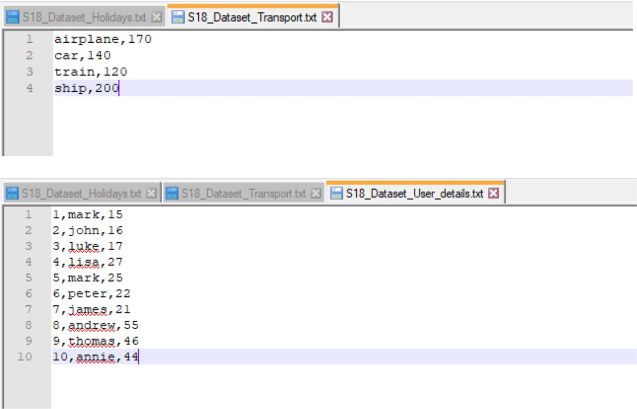

**Problem Statement:**

1. Which route is generating the most revenue per year?
2. What is the total amount spent by every user on air-travel per year?
3. Considering age groups of <20, 20-35, 35>, which age group is travelling the most every year?

**Solution:**

1. Here is the Spark code snippet to find the route generating the most revenue per year: // import required Spark packages

import org.apache.spark.sql.SparkSession

import org.apache.spark.sql.types.{IntegerType, StringType}

object Assignment18_2 {

def main(args: Array[String]): Unit = {

val spark = SparkSession

.builder()

// create a SparkSession object that can be used to

// create various contexts of Spark such as sqlContext

.config("spark.sql.warehouse.dir", "file:///c:/tmp/spark-warehouse")

.master("local[*]")

.getOrCreate()

val sqlContext = spark.sqlContext // initialize sqlContext

val input_df1 = sqlContext.read.csv ("E:\\Acadgild\\Session 18\\S18_Datasets \\S18_Dataset

_Transport.txt") // load input data file – transport.txt val transportDF = input_df1.select( // define schema for input data loaded input_df1("_c0").cast(StringType).as("travel_mode"), //assign column names to the data frame input_df1("_c1").cast(IntegerType).as("cost_per_unit")) transportDF.createOrReplaceTempView("transport") // create a temporary view - transport

val input_df2 = sqlContext.read.csv("E:\\Acadgild\\Session 18\\S18_Datasets\\S18_Dataset_

Holidays.txt")

val holidaysDF = input_df2.select(

input_df2("_c0").cast(IntegerType).as("user_id"),

input_df2("_c1").cast(StringType).as("src"),

// load input data file – holidays.txt

// define schema for input data loaded

//assign column names to the data frame

input_df2("_c2").cast(StringType).as("dest"),

input_df2("_c3").cast(StringType).as("travel_mode"),

input_df2("_c4").cast(IntegerType).as("distance"),

input_df2("_c5").cast(IntegerType).as("year_of_travel"))

holidaysDF.createOrReplaceTempView("holidays") // create a temporary view - holidays

// SQL query to find the route generating the most revenue per year

val result = sqlContext.sql("SELECT y.src, y.dest, y.year_of_travel " +

"FROM transport x, holidays y " + "WHERE x.travel_mode = y.travel_mode " + "GROUP BY y.src , y.dest ,y.year_of_travel " + "ORDER BY SUM(x.cost_per_unit) DESC").take(6)

result.foreach(println) // print the result

}

}

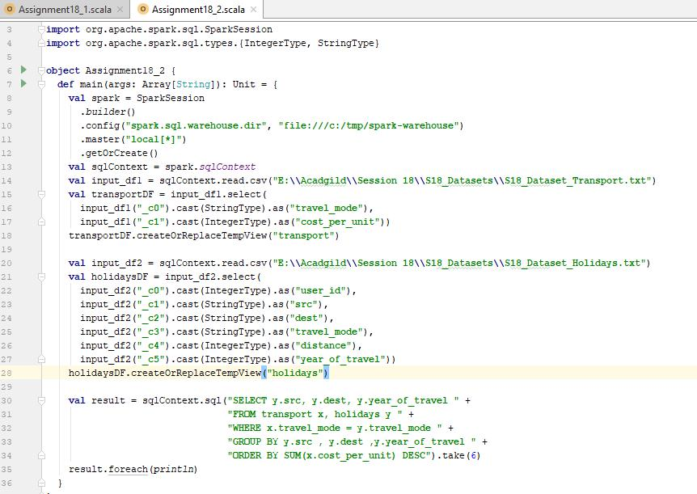

**Output:**

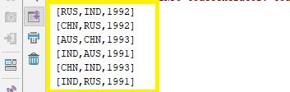

1. Here is the Spark code to find the total amount spent by every user on air-travel per year: // import required Spark packages

import org.apache.spark.sql.SparkSession

import org.apache.spark.sql.types.{IntegerType, StringType}

object Assignment18_2 {

def main(args: Array[String]): Unit = {

val spark = SparkSession // create a SparkSession object that can be used to

.builder() // create various contexts of Spark such as sqlContext

.config("spark.sql.warehouse.dir", "file:///c:/tmp/spark-warehouse")

.master("local[*]")

.getOrCreate()

val sqlContext = spark.sqlContext // initialize sqlContext

val input_df1 = sqlContext.read.csv ("E:\\Acadgild\\Session 18\\S18_Datasets \\S18_Dataset

_Transport.txt") // load input data file – transport.txt val transportDF = input_df1.select( // define schema for input data loaded input_df1("_c0").cast(StringType).as("travel_mode"), //assign column names to the data frame input_df1("_c1").cast(IntegerType).as("cost_per_unit")) transportDF.createOrReplaceTempView("transport") // create a temporary view - transport

val input_df2 = sqlContext.read.csv("E:\\Acadgild\\Session 18\\S18_Datasets\\S18_Dataset_

Holidays.txt") // load input data file – holidays.txt

val holidaysDF = input_df2.select( // define schema for input data loaded

input_df2("_c0").cast(IntegerType).as("user_id"), //assign column names to the data frame

input_df2("_c1").cast(StringType).as("src"),

input_df2("_c2").cast(StringType).as("dest"),

input_df2("_c3").cast(StringType).as("travel_mode"),

input_df2("_c4").cast(IntegerType).as("distance"),

input_df2("_c5").cast(IntegerType).as("year_of_travel"))

holidaysDF.createOrReplaceTempView("holidays") // create a temporary view - holidays

val input_df3 = sqlContext.read.csv("E:\\Acadgild\\Session 18\\S18_Datasets\\S18_Dataset_

User_details.txt")

val usersDF = input_df3.select(

input_df3("_c0").cast(IntegerType).as("user_id"),

input_df3("_c1").cast(StringType).as("name"),

input_df3("_c2").cast(IntegerType).as("age"))

// load input data file – user_details.txt // define schema for input data loaded //assign column names to the data frame

usersDF.createOrReplaceTempView("users") // create a temporary view - users

* SQL query to find the total amount spent by every user on air-travel per year sqlContext.sql("SELECT z.user_id, z.name, y.year_of_travel, SUM(x.cost_per_unit) as total_amount " +

"FROM transport x, holidays y, users z " +

"WHERE x.travel_mode = y.travel_mode AND x.travel_mode = 'airplane' and y.user_id = z.user_id " +

"GROUP BY z.user_id, z.name, y.year_of_travel " +

"ORDER by z.user_id, z.name, y.year_of_travel").show() // print the result

}

}

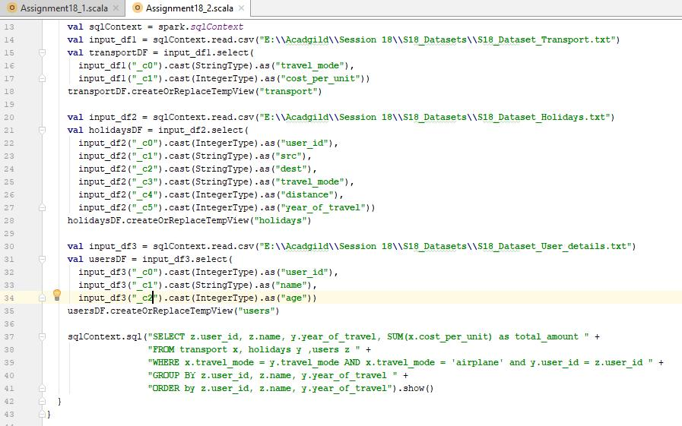

**Output:**

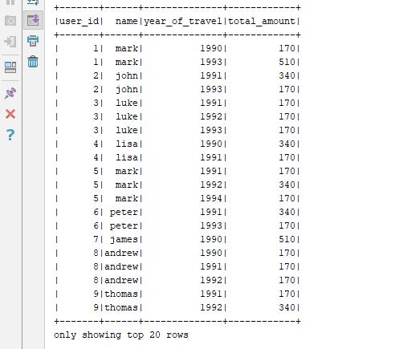

1. Here is the Spark code to find the age group that is travelling the most every year: // import required Spark packages

import org.apache.spark.sql.SparkSession

import org.apache.spark.sql.types.{IntegerType, StringType}

object Assignment18_2 {

def main(args: Array[String]): Unit = {

val spark = SparkSession // create a SparkSession object that can be used to

.builder() // create various contexts of Spark such as sqlContext

.config("spark.sql.warehouse.dir", "file:///c:/tmp/spark-warehouse")

.master("local[*]")

.getOrCreate()

val sqlContext = spark.sqlContext

// initialize sqlContext

val input_df2 = sqlContext.read.csv("E:\\Acadgild\\Session 18\\S18_Datasets\\S18_Dataset_

Holidays.txt")

val holidaysDF = input_df2.select(

input_df2("_c0").cast(IntegerType).as("user_id"),

input_df2("_c1").cast(StringType).as("src"),

// load input data file – holidays.txt

// define schema for input data loaded

//assign column names to the data frame

input_df2("_c2").cast(StringType).as("dest"),

input_df2("_c3").cast(StringType).as("travel_mode"),

input_df2("_c4").cast(IntegerType).as("distance"),

input_df2("_c5").cast(IntegerType).as("year_of_travel"))

holidaysDF.createOrReplaceTempView("holidays") // create a temporary view - holidays

val input_df3 = sqlContext.read.csv("E:\\Acadgild\\Session 18\\S18_Datasets\\S18_Dataset_

User_details.txt")

val usersDF = input_df3.select(

input_df3("_c0").cast(IntegerType).as("user_id"),

// load input data file – user_details.txt // define schema for input data loaded //assign column names to the data frame

input_df3("_c1").cast(StringType).as("name"),

input_df3("_c2").cast(IntegerType).as("age"))

usersDF.createOrReplaceTempView("users")

// create a temporary view – users

* SQL query to find the age group that is travelling the most every year val result = sqlContext.sql("SELECT age " +

"FROM users x, holidays y " + "WHERE x.user_id = y.user_id " + "GROUP BY age " +

"ORDER BY COUNT(age) DESC").take(1)

result.foreach(println) // print the result

}

}

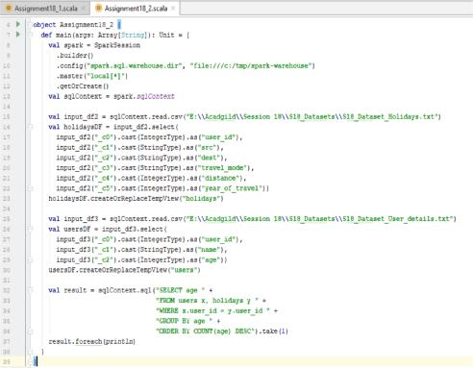

**Output:**

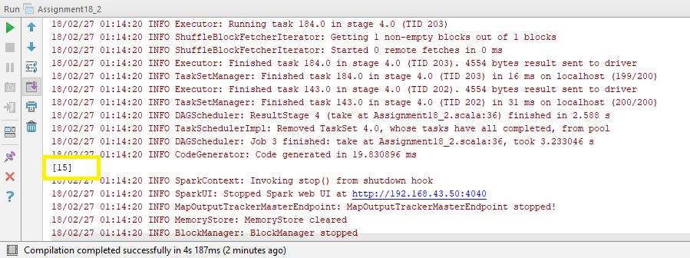

**Conclusion:** People who are **under the age of 20 (to be precise, people with age 15)** travels themost every year.