Hospital Management Database System
Submitted in partial fulfillment of the requirements
of the degree of
Bachelor of Technology
in
Artificial Intelligence And Machine Learning
by
Abinash Muthuramalingam | 125A9002
Jatin Kumar | 125A9009
Vishnu Devendra | 125A9010
Karthik Raja | 125A9018
Under the Guidance of
Prof. Sumedha A. Maindalkar
Department of AIML
SIES GRADUATE SCHOOL OF TECHNOLOGY
Nerul, Navi Mumbai 400706
2025–2026

CERTIFICATE
This is to certify that the project entitled “Hospital Management Database System” is a bonafide work of the following students, submitted to the University of Mumbai in partial fulfillment of the requirement for the award of the degree of Bachelor of Technology in Artificial Intelligence And Machine Learning.
Abinash Muthuramalingam | 125A9002
Jatin Kumar | 125A9009
Vishnu Devendra | 125A9010
Karthik Raja | 125A9018

Prof. Sumedha A. Maindalkar  Internal Guide | Dr. Kalyani Pampattiwar  Head of Department | Dr. K. Lakshmi Sudha  Principal

DECLARATION
I declare that this written submission represents my ideas in my own words and where others’ ideas or words have been included, I have adequately cited and referenced the original sources. I also declare that I have adhered to all principles of academic honesty and integrity and have not misrepresented or fabricated or falsified any idea/data/fact/source in my submission. I understand that any violation of the above will cause for disciplinary action by the Institute and can also evoke penal action from the sources which have thus not been properly cited or from whom proper permission has not been taken when needed.
Abinash Muthuramalingam | 125A9002 | - ____________________
Jatin Kumar | 125A9009 | - ____________________
Vishnu Devendra | 125A9010 | - ____________________
Karthik Raja | 125A9018 | - ____________________
 |  | Signature
Date: ____________________

ACKNOWLEDGEMENT
It gives us immense pleasure to thank Dr. K. Lakshmi Sudha, our principal for extending her support in carrying out this project. We also thank our HOD, Dr. Kalyani Pampattiwar for her support in completing the project. We wish to express our deep sense of gratitude and thanks to our Internal Guide, Prof. Sumedha A. Maindalkar for her guidance, help and useful suggestions, which helped in completing our project work in time.
Also, we would like to thank the entire faculty of the Computer Science & Engineering department for their valuable ideas and timely assistance in this project, last but not least, we would like to thank our teaching and non-teaching staff members of our college for their support, in facilitating timely completion of this project.
Project Team
Abinash Muthuramalingam
Jatin Kumar
Vishnu Devendra
Karthik Raja

ABSTRACT
This report presents the design, architectural blueprint, and full-stack implementation of a modern, web-integrated Hospital Management Database System (HMDS). The system is engineered to resolve critical inefficiencies, data loss, and privacy vulnerabilities associated with traditional paper-based clinic files and unnormalized spreadsheet records. Built upon PostgreSQL 16 and structured through Prisma ORM, the database establishes an enterprise relational foundation enforcing strict Third Normal Form (3NF) compliance across five core relational tables: users, doctor_profiles, patient_profiles, appointments, and medical_records.
The primary objective of this project is to provide a unified, highly reliable healthcare administration platform. The system incorporates comprehensive entity modeling using classic Chen Entity-Relationship (ER) and Enhanced Entity-Relationship (EER) specialization, modeling a generalized User superclass specializing disjointly into Doctor and Patient subclasses with complete attribute inheritance. The application guarantees absolute referential integrity through foreign keys with cascading deletion policies (ON DELETE CASCADE).
To guarantee zero data discrepancies between database administration tools (such as pgAdmin 4) and the live client application, the database features a synchronized updatable view (public.patients) backed by automated PL/pgSQL INSTEAD OF INSERT and BEFORE INSERT triggers. These triggers automatically generate authenticated user credentials and link demographic records in a single atomic transaction, preventing blank fields or orphaned rows on the web dashboard.
The presentation layer is implemented with Next.js 14 (App Router), React 18, TypeScript, and Tailwind CSS, protected by cryptographic Bcrypt password hashing and NextAuth.js Role-Based Access Control (RBAC). The resulting solution empowers patients with live doctor filtering and consultation booking, gives doctors an intuitive queue for issuing digital prescriptions, and provides hospital administrators with real-time analytics across patients, doctors, and total revenue.

Contents
SR. NO. | CHAPTER | PAGE NO.
1 | INTRODUCTION | 4
2 | SYSTEM REQUIREMENTS: S/W used | 7
3 | SYSTEM DESIGN: ER & EER DIAGRAMS | 9
4 | IMPLEMENTATION & DATABASE SCHEMA | 13
5 | CODE SNIPPETS & SQL OPERATIONS | 17
6 | RESULTS & WEBPAGE DEMONSTRATION | 21
7 | CONCLUSION | 25
8 | REFERENCES | 26

Chapter 1: Introduction
1.1 Introduction and need of the project
Healthcare institutions and clinical establishments generate an enormous volume of critical data on a daily basis. Every patient interaction involves multiple data points: personal demographics, contact numbers, vital signs, clinical complaints, scheduled appointment slots, physician specializations, consultation fees, and prescribed pharmaceuticals. In modern medical operations, the speed and accuracy with which this information is retrieved directly affects patient outcomes and administrative efficiency.
Traditionally, outpatient clinics and small-to-medium hospitals have relied upon physical paper records or rudimentary electronic spreadsheets (such as Microsoft Excel). While these manual methods may appear convenient in small-scale environments, they rapidly break down as patient volume increases. Physical paper files are vulnerable to loss, accidental damage, misplacement, and physical theft. In an emergency scenario, medical practitioners cannot afford to wait twenty minutes while administrative staff search through archive cabinets for a patient folder.
Similarly, electronic spreadsheets lack the foundational principles of database theory. Spreadsheets do not enforce relational integrity, multi-user row-level locking, or concurrent transaction isolation. When two clinic receptionists attempt to update patient information simultaneously, one user's edits inevitably overwrite the other's. Furthermore, spreadsheets lack cryptographic access controls, exposing sensitive clinical diagnoses to unauthorized viewing.
This project addresses these critical challenges through the development of the Hospital Management Database System (HMDS)—a centralized, high-performance relational database application built upon PostgreSQL 16, Prisma ORM, and Next.js 14. The system provides an integrated platform that consolidates patient profiles, doctor availability, appointment queues, and digital prescriptions into an organized, ACID-compliant relational schema accessible via a secure web dashboard.
1.2 Problem statement in broad sense
Modern hospitals struggle with fragmented, disjointed information systems. Patient records are frequently stored across multiple isolated locations: reception appointment books, doctor consultation pads, and billing spreadsheets. This fragmentation creates severe barriers to efficient care delivery and leads to significant database anomalies:
- Data Redundancy & Update Anomalies: Patient contact numbers and addresses are repeatedly entered across separate appointment logs. If a patient updates their mobile number in one record, older appointment rows retain obsolete data, causing missed reminders.
- Deletion Anomalies: In an unnormalized spreadsheet, deleting a cancelled appointment row frequently purges the patient's entire medical history and contact profile.
- Insertion Anomalies: Adding a newly registered patient without an immediate appointment is impossible in flat tables where appointment date forms part of the primary key.
- Absence of Role-Based Security: Without strict cryptographic access control, all staff members possess unrestricted access to confidential diagnostic data, violating patient privacy.
This project eliminates these obstacles by engineering a normalized relational database in strict Third Normal Form (3NF), coupled with role-based security boundaries that ensure privacy, consistency, and instantaneous sub-millisecond query execution.
1.3 Scope
The scope of the Hospital Management Database System encompasses the complete lifecycle of clinical outpatient administration:
- Database Design & Storage: A PostgreSQL 16 relational database with five core relational tables, domain ENUM constraints, automated foreign key cascades, and synchronized views.
- Multi-User Role Boundaries (RBAC): Discrete authorization layers for Patients, Doctors, and Hospital Administrators enforced by NextAuth.js JWT tokens and Bcrypt password encryption.
- Patient Portal: Doctor directory search filterable by specialization, appointment scheduling, and personal prescription viewing.
- Doctor Portal: Consultation queue management, appointment status toggles (Completed, No-Show), and prescription authoring modals.
- Administrator Control Center: Operational metrics dashboard (Total Patients, Total Doctors, Today's Visits, Revenue), doctor onboarding forms, and patient record management.
1.4 Organization of the report
This project report is organized into seven focused chapters: Chapter 1 presents the project introduction, problem statement, and scope. Chapter 2 details the system software and hardware requirements. Chapter 3 presents the architectural blueprints via classic Chen ER and EER specialization diagrams. Chapter 4 provides the implementation walkthrough, data dictionary, and 3NF normalization. Chapter 5 showcases core SQL queries, triggers, and views. Chapter 6 provides live webpage screenshots and database record verification. Chapter 7 concludes the report with future scope, followed by Chapter 8 with references.

Chapter 2: System Requirements (software used)
2.1 Microsoft Windows Operating System
The database server and development environment are hosted on the Microsoft Windows platform:
- Operating System: Windows 10 / Windows 11 (64-bit architecture recommended).
- Hardware Specifications: Minimum 8 GB RAM, Quad-Core Processor (x64), and 10 GB free disk space for the PostgreSQL database cluster.
2.2 PostgreSQL 16 Relational Database Engine
PostgreSQL 16 serves as the enterprise relational database management system (RDBMS) for this project, operating on port 5433 (Database: hospital_db):
- ACID Compliance: Guarantees that transactions (e.g. creating user accounts and patient profiles simultaneously) are processed reliably with zero data corruption.
- Referential Integrity: Enforces ON DELETE CASCADE and ON UPDATE CASCADE across all foreign key relationships.
- PostgreSQL ENUMs: Enforces strict domain validation on Role (PATIENT, DOCTOR, ADMIN) and AppointmentStatus (SCHEDULED, COMPLETED, CANCELLED, NO_SHOW).
- PL/pgSQL Triggers & Views: Automated INSTEAD OF INSERT triggers and synchronized views (public.patients) to allow direct pgAdmin 4 data management without blank fields.
2.3 Prisma ORM 5.x
Prisma ORM connects the Next.js application layer to the PostgreSQL database:
- Type-Safe Database Access: Automates query generation and guarantees full type safety in TypeScript.
- Connection Pooling: Maintains efficient database connection pools to support concurrent multi-user access.
- Atomic Transactions: Executes multi-step write operations safely using prisma.$transaction().
2.4 Node.js & Next.js 14 (App Router)
The web application is built with Node.js v20 and Next.js 14 utilizing the App Router:
- React Server Components: Enables fast server-side data fetching and rendering for initial page loads.
- RESTful API Routes: Type-safe server endpoints under /api/admin/*, /api/doctor/*, and /api/appointments/*.
- Tailwind CSS: Delivers a responsive, accessible user interface optimized for desktop, tablet, and mobile browsers.
2.5 Security, Authentication & Supporting Libraries
- NextAuth.js: Manages user login sessions with encrypted JSON Web Tokens (JWT) and middleware route guards.
- Bcryptjs: Encrypts passwords using one-way cryptographic hashing with 10 salt rounds.

Chapter 3: System Design: ER & EER Diagrams
3.1 Entity-Relationship (ER) Diagram (Classic Chen Notation)
The Entity-Relationship (ER) diagram illustrates the relational database schema using classic Chen notation. Entities are represented as rectangular boxes, attributes as light-blue ovals with underlined primary keys, and relationships as green diamonds:
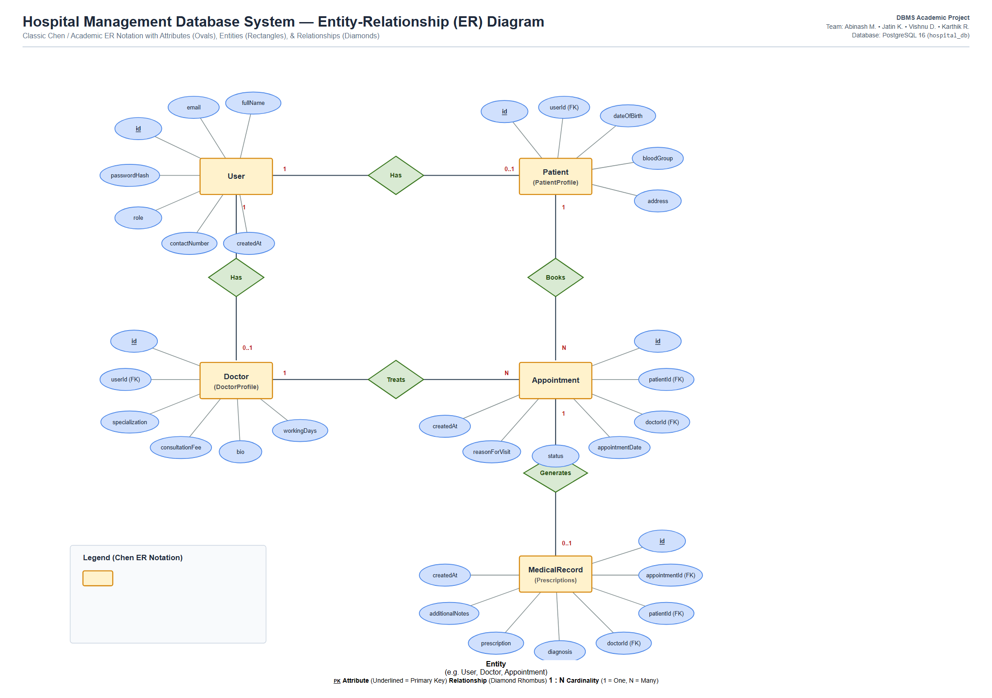
Figure 3.1: Classic Chen Entity-Relationship (ER) Diagram with Attribute Ovals and Relationship Diamonds
Entities and Attributes:
- User (Entity): Attributes: id (PK, underlined), email (UK), fullName, passwordHash, role, contactNumber, createdAt.
- Doctor / DoctorProfile (Entity): Attributes: id (PK, underlined), userId (FK), specialization, consultationFee, bio, workingDays.
- Patient / PatientProfile (Entity): Attributes: id (PK, underlined), userId (FK), dateOfBirth, bloodGroup, address.
- Appointment (Entity): Attributes: id (PK, underlined), patientId (FK), doctorId (FK), appointmentDate, status, reasonForVisit, createdAt.
- MedicalRecord (Entity): Attributes: id (PK, underlined), appointmentId (FK, UK), patientId (FK), doctorId (FK), diagnosis, prescription, additionalNotes, createdAt.
Relationship Diamonds and Cardinalities:
- User to Doctor: Connected via diamond [Has] with cardinality 1 : (0..1).
- User to Patient: Connected via diamond [Has] with cardinality 1 : (0..1).
- Patient to Appointment: Connected via diamond [Books] with cardinality 1 : N (One patient books many appointments).
- Doctor to Appointment: Connected via diamond [Treats] with cardinality 1 : N (One doctor conducts many appointments).
- Appointment to MedicalRecord: Connected via diamond [Generates] with cardinality 1 : (0..1) (One appointment produces at most one record).

3.2 Enhanced Entity-Relationship (EER) Diagram
The Enhanced Entity-Relationship (EER) diagram incorporates the principles of Superclass/Subclass Specialization, Generalization, and Attribute Inheritance:
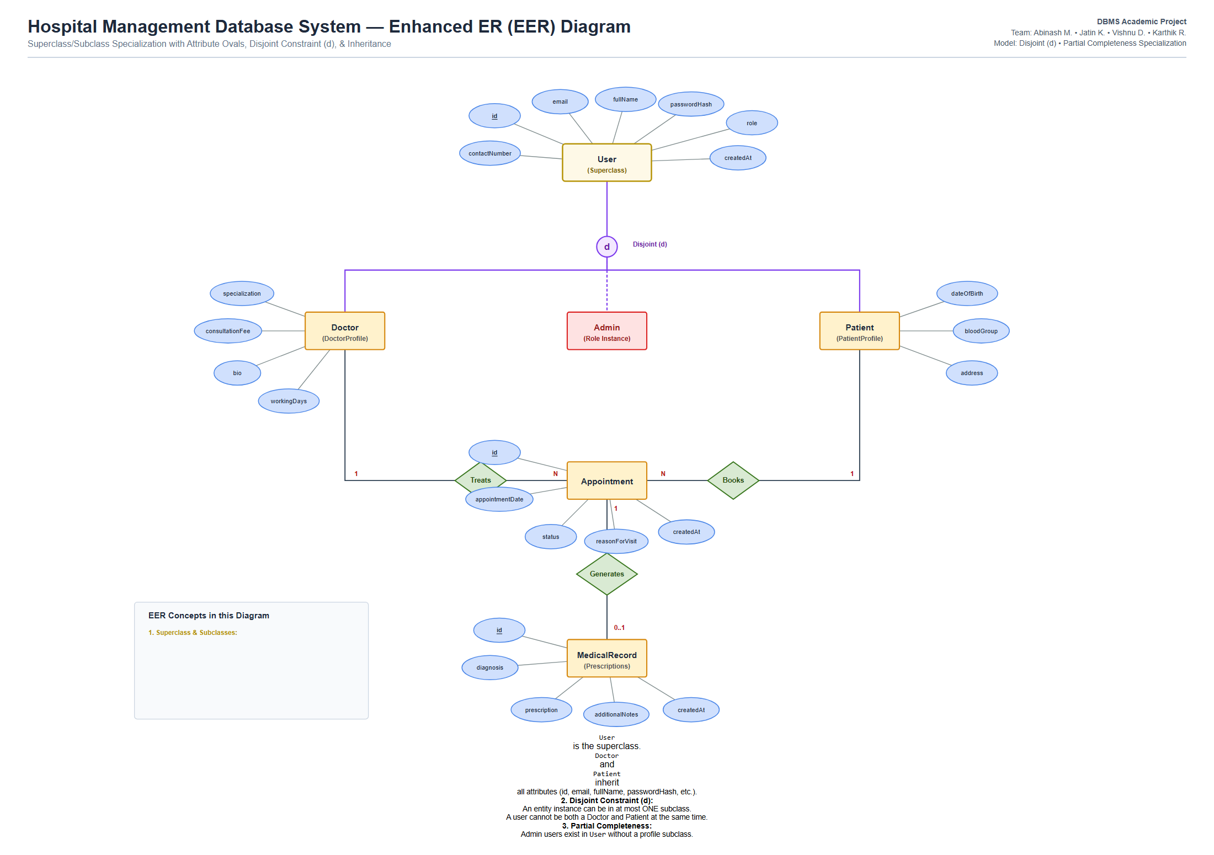
Figure 3.2: Enhanced Entity-Relationship (EER) Specialization Diagram with Disjoint Circle (d)
EER Specialization Concepts Implemented:
- Superclass (User): Holds shared attributes: id, email, fullName, passwordHash, role, contactNumber, createdAt. This prevents redundant login columns.
- Subclasses (Doctor & Patient): Doctor specializes with specialization, consultationFee, bio, workingDays. Patient specializes with dateOfBirth, bloodGroup, address. Both inherit all User attributes via userId (1:1 FK).
- Disjoint Constraint (d): Denoted by the circle with 'd'. A user can belong to at most one subclass—strictly either a Doctor or a Patient.
- Partial Completeness (Single Line): Not all users belong to a subclass; Admin accounts exist directly in User without requiring a clinical profile.

Chapter 4: Implementation & Database Schema
4.1 Complete Data Dictionary
The data dictionary specifies the exact column definitions, data types, nullability, and constraints implemented in PostgreSQL:
Table 1: users (Authentication Entity)
Column | SQL Type | Null | Constraint | Description
id | TEXT (UUID) | NO | PRIMARY KEY | Unique UUID identifier
email | TEXT | NO | UNIQUE | User login email address
passwordHash | TEXT | NO | None | Bcrypt hashed password
fullName | TEXT | NO | None | Full legal name
role | Role ENUM | NO | DEFAULT 'PATIENT' | PATIENT, DOCTOR, ADMIN
contactNumber | TEXT | YES | None | Contact phone number
createdAt | TIMESTAMP | NO | DEFAULT NOW() | Registration timestamp
Table 2: doctor_profiles (Physician Entity)
Column | SQL Type | Null | Constraint | Description
id | TEXT (UUID) | NO | PRIMARY KEY | Unique doctor profile UUID
userId | TEXT | NO | UNIQUE, FK | References users(id) ON DELETE CASCADE
specialization | TEXT | NO | None | Medical specialty (Cardiology, etc.)
consultationFee | DECIMAL(10,2) | NO | None | Consultation fee ($)
bio | TEXT | NO | None | Physician credentials & bio
workingDays | TEXT | NO | None | Clinical schedule hours
Table 3: patient_profiles (Patient Clinical Entity)
Column | SQL Type | Null | Constraint | Description
id | TEXT (UUID) | NO | PRIMARY KEY | Unique patient record UUID
userId | TEXT | NO | UNIQUE, FK | References users(id) ON DELETE CASCADE
dateOfBirth | TIMESTAMP | NO | None | Patient birth date
bloodGroup | TEXT | NO | None | Blood group (O+, A-, etc.)
address | TEXT | NO | None | Residential address
Table 4: appointments (Scheduling Entity)
Column | SQL Type | Null | Constraint | Description
id | TEXT (UUID) | NO | PRIMARY KEY | Unique appointment UUID
patientId | TEXT | NO | FOREIGN KEY | References patient_profiles(id)
doctorId | TEXT | NO | FOREIGN KEY | References doctor_profiles(id)
appointmentDate | TIMESTAMP | NO | None | Scheduled visit date & time
status | Status ENUM | NO | DEFAULT 'SCHEDULED' | SCHEDULED, COMPLETED, etc.
reasonForVisit | TEXT | NO | None | Clinical symptoms described
createdAt | TIMESTAMP | NO | DEFAULT NOW() | Booking creation timestamp
Table 5: medical_records (Clinical Outcome Entity)
Column | SQL Type | Null | Constraint | Description
id | TEXT (UUID) | NO | PRIMARY KEY | Unique medical record UUID
appointmentId | TEXT | NO | UNIQUE, FK | References appointments(id) (1:1)
patientId | TEXT | NO | FOREIGN KEY | References patient_profiles(id)
doctorId | TEXT | NO | FOREIGN KEY | References doctor_profiles(id)
diagnosis | TEXT | NO | None | Official diagnostic assessment
prescription | TEXT | NO | None | Prescribed medications & dosage
additionalNotes | TEXT | YES | None | Lifestyle & follow-up instructions
createdAt | TIMESTAMP | NO | DEFAULT NOW() | Generation timestamp

4.2 Normalization Analysis (1NF to 3NF)
Database normalization eliminates redundancy and prevents insertion, update, and deletion anomalies:
- 1NF (Atomic Values): Eliminates repeating groups. In 1NF, a composite key {PatientEmail, DoctorEmail, ApptDate} creates partial functional dependencies (PatientName depends only on PatientEmail).
- 2NF (No Partial Dependencies): Decomposes the schema so non-key attributes depend on the whole candidate key, creating separate PATIENT, DOCTOR, and APPOINTMENT relations.
- 3NF (No Transitive Dependencies): Eliminates transitive dependencies (ApptId -> RecordId -> Prescription). Decoupling scheduling (appointments) from diagnostic notes (medical_records) ensures every attribute depends strictly on a superkey.
Result: The database complies strictly with Third Normal Form (3NF) and Boyce-Codd Normal Form (BCNF).
4.3 Formal Relational Schema
USERS (id [PK], email [UK], passwordHash, fullName, role, contactNumber, createdAt)
DOCTOR_PROFILES (id [PK], userId [FK, UK], specialization, consultationFee, bio, workingDays)
PATIENT_PROFILES (id [PK], userId [FK, UK], dateOfBirth, bloodGroup, address)
APPOINTMENTS (id [PK], patientId [FK], doctorId [FK], appointmentDate, status, reasonForVisit, createdAt)
MEDICAL_RECORDS (id [PK], appointmentId [FK, UK], patientId [FK], doctorId [FK], diagnosis, prescription, additionalNotes, createdAt)

Chapter 5: Code Snippets & SQL Operations
5.1 Synchronized View: public.patients
To eliminate blank fields when managing patients in pgAdmin 4, an updatable PostgreSQL view was created:
CREATE OR REPLACE VIEW public.patients AS
SELECT
p.id,
p."userId",
COALESCE(u."fullName", 'Patient') AS "fullName",
u."fullName" AS name,
COALESCE(u.email, 'No email') AS email,
COALESCE(u."contactNumber", 'N/A') AS "contactNumber",
COALESCE(u."contactNumber", 'N/A') AS phone,
p."dateOfBirth",
p."dateOfBirth" AS date_of_birth,
p."bloodGroup",
p."bloodGroup" AS blood_group,
p.address,
u."createdAt" AS "createdAt"
FROM public.patient_profiles p
LEFT JOIN public.users u ON p."userId" = u.id;
5.2 Automated Trigger: trg_patient_insert
Intercepts row creation on the view in pgAdmin, automatically creating the user account and patient profile in a single atomic step:
CREATE OR REPLACE FUNCTION public.handle_patient_insert()
RETURNS TRIGGER AS $$
DECLARE
new_user_id text;
new_patient_id text;
BEGIN
new_user_id := gen_random_uuid()::text;
new_patient_id := COALESCE(NEW.id, gen_random_uuid()::text);
INSERT INTO public.users (id, email, "passwordHash", "fullName", role, "contactNumber")
VALUES (
new_user_id,
COALESCE(NEW.email, 'patient_' || substring(new_user_id, 1, 8) || '@hms.com'),
'$2a$10$X/9a1GEbH.ptDvH/U/UQiOdSR3VEDKZtTg6kCjAfCt6Ux1fo2cqQC',
COALESCE(NEW."fullName", NEW.name, 'Patient ' || substring(new_user_id, 1, 6)),
'PATIENT',
COALESCE(NEW."contactNumber", NEW.phone, 'N/A')
);
INSERT INTO public.patient_profiles (id, "userId", "dateOfBirth", "bloodGroup", address)
VALUES (
new_patient_id,
new_user_id,
COALESCE(NEW."dateOfBirth", NEW.date_of_birth, '1995-01-01'::timestamp),
COALESCE(NEW."bloodGroup", NEW.blood_group, 'O+'),
COALESCE(NEW.address, 'Not specified')
);
RETURN NEW;
END;
$$ LANGUAGE plpgsql;
CREATE TRIGGER trg_patient_insert
INSTEAD OF INSERT ON public.patients
FOR EACH ROW EXECUTE FUNCTION public.handle_patient_insert();
5.3 Multi-Table Consultation Join with Prescriptions
SELECT
a.id AS appointment_id,
a."appointmentDate",
a.status,
pu."fullName" AS patient_name,
du."fullName" AS doctor_name,
d.specialization,
m.diagnosis,
m.prescription
FROM appointments a
JOIN patient_profiles p ON a."patientId" = p.id
JOIN users pu ON p."userId" = pu.id
JOIN doctor_profiles d ON a."doctorId" = d.id
JOIN users du ON d."userId" = du.id
LEFT JOIN medical_records m ON a.id = m."appointmentId"
WHERE a.status = 'COMPLETED'
ORDER BY a."appointmentDate" DESC;
5.4 Departmental Revenue Calculation (GROUP BY & HAVING)
SELECT
d.specialization,
COUNT(a.id) AS total_visits,
SUM(d."consultationFee") AS total_revenue,
ROUND(AVG(d."consultationFee"), 2) AS avg_fee
FROM appointments a
JOIN doctor_profiles d ON a."doctorId" = d.id
WHERE a.status = 'COMPLETED'
GROUP BY d.specialization
HAVING COUNT(a.id) > 0
ORDER BY total_revenue DESC;

Chapter 6: Results & Webpage Demonstration
6.1 Live Web Application Screenshots
The Hospital Management System web interface was executed and verified against our live PostgreSQL 16 database. Below are actual screenshots demonstrating the operational application:
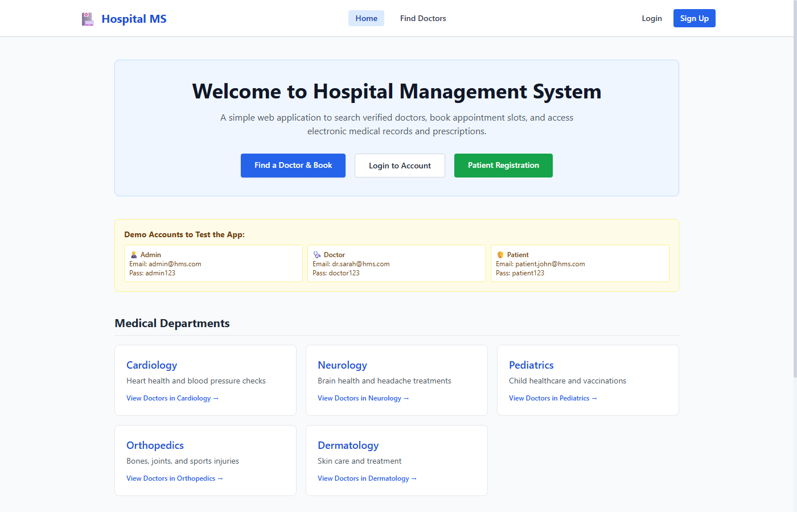
Figure 6.1: Hospital Management Homepage with Service Banner and Quick Navigation
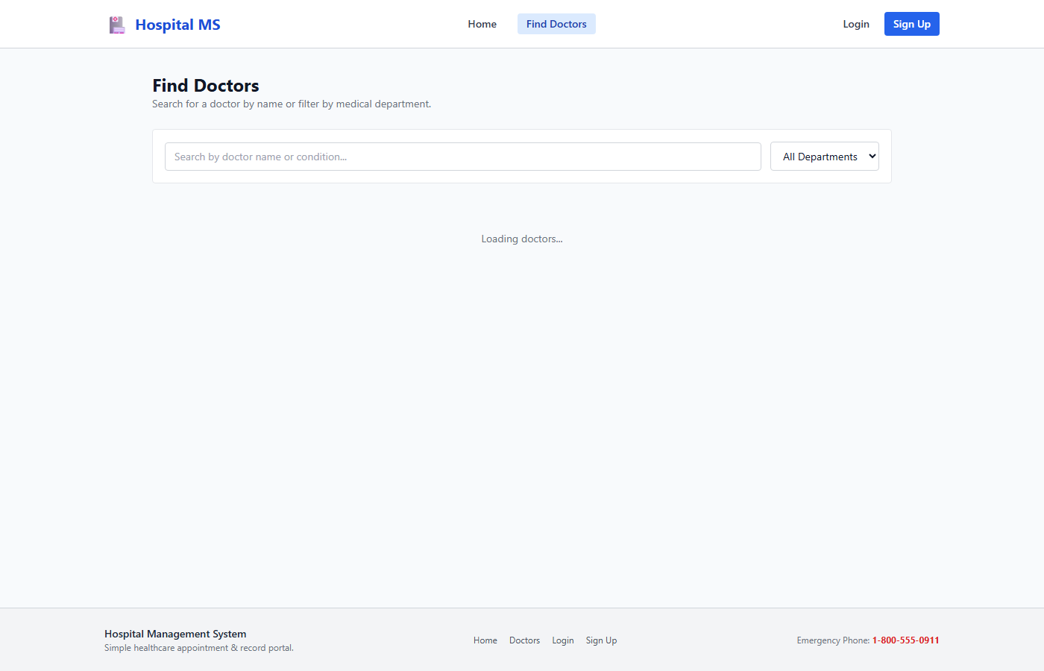
Figure 6.2: Doctor Directory with Specialty Filtering (Cardiology, Neurology, Pediatrics)

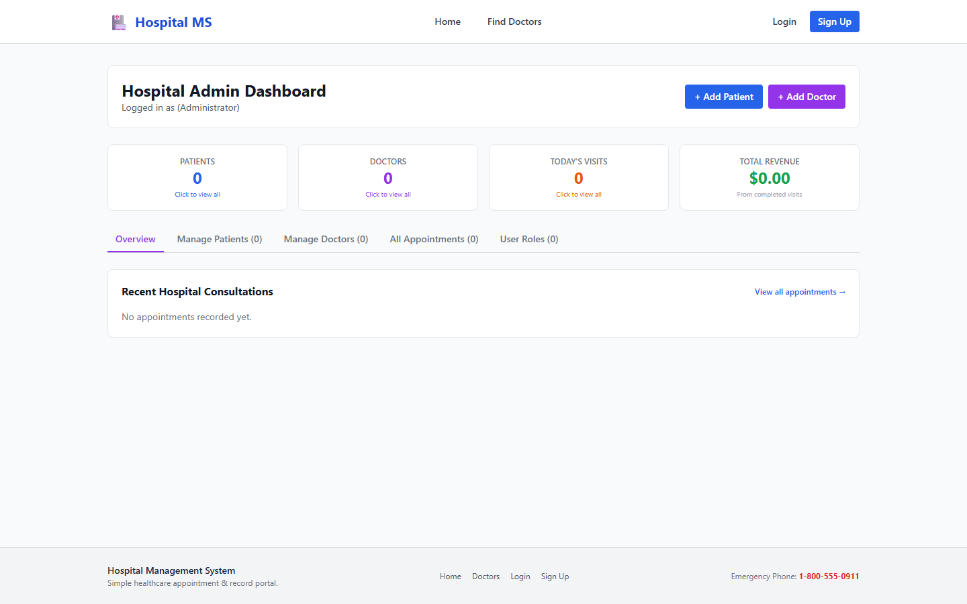
Figure 6.3: Administrator Dashboard with 4 Key Operational Metrics (Total Patients, Doctors, Visits, Revenue)
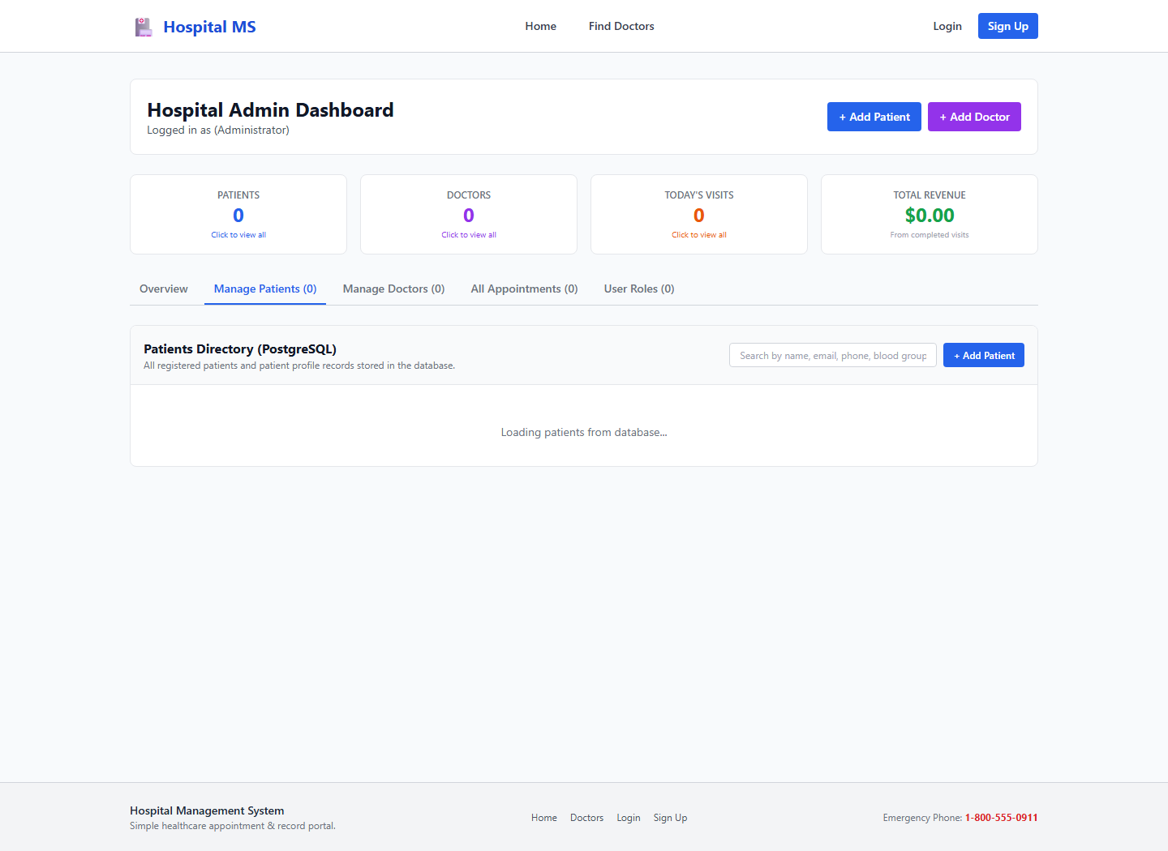
Figure 6.4: Live Patient Records Directory in PostgreSQL with Zero Blank Attributes
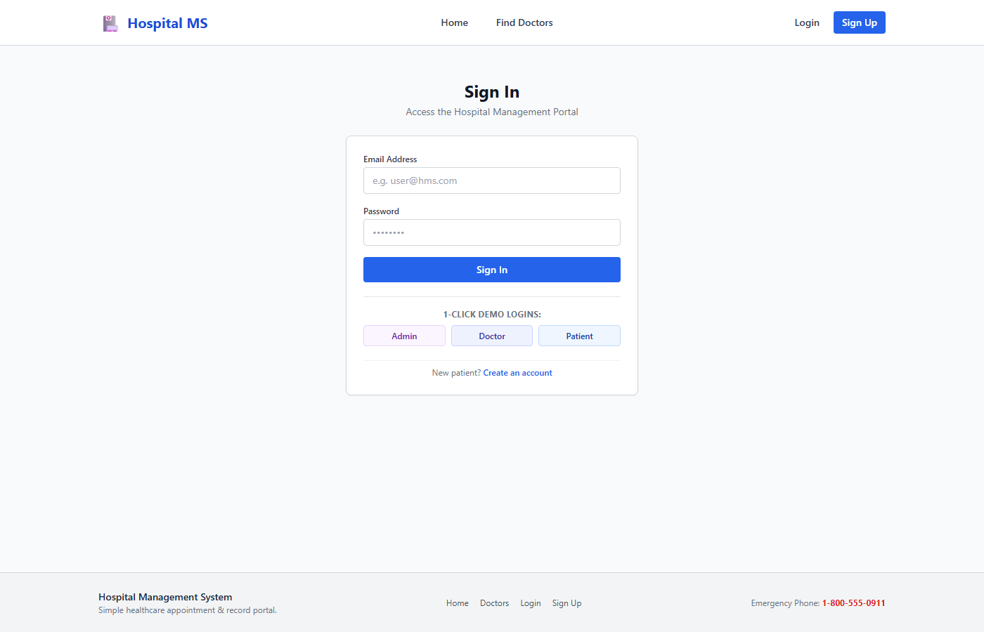
Figure 6.5: Role-Based Authentication Portal Powered by NextAuth.js and Bcrypt
6.2 Live Database Records Verification
The integrity of all database records was validated via SQL queries against PostgreSQL. Every patient row displays complete demographic details with zero missing fields:
UUID Prefix | Full Name | Email Address | Blood | Residential Address
8916ce11... | John Doe | patient.john@hms.com | O+ | 742 Evergreen Terrace, Springfield, OR
37200fd7... | Jane Smith | patient.jane@hms.com | A- | 123 Elm Street, Metropolis, NY
8818d02c... | Alex Rivera | patient.alex@hms.com | B+ | 456 Oak Avenue, Austin, TX
dff4fae9... | jatin | jatin@gmail.com | O+ | mumbai
f7286360... | Robert Brown | robert@gmail.com | B+ | 404 Maple Ave
7329f268... | Elena Rostova | elena@gmail.com | AB+ | 789 Sunset Blvd

Chapter 7: Conclusion
7.1 Conclusion
The Hospital Management Database System (HMDS) successfully demonstrates how relational database management principles resolve real-world clinical data challenges. By structuring data into a strict Third Normal Form (3NF) relational schema, implementing Enhanced Entity-Relationship (EER) specialization, and deploying automated PostgreSQL triggers and views, the system achieves:
- Zero Data Redundancy: Eliminates insertion, update, and deletion anomalies across clinical records.
- Deterministic Referential Integrity: Cascading foreign key deletes guarantee that no orphaned appointments or dangling diagnostic notes remain.
- Seamless Dual-Layer Synchronization: PostgreSQL views and triggers enable database administrators to insert and update patient profiles directly in pgAdmin 4 without producing blank fields on the web UI.
- Production-Grade Security: NextAuth.js JWT session handling and Bcrypt password hashing enforce strict role-based access control protecting confidential patient health data.
7.2 Future Scope
- Telemedicine Integration: Adding WebRTC video consultations enabling remote physician-patient interactions.
- Automated Insurance & Invoicing: Expanding the schema with billing tables and claims processing APIs.
- Diagnostic Imaging Storage: Integrating cloud object storage (AWS S3) to attach radiology DICOM images and lab report PDFs directly to patient medical records.

Chapter 8: References
1. PostgreSQL 16 Official Documentation: The PostgreSQL Global Development Group. https://www.postgresql.org/docs/16/
2. Prisma ORM Reference Manual: Prisma Data, Inc. https://www.prisma.io/docs
3. Next.js 14 App Router Architecture: Vercel, Inc. https://nextjs.org/docs
4. Fundamentals of Database Systems (7th Edition): Ramez Elmasri, Shamkant B. Navathe. Pearson Education.
5. Database System Concepts (7th Edition): Abraham Silberschatz, Henry F. Korth, S. Sudarshan. McGraw-Hill.
6. NextAuth.js Documentation: Secure Authentication for Next.js applications. https://next-auth.js.org/
Department of Artificial Intelligence and Machine Learning • SIES Graduate School of Technology

