Data Engineering ETL pipeline using Airflow and postgresql
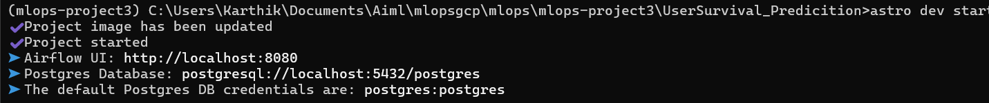

Steps1:
Astro dev init
Astro dev start
Endpoint connection
Admin -connection
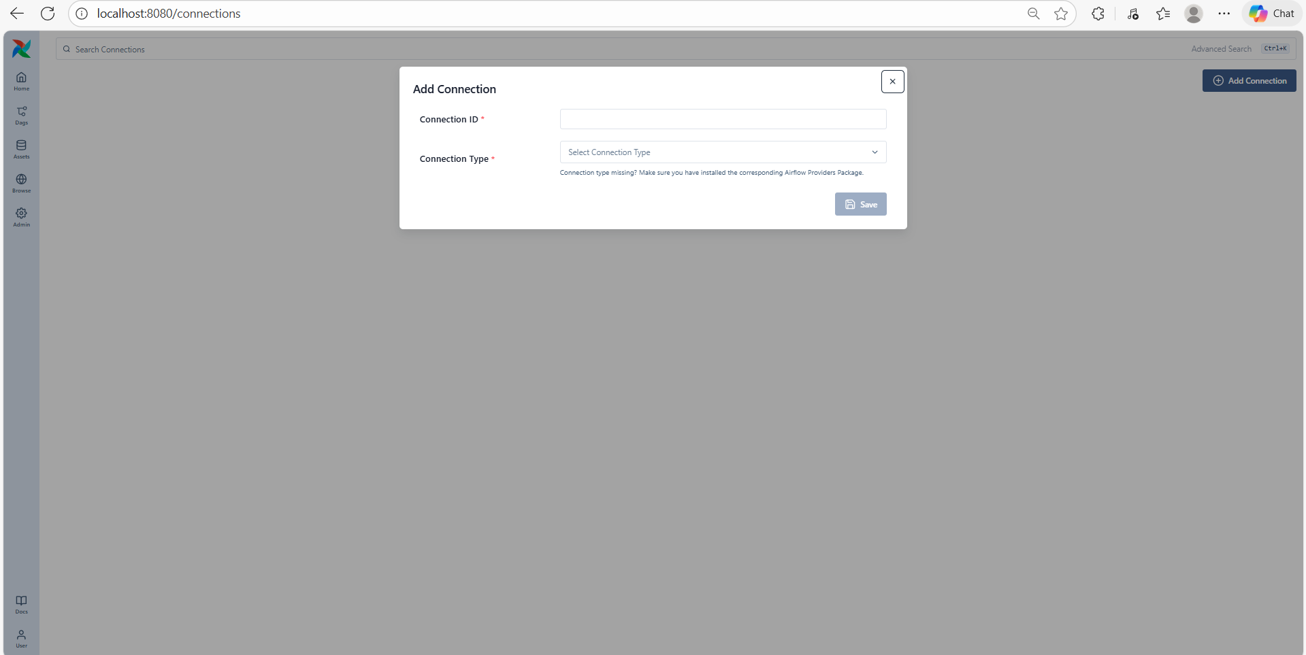
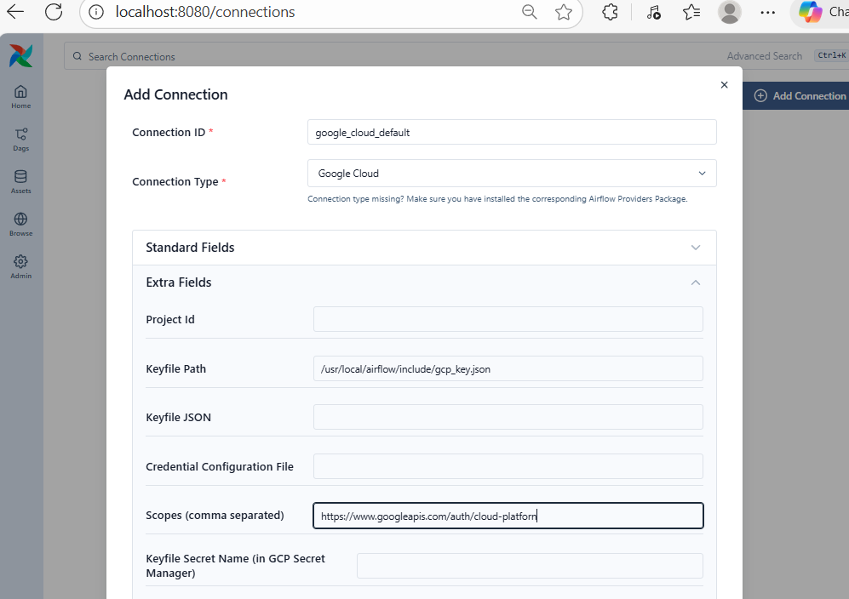
https://www.googleapis.com/auth/cloud-platform
save

step2. Create another connection endpoint for postgres
pip install apache-airflow-providers-postgres
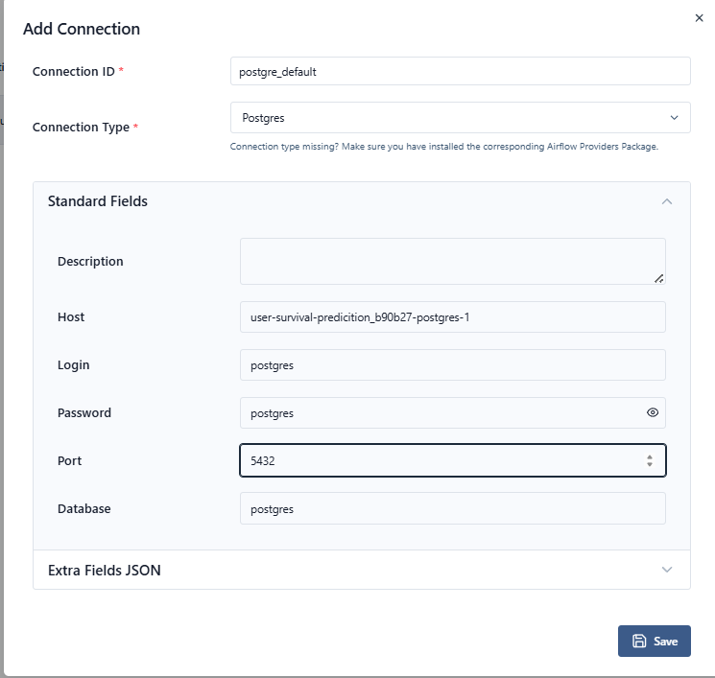
Save

Updated Dag and trigger
Green- succcess
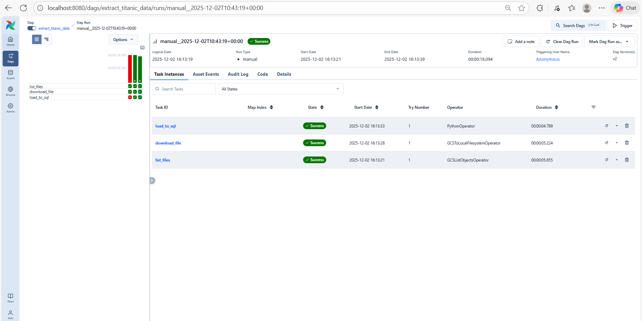
Successfully loaded data into sql database

================================================================================
Docker ->container-postgre container
Directly cant be view database as it is running on container -> to see a databse require external tool
Search for dbeaver download -google
Download | DBeaver Community

Open Dbeaver ->
Database -new connection
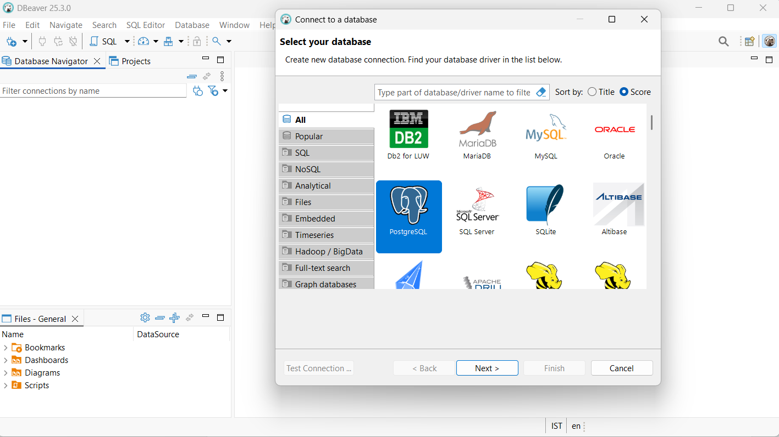
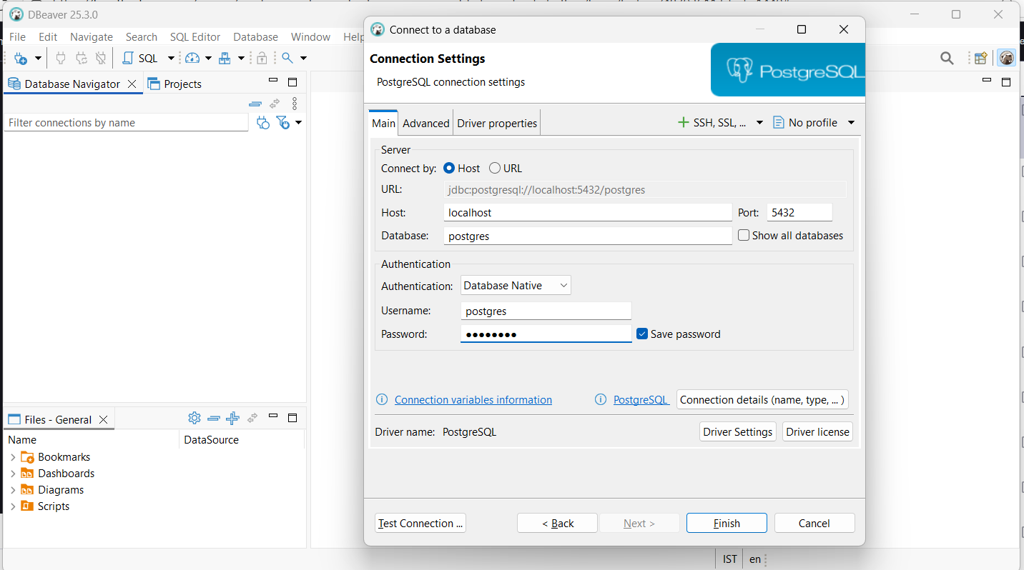
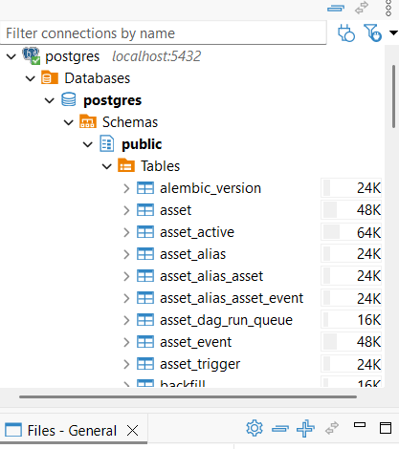
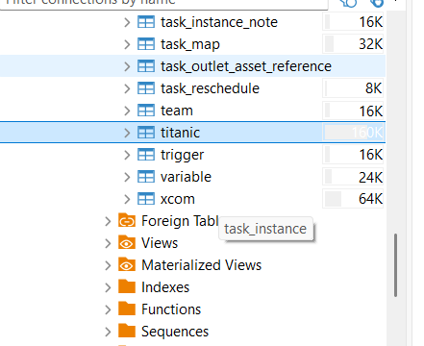
Titanic data successfully loaded into the database
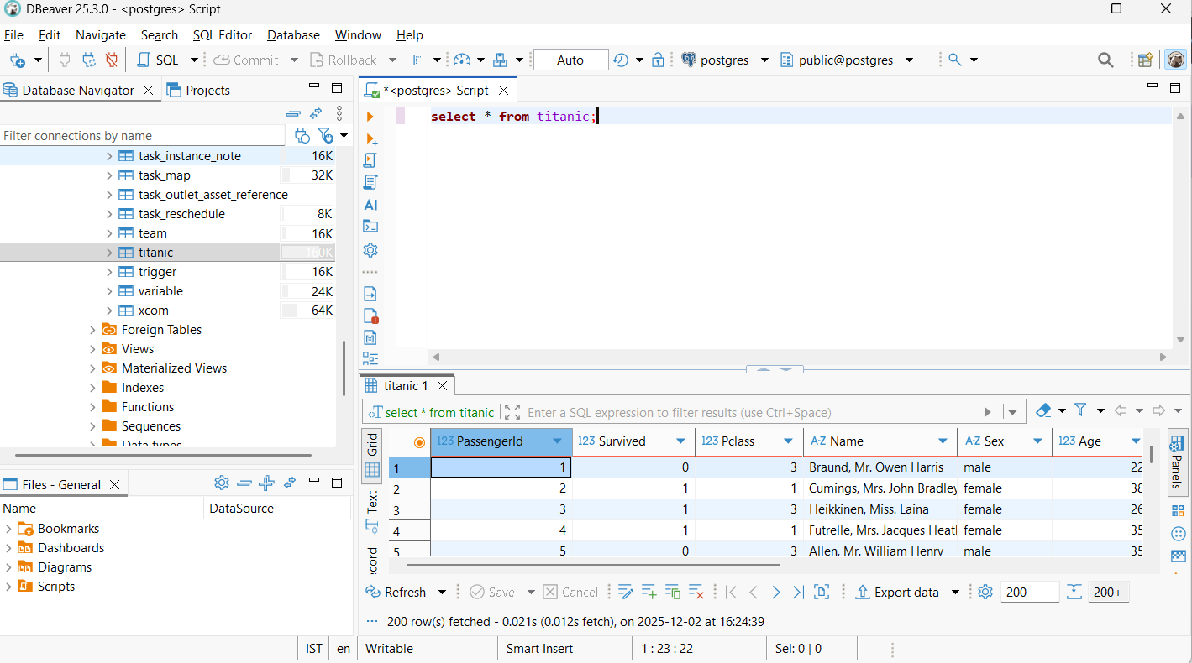
Successfully implemented Etl pipeline

Grafana
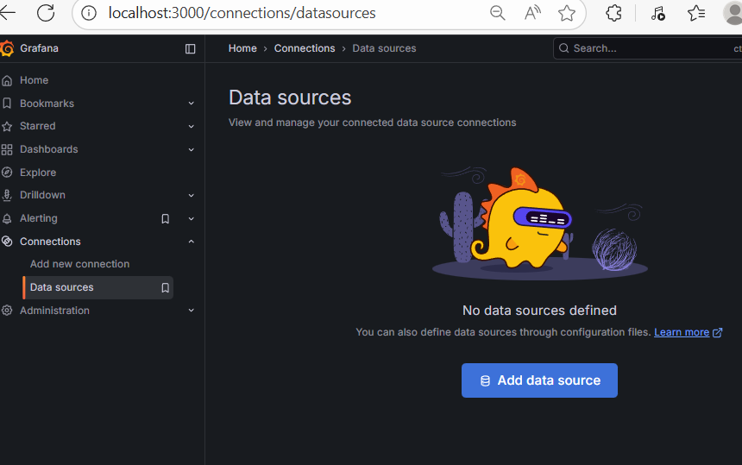
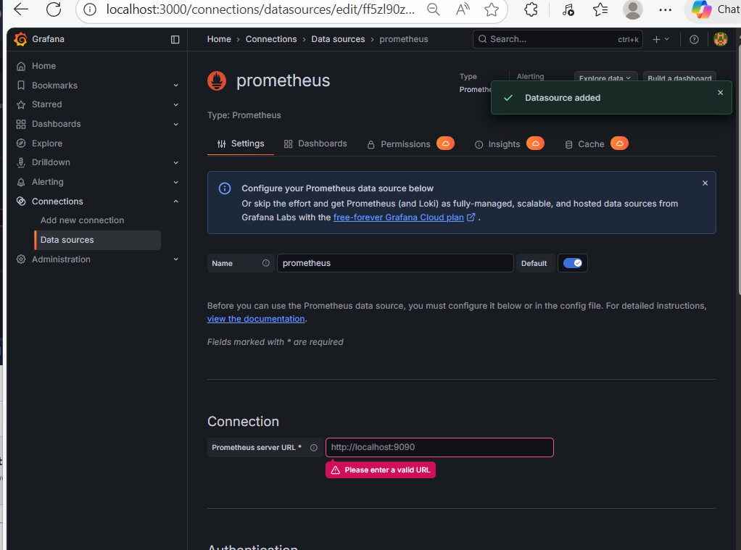
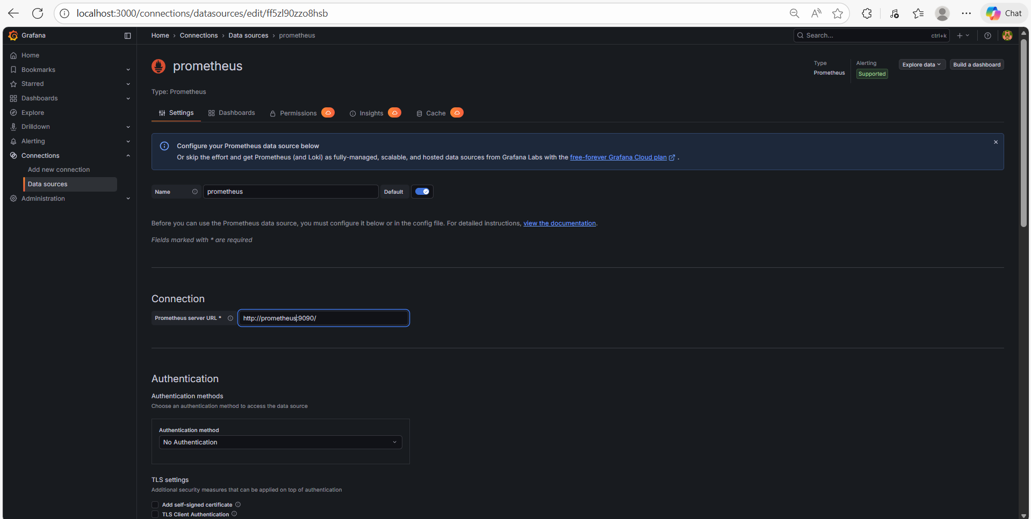
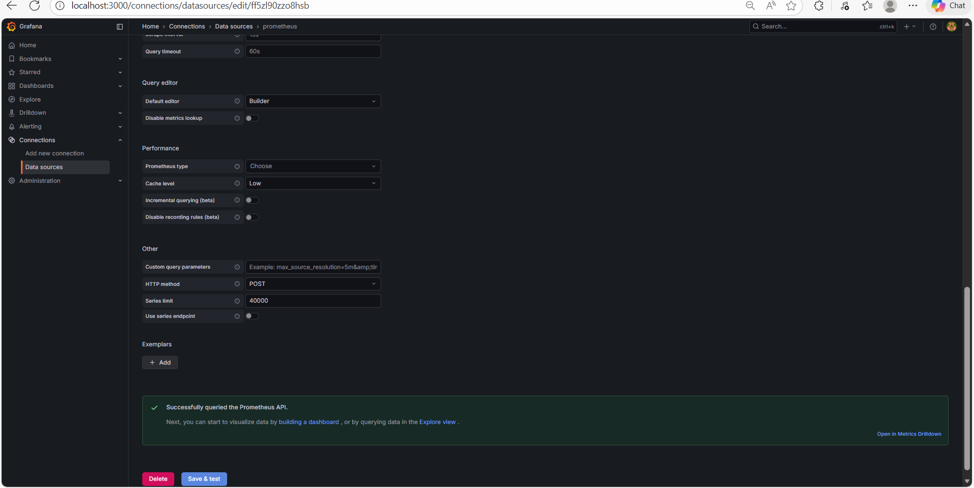
Dashboards

Dashboards-create dashboards

Select builder
