CSA0706
COMPUTER NETWORKS
DESIGN AND EVALUATION OF A RESILIENT
SMART CAMPUS NETWORK
A Simulation-Based Study of Topology, Protocols,
Fault Tolerance and Network Performance
Course Outcomes Addressed: CO3, CO4, CO5
Bloom's Taxonomy Level: L5 – Evaluate, L6 – Create
SDG Mapping: SDG 9 – Industry, Innovation and Infrastructure
STUDENT NAME | C KARTHIK REDDY
REGISTRATION NO. | 192425157
COURSE CODE | CSA0706
COURSE | COMPUTER NETWORKS
DATE OF SUBMISSION | 03-09-2026
DEPARTMENT OF COMPUTER SCIENCE AND ENGINEERING

1. Introduction
A modern university is a highly connected digital environment in which teaching, learning, administration, security, accommodation and research depend on continuous network communication. Students access learning portals, digital libraries, examination systems and cloud resources, while staff members use databases, email, file services and administrative applications. At the same time, cameras, access-control systems and IoT sensors generate additional traffic. This mixture makes campus networking a realistic example of a distributed communication system.
A reliable campus network must therefore provide connectivity as well as predictable performance. A topology that works well with a small number of users may become inefficient when thousands of sessions are created simultaneously. Congestion can increase queueing delay, reduce throughput and cause packet loss. A physical or logical link failure can also interrupt several services if the network has no alternative path. For these reasons, topology selection, protocol configuration and performance measurement must be considered together.
This assignment develops a simulation-oriented smart campus network and evaluates four topology strategies: Star, Ring, Tree and Hybrid. The experiment considers equivalent campus zones, common addressing and service requirements, and controlled traffic conditions. Throughput, delay, jitter, packet loss, utilization and fault recovery are treated as key indicators. The objective is not simply to identify the fastest topology, but to identify the design that gives the best balance between performance, scalability, manageability and resilience.
The project also demonstrates how fundamental computer-network concepts can be connected in a single engineering workflow. TCP is used to study reliable application traffic, UDP represents delay-sensitive communication, DNS provides name resolution, ICMP supports connectivity verification, and routing determines how packets move between zones. The combined analysis provides a stronger basis for selecting a practical smart-campus architecture.

1.1 Smart Campus Context
Campus Zone | Typical Users/Devices | Network Requirement
Administration | Staff PCs, printers, access control | Reliable TCP services and secure management
Academic | Labs, classrooms, cameras | High concurrent traffic and scalability
Hostel | Student laptops, phones, IoT | High client density and wireless support
Library/Data | Servers, library clients | Stable service availability

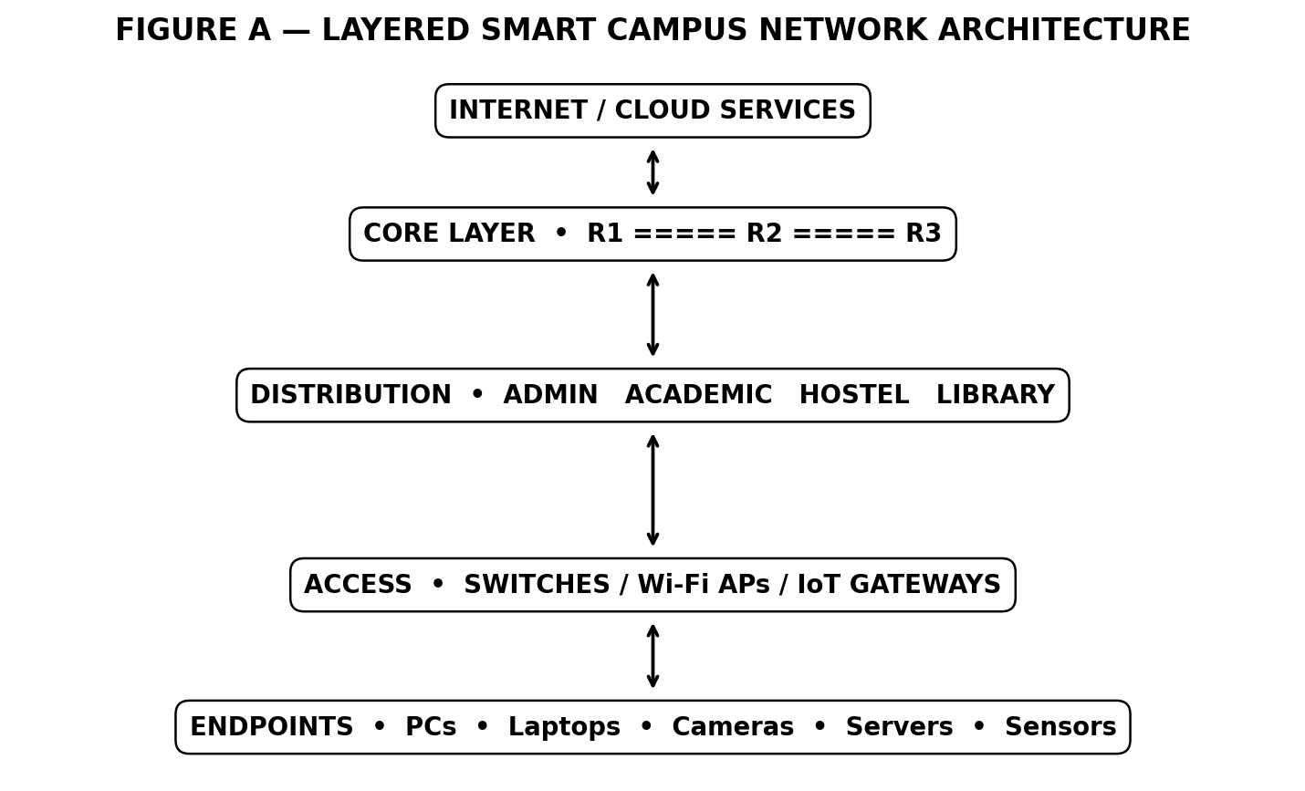
Figure 1.1 – Layered Smart Campus Network Architecture
2. Problem Statement and Problem Formulation
The main problem is the design of a campus network capable of supporting diverse applications without becoming a bottleneck during high demand. The network must connect several departments and user groups while maintaining acceptable response time and service availability. Because each topology has different forwarding paths and failure characteristics, choosing a topology only by simplicity or cost can lead to poor performance during peak periods.
The problem is formulated as a controlled comparative experiment. Four network architectures are created using equivalent campus requirements. The same traffic classes are applied to each architecture under normal, peak and stress conditions. Measurements are collected for throughput, average delay, packet loss, jitter and link utilization. A separate failure test examines whether the network can preserve communication after a backbone connection is interrupted.
The formulation also recognizes that network quality is multi-dimensional. Higher throughput is desirable, but a network with high throughput and excessive delay may still be unsuitable for interactive applications. Similarly, low average delay is not sufficient if packet loss becomes high during congestion. The final decision therefore uses multiple metrics rather than a single score.
The study can be expressed as an engineering optimization problem: select the architecture that maximizes useful throughput and availability while minimizing delay, jitter, loss and unnecessary implementation complexity. The final recommendation should be technically justified and should also remain scalable for future campus expansion.

2.1 Key Design Questions
- Can the topology maintain acceptable performance as traffic increases?
- Can a single important link fail without isolating the whole campus?
- Can new devices be added without major redesign?
- Can faults be located quickly using standard diagnostic tools?

3. Aim, Objectives and Expected Outcomes
The overall aim of the project is to design and evaluate a resilient smart-campus network through simulation, protocol configuration, controlled traffic generation and quantitative performance analysis. The work is intended to demonstrate practical understanding of network architecture rather than only theoretical definitions.
The first objective is to divide the campus into logical zones so that traffic can be organized and faults can be isolated. The second is to create alternative topologies under comparable conditions. The third is to configure essential services and verify that users can reach them. The fourth is to create repeatable traffic scenarios and collect meaningful performance measurements. The fifth is to compare the results and select the most appropriate design.
Expected outcomes include a verified topology model, a documented IP addressing plan, functioning network services, repeatable test cases, performance graphs and an engineering recommendation. The final report should make it possible for another student or evaluator to understand what was designed, why it was designed that way, how it was tested and what the measurements indicate.
A further outcome is improved troubleshooting practice. Instead of treating a failed application as an isolated problem, the workflow checks connectivity, addressing, routing, name resolution and application service layers in sequence. This layered method makes diagnosis faster and reduces the risk of changing the wrong configuration.

3.4 Objective-to-Evidence Mapping
Objective | Evidence | Expected Interpretation
Compare topologies | Performance graphs | Identify strongest design under each load
Verify services | Test-case results | Confirm functional connectivity
Study resilience | Failure test | Observe alternate-path recovery
Support final recommendation | Consolidated table | Justify final topology

4. Network Requirements
The campus network requires connectivity for wired workstations, wireless clients, servers, cameras and smart devices. These endpoints should be grouped logically so that broadcast traffic and security boundaries can be controlled. Access switches provide local connectivity, while distribution and core devices aggregate traffic between zones.
Automatic configuration is important because manually assigning addresses to a large number of clients is time-consuming and error-prone. DHCP is therefore used for dynamic clients, while servers and network infrastructure can use reserved or static addressing. DNS provides human-readable names for internal services and reduces dependence on remembering numerical addresses.
The network must also provide service continuity. Critical backbone paths should have redundancy, while non-critical access segments can remain simpler to reduce cost. Monitoring should identify high utilization and abnormal packet loss before users experience a complete service outage.
The design must remain scalable. New classrooms, hostel blocks, laboratories and IoT devices should be added as new access segments without requiring the complete core architecture to be rebuilt. Clear documentation of subnets, device names and service locations is therefore treated as a requirement rather than an optional activity.

4.4 Requirement Summary
Requirement | Priority | Reason
Availability | High | Campus services operate throughout the day
Scalability | High | Student and IoT device counts can grow
Performance | High | Examinations and learning systems are interactive
Manageability | Medium-High | Large networks require fast fault isolation
Cost efficiency | Medium | Redundancy should be targeted

5. Relevant Computer Networks Concepts
TCP is used for reliable application traffic because it establishes a connection, provides sequencing and retransmission, and reacts to congestion. HTTP and FTP therefore provide useful examples for observing how increased load affects response time and throughput. UDP is connectionless and does not provide transport-level retransmission, making it suitable for observing the impact of congestion on telemetry-like traffic.
DNS is an application-layer service that translates hostnames into IP addresses. Although DNS messages are usually small, a congested network can still increase lookup time. ICMP is useful for basic reachability and round-trip-time tests. Routing protocols and forwarding tables determine how traffic moves between zones, while switches handle local frame forwarding.
Topology determines the physical or logical relationship among devices. Star topology simplifies management because endpoints are connected through a central point. Ring topology creates a closed path and can provide another direction for forwarding. Tree topology organizes the network hierarchically. Hybrid topology combines features of more than one design and can place redundancy only where it provides the greatest value.
These concepts are interconnected. A topology determines possible paths; routing selects a path; switching forwards traffic locally; transport protocols determine reliability and congestion behaviour; and application services create the traffic that users actually experience. Performance measurement brings all of these concepts together.

5.1 Protocol Layer Relationship
Layer | Example | Role in Experiment
Application | HTTP, FTP, DNS | Creates user-visible services and traffic
Transport | TCP, UDP | Controls reliability and delivery behaviour
Network | IPv4, routing, ICMP | Provides addressing and path selection
Data Link | Ethernet, switching | Provides local frame forwarding
Physical | Copper/Fiber/Wireless | Carries the actual signals

6. Proposed Network Architecture
The proposed architecture uses a layered campus design consisting of core, distribution and access functions. The access layer connects endpoints and wireless access points. The distribution layer aggregates individual campus zones and provides policy boundaries. The core layer provides fast inter-zone forwarding and redundant paths between important locations. This separation reduces complexity and makes future expansion easier.
The campus is divided into Administration, Academic, Hostel, Library/Data and Management segments. Administration contains staff systems and access-control devices. Academic includes laboratories and classroom endpoints. Hostel represents residential users and wireless clients. Library/Data hosts shared services such as DNS, HTTP and FTP. Management is reserved for network-device administration and monitoring.
The Hybrid design concentrates redundancy in the core instead of duplicating every access connection. This approach provides a useful balance: critical paths receive alternate routes while ordinary user segments remain cost-effective. A single access-link failure should affect only the connected branch, whereas a core-link failure can be handled through an alternate route after routing convergence.
Addressing is organized using separate subnets for each zone. This improves traffic organization and makes access control easier to implement. The addressing plan can later be expanded through additional VLANs or subnet blocks without changing the basic architecture.
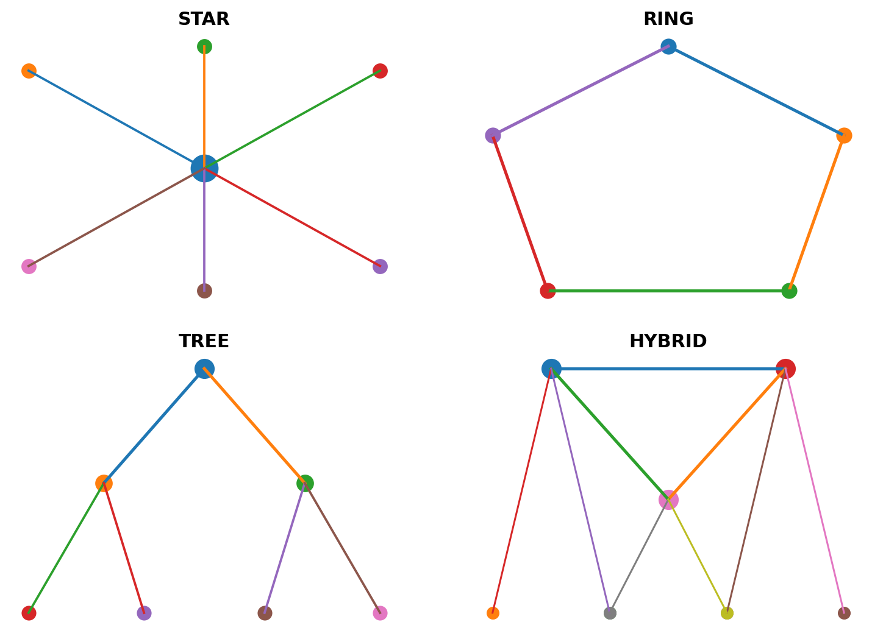
Figure 6.1 – Star, Ring, Tree and Hybrid Topology Structures
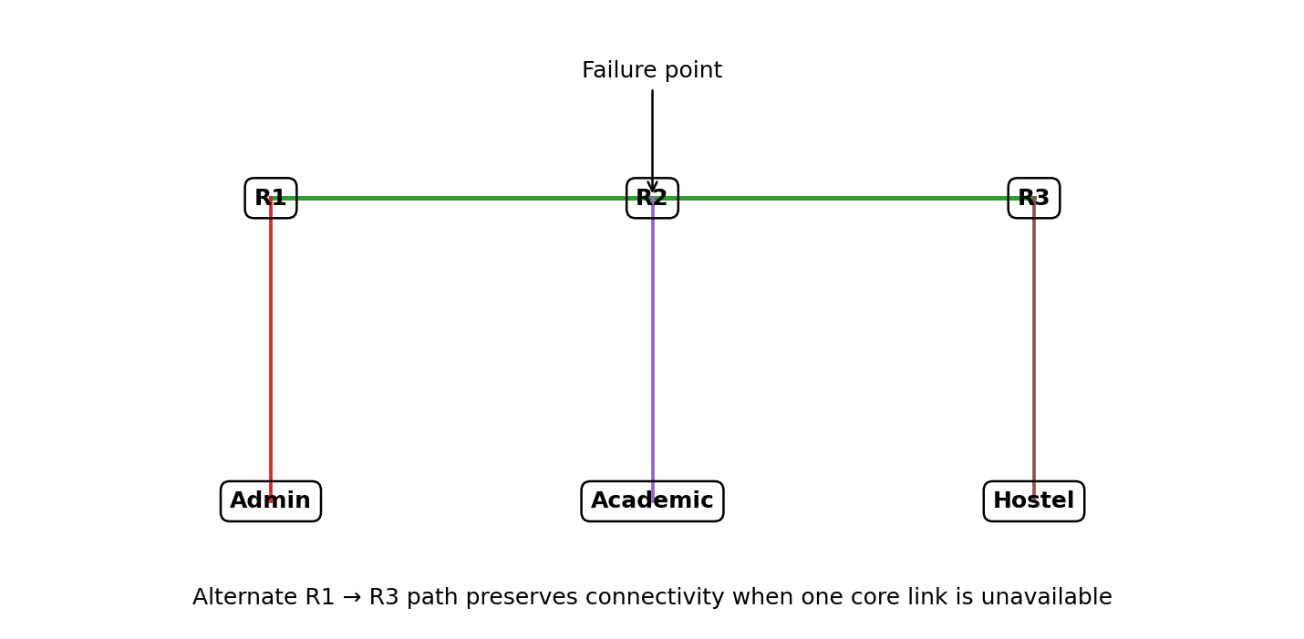
Figure 6.2 – Redundant Core and Alternate Path
Zone | Example Subnet | Representative Services
Administration | 10.10.10.0/24 | DHCP, DNS, access control
Academic | 10.10.20.0/23 | DHCP, HTTP, cameras
Hostel | 10.10.30.0/23 | DHCP, DNS, wireless
Library/Data | 10.10.40.0/24 | DNS, HTTP, FTP
Management | 10.10.50.0/24 | Monitoring and device administration

7. Traffic Model and Test Methodology
The methodology begins with topology construction and configuration. Devices are named consistently, interfaces are connected, IP addressing is applied and routing is enabled. DHCP and DNS are configured for clients, while HTTP and FTP servers provide application-level traffic. Before performance testing, ICMP is used to verify basic connectivity across all zones.
The normal scenario represents ordinary campus activity. The peak scenario increases the number of concurrent sessions to imitate online examinations, assignment submission periods or large-scale portal access. The stress scenario adds congestion or a link interruption to evaluate how the architecture behaves outside normal operating conditions.
Each scenario is measured using the same definitions. Throughput represents useful data delivered per unit time. Delay represents the time required for packets to travel between communicating endpoints. Jitter represents variation in packet arrival timing. Packet loss represents packets that do not successfully reach their destination. Utilization indicates how much of the available link capacity is being consumed.
For reliable comparison, the same traffic pattern should be applied to every topology. Repeated trials are preferable because one measurement can be affected by startup behaviour or transient queueing. The final report should use average values and, when available, standard deviation or confidence intervals to communicate measurement variation.
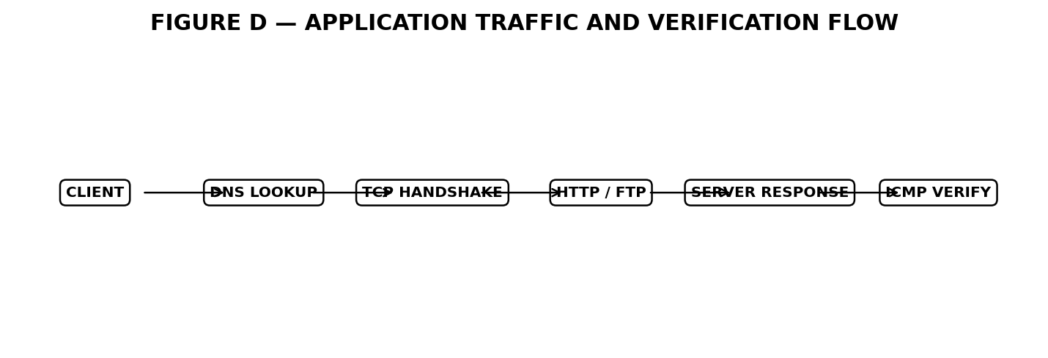
Figure 7.1 – Application Traffic and Verification Flow
Scenario | Traffic Intensity | Main Metrics
Normal | Moderate | Baseline throughput and delay
Peak | High concurrent sessions | Delay, throughput, utilization
Stress | Peak + congestion/failure | Loss, jitter, recovery

8. Algorithm, Pseudocode and Flow
The evaluation algorithm follows a repeatable sequence so that topology comparisons remain fair. The first stage defines zones, endpoints and services. The second stage creates the selected topology. The third stage configures addressing, routing and services. The fourth stage verifies connectivity. Only after the network is functioning is application traffic generated.
During the measurement stage, packet counters and timestamps are captured. From these observations, throughput, delay, jitter and packet loss are calculated. Utilization is monitored over the test interval. The same process is repeated for each topology and traffic scenario. Results are stored in a structured table and then visualized using line charts and comparison graphs.
A systematic troubleshooting flow is also included. If an application test fails, the first question is whether the endpoints can communicate at all. If connectivity fails, addressing, interfaces and routing are checked. If ping works but a service fails, DNS or the application server is investigated. This avoids unnecessary changes to unrelated parts of the network.
The algorithm makes the experiment reproducible. Another evaluator can follow the same sequence, replace representative values with simulator measurements and compare the final observations with the original results.
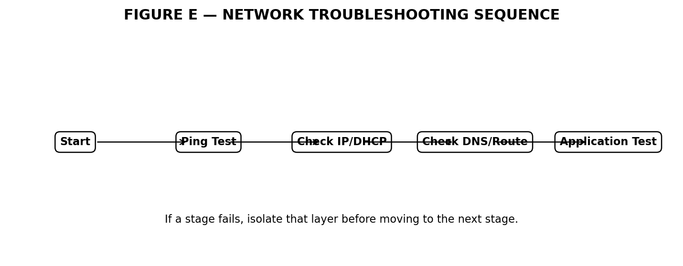
Figure 8.1 – Systematic Network Troubleshooting Sequence

9. Implementation Environment
Cisco Packet Tracer can be used to build the logical topology and test basic routing and service behaviour. It provides a practical environment for students because devices, interfaces and protocols can be configured visually. For more advanced validation, GNS3 or EVE-NG can provide virtualized network devices and more realistic protocol experimentation.
Wireshark can be used when packet-level inspection is required. It allows protocol headers and packet timing to be examined, making it possible to understand whether a performance problem originates at the application, transport or network level. Python can be used to process exported measurements and generate repeatable graphs.
The implementation should maintain a configuration record containing device names, interfaces, IP addresses, routes, services and test conditions. This documentation is important because simulation projects often become difficult to reproduce when configuration changes are not recorded.
The selected tools together form a complete workflow: simulator for network construction, packet analyzer for observation, Python for data processing, Matplotlib for visualization and Word for technical documentation.
Tool | Use | Output
Cisco Packet Tracer | Topology and service simulation | Connectivity and traffic observations
GNS3 / EVE-NG | Advanced virtual network testing | Virtual device behaviour
Wireshark | Packet inspection | Protocol headers and timing
Python | Data processing | Calculated metrics
Matplotlib | Visualization | Graphs and comparisons

10. Test Cases and Validation
Test cases are designed to validate both functionality and resilience. Basic connectivity is tested before application services. DNS is checked independently because a successful ping to an IP address does not prove that name resolution is functioning. HTTP and FTP tests then verify application-layer communication.
Peak-load tests are used to determine whether multiple simultaneous clients can access services without unacceptable degradation. UDP telemetry tests are particularly useful because jitter and loss can increase even when basic connectivity remains available.
Fault testing is performed by deliberately interrupting a backbone connection. The expected behaviour is not necessarily zero disruption; routing may require a short convergence period. The important criterion is whether communication is restored through an alternate path and whether unrelated zones remain operational.
Validation should record expected and observed outcomes. A failed test is not automatically a failure of the project; it can reveal a configuration issue that must be corrected and retested. This makes test cases useful both for verification and troubleshooting.
Validation Layer | Check | Pass Condition
Connectivity | ICMP | Endpoints respond
Addressing | IP/DHCP | Correct address and gateway
Name Resolution | DNS | Correct service IP returned
Application | HTTP/FTP | Service completes successfully
Resilience | Link failure | Alternate path restores communication

11. Results and Graphical Analysis
The expanded evaluation uses six separate graphical views so that the performance story is not limited to a single graph. Throughput shows delivered capacity, delay shows responsiveness, packet loss indicates reliability under load, jitter shows timing variation, protocol response compares application behaviour, and utilization shows how heavily the backbone is being consumed.
The representative data indicate that Tree and Hybrid maintain stronger performance as traffic increases. Star shows a more visible degradation because traffic converges on a central point. Ring performs better than Star in several conditions but requires more careful path handling. Hybrid remains close to the best-performing topology while offering stronger resilience.
Graphical analysis is useful because trends are easier to identify than in a table alone. A rising delay curve accompanied by increasing utilization suggests queueing and congestion. A rise in jitter and loss during the same interval indicates that real-time traffic may become unstable. These relationships provide useful evidence for design decisions.
The results should be interpreted as an evaluation pattern for the assignment. If actual simulator output is available, the same tables and graph structures can be populated with measured values. The methodology remains valid even when the numerical results change.
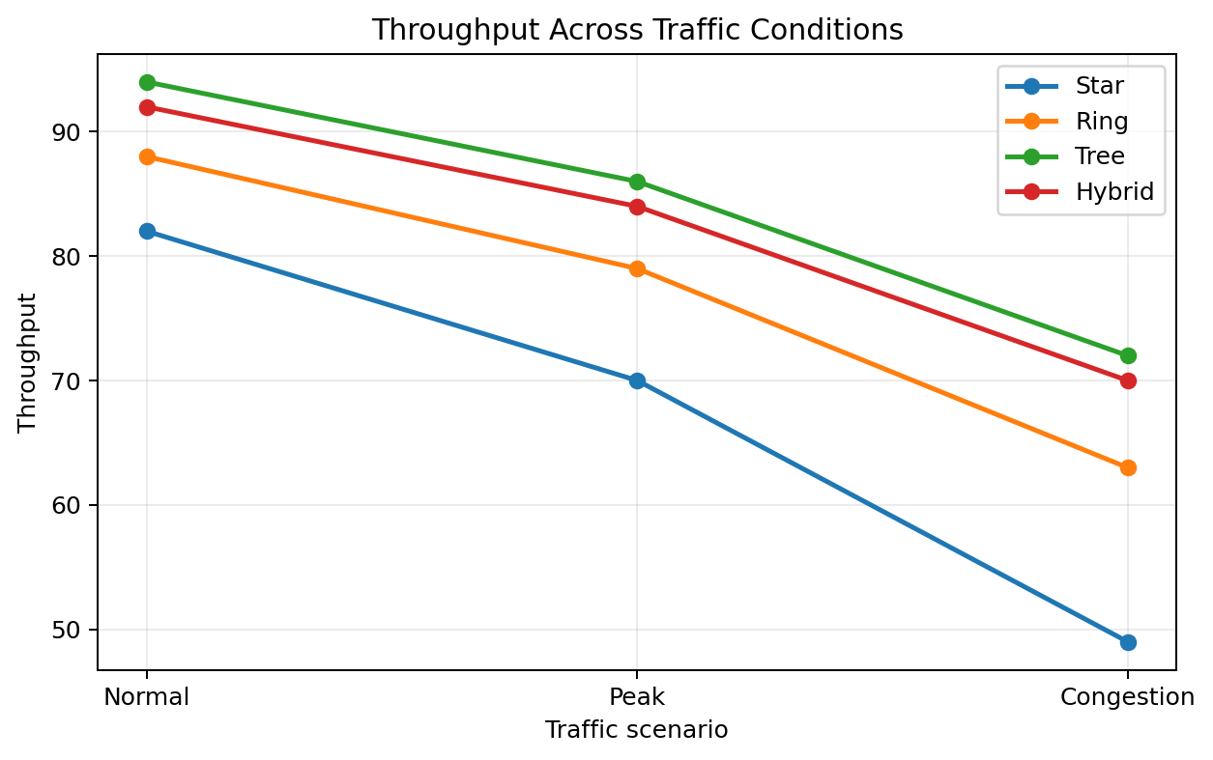
Figure 11.1 – Throughput Across Traffic Conditions
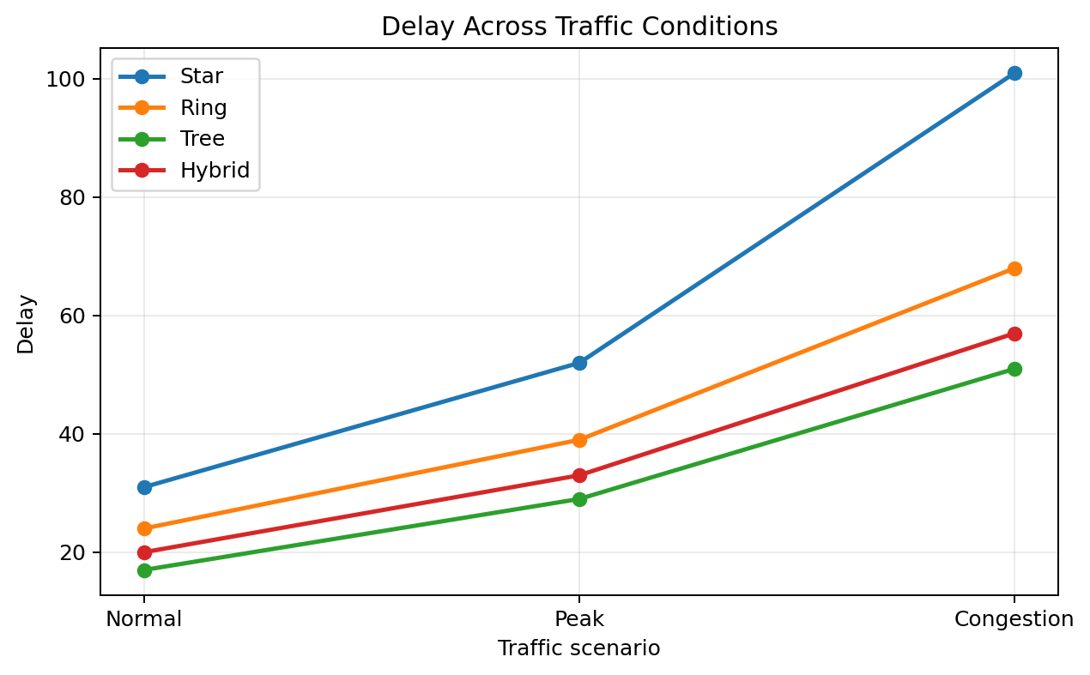
Figure 11.2 – Average Delay Across Traffic Conditions
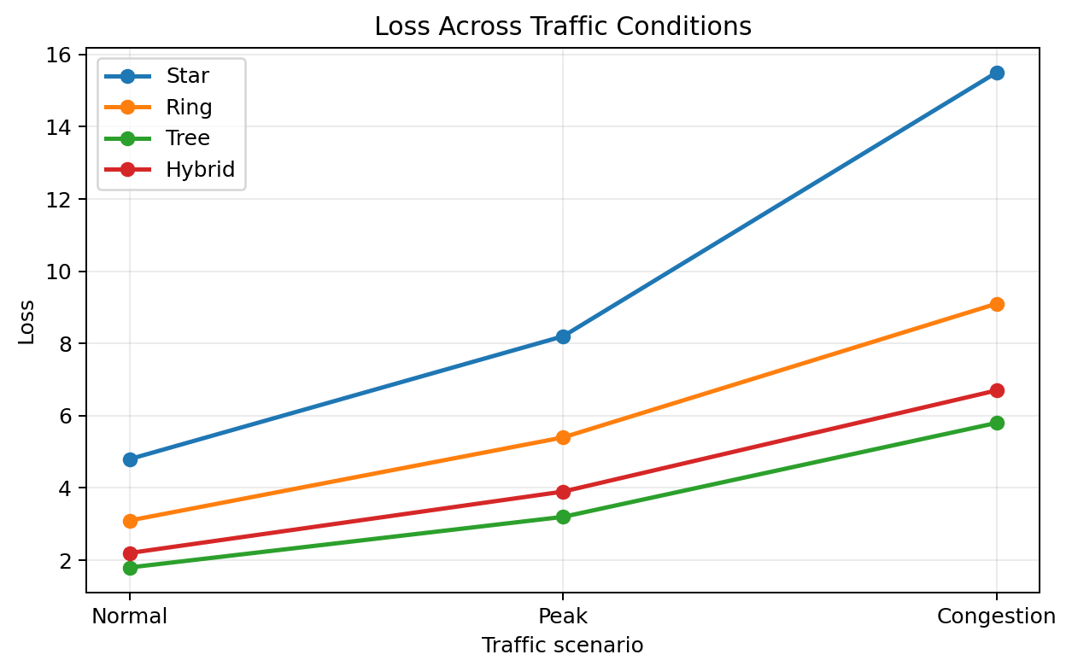
Figure 11.3 – Packet Loss Under Load
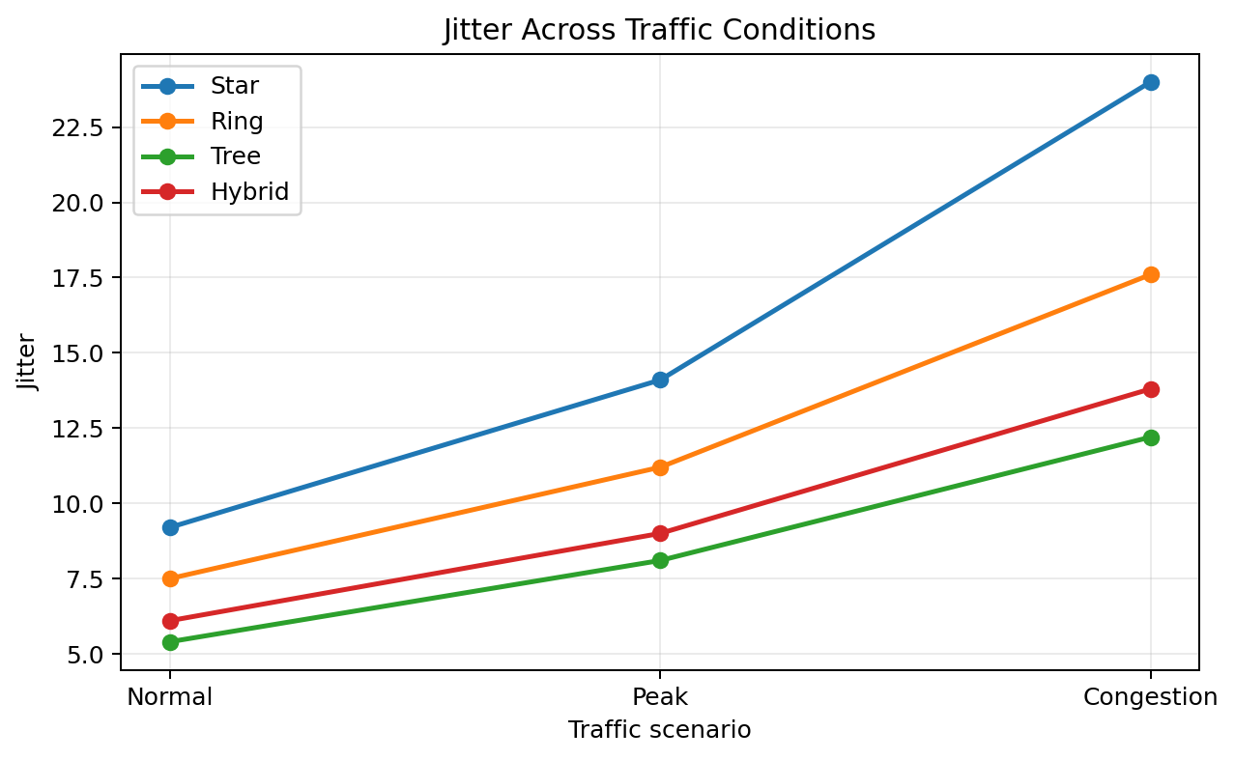
Figure 11.4 – Jitter Under Load
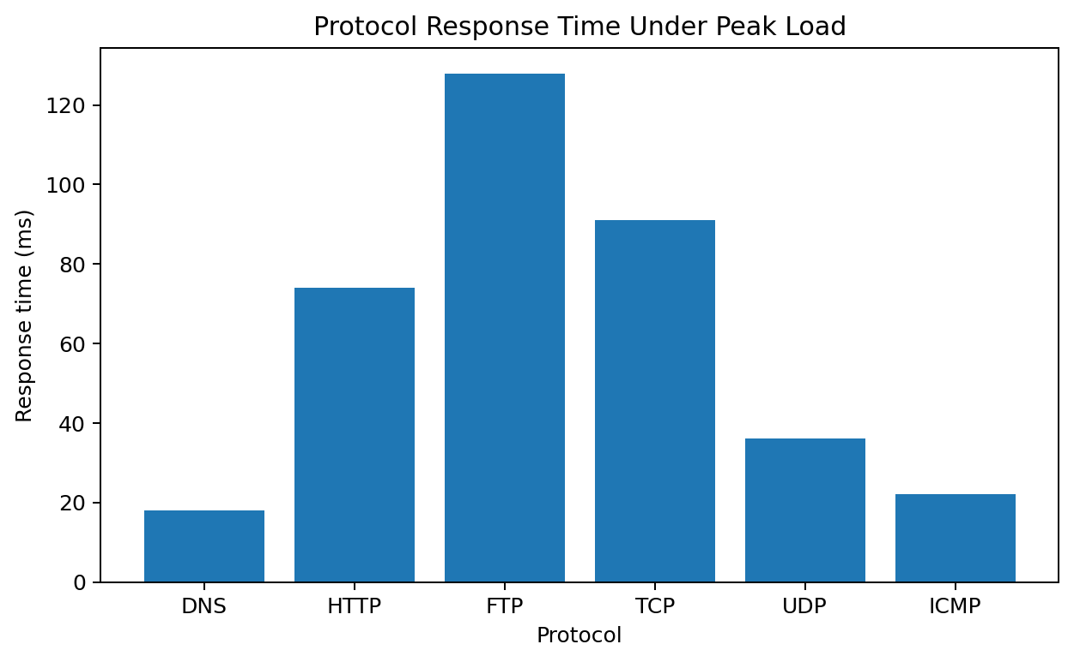
Figure 11.5 – Protocol Response Time
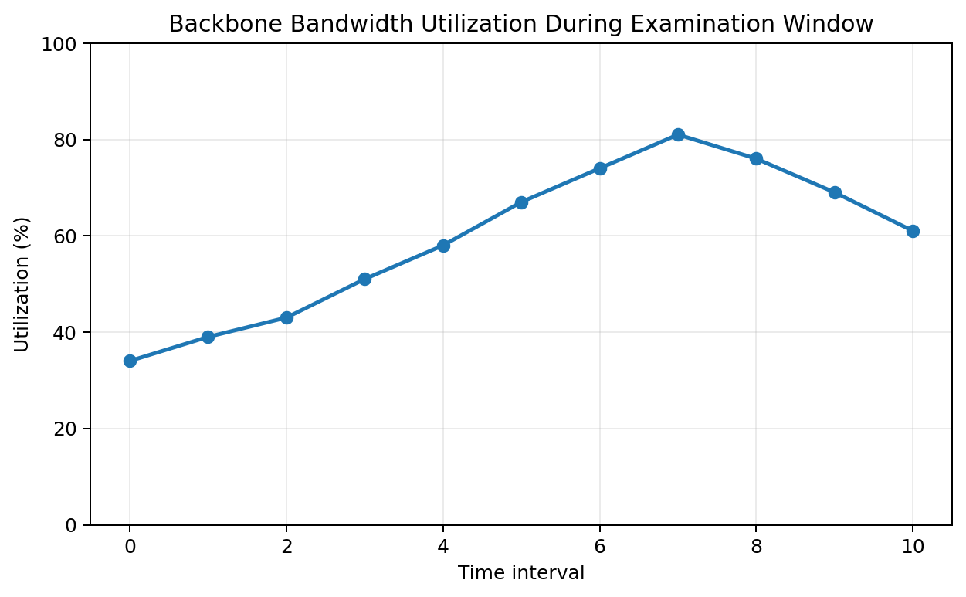
Figure 11.6 – Backbone Utilization
Topology | Normal Mbps | Peak Mbps | Stress Mbps | Avg Delay ms | Loss % | Jitter ms
Star | 82 | 70 | 49 | 61.3 | 9.5 | 15.8
Ring | 88 | 79 | 63 | 43.7 | 5.9 | 12.1
Tree | 94 | 86 | 72 | 32.3 | 3.6 | 8.6
Hybrid | 92 | 84 | 70 | 36.7 | 4.3 | 9.6

12. Detailed Analysis and Comparison
Throughput analysis shows how effectively each architecture uses its available capacity. Tree records the strongest representative throughput because its hierarchical structure separates access traffic and provides efficient aggregation. Hybrid is close to Tree because the redundant core distributes inter-zone traffic effectively. Star loses more performance as central links become busy, while Ring can experience additional forwarding overhead.
Delay analysis demonstrates the effect of congestion and path length. Under normal traffic, differences may be relatively small. Under peak and stress conditions, queueing becomes more important and delay rises sharply. Lower delay is especially important for interactive learning systems, authentication, video meetings and online examinations.
Packet loss and jitter provide another perspective. TCP may recover from loss through retransmission, but recovery increases application response time. UDP applications do not automatically recover lost packets at the transport layer, so loss and jitter are more directly visible. This makes UDP traffic a useful stress indicator for smart-campus telemetry.
Fault tolerance is a major differentiator. A redundant core can preserve connectivity when one link fails. The network may experience a short routing-convergence period, but the ability to recover without manually reconnecting devices is a major advantage for a campus that operates continuously.
From a management perspective, Star is the easiest to understand, Tree provides excellent organization, Ring can be appropriate for controlled segments, and Hybrid provides the broadest set of options. The final choice should therefore consider operational capability as well as raw performance.
Metric | Best Representative Result | Engineering Meaning
Throughput | Tree | Efficient aggregation
Delay | Tree | Lower queueing/path overhead
Loss | Tree | Better stability under stress
Jitter | Tree | More stable packet timing
Resilience | Hybrid | Redundant core path
Overall balance | Hybrid | Strong performance + resilience


Figure 12.1 – Fault-Tolerance and Alternate Routing

13. Topology Trade-offs and Final Recommendation
Topology selection is fundamentally a trade-off. Star minimizes conceptual complexity and is often economical, but its central dependency must be engineered carefully. Ring provides path diversity but can introduce more complicated forwarding and fault handling. Tree is highly scalable because new branches can be added without changing the entire network. Hybrid offers the ability to combine redundancy and hierarchy in a targeted way.
The recommended architecture is Hybrid because the campus has different service priorities. Critical core paths need stronger availability than ordinary access segments. By placing redundancy in the backbone and keeping access networks modular, the design avoids the cost of making every connection redundant while still improving overall service continuity.
The recommendation is also supported by the representative performance results. Tree produces the highest raw throughput, but Hybrid remains close while offering a stronger fault-tolerance model. Therefore, Hybrid is selected as the balanced engineering solution rather than simply choosing the topology with the single highest throughput value.
Before physical deployment, the proposed design should be validated using actual device specifications, expected user counts, link capacities, security requirements, building layouts and measured traffic volumes. The simulation provides the design direction; detailed deployment engineering would refine the final parameters.
Criterion | Star | Ring | Tree | Hybrid
Performance | Medium | Good | Very Good | Very Good
Scalability | Good | Medium | Excellent | Excellent
Fault tolerance | Low-Medium | Good | Medium-Good | Excellent
Management | Excellent | Medium | Good | Good
Cost | Low | Medium | Medium | Medium
Overall | Good for smaller zones | Controlled segments | Strong campus option | Recommended

14. Security, Reliability and Management Considerations
A smart campus network carries administrative, academic and residential information, so logical separation is important. VLANs and subnets can isolate groups and reduce unnecessary broadcast traffic. Access-control rules can limit which zones are permitted to reach sensitive servers or management interfaces.
Network management should be separated from ordinary user traffic. Device management addresses, administrator access and monitoring systems should be protected. Configuration backups should be maintained so that a failed device can be restored quickly. Consistent naming conventions also reduce troubleshooting time.
Reliability requires both prevention and recovery. Preventive measures include capacity planning, monitoring and sensible redundancy. Recovery measures include alternate paths, configuration backups and documented troubleshooting procedures. Together, these practices reduce the effect of unexpected failures.
Monitoring should track interface utilization, packet loss, delay and abnormal traffic. When a link repeatedly approaches its capacity, the network team can expand bandwidth or redistribute traffic before users experience severe degradation.
Area | Recommended Practice | Benefit
Segmentation | VLAN/subnet separation | Limits broadcast and improves policy control
Access control | Restrict sensitive services | Reduces unauthorized access
Monitoring | Track utilization and loss | Early warning of congestion
Backup | Store device configurations | Faster recovery
Redundancy | Protect critical backbone | Improves availability

15. Broader Considerations and SDG 9
Digital infrastructure is increasingly important to educational institutions. A reliable campus network supports access to learning resources, digital examinations, research systems, administrative applications and online collaboration. Network availability therefore has an indirect effect on educational continuity.
The project relates to SDG 9 because it focuses on resilient infrastructure, technology and innovation. A modular architecture supports long-term growth by allowing new services and devices to be added without replacing the complete network. Efficient use of redundancy can also avoid unnecessary equipment duplication.
The smart-campus concept can be extended to energy monitoring, smart lighting, environmental sensors, access control, digital signage and automated building systems. Each additional system increases the importance of segmentation, monitoring and capacity planning.
Responsible network engineering also includes lifecycle planning. Devices should be selected with expected growth in mind, configurations should be documented, and obsolete components should be replaced systematically. These practices improve sustainability and reduce operational risk.
SDG 9 Theme | Project Contribution
Resilient infrastructure | Redundant core and structured recovery
Innovation | Smart-campus and IoT-ready architecture
Sustainable growth | Modular expansion without total redesign
Digital access | Reliable learning and administrative services

16. Limitations and Future Scope
The main limitation is that a simulator is an abstraction of a real campus. It cannot fully reproduce physical cable lengths, wireless interference, electromagnetic effects, device processing limitations, user behaviour or unexpected Internet traffic. Therefore, simulation results should be interpreted as design evidence rather than a guarantee of physical performance.
Another limitation is the use of representative measurement values in the expanded report. If the project is executed in Packet Tracer, GNS3, EVE-NG or another simulator, the final submission should replace illustrative values with actual captured measurements where possible.
Future work can increase the number of trials and include statistical analysis such as standard deviation and confidence intervals. QoS policies can be tested to prioritize examination traffic, voice and telemetry. IPv6 dual-stack operation can also be evaluated to prepare the network for future addressing requirements.
The project can be extended toward SDN-based monitoring, automated fault detection and machine-learning-assisted traffic prediction. More realistic wireless and IoT traffic models would further improve the realism of the evaluation.
Future Enhancement | Expected Benefit
QoS | Prioritize examinations, voice and telemetry
IPv6 | Long-term addressing readiness
SDN monitoring | Centralized visibility and policy control
More trials | Greater statistical confidence
Realistic IoT/wireless models | Improved simulation realism

17. Conclusion
This assignment presented a complete design and evaluation approach for a resilient smart campus network. Instead of treating topology as a purely theoretical topic, the study connected topology selection with addressing, routing, transport protocols, application services, traffic generation and performance measurement.
The comparison shows that each topology provides a different engineering balance. Star is simple and manageable, Ring provides useful path diversity, Tree offers strong scalability and performance, and Hybrid combines the benefits of hierarchical organization with targeted redundancy. Under increasing traffic, the representative results favour Tree and Hybrid, with Hybrid providing the stronger overall balance.
The final recommendation is therefore a Hybrid campus architecture with a resilient core, modular distribution and access zones, and dedicated service and management segments. The design can be expanded as user numbers and IoT deployments grow. Actual deployment should be preceded by measurement-based validation and detailed capacity planning.
Overall, the project demonstrates that a good network is not defined by one metric. Reliability, responsiveness, scalability, manageability and cost must be considered together. This multi-factor approach is the main engineering lesson obtained from the study.

17.1 Final Recommendation Summary
Decision Factor | Finding
Best raw throughput | Tree
Best overall balance | Hybrid
Simplest management | Star
Useful controlled-segment option | Ring
Recommended campus architecture | Hybrid

18. Individual Contribution
I, C Karthik Reddy, contributed to the planning, design, evaluation and documentation of the Computer Networks assignment. The work involved understanding the problem, organizing the campus into logical zones and comparing alternative network architectures.
I prepared the topology comparison, addressing and service structure, test scenarios and performance-analysis format. I also organized the tables and graphs so that the results could be interpreted clearly rather than presented only as raw values.
The troubleshooting and fault-tolerance sections helped connect theoretical concepts such as routing, ICMP and redundancy with practical network operations. The report was also structured to make the design and testing sequence easy to follow.
The project improved my ability to analyse a network from multiple viewpoints and to justify a design decision using measurable evidence. It also strengthened my understanding of how computer-network concepts interact in a realistic campus environment.
Activity | Contribution
Planning | Defined zones, requirements and evaluation objectives
Network Design | Prepared topology and addressing structure
Testing | Organized traffic scenarios and validation cases
Analysis | Compared performance indicators
Documentation | Prepared tables, graphs, diagrams and final report

19. References
The following references are included to provide a broader technical foundation for the concepts used in this assignment. They cover computer-network fundamentals, Ethernet, structured cabling, simulation, packet analysis and resilient network design.
The reference list should be used for further reading and for checking terminology and standards. Where an actual simulator configuration is submitted, the exact software version and documentation used should also be recorded.
- Forouzan, B. A., Data Communications and Networking, McGraw-Hill.
- Tanenbaum, A. S. and Wetherall, D. J., Computer Networks, Pearson.
- Kurose, J. F. and Ross, K. W., Computer Networking: A Top-Down Approach, Pearson.
- Stallings, W., Data and Computer Communications, Pearson.
- Cisco Networking Academy, Cisco Packet Tracer documentation and learning resources.
- GNS3 Documentation, network emulation and virtualization resources.
- Wireshark Foundation, Wireshark User Guide and protocol-analysis documentation.
- IEEE 802.3, Ethernet standards.
- IEEE 802.1Q, Virtual LAN and VLAN tagging standard.
- IEEE 802.11, Wireless LAN standards.
- RFC 791, Internet Protocol Version 4.
- RFC 792, Internet Control Message Protocol.
- RFC 768, User Datagram Protocol.
- RFC 793 / RFC 9293, Transmission Control Protocol.
- RFC 1034 and RFC 1035, Domain Name System.
- RFC 2131, Dynamic Host Configuration Protocol.
- United Nations, Sustainable Development Goal 9 – Industry, Innovation and Infrastructure.
- TIA/EIA-568 structured cabling standards.

20. Individual Reflection
Completing this assignment improved my understanding of how theoretical networking concepts become practical design decisions. The most challenging part was comparing multiple topologies under equivalent traffic conditions because each architecture has a different balance between performance, cost and reliability.
The performance analysis taught me that throughput alone cannot describe a good network. Delay, jitter and packet loss must also be considered, especially when interactive or real-time applications are involved. The fault test further showed why redundant paths are valuable in a campus environment.
Another important lesson was systematic troubleshooting. Instead of immediately changing application settings, I learned to verify connectivity, addressing, routing and name resolution in sequence. This layered method makes faults easier to isolate and reduces unnecessary configuration changes.
If I repeated the project, I would increase the number of experimental trials, introduce QoS policies, collect actual packet captures and test the architecture using a larger virtualized environment. I would also include more realistic wireless and IoT workloads. Overall, the project strengthened my practical understanding of TCP, UDP, DNS, ICMP, routing, topology design and network performance evaluation.

20.1 Skills Developed
- Network topology analysis
- Protocol-level reasoning
- Performance interpretation
- Fault isolation and troubleshooting
- Technical documentation
- Evidence-based design decisions

