1. Introduction
1.1 Objective of Project:

This project mainly used to get the feed-back from the pupils of the college regarding the faculty and the resources provided to them by the college.

1.2 Description:

The college feed back System automates the feed back given by students. To provide a College feedback system for college, this would provide feedback from student improve uses services and reduce paperwork. The actual application decreases the overheads that exist on the job schedules among the lecturers and the administration.
The actual purpose in designing the system is to make the organizational process to get speed up. The management can have the expected information at its bay at any instance. Much easier and information availability at the hand. The system not only becomes false proof and higher levels of satisfaction prevail at the side of the student, and administrators. The application is also security oriented and gets associated with in the system.

1.3 Scope of Project:
→To make the existing system more efficient
→To provide a user friendly environment where user can be
Serviced better.
→Make functioning of feedback faster.

2. System Analysis
2.1 Existing System

Here the existing system is a manual one using which the administrator has to maintain the feedback given by student. Feedback is taken manually by using feed back forms which is very difficult to calculate the feed back statistics and time consuming process. It has certainly an edge over the manually taken process where in this it relieves the burden of going to each and every student and taking the details.

2.2 Proposed System
Here the proposed system is a software application using we can automate the above features. This project computerizes feedback process in which students give their feed back through a system that is connected in a LAN by using their login credentials. College feedback system is a software solution where it can be used as efficient application software for college. Using this software the students can directly give the feedback regarding the college resources and staff. By evaluating the feedback the administrator can easily find the feedback for each different category effectively.
It is a very user friendly application that whenever student enters his details it directly provides the details of him and he just need to provide his feedback.
It can be used as a one stop access for students and the management by the way. Using this software the students can choose for diversified options where in they can provide feedback to different fields according to his choice. It can be an excellent application for college where in they can be free from keeping separate working persons for collecting feed back by moving onto students. Students also have a chance of selecting level of choice in providing feedback. It is a effective user friendly interface so that students can but like to provide the feedback with utmost interest. More over it is a little bit logical in concerning the details of the students of the passed out students who cannot provide feedback, and having constraints over their choice of feedback.

2.3 Feasibility Study

All projects are feasible given unlimited time & money resources. So it’s necessary & prudent to evaluate the feasibility of a project; otherwise, months or years, & thousands or millions of dollars can be lost if a bad system is developed.
Not everything imaginable is feasible. Software feasibility has four solid dimensions:
- Technical Feasibility: Is a project technically feasible? Is it within the state of the art? Can defects be reduced to a level matching the application's needs? These types of projects are already available in the market so it is feasible.
- Financial Feasibility: Is it financially feasible? Can development be completed at a cost the software organization, its client, or the market can afford?
- Time Feasibility: Will the project's time to market beat the competition?
- Resource Feasibility: Does the organization have the resources needed to succeed?
- Legal Feasibility: Legal feasibility is the determination of any infringement, violation, or the liability that could result from the development of the system. The Oxford Repository is software for universities. This type of software is already being used in the business and is legally approved. Hence our system is legally feasible.
Our project is technically, economically, and operationally feasible.

2.4 HARDWARE AND SOFTWARE REQUIREMENTS:

2.4.1 Software Requirements

Operating System : Windows XP/2000
User Interface : HTML, CSS
Client-side Scripting : JavaScript
Programming Language : Java
Web Applications : JDBC, Servlets, JSP
IDE/Workbench : My Eclipse 6.0
Database : Oracle 10g
Server Deployment : Apache Tomcat 5.0

2.4.2 Hardware Requirements

Processor : Pentium IV
Hard Disk : 80 GB
RAM : 512 MB

3. System Design

3.1 Architecture Diagram

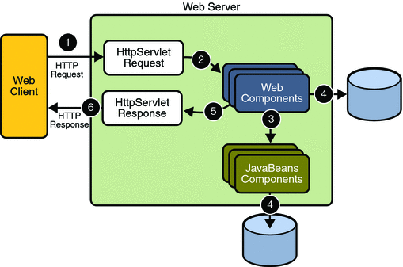

`
3.2 Functional Specification
- Administrator should add a course.
- Administrator should provide details about the course while creation.
- Administrator should add subjects for each branch and year wise.
- Administrator should select course, year, branch, section while taking feedback.
- Students should register before giving feedback.
- Student should give feedback by selecting radio buttons

3.3 Non-Functional Specifications

3.3.1Constraints
These are the requirements that are not directly related to the functionality of the system. These should be considered as mandatory when the system is developed. The following Constraints were arrived at for the system:

1. The system should be available across the lan, the Users like the Admin and Student can use the system from their respective systems.

2. For gaining entry into the system the user details should be registered by the admin and these users should use login & passwords for gaining access in to this system.

3. The users should be able to change their passwords for increased security.

4. The system should be easy to understand and organized in a structured way

5. There should be no limitation about the hardware platform that is to be used to run the system.

6. Data integrity should be maintained if an error occurs or the whole system comes down.

3.3.2 Guidelines

We have discussed mandatory requirements in the previous section. The requirements in this section should be taken as suggestions & they should be thought of as recommendations to further enhance the usability of the system.

1. The system should display a menu for users to choose from.

2. The system should display user-friendly screens to submit or download the documents.

3. The system should be designed in such a way that it is easy to enhance it with more functionality. It should be scalable & easily maintainable.

4. Better component design to get better performance at peak time Flexible service based architecture will be highly desirable for future extension.

  - Modules:
3.4.1 Admin Module
In this module we have to create facility like. Add course with all details.
Add students to the particular course, Taking Feed back by selecting course, branch, year and section. Promoting students which reduces the burden of reentering the students details get previous feedback which allows us to get statistics of previously taken feed back

3.4.2 Student Module
In this module we create Feedback form for students get previous feedback
Which allows us to get statistics of previously taken feed back. Student module in
We create student feedback form.

3.5 INPUT DESIGN:
The input design is the link that ties the information System into the real world of its users. The inputs, which are given by the user, will form the core of the processes. So the inputs have to be care fully analyzed and care has to be taken to avoid in correct inputs.
The guidelines that have been followed in designing the input forms are.

- Minimizing the number of input by collecting only required Data and grouping similar or related data.
- Maintain consistently between information display and input.
- Providing help facilities those are context sensitive.
- The format of the same data in different screens must be same.
- Consistent terminology’s are to be used throughout the system

3.6 OUTPUT DESIGN:

Computer out put is the most important and direct source of information to user. Efficient, intelligible output design should provide user with systems relationships and help in decision-making.
The major form of output is hard copy from the printer, printouts are to be designed around the out put requirements of the user. The output devices to be considered depends on factors such as compatibility of the device with the system, response time requirements, expected print quality and number of copies needed.
The output design was carried out in consultation with the user reports, which have many columns, are printed n compressor mode, which can be printed on laser printers and others in uncompressed mode so as to facilitate its usage online printers.

3.7 UML Diagrams
The unified modeling language allows the software engineer to express an analysis model using the modeling notation that is governed by a set of syntactic semantic and pragmatic rules.
A UML system is represented using five different views that describe the system from distinctly different perspective. Each view is defined by a set of diagram, which is as follows.
  - User Model View
    - This view represents the system from the users perspective.
    - The analysis representation describes a usage scenario from the end-users perspective.

  - Structural model view
    - In this model the data and functionality are arrived from inside the system.
    - This model view models the static structures.

- Behavioral Model View
It represents the dynamic of behavioral as parts of the system, depicting the interactions of collection between various structural elements described in the user model and structural model view.

- Implementation Model View
In this the structural and behavioral as parts of the system are represented as they are to be built.

- Environmental Model View
In this the structural and behavioral aspects of the environment in which the system is to be implemented are represented.

UML is specifically constructed through two different domains they are:
- UML Analysis modeling, this focuses on the user model and structural model views of the system.
- UML design modeling, which focuses on the behavioral modeling, implementation modeling and environmental model views.

Use case Diagrams represent the functionality of the system from a user’s point of view. Use cases are used during requirements elicitation and analysis to represent the functionality of the system. Use cases focus on the behavior of the system from external point of view.

Actors are external entities that interact with the system. Examples of actors include users like administrator, bank customer …etc., or another system like central database.

3.7.1 USE CASE DIAGRAM:
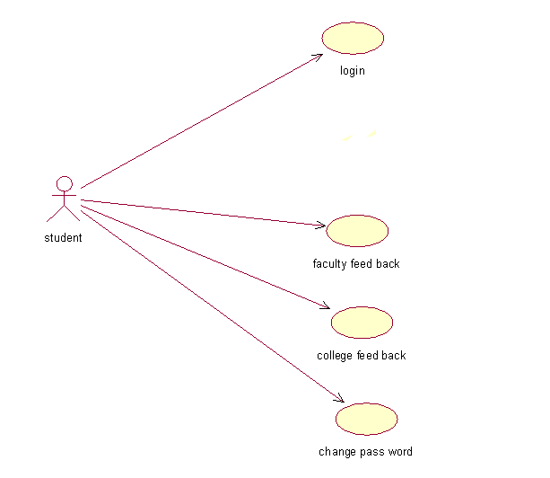

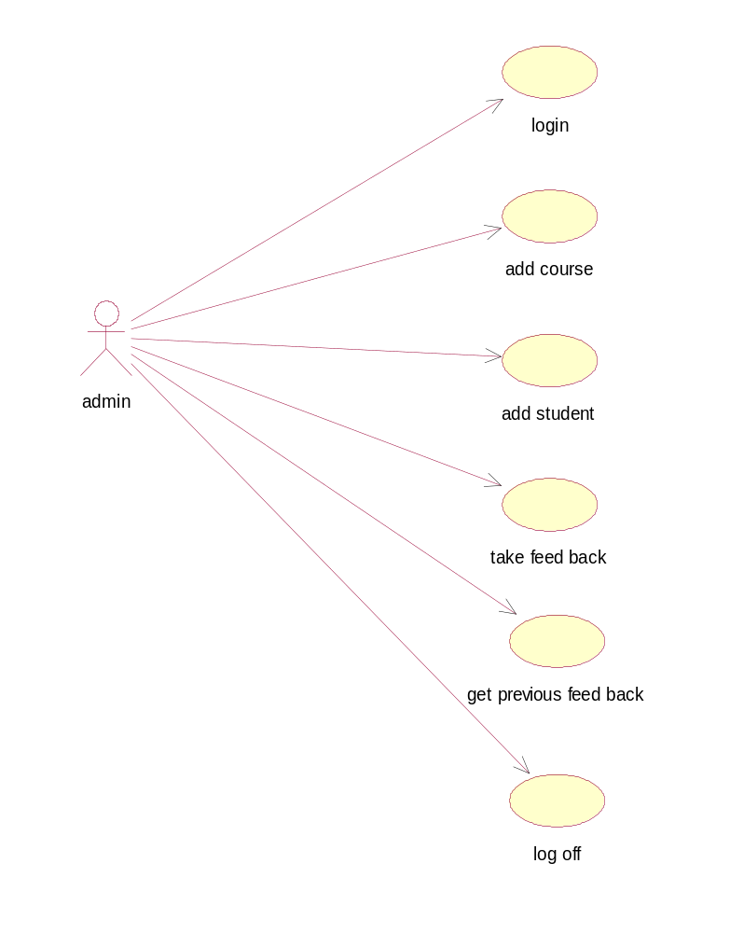

3.7.2 State Diagram

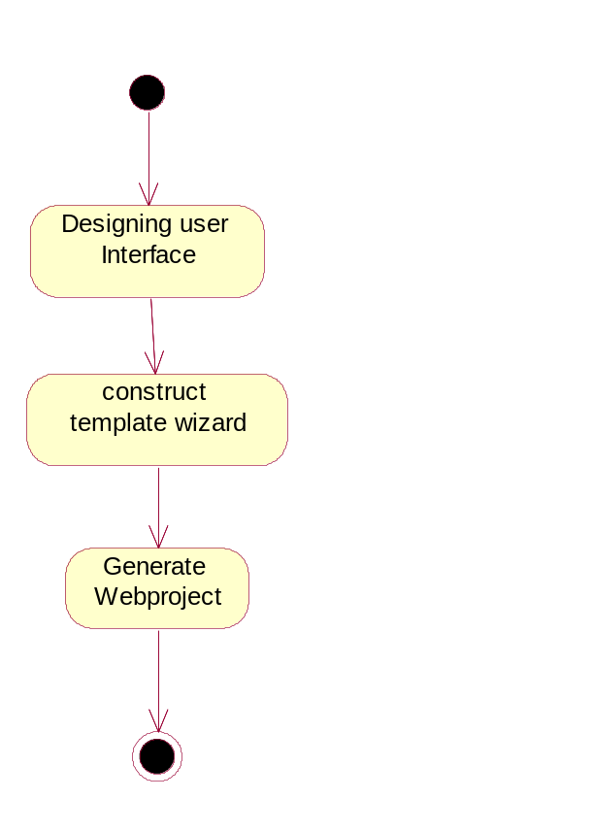

3.7.3 Activity Diagram:
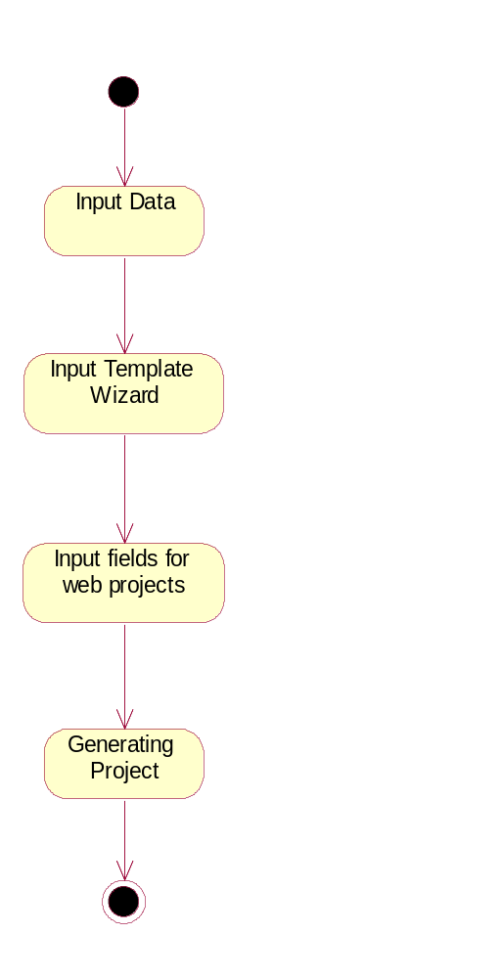

3.7.4 Sequence Diagram:
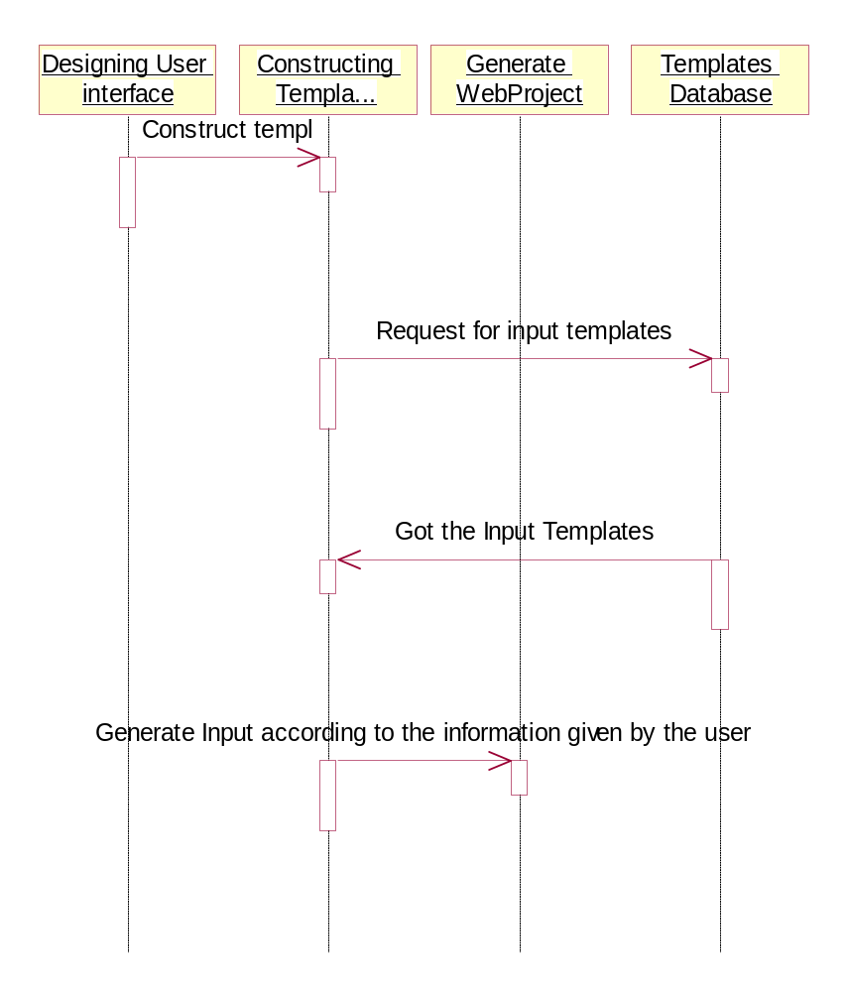
3.7.5 Collaboration Diagram:

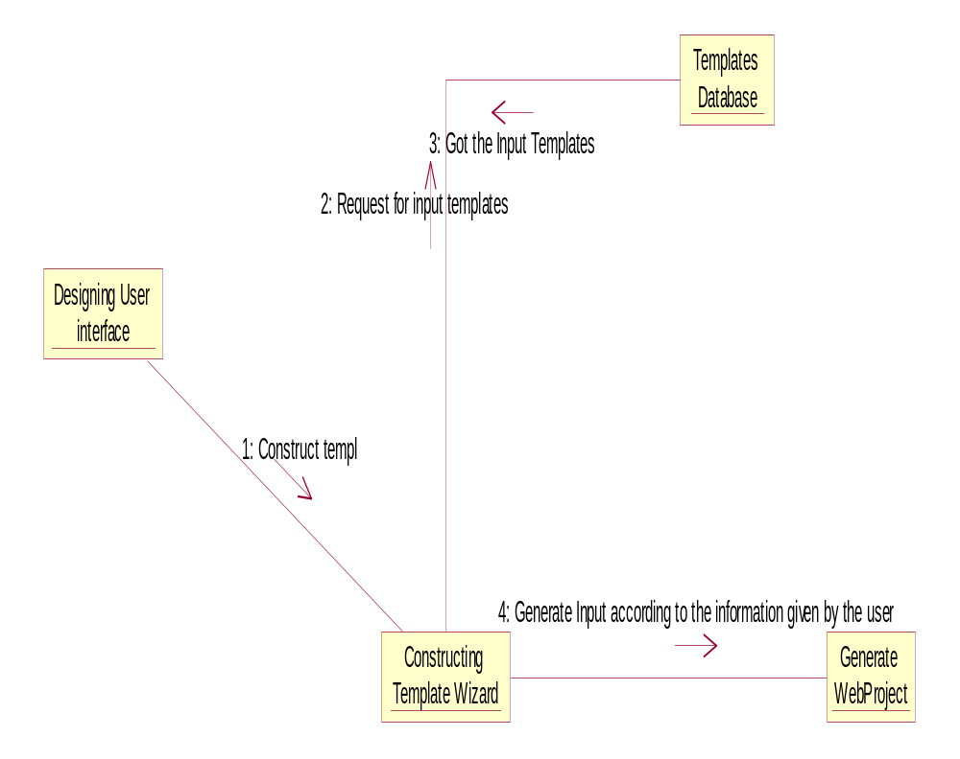

3.7.6Class diagram
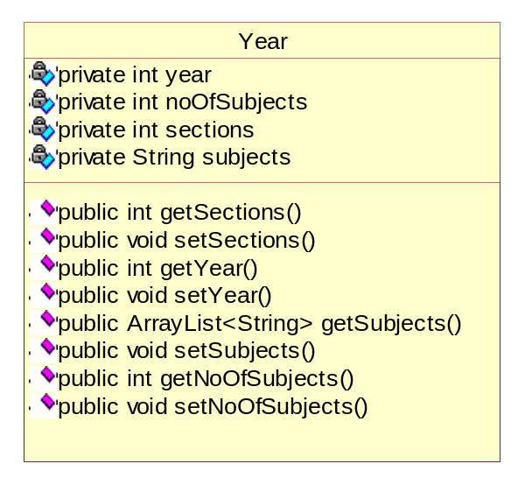

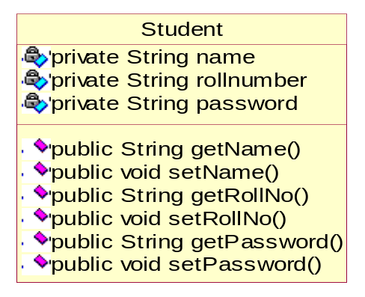
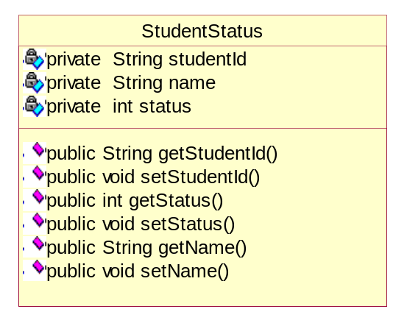

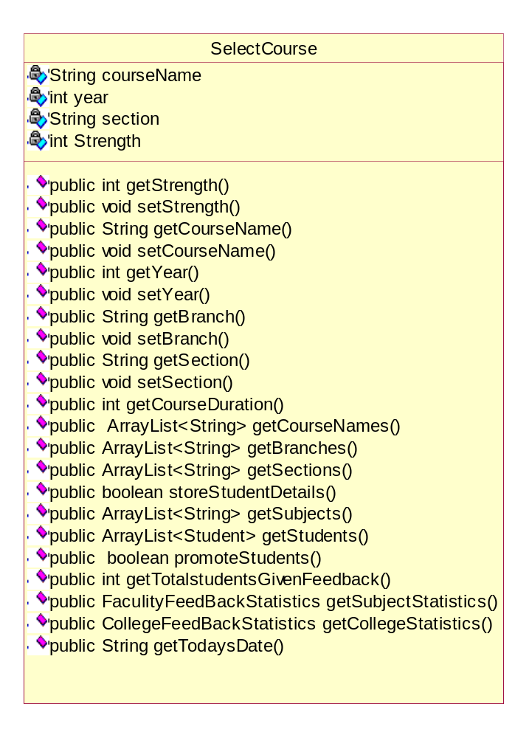

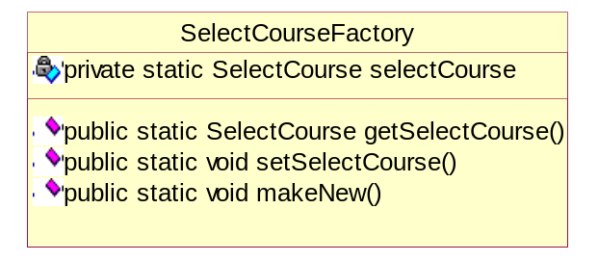

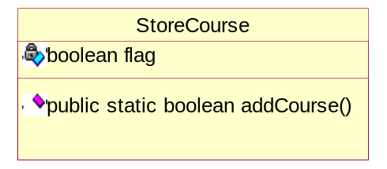
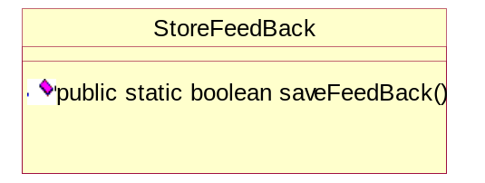

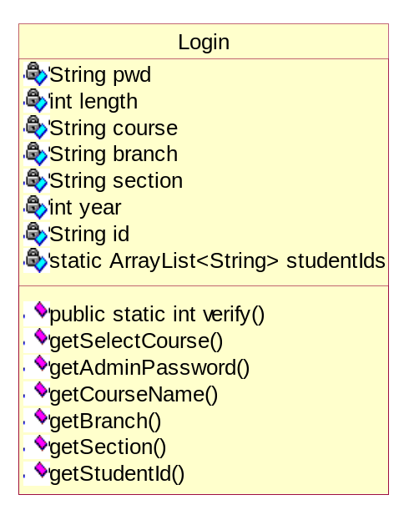
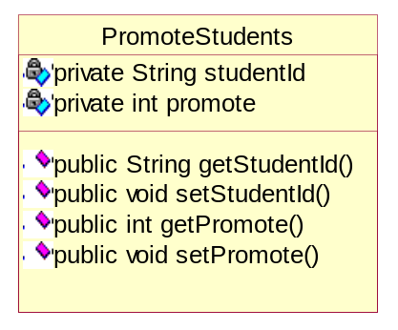

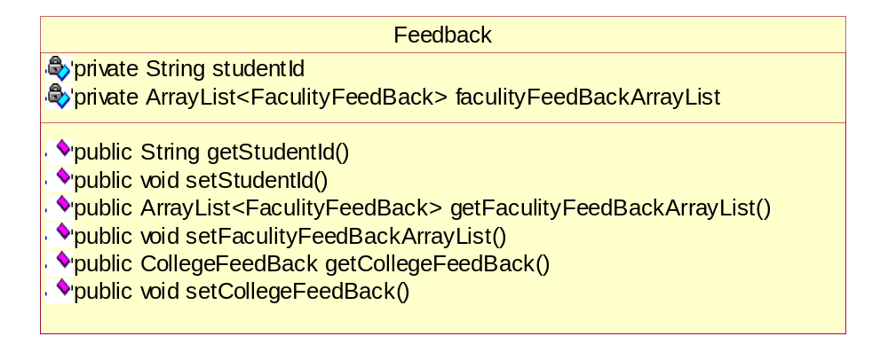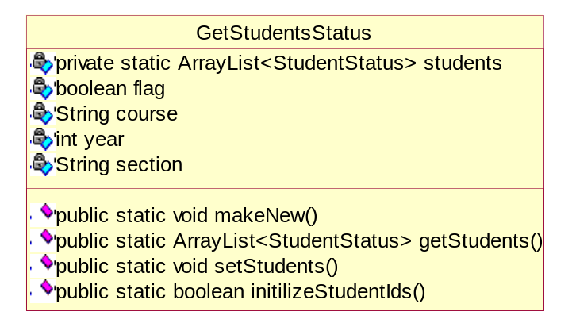

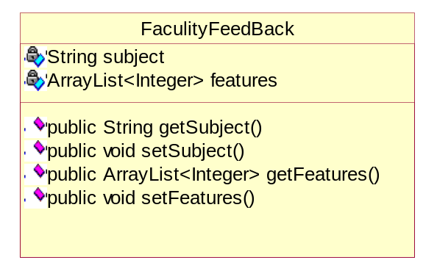
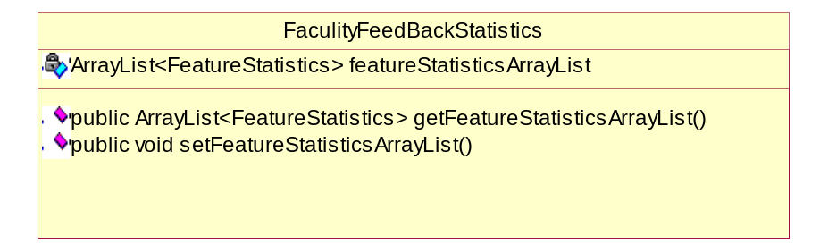
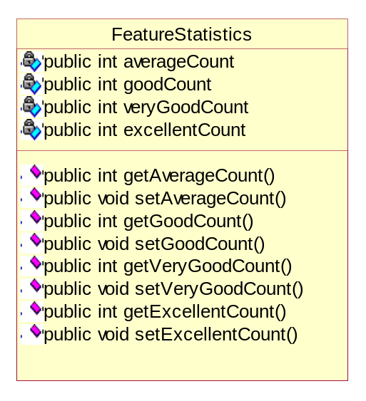
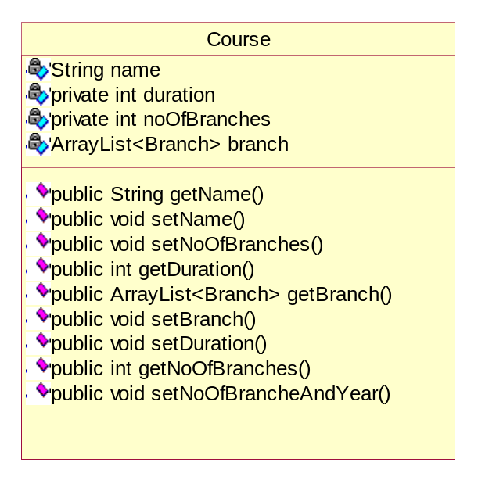
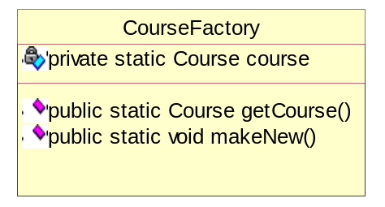
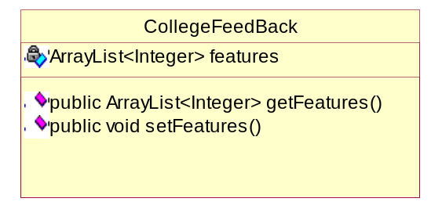
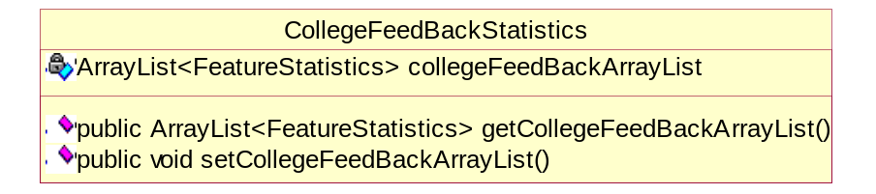
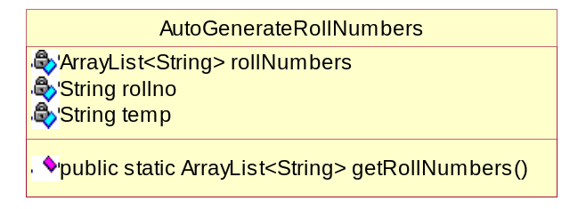
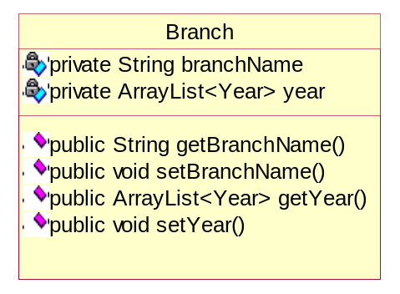
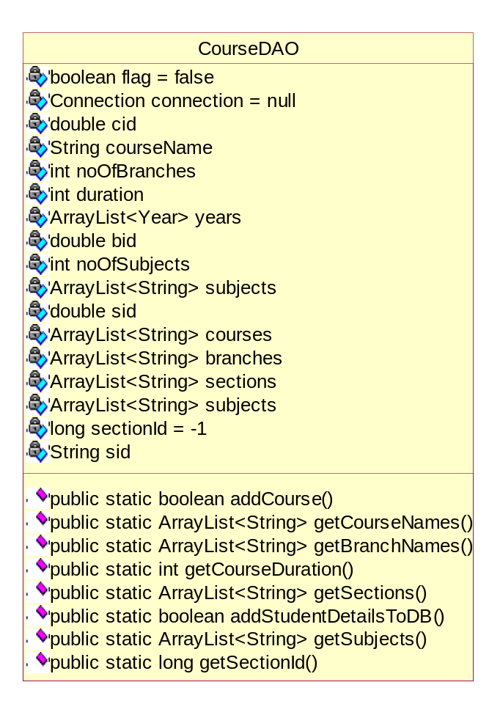
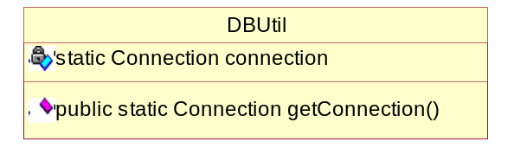
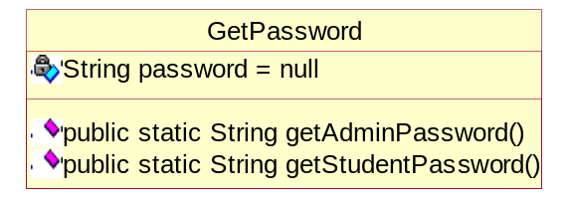
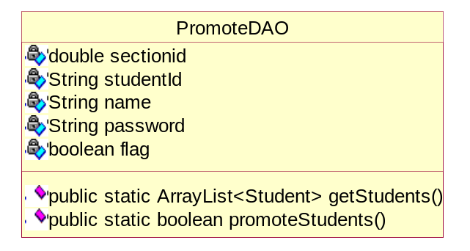
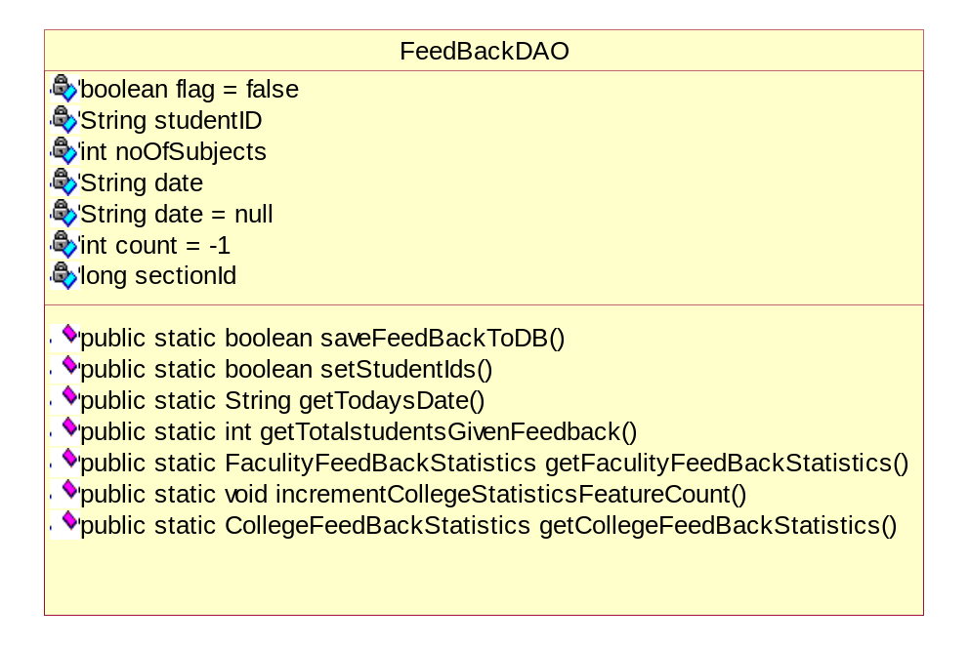

4. SOFTWARE ENGINEERING PARADIGM APPLIED

4.1 DESIGN SPECIFICATION:
Design of software involves conceiving planning out and specifying the externally observable characteristics of the software product. We have data design, architectural design and user interface design in the design process. These are explained in the following section. The goals of design process it to provide a blue print for implementation, testing, and maintenance activities.

4.2 DATA DESIGN:
The primary activity during data design is to select logical representations of data objects identified during requirement analysis and software analysis. A data dictionary explicitly on the elements of the data structure. A data dictionary should be established and used to define both data and program design.

4.3 DESIGN METHODOLOGY:
The two basic modern design strategies employed in software design are
- Top Down Design
- Bottom Up Design
Top down Design is basically a decomposition process, which focuses on the flow of control. At later stages it concern itself with the code production. The first step is to study the overall aspects of the tasks at hand and to break it into a number of independent modules. The second step is to break each one of these modules further into independent sub-modules. The process is repeated one to obtain modules, which are small enough to group mentally and to code in a straightforward manner. One important feature is that at each level the details of the design at the lower level are hidden. Only the necessary data and control that must be called back and forth over the interface are defined.
In a bottom-up design one first identifies and investigates parts of design that are most difficult and necessary designed decision are made the reminder of the design is tailored to fit around the design already chose for crucial part. It vaguely represents a synthesis process explained in previous section.
One storage point of the top-down method is that it postpones details of the decision until the last stage of the decision. It allows making small design changes when the design is half way through. There is danger that the specifications will be incompatible and this will not be discovered until late in the design process. By contrast the bottom-up strategy first focuses on the crucial part so that feasibility of the design is tested at early stage.
In mixing top-down and bottom-up design it often appears that we start in the middle of the problem and work our way both up and down there. In a complex problem, it is often difficult to decide how to modularize the various procedures in such cases one might consider a list of system inputs and decide what functions are necessary to process these inputs. This is called back to front design. Similarly one can start with the required outputs and work backwards evolving so called front-back design. We have applied both the top down and bottom up approach in our design approach.

4.4 DATABASE DESIGN

Databases are normally implemented by using a package called a Data Base Management System (DBMS). Each particular DBMS has somewhat unique characteristics, and so such, general techniques for the design of database are limited. One of the most useful methods of analyzing the data required by the system for the data dictionary has developed from research into relational database, particularly the work of E.F.Codd. This method of analyzing data is called “Normalization”. Unorganized data
Are converted into normalized data by three stages. Each stage has a procedure to follow.

4.5 NORMALIZATION

The first stage is normalization is to reduce the data to its first normal form, by removing repeating items showing them as separate records but including in them the key fields of the original record.
The next stage of reduction to the second normal form is to check that the record, which one is first normal form, all the items in each record are entirely dependent on the key of the record. If a data item is not dependent on the key of the record, but on the other data item, then it is removed with its key to form another record. This is done until each record contains data items, which are entirely dependent on the key of their record.
The final stage of the analysis, the reduction of third normal form involves examining each record, which one is in second normal form to see whether any items are mutually dependent. If there are any item there are removed to a separate record leaving one of the items behind in the original record and using that as the key in the newly created record.

4.6 BUSINESS MODELING:
The information flow among business function is modeled in a way that answers the following questions: what information drives the business process? What information is generated? What generate it? Where does the information go? Who process it?
4.7 DATA MODELING:
The information flow defined as a process of the business modeling is refined into a set of data objects that are needed to support the business. The characteristics (called attributes) of each object are identified and relationships between these objects are defined.
4.8 PROCESS MODELING:
The data objects defined in the data-modeling phase are transformed to achieve the information flow necessary to implement a business function. Processing description are created for addition, modifying, deleting, or retrieving a data object.
4 .9 THE LINEAR SEQUENTIAL MODEL:
The linear sequential model for software engineering some times called the “classic model” or the “water fall model,” the linear sequential suggests a systematic, sequential approach to software development that begins at eth system level and process through analysis, design, coding, testing, and maintenance.
The linear sequential model is the oldest and the most widely used paradigm for software engineering. Modeled after the conventional engineering cycle, the linear sequential model encompasses the following activities:

1) SYSTEM/INFORMATION ENGINEERING AND MODELLING:
- Because software is always part of a larger system (or business), work begins by establishing requirements for all system elements and then allocating some subset of these requirements to software. This system view is essential when software must interface with other elements such as hardware, people, and databases.
- System engineering and analysis encompasses requirements gathering at the system level with a small amount of top-level analysis and design. Information engineering encompasses requirements gathering at the strategic business level and at the strategic business level and at the business area level.
2) SOFTWARE REQUIREMENTS ANALYSIS:
- The requirements gathering process is intensified and focused specifically on software. To understand the nature of the programs to be built, the software Engineer must under stand the information domain for the software, as well as required function, behavior, performance, and inter facing. Requirements for the both the system and the software are documented and reviewed with the customer.
3) DESIGN:
- Software design is actually a multi step process that focuses on four distinct attributes of a program: data structure, software architecture, interface representations, and procedural detail. The design process translates requirements into a representation of the software that can be assessed for quality before code generation begins. Like requirements the design is documented and becomes part of the software configuration.
4) CODE GENERATION:
- The design must be translated into a machine-readable form. The code generation step performs this task. If design is performed in a detailed manner, code generation can be accomplished mechanisam.

5) TESTING:
- Once code has been generated, program testing process focuses on the logical internals of the software, assuring that all statements have been tested, and on the functional externals that is, conducting tests to uncover errors and ensure that defined input will produce actual results that agree with required results.

6) MAINTENANCE:
- Software will undoubtedly undergo change after it is delivered to the customer. Change will occur because errors have been encountered, because the software must be adapted to accommodate changes in its external environment (e.g., a change required because of a new operating system or peripheral devices), or because the customer requires functional or performance enhancement. Software maintenance reapplies each of the preceding phases to an existing program rather than a new one

5. Implementation

5.1 SYSTEM DEVLOPMENT ENVIRONMENT
5.1.1 Java and Internet:
The Internet helped catapult Java to the forefront of programming and Java in turn has had a profound effect on the Internet. The reason is simple: Java expands the universe of objects that can move about freely in cyberspace. In a network, there are two broad categories of objects transmitted between the Server and your Personal Computer: passive information and dynamic, active programs like an object that can be transmitted to your computer, which is a dynamic, self-executing program. Such a program would be an active agent ton the client computer, yet the server would initiate it. As desirable as dynamic, networked programs are, they also present serious problems in the areas of security and portability. Prior to Java cyberspace was effectively closed to half the entities that now live there. Java addresses these concerns and doing so, has opened the door to an exiting a new form of program.
The rise of server-side Java applications is one of the latest and most exciting trends in Java programming. It was first hyped as a language for developing elaborate client-side web content in the form of applets. Now, Java is coming into its own as a language ideally suited for server-side development. Businesses in particular have been quick to recognize Java’s potential on the server-Java is inherently suited for large client/server applications. The cross platform nature of Java is extremely useful for organizations that have a heterogeneous collection of servers running various flavors of the Unix of Windows operating systems. Java’s modern, object-oriented, memory-protected design allows developers to cut development cycles and increase reliability. In addition, Java’s built-in support for networking and enterprise API provides access to legacy data, easing the transition from older client/server systems.
Java Servlets are a key component of server-side java development. A Servlets is a small, plug gable extension to a server that enhances the server’s functionality. Servlets allow developers to extend and customize and Java enabled server a web server, a mail server, an application server, or any custom server with a hitherto unknown degree of portability, flexibility and ease.

5.1.2 JAVA SERVER PAGE (JSP)
Java Server Pages is a simple, yet powerful technology for creating and maintaining dynamic-content web pages. Based on the Java programming language, Java Server Pages offers proven portability, open standards, and a mature re-usable component model.

5.1.3 PORTABILITY
Java Server Pages files can be run on any web server or web-enabled application server that provides support for them. Dubbed the JSP engine, this support involves recognition, translation and management of the Java Server Pages lifecycle and its interaction with associated components.
The JSP engine for a particular server might be built-in or might be provided through a 3rd –party add-on. As long as the server on which you plan to execute the Java Server Pages supports the same specification level as that to which the file was written, no change should be necessary as you move your files from server to server. Note, however, that instructions for the setup and configuration of the files may differ between files.

5.1.4 COMPOSITION
It was mentioned earlier that the Java Server Pages architecture could include reusable Java components. The architecture also allows for the embedding of a scripting language directly into the Java Server Pages file. The components current supported include Java Beans and Serves. As the default scripting language, Java Server Pages use the Java Programming language. This means that scripting on the server side can take advantage of the full set of capabilities that the Java programming language offers.

5.1.5 PROCESSING
A Java Server Pages file is essentially an HTML document with JSP scripting or tags. It may have associated components in the form of. class, .jar, or .ser files- -or it may not. The use of components is not required.
The Java Server Pages file has a .jsp extension to identify it to the server as a Java Server Pages file. Before the page is served, the Java Server Pages syntax is parsed and processed into a servlet on the server side. The servlet that is generated, outputs real content in straight HTML for responding to the customer. Because it is standard HTML, the dynamically generated response looks no different to the customer browser than a static response.

5.1.6 ACCESS MODELS
A Java Server Pages file may be accessed in at least two different ways: A client request comes directly into a Java Server Page.

In this scenario, suppose the page accessed reusable Java Bean components that perform particular well-defined computations like accessing a database. The result of the Bean’s computations, called result sets is stored within the Bean as properties. The page uses such Beans to generate dynamic content and present it back to the client. A request comes through a servlet.
The servlet generates the dynamic content. To handle the response to the client, the servlet creates a Bean and stores the dynamic content (sometimes called the result set) in the Bean. The servlet then invokes a Java Server Page that will present the content along with the Bean containing the generated from the servlet.

There are two APIs to support this model of request processing using Java Server Pages. One API facilitates passing context between the invoking servlet and the Java Server Page. The other API lets the invoking servlet specify which Java Server Page to use.
In both of the above cases, the page could also contain any valid Java code. The Java Server Pages architecture separation of content from presentation- -it does not mandate it.
JDBC requires that the SQL statements be passed as Strings to Java methods. For example, our application might present a menu of database tasks from which to choose. After a task is selected, the application presents prompts and blanks for filling information needed to carry out the selected task. With the requested input typed in, the application then automatically invokes the necessary commands.
In this project we have implemented three-tier model, commands are sent to a “middle tier” of services, which then send SQL statements to the database. The database process the SQL statements and sends the results back to the middle tier, which then sends them to the user. JDBC is important to allow database access from a Java middle tier.

What Is JDBCTM?
JDBCTM is a Java TM API for executing SQL statements. (As a point of interest, JDBC is a trademarked name and is not an acronym; nevertheless, JDBC is often thought of as standing for "Java Database Connectivity".) It consists of a set of classes and interfaces written in the Java programming language. JDBC provides a standard API for tool/database developers and makes it possible to write database applications using a pure Java API.
Using JDBC, it is easy to send SQL statements to virtually any relational database. In other words, with the JDBC API, it isn't necessary to write one program to access a Sybase database, another program to access an Oracle database, another program to access an Informix database, and so on. One can write a single program using the JDBC API, and the program will be able to send SQL statements to the appropriate database. And, with an application written in the Java programming language, one also doesn't have to worry about writing different applications to run on different platforms. The combination of Java and JDBC lets a programmer write it once and run it anywhere.
Java being robust, secure, easy to use, easy to understand, and automatically downloadable on a network, is an excellent language basis for database applications. What is needed is a way for Java applications to talk to a variety of different databases. JDBC is the mechanism for doing this.
JDBC extends what can be done in Java. For example, with Java and the JDBC API, it is possible to publish a web page containing an applet that uses information obtained from a remote database. Or an enterprise can use JDBC to connect all its employees (even if they are using a conglomeration of Windows, Macintosh, and UNIX machines) to one or more internal databases via an intranet. With more and more programmers using the Java programming language, the need for easy database access from Java is continuing to grow.
MIS managers like the combination of Java and JDBC because it makes disseminating information easy and economical. Businesses can continue to use their installed databases and access information easily even if it is stored on different database management systems. Development time for new applications is short. Installation and version control are greatly simplified. A programmer can write an application or an update once, put it on the server, and everybody has access to the latest version. And for businesses selling information services, Java and JDBC offer a better way of getting out information updates to external customers.

5.1.7 CONNECTION
A connection object represents a connection with a database. A connection session includes the SQL statements that are executed and the results that are returned over the connection. A single application can have one or more connections with a single database, or it can have connections with many different databases.

OPENING A CONNECTION
The standard way to establish a connection with a database is to call the method DriverManager.getConnection. This method takes a string containing a URL. The Driver Manager class, referred to a the JDBC management layer, attempts to locate a driver than can connect to the database represented Driver classes, and when the method get Connection is called, it checks with each driver in the list until it finds one that can connect uses this URL to actually establish the connection.
<Sub protocol>-usually the driver or the database connectivity mechanism, which may be supported by one or more drivers. A prominent example of a sub protocol name is “oracle”, which has been reserved for URLs that specify “thin”-style data source names.
<Sub name>- a way to identify the database. The sub names can vary, depending on the sub protocol, and it can have a sub name with any internal syntax the driver writer chooses. The point of a sub name is to give enough information to locate the database.
5.1.8 SENDING STATEMENT:
Once a connection is established, it is used to pass SQL statements to its underlying database. JDBC does not put any restrictions on the kinds of SQL statements that can be sent; this provides a great deal of flexibility, allowing the use of database-specific statements or even non-SQL statements. It requires, however, that the user be responsible for making sure that the underlying database can process the SQL statements being sent and suffer the consequences if it cannot.
5.1.9 DRIVER MANAGER:
The Driver Manager class is the management layer of JDBC, working between the user and the drivers. It keeps track of the drivers that are available and handles establishing a connection between a database and the appropriate driver. It addition, the driver manager class attends to things like driver login time limits and the printing of log and tracing messages. The only method in this class that a general programmer needs to use directly is DriverManager.getConnection. As its name implies, this method establishes a connection to a database.

5.2 Introduction to Oracle:
Any programming environment used to create containers, to manage human data, in the conceptualization as a Data Management System. Traditionally, the block of human data being managed is called a Database. Hence, in very simple terms, these programming environments can the conceptualized as Database Management Systems, in short DBM systems.
All Databases Management Systems (that is, Oracle is DBMS) allow users to create containers for data stories and management. These containers are called ‘cells’. The minimum information that has to be given to Oracle for a suitable container to be constructed, which can hold free from human data. Another name that programming environments use for a ‘Cell’ is ‘Field’. These can the conceptualized as follows.
Basic Database Concepts:
A database is a corporate collection of data with some inherent meaning, designed, built and populated with data for a specific purpose. A database stores data that is useful to us. This data is only a part of the entire data available in the world around us.
To be able to successfully design and maintain databases we have to do the following:
Identify which part of the world’s data is of interest to us.
Identify what specific objects in that part of the world’s data are of interest to us.
Identify a relationship between the objects.
Hence the objects, their attributes and the relationship between them that are of interest to us are still owed in the database that is designed, built and populated with data for a specific purpose.
Characteristics of a Database Management System:

It represents a complex relationship between data.
Keeps a tight control of debtor redundancy.
Enforces user-defined rules to ensure integrity of table data.
Has a centralized data dictionary for the storage of information pertaining to data and its manipulation.
Ensures that data can be shared across applications.
Enforces data access authorization has automatic, intelligent backup and recovery procedures for data.
Have different interfaces via which users can manipulate data.
Relational Database Management:
A relational database management system uses only its relational capabilities to manage the information stored in its databases.

Information Representation:
All information stored in a relational database is represented only by data item values, which are stored in the tables that make up the database. Associations between data items are not logically represented in any other way, such as the use of pointers from one table to the other.

Logical accessibility:
Every data item value stored in relational database is accessible by stating the nature of the table it is stored in, the name of the column under which it is stored and the value of the primary key that defines the row in which it is stored.
Representation of null values:
The database management system has a consistent method for representing null values. For example, null values for numeric data must be distinct from zero or any other numeric and for the character data it must be different from a string of blanks or any other character value.
Catalogue facilities:
The logical description of the relation database is represented in the same manner as ordinary data. This is done so that the facilities of the relation database management system itself can be used to maintain database description.
Data Language:
The relational database management system may support many types of languages for describing data and accessing the database. However, there must be at least one language that uses ordinary character strings to support the definition of data, the definition of views, the manipulation of data, constraints on data integrity, information concerning authorization and the boundaries for recovery of units.

View Updatability:
Any view that can be defined using combination of basic tables, that are theoretically updateable, these capital of being updated by the relational database management system
Insert, Update and Delete:
Any operand that describes the results of a single retrieval operation is capable of being applied to an insert update or delete operation as well.
Physical data independence:
Changes made to physical storage representation or access methods do not require changes to be made to application programmers.

Logical Data Independence:
Changes made to tables, that do not modify any data stored in that table, do not require changes to be made to application programmers.
Integrity Constraints:
Constraints that apply to entity integrity and referential integrity are specifiable by the data language implemented by the database management system and not by the statements coded into the application program.
Database Distribution:
The data language implemented by the relation database management system supports the ability to distribute the database without requiring changes to be made to application programmers. This facility must be provided in the data language, whether or not the database management system itself supports distributed databases.
Non- Subversion:
If the relational database management system supports facilities that allow application programmers to operate on the tables a row at a time, an application programmer using this type access is prevented from by passing entity integrity or referential integrity constraints that are defined for the database.

5.3 DATABASE DESIGN
1)Courses Table contains details of different Courses.
Field Name | Data Type/Size | Description
Courseid | Number(9) | Course id (Primary Key)
Course Name | Varchar2(15) | Name of the Course
Duration | Number(5) | Duration of course
Noofbranches | Number(5) | Number branches in the course

2)Branches Table contains details of different branches present in the courses.
Field Name | Data Type/Size | Description | Constraint
Courseid | Number(9) | Courseid | Forien Key
Branchid | Number(9) | Branchid | Primary Key
BranchName | Varchar2(20) | Name of the branch | NotNull
Year | Number(4) | Year of the branch | NotNull

3) Sections Table contains details of different sections present in the branches.
Field Name | Data Type/Size | Description | Constraint
Branchid | Number(9) | Courseid | Forien Key
Sectionid | Number(9) | Branchid | Primary Key
Section | Varchar2(9) | Name of the section | NotNull

4) Subjects Table contains details of different subjects present in the branch.
Field Name | Data Type/Size | Description | Constraint
Branchid | Number(9) | Branchid | Forien Key
Subjectid | Number(9) | Subjectid | Primary Key
Subject | Varchar2(20) | Name of the subject

5) Admin Table contains details of admin user name and password
Field Name | Data Type/Size | Description | Constraint
Userid | Varchar2(30) | adminid | Primary Key
Password | Varchar2(30) | Password

6) Students Table contains details of students
Field Name | Data Type/Size | Description | Constraint
Sectionid | Number(9) | Courseid | Forien Key
Studentid | Varchar2(15) | Branchid | Primary Key
Password | Varchar2(20) | Name of the branch | NotNull
Name | Varchar2(30) | Name of the student | Not Null

7)FaculityFeedback Table contains Statistics of faculityfeedback

Field Name | Data Type/Size | Description | Constraint
Studentid | Varchar2(15) | Studentid | Forienkey
DateTaken | Date | Date feedBack taken | NotNull
Subjectid | Number(9) | Subjectid | Forienkey
Feature1 | Varchar2(4) | Feature1 Status | NotNull
Feature2 | Varchar2(4) | Feature2 Status | NotNull
Feature3 | Varchar2(4) | Feature3 Status | NotNull
Feature4 | Varchar2(4) | Feature4 Status | NotNull
Feature5 | Varchar2(4) | Feature5 Status | NotNull
Feature6 | Varchar2(4) | Feature6 Status | NotNull
Feature7 | Varchar2(4) | Feature7 Status | NotNull
Feature8 | Varchar2(4) | Feature8 Status | NotNull
Feature9 | Varchar2(4) | Feature9 Status | NotNull
Feature10 | Varchar2(4) | Feature10 Status | NotNull
Feature11 | Varchar2(4) | Feature11 Status | NotNull
Feature12 | Varchar2(4) | Feature12 Status | NotNull
Feature13 | Varchar2(4) | Feature13 Status | NotNull
Feature14 | Varchar2(4) | Feature1 4 Status | NotNull
Feature15 | Varchar2(4) | Feature1 5 Status | NotNull

8)CollegeFeedback Table contains Statistics of faculity feedback

Field Name | Data Type/Size | Description | Constraint
Studentid | Varchar2(15) | Studentid | Forienkey
DateTaken | Date | Date feedBack taken | NotNull
Subjectid | Number(9) | Subjectid | Forienkey
Feature1 | Varchar2(4) | Feature1 Status | NotNull
Feature2 | Varchar2(4) | Feature2 Status | NotNull
Feature3 | Varchar2(4) | Feature3 Status | NotNull
Feature4 | Varchar2(4) | Feature4 Status | NotNull
Feature5 | Varchar2(4) | Feature5 Status | NotNull
Feature6 | Varchar2(4) | Feature6 Status | NotNull
Feature7 | Varchar2(4) | Feature7 Status | NotNull
Feature8 | Varchar2(4) | Feature8 Status | NotNull
Feature9 | Varchar2(4) | Feature9 Status | NotNull
Feature10 | Varchar2(4) | Feature10 Status | NotNull

9)CourseIdSequence Sequence it is used to generate courseid for courses
Increment By | 1
Start With | 1
Max Value | No
Min Value | 1
Cycle | No

10)BranchIdSequence Sequence it is used to generate branchid for branches
Increment By | 1
Start With | 1
Max Value | No
Min Value | 1
Cycle | No

11) sectionIdSequence Sequence it is used to generate sectionid for sections
Increment By | 1
Start With | 1
Max Value | No
Min Value | 1
Cycle | No

9) subjectIdSequence Sequence it is used to generate subjectid for subjects
Increment By | 1
Start With | 1
Max Value | No
Min Value | 1
Cycle | No

6. testing
Software Testing is the process used to help identify the correctness, completeness, security, and quality of developed computer software. Testing is a process of technical investigation, performed on behalf of stakeholders, that is intended to reveal quality-related information about the product with respect to the context in which it is intended to operate. This includes, but is not limited to, the process of executing a program or application with the intent of finding errors. Quality is not an absolute; it is value to some person. With that in mind, testing can never completely establish the correctness of arbitrary computer software; testing furnishes a criticism or comparison that compares the state and behaviour of the product against a specification. An important point is that software testing should be distinguished from the separate discipline of Software Quality Assurance (SQA), which encompasses all business process areas, not just testing.

There are many approaches to software testing, but effective testing of complex products is essentially a process of investigation, not merely a matter of creating and following routine procedure. One definition of testing is "the process of questioning a product in order to evaluate it", where the "questions" are operations the tester attempts to execute with the product, and the product answers with its behavior in reaction to the probing of the tester[citation needed]. Although most of the intellectual processes of testing are nearly identical to that of review or inspection, the word testing is connoted to mean the dynamic analysis of the product—putting the product through its paces. Some of the common quality attributes include capability, reliability, efficiency, portability, maintainability, compatibility and usability. A good test is sometimes described as one which reveals an error; however, more recent thinking suggests that a good test is one which reveals information of interest to someone who matters within the project community.

6.1 Introduction
In general, software engineers distinguish software faults from software failures. In case of a failure, the software does not do what the user expects. A fault is a programming error that may or may not actually manifest as a failure. A fault can also be described as an error in the correctness of the semantic of a computer program. A fault will become a failure if the exact computation conditions are met, one of them being that the faulty portion of computer software executes on the CPU. A fault can also turn into a failure when the software is ported to a different hardware platform or a different compiler, or when the software gets extended. Software testing is the technical investigation of the product under test to provide stakeholders with quality related information.

Software testing may be viewed as a sub-field of Software Quality Assurance but typically exists independently (and there may be no SQA areas in some companies). In SQA, software process specialists and auditors take a broader view on software and its development. They examine and change the software engineering process itself to reduce the amount of faults that end up in the code or deliver faster.

Regardless of the methods used or level of formality involved the desired result of testing is a level of confidence in the software so that the organization is confident that the software has an acceptable defect rate. What constitutes an acceptable defect rate depends on the nature of the software. An arcade video game designed to simulate flying an airplane would presumably have a much higher tolerance for defects than software used to control an actual airliner.
A problem with software testing is that the number of defects in a software product can be very large, and the number of configurations of the product larger still. Bugs that occur infrequently are difficult to find in testing. A rule of thumb is that a system that is expected to function without faults for a certain length of time must have already been tested for at least that length of time. This has severe consequences for projects to write long-lived reliable software.
A common practice of software testing is that it is performed by an independent group of testers after the functionality is developed but before it is shipped to the customer. This practice often results in the testing phase being used as project buffer to compensate for project delays. Another practice is to start software testing at the same moment the project starts and it is a continuous process until the project finishes.
Another common practice is for test suites to be developed during technical support escalation procedures. Such tests are then maintained in regression testing suites to ensure that future updates to the software don't repeat any of the known mistakes.

It is commonly believed that the earlier a defect is found the cheaper it is to fix it.
In counterpoint, some emerging software disciplines such as extreme programming and the agile software development movement, adhere to a "test-driven software development" model. In this process unit tests are written first, by the programmers (often with pair programming in the extreme programming methodology). Of course these tests fail initially; as they are expected to. Then as code is written it passes incrementally larger portions of the test suites. The test suites are continuously updated as new failure conditions and corner cases are discovered, and they are integrated with any regression tests that are developed.
Unit tests are maintained along with the rest of the software source code and generally integrated into the build process (with inherently interactive tests being relegated to a partially manual build acceptance process).
The software, tools, samples of data input and output, and configurations are all referred to collectively as a test harness.

6.2 Test levels
- Unit testing tests the minimal software component and sub-component or modules by the programmers.
- Integration testing exposes defects in the interfaces and interaction between integrated components (modules).
- Functional testing tests the product according to programmable work.
- System testing tests an integrated system to verify/validate that it meets its requirements.
  - Acceptance testing testing can be conducted by the client. It allows the end-user or customer or client to decide whether or not to accept the product. Acceptance testing may be performed after the testing and before the implementation phase. See also Development stage
  - Alpha testing is simulated or actual operational testing by potential users/customers or an independent test team at the developers' site. Alpha testing is often employed for off-the-shelf software as a form of internal acceptance testing, before the software goes to beta testing.
  - Beta testing comes after alpha testing. Versions of the software, known as beta versions, are released to a limited audience outside of the company. The software is released to groups of people so that further testing can ensure the product has few faults or bugs. Sometimes, beta versions are made available to the open public to increase the feedback field to a maximal number of future users.
It should be noted that although both Alpha and Beta are referred to as testing it is in fact use emersion. The rigors that are applied are often unsystematic and many of the basic tenets of testing process are not used. The Alpha and Beta period provides insight into environmental and utilization conditions that can impact the software.
After modifying software, either for a change in functionality or to fix defects, a regression test re-runs previously passing tests on the modified software to ensure that the modifications haven't unintentionally caused a regression of previous functionality. Regression testing can be performed at any or all of the above test levels. These regression tests are often automated.

Test cases, suites, scripts and scenarios
A test case is a software testing document, which consists of event, action, input, output, expected result and actual result. Clinically defined (IEEE 829-1998) a test case is an input and an expected result. This can be as pragmatic as 'for condition x your derived result is y', whereas other test cases described in more detail the input scenario and what results might be expected. It can occasionally be a series of steps (but often steps are contained in a separate test procedure that can be exercised against multiple test cases, as a matter of economy) but with one expected result or expected outcome. The optional fields are a test case ID, test step or order of execution number, related requirement(s), depth, test category, author, and check boxes for whether the test is automatable and has been automated. Larger test cases may also contain prerequisite states or steps, and descriptions. A test case should also contain a place for the actual result. These steps can be stored in a word processor document, spreadsheet, database or other common repository. In a database system, you may also be able to see past test results and who generated the results and the system configuration used to generate those results. These past results would usually be stored in a separate table.
The term test script is the combination of a test case, test procedure and test data. Initially the term was derived from the byproduct of work created by automated regression test tools. Today, test scripts can be manual, automated or a combination of both.
The most common term for a collection of test cases is a test suite. The test suite often also contains more detailed instructions or goals for each collection of test cases. It definitely contains a section where the tester identifies the system configuration used during testing. A group of test cases may also contain prerequisite states or steps, and descriptions of the following tests.
Collections of test cases are sometimes incorrectly termed a test plan. They might correctly be called a test specification. If sequence is specified, it can be called a test script, scenario or procedure.

6.3 A sample testing cycle
Although testing varies between organizations, there is a cycle to testing:
- Requirements Analysis: Testing should begin in the requirements phase of the software development life cycle.
During the design phase, testers work with developers in determining what aspects of a design are testable and under what parameter those tests work.
- Test Planning: Test Strategy, Test Plan(s), Test Bed creation.
- Test Development: Test Procedures, Test Scenarios, Test Cases, Test Scripts to use in testing software.
- Test Execution: Testers execute the software based on the plans and tests and report any errors found to the development team.
- Test Reporting: Once testing is completed, testers generate metrics and make final reports on their test effort and whether or not the software tested is ready for release.
- Retesting the Defects
Not all errors or defects reported must be fixed by a software development team. Some may be caused by errors in configuring the test software to match the development or production environment. Some defects can be handled by a workaround in the production environment. Others might be deferred to future releases of the software, or the deficiency might be accepted by the business user. There are yet other defects that may be rejected by the development team (of course, with due reason) if they deem it inappropriate to be called a defect.

Test Cases
Test  C.No. | Input | Expected Behaviour | Observed  behaviour | Status  P = Passed  F = Failed
1 | Login as admin with correct login details | Frame for admin should be displayed | -do- | P
2 | Login as admin with wrong login details | Error message should be displayed | -do- | P
3 | Add a New Entry for a course | It should add a new course in the database | -do- | P
4 | Add students | It should add Student details to database | -do- | P
5 | Promote students | Student details should be updated to next year | -do- | P
6 | Take Feedback | Options to select students  Course , branch, year and section to be displayed .Status of the students should be displayed
7 | Login as student with correct login details | Frame for feedback form should be displayed | -do- | P
8 | Login as student with wrong login details | Error message should be displayed | -do- | P
9 | Re login as student with correct login details | Error message should be displayed | -do- | P

7.Snapshots

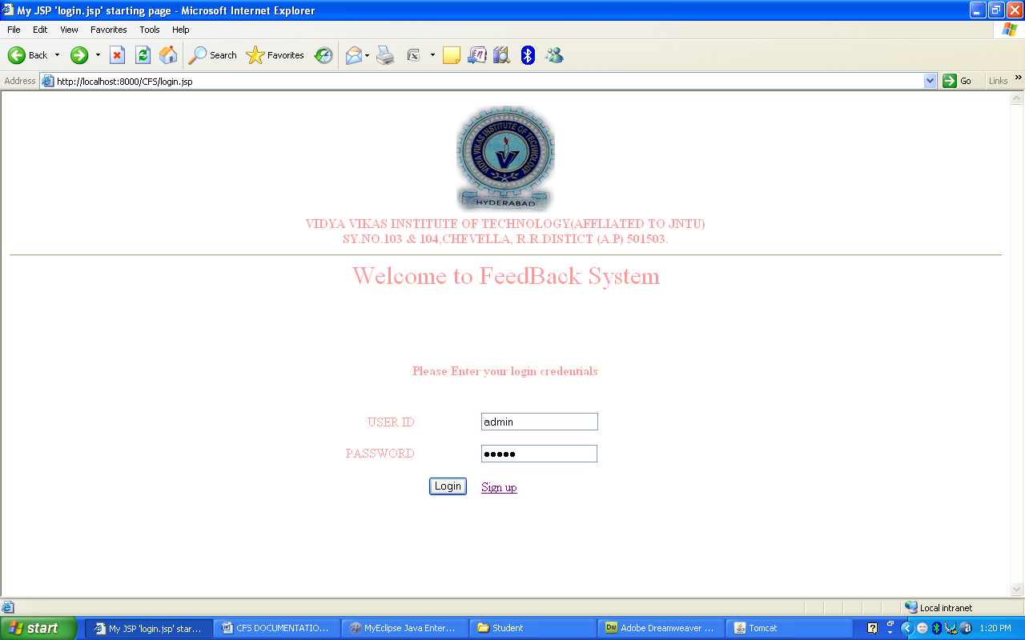

- This is login page for both student and admin
- Depends on the credentials client will be redirected to either admin home page or student feedback form page

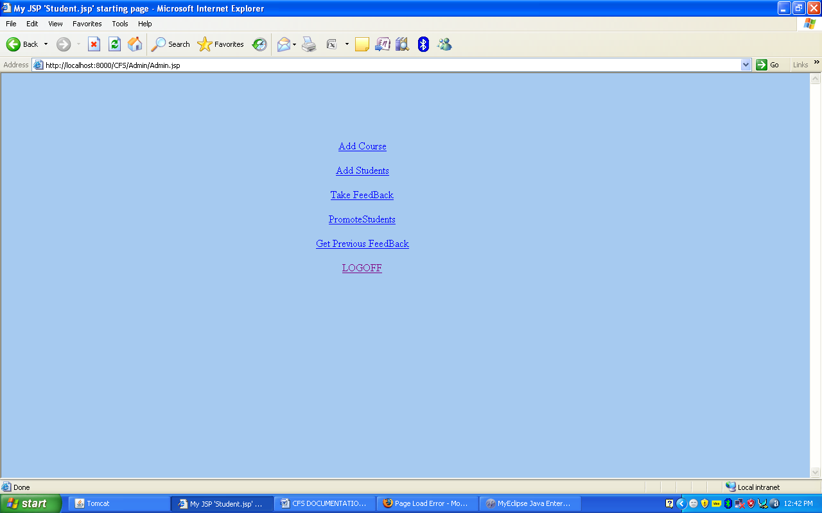

- This is Admin Home page in this he will have options Add a course to database
by entering the details of the course such as duration of the course ,number of branches , number
of subjects , subject names

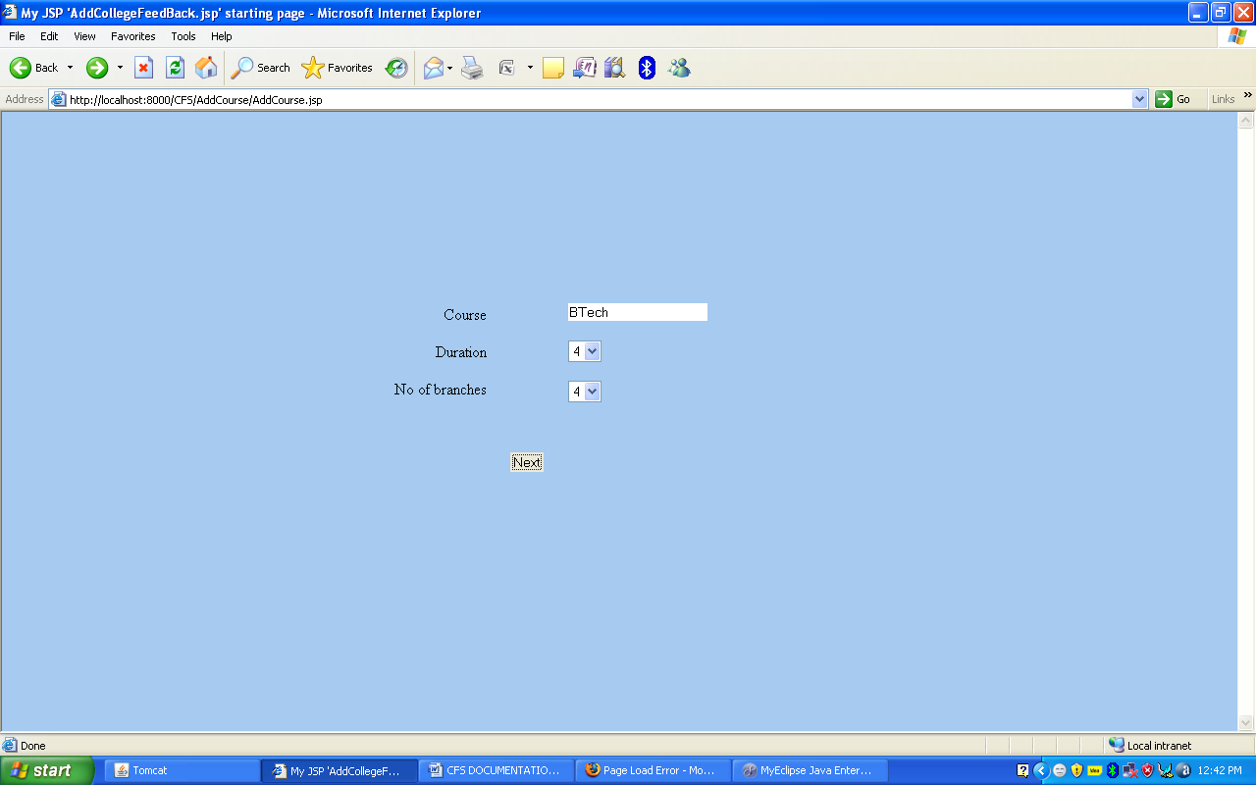

- In this page admin has to enter course name ,course duration number of branches
- After entering details ,he has to click next this will take him to next page

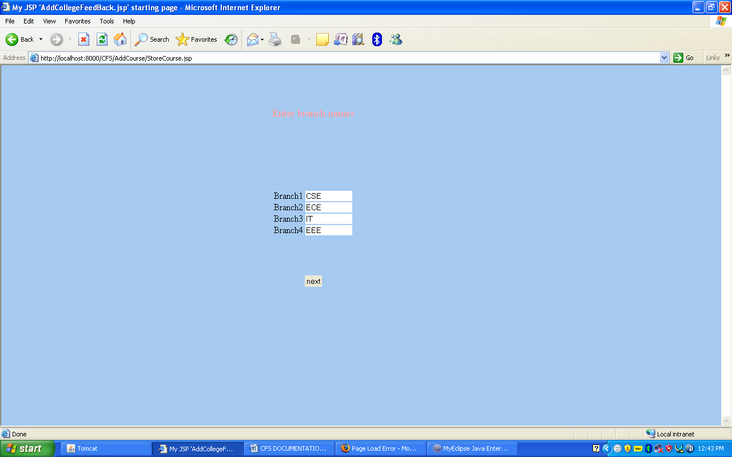

- In this page admin has to enter branch names and click next

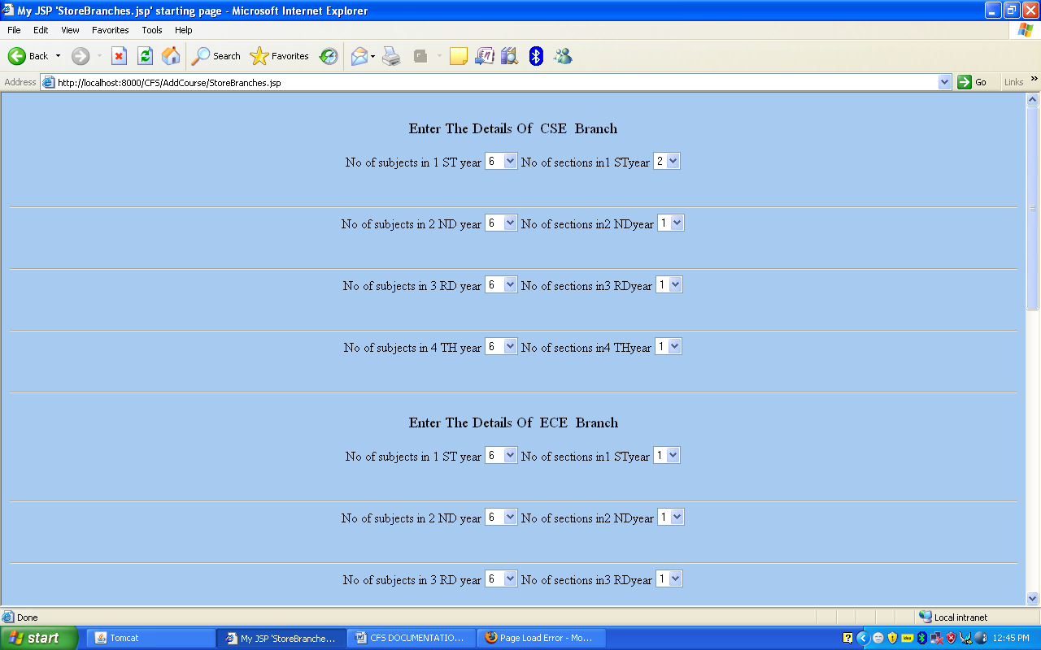

- In this page admin has to select Number of subjects and Number of sections for every year and branch

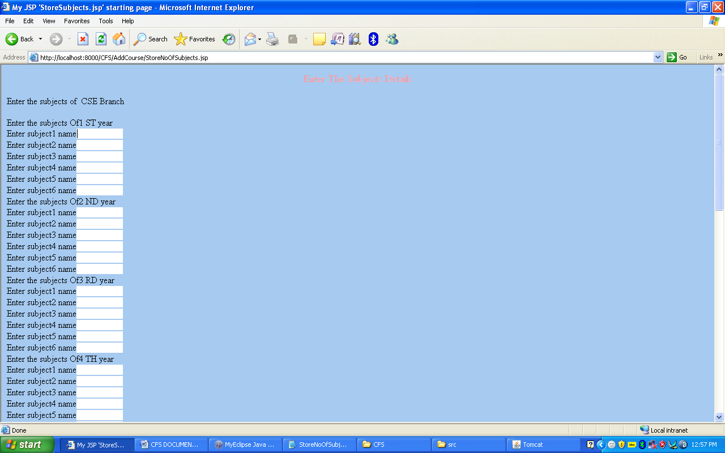

- In this page admin has to enter subjects of every branch and year and click next

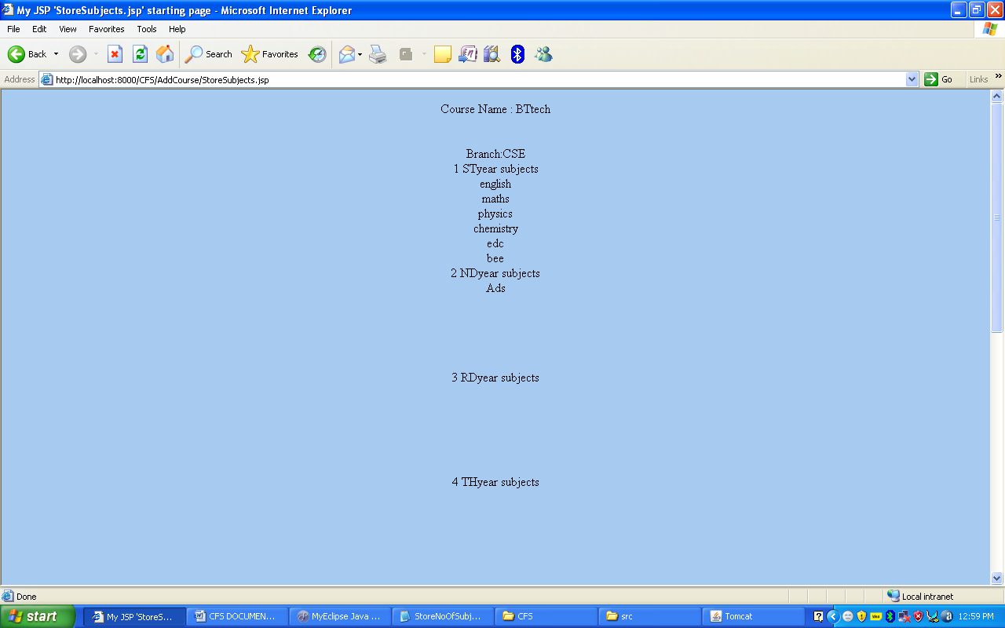
- This page displays the summery of Course details after that he click the StoreToDB button details of course will be added to database

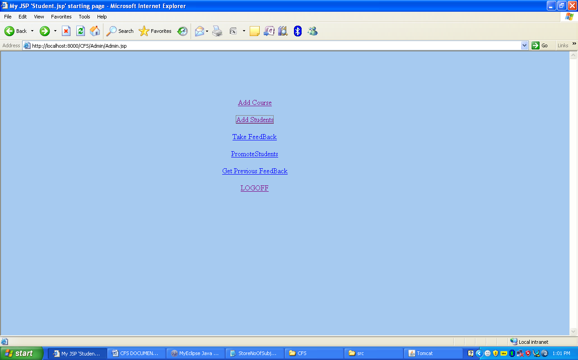

- From admin home page if he clicks on Takefeedback he will be redirected to a page where drop down control is present Which contains all course present in the database he have to select one and click next and then he have to select branch year section and finally click on Takefeedback

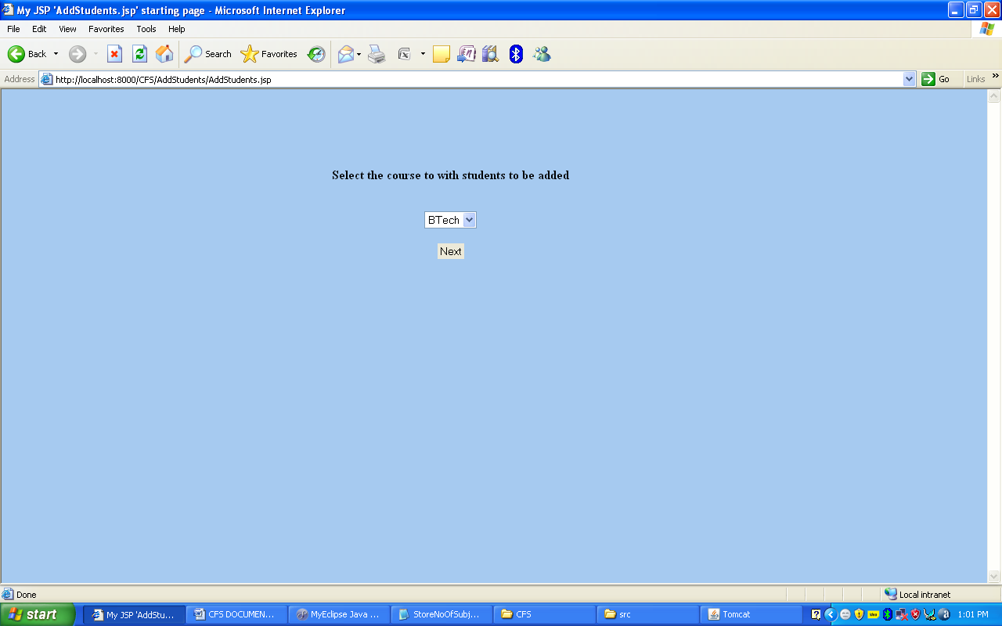
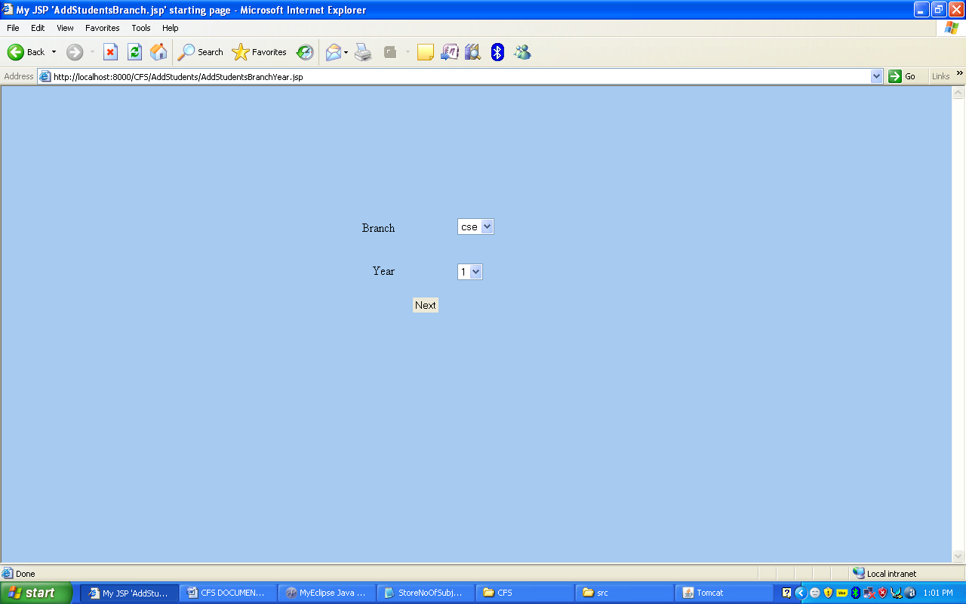
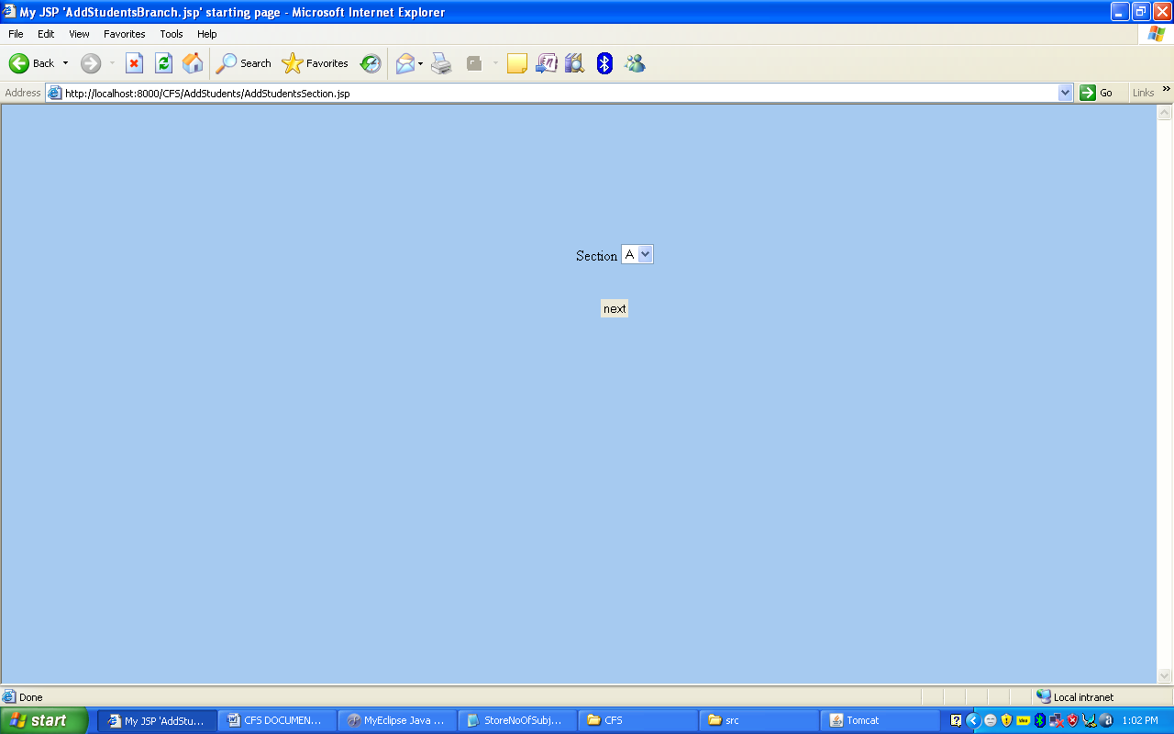

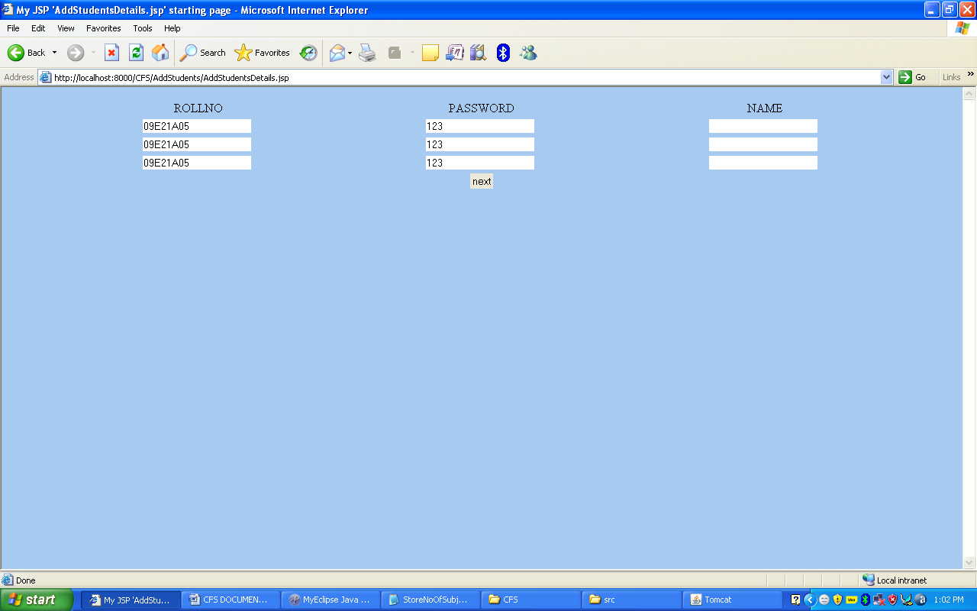

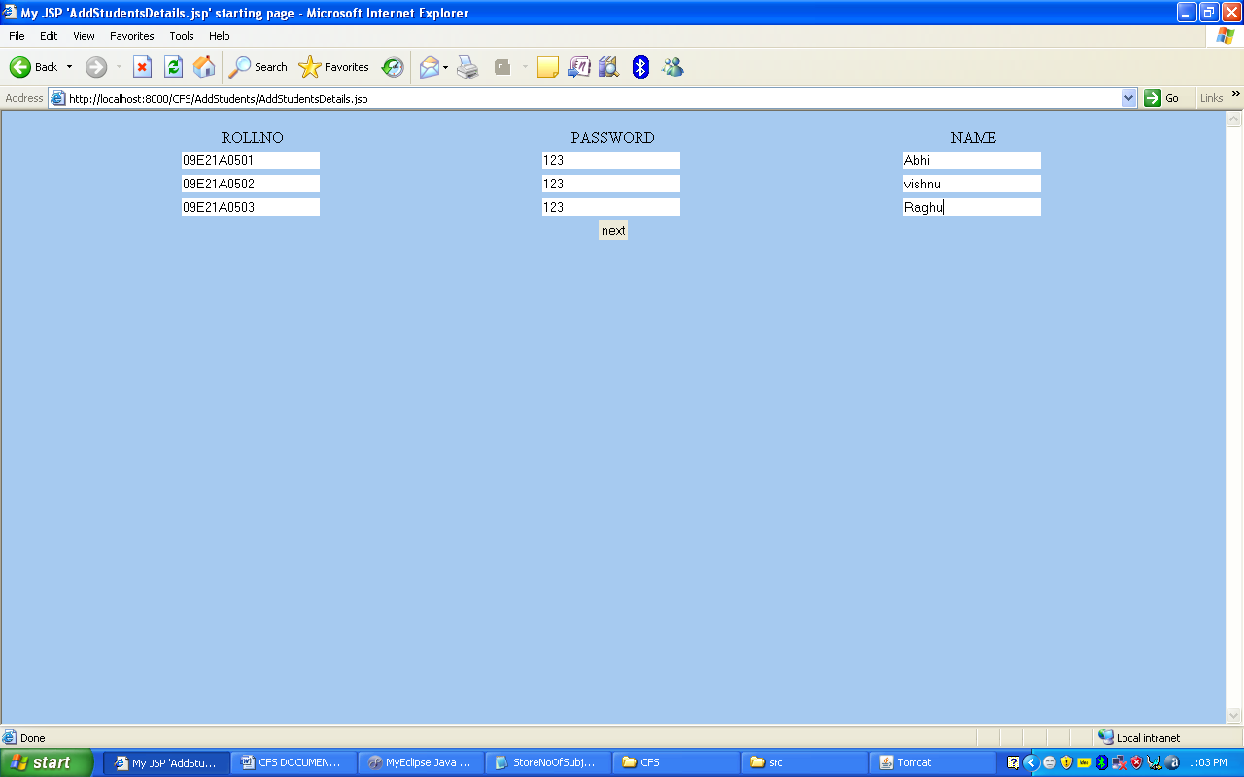
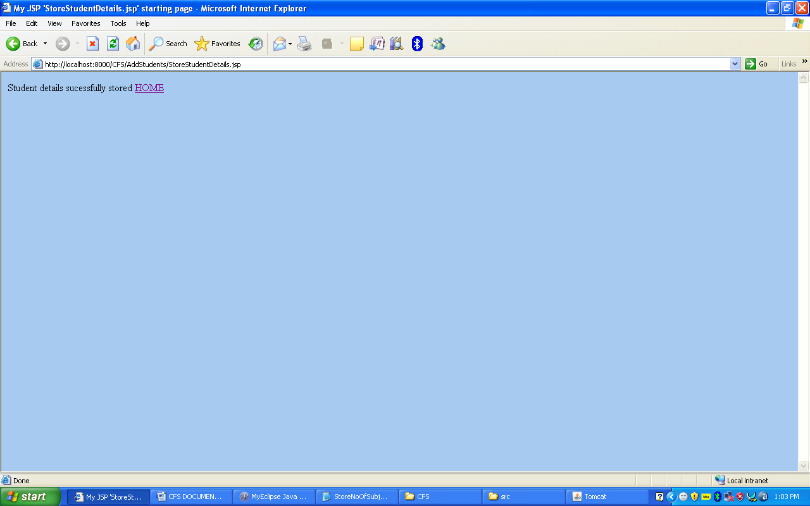

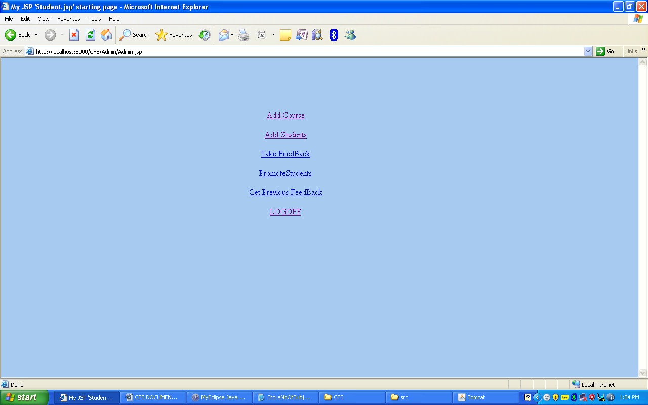

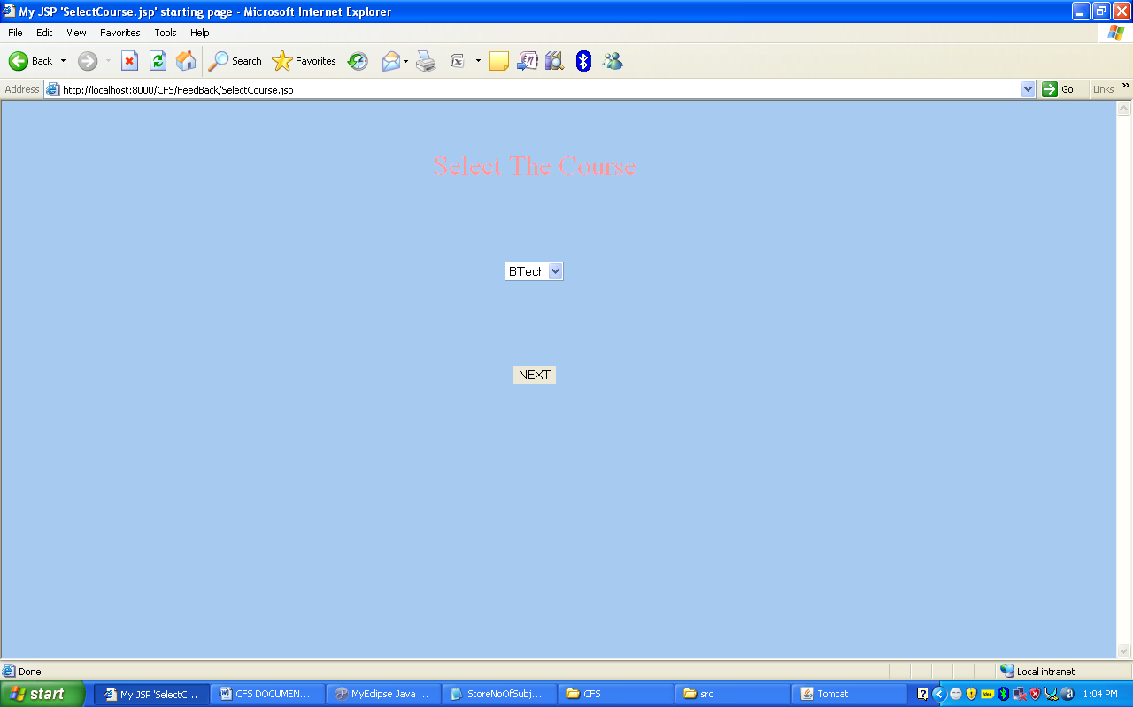

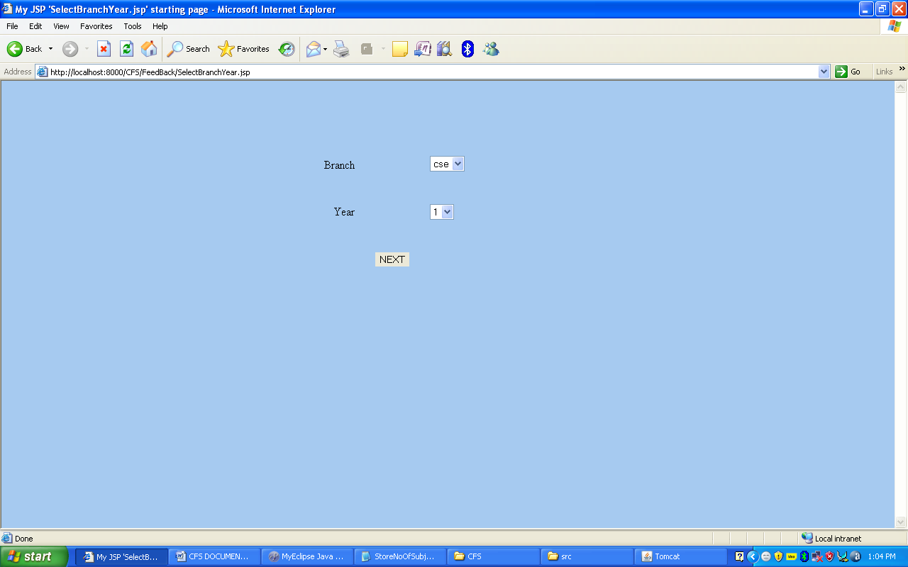

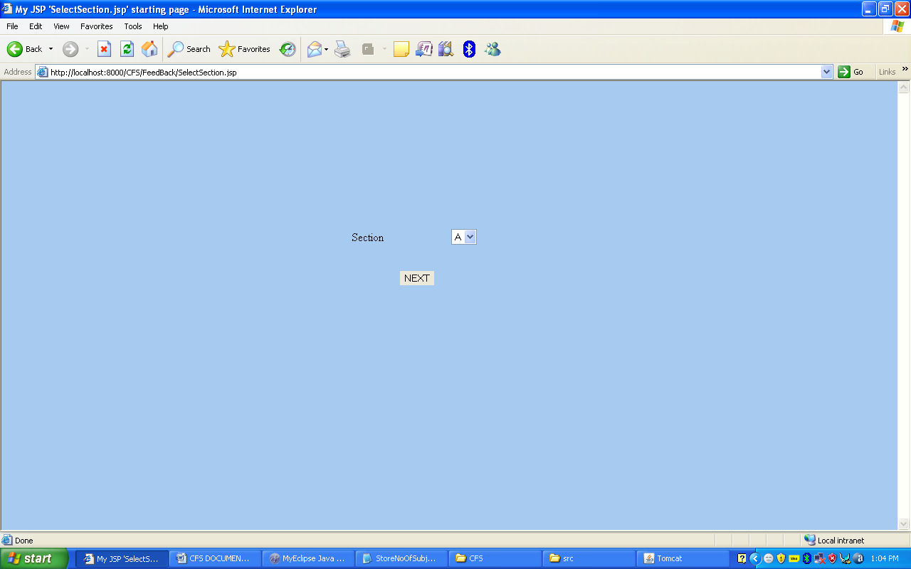
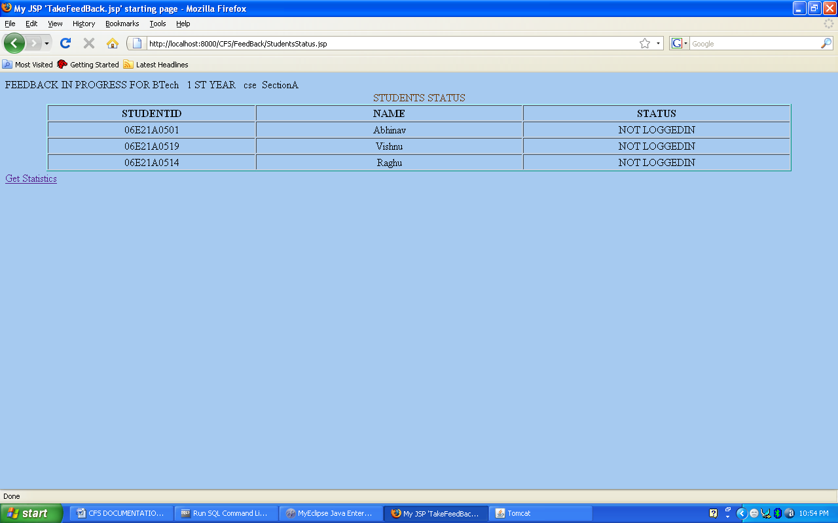

- After selecting on section as soon he clicks on next he will be redirected
to a page where status of the students
with his name and roll number is will be displayed student status will be updated
for every 3 seconds

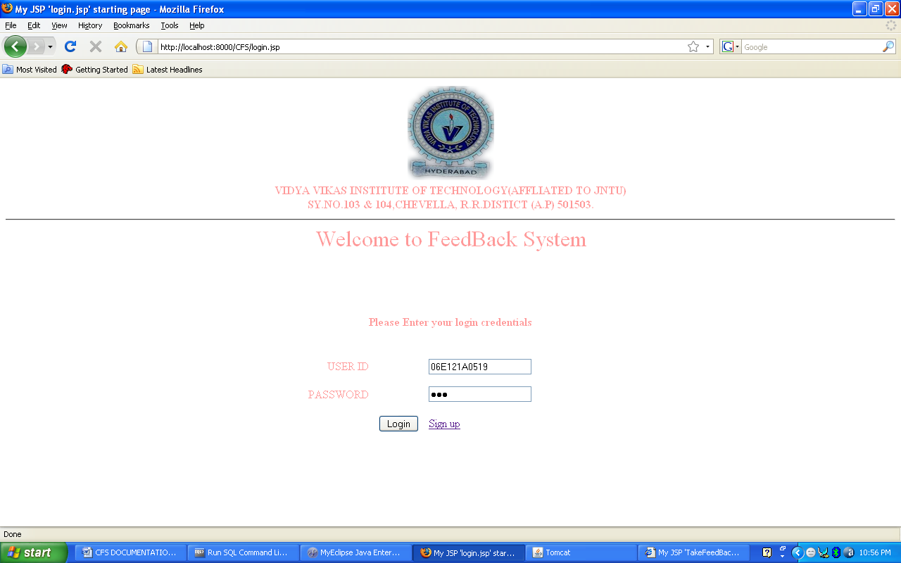

- Soon after students login his credentials will be validated if it is valid he will be directed to page where students feed back form will be displayed in which he have select to radio button for every feature . He have to repeated this for every subject

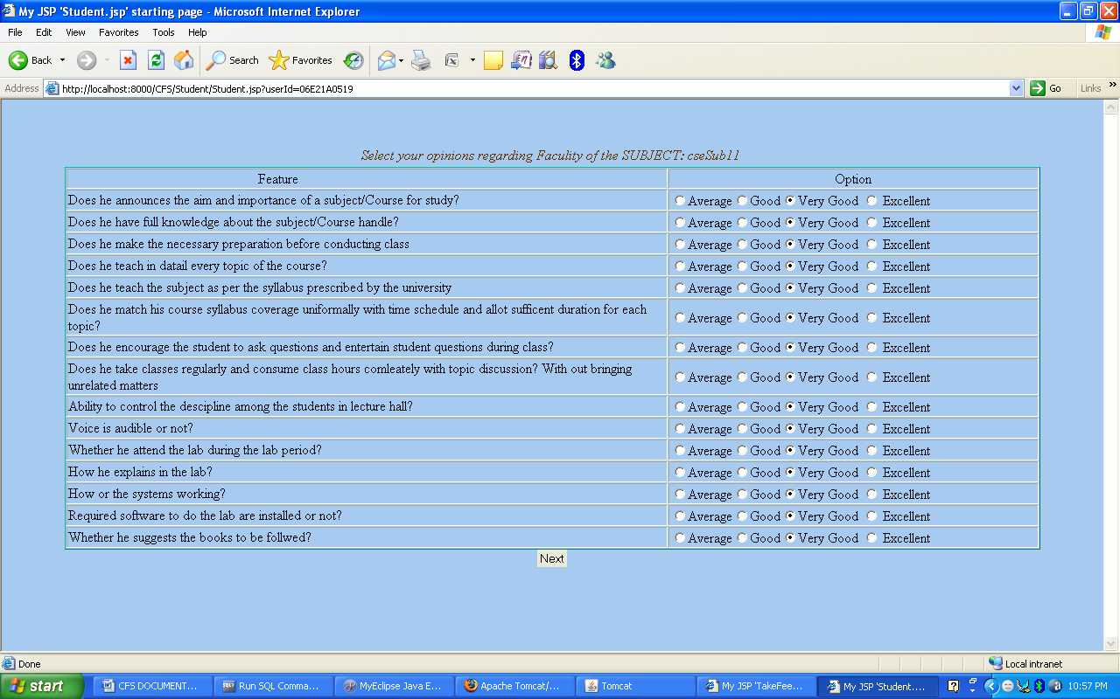
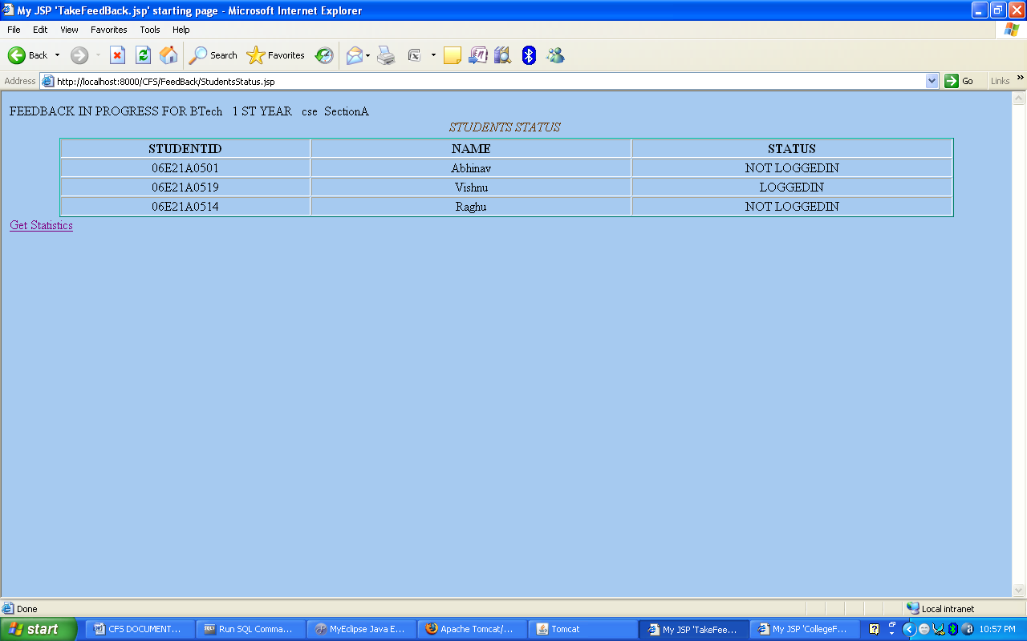

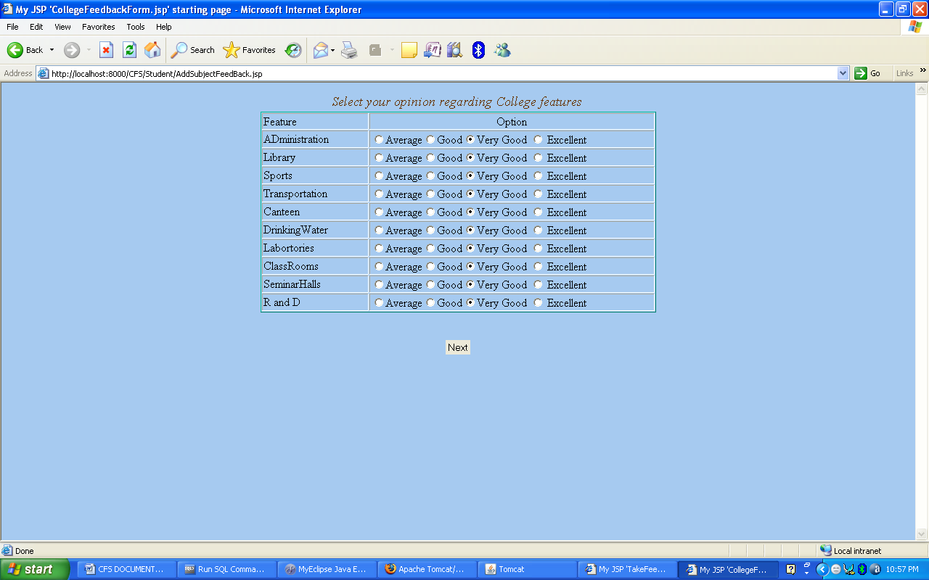

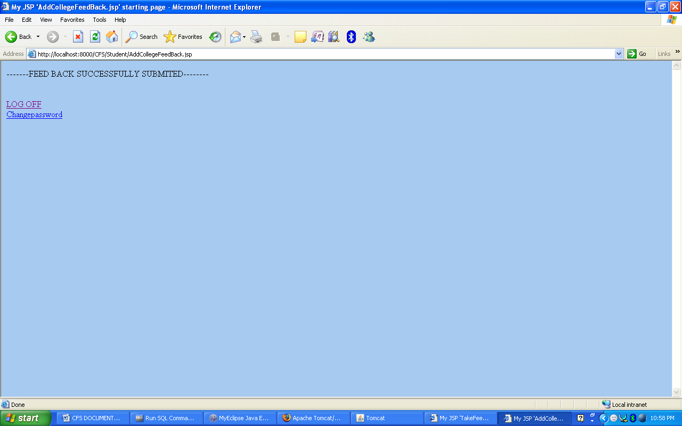
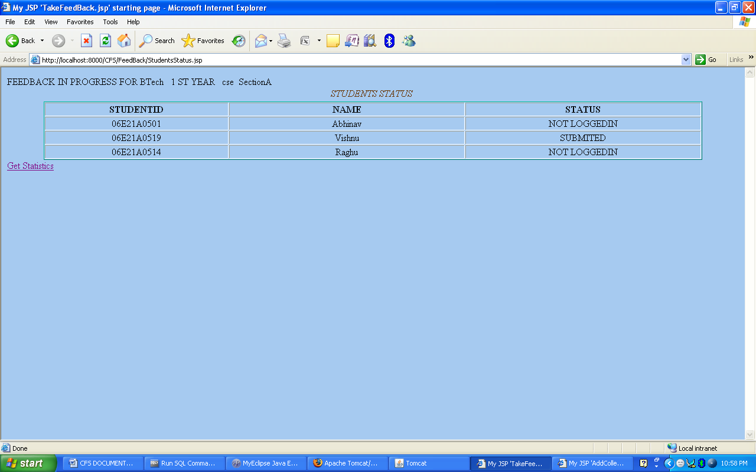
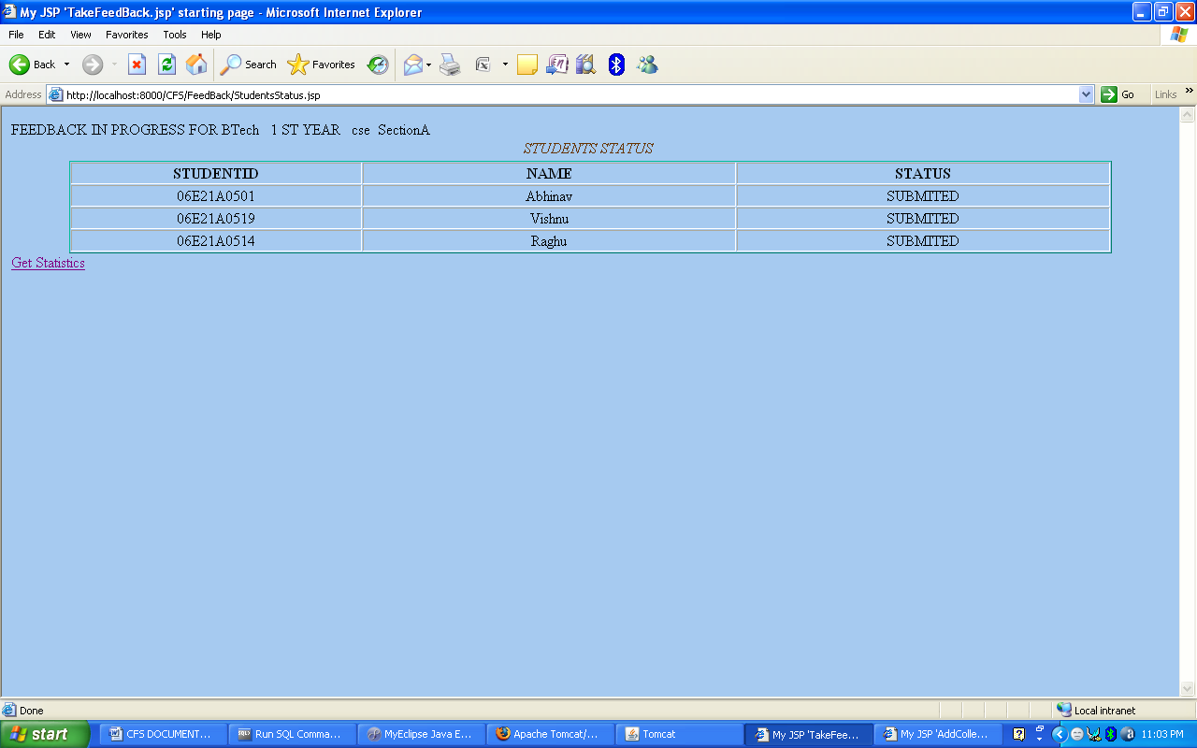

- Soon after all students submit feed back
admin has to click on GetStatistics hyperlink he will be redirected to page where all subjects are displayed

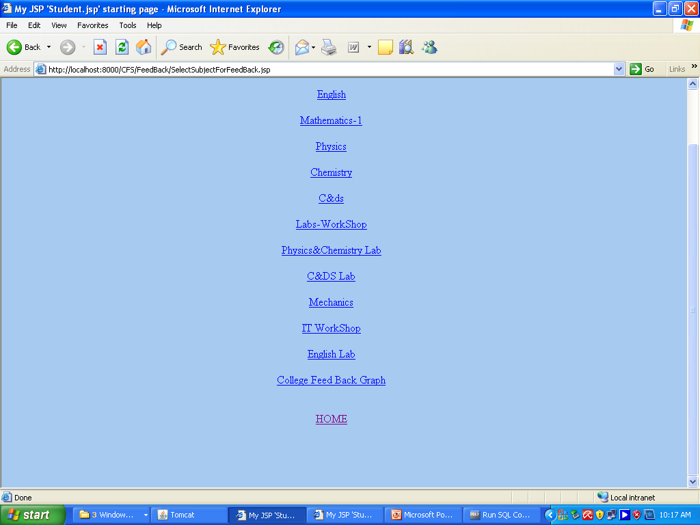

- When particular subject is selected
statistics of the subject is displayed in percentages for every feature
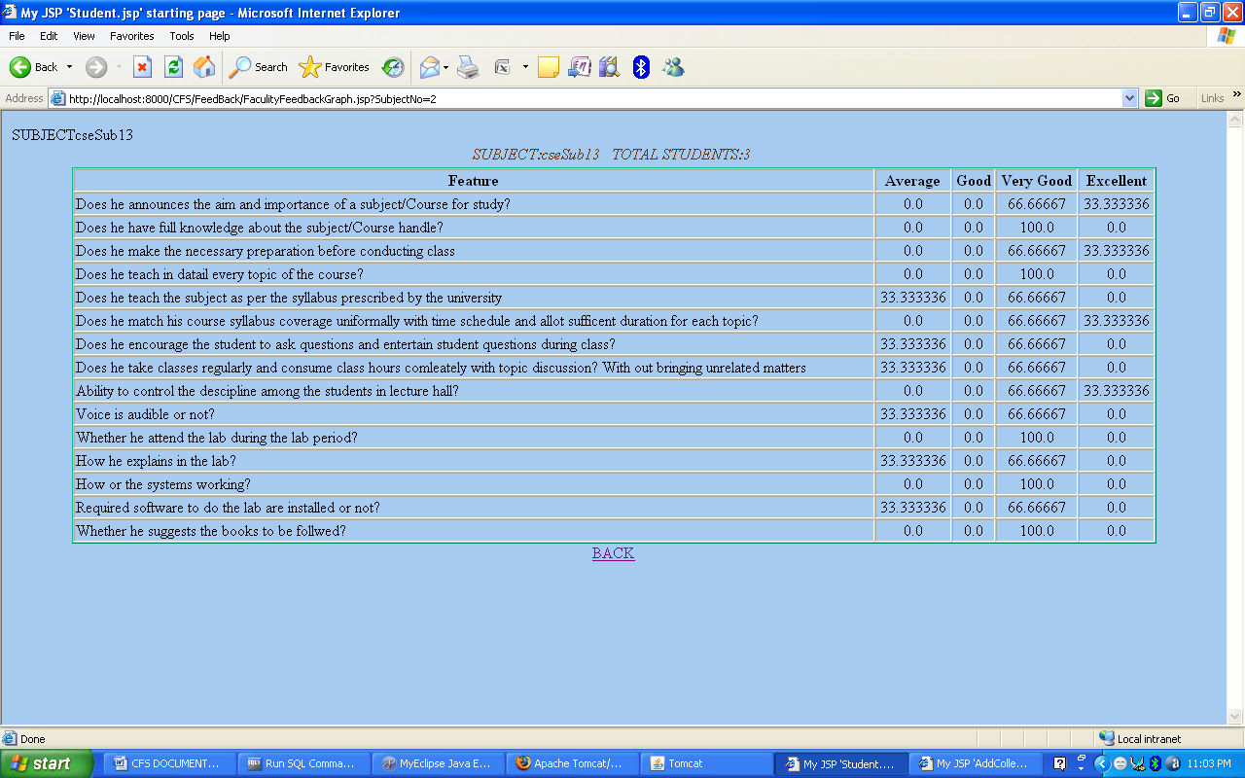
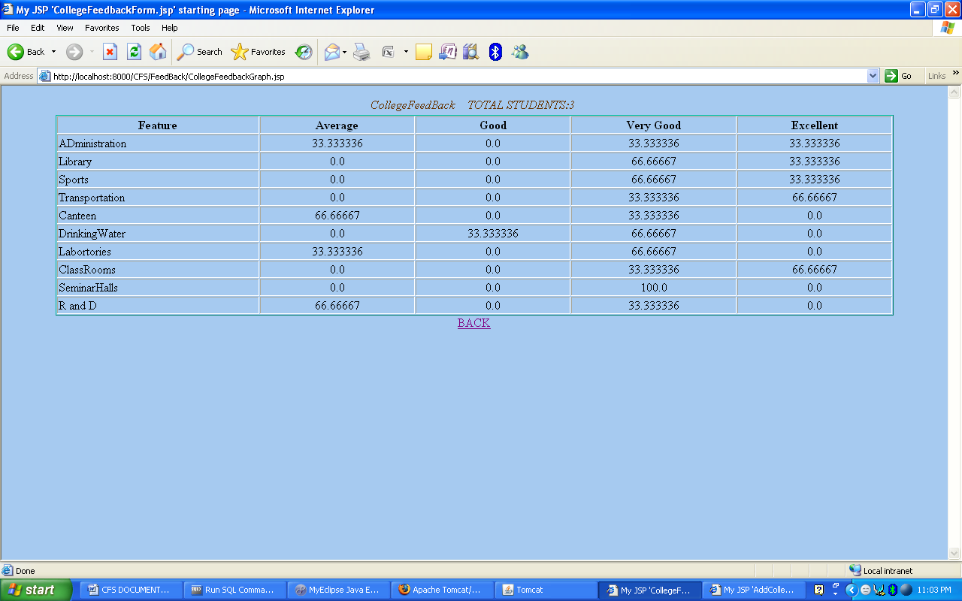
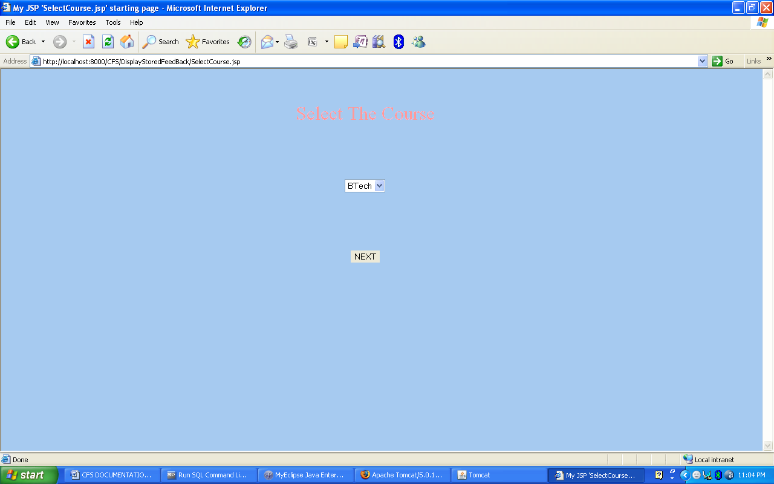
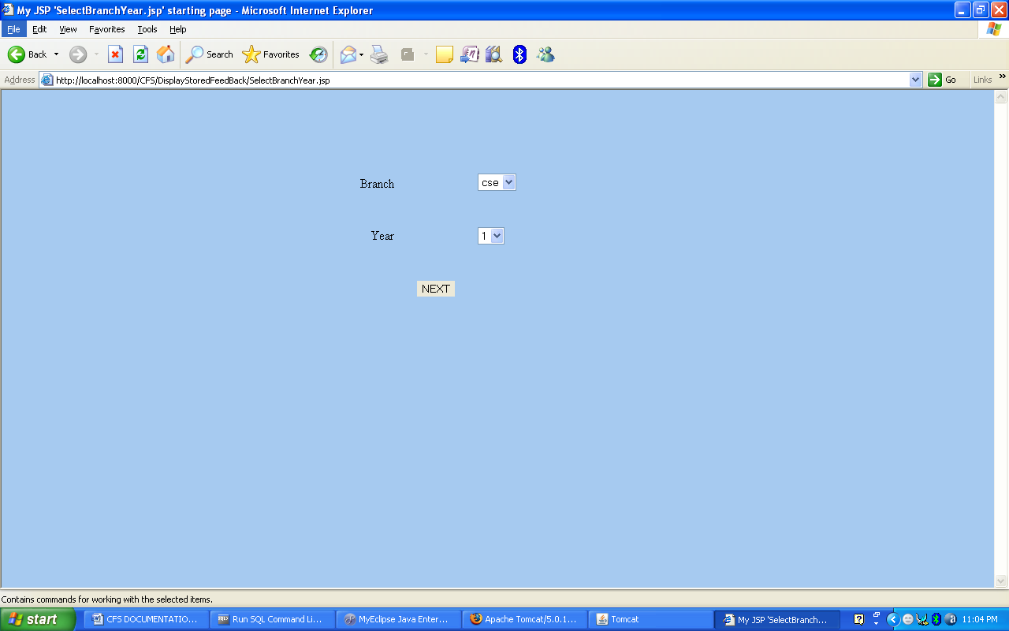
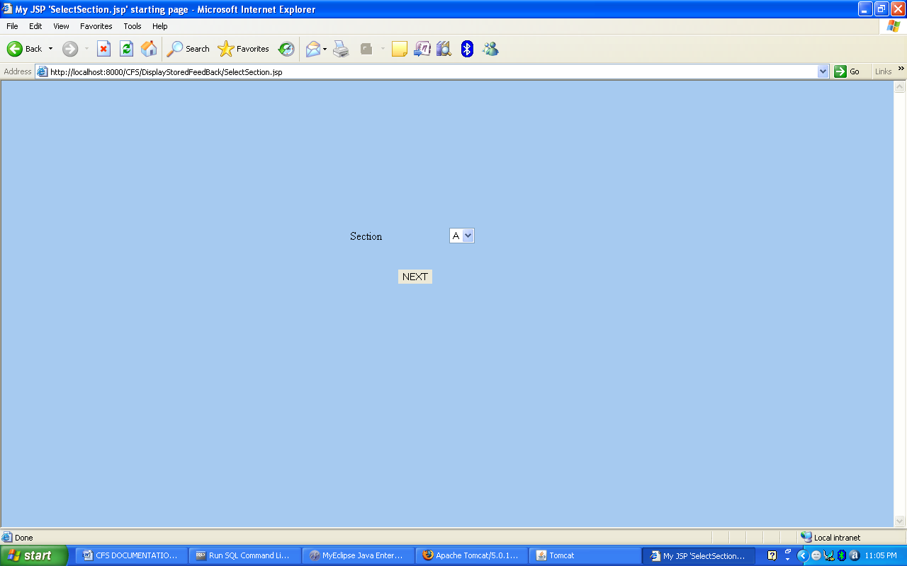

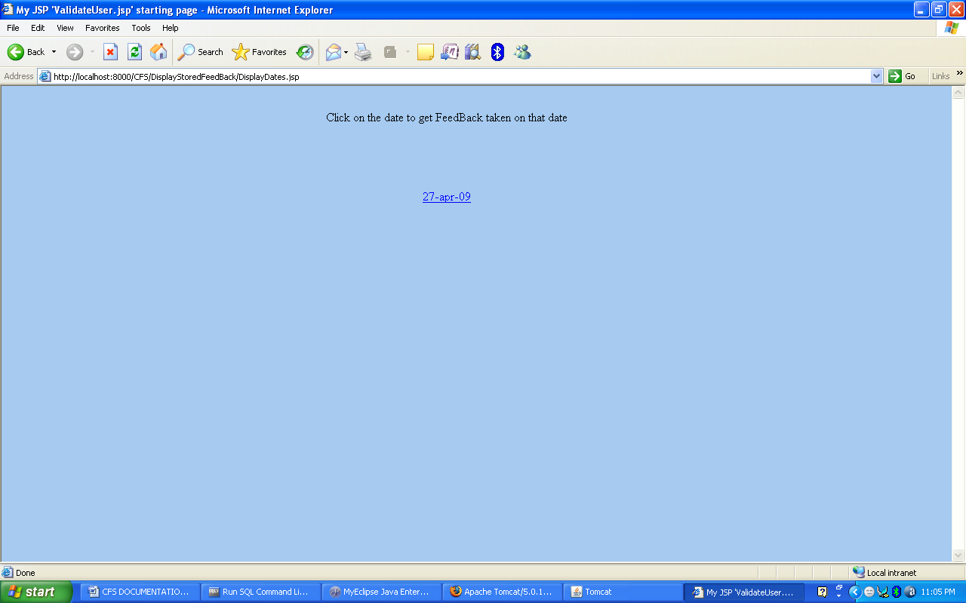
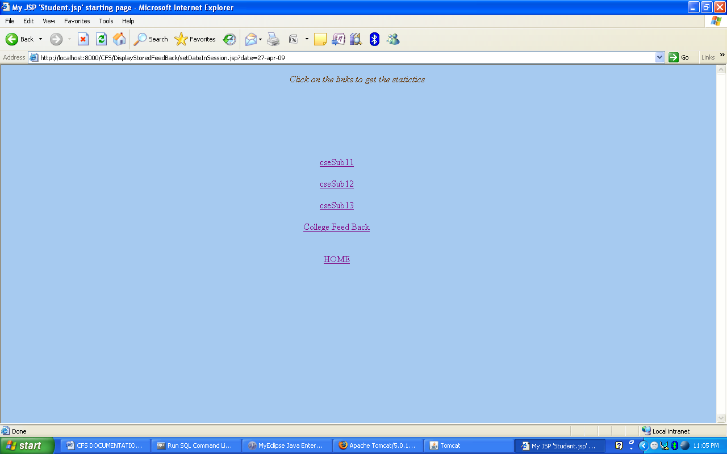

8.CONCLUSION

This application software has been computed successfully and was also tested successfully by taking “test cases”. It is user friendly, and has required options, which can be utilized by the user to perform the desired operations.

The software is developed using Java as front end and Oracle as back end in Windows environment. The goals that are achieved by the software are:

- Instant access.
- Improved productivity.
- Optimum utilization of resources.
- Efficient management of records.
- Simplification of the operations.
- Less processing time and getting required information.
- User friendly.
- Portable and flexible for further enhancement.
- It has thoroughly tested and implemented.

9.Bibliography

Core Java™ 2 Volume I – Fundamentals 7th Edition | - Cay S. Hortsman
Pearson Education – Sun Microsystems | Gary Cornell
Core Java™ 2 Volume II – Advanced | - Cay S. Hortsman
Pearson Education – Sun Microsystems | Gary Cornell
Effective Java – Programming Language Guide | - Joshua Bloch
Pearson Education – Sun Microsystems
Java Database Best Practices | - George Reese
O’Reilly – SPD1
Some preferred websites : www.bruceeckel.com
www.sun.com/j2se

