|  |
| --- |
| IEE PROJECT |
| SMART WATER HEATER |
| To Lead a smart life |

|  |
| --- |
| By : Karthik.J (080)  Jayaswini.T (079)  Keerthana.ch(081)  02/04/19 |

Abstract

Heater is an essential element in our day to day lives.

Domestically water is heated in vessels, kettles. But this heating technique is made easy, is improved by heaters.

Water heaters are becoming increasingly attractive in these days. They are made available to all people at a very low cost.

Existing electric water heaters can become inefficient through the overheating of water and through parasitic heat loss. Efforts are made continuously to make them more efficient. But these heaters become easily damaged when they are over heated.

Think once when we forget to switch off the heater, it gets heated more and more and sometimes may result in a small explosion!!!

This is where smart water heaters come into picture. Smart water heaters are specially designed to heat the water to a required particular temperature. Smart water heater allows the user to set a particular temperature to the heater which prevents the heater from overheating.

This heater mainly consists of a sensor embedded in it which senses a particular temperature and heats accordingly. This reduces the main cause that damages the heater. Even in case of any delay this smart heater gives an indication which cautions us.

Basically smart water heaters give us the idea of control of heating of water up to a desired temperature.

INDEX

Contents:

* Introduction
* Description of components:

1. Arduino
2. Bread board
3. Motor driver
4. 7 grid LED
5. Limiting Resistors
6. Pull up Resistors
7. Pull down Resistors
8. Sensor

* Description of project:

1. Introduction
2. Working
3. Construction

* Conclusion

INTRODUCTION

The temperature of the water to be tested is tested by a DS18b20 sensor. The sensor consists of a Analog to digital convertor. It senses the temperature in terms of current and time and sends the digital value to the arduino uno. Here the output from the sensor is hen sent to the 7 segment led display and the temperature is displayed.

In this project two power sources are used - (9 V battery). One is connected to the arduino while is connected to motor driver. The arduino power supply is used to power the Led while the other is used by the sensor.

As the temperature keeps on increasing, once it reaches the threshold temperature the arduino sends signal to the buzzer and the sound is heard.

ARDUINO

**Arduino Uno** is a microcontroller board based on the ATmega328P . It has 14 digital input/output pins (of which 6 can be used as PWM outputs), 6 analog inputs, a 16 MHz quartz crystal, a USB connection, a power jack, an ICSP header and a reset button. It contains everything needed to support the microcontroller; simply connect it to a computer with a USB cable or power it with a AC-to-DC adapter or battery to get started.

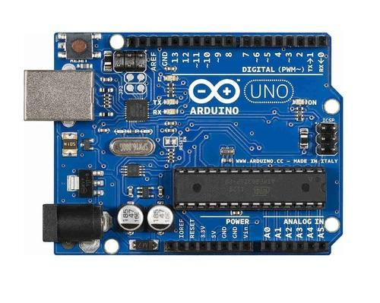

## Introduction to the Arduino Board:

Looking at the board from the top down, this is an outline of what you will see (parts of the board you might interact with in the course of normal use are highlighted):

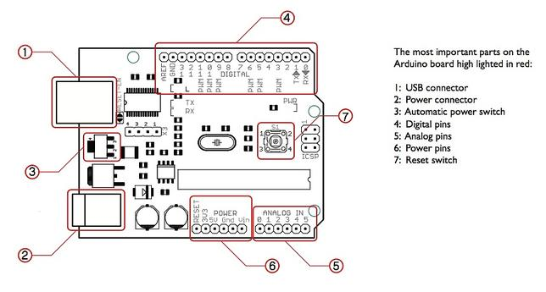

* Digital Ground (4)
* Digital Pins 2-13 (4)
* Digital Pins 0-1/Serial In/Out - TX/RX (4) - These pins cannot be used for digital i/o (**digitalRead** and **digitalWrite**) if you are also using serial communication (e.g. **Serial.begin**).
* Reset Button – (7)
* In-circuit Serial Programmer
* Analog In Pins 0-5 (5)
* Power and Ground Pins (6)
* External Power Supply (2)
* Toggles External Power and USB Power (place jumper on two pins closest to desired supply) - SV1 (3)
* USB (used for uploading sketches to the board and for serial communication between the board and the computer; can be used to power the board) (1)

Features:

1. MEMORY:  
The Arduino Uno has 32 KB memory. It comes with 2 KB of SRAM and also 1 KB of EEPROM (EEPROM library is required to read or write into this).  
  
2. CLOCK SPEED:  
The performance of this controller is based on its clock speed. The Clock speed of the Arduino is 16 Mhz so it can perform a particular task faster than the other processor or controller  
  
3. USB INTERFACE:  
Most important feature of Arduino Uno is USB connectivity. It means if we want to operate Arduino with PC, then we can do that and data communication between PC and Arduino become easy.  
  
4. INPUT OUTPUT VOLTAGE:  
The Arduino Uno can be powered via the USB connection or with an external power supply. If we are using external power then we can supply 6 to 20 volts. Arduino works on 5 volts.  
  
5. INPUT OUTPUT PINS:  
Each of the 14 digital pins on the Uno can be used as an input or output. 6 pins out of 14 can be used as PWM output. 6 pins can be used as analog pins.

BREAD BOARD

A breadboard is a solderless device for temporary prototype with electronics and test circuit designs. Most electronic components in electronic circuits can be interconnected by inserting their leads or terminals into the holes and then making connections through wires where appropriate.

The breadboard has strips of metal underneath the board and connects the holes on the top of the board. The metal strips are laid out as shown below. Note that the top and bottom rows of holes are connected horizontally and split in the middle while the remaining holes are connected vertically.

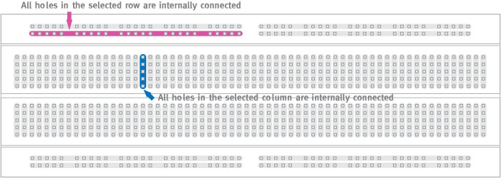

Temperature sensor

The DS18B20 Digital Thermometer provides 9 to 12-bit (configurable) temperature readings which indicate the temperature of the device. The DS18B20 communicates over a 1-Wire bus that by definition requires only one data line (and ground) for communication with a central microprocessor. In addition, the DS18B20 can derive power directly from the data line (“parasite power”), eliminating the need for an external power supply. This sensor has been included in many applications such as Thermostatic Controls, Industrial Systems, Consumer Products,Thermometers,Thermally Sensitive Systems.

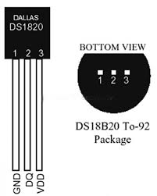

Features:

* Power supply range is 3.0V to 5.5V
* Measures temperatures from -55°C to +125°C. Fahrenheit equivalent is -67°F to +257°F
* ±0.5°C accuracy from -10°C to +85°C
* Converts 12-bit temperature to digital word in 750 ms (max.)
* Can be powered from data line
* Water proof

MOTOR DRIVER

The L298N is a dual H-Bridge motor driver which allows speed and direction control of two DC motors at the same time. The module can drive DC motors that have voltages between 5 and 35V, with a peak current up to 2A.

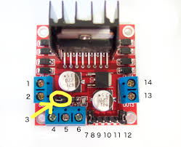

The module has two screw terminal blocks for the motor A (1,2) and B(13,14), and another screw terminal block for the Ground pin, the VCC for motor and a 5V pin which can either be an input or output.

This depends on the voltage used at the motors VCC. The module have an onboard 5V regulator which is either enabled or disabled using a jumper. If the motor supply voltage is up to 12V we can enable the 5V regulator (3) and the 5V pin can be used as output, for example for powering our Arduino board. But if the motor voltage is greater than 12V we must disconnect the jumper because those voltages will cause damage to the onboard 5V regulator. In this case the 5V pin will be used as input as we need connect it to a 5V power supply in order the IC to work properly.

Features:

High operating voltage, which can be up to 40 volts.  
Large output current, the instantaneous peak current can be up to 3A

With 25W rated power

Drive voltage: 5-35V

7 SEGMENT LED

A **seven-segment display** (**SSD**), or **seven-segment indicator**, is a form of electronic display device for displaying decimal numerals that is an alternative to the more complex dot matrix displays.

Seven-segment displays are widely used in digital clocks, electronic meters, basic calculators, and other electronic devices that display numerical information.

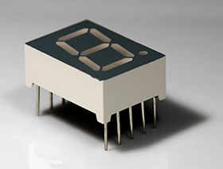

1. The Common Cathode (CC) – In the common cathode display, all the cathode connections of the LED segments are joined together to logic “0” or ground. The individual segments are illuminated by application of a “HIGH”, or logic “1” signal via a current limiting resistor to forward bias the individual Anode terminals (a-g).

**Common Cathode 7-segment Display**

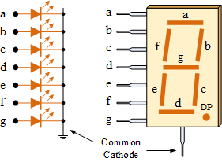

2. The Common Anode (CA) – In the common anode display, all the anode connections of the LED segments are joined together to logic “1”. The individual segments are illuminated by applying a ground, logic “0” or “LOW” signal via a suitable current limiting resistor to the Cathode of the particular segment (a-g).

**Common Anode 7-segment Display**

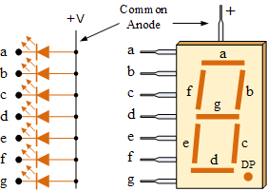

In general, common anode displays are more popular as many logic circuits can sink more current than they can source. Also note that a common cathode display is not a direct replacement in a circuit for a common anode display and vice versa, as it is the same as connecting the LEDs in reverse, and hence light emission will not take place.

1. The Common Cathode (CC) – In the common cathode display, all the cathode connections of the LED segments are joined together to logic “0” or ground. The individual segments are illuminated by application of a “HIGH”, or logic “1” signal via a current limiting resistor to forward bias the individual Anode terminals (a-g).

### 7-Segment Display Segments for all Numbers.

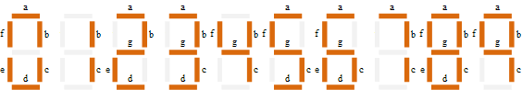

PULL UP RESISTOR AND PULL DOWN RESISTOR

In electronic logic circuits, a pull-up resistor or pull-down resistor is a resistor used to ensure a known state for a signal. It is typically used in combination with components such as switches and transistors, which physically interrupt the connection of subsequent components to ground or to VCC.

The most common method of ensuring that the inputs of digital logic gates and circuits can not self-bias and float about is to either connect the unused pins directly to ground (0V) for a constant low “0” input, (OR and NOR gates) or directly to Vcc (+5V) for a constant high “1” input (AND and NAND gates).

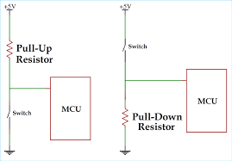

PROJECT DESCRIPTION

INTRODUCTION:

The temperature of the water to be tested is tested by a DS18b20 sensor. The sensor consists of a Analog to digital convertor. It senses the temperature in terms of current and time and sends the digital value to the arduino uno. Here the output from the sensor is hen sent to the 7 segment led display and the temperature is displayed.

In this project two power sources are used - (9 V battery). One is connected to the arduino while is connected to motor driver. The arduino power supply is used to power the Led while the other is used by the sensor.

As the temperature keeps on increasing, once it reaches the threshold temperature the arduino sends signal to the buzzer and the sound is heard.

Components used :

* Arduino uno
* DS18b20 water proof sensor
* Resistor
* R – 4.7kohms
* R – 1kohms
* Buzzer
* Jumping wires
* 2 - 9V batteries
* Motor driver
* Push buttons
* Bread board
* 7 segment Led display

Working:

As per the connections, the sensor senses the temperature and gives the output to the Arduino where the data pin is connected which is an input to the Arduino. This input is processed in the microprocessor as per the program and the corresponding temperature is printed on the LED. The sensor (l298n) gives the output in digital values as it already had inbuilt analogue to digital converter. The input taken from the Arduino is only 5V which is not sufficient; hence a motor driver is used to give power supply to sensor. The sensor takes input through the motor driver through pull up resistor and keeps noticing the changes in the temperature and corresponding changes are processed in the Arduino and printed on the LED. The same process continues until the threshold temperature is reached, once that particular temperature is reached the current flows through the buzzer and the buzzer rings. As soon as the buzzer rings the user will get to know and the water can be heated to the particular temperature.

CONCLUSION

Ever since the invention of water heaters, cold and harsh weather conditions have become bearable for people. Winters are no longer freezing months. Water heaters provide a ready supply of hot water whenever required. But we often face a problem where the water is over heated or the heater is damaged within a short span of time due to overheating.

The main scope of this project is to design a water heater which can sense the temperature and alert the user when it is overheating. This project will monitor the temperature of the given water sample and when the water is heated up to the threshold temperature (set by the user) the buzzer is turned on and the user can now turn off the heater. This way the heater can be protected from damage and its life span increases.