Fundamentals of Data Science - Lab Manual
Question 4
Total yearly sales and percentage increase
AIM:
To calculate the total sales for the year and the percentage increase in sales from the first quarter to the fourth quarter using NumPy arithmetic operations.
ALGORITHM:
Step 1: Start the program and import NumPy.
Step 2: Store the four quarterly sales amounts in the array sales_data.
Step 3: Calculate the total sales using np.sum().
Step 4: Calculate the percentage increase = (Q4 - Q1) / Q1 x 100.
Step 5: Display the total sales and the percentage increase.
Step 6: Stop the program.
PROGRAM:
import numpy as np

sales_data = np.array([250000, 280000, 310000, 350000]) # Q1 to Q4

total_sales = np.sum(sales_data)
increase = (sales_data[3] - sales_data[0]) / sales_data[0] * 100

print("Quarterly sales :", sales_data)
print("Total sales for the year :", total_sales)
print(f"Percentage increase Q1 to Q4: {increase:.2f}%")
INPUT:
Quarter | Q1 | Q2 | Q3 | Q4
Sales amount | 250000 | 280000 | 310000 | 350000

OUTPUT:
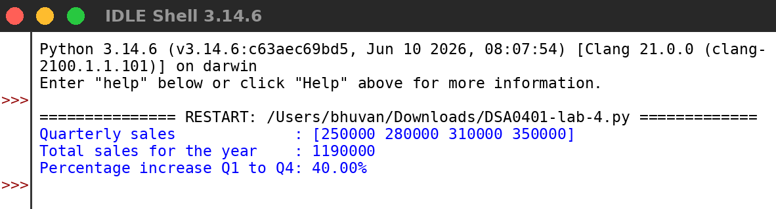
RESULT:
Thus the program was written and executed successfully and the output was verified.

