Fundamentals of Data Science - Lab Manual
Question 5
Average fuel efficiency and percentage improvement
AIM:
To use NumPy arrays and arithmetic operations to calculate the average fuel efficiency and the percentage improvement in fuel efficiency between two car models.
ALGORITHM:
Step 1: Start the program and import NumPy.
Step 2: Store the fuel efficiency (miles per gallon) of the car models in the array fuel_efficiency.
Step 3: Calculate the average fuel efficiency using np.mean().
Step 4: Select the two models to compare (Model 1 and Model 5).
Step 5: Calculate improvement % = (new - old) / old x 100.
Step 6: Display the average and the percentage improvement.
Step 7: Stop the program.
PROGRAM:
import numpy as np

fuel_efficiency = np.array([28.5, 32.0, 35.5, 30.0, 40.0]) # miles per gallon

average = np.mean(fuel_efficiency)

old_model, new_model = fuel_efficiency[0], fuel_efficiency[4] # Model 1 and Model 5
improvement = (new_model - old_model) / old_model * 100

print("Fuel efficiency (mpg) :", fuel_efficiency)
print(f"Average fuel efficiency : {average:.2f} mpg")
print(f"Improvement from Model 1 to 5: {improvement:.2f}%")
INPUT:
Model | 1 | 2 | 3 | 4 | 5
Fuel efficiency (mpg) | 28.5 | 32.0 | 35.5 | 30.0 | 40.0

OUTPUT:
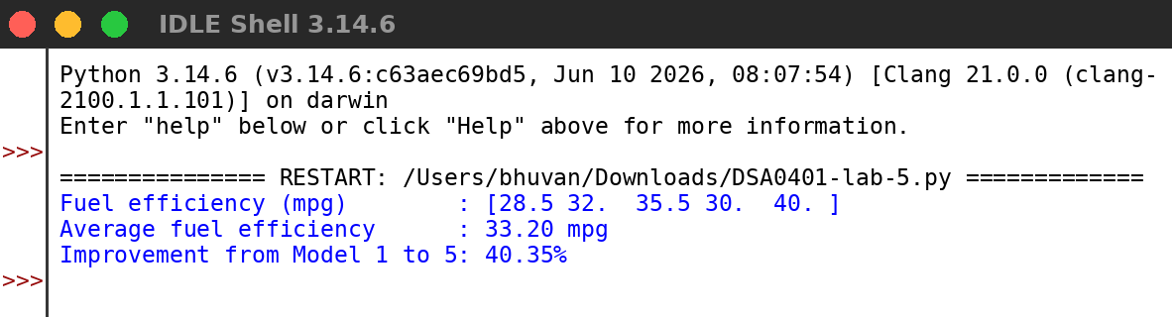
RESULT:
Thus the program was written and executed successfully and the output was verified.

