Fundamentals of Data Science - Lab Manual
Question 6
Total cost with discount and tax
AIM:
To calculate the total cost of a customer purchase, including discount and tax, from the item prices, quantities, discount rate and tax rate using arithmetic operations.
ALGORITHM:
Step 1: Start the program and import NumPy.
Step 2: Store item prices and quantities in two lists; set the discount rate and tax rate (in %).
Step 3: Compute the subtotal = sum(price x quantity).
Step 4: Compute the discount amount = subtotal x discount rate / 100 and subtract it.
Step 5: Compute the tax on the discounted amount = amount x tax rate / 100.
Step 6: Total cost = discounted amount + tax. Display the bill.
Step 7: Stop the program.
PROGRAM:
import numpy as np

prices = [50, 120, 30, 80] # price of each item
quantities = [2, 1, 5, 3] # quantity of each item
discount_rate = 10 # percent
tax_rate = 5 # percent

subtotal = np.sum(np.array(prices) * np.array(quantities))
discount = subtotal * discount_rate / 100
discounted_amount = subtotal - discount
tax = discounted_amount * tax_rate / 100
total_cost = discounted_amount + tax

print(f"Subtotal : {subtotal:.2f}")
print(f"Discount ({discount_rate}%) : {discount:.2f}")
print(f"After discount : {discounted_amount:.2f}")
print(f"Tax ({tax_rate}%) : {tax:.2f}")
print(f"Total cost to pay : {total_cost:.2f}")
INPUT:
Item | Price | Quantity
Item 1 | 50 | 2
Item 2 | 120 | 1
Item 3 | 30 | 5
Item 4 | 80 | 3

Discount rate = 10 % Tax rate = 5 %
OUTPUT:
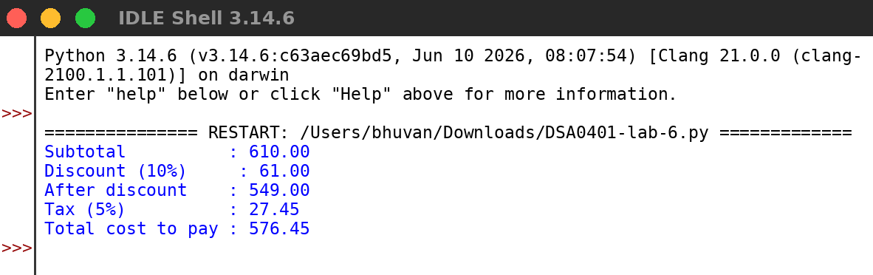
RESULT:
Thus the program was written and executed successfully and the output was verified.

