Fundamentals of Data Science - Lab Manual
Question 7
Customer order analysis using Pandas
AIM:
To use Pandas DataFrame operations to find the number of orders per customer, the average order quantity per product, and the earliest and latest order dates.
ALGORITHM:
Step 1: Start the program and import Pandas.
Step 2: Create the DataFrame order_data with columns customer ID, order date, product name and order quantity.
Step 3: Convert the order date column to datetime format.
Step 4: Group by customer ID and count the orders.
Step 5: Group by product name and find the mean of order quantity.
Step 6: Find the minimum and maximum of the order date column.
Step 7: Display the results and stop.
PROGRAM:
import pandas as pd

order_data = pd.DataFrame({
"customer_id": [101, 102, 101, 103, 102, 101, 104, 103, 105, 102],
"order_date": ["2026-09-01", "2026-09-03", "2026-09-04", "2026-09-06",
"2026-09-09", "2026-09-12", "2026-09-15", "2026-09-18",
"2026-09-21", "2026-09-27"],
"product_name": ["Laptop", "Mouse", "Mouse", "Keyboard", "Laptop",
"Keyboard", "Monitor", "Mouse", "Laptop", "Monitor"],
"order_quantity": [1, 3, 2, 2, 1, 4, 2, 5, 1, 2]})

order_data["order_date"] = pd.to_datetime(order_data["order_date"])

print(order_data)

print("\n1. Total number of orders by each customer")
print(order_data.groupby("customer_id").size())

print("\n2. Average order quantity for each product")
print(order_data.groupby("product_name")["order_quantity"].mean())

print("\n3. Earliest and latest order dates")
print("Earliest order date:", order_data["order_date"].min().date())
print("Latest order date :", order_data["order_date"].max().date())
INPUT:
order_data - Pandas DataFrame with 10 orders (shown in the output below).
OUTPUT:
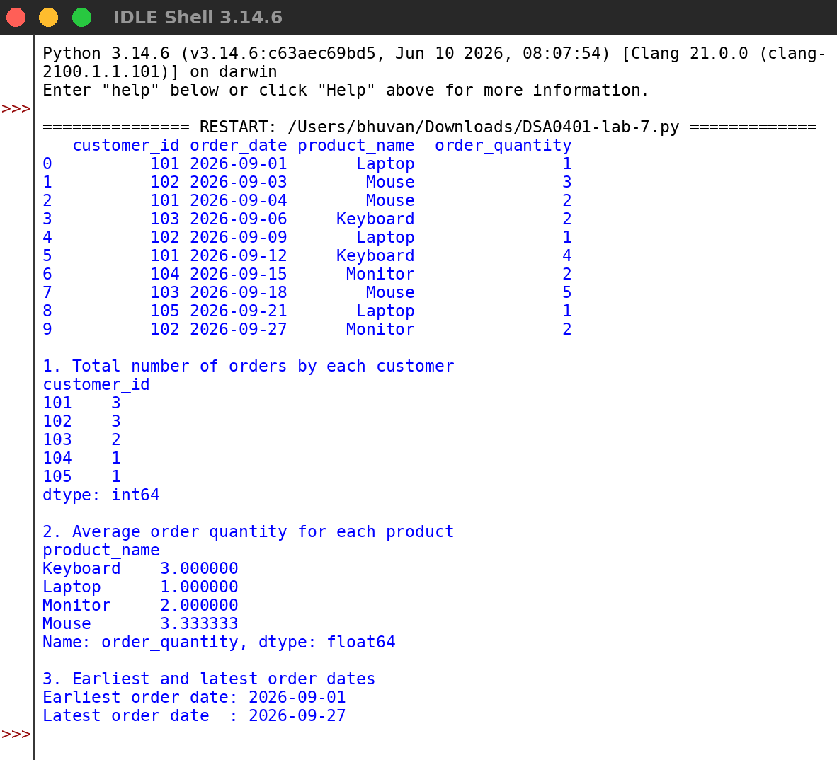
RESULT:
Thus the program was written and executed successfully and the output was verified.

