Fundamentals of Data Science - Lab Manual
Question 8
Top 5 best-selling products
AIM:
To find the top 5 products that have been sold the most in the past month using a Pandas DataFrame.
ALGORITHM:
Step 1: Start the program and import Pandas.
Step 2: Create a DataFrame of the sales records with the columns product and quantity_sold.
Step 3: Group the records by product and add up the quantity sold.
Step 4: Select the 5 largest totals using nlargest(5).
Step 5: Display the top 5 products.
Step 6: Stop the program.
PROGRAM:
import pandas as pd

sales = pd.DataFrame({
"product": ["Laptop", "Mouse", "Keyboard", "Monitor", "Headphones", "Webcam",
"USB Drive", "Printer", "Mouse", "Laptop", "Keyboard", "Headphones",
"USB Drive", "Speaker", "Mouse", "USB Drive", "Webcam", "Monitor",
"Headphones", "Mouse"],
"quantity_sold": [5, 20, 12, 6, 15, 4, 25, 2, 18, 7,
10, 9, 30, 8, 14, 22, 5, 4, 11, 16]})

# total quantity sold for every product
total_sold = sales.groupby("product")["quantity_sold"].sum()

top5 = total_sold.nlargest(5)

print("Top 5 products sold in the past month")
print(top5)
INPUT:
sales - Pandas DataFrame with 20 sales records of 9 different products (product, quantity_sold).
OUTPUT:
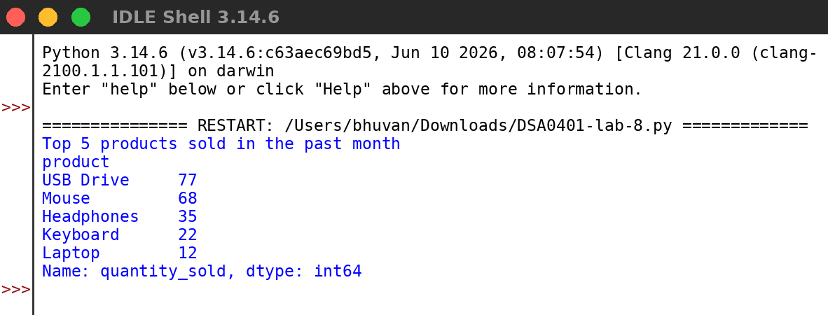
RESULT:
Thus the program was written and executed successfully and the output was verified.

