Fundamentals of Data Science - Lab Manual
Question 9
Property data analysis using Pandas
AIM:
To use Pandas DataFrame operations to find the average listing price per location, the number of properties with more than four bedrooms, and the property with the largest area.
ALGORITHM:
Step 1: Start the program and import Pandas.
Step 2: Create the DataFrame property_data (property ID, location, bedrooms, area, listing price).
Step 3: Group by location and calculate the mean listing price.
Step 4: Count the rows where bedrooms > 4.
Step 5: Use idxmax() on the area column to locate the property with the largest area.
Step 6: Display the results and stop.
PROGRAM:
import pandas as pd

property_data = pd.DataFrame({
"property_id": [1, 2, 3, 4, 5, 6, 7, 8],
"location": ["Adyar", "Velachery", "Adyar", "Anna Nagar",
"Velachery", "Anna Nagar", "Adyar", "Velachery"],
"bedrooms": [3, 5, 4, 6, 2, 5, 3, 4],
"area_sqft": [1500, 2800, 2000, 3400, 950, 2900, 1650, 2200],
"listing_price": [9500000, 15500000, 12000000, 21000000,
5200000, 17500000, 9900000, 11000000]})

print(property_data)

print("\n1. Average listing price in each location")
print(property_data.groupby("location")["listing_price"].mean())

print("\n2. Number of properties with more than four bedrooms:",
(property_data["bedrooms"] > 4).sum())

print("\n3. Property with the largest area")
print(property_data.loc[property_data["area_sqft"].idxmax()])
INPUT:
property_data - Pandas DataFrame with 8 properties (shown in the output below).
OUTPUT:
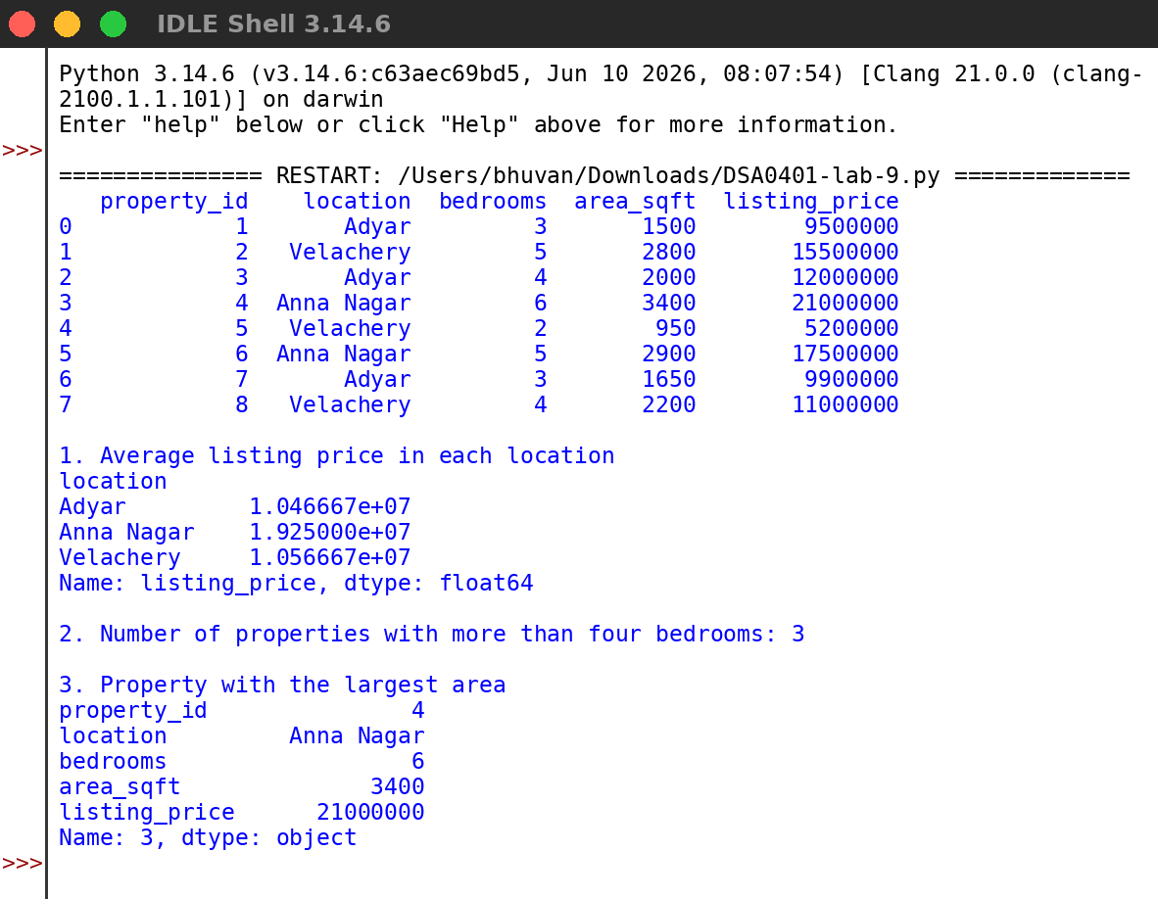
RESULT:
Thus the program was written and executed successfully and the output was verified.

