Fundamentals of Data Science - Lab Manual
Question 10
Line plot and bar plot of monthly sales
AIM:
To develop a Python program using Matplotlib to create (1) a line plot and (2) a bar plot of the monthly sales data of a company.
ALGORITHM:
Step 1: Start the program and import matplotlib.pyplot.
Step 2: Store the months and the corresponding sales values in two lists.
Step 3: Line plot: call plt.plot(months, sales) with marker, title, axis labels and grid, then plt.show().
Step 4: Bar plot: call plt.bar(months, sales) with title and axis labels, then plt.show().
Step 5: Stop the program.
PROGRAM:
import matplotlib.pyplot as plt

months = ["Jan", "Feb", "Mar", "Apr", "May", "Jun",
"Jul", "Aug", "Sep", "Oct", "Nov", "Dec"]
sales = [12000, 15000, 14000, 18000, 21000, 19500,
23000, 24500, 22000, 26000, 29000, 33000]

# 1. Line plot
plt.figure(figsize=(8, 4.5))
plt.plot(months, sales, marker="o", color="blue")
plt.title("Monthly Sales - Line Plot")
plt.xlabel("Month")
plt.ylabel("Sales")
plt.grid(True)
plt.show()

# 2. Bar plot
plt.figure(figsize=(8, 4.5))
plt.bar(months, sales, color="orange")
plt.title("Monthly Sales - Bar Plot")
plt.xlabel("Month")
plt.ylabel("Sales")
plt.show()
INPUT:
Month | Jan | Feb | Mar | Apr | May | Jun
Sales | 12000 | 15000 | 14000 | 18000 | 21000 | 19500

Month | Jul | Aug | Sep | Oct | Nov | Dec
Sales | 23000 | 24500 | 22000 | 26000 | 29000 | 33000

OUTPUT:
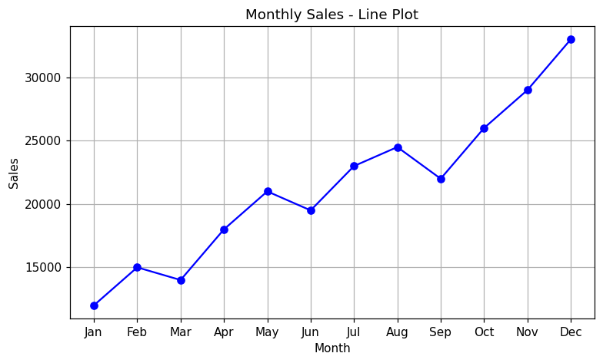
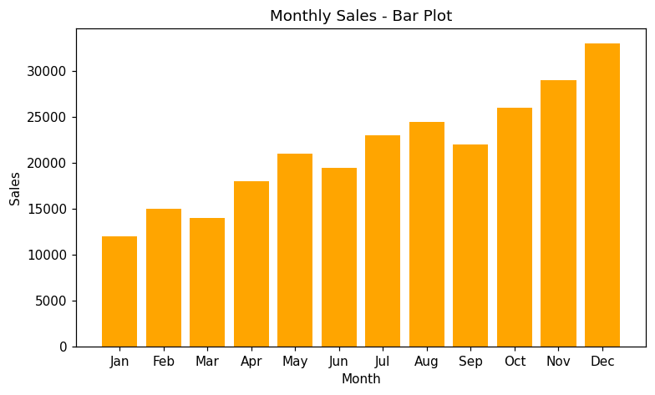
RESULT:
Thus the program was written and executed successfully and the output was verified.

