Fundamentals of Data Science - Lab Manual
Question 11
Line, scatter and bar plots of monthly sales
AIM:
To create a line plot, a scatter plot and a bar plot of the sales of a product over a month using Matplotlib.
ALGORITHM:
Step 1: Start the program and import matplotlib.pyplot.
Step 2: Store the day numbers (1 to 10 of the month) and the units sold on each day in two lists.
Step 3: Line plot: plt.plot(days, sales) with title, labels and grid; display with plt.show().
Step 4: Scatter plot: plt.scatter(days, sales) with title and labels; display with plt.show().
Step 5: Bar plot: plt.bar(days, sales) with title and labels; display with plt.show().
Step 6: Stop the program.
PROGRAM:
import matplotlib.pyplot as plt

days = [1, 2, 3, 4, 5, 6, 7, 8, 9, 10]
sales = [120, 135, 128, 150, 165, 160, 180, 175, 195, 210] # units sold per day

# 1. Line plot
plt.figure(figsize=(7, 4))
plt.plot(days, sales, marker="o", color="green")
plt.title("Daily Sales - Line Plot")
plt.xlabel("Day of the month")
plt.ylabel("Units sold")
plt.grid(True)
plt.show()

# 2. Scatter plot
plt.figure(figsize=(7, 4))
plt.scatter(days, sales, color="red")
plt.title("Daily Sales - Scatter Plot")
plt.xlabel("Day of the month")
plt.ylabel("Units sold")
plt.show()

# 3. Bar plot
plt.figure(figsize=(7, 4))
plt.bar(days, sales, color="purple")
plt.title("Daily Sales - Bar Plot")
plt.xlabel("Day of the month")
plt.ylabel("Units sold")
plt.show()
INPUT:
Day | 1 | 2 | 3 | 4 | 5 | 6 | 7 | 8 | 9 | 10
Units sold | 120 | 135 | 128 | 150 | 165 | 160 | 180 | 175 | 195 | 210

OUTPUT:
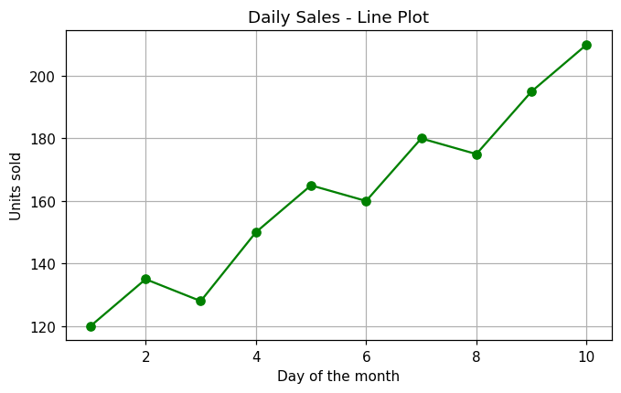
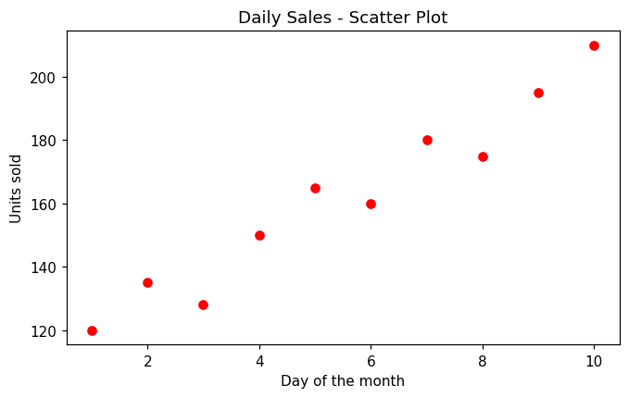
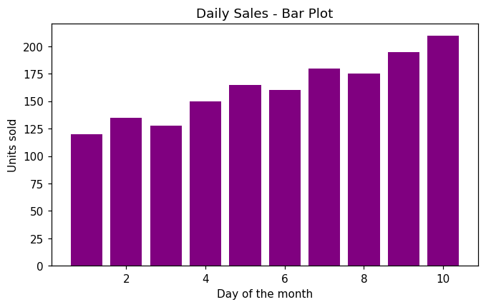
RESULT:
Thus the program was written and executed successfully and the output was verified.

