Jupyter Notebook

To read data from csv file we use pandas library,

Import pandas as pd

Store it in a variable

Var_name = pd.read_csv(‘data_mall.csv’)

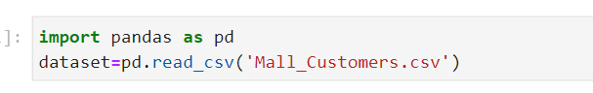

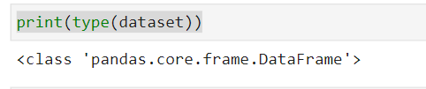

Dataset will be of type dataframe

To print top 5 data in dataset

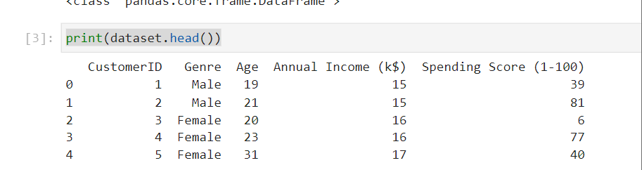

Here we want all last two columns for analysis

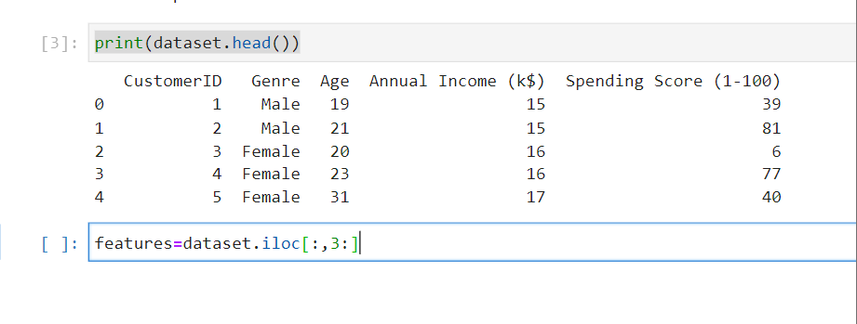

The : indicates all the rows,

3: indicates from index 3 till end

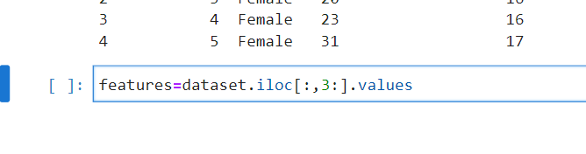

If we don’t put .values it will in dataframe, to make it ndarray we use values

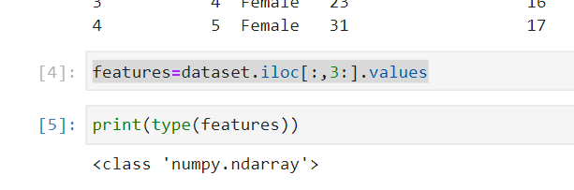

To print first 5 in features variable

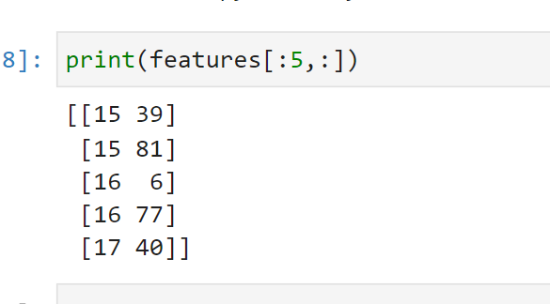

For visulaisation we have to import matplotlib library

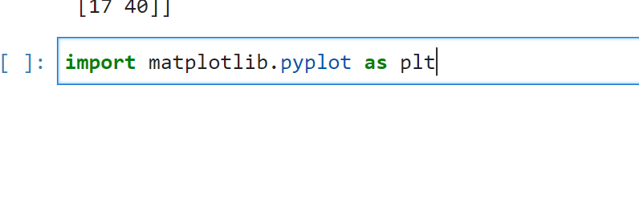

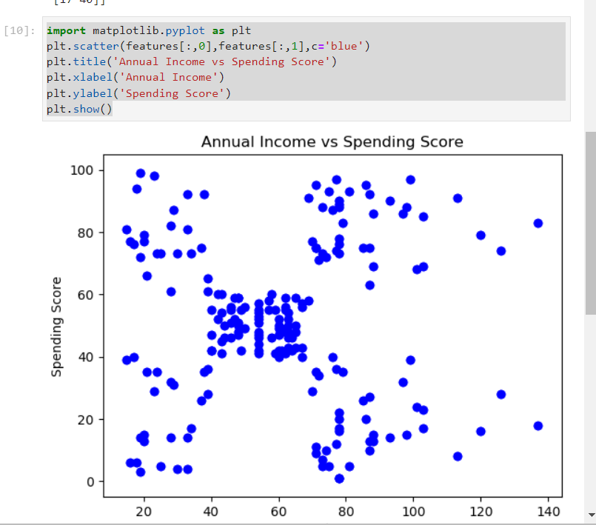

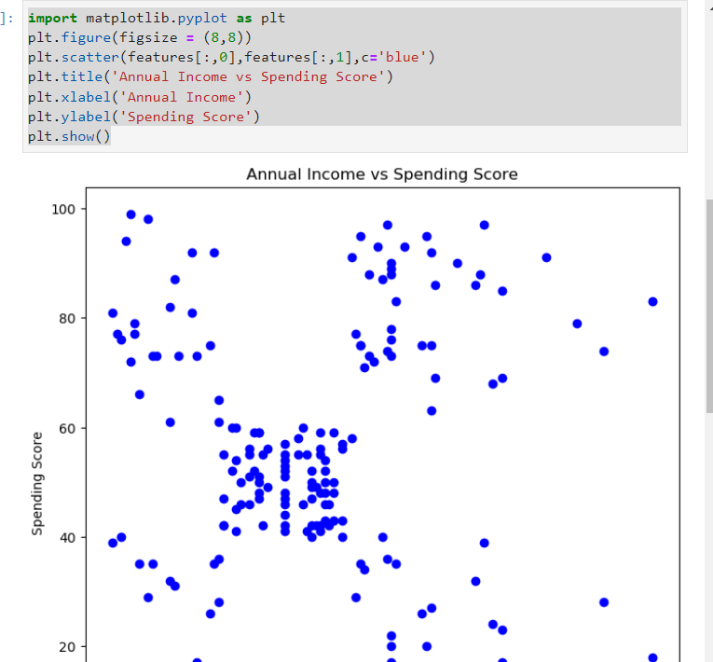

Plt.figure(figsize=(8,8)) to make the size bigger

We have to make use of elbow method to find the number of clusters(k) to divide our dataset

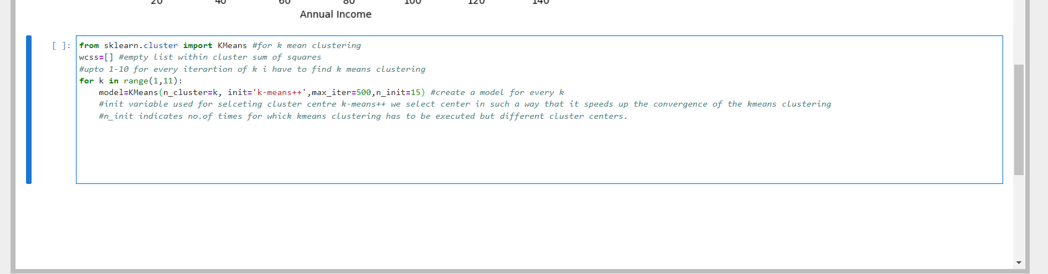

Last two parameters not required.

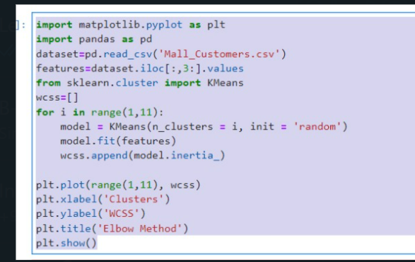

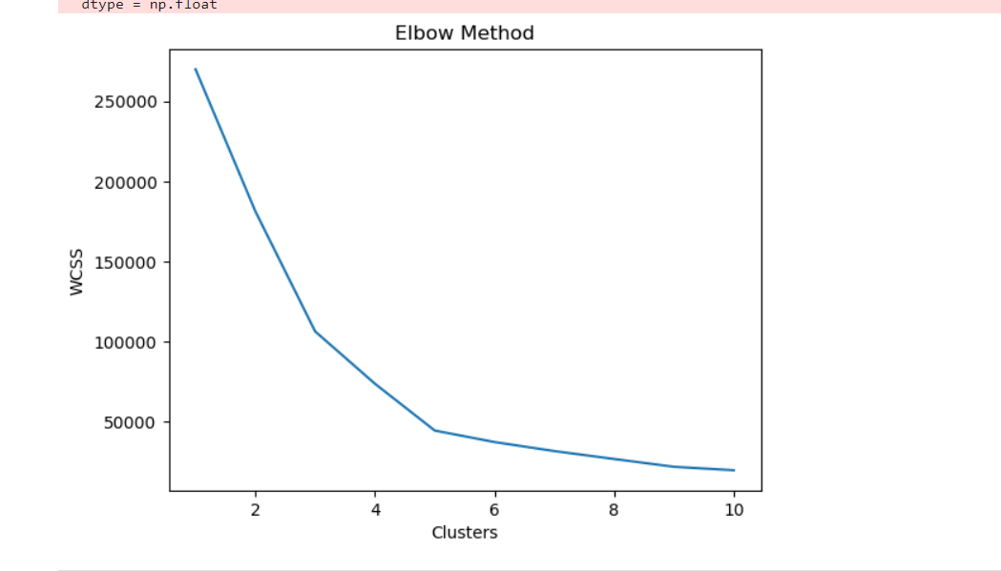

Wcss: within cluster sum of squares

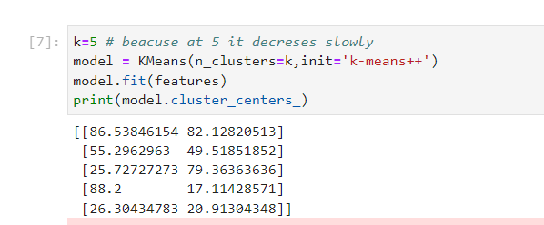

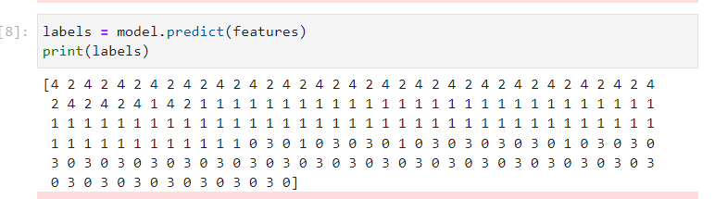

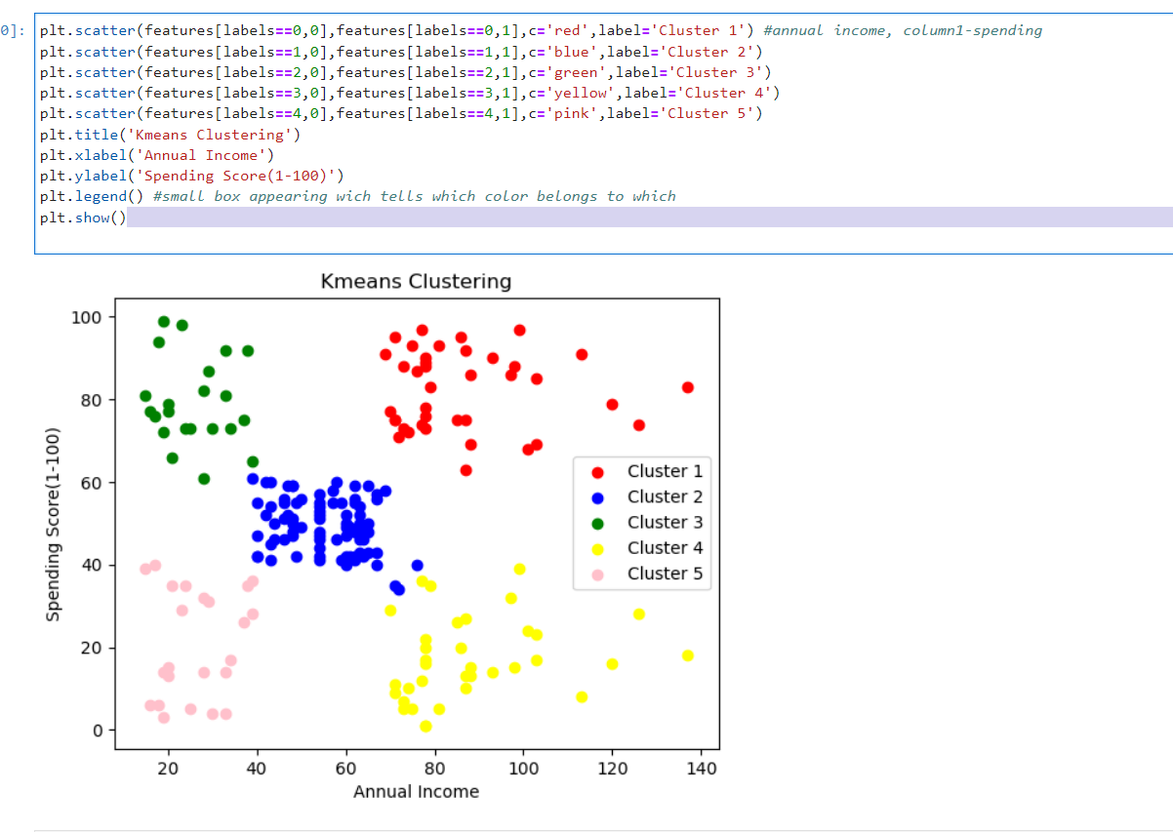

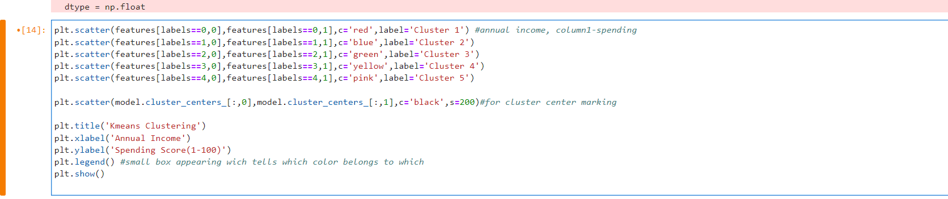

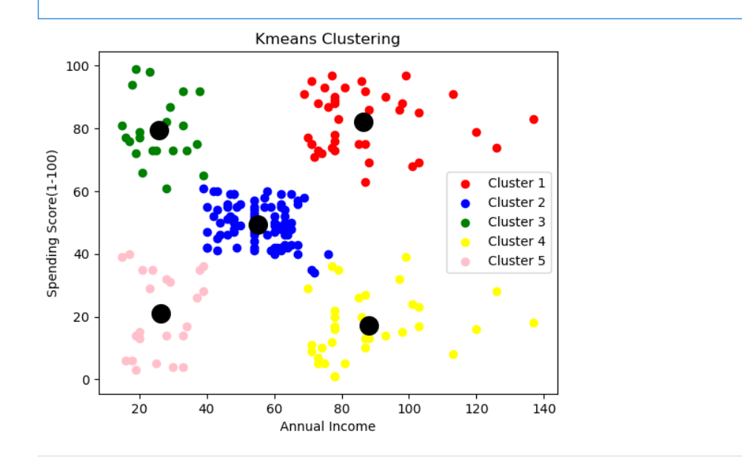

Extracting meaning from the graph

The pink cluster belongs to people having low income and low spending scores.

The green cluster belongs to customer having low income and high spending scores

The red cluster belongs to customer having high income and high spending scores

The blue cluster belongs to customer having medim income and high medim scores

The yellow cluster belongs to customer having high income and low spending scores

Bigger size plot:

