**Lab Practice Sheet -1**

**Banking Case Study Example – Risk Management**

Assume you are the chief risk officer (CRO) for CyndiCat bank that has disbursed 60816 auto loans in the quarter between April–June 2012. Today, about a year and a quarter since the loans disbursal, you know that the loans have seasoned or bad loans are tagged to a greater certainty .

you want to analyze the bad rate across several individual variables. You have a hunch based on your experience that borrower’s age at the time of loan disbursal is a key distinguishing factor for bad rates. Therefore, you have divided the loans based on the age of the borrowers and created a table something like the one below.

[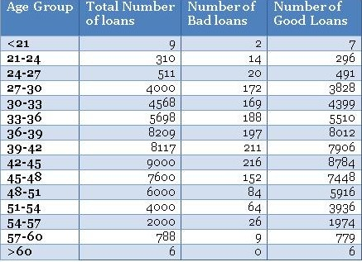](https://i2.wp.com/ucanalytics.com/blogs/wp-content/uploads/2013/09/table-1.jpg)

[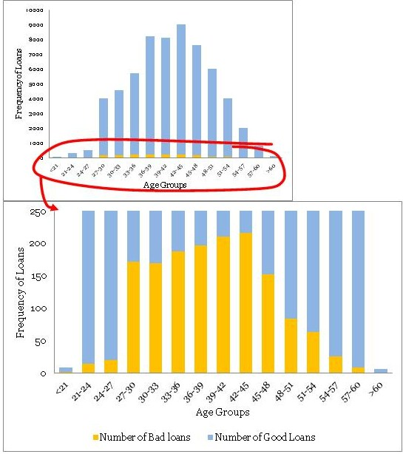](https://i0.wp.com/ucanalytics.com/blogs/wp-content/uploads/2013/09/Graph-Loans.jpg)

Identify the distribution of loans across age groups

• The maximum bad loans are in the age bucket

• The data is really thin on the fringe buckets

Learning Task

Explore Matplotlib in Python

Basic Plotting with Matplotlib

Histograms

Bar Charts

Pie Charts

Box Plots

Scatter Plots