AI UX Discovery-to-Prototype Pipeline
Workflow explanation, artifact guide, and visual architecture
4  Phases | 4  Human gates | 22  Reusable skills | 32  Passing tests

What this package represents
The repository demonstrates a governed AI-assisted UX process that takes a synthetic business requirements document through research, ideation, design, prototype creation, and validation. All four review gates were explicitly approved by a human reviewer.
- Markdown files define phases, agents, reusable skills, gates, inputs, outputs, and evidence rules.
- The runnable HTML/CSS/JavaScript prototype demonstrates the appointment-request experience.
- The Python layer validates structural contracts and routes the workflow without replacing agent judgment.
- The final approval applies only to the documented synthetic demo scope; it is not real-user, production, legal, or WCAG verification.

1. End-to-end workflow
Each phase produces traceable artifacts for a human gate. APPROVE advances; REVISE returns only to affected work; REJECT stops execution. Agents cannot approve gates.
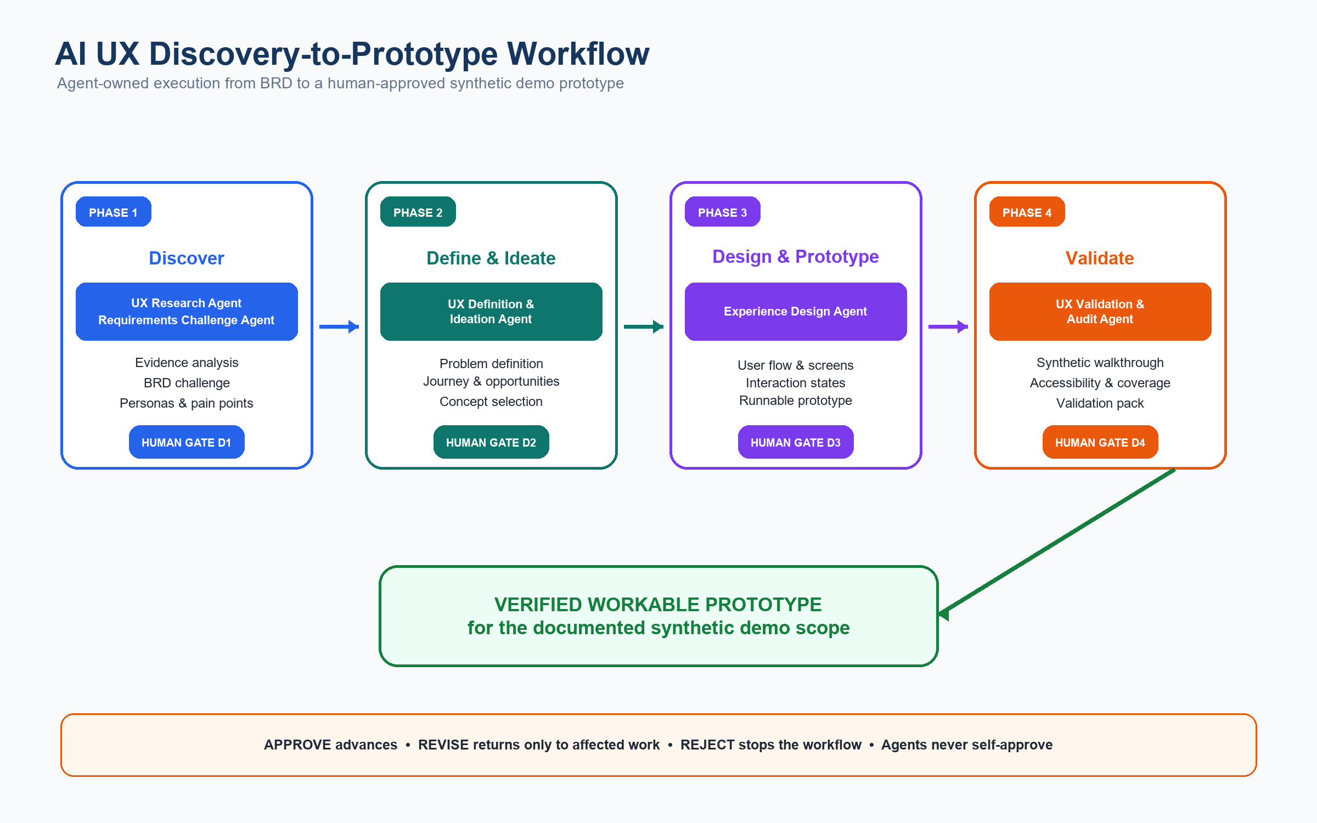
Figure 1. Color workflow from BRD input to D4-approved synthetic demo prototype.

2. Phase outputs
Phase 1 — Discover
Agent owner: UX Research Agent + Requirements Challenge Agent
Challenges the BRD and synthesizes evidence without converting assumptions into user facts.
- Outputs: brd-risk-review.md; persona.md; pain-points.md; research-gaps.md
- Human gate: D1 — Research & Requirements Review
Phase 2 — Define & Ideate
Agent owner: UX Definition & Ideation Agent
Converts approved evidence into problem definitions, journeys, opportunities, and alternative concepts.
- Outputs: problem-definition.md; journey-map.md; opportunities.md; concept-options.md; selected-concept.md
- Human gate: D2 — Definition & Ideation Review
Phase 3 — Design & Prototype
Agent owner: Experience Design Agent
Turns the selected concept into flows, screen/state specifications, and a runnable local prototype.
- Outputs: user-flow.md; screen-spec.md; interaction-states.md; prototype-spec.md; prototype/
- Human gate: D3 — Design & Prototype Review
Phase 4 — Validate
Agent owner: UX Validation & Audit Agent
Performs synthetic walkthroughs and evidence-bounded accessibility, design-system, requirement, and edge-case checks.
- Outputs: validation-report.md; validation-issues.md; requirement-coverage.md; accessibility-audit.md
- Human gate: D4 — Final UX Validation Review

Validation outcome
The core appointment-request path works, including required-field blocking, privacy consent, duplicate-submit prevention, and explicit pending/timeout wording. Accepted limitations include missing cancellation and session-expiry execution, incomplete accessible error/focus behavior, and simulated backend/notification behavior.

3. Folder architecture
The repository separates stable workflow definitions, active project inputs/state, generated phase outputs, executable runtime code, and automated tests.
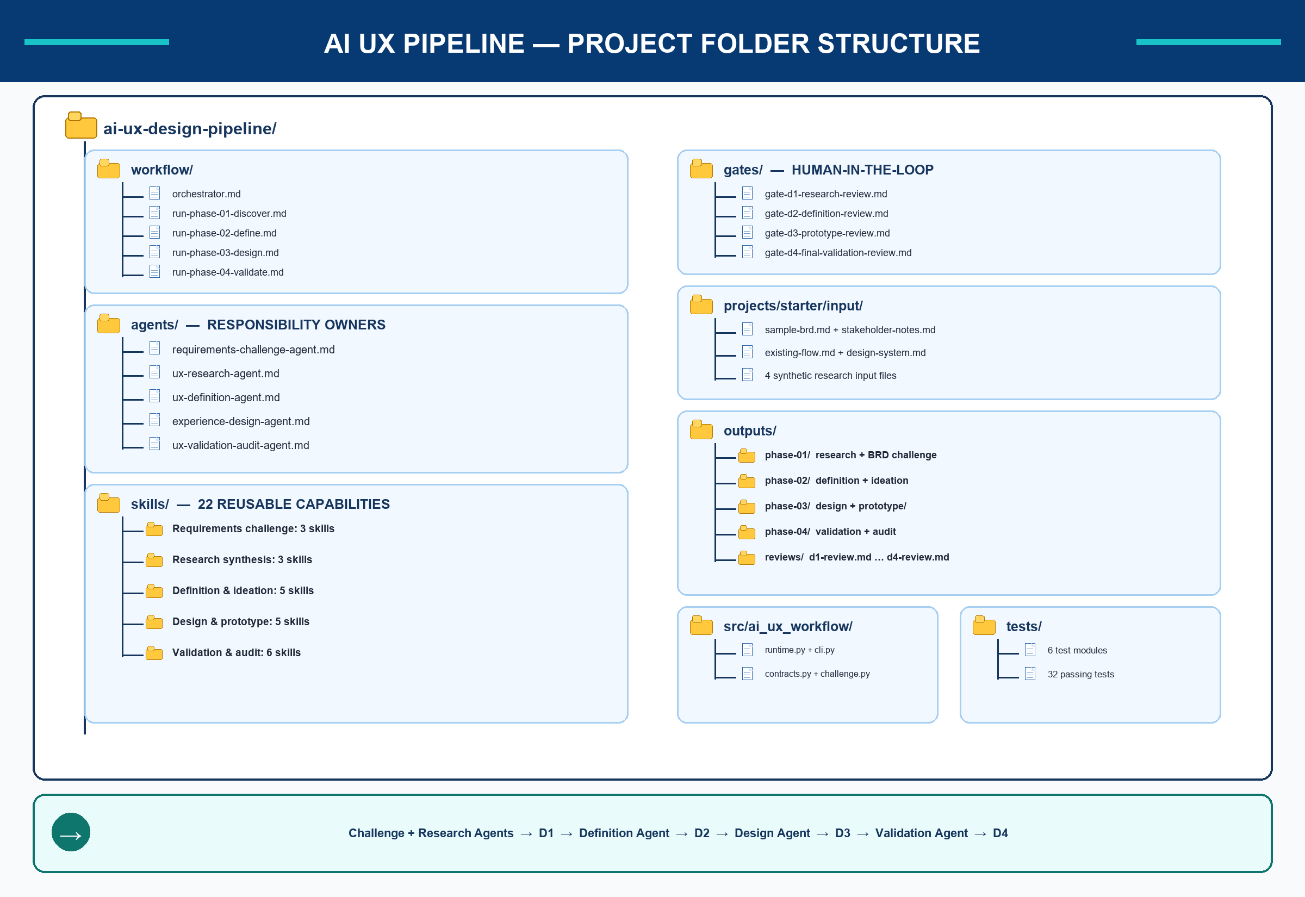
Figure 2. Color-coded folder structure and responsibility boundaries.

4. Folder reference
Folder / file | Responsibility
workflow/ | Orchestrator and four phase runbooks; controls routing and declared execution order.
agents/ | Five responsibility owners: Requirements Challenge, UX Research, UX Definition & Ideation, Experience Design, and UX Validation & Audit.
skills/ | Twenty-two reusable capabilities invoked by agents in an explicit order.
gates/ | D1–D4 human review contracts with APPROVE, REVISE, and REJECT decisions.
projects/starter/input/ | Synthetic BRD, stakeholder notes, existing flow, design system, and demo research inputs.
outputs/phase-01/ | BRD challenge, personas, pain points, and research gaps.
outputs/phase-02/ | Problem definition, journey, opportunities, concepts, and selected direction.
outputs/phase-03/ | Flow, screens, states, prototype specification, and runnable web prototype.
outputs/phase-04/ | Validation report, issues, requirement coverage, and accessibility audit.
outputs/reviews/ | Explicit human decision records for D1 through D4.
src/ai_ux_workflow/ | Python validation, routing, command-line interface, and deterministic challenge demo.
tests/ | Contract, cross-reference, safety, sample-input, assignment-compliance, and runtime tests.

Usage note
The Markdown workflow can be used in compatible agentic environments by instructing the agent to read the orchestrator, active project configuration/state, and the relevant phase runbook. The Python runtime is an optional deterministic validation and demonstration layer, not the only way to use the workflow.

